**CHAPTER - 1**

**INTRODUCTION**

**Process Mining is the combination of two disciplines:** Data Science and Business Process Management. Process Mining essentially uses Data Science techniques, such as Big Data and AI, to address Process Science problems such as process improvement and automation. Process Mining is the leading new technology when it comes to talking about algorithmic businesses - in other words, businesses that use algorithms and large amounts of real-time data to create business value. This has only become possible through the advent of information systems and administrative tools (e.g. Enterprise Resource Planning or Customer Relationship Management systems) which provide a good data source for process analytics.

According to MarketWatch (opens in a new tab), Global Process Mining Software Market is valued approximately at USD 322.02 Million in 1818 and is anticipated to grow more than 50.1% by 1827. The strong development of Celonis - from a student startup to a company with over 3000 employees in 1822 and a customer base of the biggest enterprises like Coca-Cola, Unilever, Vodafone or Uber - paints the same picture. Process Mining is in high demand, which is further backed up by current hypes around automation and other performance acceleration measures (cf. Gartner 1818).

Process Mining is achieved by taking the digital footprints that are created in IT systems and using them to reconstruct and visualize process flows. From here, Process Mining technology can identify patterns and deviations and ultimately eliminate bottlenecks.

**1.1 What is process mining**

Process mining is a data-driven approach used to analyze and improve business processes. It involves extracting information from event logs recorded by information systems to create visual representations of process flows. By analyzing these representations, organizations can identify bottlenecks, inefficiencies, and deviations from expected processes. This helps in optimizing processes, enhancing transparency, and making data-driven decisions to improve overall operational efficiency and effectiveness.

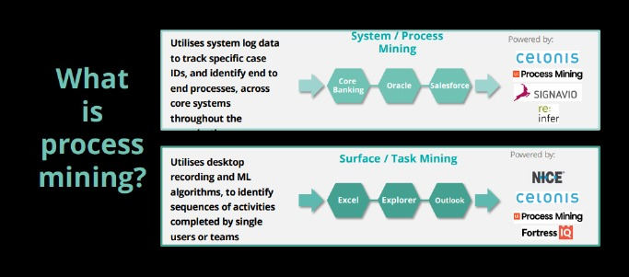

**Fig 1.1-system and surface process mining**

The main goal of process mining is to gain insights into how processes are actually being executed, rather than how they are supposed to be executed according to documentation or guidelines. This involves three main steps:

**Data Extraction:** The first step involves collecting and aggregating data from various sources such as ERP systems, CRM systems, databases, and other software applications. This data is often stored as event logs that capture information about the activities, timestamps, resources, and relationships within a process.

**Process Discovery:** In this step, process mining algorithms analyze the event logs to create a visual representation of the actual process flow. This can take the form of process maps, flowcharts, or other graphical representations that show the sequence of activities, decision points, loops, and variations in the process.

**CHAPTER - 2**

**PROCESS MINING FUNDAMENTALS**

Process mining is a data-driven approach that aims to discover, monitor, and improve processes by analyzing event data logs generated during the execution of these processes. It provides insights into how processes are actually being executed, allowing organizations to identify bottlenecks, inefficiencies, and opportunities for optimization. Here are the fundamentals of process mining:

**1. Event Logs and Data Collection:** Event logs are the heart of process mining. These logs capture timestamped events generated during the execution of a process. Events could be actions, decisions, or any significant steps in the process. Data sources for event logs include IT systems, applications, sensors, and manual inputs.

**2. Process Discovery:** This is the initial phase of process mining. It involves transforming raw event data into process models that visualize the sequence of activities and their relationships. Process discovery techniques include alpha-algorithm, heuristic mining, and more advanced approaches like Petri nets and genetic algorithms.

**3. Process Conformance:** After creating a process model, it's important to compare it with the real-world event data to identify deviations. Process conformance analysis highlights discrepancies between the expected process flow and the actual executions, helping to uncover non-compliance and inefficiencies.

**4. Process Enhancement:** Once discrepancies are identified, organizations can focus on process improvement. This involves identifying bottlenecks, inefficiencies, and opportunities for automation or optimization. By aligning the process model with the desired outcomes, organizations can enhance their processes.

**5. Process Monitoring:** Process mining isn't just a one-time effort. Continuous process monitoring involves tracking the ongoing execution of processes using real-time data feeds. Deviations from the expected process flow can be immediately identified and addressed.

**6. Key Performance Indicators (KPIs):** Process mining often involves defining and tracking relevant KPIs to measure the effectiveness and efficiency of a process. KPIs could include cycle time, throughput, resource utilization, and error rates.

**7. Process Visualization:** Visualization techniques play a crucial role in process mining. Process models can be presented using flowcharts, Gantt charts, Petri nets, or other graphical representations. These visualizations make it easier to comprehend the process structure and identify areas for improvement.

**8. Data Preprocessing:** Raw event data often needs preprocessing to remove noise, handle missing data, and aggregate events. This ensures that the data used for analysis is accurate and meaningful.

**9. Tools and Software:** There are various commercial and open-source tools available for process mining, such as ProM, Disco, Celonis, and more. These tools provide functionalities for data import, process discovery, conformance analysis, and visualization.

**10. Ethical Considerations:** Process mining deals with sensitive data related to how organizations operate. Ensuring privacy and compliance with data protection regulations is essential. Anonymizing or pseudonymizing data, obtaining consent, and following legal guidelines are important ethical aspects.

Process mining is a multidisciplinary field that intersects with data mining, business process management, and information systems. It empowers organizations to gain data-driven insights, streamline processes, and make informed decisions to improve efficiency and customer satisfaction.

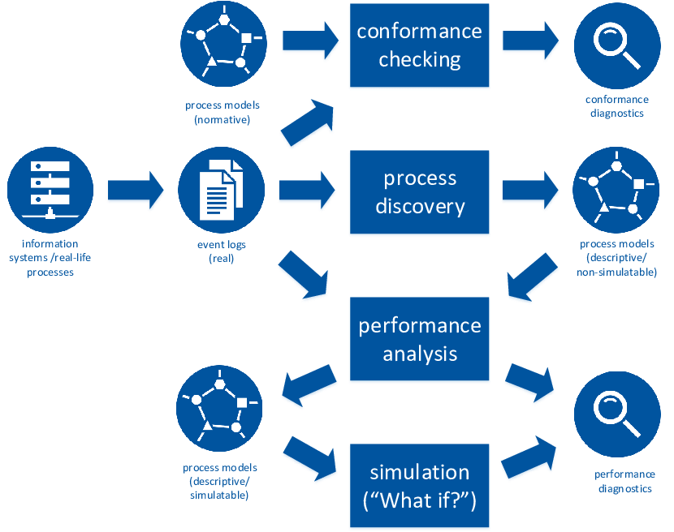

**Fig. No. 2.1: Process Mining Fundamentals**

**CHAPTER - 3**

**APPLICATIONS OF PROCESS MINING**

Financial services, telecommunications, healthcare, and retail are just a few examples of industries where process mining can be used for business process management and process improvement. These sectors have a wealth of data that can be used as a starting point, and process deviations from their intended behavior can have expensive repercussions.

### ****1. Financial Services:****Because of the rise in transaction volume and the digitization of more industries, aberrant activity is harder to detect using manual methods. Companies in the financial services sector have the chance to continually and thoroughly identify issues within high-volume processes thanks to process mining, which is a solution to the increased regulatory and audit requirements.

### ****2. Telecommunications:**** As subscriber quantities increase and activations become more and more automated, there is a greater danger of unsuccessful activations. When telecom companies get more orders, process mining gives them the chance to identify pricey issues and client blowback in their Order-to-Activation processes.

### ****3. Healthcare:****The risks associated with preserving population health and achieving individual patient journey objectives rise as data about patient experiences and results keep growing. Process mining supports the delivery of effective and high-quality end-to-end patient journeys for healthcare organizations dealing with the exponential growth of data, from before a first doctor appointment through treatment regimens to closed treatment cases.

### ****4. Retail:**** Due to technology or process problems, retail businesses have seen expensive consumer fallout from complicated e-commerce operations. Process mining assists merchants in ensuring that consumers can complete transactions efficiently and without issues despite rising transaction volumes.

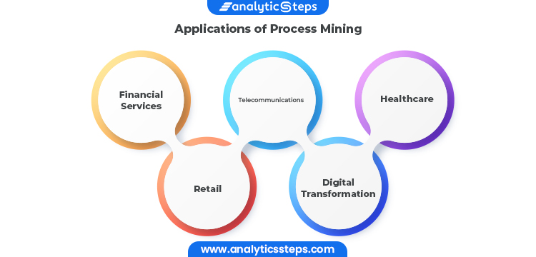

**Fig. No. 3.1: Applications**

**5. Digital Transformation:** Process mining is frequently used in larger-scale digital transformation initiatives because it can give you the precise insights needed for process improvement, allowing systems to run more quickly, smoothly, and efficiently, as well as objective data-driven insights into the causes of delays and inefficiencies within business processes.

As a result, process mining may assist in identifying the digital transformation opportunities with the greatest potential for value addition and determining whether or not transformation activities have really produced the desired results. To optimize returns on investments in projects for digital transformation, process mining becomes a crucial instrument.

### 

**CHAPTER - 4**

**MODULES OF PROCESS MINING**



**Fig. No. 1.1: Life cycle**

**Fig. No. 1(**Chapter Number**).1(**Figure number in that chapter**)**