**Assignment-1:**

**1. Setup GitHub Copilot:**

* Install **Visual Studio Code** (if not already installed).
* Install the **GitHub Copilot extension** from the VS Code Marketplace.
* Authenticate with your **GitHub account** (must have access to Copilot free or trial).
* Enable Copilot in the settings and verify its status.

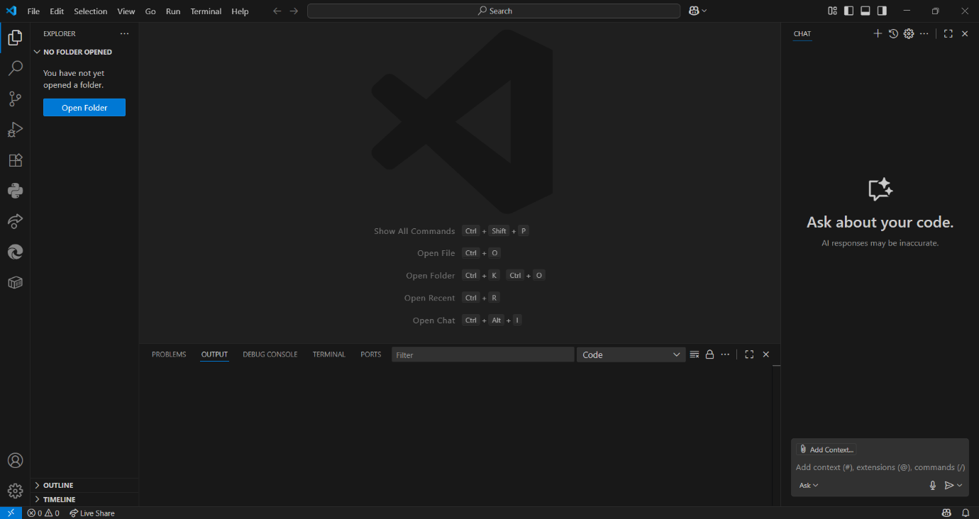

**2. First Use:**

* Create a new Python or JavaScript file.
* Start writing a function like def calculate_factorial(n): and observe Copilot suggestions.
* Accept, reject, or modify suggestions as needed.

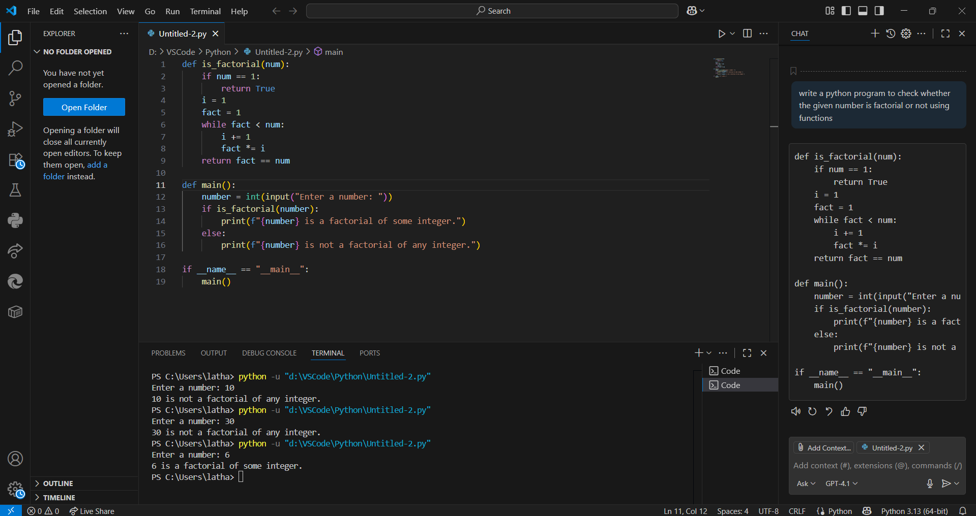

**Explanation:**

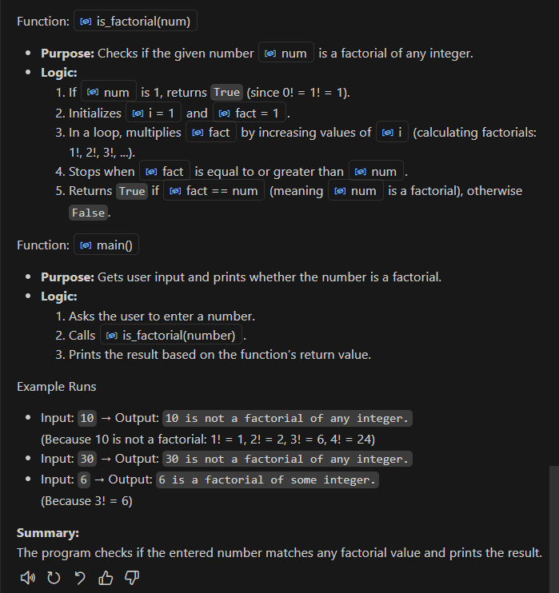

**3. Mini Project:**

* Write a small program with functions such as:
  + User login simulation
  + File I/O operations
  + JSON data parsing
* Use Copilot to generate parts of the logic, then manually review and refine.

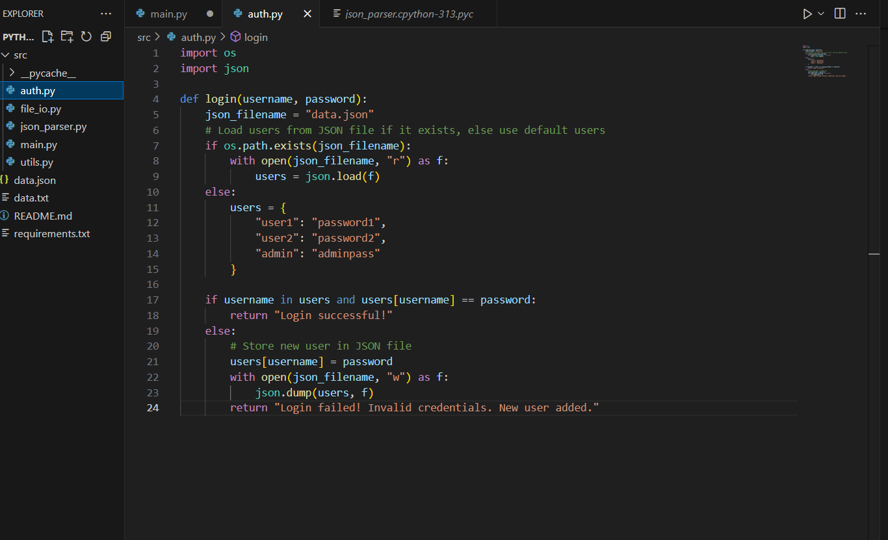

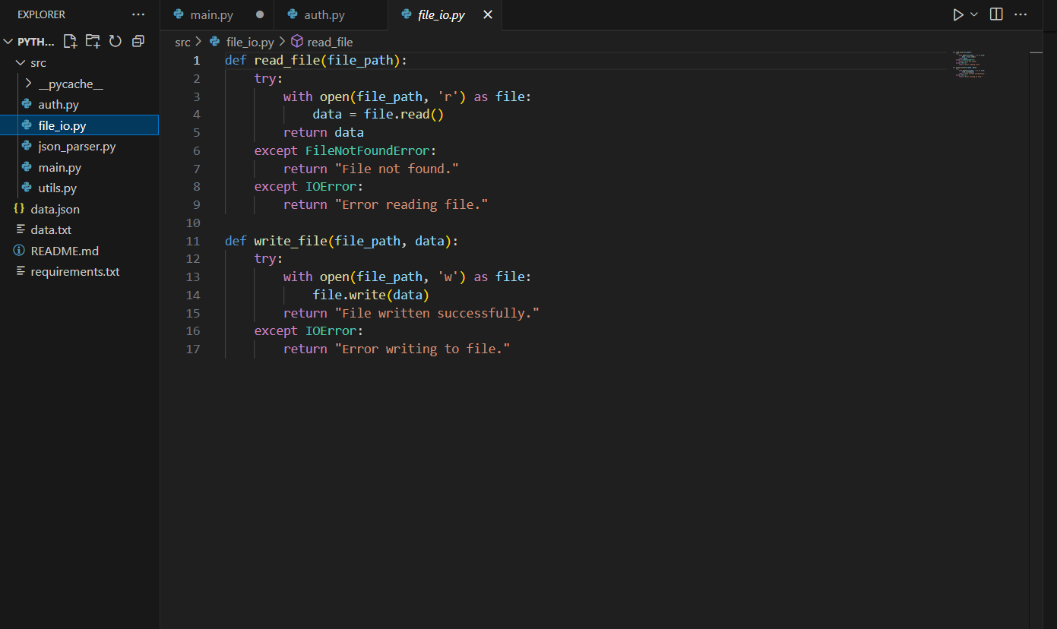

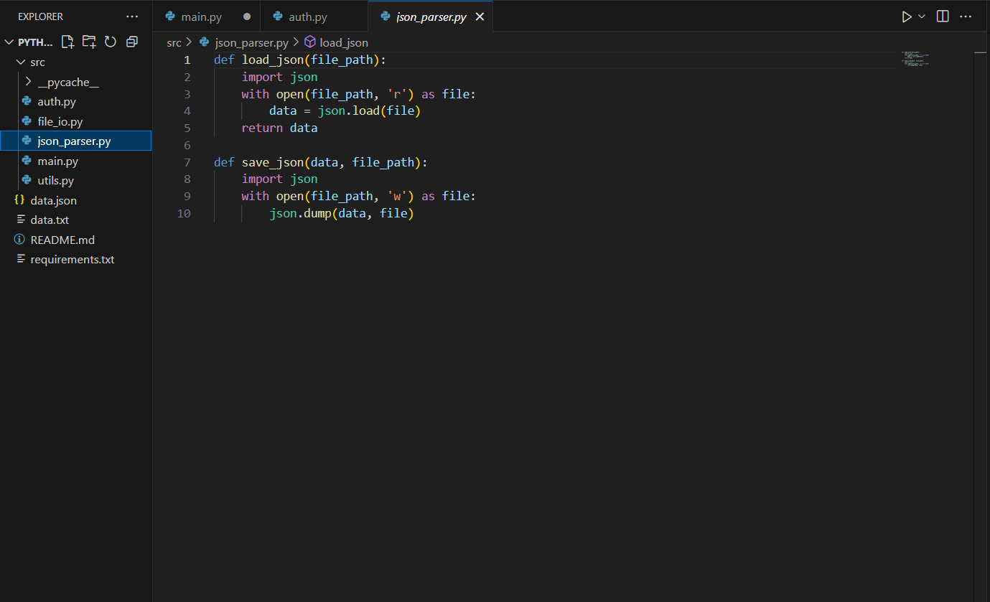

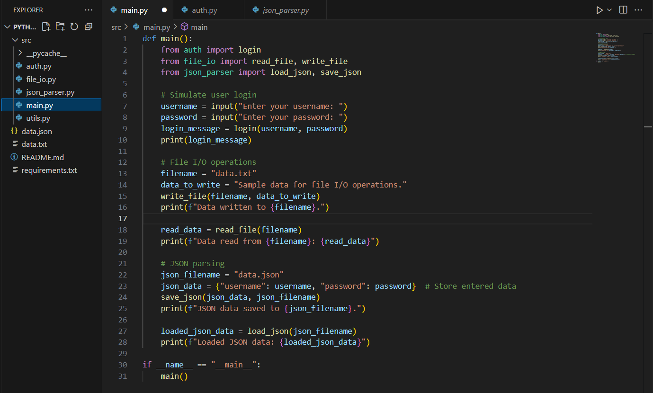

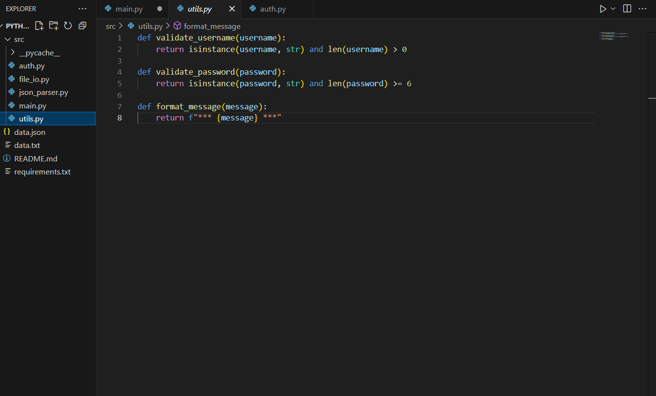

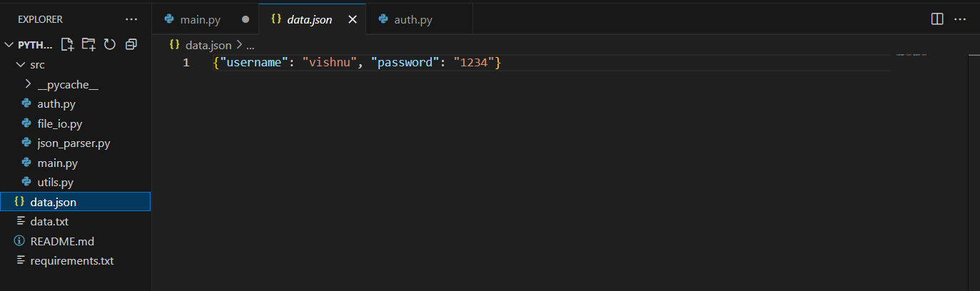

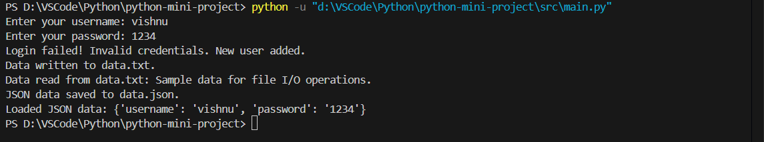

**Explanation:**

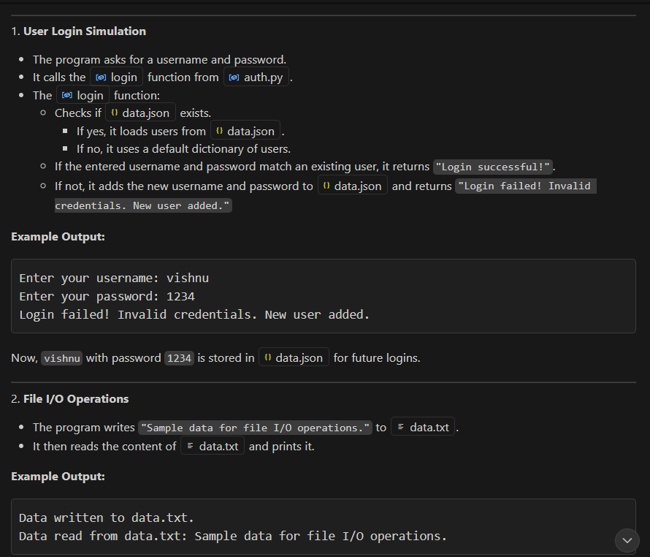

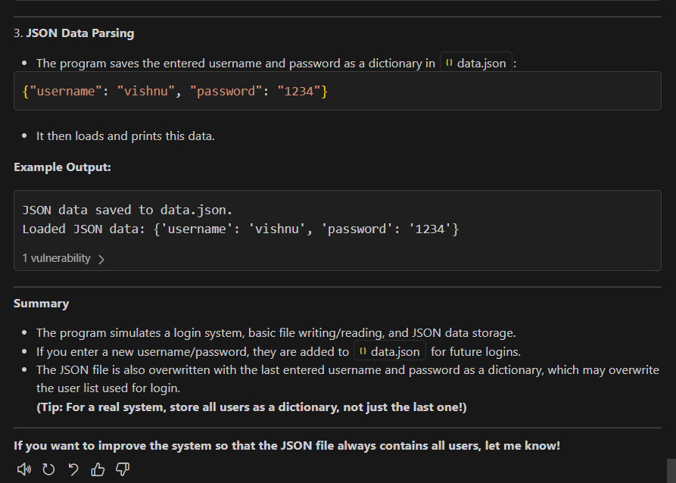

**4. Observation and Report:**

* Record your experience: What kind of suggestions did Copilot offer? Were they accurate? How much time did it save?

**Observation and Report:**

**Suggestions Offered:**  
Copilot provided highly relevant and practical suggestions throughout my project. For example:

* It gave me complete code samples for multi-page web apps with localStorage integration.
* It helped me implement social login buttons and responsive UI elements.
* It offered troubleshooting tips when I faced issues with user authentication and dashboard rendering.
* It even suggested design improvements that matched professional platforms like Canvas and Google.

**Accuracy:**  
The suggestions were consistently accurate and aligned with current best practices. Copilot explained each step clearly and tailored its guidance to my specific goals—like building a polished user journey from signup to dashboard. It also adapted to my evolving needs, offering UI/UX enhancements and debugging help as I progressed.

**Time Saved:**  
Copilot significantly reduced my development time. Instead of spending hours searching for solutions or testing random fixes, I got:

* Instant code snippets ready to use
* Clear explanations that deepened my understanding
* Design inspiration that helped me avoid trial-and-error

Overall, I estimate it saved me **several hours per feature**, especially during complex tasks like profile management and dynamic dashboard creation.