**Assignment-4.3**

**Task Description#1:**  
● Zero-shot: Prompt AI to write a function that checks whether a given year is a leap  
year.

**Code:**

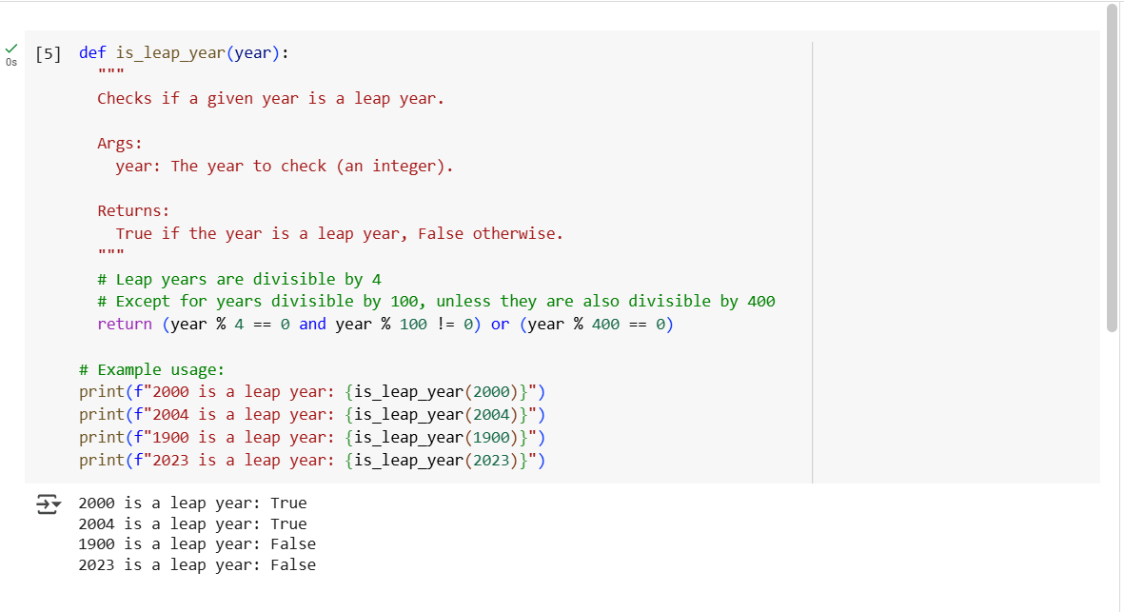

**Explanation:**

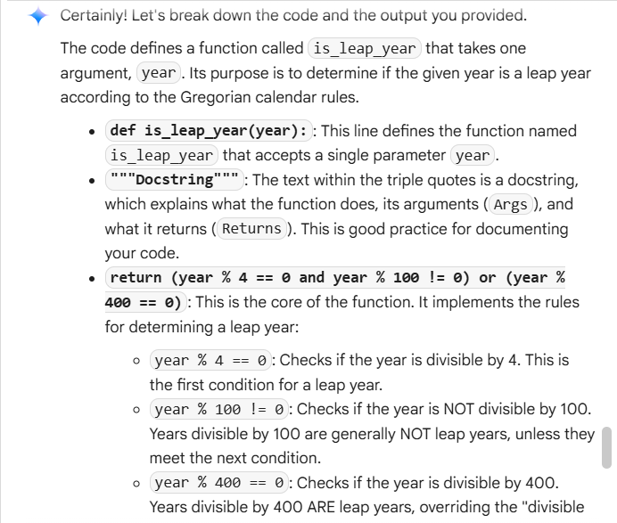

**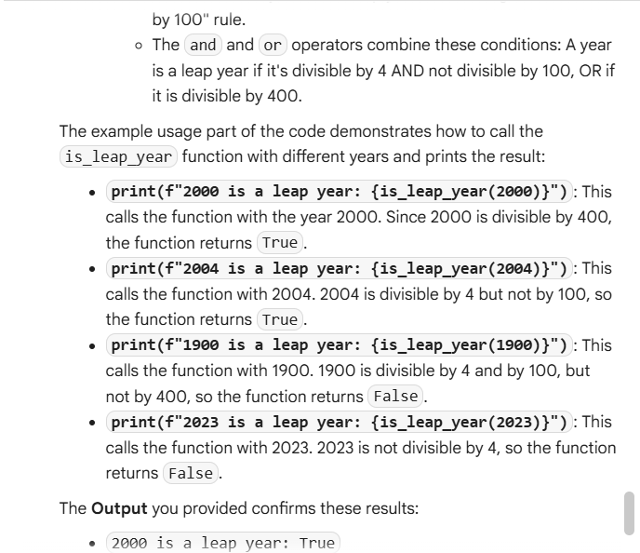  
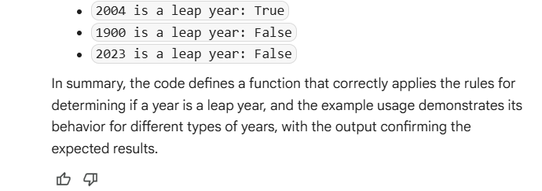**

**Task Description#2**● One-shot: Give one input-output example to guide AI in writing a function that  
converts centimeters to inches.

**Code:**

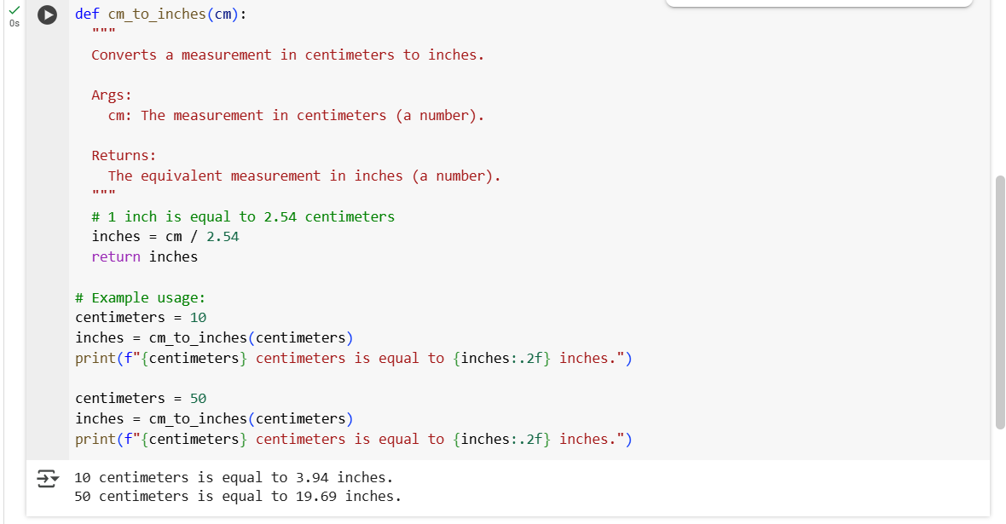

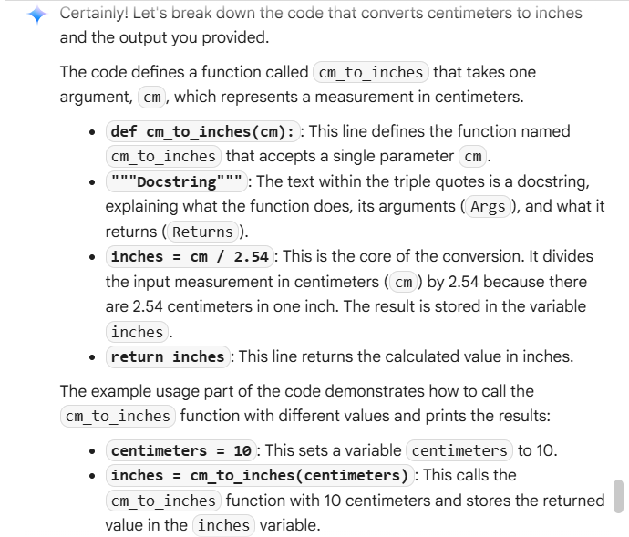**Explanation:**

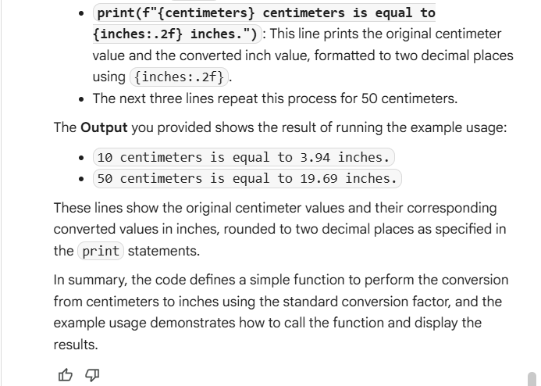

**Task Description#3**:  
● Few-shot: Provide 2–3 examples to generate a function that formats full names as “Last, First”.

**Code:**

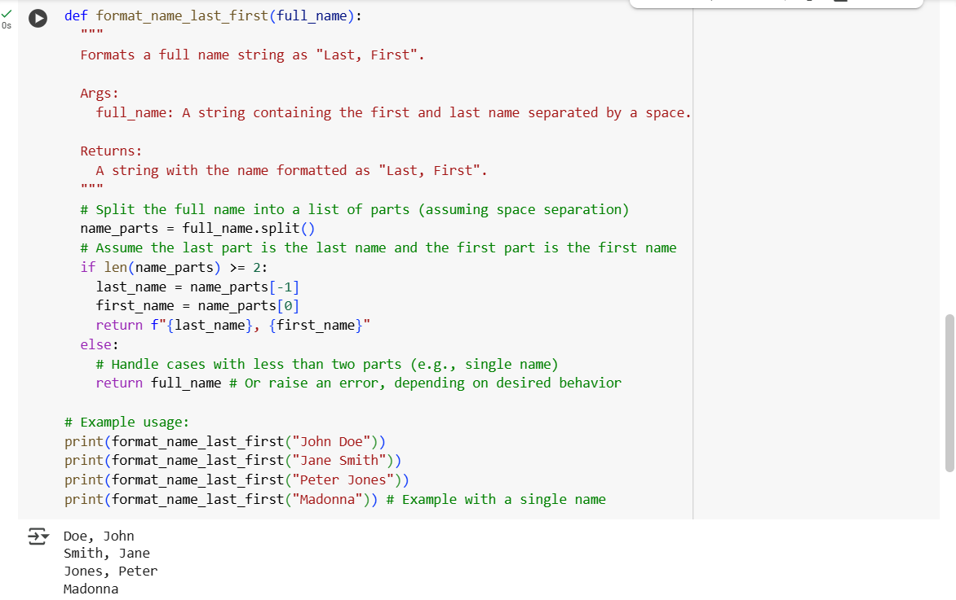

**Explanation:**

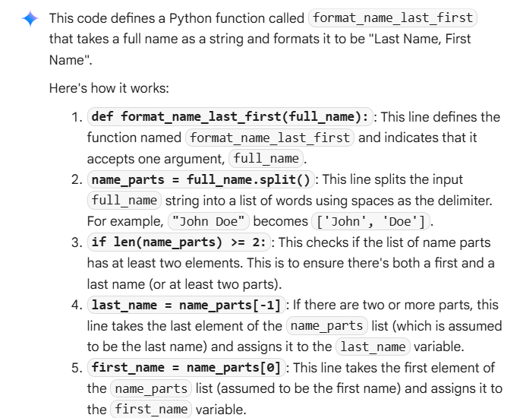

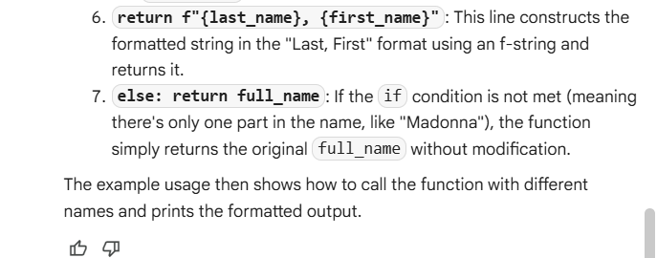

**Task Description#4:**● Compare zero-shot and few-shot prompts for writing a function that counts the  
number of vowels in a string.

**Code:**

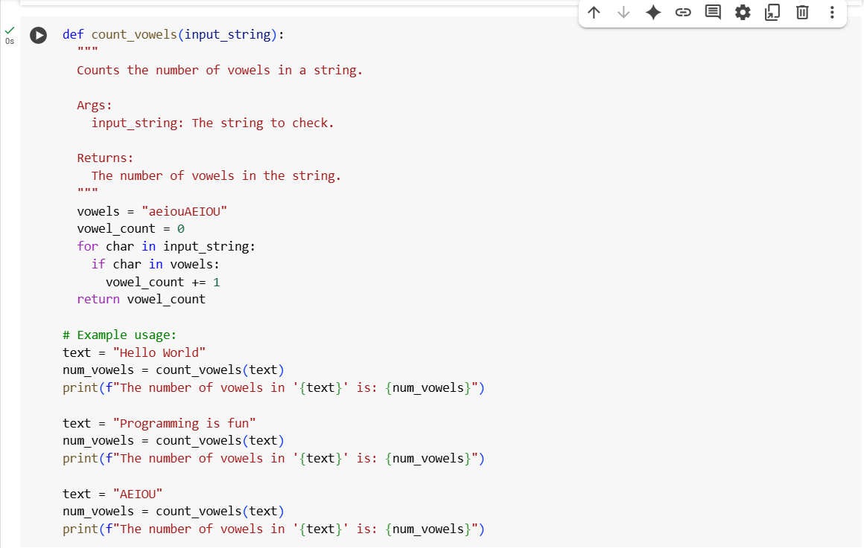



**Explanation:**

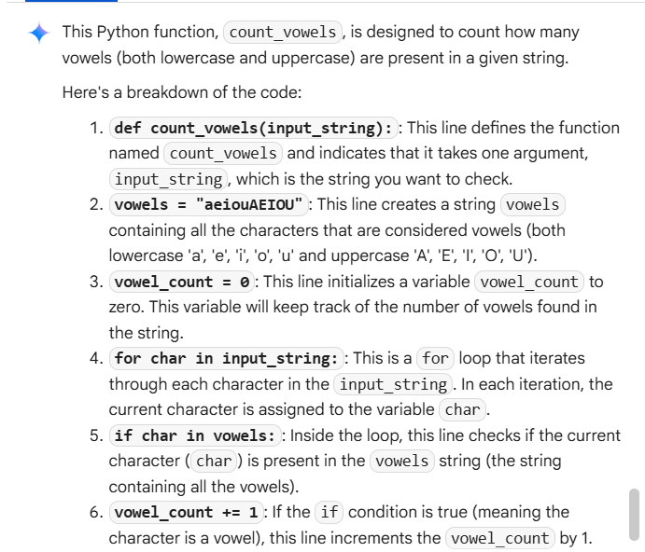

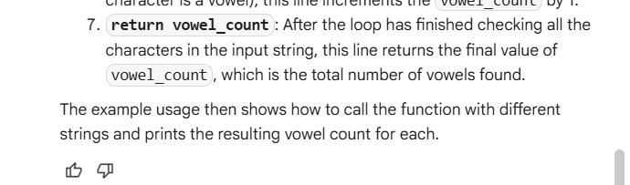

**Task Description#5:**● Use few-shot prompting to generate a function that reads a .txt file and returns the  
number of lines.

**Code:**

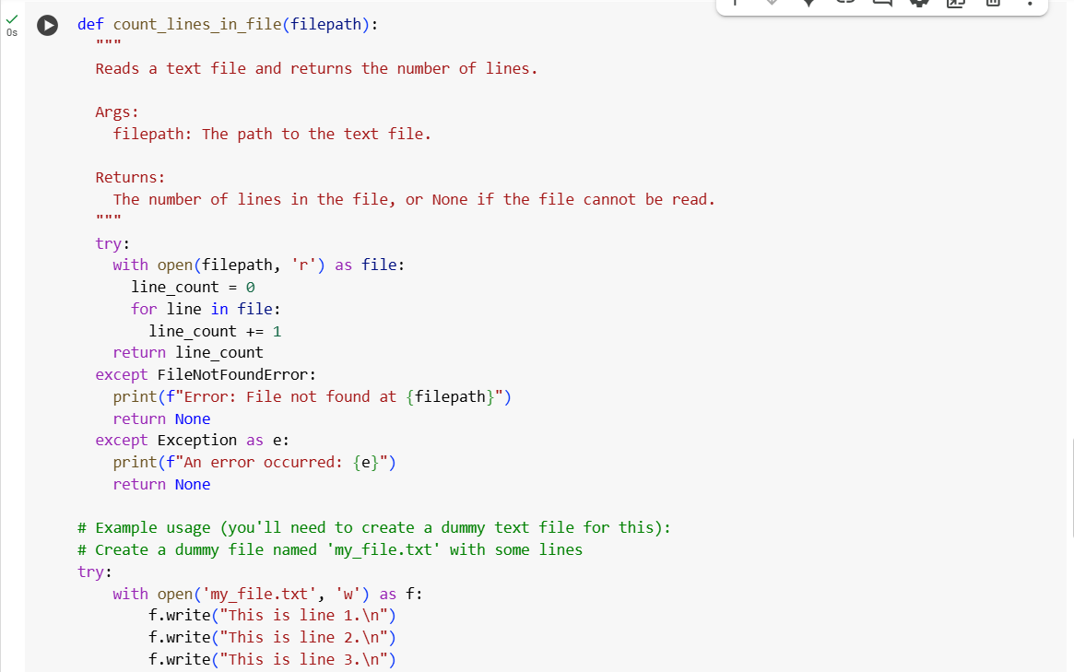

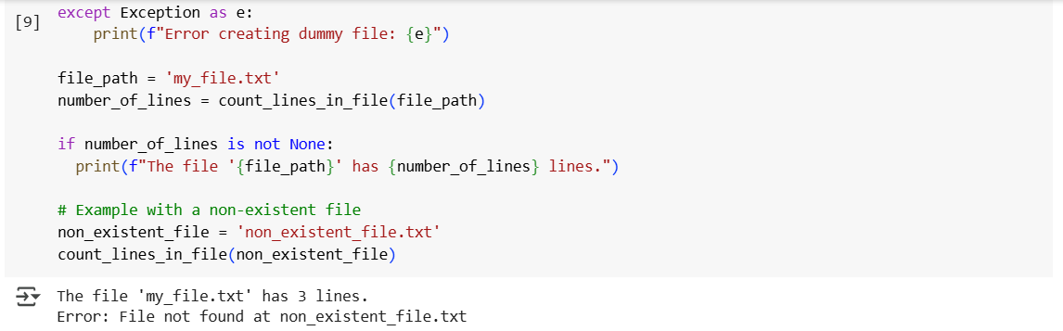

**Explanation:**

