**Assignment-6.4**

**Task Description #1:**  
• Start a Python class named Student with attributes name, roll_number, and marks. Prompt  
GitHub Copilot to complete methods for displaying details and checking if marks are above  
average.

**Code:**

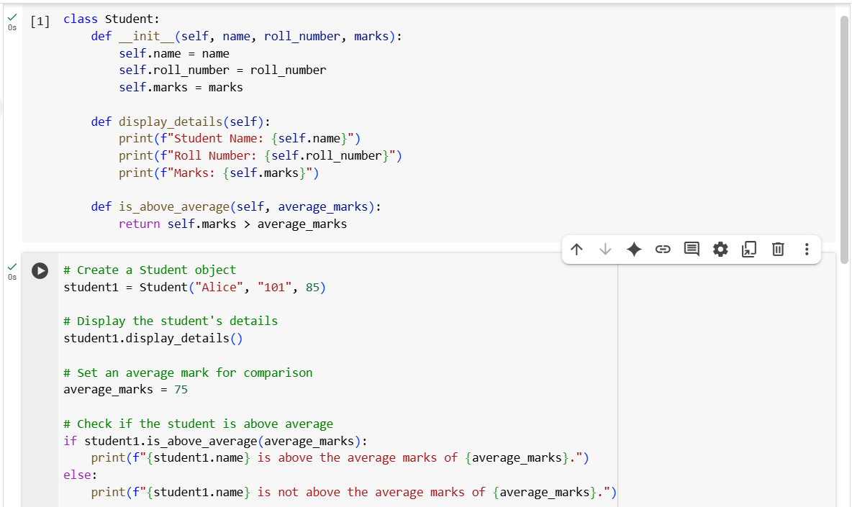

 **Explanation:**

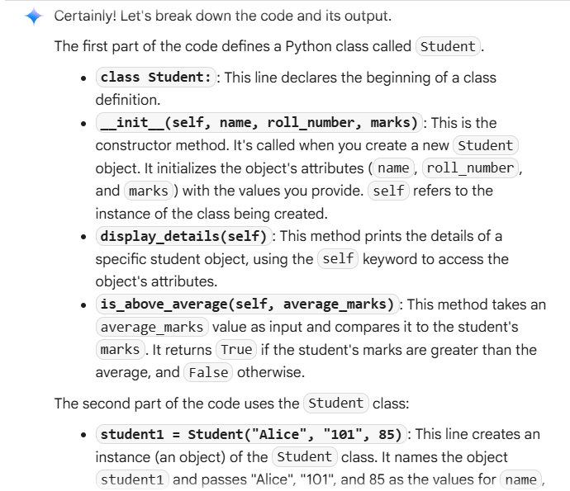

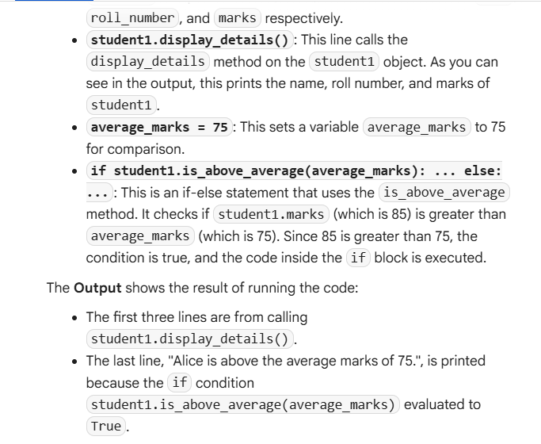

**Task Description #2:**  
• Write the first two lines of a for loop to iterate through a list of numbers. Use a comment  
prompt to let Copilot suggest how to calculate and print the square of even numbers only.

**Code:** 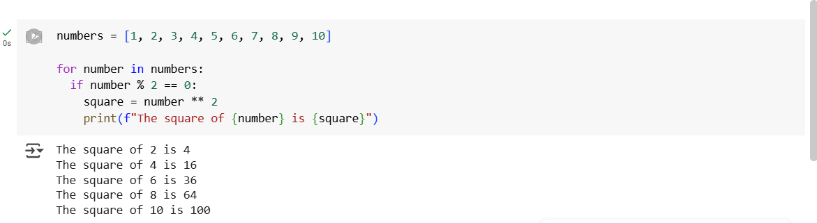

**Explanation:** 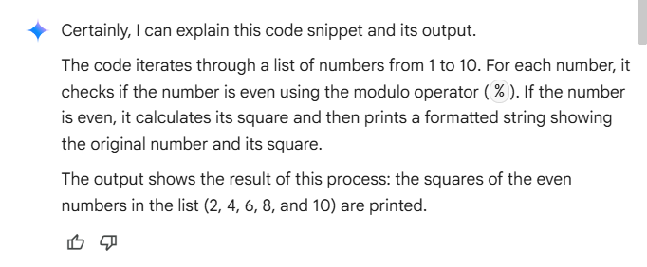

**Task Description #3:**• Create a class called Bank Account with attributes account_holder and balance. Use Copilot to complete methods for deposit( ), withdraw( ), and check for insufficient balance.

**Code:**

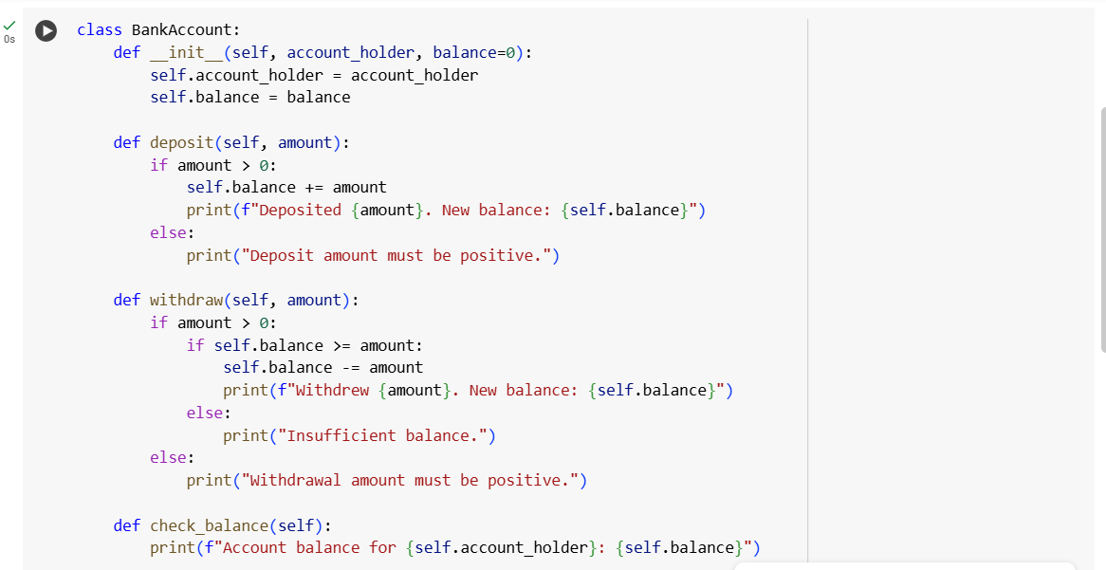

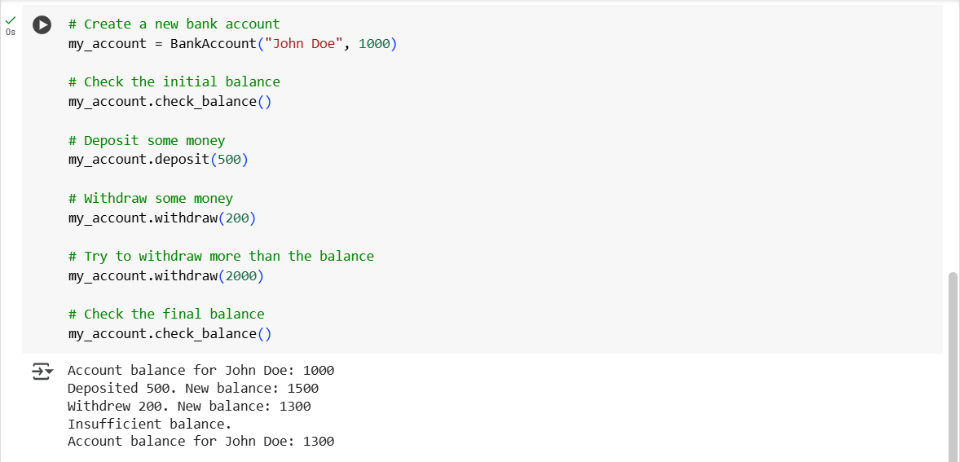

**Explanation:**

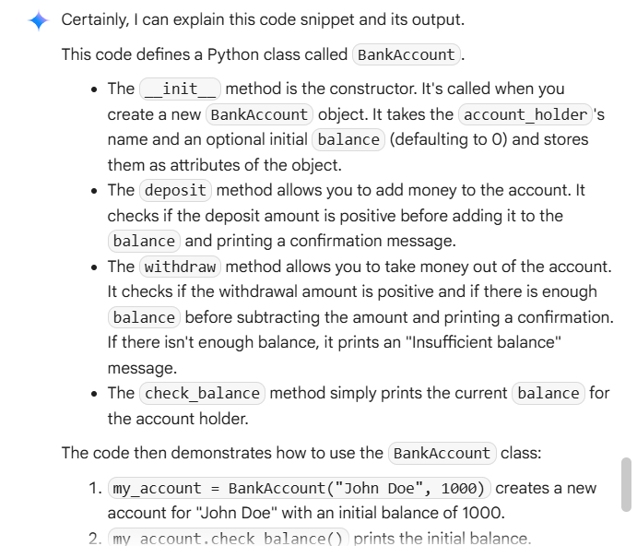

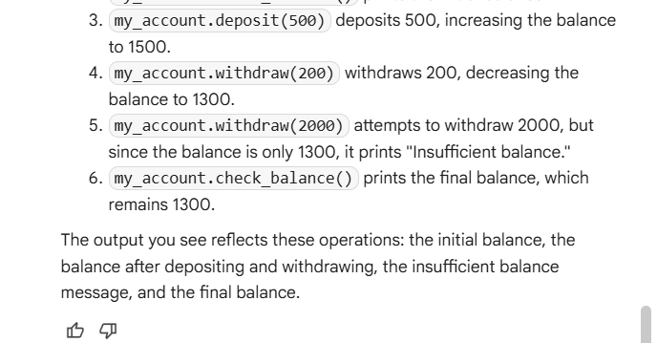

**Task Description #4:**  
• Define a list of student dictionaries with keys name and score. Ask Copilot to write a while  
loop to print the names of students who scored more than 75.  
**Code:**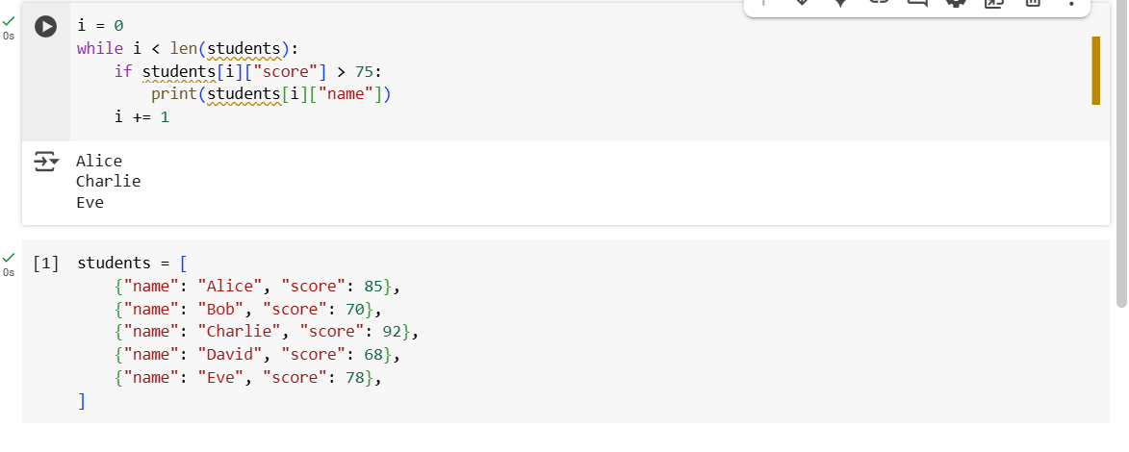

**Explanation:**

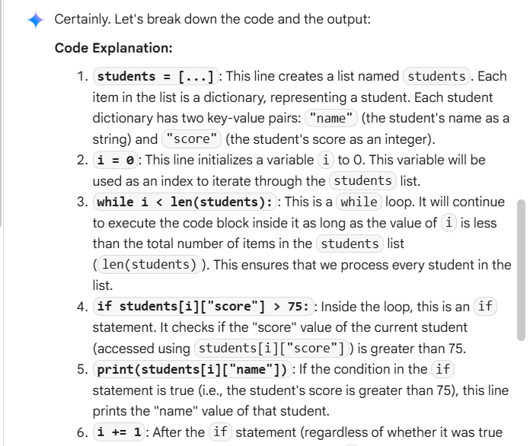

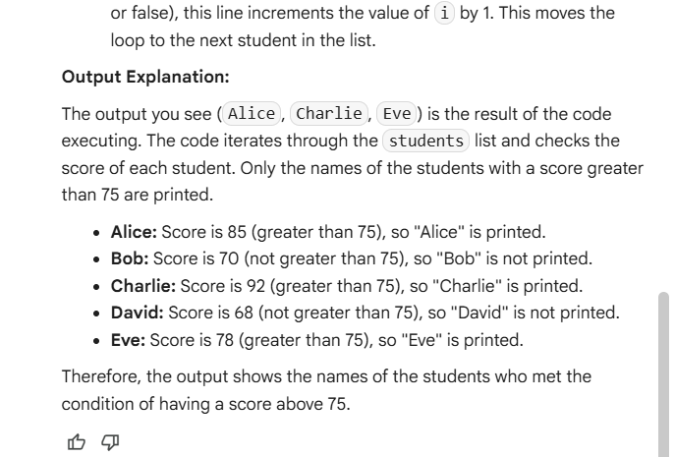

**Task Description #5:**Begin writing a class ShoppingCart with an empty items list. Prompt Copilot to generate  
methods to add_item, remove_item, and use a loop to calculate the total bill using conditional discounts.

**Code:**

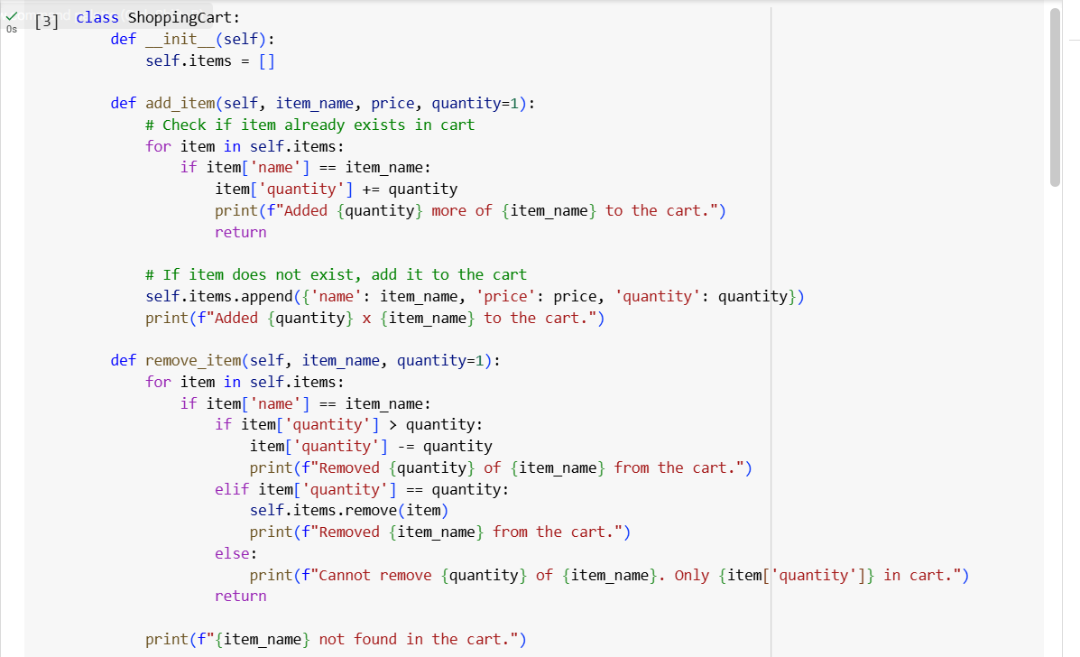

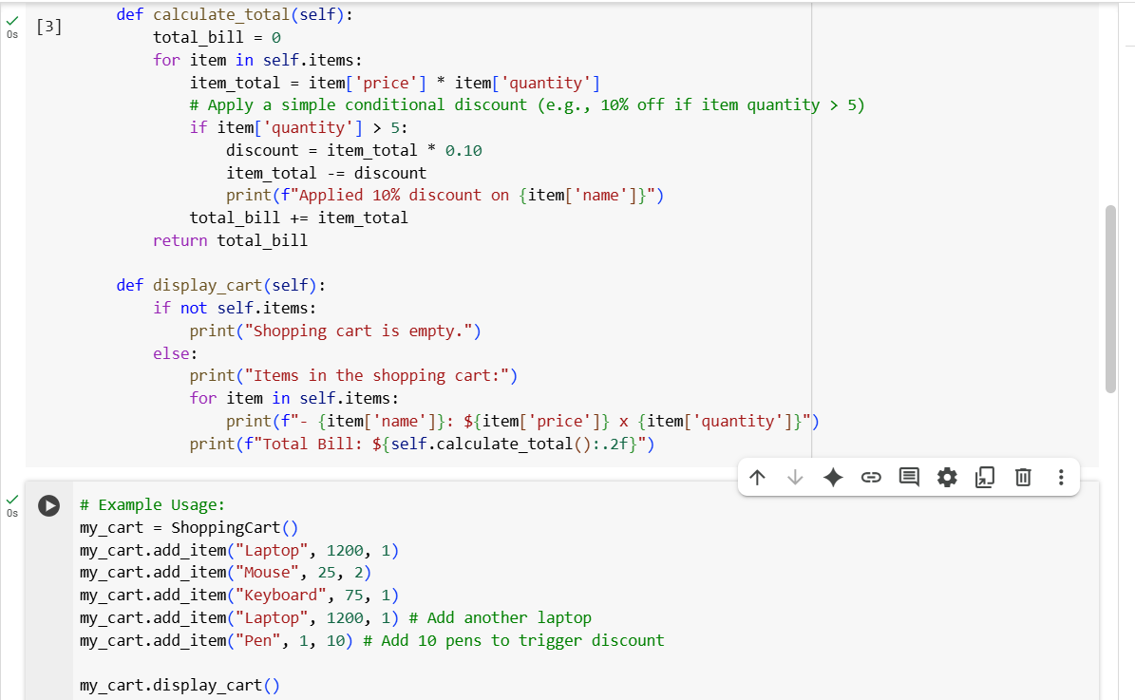

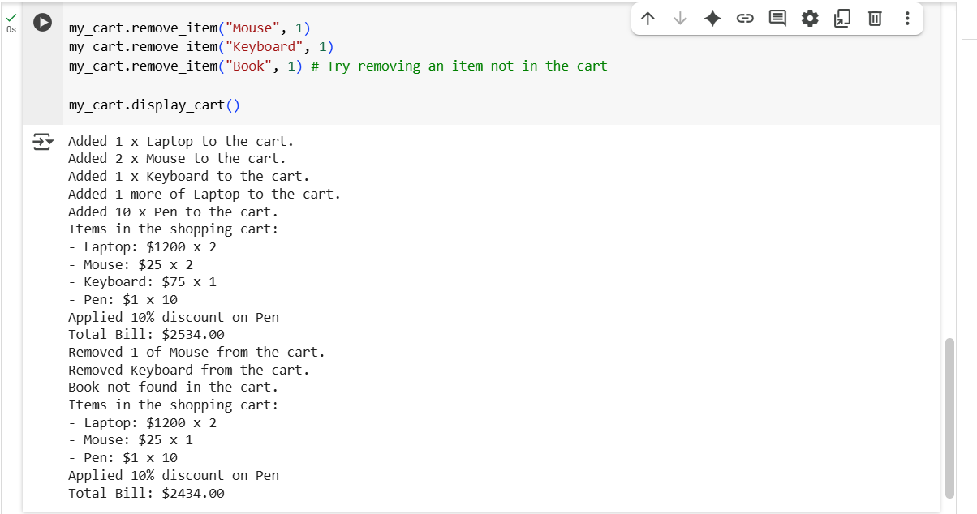

**Explanation:**

