**AssignmentNumber:3.2**

**Task Description#1: Tuesday, 12 August 2025**

* Ask AI to write a function to calculate compound interest, starting with only the function name. Then add a docstring, then input-output example.

**Code:**

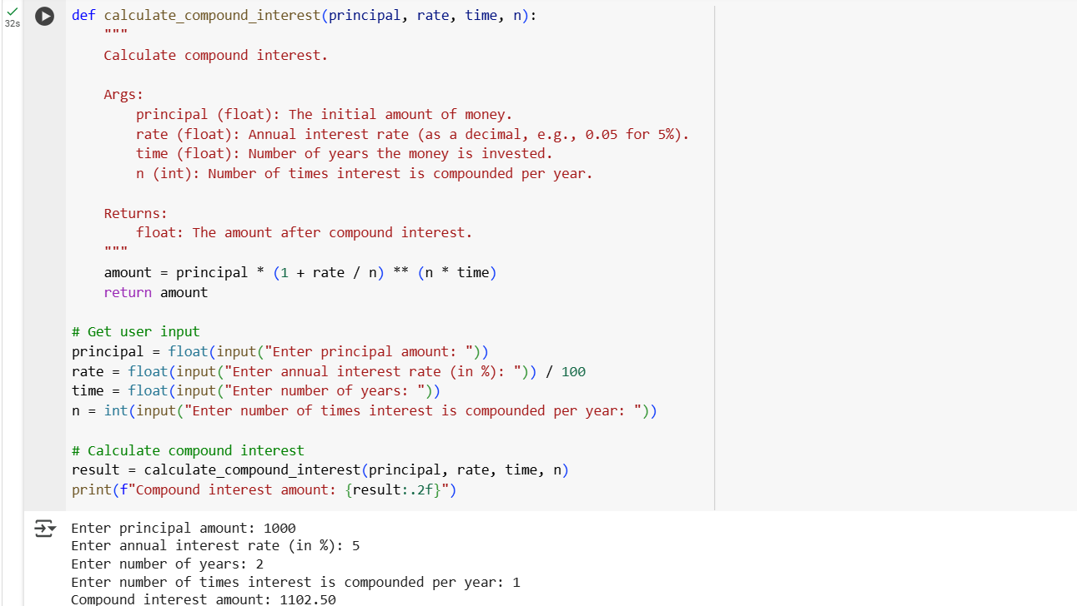

**Explanation:**

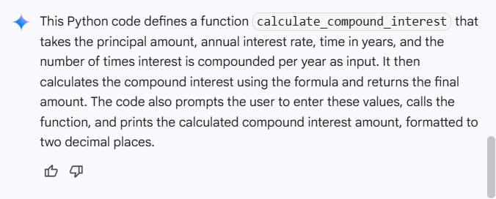

**Task Description#2:**

* Do math stuff, then refine it to: # Write a function to calculate average, median, and mode of a list of numbers.

**Code:**

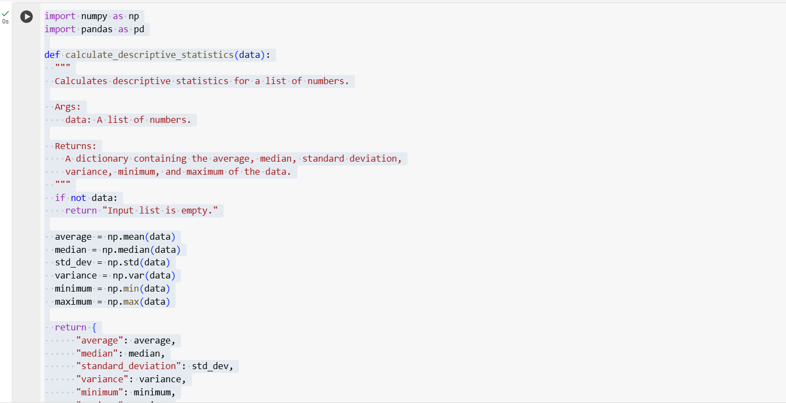

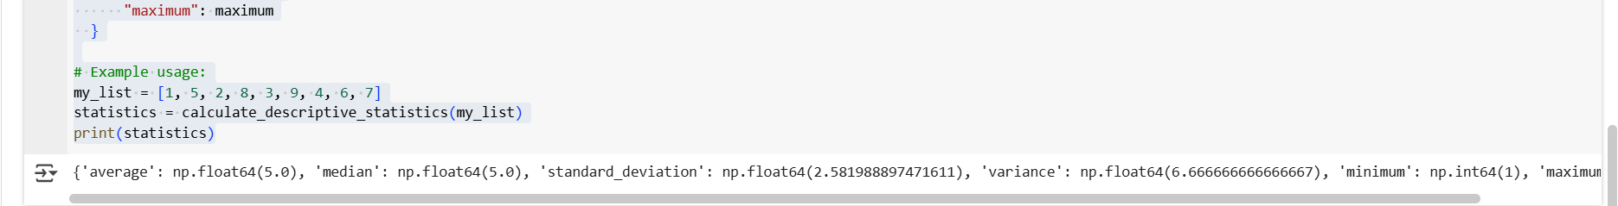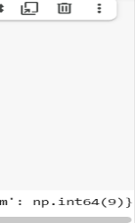

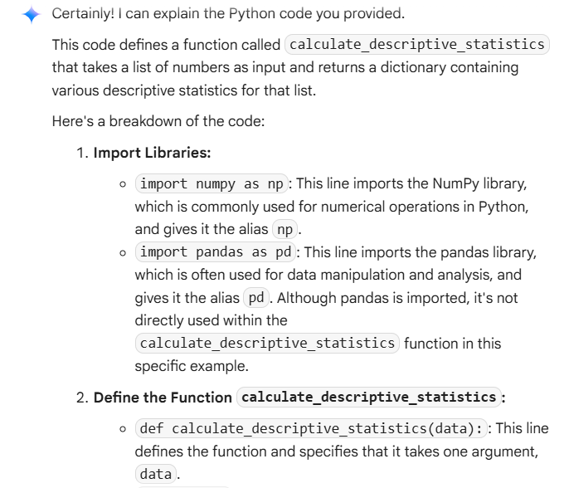**Explanation:**

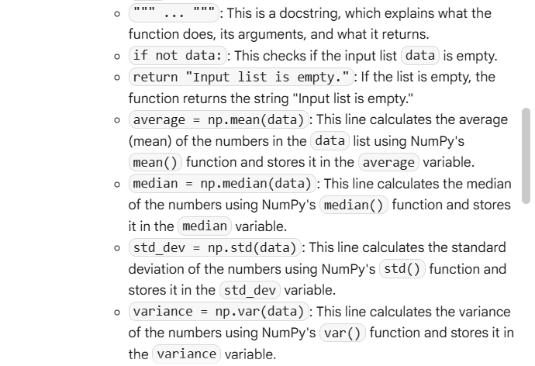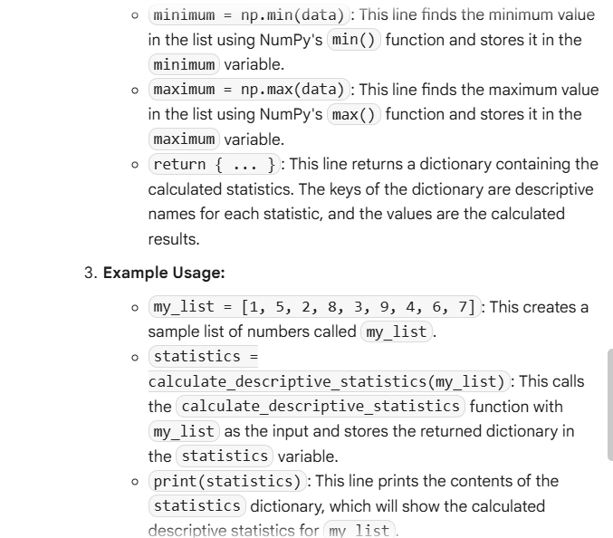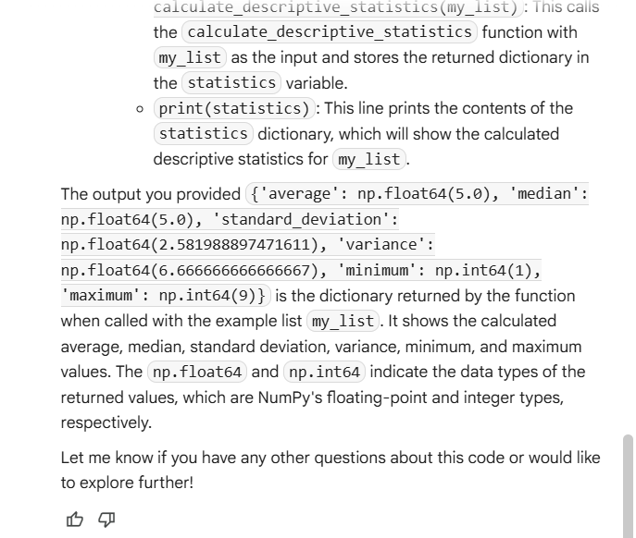

**Task Description#3:**

* Provide multiple examples of input-output to the AI for convert_to_binary(num) function. Observe how AI uses few-shot prompting to generalize.

**Code:**

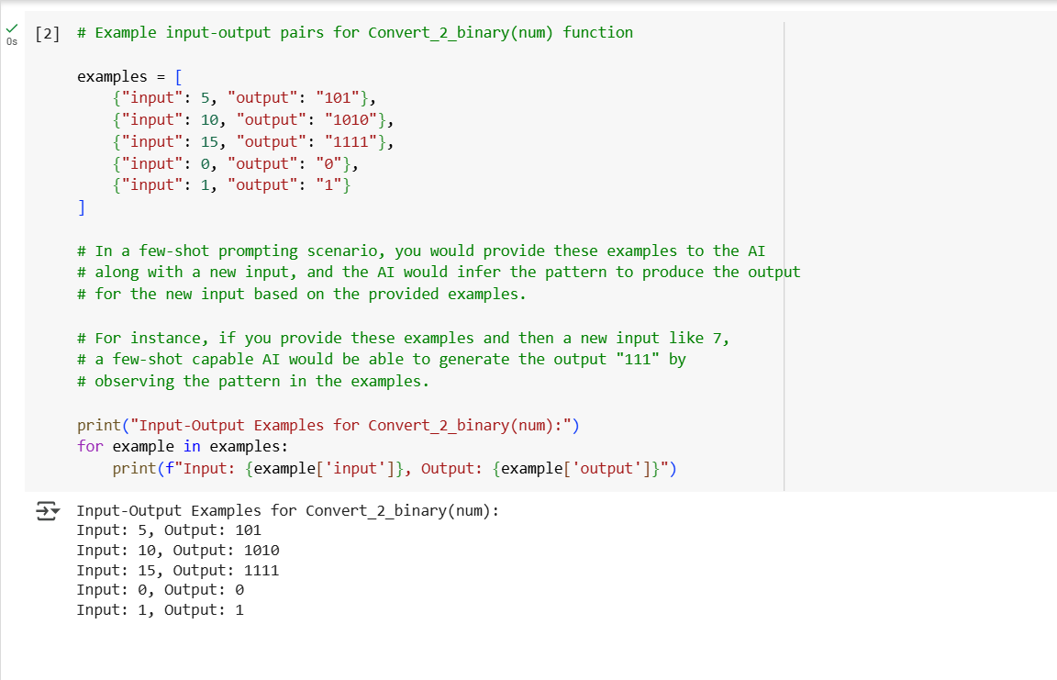

**Explanation:**

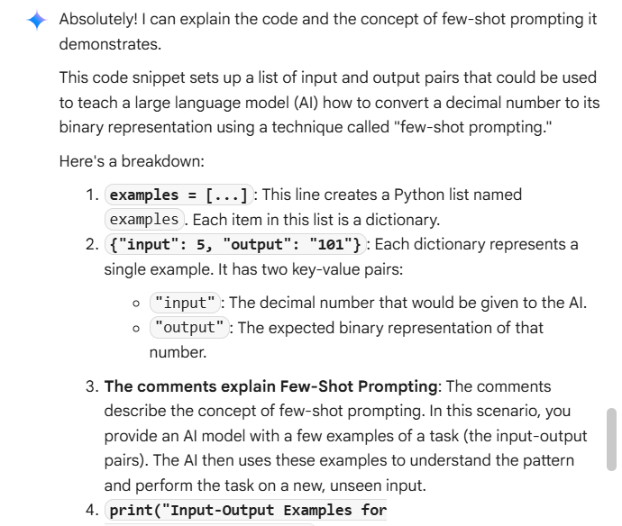

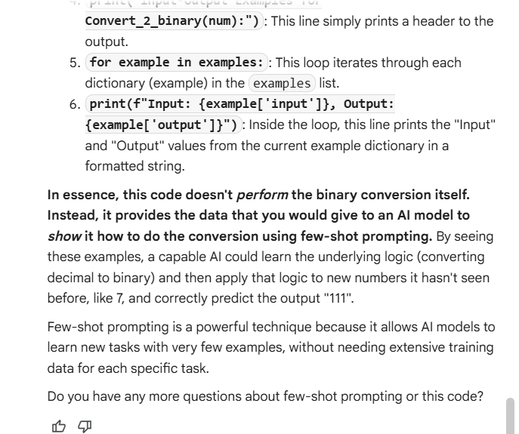

**Task Description#4:**

* Create an user interface for an hotel to generate bill based on customer requirements.

**Code:**

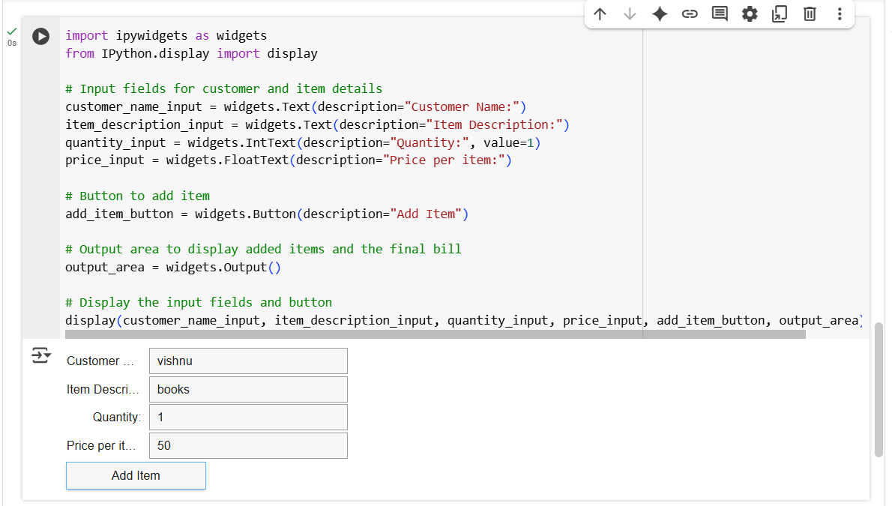

**Explanation:**

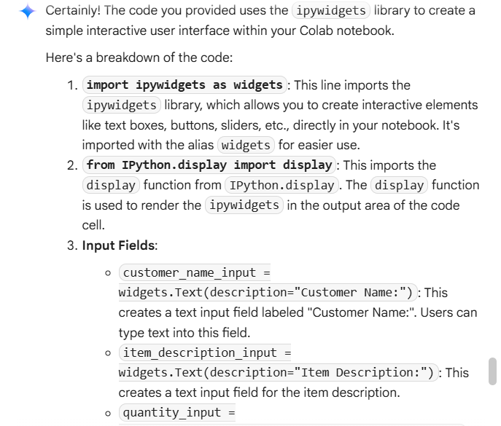

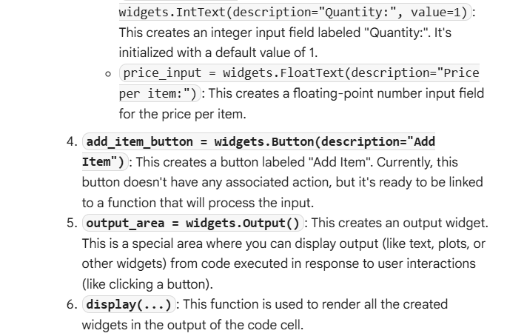

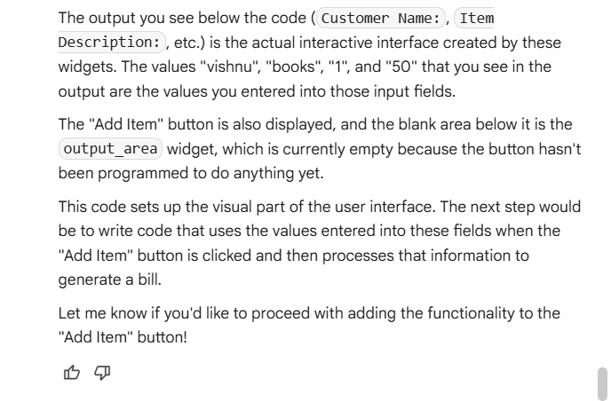

**Task Description#5:**

* Analyzing Prompt Specificity: Improving Temperature Conversion Function with Clear Instructions.

**Code:**

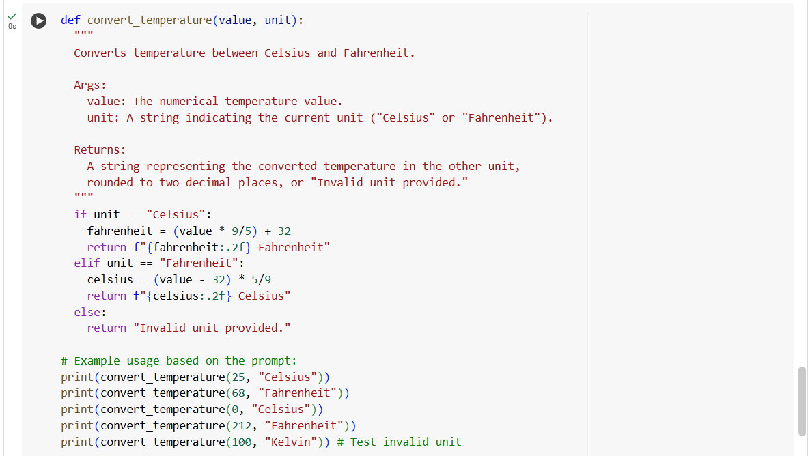

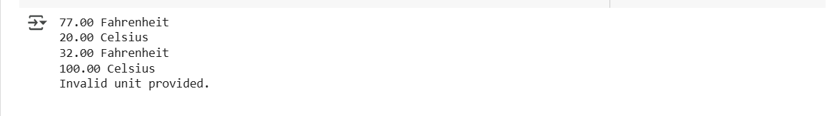

**Explanation:**

