Assignment-9.3
Task Description#1 Basic Docstring Generation
• Write python function to return sum of even and odd numbers in the given list.
• Incorporate manual docstring in code with Google Style
• Use an AI-assisted tool (e.g., Copilot, Cursor AI) to generate a docstring describing
the function.
• Compare the AI-generated docstring with your manually written one.
Expected Outcome#1:
Students understand how AI can produce function-level documentation.
Code:
Google colab:
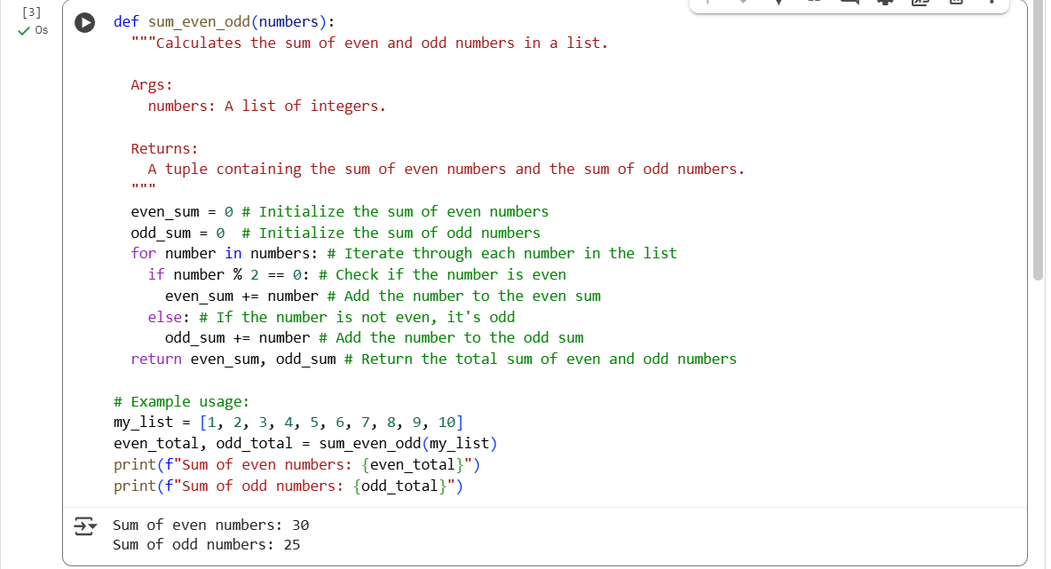
Explanation:
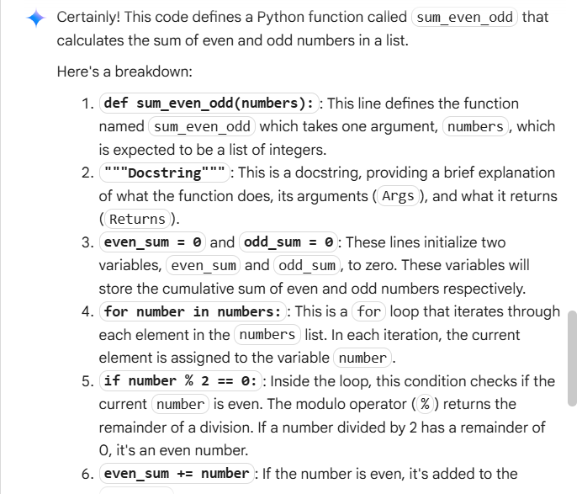

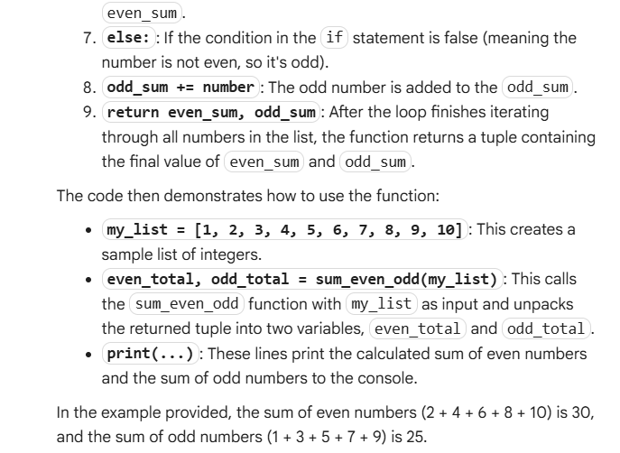

VS Code:
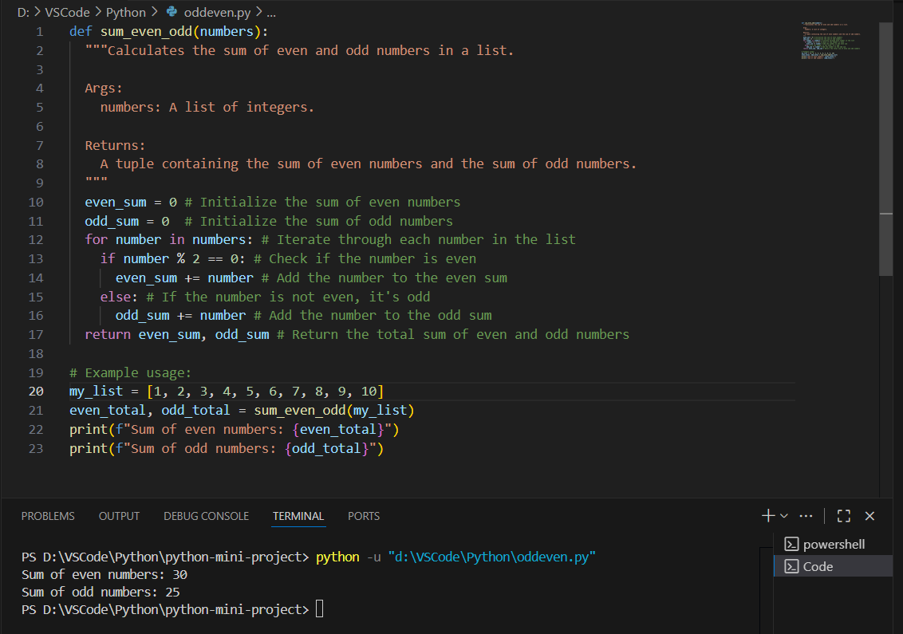
Explanation:
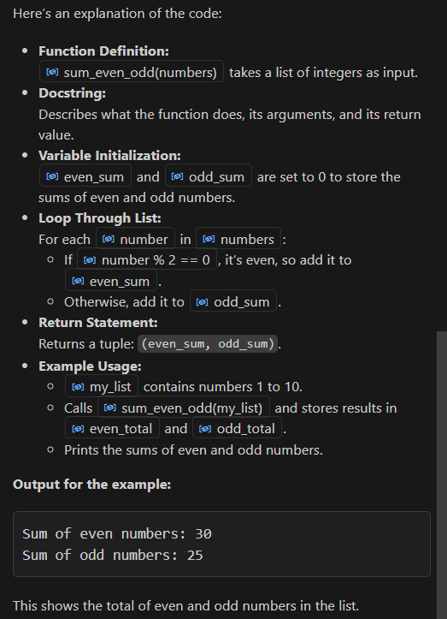
Task Description#2 Automatic Inline Comments
• Write python program for sru_student class with attributes like name, roll no.,
hostel_status and fee_update method and display_details method.
• Write comments manually for each line/code block
• Ask an AI tool to add inline comments explaining each line/step.
• Compare the AI-generated comments with your manually written one.
Expected Output#2:
Students critically analyze AI-generated code comments.
Code:
Google colab:
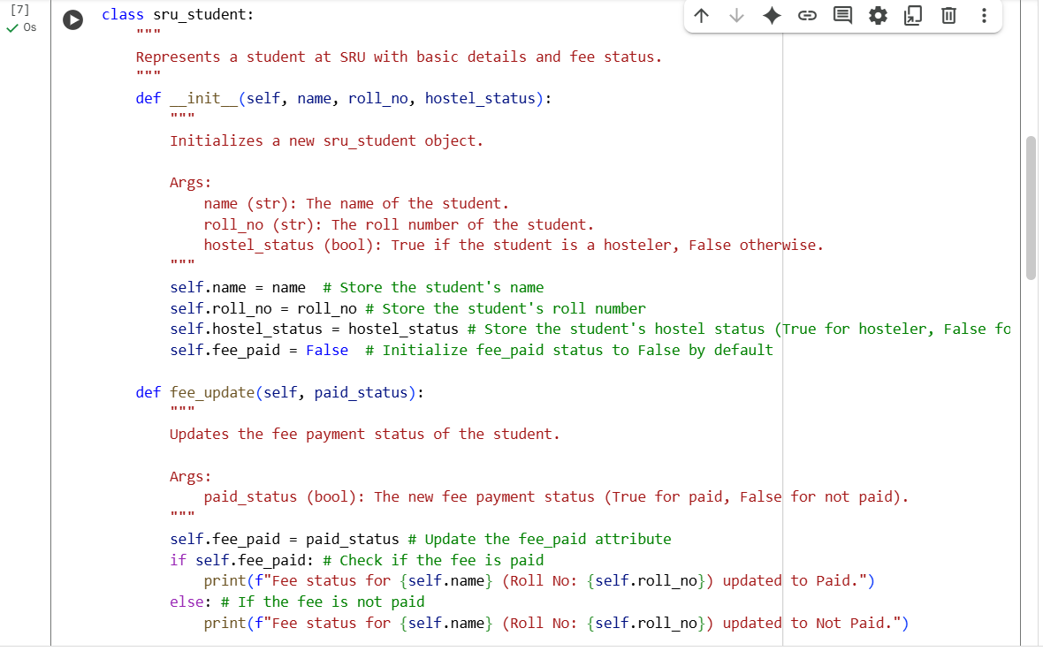
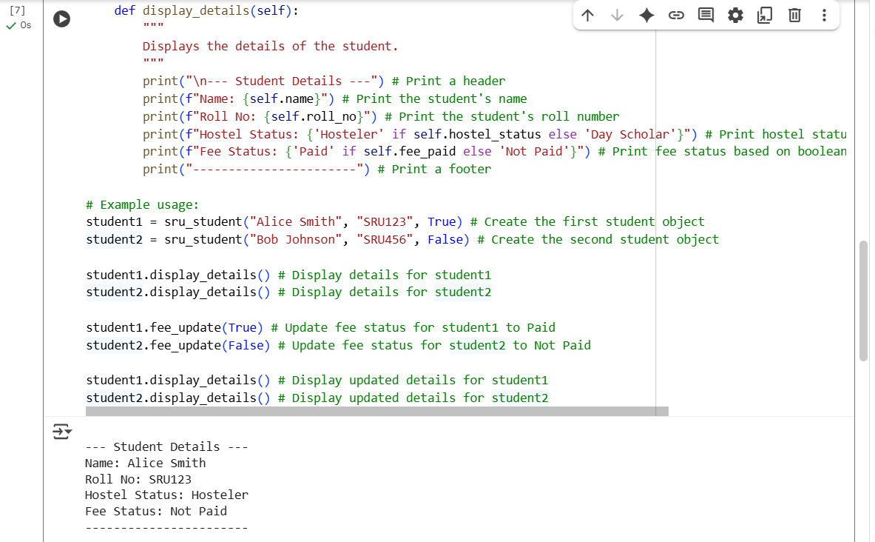
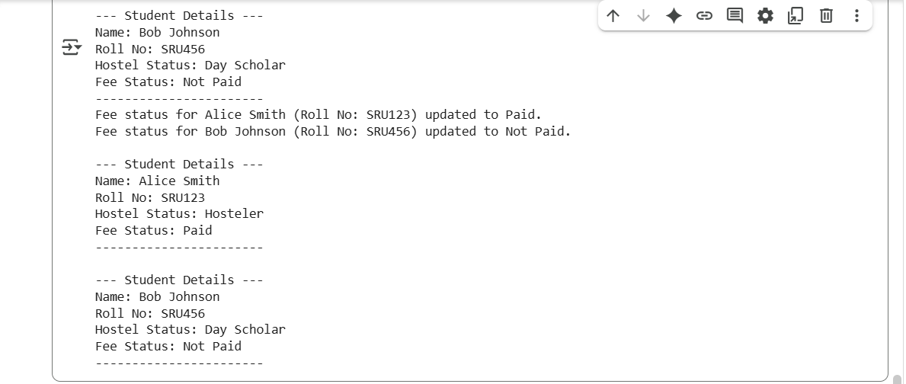
Explanation:
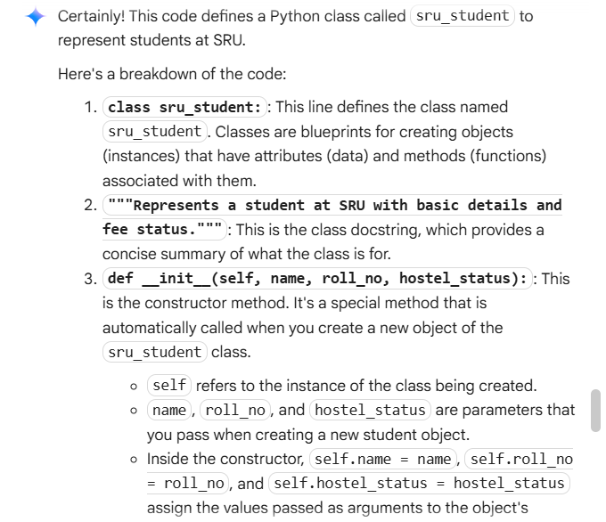
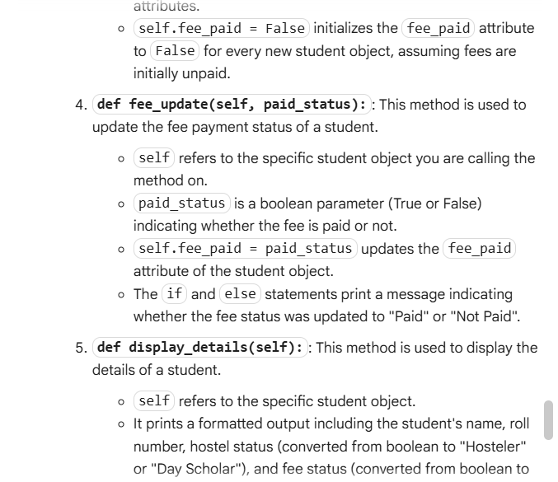
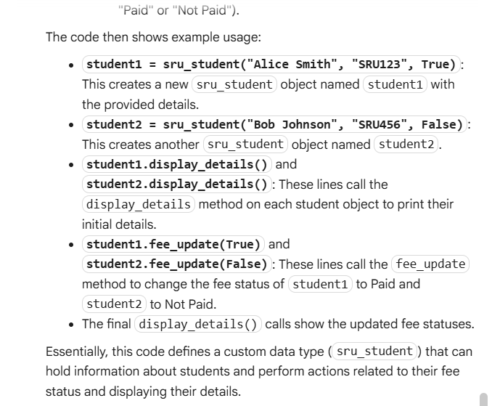

VS Code:
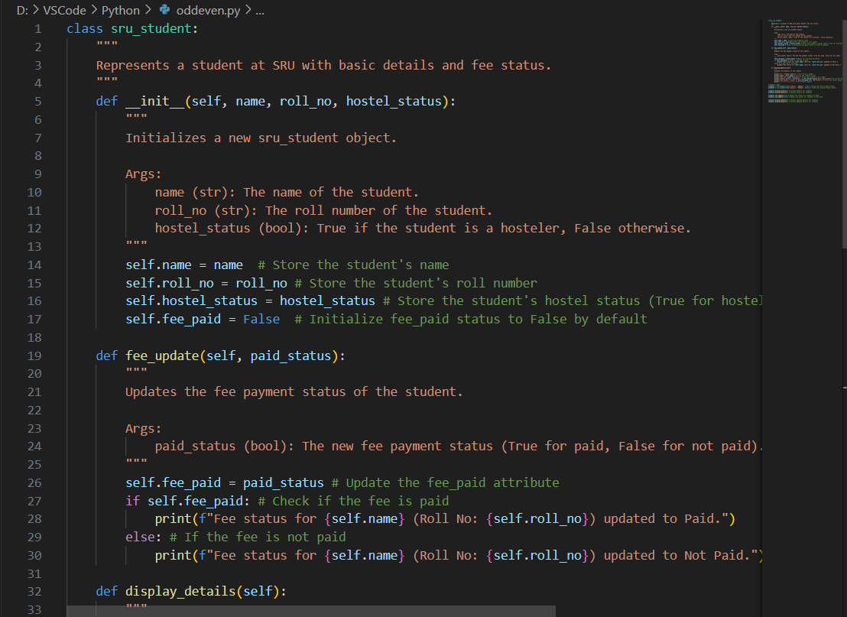
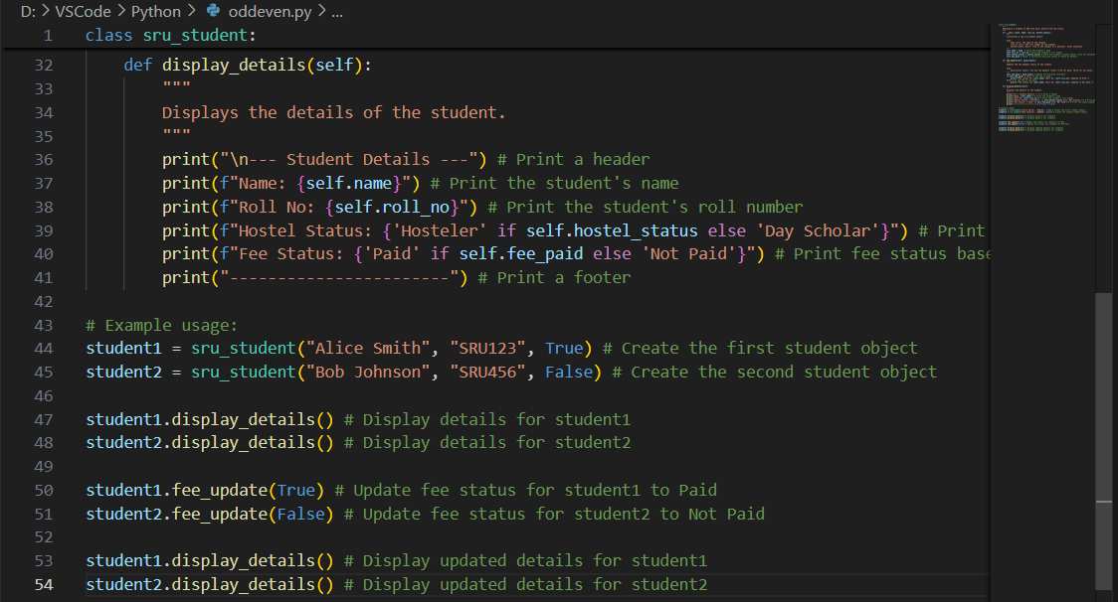
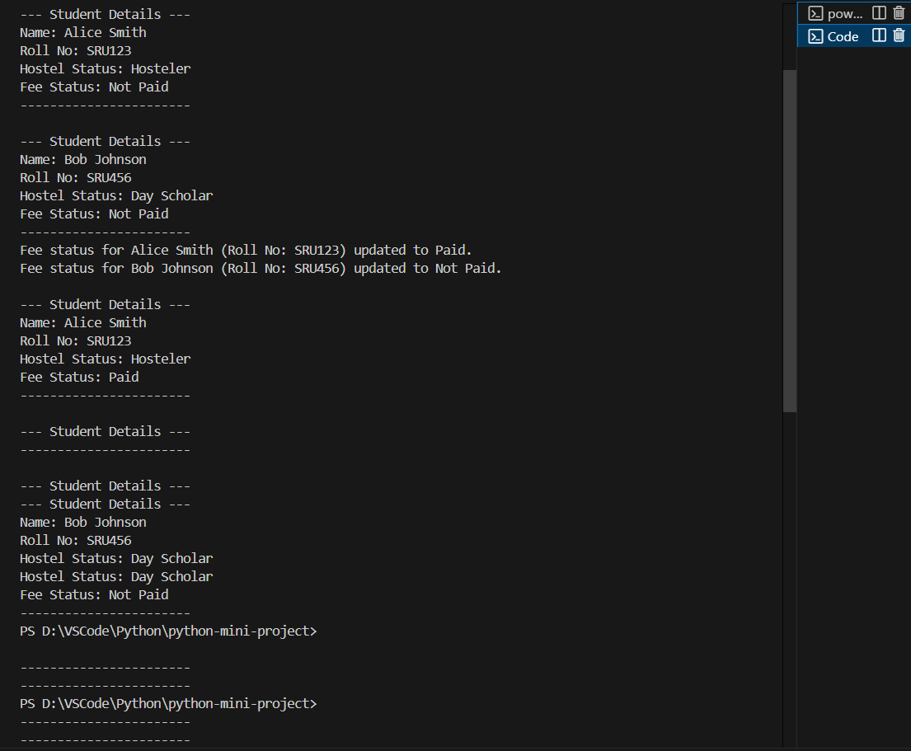
Explanation:
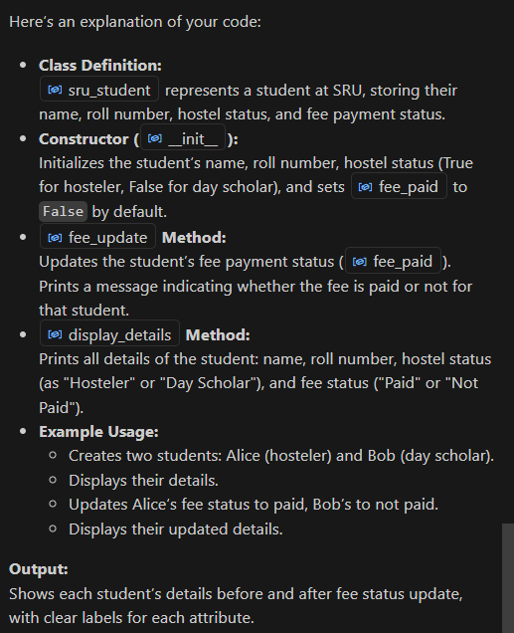
Task Description#3:
• Write a Python script with 3–4 functions (e.g., calculator: add, subtract, multiply,
divide).
• Incorporate manual docstring in code with NumPy Style
• Use AI assistance to generate a module-level docstring + individual function
docstrings.
• Compare the AI-generated docstring with your manually written one.
Expected Output#3:
Students learn structured documentation for multi-function scripts.
Code:
Google colab:
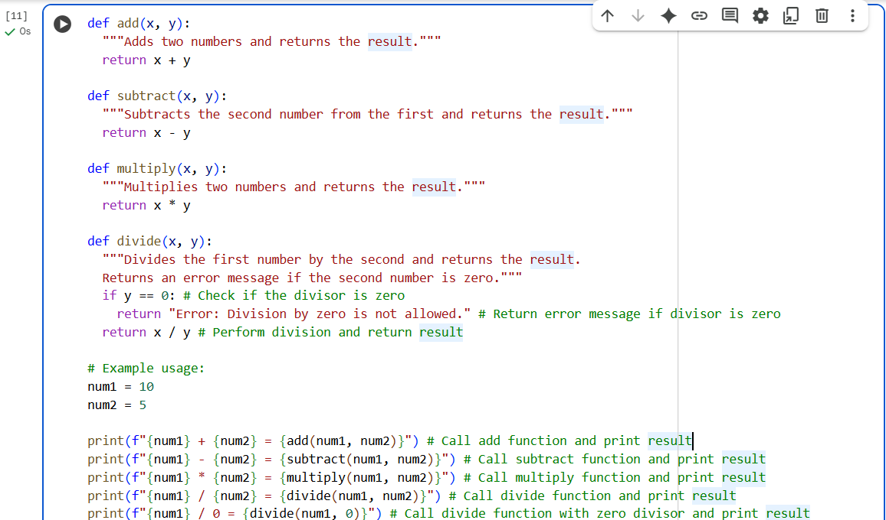
Explanation:
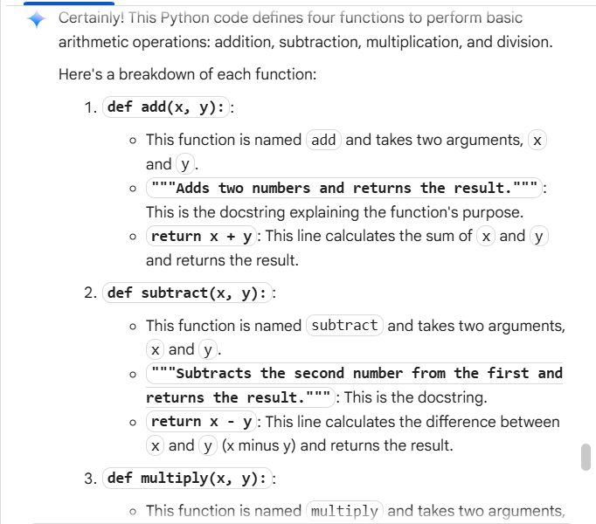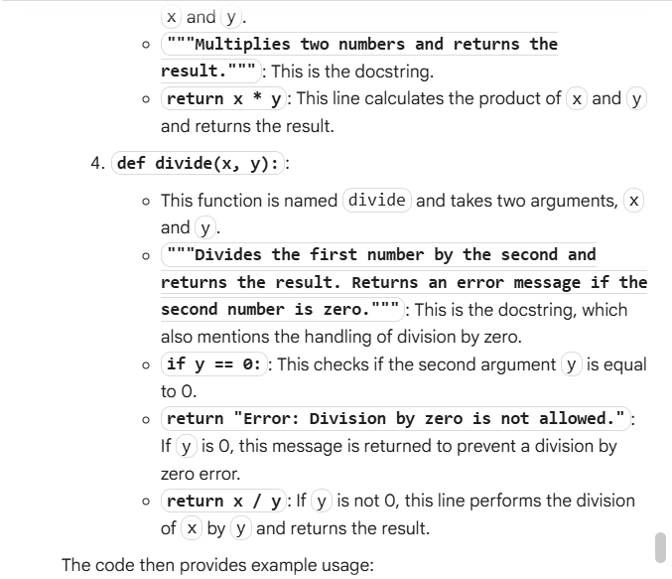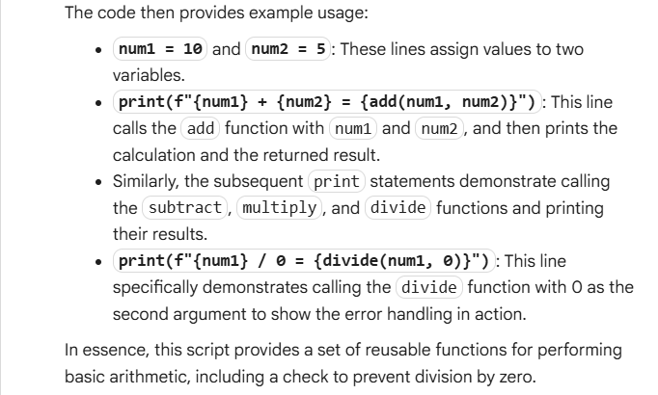
VS Code:
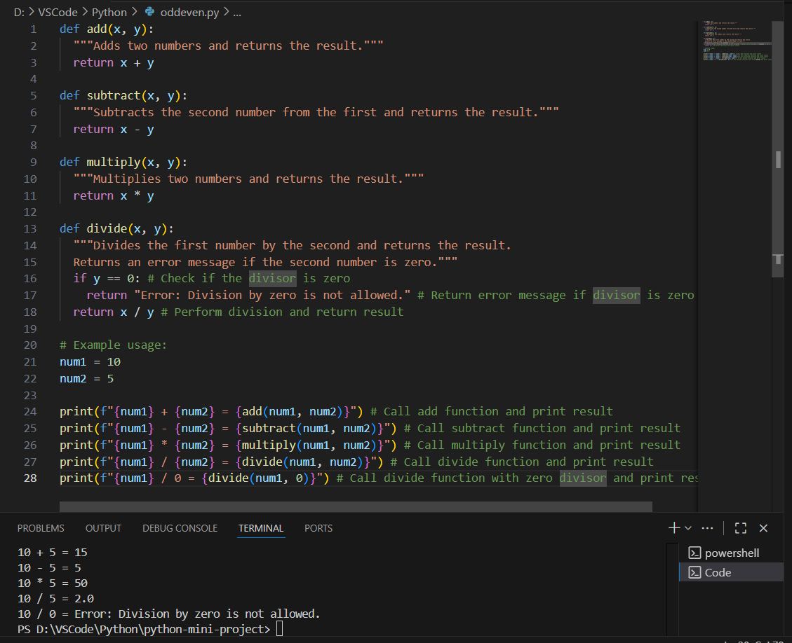
Explanation:
