Assignment-12.4

Task 1: Implementing Bubble Sort with AI Comments
• Task: Write a Python implementation of Bubble Sort.
• Instructions:
o Students implement Bubble Sort normally.
o Ask AI to generate inline comments explaining key
logic (like swapping, passes, and termination).
o Request AI to provide time complexity analysis.
Expected Output:
o A Bubble Sort implementation with AI-generated
explanatory comments and complexity analysis.
Code:
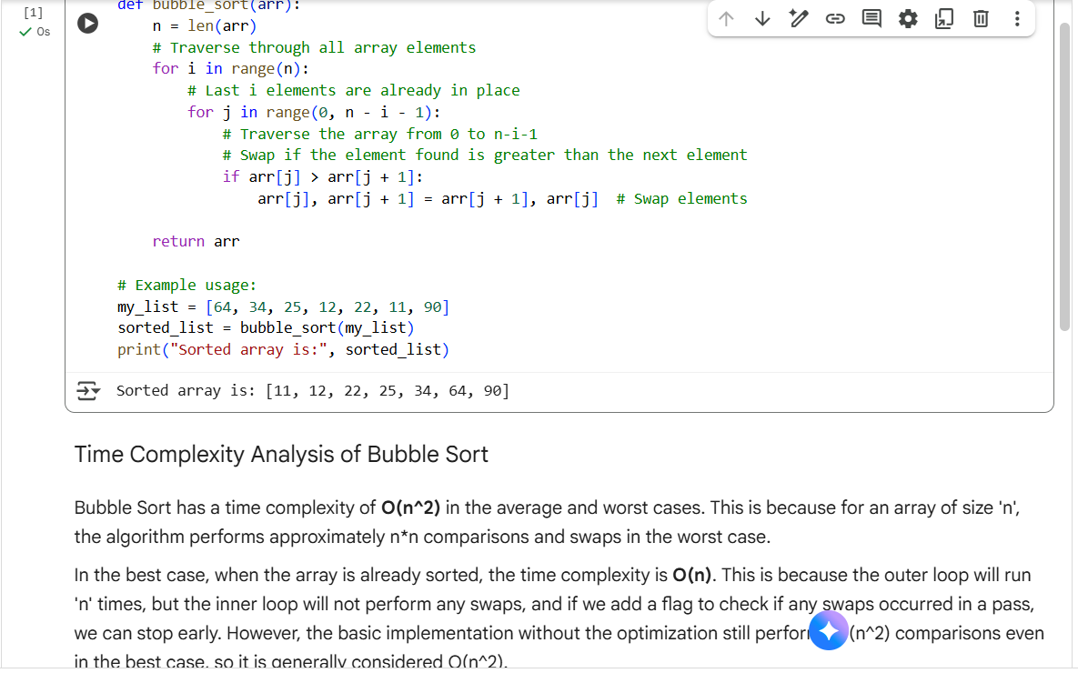
Explanation:
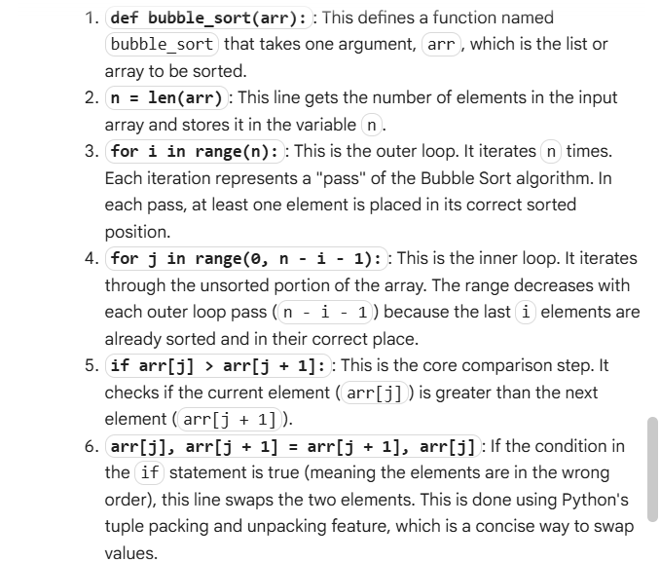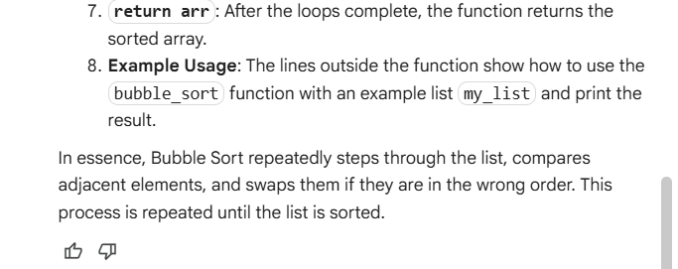

Task 2: Optimizing Bubble Sort → Insertion Sort
• Task: Provide Bubble Sort code to AI and ask it to suggest a
more efficient algorithm for partially sorted arrays.
• Instructions:
o Students implement Bubble Sort first.
o Ask AI to suggest an alternative (Insertion Sort).
o Compare performance on nearly sorted input.
Expected Output:
o Two codes (Bubble Sort + Insertion Sort).
o AI explanation of why Insertion Sort is more efficient for
partially sorted data.
Code:
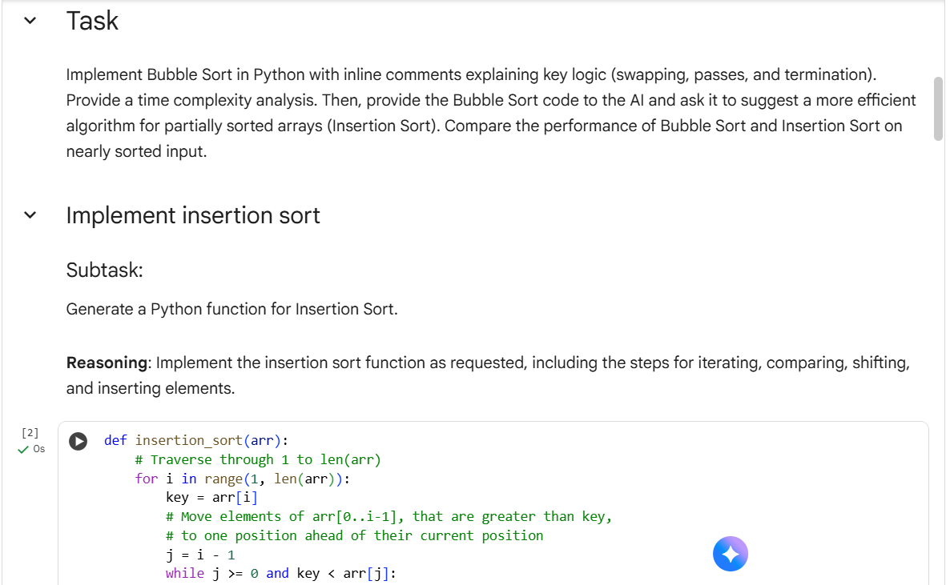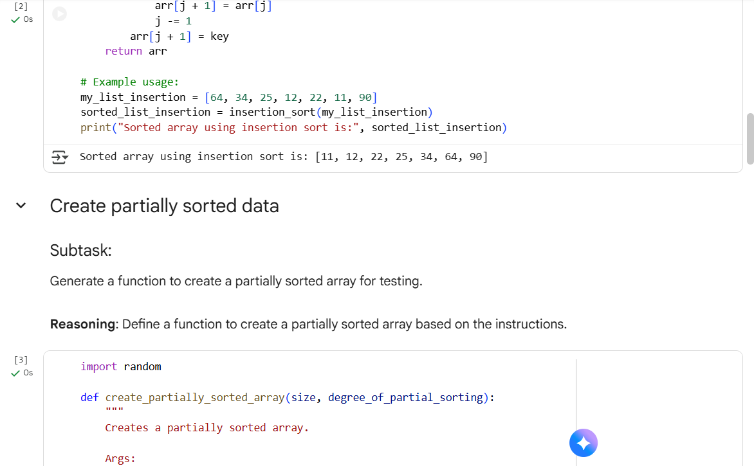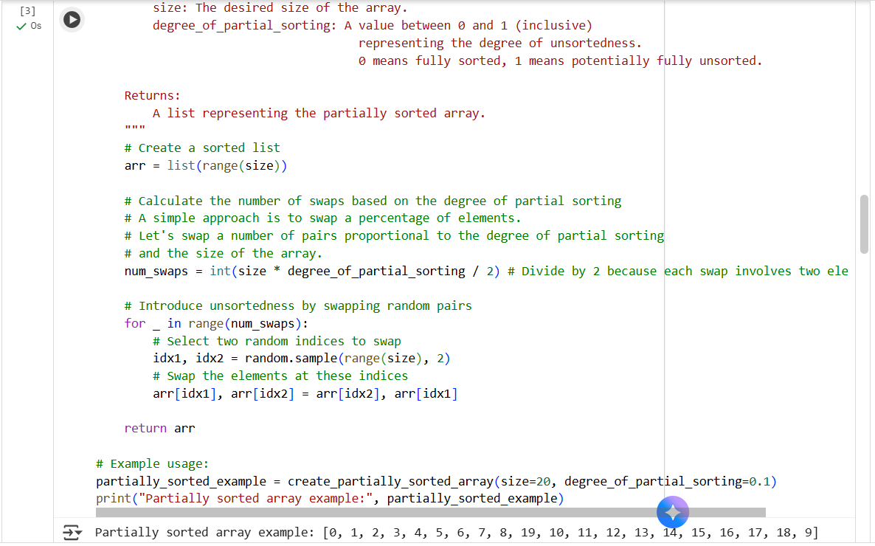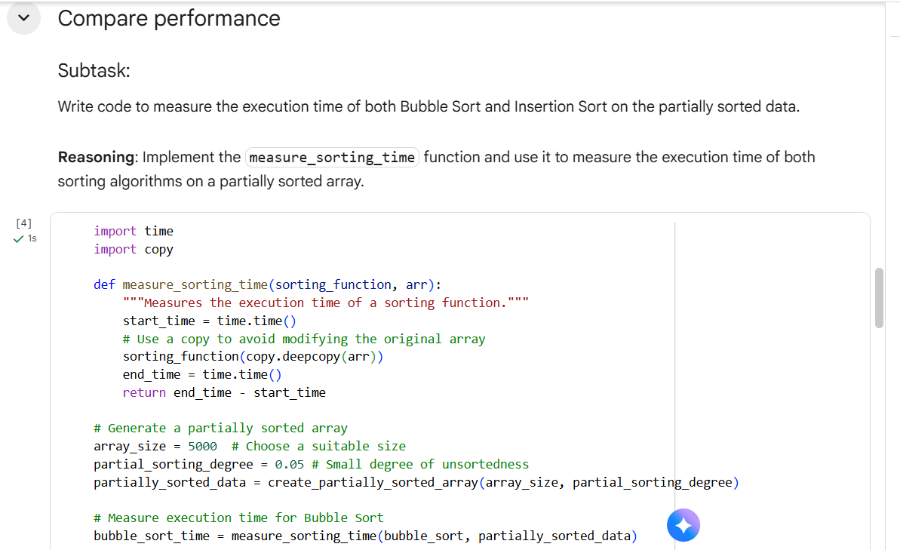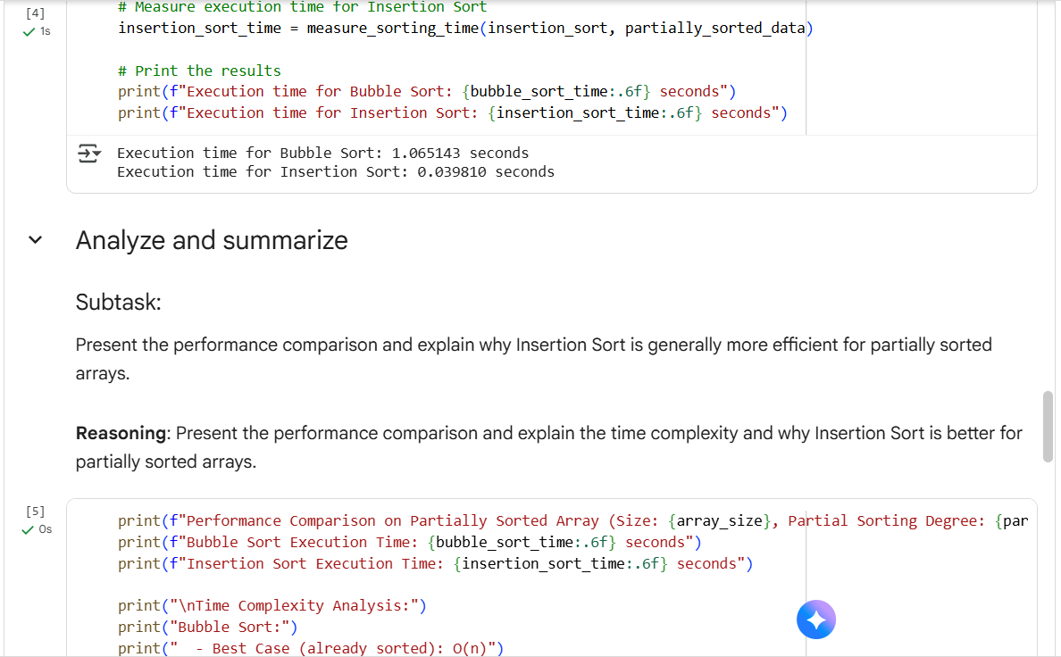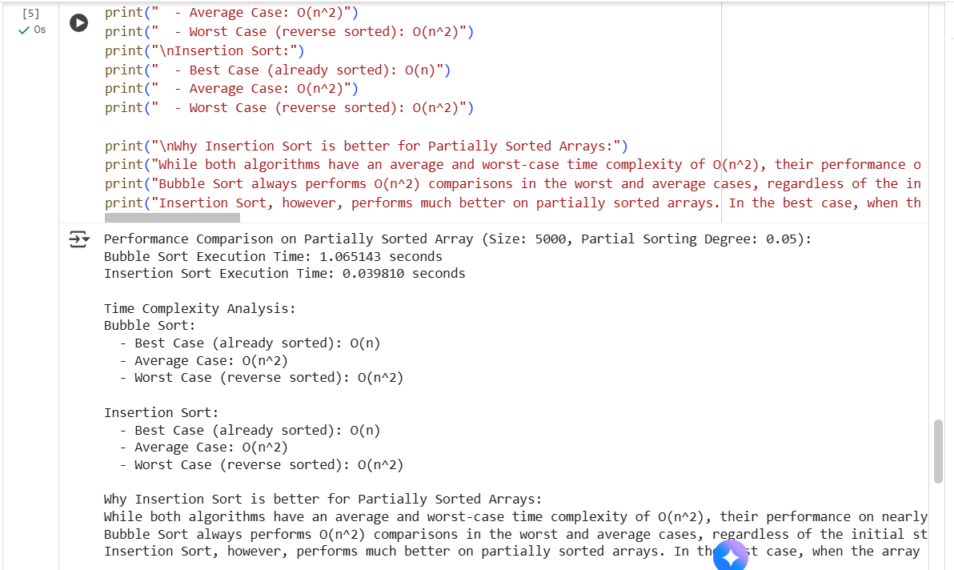
Explanation:
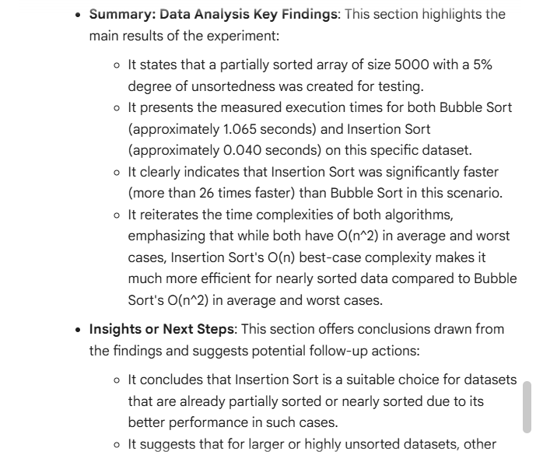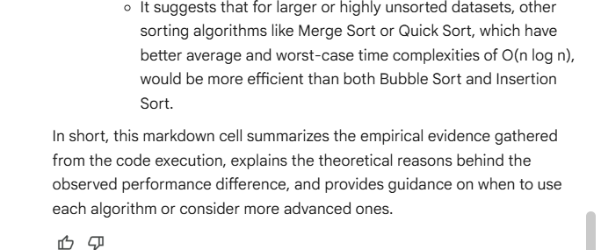

Task 3: Binary Search vs Linear Search
• Task: Implement both Linear Search and Binary Search.
• Instructions:
o Use AI to generate docstrings and performance notes.
o Test both algorithms on sorted and unsorted data.
o Ask AI to explain when Binary Search is preferable.
Expected Output:
o Two implementations with docstrings.
o A student observation table comparing performance
(Linear vs Binary Search).
Code:
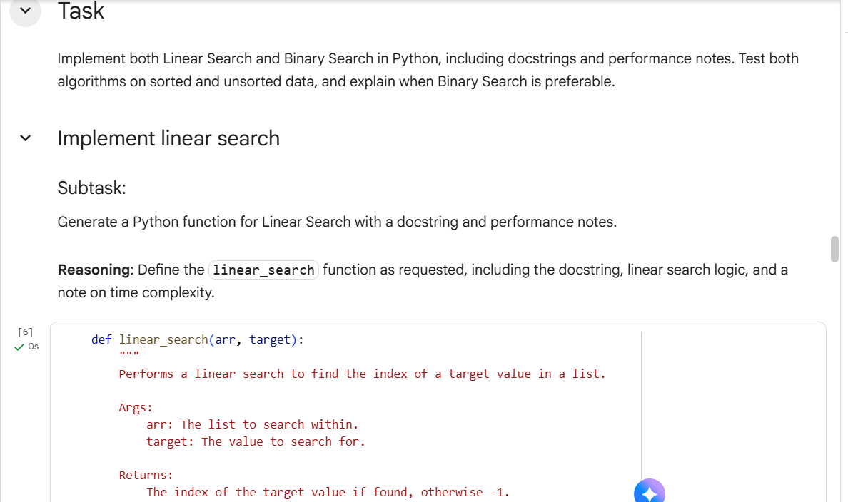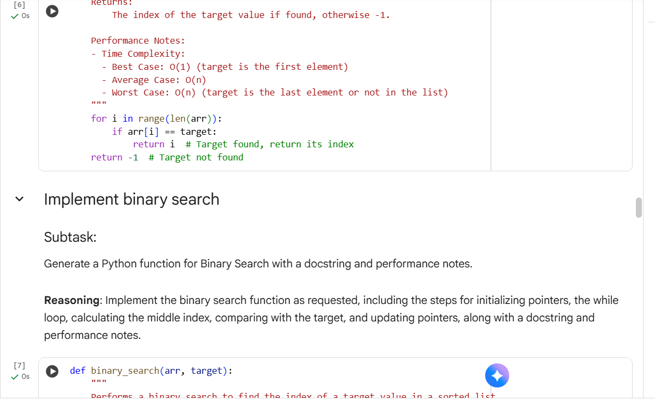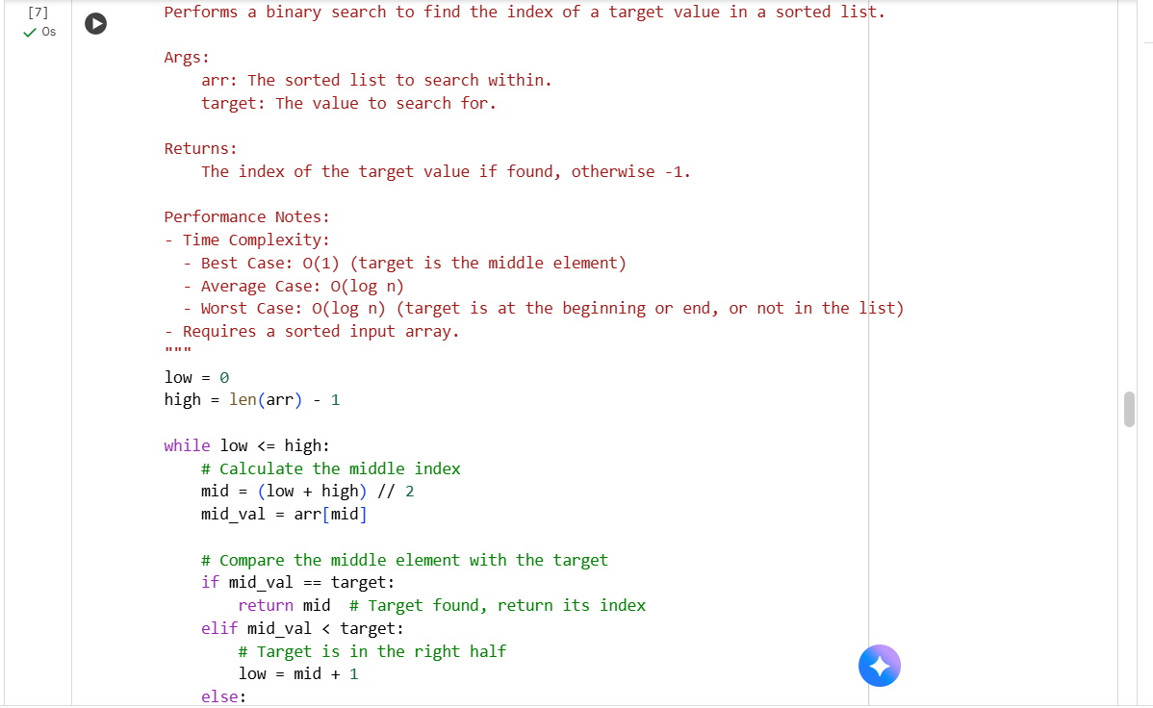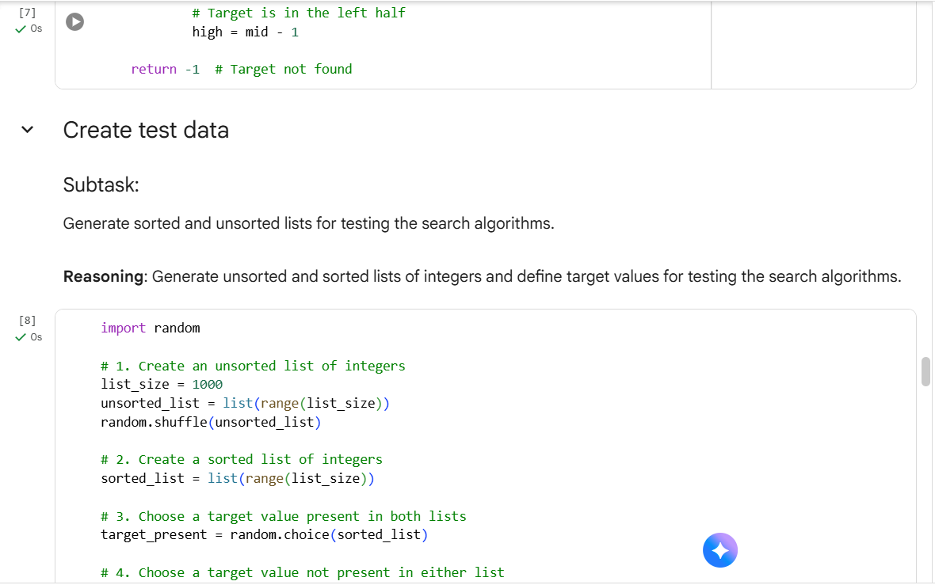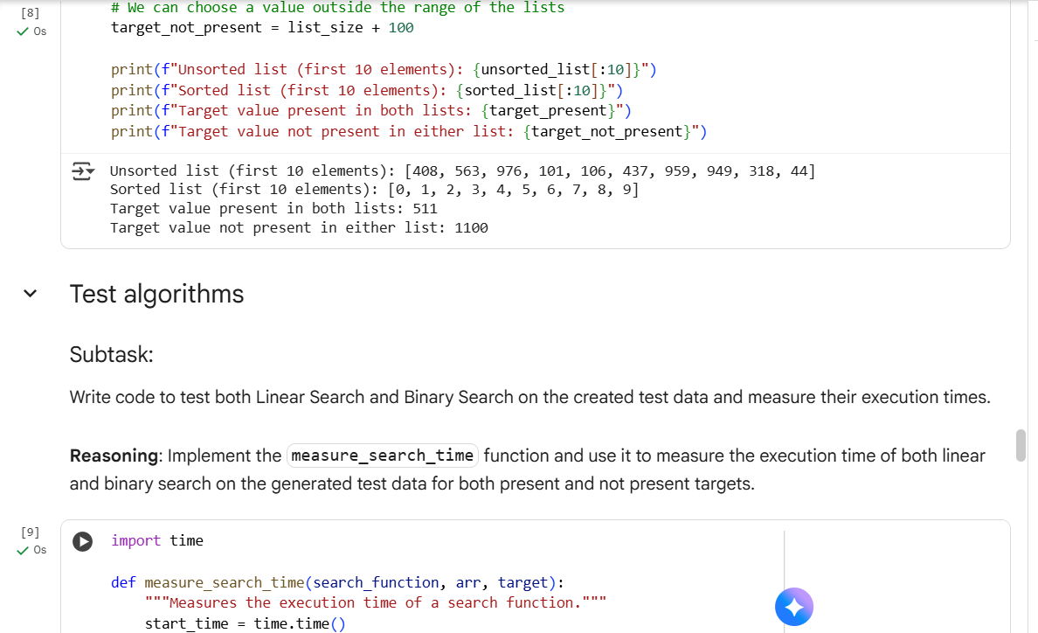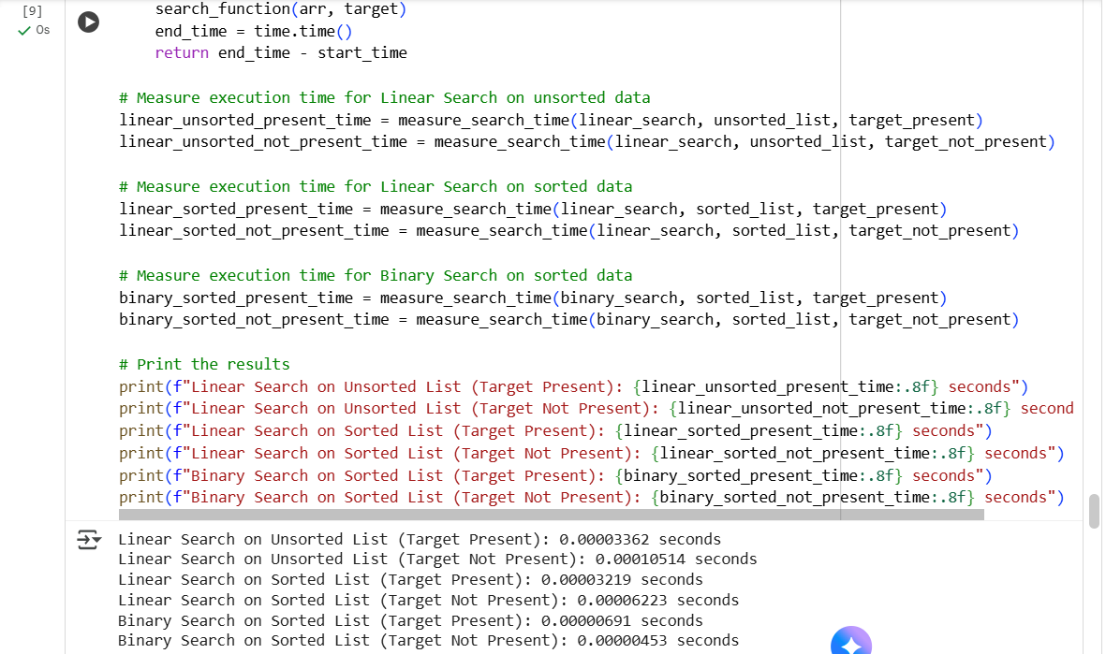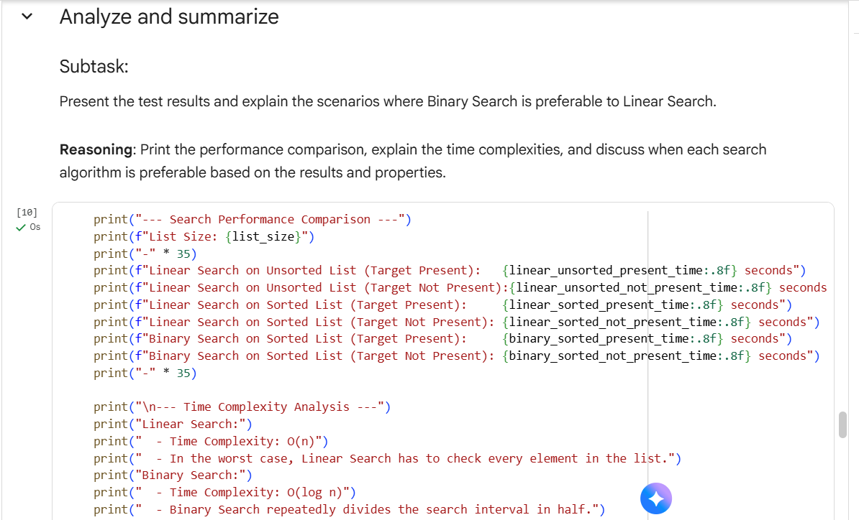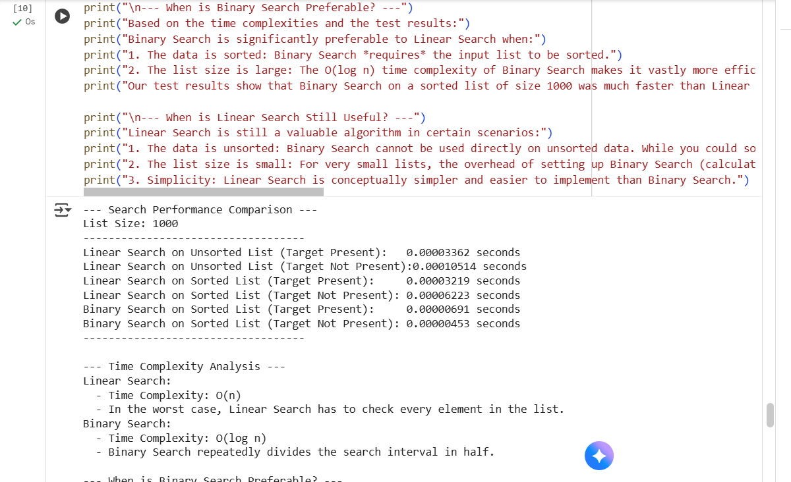
Explanation:
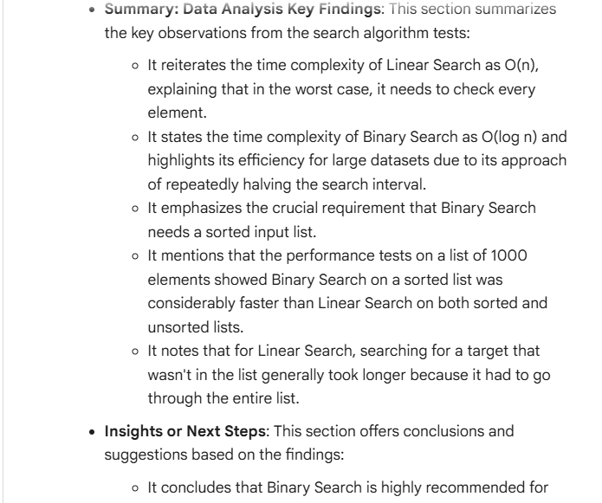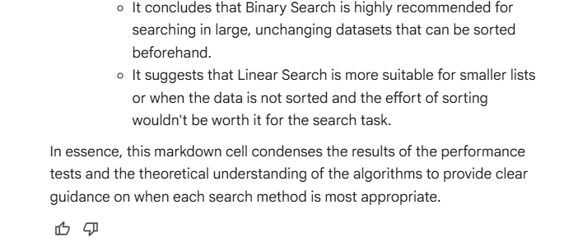

Task5: Implement Quick Sort and Merge Sort using recursion.
• Instructions:
o Provide AI with partially completed functions for
recursion.
o Ask AI to complete the missing logic and add docstrings.
o Compare both algorithms on random, sorted, and reverse-
sorted lists.
Expected Output:
o Working Quick Sort and Merge Sort implementations.
o AI-generated explanation of average, best, and worst-case
complexities.
Code:
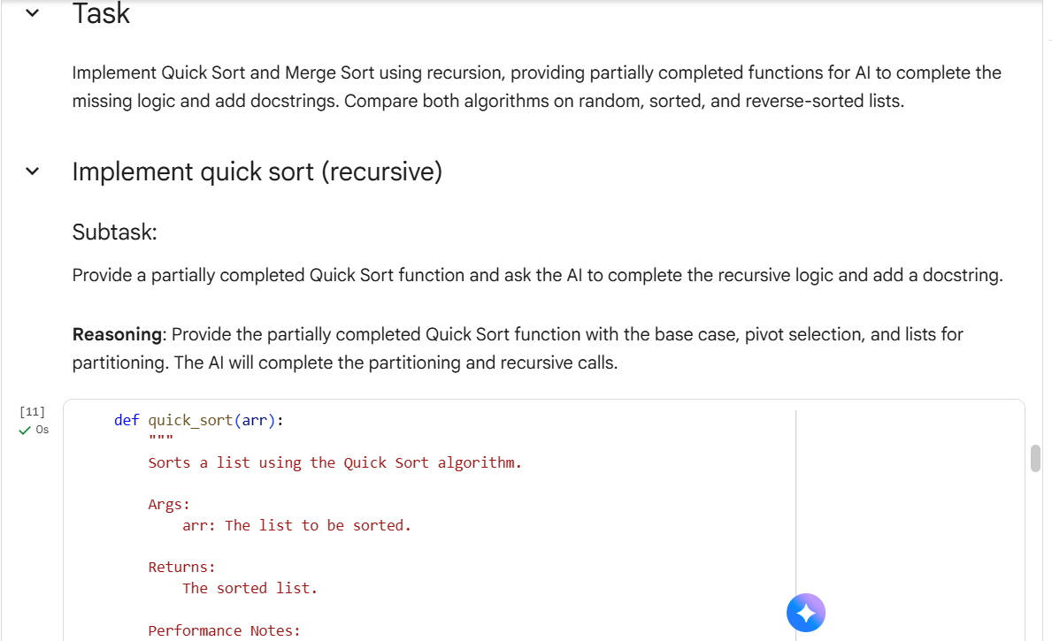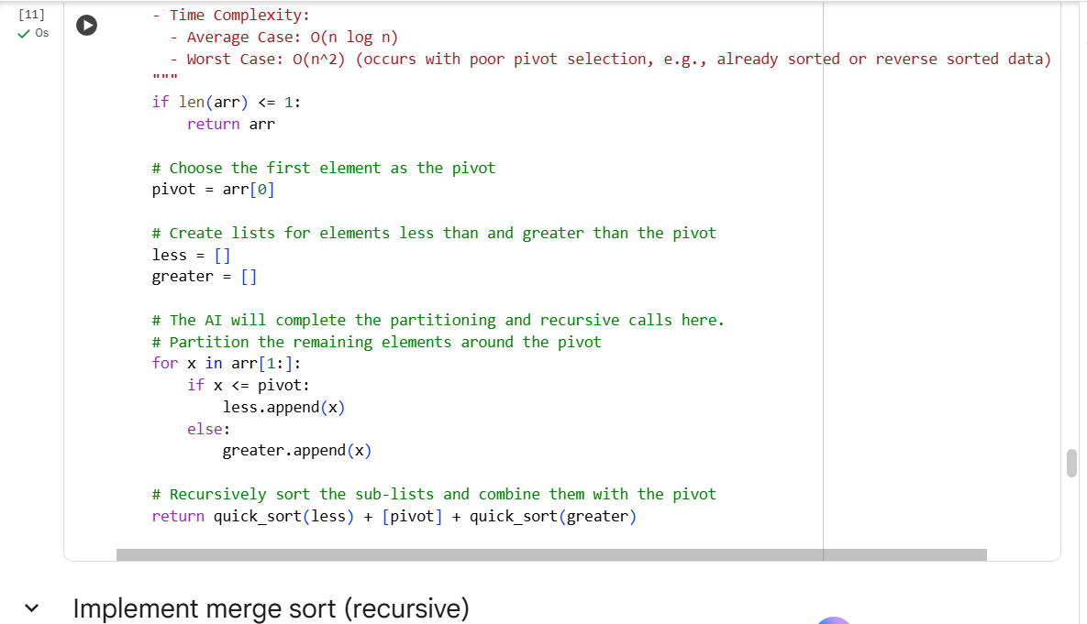
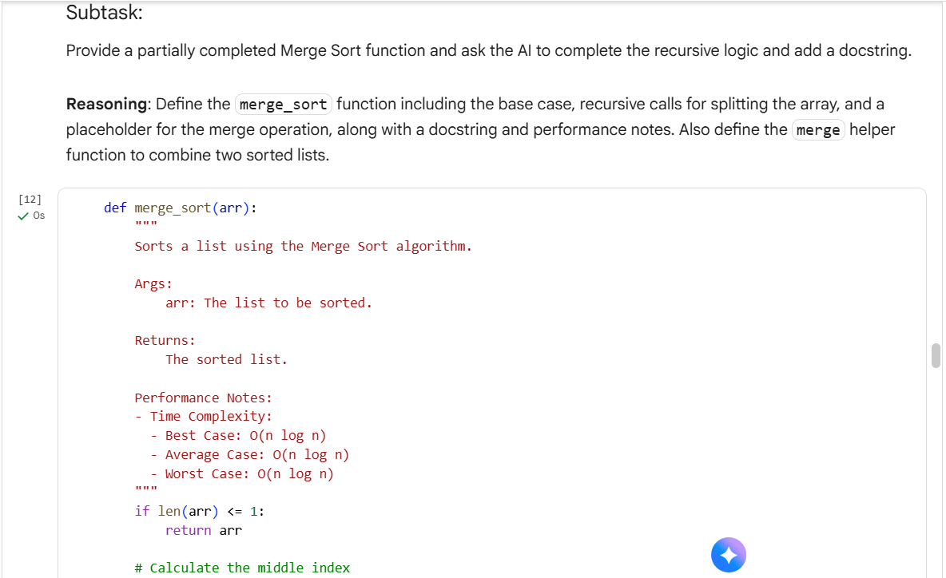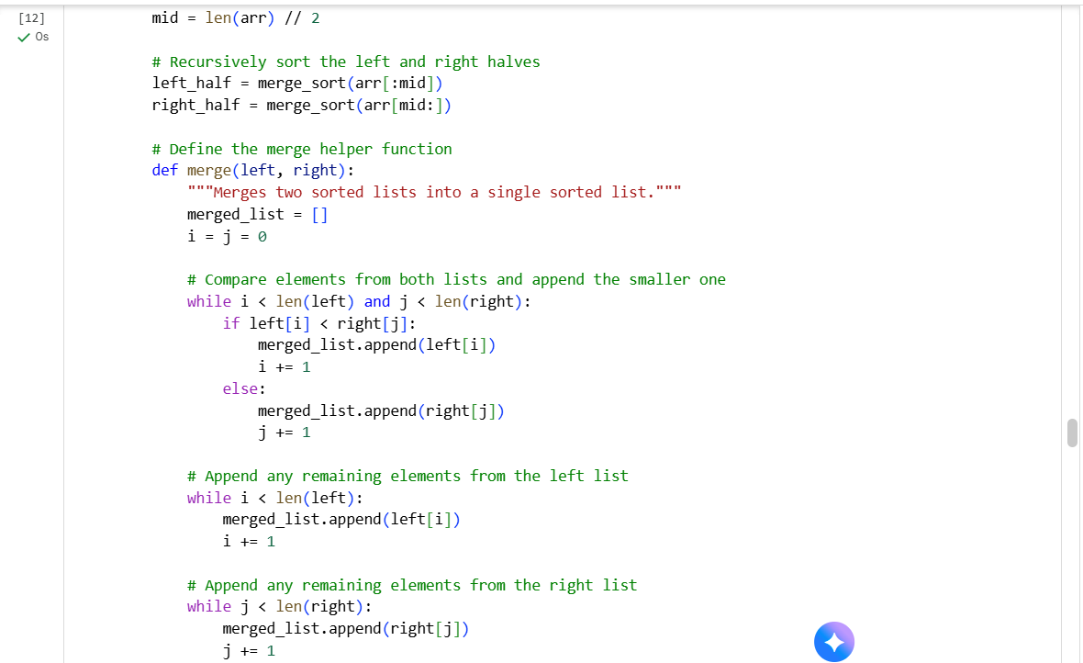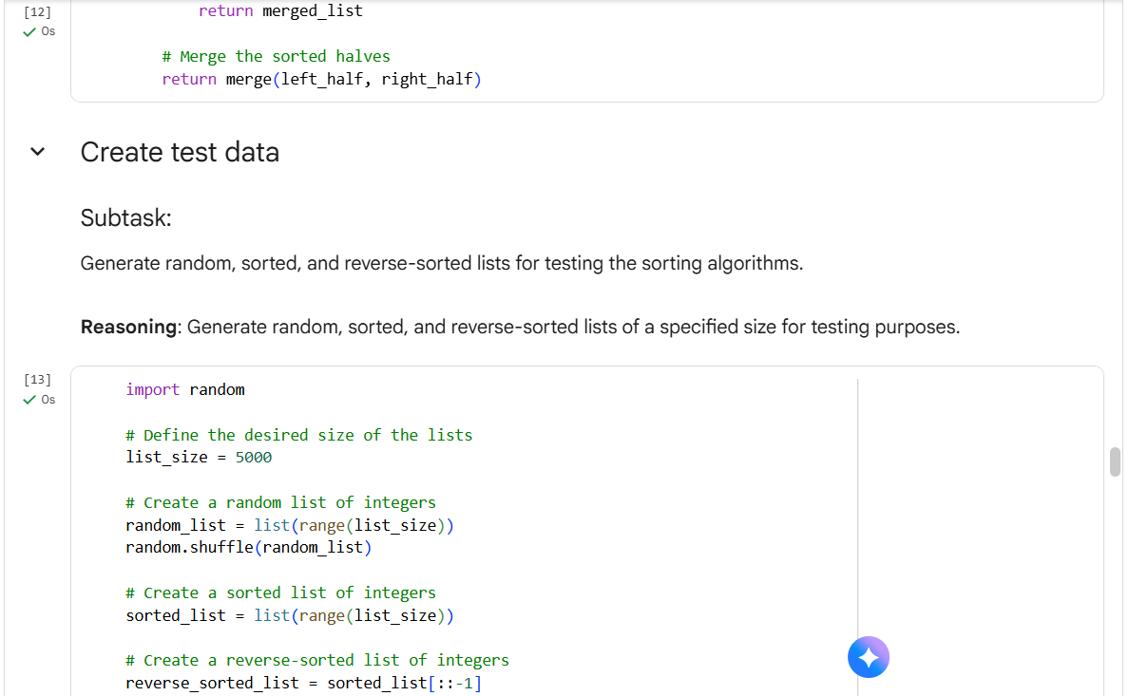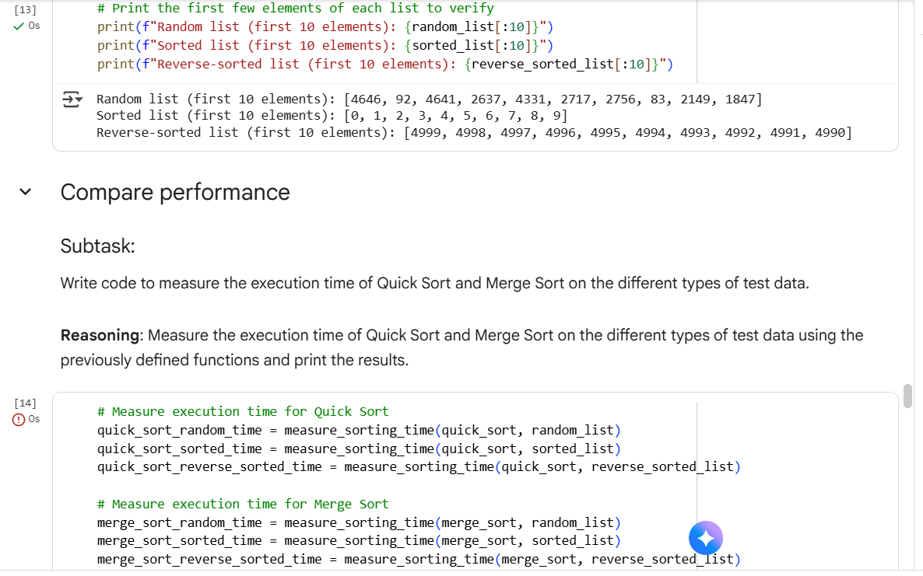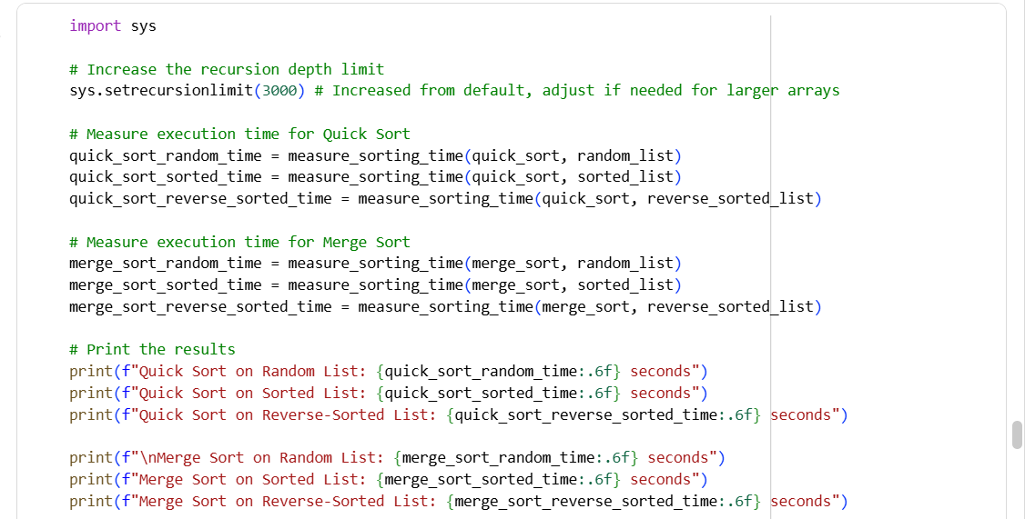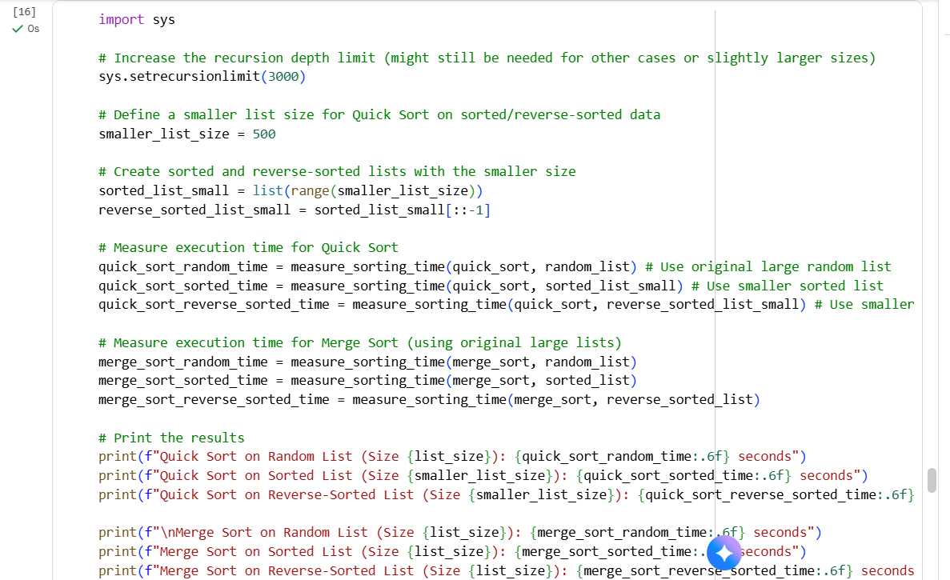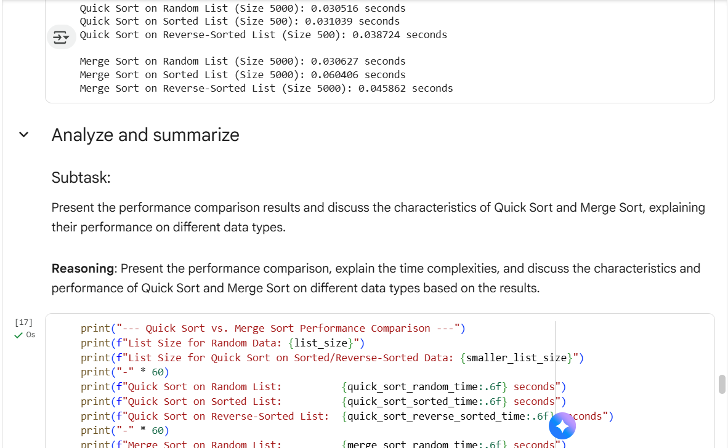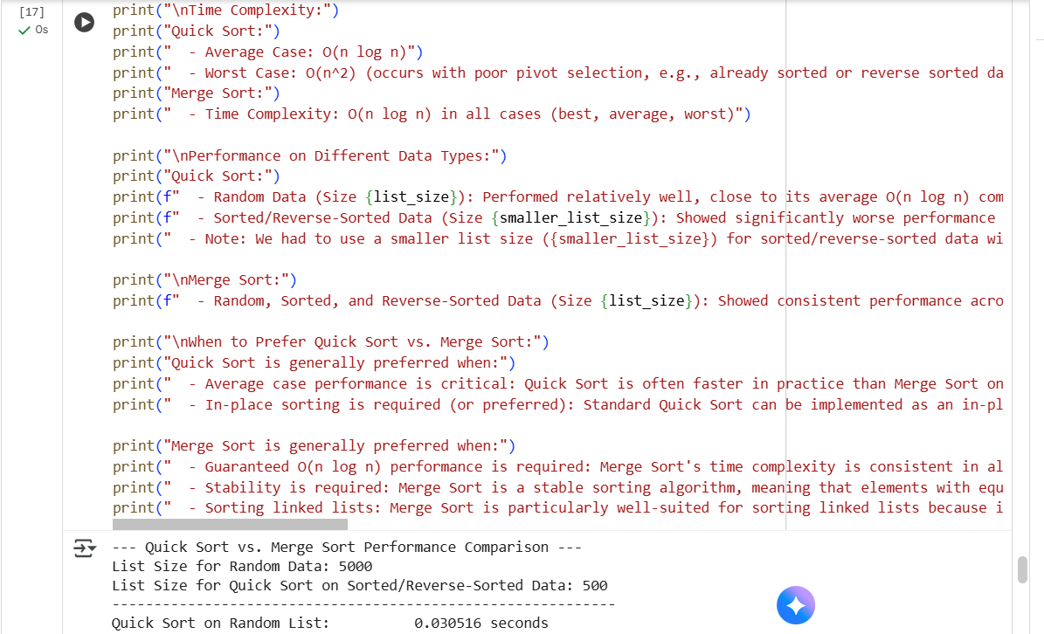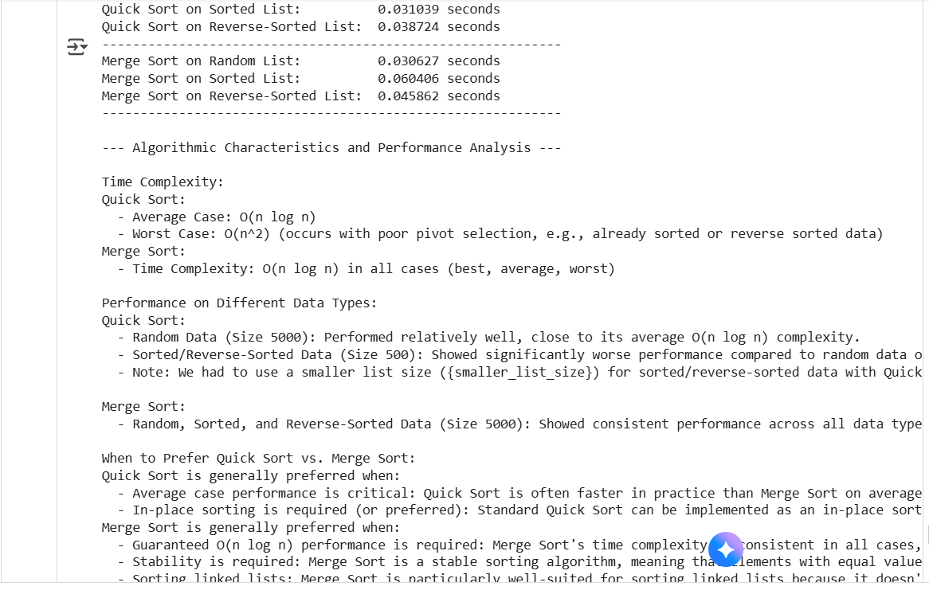
Explanation:
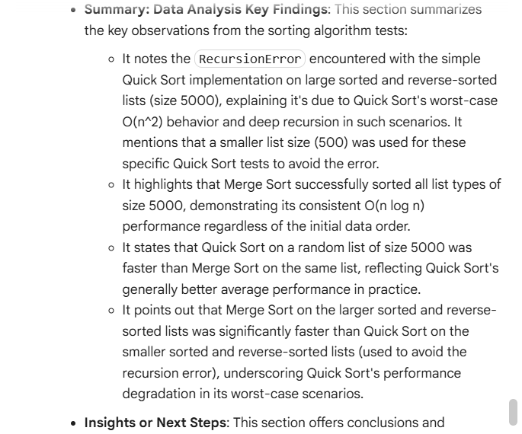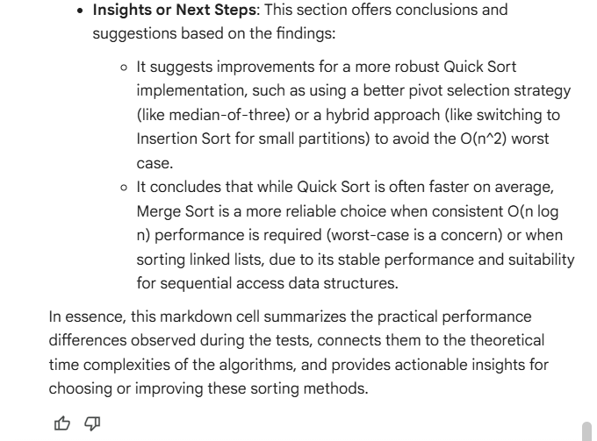

Task 5: AI-Suggested Algorithm Optimization
• Task: Give AI a naive algorithm (e.g., O(n²) duplicate search).
• Instructions:
o Students write a brute force duplicate-finder.
o Ask AI to optimize it (e.g., by using sets/dictionaries with
O(n) time).
o Compare execution times with large input sizes.
Expected Output:
o Two versions of the same algorithm (brute force +
optimized).
o AI explanation of how complexity was improved.
Code:
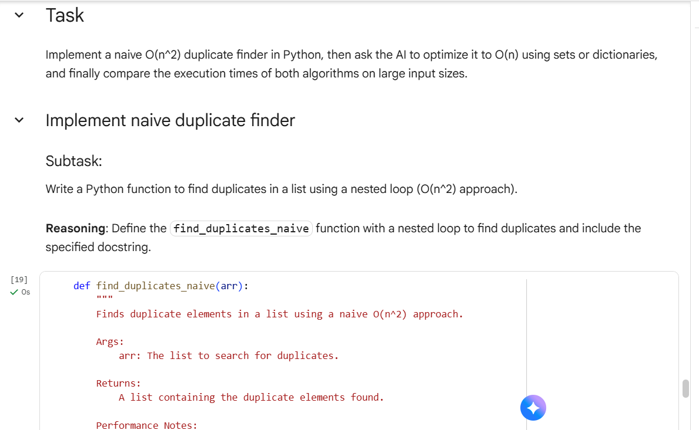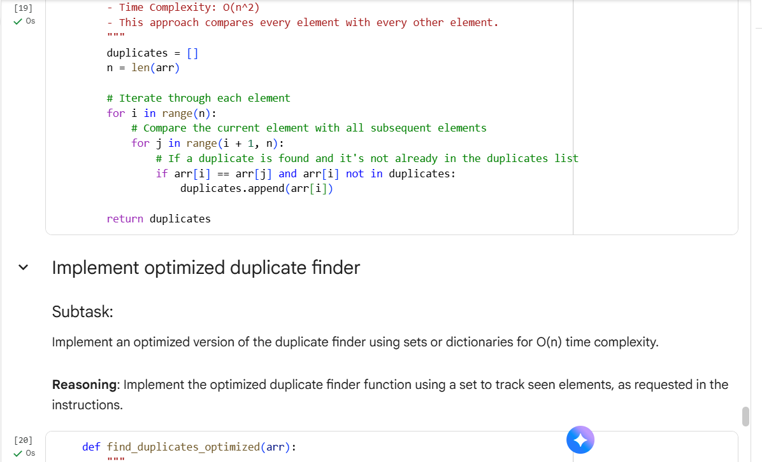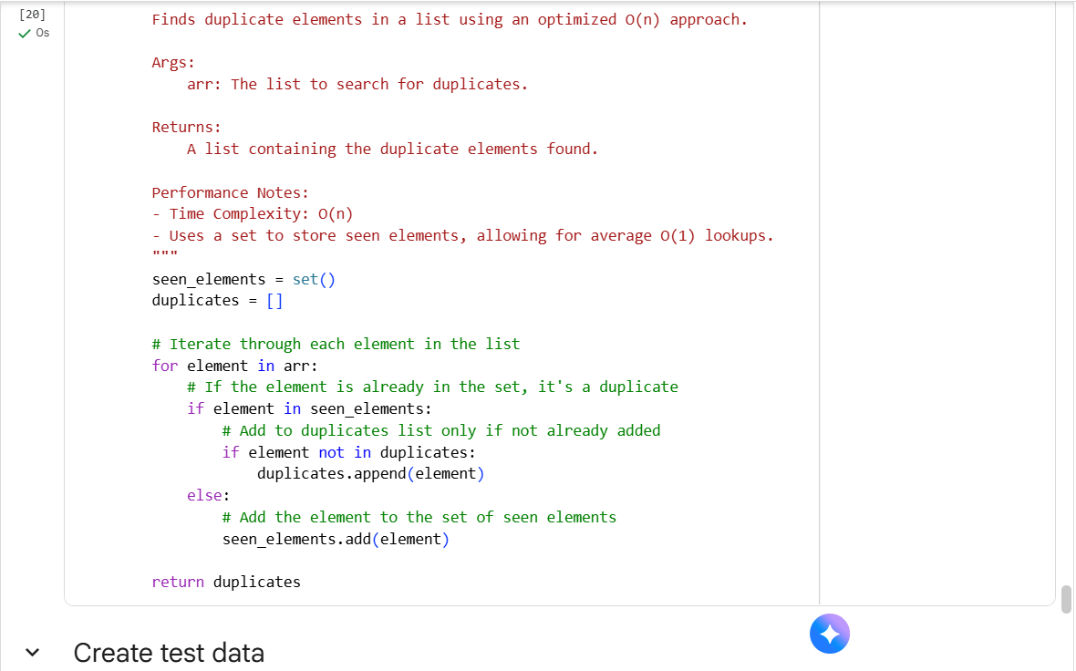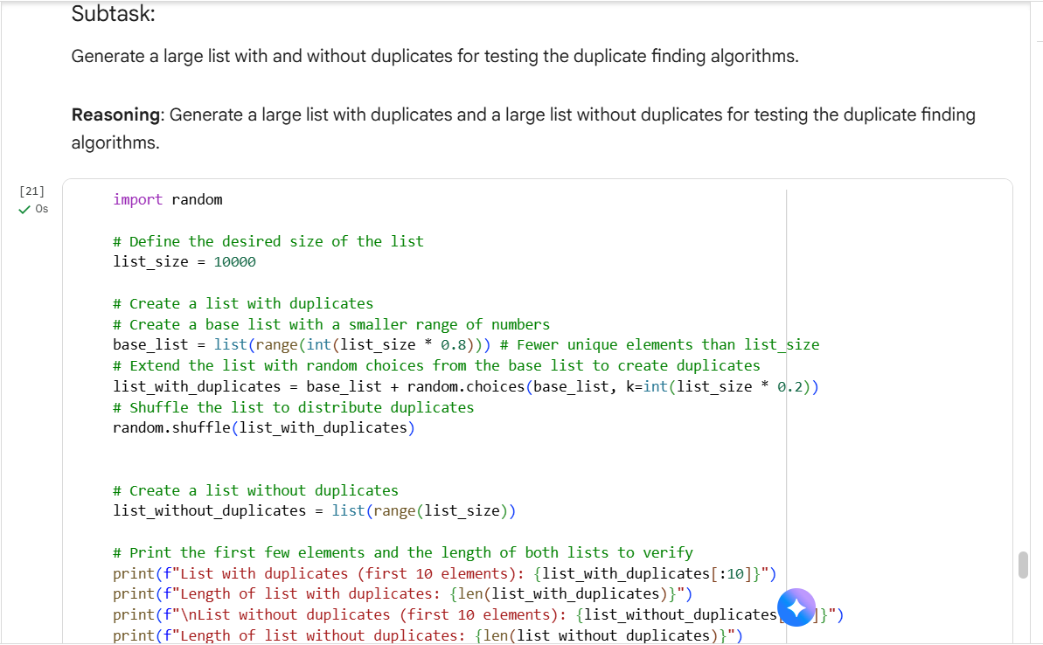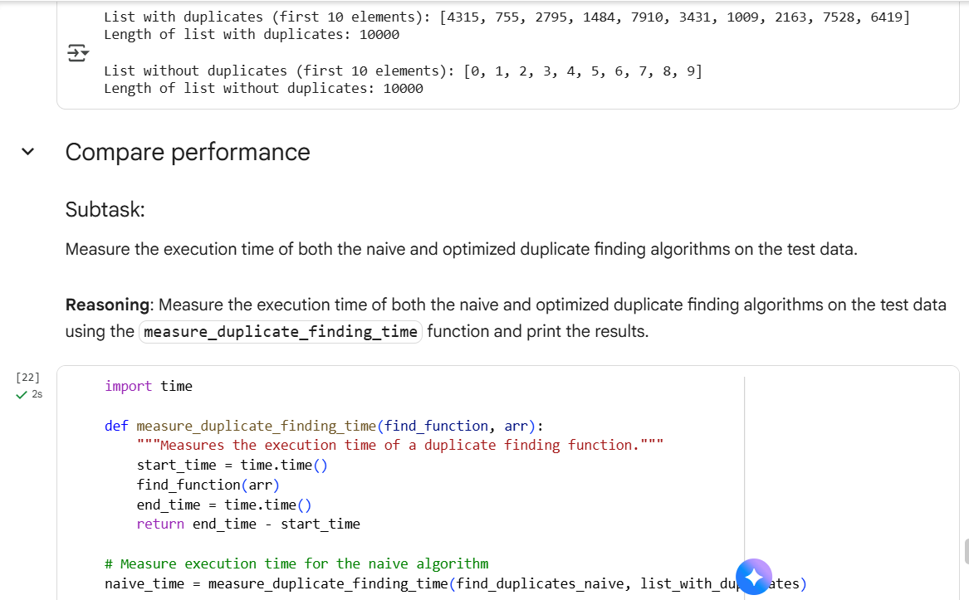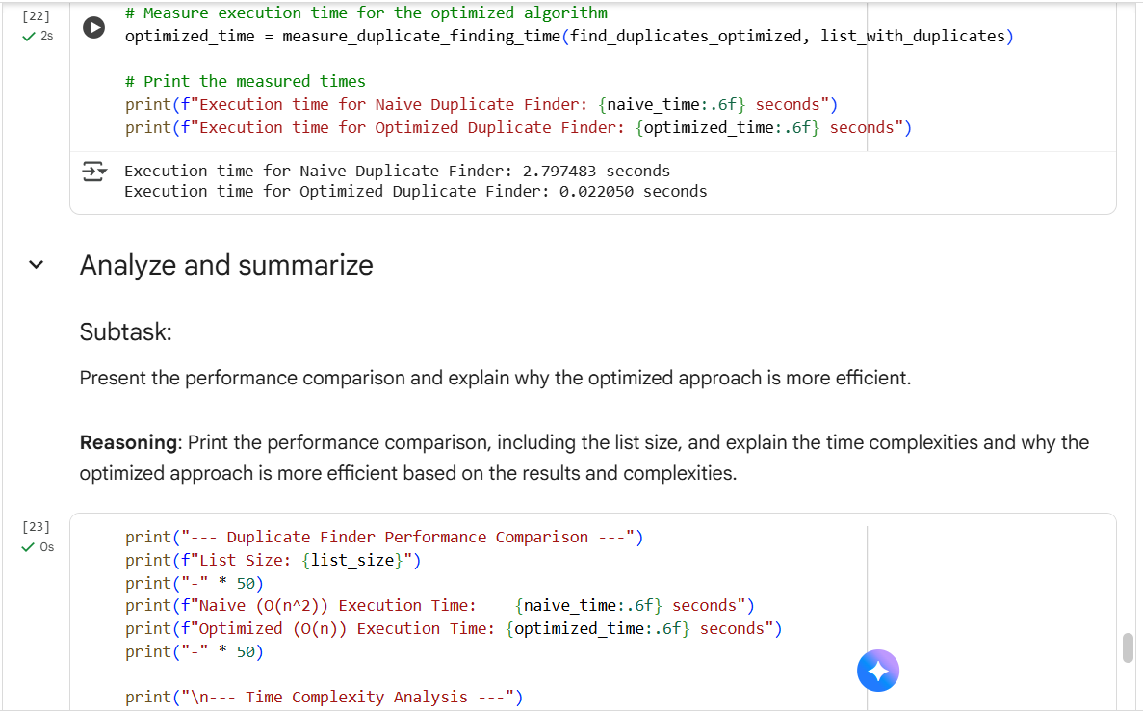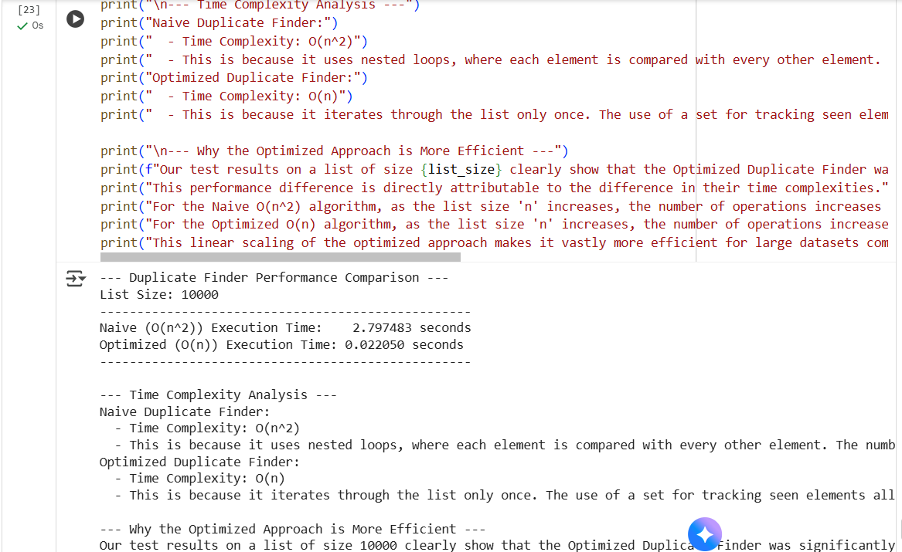
Explanation:
