**TRAFFIC MANAGEMENT SYSTEM**

**TEAM MEMBER**

**820421104078: VENISHRI N**

**PHASE:2 PROJECT SUBMISSION DOCUMENT**

**Introduction:**

**In an era of rapid urbanization and increasing vehicular traffic, the need for more efficient and intelligent traffic management systems has become paramount. The integration of the Internet of Things (IoT) technology with traffic management has ushered in a new era of smart and data-driven urban mobility solutions.**

**A Traffic Management System using IoT leverages a network of interconnected sensors, devices, and data analytics to monitor, control, and optimize traffic flow on roadways, highways, and urban areas. It represents a significant advancement in the way we address traffic-related challenges, aiming to enhance safety, reduce congestion, lower emissions, and provide a smoother commuting experience for both residents and visitors**.

**Innovative Design Using IoT to Solve Traffic Management Issues:**

**To effectively tackle traffic management challenges, an innovative approach using the Internet of Things (IoT) technology is proposed. IoT offers a dynamic, data-driven solution to transform traditional traffic management into a smarter, more adaptable, and proactive system. Here's an innovative design that leverages IoT to address traffic management issues:**

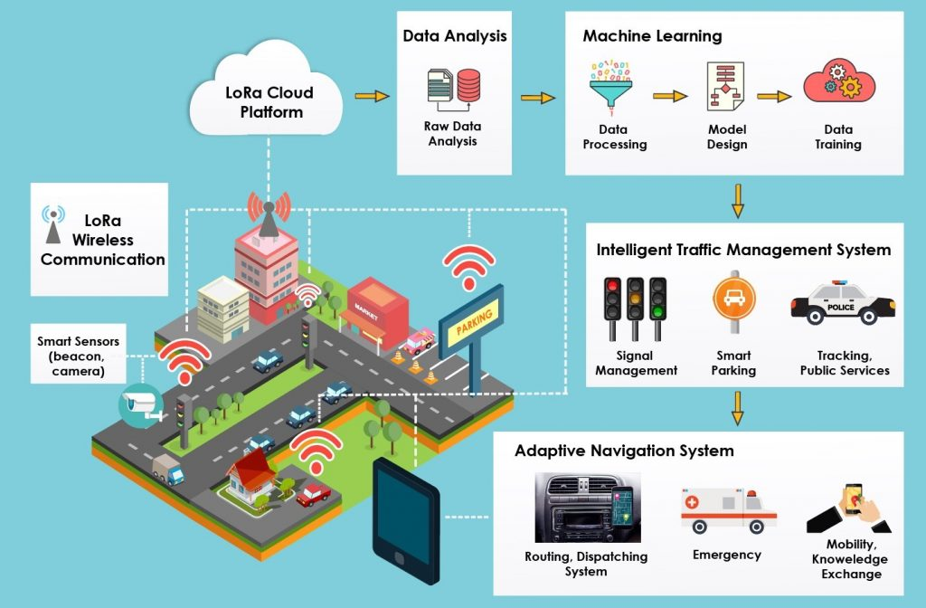

**1. Smart Traffic Lights:**

* **Iot sensors: Intersection-based IoT sensors continuously collect data on traffic flow, vehicle types, and pedestrian activity.**
* **Real-time optimization: Machine learning algorithms process this data in real-time and adjust traffic signal timings accordingly, reducing congestion and improving traffic flow.**
* **Emergency vehicle priority: IoT-connected traffic lights can quickly respond to prioritize emergency vehicles, reducing response times during critical situations.**

**2. Predictive Analytics:**

* **Data Sources: IoT sensors placed throughout the city collect data on traffic conditions, weather, and events.**
* **Advanced Algorithms: Predictive models, powered by artificial intelligence, analyze historical and real-time data to forecast traffic congestion.**
* **Proactive Alerts: Citizens receive real-time alerts and suggested alternative routes through mobile apps or electronic signs, enabling them to avoid congested areas.**

**3. Connected Vehicles:**

* **IoT Integration: Encouraging the integration of IoT technology in vehicles allows them to communicate with each other and with traffic infrastructure.**
* **Real-time Updates: Connected vehicles receive real-time traffic updates, road hazard alerts, and safety warnings, reducing accidents and traffic jams.**
* **Data Contribution: Vehicles equipped with IoT sensors contribute data to the overall traffic management system, enhancing its accuracy.**

**4. Traffic Enforcement:**

* **IoT Surveillance: IoT cameras and sensors monitor traffic violations such as speeding, illegal parking, and running red lights.**
* **Automated Fines: Automated ticketing systems issue fines to violators, promoting safer driving habits and improving traffic safety.**

**5. Sustainable Mobility:**

* **IoT Platforms: Create IoT-powered platforms that provide information on sustainable transportation options like electric scooters, bikes, and ridesharing services.**
* **Availability Tracking: IoT data tracks the availability of these services in real-time, encouraging their use and reducing the number of personal vehicles on the road.**

**6. Emergency Response Integration:**

* **Real-time Communication: IoT-enabled traffic management systems communicate with emergency services to ensure rapid response.**
* **Priority Routing: Ambulances, fire trucks, and police vehicles receive priority routing through traffic, significantly reducing response times and saving lives.**

**7. Public Participation:**

* **IoT Engagement: Engage the community through IoT-powered platforms and mobile apps.**
* **User Feedback: Citizens can report traffic incidents, road hazards, and suggest improvements through these platforms.**

**8. Data Security and Privacy:**

* **Security Measures: Implement robust security measures to safeguard IoT data from unauthorized access and cyberattacks.**
* **Privacy Protections: Ensure privacy by anonymizing and securely storing sensitive data collected from IoT devices, complying with data protection regulations.**

**9. Scalability and Future-Readiness:**

* **Scalable Design: The system is designed to scale seamlessly, accommodating increased traffic and expanding to cover larger areas.**
* **Technology Evolution: Stay updated with emerging IoT technologies to continuously enhance traffic management capabilities, ensuring future readiness.**

**Smart Traffic Sensors:**

**IOT SENSORS provide the backbone of data that intelligent transportation management systems analyze to increase actionable insights. Smart traffic management systems use integrated sensors like:**

* **Radio frequency identification (RFID) tags**
* **Automatic identification and data collection (AIDC) tags**
* **Temperature sensors**
* **Air quality sensors**

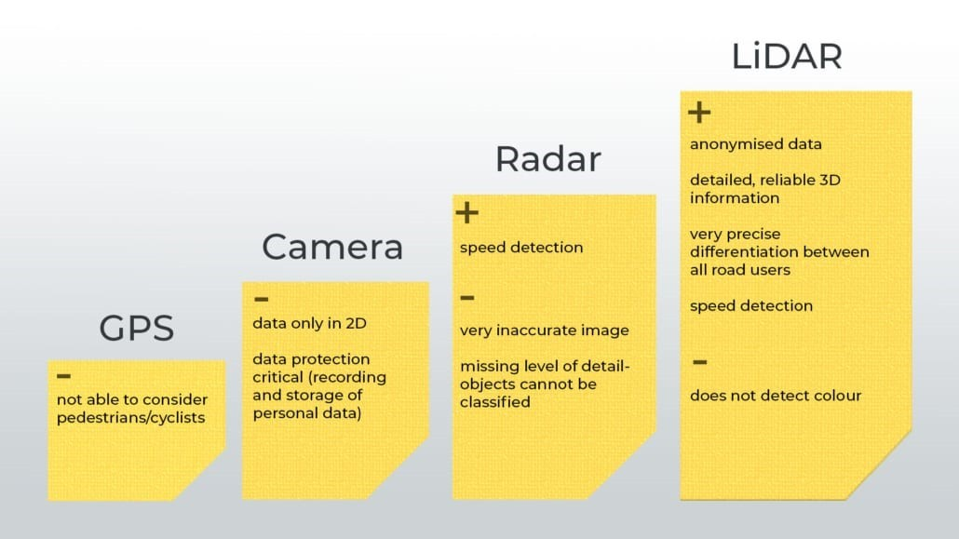

**Integrating historical traffic data and machine learning algorithms to predict congestion patterns**

**Integrating historical traffic data and machine learning algorithms to predict congestion patterns in a Traffic Management System using IoT is a powerful approach to proactively manage traffic flow. Here's how this integration can work:**

**1. Data Collection:**

**Historical traffic data is collected from various sources, including traffic cameras, sensors, GPS devices in vehicles, and traffic management systems. This data encompasses information such as traffic volume, vehicle speeds, accident reports, weather conditions, and more.**

**2. Data Preprocessing:**

**Raw historical traffic data must undergo preprocessing to clean and prepare it for analysis. This includes handling missing values, outliers, and ensuring data consistency.**

**3. Feature Engineering:**

**Feature engineering involves selecting and transforming relevant features from the historical data to create meaningful input variables for machine learning models. These features might include time of day, day of the week, weather conditions, traffic signal patterns, and past congestion levels.**

**4. Model Selection:**

**Choose the appropriate machine learning model for predicting congestion patterns. Time series forecasting models, regression models, or deep learning models like recurrent neural networks (RNNs) and long short-term memory networks (LSTMs) can be effective for this purpose.**

**5. Training the Machine Learning Model:**

**Historical traffic data is split into training and testing datasets. The model is trained using the training data to learn patterns and relationships between various features and congestion levels. Hyperparameter tuning may be required to optimize the model's performance.**

**6. Real-time Data Integration:**

**Historical traffic data is integrated with real-time data from IoT sensors and cameras to provide up-to-date information. This real-time data includes current traffic conditions, accidents, and other incidents.**

**7. Predictive Modeling:**

**The machine learning model analyzes the integrated data to make predictions. It can forecast congestion levels for specific timeframes and locations, allowing for the proactive management of traffic.**

**8. Decision Support System:**

**The predictions from the machine learning model are integrated into the traffic management system's decision support system. Traffic operators can access these predictions and use them to make informed decisions about adjusting traffic signal timings, deploying resources, and optimizing routes.**

**9. Feedback Loop:**

**The system continually collects real-time traffic data, validates the model's predictions against actual conditions, and updates the model as needed. This iterative process ensures that the predictions become increasingly accurate over time.**

**10. Communication with Drivers:**

**Drivers can be informed of predicted congestion patterns and alternative routes via mobile apps, electronic signs, or other communication channels.**

**The integration of historical traffic data and machine learning algorithms enhances the capabilities of an IoT-based traffic management system by enabling proactive decision-making and congestion management. This approach can lead to reduced traffic congestion, shorter travel times, and improved overall traffic efficiency.**

**Python program:**

**import pandas as pd**

**from sklearn.model_selection import train_test_split**

**from sklearn.linear_model import LinearRegression**

**from sklearn.metrics import mean_squared_error**

**import matplotlib.pyplot as plt**

**# Sample historical traffic data (you would need a real dataset)**

**data = pd.DataFrame({**

**'Hour': [1, 2, 3, 4, 5, 6, 7, 8, 9, 10],**

**'Congestion': [10, 20, 30, 40, 50, 60, 70, 80, 90, 100]**

**})**

**# Split the data into features and target**

**X = data[['Hour']]**

**y = data['Congestion']**

**# Split the data into training and testing sets**

**X_train, X_test, y_train, y_test = train_test_split(X, y, test_size=0.2, random_state=42)**

**# Create a linear regression model**

**model = LinearRegression()**

**# Train the model**

**model.fit(X_train, y_train)**

**# Make predictions**

**y_pred = model.predict(X_test)**

**# Evaluate the model**

**mse = mean_squared_error(y_test, y_pred)**

**print(f"Mean Squared Error: {mse}")**

**# Plot the data and the regression line**

**plt.scatter(X_test, y_test, color='blue')**

**plt.plot(X_test, y_pred, color='red', linewidth=2)**

**plt.xlabel('Hour')**

**plt.ylabel('Congestion')**

**plt.title('Traffic Congestion Prediction')**

**plt.show()**

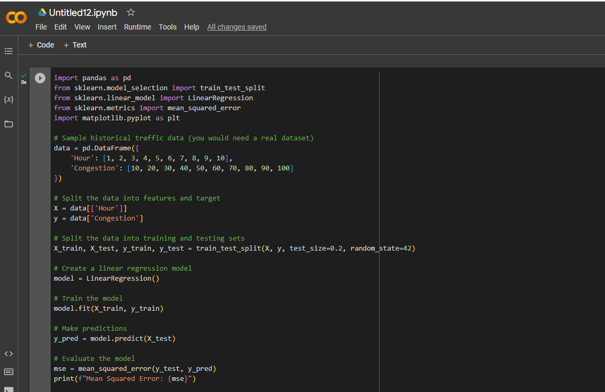

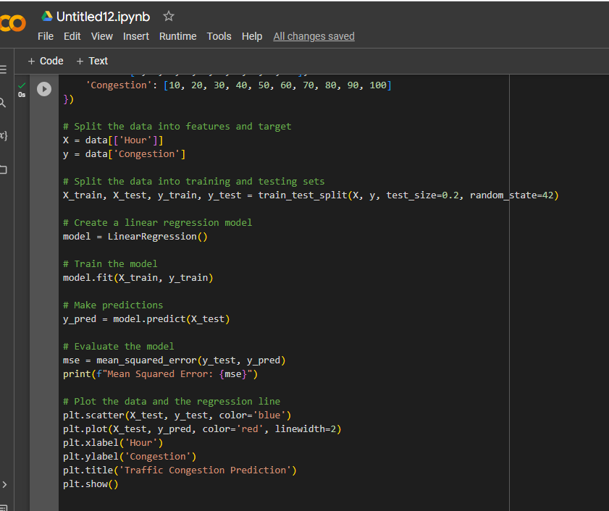

**Output:**

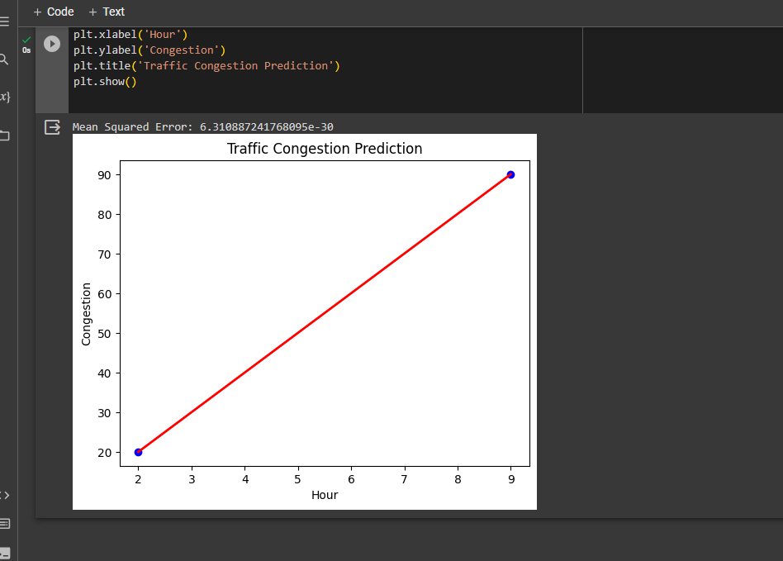

**Python program to basic machine learning model to predict congestion patterns.**

**import numpy as np**

**import pandas as pd**

**from sklearn.model_selection import train_test_split**

**from sklearn.ensemble import RandomForestRegressor**

**from sklearn.metrics import mean_squared_error**

**import matplotlib.pyplot as plt**

**# Generate synthetic data**

**np.random.seed(0)**

**n_samples = 1000**

**historical_data = pd.DataFrame({**

**'Time of Day': np.random.uniform(0, 24, n_samples),**

**'Day of Week': np.random.randint(0, 7, n_samples),**

**'Weather Condition': np.random.randint(0, 3, n_samples),**

**'Special Events': np.random.randint(0, 2, n_samples),**

**'Traffic Volume': np.random.randint(100, 1000, n_samples),**

**'Congestion Level': np.random.uniform(0, 10, n_samples)**

**})**

**# Split the data into features (X) and target variable (y)**

**X = historical_data.drop('Congestion Level', axis=1)**

**y = historical_data['Congestion Level']**

**# Split the data into training and testing sets**

**X_train, X_test, y_train, y_test = train_test_split(X, y, test_size=0.2, random_state=42)**

**# Create and train a Random Forest Regressor model**

**model = RandomForestRegressor(n_estimators=100)**

**model.fit(X_train, y_train)**

**# Make predictions on the test data**

**y_pred = model.predict(X_test)**

**# Evaluate the model's performance**

**mse = mean_squared_error(y_test, y_pred)**

**print(f"Mean Squared Error: {mse}")**

**# Plot the predicted vs. actual congestion levels**

**plt.scatter(y_test, y_pred)**

**plt.xlabel("Actual Congestion Level")**

**plt.ylabel("Predicted Congestion Level")**

**plt.title("Actual vs. Predicted Congestion Levels")**

**plt.show()**

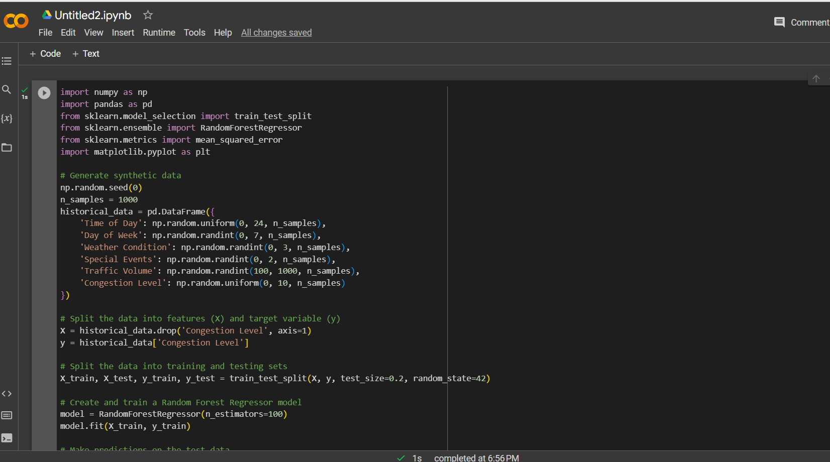

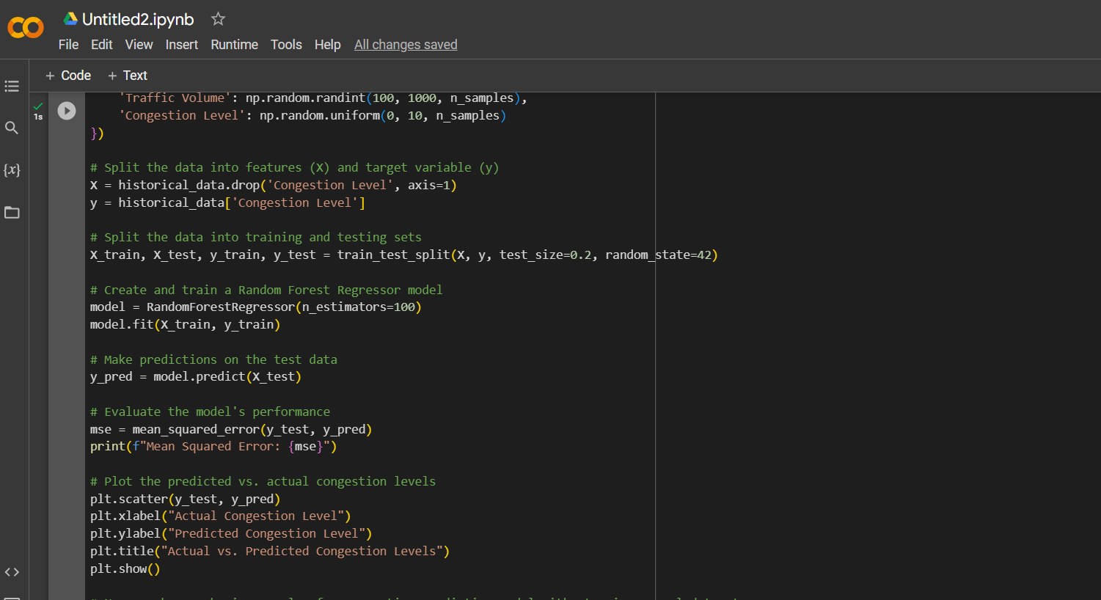

**Output:**

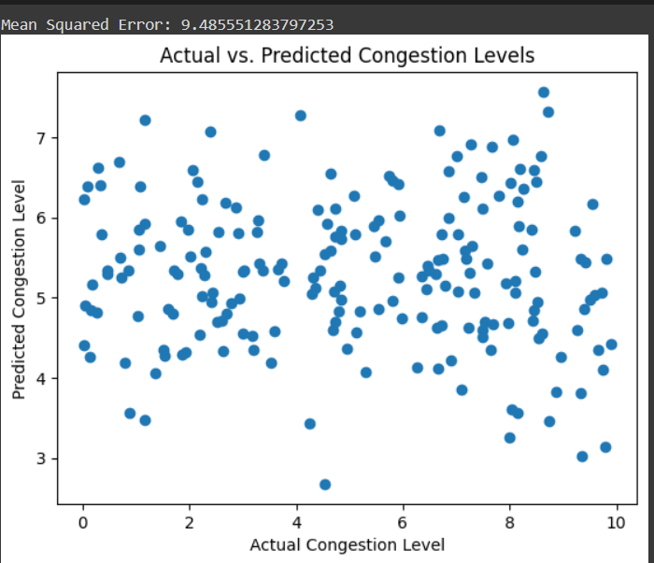

**Conclusion:**

**Innovations in IoT-driven traffic management are revolutionizing urban mobility. With real-time data from sensors, adaptive traffic signals optimize flow and reduce congestion. Predictive analytics enable proactive congestion mitigation, while multi-modal integration promotes sustainable transportation. Real-time V2V and V2I communication enhance safety and efficiency. Environmental sensors monitor air quality, aligning with sustainability goals. Efficient parking management reduces circling and emissions. Prioritizing security and privacy safeguards against cyber threats. These advancements collectively improve urban transportation, making it safer, more efficient, and environmentally friendly.**