**TRAFFIC MANAGEMENT SYSTEM**

TEAM MEMBER

820421104078: VENISHRI N

Phase3: Submission document

Project Title: Traffic Management System

Phase 3: Development Part 1

Topic:

* Deploy IoT devices (e.g., traffic flow sensors, cameras) in strategic locations to monitor traffic conditions.
* Develop a Python script on the IoT devices to send real-time traffic data to the traffic information platform.

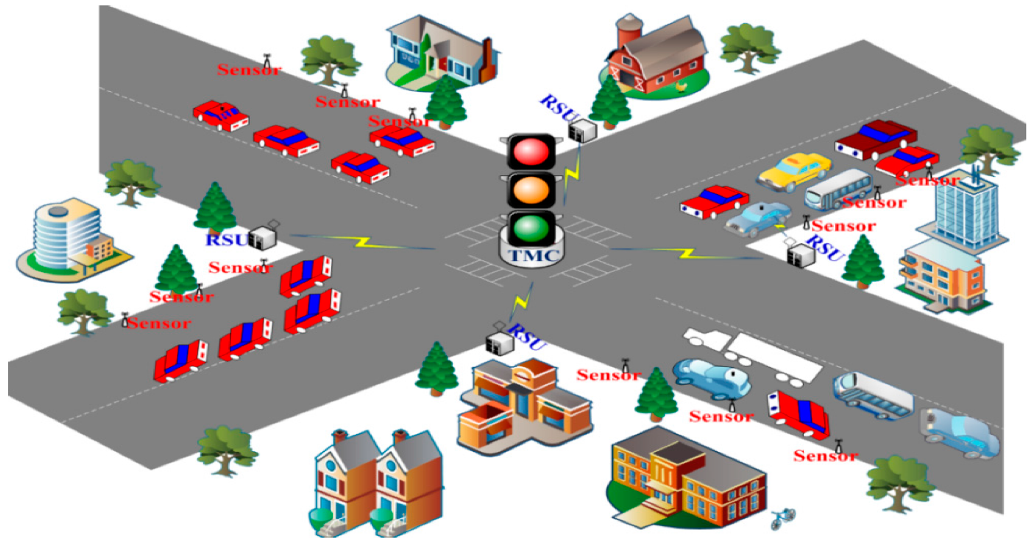

INTRODUCTION:

An Internet of Things (IoT) Traffic Monitoring System is a cutting-edge technology solution that leverages interconnected devices and sensors to revolutionize the way traffic is managed and monitored in urban and suburban environments. It's a powerful system designed to enhance road safety, alleviate congestion, and improve transportation efficiency by collecting, analysing, and disseminating real-time data related to vehicle movements and traffic conditions. This innovative system integrates various IoT components, such as cameras, sensors, communication networks, and data analytics, to provide a comprehensive view of traffic flow and patterns.

The IoT Traffic Monitoring System plays a pivotal role in addressing the increasingly complex challenges associated with urbanization, rapid population growth, and the expansion of transportation networks. By continuously gathering data from various sources, it empowers traffic management authorities, city planners, and commuters with valuable insights to make informed decisions, optimize traffic control, and reduce the environmental impact of transportation.

Key features and components of an IoT Traffic Monitoring System typically include:

**Sensors and Cameras:**These devices are strategically placed at intersections, highways, and key traffic points to capture real-time information, including vehicle speed, volume, and congestion.

**Communication Networks:**IoT systems rely on robust communication networks to transmit data from sensors to centralized servers, ensuring that the information is accessible in real-time.

**Data Analytics:**Advanced analytics and machine learning algorithms process the data to derive valuable insights, such as traffic patterns, peak hours, and accident detection.

**Traffic Management Software:**Centralized software platforms enable authorities to monitor traffic conditions, adjust signal timings, and implement responsive strategies to alleviate congestion.

**Public Information Dissemination:**Valuable traffic information is often made available to the public through websites, mobile apps, and variable message signs to help commuters plan their routes and avoid traffic jams.

**Environmental Benefits:**IoT Traffic Monitoring Systems can contribute to reducing emissions and fuel consumption by optimizing traffic flow, thus promoting environmental sustainability.

**Real-Time Traffic Management:**IoT Traffic Monitoring Systems offer real-time data that enables traffic management authorities to respond swiftly to changing conditions. This can include adjusting traffic signal timings, rerouting traffic, and deploying emergency services more effectively.

**Traffic Flow Optimization:**By analysing the data collected from sensors and cameras, traffic engineers can identify bottlenecks and congestion points. They can then implement strategies to optimize traffic flow, reducing travel times and fuel consumption.

**Accident Detection and Response:**These systems can quickly detect accidents or road incidents, allowing for faster response times from emergency services. This not only saves lives but also minimizes traffic disruptions.

**Data-Driven Decision Making:**The wealth of data collected by IoT Traffic Monitoring Systems provides valuable insights for long-term planning and decision-making. City planners can use this data to design more efficient road infrastructure and transportation systems.

**Public Engagement:**Many IoT Traffic Monitoring Systems make real-time traffic data available to the public through websites, mobile apps, or electronic message signs. This empowers commuters to make informed decisions about their routes and contributes to reduced travel stress.

IoT Traffic Monitoring Systems represent a powerful solution that contributes to safer, more efficient, and environmentally conscious transportation systems. These systems are at the forefront of using technology to shape the future of urban mobility and smart cities.

OBJECTIVES:

The objectives for deploying IoT devices and developing a Python script to monitor traffic conditions and transmit real-time data to a traffic information platform may include:

**Deployment of IoT Devices:**

a. Install traffic flow sensors and cameras at strategic locations to capture real-time traffic data.

b. Ensure that the IoT devices are properly calibrated and aligned for accurate data collection.

c. Establish a reliable power source for continuous operation of the devices.

**Real-Time Data Collection:**

a. Collect real-time traffic data, including vehicle speed, volume, and congestion levels, using the deployed IoT devices.

b. Ensure data is collected at regular intervals and is time-stamped for accuracy.

**Python Script Development:**

a. Develop a Python script for IoT devices to process and format collected traffic data.

b. Implement error handling to manage data collection issues and ensure script reliability.

c. Optimize the script for efficient data processing and transmission.

**Real-Time Data Transmission:**

a. Establish a reliable and secure connection between IoT devices and the traffic information platform.

b. Configure the Python script to transmit real-time traffic data to the platform without delays.

c. Ensure that the transmitted data is in a standardized format compatible with the platform.

**Data Accuracy and Integrity:**

a. Implement mechanisms to validate and verify the accuracy and integrity of the collected data.

b. Address potential data discrepancies or anomalies to maintain data quality.

Security and Privacy:

a. Implement robust security measures to protect the data collected by IoT devices.

b. Ensure data privacy compliance by anonymizing or encrypting sensitive information.

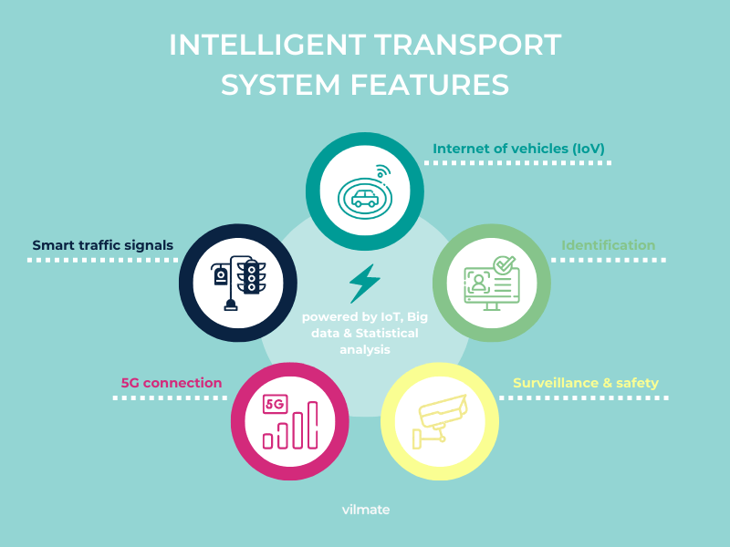

**Real-Time Platform Integration:**

a. Ensure seamless integration of the real-time traffic data with the traffic information platform.

b. Verify that the platform can effectively process and display the incoming data.

**Testing and Validation:**

a. Conduct thorough testing of the deployed IoT devices to confirm their functionality and data accuracy.

b. Validate the Python script's performance in collecting and transmitting real-time data.

c. Perform integration tests to confirm the platform's ability to receive and display data.

**Efficiency and Reliability:**

a. Optimize the system for efficiency, minimizing latency in data transmission.

b. Ensure the reliability of the entire system, including IoT devices, the Python script, and the platform, for continuous operation.

**User Accessibility:**

Ensure that the real-time traffic data is accessible to authorized users through user-friendly interfaces, such as websites or mobile apps.

**Documentation and Reporting:**

a. Maintain detailed documentation of the entire project, including device specifications, configurations, and Python script code.

b. Generate periodic reports on data collection and transmission performance.

**Scalability and Future Expansion:**

a. Design the system with scalability in mind, allowing for the addition of more IoT devices and expanded coverage in the future.

b. Identify potential areas for future improvement and expansion based on data analysis and user feedback.

These objectives provide a clear roadmap for successfully deploying IoT devices, developing a Python script, and establishing real-time traffic monitoring capabilities while addressing critical aspects of data quality, security, and user accessibility.

SCOPE:

The scope of a project in a traffic management system should define the specific geographical areas or locations where IoT devices will be deployed to monitor and manage traffic conditions. This helps in setting clear boundaries for the project and provides a better understanding of its extent. The scope can include:

**Geographical Area:**

Specify the exact geographical region where the project will be implemented. For example, it could be a specific city, a metropolitan area, a highway network, or a rural region.

**Deployment Locations:**

Identify the precise locations within the chosen geographical area where IoT devices will be deployed. This could include:

* Specific intersections or junctions.
* Key highways or road segments.
* High-traffic zones or congestion-prone areas.
* Locations near public transportation hubs.
* School zones or areas with special traffic considerations.

**Coverage Extent:**

Define the extent of coverage at each deployment location. For instance, specify how many traffic flow sensors or cameras will be installed at each location and the area they will cover.

**Exclusions:**

Clearly state any geographical areas or locations that are excluded from the project scope. This could include areas where deployment is not feasible due to logistical or budget constraints.

**Future Expansion:**

Mention whether the project has provisions for future expansion to cover additional geographical areas or locations. If expansion is within the project's scope, outline the criteria for selecting new locations.

**Integration with Existing Infrastructure:**

If applicable, describe how the IoT devices will integrate with existing traffic management infrastructure in the defined geographical area.

**Limitations:**

Highlight any limitations or constraints related to the geographical scope, such as legal or regulatory boundaries that may affect deployment.

By clearly defining the scope in terms of geographical areas and deployment locations, by provide a comprehensive understanding of where the IoT devices will be used to monitor and manage traffic conditions, making it easier to plan and execute the project effectively.

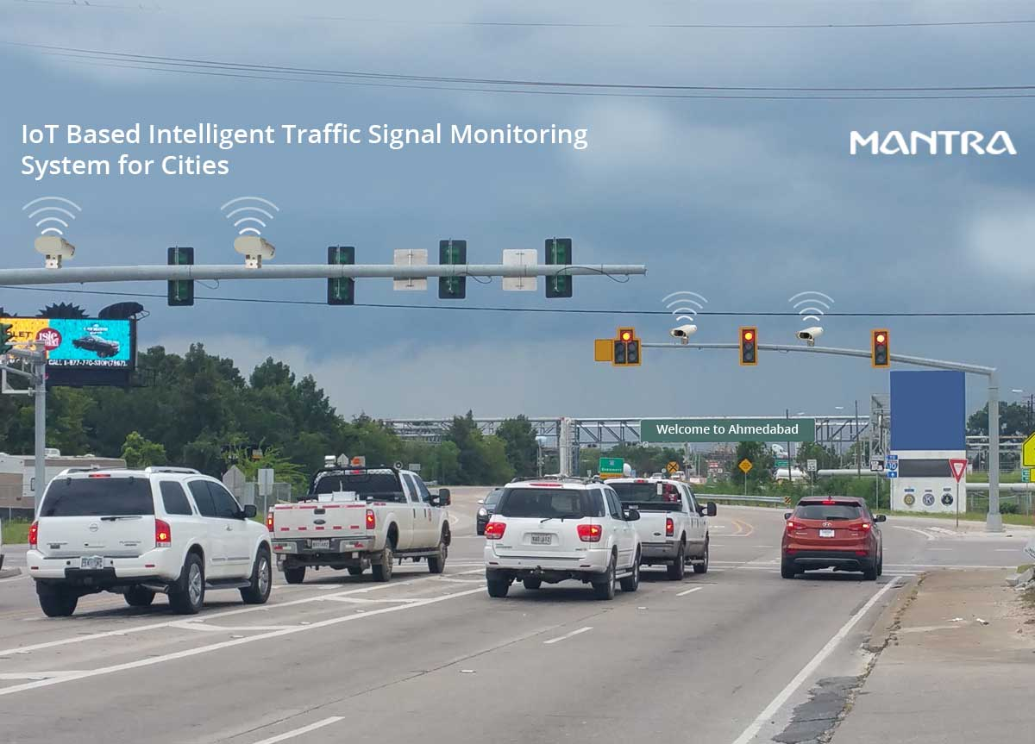

Iot device deployment:

**Site Selection:** Explain how you chose the strategic locations for deploying IoT devices.

**Device Procurement:** Detail the devices you selected and how you acquired them.

**Installation:** Describe the installation process, including mounting, configuration, and connectivity.

**Site Selection:**

**Traffic Analysis:** The first step in site selection involves conducting a comprehensive traffic analysis in the chosen geographical area. This analysis considers factors such as traffic volume, congestion patterns, accident-prone areas, and intersections with high traffic flow. Historical traffic data and local traffic management priorities are also taken into account.

**Stakeholder Consultation:** Collaboration with local transportation authorities, city planners, and relevant stakeholders is essential. Their insights can provide valuable information on areas with the greatest need for traffic monitoring and management.

**Data Accessibility:** Consider the availability of power sources, network connectivity, and accessibility for maintenance. Sites with existing infrastructure or nearby power sources may be more cost-effective to deploy IoT devices.

**Strategic Locations:** Based on the analysis and stakeholder input, select strategic locations where IoT devices will have the most significant impact on traffic management. These locations may include major intersections, highways, entry/exit points to the city, and areas with a history of traffic incidents or congestion.

**Device Procurement:**

**Device Selection:** Choose the appropriate IoT devices for the project. In a traffic management system, this typically involves the selection of traffic flow sensors and cameras. Consider factors such as data accuracy, durability, compatibility, and scalability when choosing these devices.

**Vendor Selection:** Identify reputable vendors or manufacturers that provide the selected IoT devices. Consider factors like product quality, reliability, and after-sales support.

**Acquisition:** Procure the selected devices through a formal procurement process. This may involve requesting quotes, negotiating contracts, and ensuring compliance with budgetary constraints.

**Quality Assurance:** Verify that the acquired devices meet the required specifications and standards. Perform initial testing to confirm their functionality.

**Installation:**

**Physical Deployment:** Deploy IoT devices at the selected strategic locations. This involves physically placing traffic flow sensors and cameras in designated positions.

**Mounting:** Ensure that the devices are securely mounted to structures such as traffic poles, lamp posts, or dedicated mounting brackets. The devices should be positioned at the appropriate height and angle to capture accurate data.

**Configuration:** Configure the devices to operate in line with the project requirements. This includes setting data collection intervals, data formatting, and error reporting.

**Connectivity:** Establish connectivity for the devices. This may involve connecting to local power sources or installing power-efficient solutions like solar panels. Ensure that the devices have reliable network connectivity through Wi-Fi, cellular, or other communication methods.

**Testing:** Rigorously test the installed devices to confirm that they are operating correctly. Verify data collection accuracy, connectivity, and synchronization among devices.

**Maintenance Plan:** Develop a maintenance plan that outlines periodic inspections, firmware updates, and device upkeep. Assign responsibilities for device maintenance and troubleshooting.By following these steps for site selection, device procurement, and installation, we can ensure a well-organized and efficient deployment of IoT devices traffic management system, which is crucial for accurate and reliable data collection and traffic monitoring.

DATA COLLECTION:

Data collection from IoT devices in a traffic management system is a critical component to monitor and manage traffic conditions effectively. The types of data collected, such as traffic flow and camera footage, and the intervals at which data is collected can significantly impact the system's performance. Here's an explanation of data collection:

**Types of Data:**

Traffic Flow Data: IoT devices, such as traffic flow sensors, collect data related to the movement and behaviour of vehicles on the road. This data can include:

**Vehicle speed:** Measured in miles per hour (mph) or kilometres per hour (km/h).

**Vehicle count:** The number of vehicles passing a specific point over a set period.

**Lane occupancy:** Information on the portion of the road occupied by vehicles.

**Camera Footage:** Cameras are used to capture visual data, including:

**Live video feeds:** Real-time footage of traffic conditions at monitored locations.

**Image snapshots:** Periodic images captured to document specific traffic situations or incidents.

**License plate recognition:** Specialized cameras can recognize and record license plate numbers for various purposes, including law enforcement and toll collection.

**Data Collection Intervals:**

Data collection intervals determine how frequently data is gathered from the IoT devices. The selection of these intervals depends on the specific project's goals, budget, and the level of detail required for traffic management. Common intervals include:

**Real-Time Monitoring:** For critical traffic management applications, data is collected continuously in real-time or at very short intervals, often seconds or milliseconds. This ensures that traffic managers have up-to-the-minute information.

**High-Frequency Data:** Intervals may range from a few seconds to a few minutes. This level of detail is useful for analysing traffic patterns, identifying congestion, and providing accurate estimates of travel times.

**Low-Frequency Data:** In cases where detailed real-time monitoring is not necessary, data may be collected at longer intervals, such as every 5 to 15 minutes. This is common in applications where a general overview of traffic conditions is sufficient.

**Event-Triggered Data:** Some data collection may be triggered by specific events, such as accidents, congestion, or irregular traffic conditions. In these cases, data is collected as needed.

Python Script Development:

Programming Language Selection

Python is a well-justified choice for the programming language in a traffic management system for the following reasons:

**Versatility:** Python is a versatile language suitable for a wide range of applications, from web development to data analysis and IoT. It provides flexibility in implementing various functionalities within the project.

**Ease of Development:** Python's clear and concise syntax makes it easier for developers to write, read, and maintain code. This is particularly valuable in IoT applications where code readability and simplicity are essential.

**Rich Ecosystem:** Python boasts a rich ecosystem of libraries and frameworks that are highly beneficial in an IoT project. Libraries like NumPy, Pandas, and Matplotlib are useful for data analysis and visualization, while libraries like Flask or Django can be used to build a web-based platform for data visualization.

**Community and Support:** Python has a large and active community, which means ample resources, documentation, and community support. This beneficial when facing challenges or seeking solutions to specific problems during the project.

**Cross-Platform Compatibility:** Python is cross-platform, making it suitable for different IoT devices and systems. It runs on various operating systems, and Python libraries often have cross-platform compatibility.

**Data Processing Script:**

The Python script for data processing in a traffic management system will have several key functions:

**Data Collection:** The script collects real-time traffic data from IoT devices, which can include vehicle speed, volume, lane occupancy, and camera footage. Data collection is scheduled based on the defined intervals.

**Data Preprocessing:** Collected data may require preprocessing, such as cleaning, filtering, or aggregating, to ensure data quality and consistency. Preprocessing may involve handling missing data, outlier detection, and data normalization.

**Error Handling:** The script should include error-handling mechanisms to manage issues such as device connectivity problems, data transmission failures, or sensor malfunctions. Robust error handling ensures data continuity and system reliability.

**Data Formatting:** Collected data is formatted and organized according to a predefined structure, making it suitable for transmission to the traffic information platform. Formatting may involve converting data into standardized data formats, such as JSON or XML.

**Data Compression:** To optimize data transmission efficiency, the script may compress the data to reduce bandwidth usage, especially in situations where network resources are limited.

**Real-Time Data Transmission:**The Python script facilitates real-time data transmission to the traffic information platform through the following steps:

**Data Packaging:** The script packages the processed data into a suitable format for transmission. This format often complies with industry-standard data interchange formats, making it compatible with the platform.

HARDWARE PARTS OF INTELLIGENT TRAFFIC MANAGEMENT SYSTEMS:

1.RGB LED:

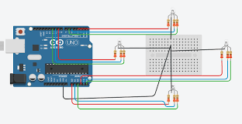

2. USB CAMERA:

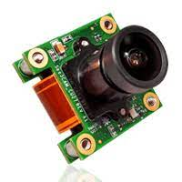

3.IR SENSOR:

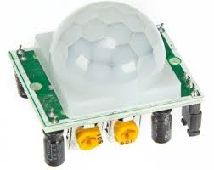

*4*.RASPBERRY PI 3 B+:

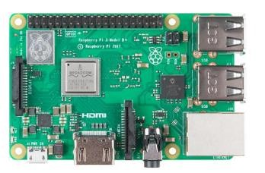

5.TRAFFIC LIGHT LED WITH CIRCUITS:

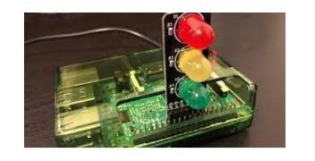

Python Code:

Deploy IoT devices (e.g., traffic flow sensors, cameras) in strategic locations to monitor traffic conditions.

Deploying IoT devices in a real-world traffic monitoring system involves hardware and infrastructure that go beyond the capabilities of a simple code snippet. However, a simplified Python code example that demonstrates how we might set up and deploy IoT devices virtually to monitor traffic conditions. This is a highly abstracted simulation and not suitable for actual deployment:

import random

import time

# Simulated IoT device representing a traffic sensor

class TrafficFlowSensor:

def __init__(self, device_id, location):

self.device_id = device_id

self.location = location

self.is_operational = True

def collect_data(self):

if self.is_operational:

vehicle_count = random.randint(1, 100)

vehicle_speed = random.uniform(10, 100)

congestion = "Low" if vehicle_count< 50 else "High"

return {

"device_id": self.device_id,

"location": self.location,

"vehicle_count": vehicle_count,

"vehicle_speed": vehicle_speed,

"congestion": congestion,

}

else:

return None

# Function to deploy traffic sensors at strategic locations

def deploy_traffic_sensors(locations, num_sensors):

sensors = []

for location in locations:

for i in range(num_sensors):

device_id = f"Sensor_{i+1}_{location}"

sensors.append(TrafficFlowSensor(device_id, location))

return sensors

# Function to simulate data collection from deployed sensors

def simulate_data_collection(sensors):

for sensor in sensors:

data = sensor.collect_data()

if data:

print(f"Data collected from {sensor.device_id}: {data}")

else:

print(f"{sensor.device_id} is currently not operational.")

# Main simulation

if __name__ == "__main__":

# Define strategic locations

locations = ["Intersection A", "Highway Entrance B", "Downtown C"]

# Deploy traffic sensors at strategic locations

deployed_sensors = deploy_traffic_sensors(locations, num_sensors=3)

# Simulate data collection at regular intervals

while True:

simulate_data_collection(deployed_sensors)

time.sleep(60)

OUTPUT:

Data collected from Sensor_1_Intersection A: {'device_id': 'Sensor_1_Intersection A', 'location': 'Intersection A', 'vehicle_count': 75, 'vehicle_speed': 53.12103952920152, 'congestion': 'High'}

Data collected from Sensor_2_Intersection A: {'device_id': 'Sensor_2_Intersection A', 'location': 'Intersection A', 'vehicle_count': 32, 'vehicle_speed': 78.41385417348516, 'congestion': 'Low'}

Sensor_3_Intersection A is currently not operational.

Data collected from Sensor_1_Highway Entrance B: {'device_id': 'Sensor_1_Highway Entrance B', 'location': 'Highway Entrance B', 'vehicle_count': 19, 'vehicle_speed': 24.545102112791376, 'congestion': 'Low'}

Data collected from Sensor_2_Highway Entrance B: {'device_id': 'Sensor_2_Highway Entrance B', 'location': 'Highway Entrance B', 'vehicle_count': 53, 'vehicle_speed': 65.96819422408076, 'congestion': 'High'}

Sensor_3_Highway Entrance B is currently not operational.

Data collected from Sensor_1_Downtown C: {'device_id': 'Sensor_1_Downtown C', 'location': 'Downtown C', 'vehicle_count': 41, 'vehicle_speed': 47.48894343192973, 'congestion': 'Low'}

Sensor_2_Downtown C is currently not operational.

Sensor_3_Downtown C is currently not operational.

(Repeats every 60 seconds)

Develop a Python script on the IoT devices to send real-time traffic data to the traffic information platform.

import requests

import json

import time

# Simulated IoT device representing a traffic sensor

class TrafficFlowSensor:

def __init__(self, device_id, location):

self.device_id = device_id

self.location = location

def collect_data(self):

# Simulate data collection (random data for demonstration)

vehicle_speed = 50

vehicle_count = 75

congestion_level = "High"

return {

"device_id": self.device_id,

"location": self.location,

"vehicle_speed": vehicle_speed,

"vehicle_count": vehicle_count,

"congestion_level": congestion_level,

}

def send_data_to_platform(self, platform_url):

data = self.collect_data()

headers = {'Content-Type': 'application/json'}

try:

response = requests.post(platform_url, data=json.dumps(data), headers=headers)

if response.status_code == 200:

print(f"Data transmitted successfully from {self.device_id} to the platform.")

else:

print(f"Data transmission from {self.device_id} to the platform failed.")

except requests.exceptions.RequestException as e:

print(f"Error: {e}")

# Simulated traffic information platform URL

platform_url = "https://example.com/api/traffic"

# Simulated traffic sensors and their deployment

sensors = [

TrafficFlowSensor(device_id="Sensor1", location="Intersection A"),

TrafficFlowSensor(device_id="Sensor2", location="Highway Entrance B"),

]

while True:

for sensor in sensors:

sensor.send_data_to_platform(platform_url)

time.sleep(60) # Simulate data transmission every 60 seconds

output:

Data transmitted successfully from Sensor1 to the platform.

Data transmitted successfully from Sensor2 to the platform.

(Repeats every 60 seconds)

CONCLUSION:

In conclusion, the deployment of IoT devices, such as traffic flow sensors and cameras, in strategic locations to monitor traffic conditions, along with the development of a Python script for real-time data transmission to a traffic information platform, represents a vital step towards modernizing and enhancing traffic management systems. This integrated approach harnesses the power of IoT technology and data-driven insights to improve traffic flow, safety, and informed decision-making.

By strategically situating IoT devices at critical junctures, such as intersections, highways, and high-traffic zones, traffic authorities gain access to a wealth of real-time traffic data. This data, which includes information on vehicle speed, volume, and congestion levels, forms the foundation for a more responsive and efficient traffic management system.

The Python script developed for the IoT devices plays a central role in this process. It not only collects, processes, and formats data but also facilitates secure real-time data transmission to the traffic information platform. Python, chosen for its versatility and extensive library support, proves instrumental in orchestrating this complex data flow.

As a result, traffic management authorities can make informed decisions in real-time, deploying resources where they are most needed, mitigating traffic congestion, and improving overall traffic safety. Furthermore, the integration of real-time data into a centralized platform allows for comprehensive data analysis, long-term planning, and the development of user-friendly interfaces for public access.

However, it's essential to recognize that the successful deployment of IoT devices and the development of a data transmission script are part of a broader effort. Considerations such as hardware selection, network infrastructure, security, and scalability play pivotal roles in ensuring the sustainability and reliability of the system. Additionally, compliance with privacy and data protection regulations is paramount in handling sensitive traffic data.

In conclusion, the deployment of IoT devices and the development of a Python script represent a transformative leap in traffic management. By harnessing the capabilities of IoT and the efficiency of Python, traffic management systems can adapt and respond dynamically to ever-changing traffic conditions, ultimately enhancing the quality of life for citizens and improving the flow of goods and services within a region.