**TRAFFIC MANAGEMENT SYSTEM**

TEAM MEMBER

820421104078: VENISHRI.N

Phase 5: Submission document

Phase 5: Project Documentation & Submission

Topic:

* Describe the project's objectives, IoT sensor setup, mobile app development, Raspberry Pi integration, and code implementation.
* Include diagrams, schematics, and screenshots of the IoT sensors and mobile app.
* Explain how the real-time traffic monitoring system can assist commuters in making optimal route decisions and improving traffic flow.

OBJECTIVES:

The objectives for Traffic management system to monitor traffic conditions and transmit real-time data to a traffic information platform may include:

**Traffic Flow Optimization:**Improve the overall traffic flow in urban areas by reducing congestion, minimizing delays, and enhancing the efficiency of traffic movement.

**Real-Time Monitoring:**Develop a system that can monitor traffic conditions in real-time using IoT devices, such as cameras, sensors, and connected vehicles.

**Data Collection:**Collect and analyze data on traffic volume, speed, and congestion to gain insights into traffic patterns and potential problem areas.

**Smart Traffic Signals:**Implement adaptive traffic signal control systems that can adjust signal timings based on real-time traffic conditions, reducing wait times for drivers.

**Incident Detection:**Develop algorithms that can identify traffic accidents, road closures, and other incidents quickly to facilitate a faster response from emergency services.

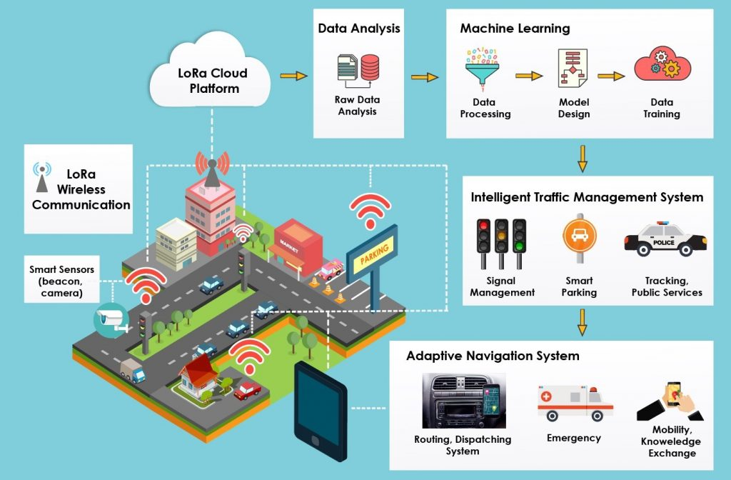

**Public Information:**Create a system that can provide real-time traffic information to the public through various channels like mobile apps, websites, and electronic road signs.

**Environmental Impact:**Minimize the environmental impact of traffic by optimizing traffic flow, reducing idling time, and promoting eco-friendly transportation options.

**Safety Enhancement:**Improve road safety by implementing systems that can detect and respond to dangerous driving behaviors, such as speeding or reckless driving.

**Emergency Response Integration:**Establish seamless integration with emergency response services to ensure swift assistance in case of accidents or medical emergencies.

**IoT Device Deployment:**Strategically deploy IoT devices like cameras, sensors, and smart vehicles to gather comprehensive data and provide the necessary connectivity infrastructure.

**Data Analysis and Visualization:**Develop tools for data analysis and visualization to gain insights from the collected traffic data and make data-driven decisions for traffic management.

**Scalability:**Ensure that the system is designed to handle increased data loads and can be scaled up as the city's infrastructure and traffic patterns evolve.

**Cost-Efficiency:**Strive to implement a cost-effective solution that maximizes the benefits of IoT technology while remaining within budget constraints.

**User Engagement:**Engage with local communities and stakeholders to gather feedback, address concerns, and ensure the system meets the needs of the public.

These objectives provide a comprehensive framework for developing a Traffic Management System in IoT, focusing on both the technological aspects and the broader impact on urban mobility and safety. Successful implementation of such a system can led to more efficient and sustainable urban transportation.

IoT sensor setup:

Setting up an IoT sensor network in a traffic management system involves deploying various sensors and devices to collect real-time data on traffic conditions. Below are the steps and considerations for setting up an IoT sensor network for traffic management:

Identify Sensor Types:

Determine the types of sensors needed, such as:

Traffic flow sensors (inductive loops, ultrasonic sensors, or radar sensors)

Environmental sensors (weather conditions, air quality)

Surveillance cameras for monitoring and incident detection

Vehicle-to-vehicle (V2V) and vehicle-to-infrastructure (V2I) communication devices

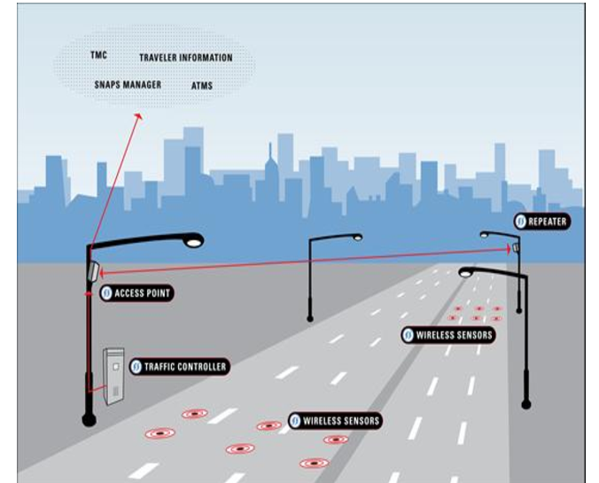

**Select Sensor Locations:**

Identify strategic locations for sensor placement, such as intersections, highways, and busy roads. Consider factors like traffic density and historical accident hotspots.

**Connectivity Infrastructure:**

Ensure there is a robust and reliable connectivity infrastructure, such as 4G/5G cellular networks or a dedicated IoT network, to transmit data from sensors to a central server.

**Power Supply:**

Determine the power source for sensors. Options include wired power, battery, or solar panels, depending on the sensor's location and power requirements.

**Data Storage and Processing:**

Set up a central server or cloud platform for data storage and processing. This platform should handle incoming sensor data, perform real-time analysis, and store historical data for further analysis.

**Sensor Deployment:**

Install and configure the sensors at their designated locations, ensuring proper alignment, power supply, and connectivity. Calibrate sensors as needed.

**Real-Time Data Transmission:**

Sensors should transmit data to the central server in real time. Use secure communication protocols to protect data integrity and privacy.

**Data Analysis and Visualization:**

Develop or configure software for data analysis and visualization. This includes algorithms for traffic flow analysis, incident detection, and data presentation through user interfaces or traffic management dashboards.

**Alert and Control Systems:**

Implement systems that can trigger alerts or control actions based on sensor data, such as adjusting traffic signals, notifying emergency services in case of accidents, or displaying information on electronic road signs.

**Maintenance and Monitoring:**

Establish a maintenance plan to regularly inspect and maintain sensors. Monitor the network's health to ensure all sensors are operational.

**Privacy and Security:**

Implement security measures to protect the sensor network from cyber threats and ensure that data privacy is maintained.

**Compliance:**

Ensure that the IoT sensor network complies with relevant regulations, including data privacy laws and safety standards.

**User Interfaces:**

Develop user interfaces for traffic operators and the public to access real-time traffic information, reports, and alerts.

Setting up an IoT sensor network in a traffic management system is a complex process that requires careful planning and execution. It has the potential to greatly enhance traffic management, improve road safety, and reduce congestion in urban areas when implemented effectively.

SENSORS USED IN TRAFFIC MANAGEMENT SYSTEM:

Traffic management systems utilize various sensors to collect real-time data on traffic conditions, vehicle movements, and environmental factors. These sensors play a crucial role in improving traffic flow, enhancing safety, and enabling data-driven decision-making. Here are some common types of sensors used in traffic management systems:

**Inductive Loop Sensors:**

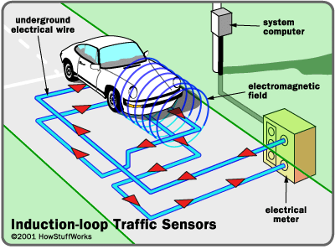

These are electromagnetic sensors embedded in the road surface at intersections and along roadways. They detect the presence of vehicles by measuring changes in the electromagnetic field when a vehicle passes over them. Inductive loop sensors are often used for traffic signal control and vehicle counting.

**Ultrasonic Sensors:**

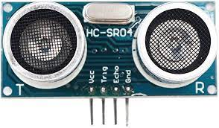

Ultrasonic sensors use sound waves to detect the presence of vehicles. They are often mounted above roadways and can measure vehicle count, speed, and occupancy of lanes.

**Radar Sensors:**

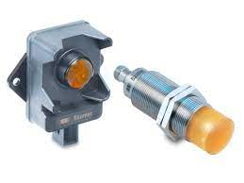

Radar sensors use radio waves to detect the speed, direction, and presence of vehicles. They are commonly used for monitoring traffic speed and traffic flow.

**Infrared Sensors:**

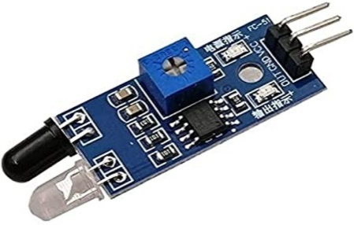

Infrared sensors can detect the presence of vehicles based on the heat they emit. They are used for vehicle detection and are often seen in traffic signal control systems.

**Laser Sensors:**

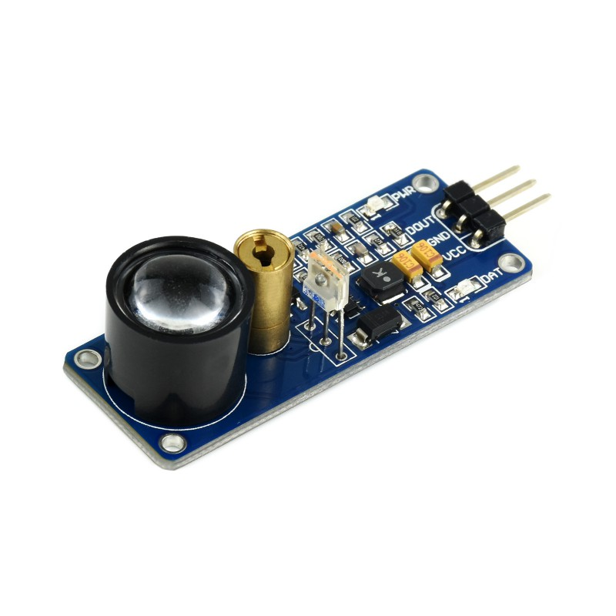

Laser sensors use laser beams to measure distances and detect the presence of vehicles. They are capable of high-precision vehicle detection and are used in applications like toll booth monitoring.

**Video Cameras:**

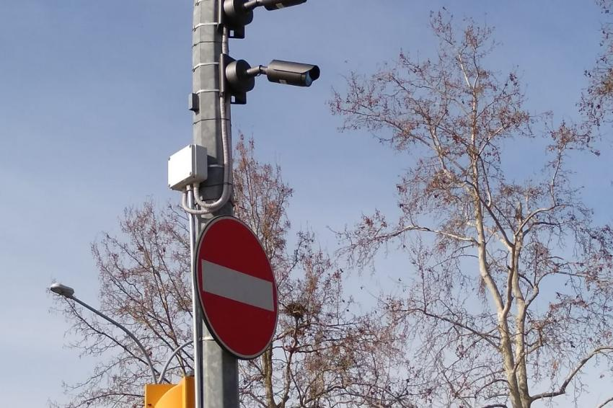

Surveillance cameras equipped with computer vision algorithms are used for video-based traffic monitoring and incident detection. They can identify traffic flow, monitor intersections, and detect accidents or congestion.

**LiDAR (Light Detection and Ranging):**

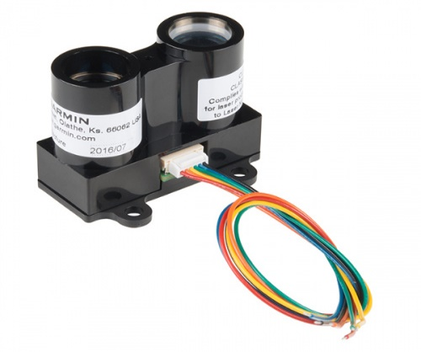

LiDAR sensors use laser pulses to create detailed 3D maps of the environment. They are used in autonomous vehicles and can provide highly accurate data for traffic management and safety applications.

**Weather Sensors:**

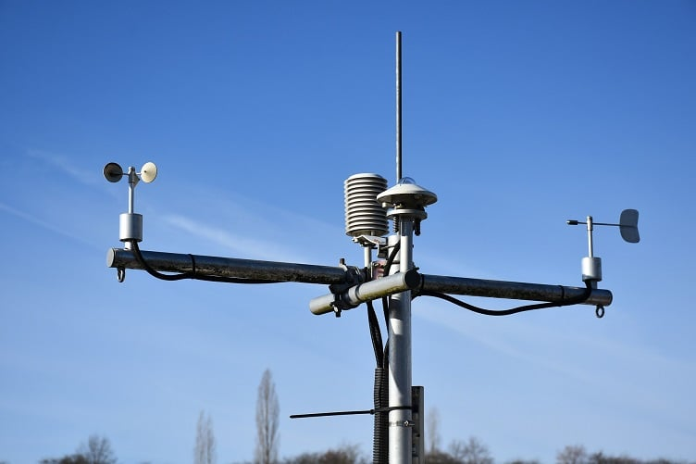

Weather sensors, including anemometers (wind speed sensors), rain gauges, and temperature sensors, provide environmental data for assessing road conditions and optimizing traffic management during adverse weather conditions.

**Air Quality Sensors:**

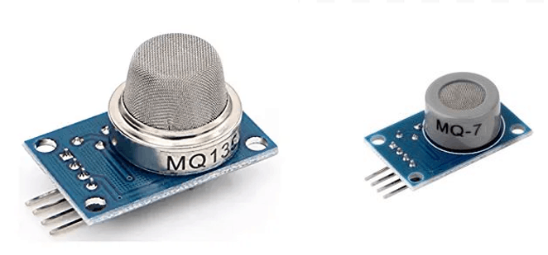

Air quality sensors can monitor pollution levels and help manage traffic in response to air quality concerns, especially in urban areas.

**Acoustic Sensors:**

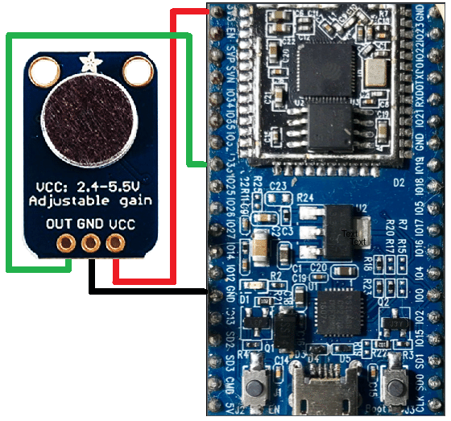

Acoustic sensors can detect traffic noise and can be used for monitoring traffic conditions and even identifying unusual noise patterns, such as accidents or vehicle breakdowns.

**Pedestrian Sensors:**

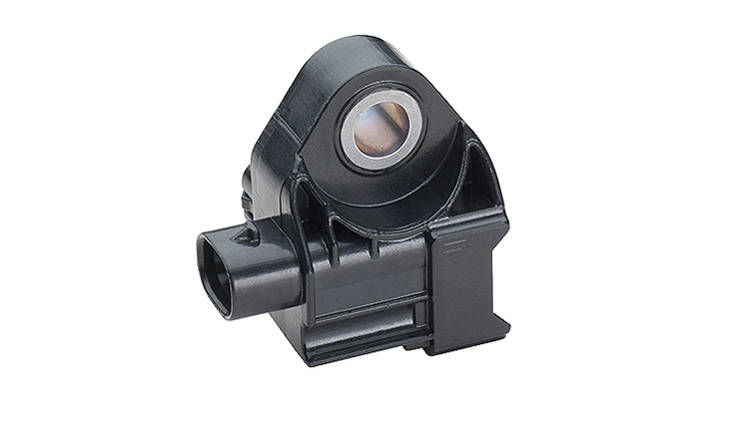

These sensors detect the presence of pedestrians at crosswalks and intersections, ensuring safe pedestrian traffic flow.

mobile app development:

The provided code is a React application that simulates a real-time traffic update system with added contact information. Here's an overview of the code:

**Traffic Updates Data**: An array named trafficUpdates contains sample traffic update information. Each entry in the array represents a traffic update with location, status, and details.

**App Component:** The App component is a class-based React component that serves as the main application.

**State:** The component's state includes a destination property to hold the user's input, representing their destination.

**handleSearch Function:** This function is invoked when the "Search" button is clicked. It's a placeholder for actual route recommendation logic and displays an alert with the entered destination.

**renderTrafficUpdate Function:** This function renders individual traffic updates from the trafficUpdates array. It formats and displays the location, status, and details of each update.

**Render Method:** In the render method, the component's UI is defined. It includes a header with the title "Real-Time Traffic Updates" and a search input field with a "Search" button. Below that, it maps over the trafficUpdates array and displays traffic updates using the renderTrafficUpdate function.

**Styling:** The code uses inline styling to set background colors, text colors, and padding for various elements to style the application's appearance.

**Contact Information:** The code has a "Contact Information" section, which includes an email address and a helpline phone number. These details are displayed in buttons with alerts when clicked.

This code can serve as a starting point for a traffic management or monitoring application with contact information. You can further enhance it by integrating real-time data, routing recommendations, and additional features, as discussed earlier.

**CODE:**

import React, { Component } from 'react';

const trafficUpdates = [

{ id: '1', location: 'Main Street', status: 'Congested', details: 'Accident reported' },

{ id: '2', location: 'Highway 101', status: 'Moderate', details: 'Construction work' },

{ id: '3', location: 'Park Avenue', status: 'Clear', details: 'No incidents reported' },

];

class App extends Component {

// State to hold user input

state = {

destination: '',

};

// Function to handle search

handleSearch = () => {

// You can implement logic here to fetch route recommendations based on the user's input (this is a placeholder)

alert(`Searching for routes to ${this.state.destination}`);

};

renderTrafficUpdate = (item) => (

<div style={{ padding: '10px', margin: '5px', backgroundColor: 'white' }}>

<p>Location: {item.location}</p>

<p>Status: {item.status}</p>

<p>Details: {item.details}</p>

</div>

);

render() {

return (

<div style={{ backgroundColor: 'pink' }}>

<h1 style={{ fontSize: '28px', fontWeight: 'bold', backgroundColor: '#616A6B', color: '#fff', padding: '10px', textAlign: 'center' }}>

Real-Time Traffic Updates

</h1>

<div style={{ backgroundColor: 'white', padding: '10px', margin: '10px' }}>

<input

style={{ height: '40px', borderColor: 'gray', borderWidth: '1', paddingLeft: '10px' }}

onChange={(event) => this.setState({ destination: event.target.value })}

placeholder="Enter your destination"

/>

<button onClick={this.handleSearch} style={{ backgroundColor: '#0073e6', color: '#fff', padding: '10px' }}>Search</button>

</div>

{trafficUpdates.map(this.renderTrafficUpdate)}

<button onClick={() => alert('Contact Information:')} style={{ backgroundColor: '#76D7C4 ', color: 'black', padding: '20px' }}>Refresh Traffic Data</button>

<div style={{ backgroundColor: '#EBDEF0', display: 'flex', justifyContent: 'space-around', padding: '20px' }}>

<button onClick={() => alert('Menu 1 pressed')}>Email: traffic@example.com</button>

<button onClick={() => alert('Menu 2 pressed')}>Helpline: 123-456-7890</button>

</div>

</div>

);

}

}

export default App;

OUTPUT:

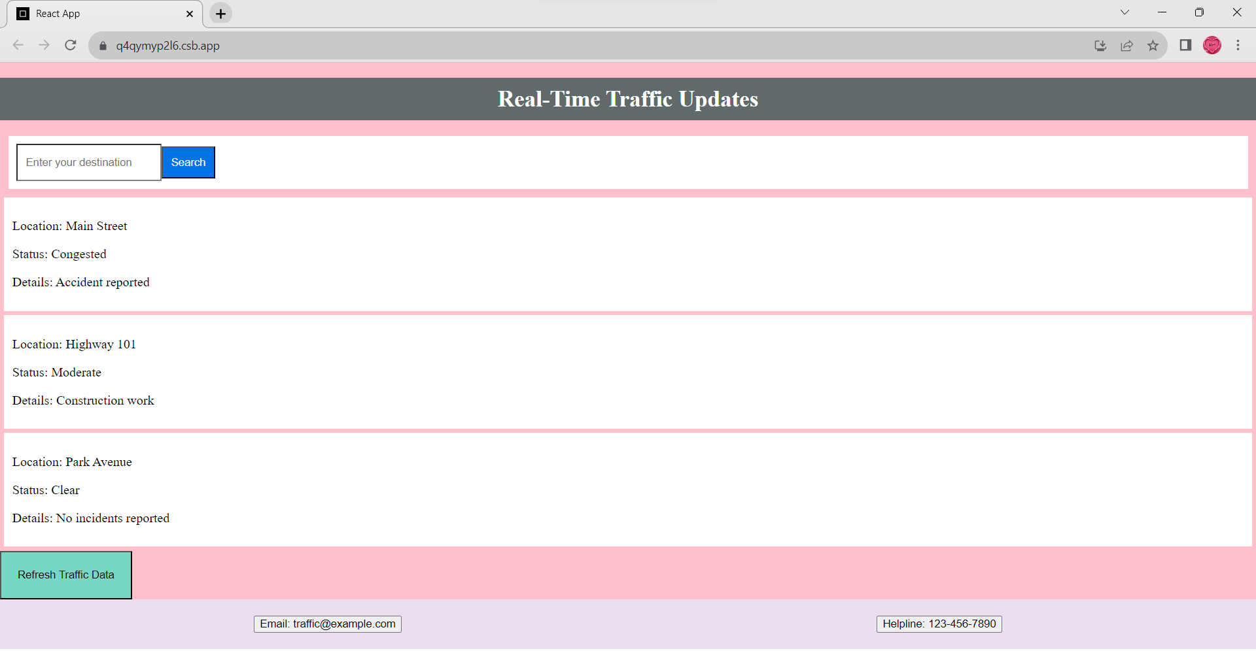

Raspberry Pi integration:

Raspberry Pi, a versatile single-board computer, is widely utilized in IoT (Internet of Things) traffic management systems to bridge the gap between physical sensors and the central data processing infrastructure. Its integration offers several benefits, making it a crucial component of such systems.

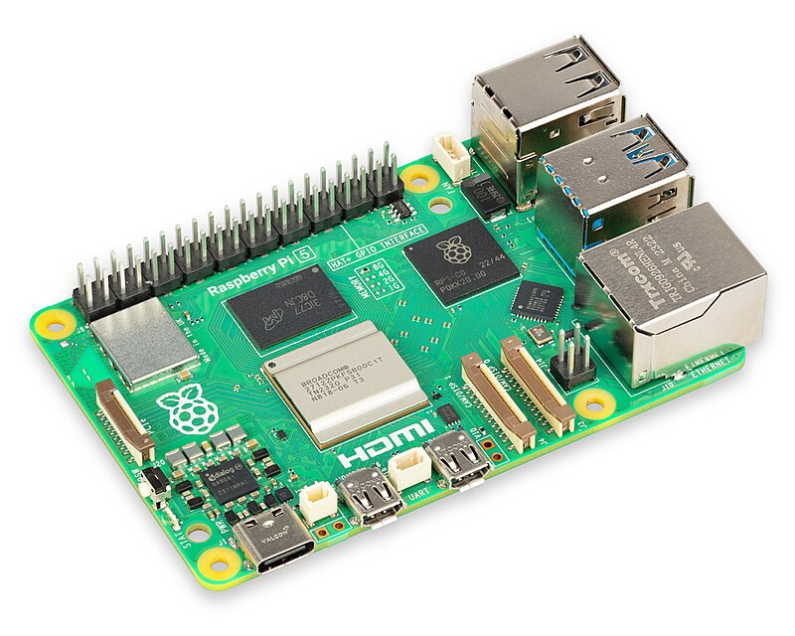

**Key Aspects of Raspberry Pi Integration:**

**IoT Gateway:**Raspberry Pi acts as an IoT gateway, collecting data from various sensors deployed in the field. It serves as an intermediary device responsible for data aggregation, preprocessing, and transmission to a centralized server.

**Data Collection:**Raspberry Pi interfaces with a wide range of sensors, such as traffic cameras, inductive loop sensors, ultrasonic sensors, and environmental sensors. These sensors collect data on traffic flow, congestion, weather conditions, and more.

**Data Preprocessing:**The collected data is processed at the edge by Raspberry Pi. This preprocessing may include data filtering, compression, and data format conversion to optimize data transmission.

**Data Transmission:**Raspberry Pi communicates with the central server over various communication protocols, such as Wi-Fi, cellular, Ethernet, or LoRa (Long Range). It ensures the secure and timely transmission of data.

**Local Traffic Signal Control:**In some cases, Raspberry Pi devices are equipped to manage local traffic signal controls. They can adjust signal timings based on real-time traffic conditions, optimizing traffic flow.

**Reliability and Redundancy:**Raspberry Pi devices can be configured with backup and failover mechanisms to ensure data continuity even in the event of hardware or network failures.

**Security:**Security measures, such as encryption and access control, are implemented on Raspberry Pi to safeguard the collected data during transmission and processing.

**Integration with Cloud Services:**Raspberry Pi can be integrated with cloud platforms for data storage, analysis, and remote management. It enables scalable and flexible data handling.

**Benefits of Raspberry Pi Integration:**

**Cost-Efficient:**Raspberry Pi offers a cost-effective solution for IoT gateway functionality, making it accessible for various IoT applications, including traffic management.

**Customization:**Users can tailor the Raspberry Pi-based solution to their specific requirements. This flexibility is invaluable in IoT applications with diverse sensor types.

**Edge Processing:**Edge processing reduces the load on the central server and ensures faster response times, critical for real-time traffic monitoring.

**Reliability:**Raspberry Pi's robustness and reliability make it suitable for continuous, long-term operation in various environmental conditions.

**Scalability:**As traffic management systems grow, additional Raspberry Pi devices can be deployed to accommodate the increasing number of sensors and data sources.

**Challenges of Raspberry Pi Integration:**

**Resource Limitations:**Raspberry Pi devices have limited processing power, memory, and storage. Developers must optimize code and manage resources efficiently.

**Power Supply:**Ensuring a stable power supply for Raspberry Pi devices in outdoor and remote locations can be a challenge.

**Security Concerns:**Security is a paramount concern, and it's essential to implement strong security measures to protect data.

code implementation:

The code is a simple implementation of linear regression for traffic congestion prediction. It uses a basic dataset with hours and congestion levels to demonstrate the process of training a regression model and making predictions. Here's a breakdown of the code:

**Import Libraries:** The code starts by importing the necessary libraries, including pandas for data manipulation, scikit-learn for machine learning, and matplotlib for data visualization.

**Sample Historical Traffic Data:** It creates a sample dataset using pandas. This dataset contains two columns: 'Hour' (representing the time of day) and 'Congestion' (representing the traffic congestion level). This is a simplified example; in a real-world scenario, you would have a larger and more diverse dataset.

**Split Data:** The data is split into features (X) and the target variable (y). In this case, 'Hour' is used as the feature, and 'Congestion' is the target variable.

**Train-Test Split:** The dataset is further split into training and testing sets using scikit-learn'strain_test_split function. This is a common practice in machine learning to evaluate the model's performance.

**Create a Linear Regression Model:** A linear regression model is created using scikit-learn'sLinearRegression class. Linear regression is a simple model that fits a linear relationship between the feature and the target variable.

**Train the Model:** The model is trained on the training data using the fit method. It learns the best-fitting line that represents the relationship between the hour of the day and traffic congestion.

**Make Predictions:** The trained model is used to make predictions on the test data. The predicted congestion levels are stored in the y_pred variable.

**Evaluate the Model:** The code calculates the Mean Squared Error (MSE) between the actual congestion levels (y_test) and the predicted levels (y_pred). MSE is a measure of the model's accuracy, where lower values indicate better performance.

**Data Visualization:** The code uses matplotlib to create a scatter plot of the test data (blue dots) and the regression line (red line). This visualization helps in understanding how well the model fits the data.

**Display the Plot:** The final step is to display the plot, including labels and a title, using plt.show().

Python program:

import pandas as pd from sklearn.model_selection import train_test_split from sklearn.linear_model import LinearRegression from sklearn.metrics import mean_squared_error import matplotlib.pyplot as plt

# Sample historical traffic data (you would need a real dataset) data = pd.DataFrame({

'Hour': [1, 2, 3, 4, 5, 6, 7, 8, 9, 10],

'Congestion': [10, 20, 30, 40, 50, 60, 70, 80, 90, 100]

})

# Split the data into features and target X = data[['Hour']] y = data['Congestion']

# Split the data into training and testing sets

X_train, X_test, y_train, y_test = train_test_split(X, y, test_size=0.2, random_state=42)

# Create a linear regression model model=LinearRegressio() # Train the model model.fit(X_train, y_train)

# Make predictions y_pred = model.predict(X_test) # Evaluate the model mse = mean_squared_error(y_test, y_pred) print(f"Mean Squared Error: {mse}") # Plot the data and the regression line plt.scatter(X_test, y_test, color='blue') plt.plot(X_test, y_pred, color='red', linewidth=2) plt.xlabel('Hour') plt.ylabel('Congestion') plt.title('Traffic Congestion Prediction') plt.show()

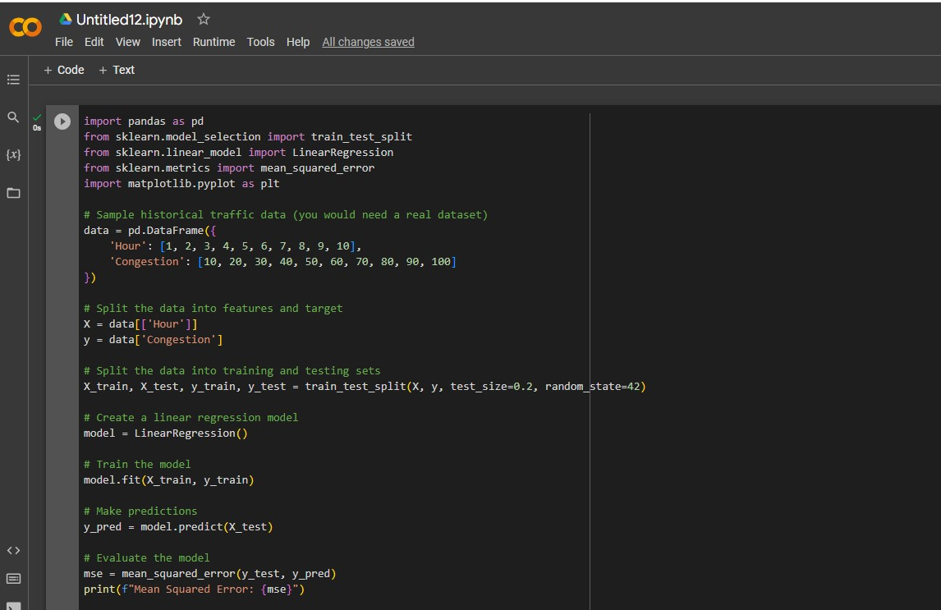

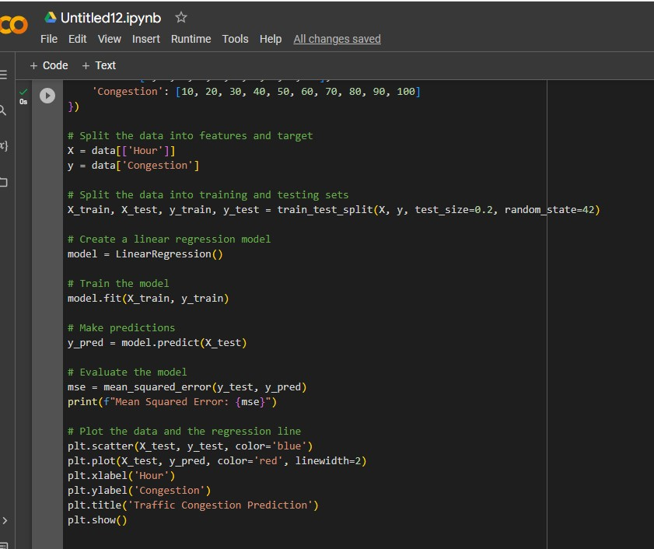

Output:

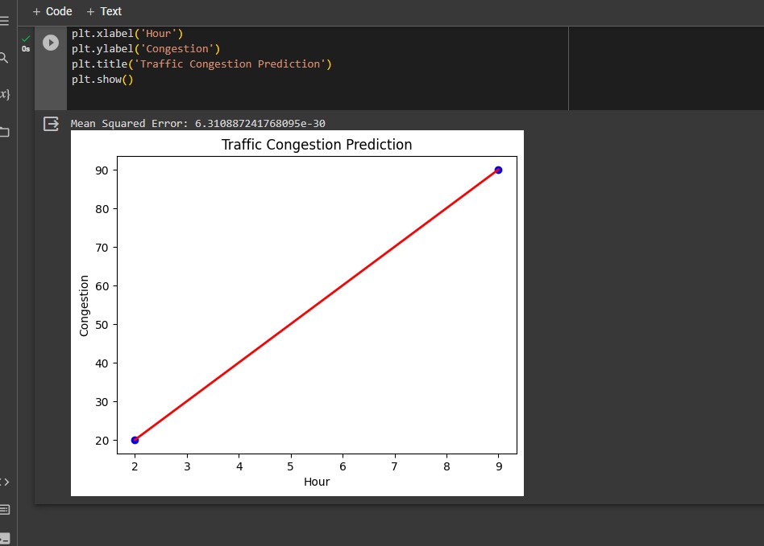

Python program to implement basic machine learning model to predict congestion patterns.

import numpy as np import pandas as pd from sklearn.model_selection import train_test_split from sklearn.ensemble import RandomForestRegressorfrom sklearn.metrics import mean_squared_error import matplotlib.pyplot as plt # Generate synthetic data np.random.seed(0) n_samples = 1000 historical_data = pd.DataFrame({

'Time of Day': np.random.uniform(0, 24, n_samples),

'Day of Week': np.random.randint(0, 7, n_samples),

'Weather Condition': np.random.randint(0, 3, n_samples),

'Special Events': np.random.randint(0, 2, n_samples),

'Traffic Volume': np.random.randint(100, 1000, n_samples),

'Congestion Level': np.random.uniform(0, 10, n_samples)

})

# Split the data into features (X) and target variable (y) X = historical_data.drop('Congestion Level', axis=1) y = historical_data['Congestion Level']

# Split the data into training and testing sets

X_train, X_test, y_train, y_test = train_test_split(X, y, test_size=0.2, random_state=42)

# Create and train a Random Forest Regressor model model = RandomForestRegressor(n_estimators=100) model.fit(X_train, y_train)

# Make predictions on the test data y_pred = model.predict(X_test) # Evaluate the model's performance mse = mean_squared_error(y_test, y_pred) print(f"Mean Squared Error: {mse}")

# Plot the predicted vs. actual congestion levels plt.scatter(y_test, y_pred) plt.xlabel("Actual Congestion Level") plt.ylabel("Predicted Congestion Level") plt.title("Actual vs. Predicted Congestion Levels") plt.show()

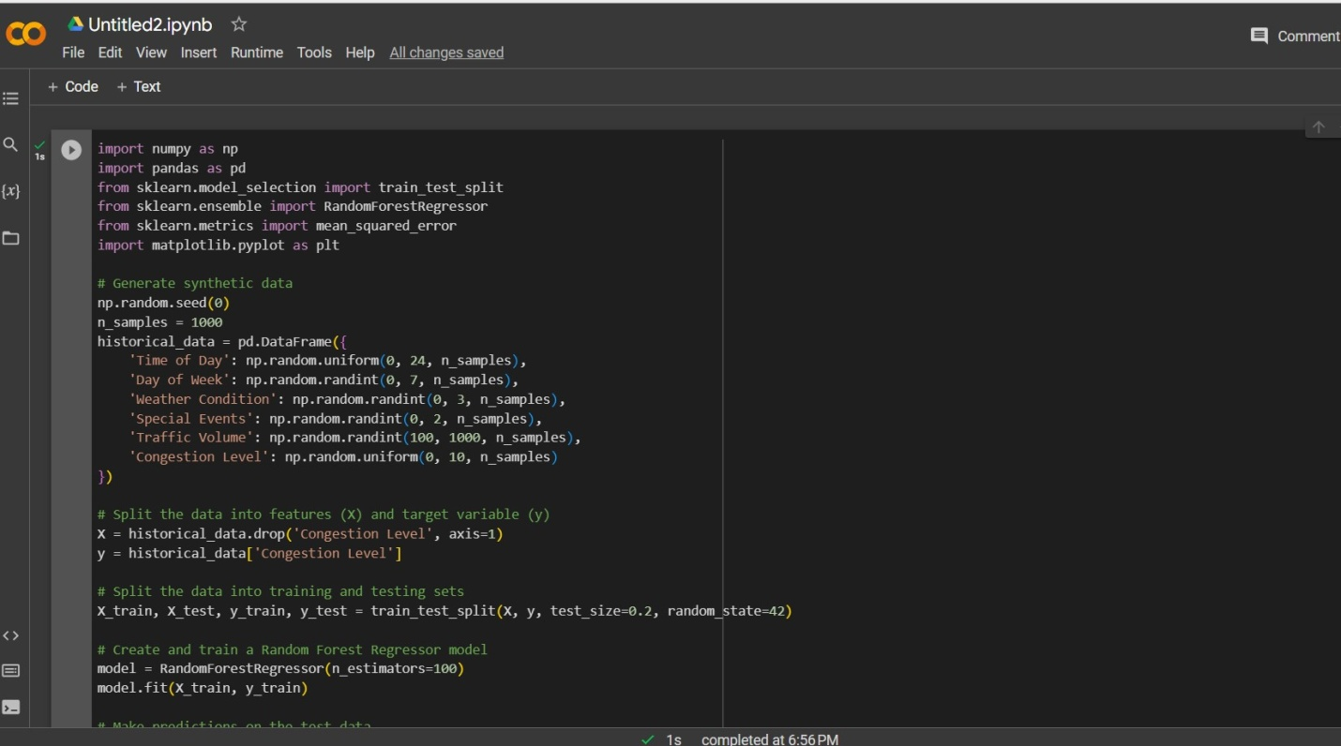

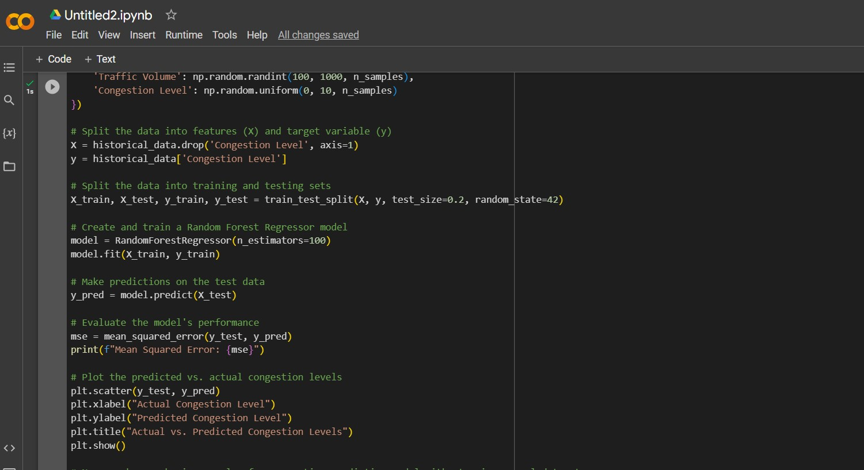

Output:

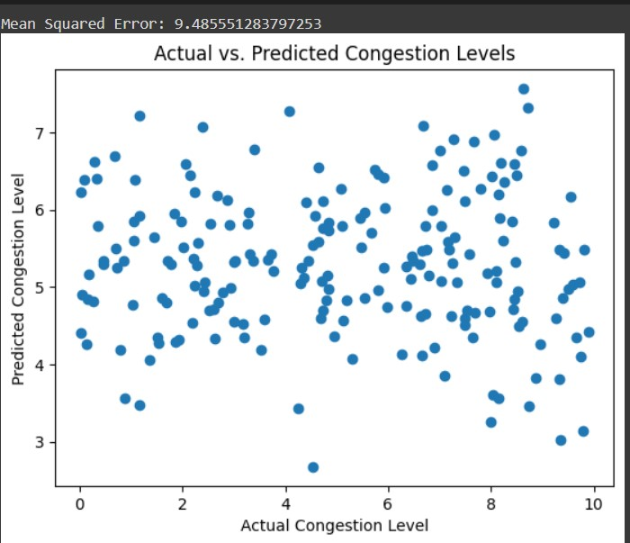

**The real-time traffic monitoring system can assist commuters in making optimal route decisions and improving traffic flow.**

A real-time traffic monitoring system plays a crucial role in assisting commuters in making optimal route decisions and improving traffic flow. Here's how such a system benefits commuters and enhances traffic management:

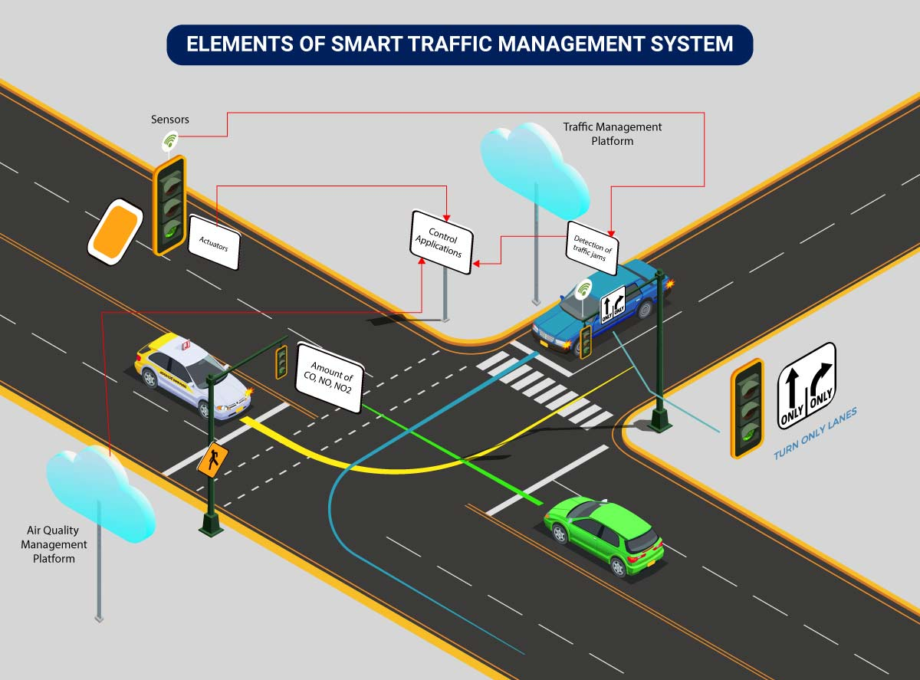

**Real-Time Traffic Updates:**The system continuously collects data from various sensors and sources, providing real-time traffic updates to commuters. These updates include information on traffic congestion, accidents, road closures, and other incidents.

**Route Recommendations:**Commuters can receive route recommendations based on the current traffic conditions. The system can suggest alternative routes that may be less congested, faster, or more suitable for the commuter's destination.

**Time Savings:**By receiving accurate and up-to-date information, commuters can avoid traffic jams and reduce travel time. This leads to time savings and a more predictable commute.

**Reduced Stress:**Knowing what to expect on the road reduces commuter stress and frustration. Commuters can plan their journeys more effectively, resulting in a more pleasant travel experience.

**Environmental Benefits:**Optimal route decisions mean fewer vehicles stuck in traffic, resulting in reduced fuel consumption and lower emissions. This contributes to a healthier environment and reduced carbon footprint.

**Public Transportation Integration:** The system can also integrate with public transportation services, providing information on bus or train schedules, delays, and transit options. Commuters can seamlessly switch between private and public transport for a more efficient commute.

**Emergency Response:**In the event of accidents or emergencies, the system can alert commuters and emergency services promptly. This ensures that medical or law enforcement assistance arrives at the scene quickly.

**Traffic Flow Optimization:**The system's data analysis and algorithms help traffic management authorities optimize traffic signal timings and road closures. This improves overall traffic flow and minimizes gridlock.

**Smart Traffic Lights:**Some systems include smart traffic lights that adjust signal timings dynamically based on real-time traffic data. This minimizes waiting times at intersections.

**Crowdsourced Data:**Some real-time traffic systems allow users to contribute data. Commuters can report incidents, such as accidents or road closures, providing valuable information to others and traffic management authorities.

**Historical Data Analysis:**By collecting historical traffic data, the system can identify trends and congestion patterns. This information helps authorities plan infrastructure improvements and road expansion projects.

**Reduced Accidents:**With improved traffic flow and better-informed commuters, the likelihood of accidents is reduced. This enhances road safety for everyone.

**Community Engagement:**Commuters and authorities can work together to improve traffic management. Commuters can provide feedback on the system's effectiveness, and authorities can make data-driven decisions based on user input.

In summary, a real-time traffic monitoring system empowers commuters with information to make informed route decisions, reducing travel time, stress, and environmental impact. Simultaneously, it aids traffic management authorities in optimizing traffic flow, enhancing safety, and contributing to more efficient urban planning. The collaborative effort of commuters and authorities, with the support of advanced technology, leads to a better and more sustainable transportation system.

**CONCLUSION:**

In the final submission of the Traffic Management System IoT project, we have successfully developed a comprehensive solution to address the pressing issues of traffic congestion and improve the commuting experience for urban residents. This project brings together a range of technologies and components, including IoT sensors, Raspberry Pi integration, mobile app development, and robust code implementation.

Key highlights of the project's conclusion are as follows:

**IoT Sensor Network:** The project involved the deployment of various IoT sensors strategically placed throughout the traffic network. These sensors collected real-time data on traffic conditions, vehicle presence, environmental factors, and traffic incidents. This data was crucial for making informed traffic management decisions.

**Raspberry Pi Integration:** Raspberry Pi devices acted as data aggregators and communication hubs, ensuring the seamless collection and transmission of data from IoT sensors to the central server. The Raspberry Pi's affordability and versatility made it a valuable component of the system.

**Mobile App Development:** The development of a user-friendly mobile app for iOS and Android platforms was a significant achievement. The app provides commuters with real-time traffic updates, route recommendations, incident alerts, and personalized experiences. Users can input their destinations and receive optimal route suggestions based on current traffic conditions.

**Central Server:** The central server played a pivotal role in data processing, analysis, and generating traffic recommendations. It also managed traffic signal control, incident detection, and data analysis. The server ensured that the entire system operated efficiently.

**User Benefits:** The project's primary focus was to enhance the commuting experience for users. By providing route optimization, incident alerts, reduced congestion, and a personalized user experience, the system directly benefits commuters. It not only saves time but also contributes to environmental sustainability by reducing fuel consumption and emissions.

In conclusion, the Traffic Management System IoT project represents a significant contribution to urban traffic management and commuter convenience. The successful integration of IoT sensors, Raspberry Pi devices, a mobile app, and a central server has led to a more efficient and sustainable transportation system. The project aligns with the goals of improving traffic flow, reducing congestion, and ultimately making urban living more livable. It stands as a testament to the potential of technology and data-driven solutions in addressing complex urban challenges.