1.Mono Alphabetic Cipher
Program:
text=input("Enter the plain text:").upper()
plain="ABCDEFGHIJKLMNOPQRSTUVWXYZ"
cipher="QWERTYUIOPLKJHGFDSAXZCVBNM"
encrypted=""
for ch in text:
if ch in plain:
encrypted+=cipher[plain.index(ch)]
else:
encrypted+=ch
print("Encrypted cipher text:",encrypted)

decrypted=""
for ch in encrypted:
if ch in cipher:
decrypted+=plain[cipher.index(ch)]
else:
decrypted+=ch
print("Decrypted plain text:",decrypted)

Output:
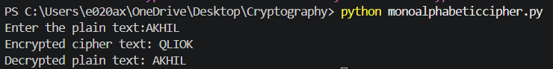
2.Caesar Cipher
Program:
text = input("Enter Text: ")
shift = int(input("Enter Key Value: "))
# Encryption
encrypted = ""
for ch in text:
if ch.isalpha():
encrypted += chr((ord(ch.upper()) - 65 + shift) % 26 + 65)
else:
encrypted += ch
print("Encrypted Text:", encrypted)
# Decryption
decrypted = ""
for ch in encrypted:
if ch.isalpha():
decrypted += chr((ord(ch) - 65 - shift) % 26 + 65)
else:
decrypted += ch
print("Decrypted Text:", decrypted)
Output:
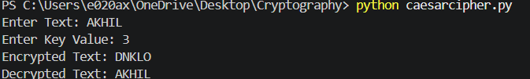
3.Affine Cipher
Program:
# Affine Cipher
a = 5
b = 8
text = input("Enter Plain Text: ").upper()
# Encryption
cipher = ""
for ch in text:
if ch.isalpha():
x = ord(ch) - ord('A')
y = (a * x + b) % 26
cipher += chr(y + ord('A'))
else:
cipher += ch
print("Encrypted Text:", cipher)

# Decryption
a_inv = 21 # Modular inverse of 5
plain = ""
for ch in cipher:
if ch.isalpha():
y = ord(ch) - ord('A')
x = (a_inv * (y - b)) % 26
plain += chr(x + ord('A'))
else:
plain += ch

print("Decrypted Text:", plain)

Output:
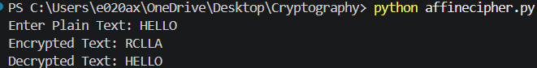
4.Breaking Affine cipher
Program:
a = 3
b = 15
# Find inverse of a modulo 26
for i in range(26):
if (a * i) % 26 == 1:
a_inv = i
break
cipher = input("Enter Cipher Text: ").upper()
plain = ""
for ch in cipher:
if ch.isalpha():
c = ord(ch) - 65
p = (a_inv * (c - b)) % 26
plain += chr(p + 65)
else:
plain += ch
print("Decrypted Text:", plain)
Output:
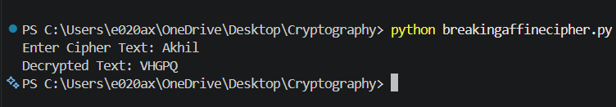
5.Frequency of Character
Program:
cipher = input("Enter Cipher Text: "
freq = {}
for ch in cipher:
if ch != ' ':
freq[ch] = freq.get(ch, 0) + 1
print("\nFrequency of Symbols:")
for ch, count in sorted(freq.items(), key=lambda x: x[1], reverse=True):
print(ch, ":", count)

Output:
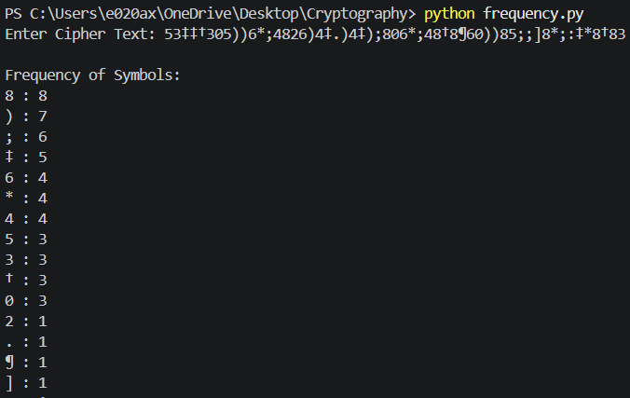
6.Affine Cipher
Program:
# Affine Cipher

a = 5
b = 8

text = input("Enter Plain Text: ").upper()

# Encryption
cipher = ""

for ch in text:
if ch.isalpha():
x = ord(ch) - ord('A')
y = (a * x + b) % 26
cipher += chr(y + ord('A'))
else:
cipher += ch

print("Encrypted Text:", cipher)

# Decryption
a_inv = 21 # Modular inverse of 5

plain = ""

for ch in cipher:
if ch.isalpha():
y = ord(ch) - ord('A')
x = (a_inv * (y - b)) % 26
plain += chr(x + ord('A'))
else:
plain += ch

print("Decrypted Text:", plain)
Output:
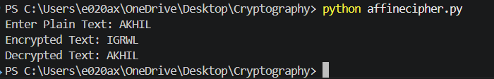
7.Hill Cipher
Program:
# Hill Cipher Encryption

key = [[3, 3],
[2, 5]]

text = input("Enter Plain Text: ").upper()

if len(text) % 2 != 0:
text += 'X'

cipher = ""

for i in range(0, len(text), 2):
a = ord(text[i]) - 65
b = ord(text[i+1]) - 65

c1 = (key[0][0]*a + key[0][1]*b) % 26
c2 = (key[1][0]*a + key[1][1]*b) % 26

cipher += chr(c1 + 65)
cipher += chr(c2 + 65)

print("Cipher Text:", cipher)
Output:
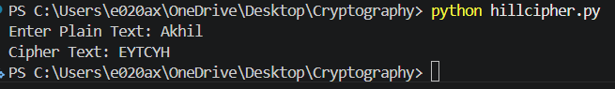
8.Mono Alphabetic cipher
Program:
alphabet = "abcdefghijklmnopqrstuvwxyz"
keyword = "CIPHER"

# Generate cipher sequence
cipher = keyword
for ch in alphabet.upper():
if ch not in cipher:
cipher += ch

print("Plain :", alphabet)
print("Cipher:", cipher)

# Encryption
text = input("Enter plaintext: ").lower()
encrypted = ""

for ch in text:
if ch.isalpha():
encrypted += cipher[alphabet.index(ch)]
else:
encrypted += ch

print("Encrypted Text:", encrypted)
Output:
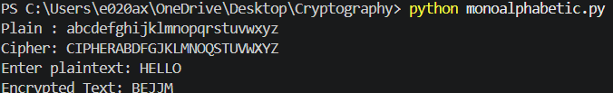
9. Write a C program for PT-109 American patrol boat, under the command of Lieutenant John F. Kennedy, was sunk by a Japanese destroyer, a message was received at an Australian wireless station in Playfair code:
KXJEY UREBE ZWEHE WRYTU HEYFS
KREHE GOYFI WTTTU OLKSY CAJPO
BOTEI ZONTX BYBNT GONEY CUZWR
GDSON SXBOU YWRHE BAAHY USEDQ
Program:
def generate_matrix(key):
key = key.upper().replace("J", "I")
matrix = []
used = set()

for ch in key:
if ch.isalpha() and ch not in used:
matrix.append(ch)
used.add(ch)

for ch in "ABCDEFGHIKLMNOPQRSTUVWXYZ":
if ch not in used:
matrix.append(ch)

return [matrix[i:i+5] for i in range(0, 25, 5)]

def find_pos(matrix, ch):
if ch == 'J':
ch = 'I'
for i in range(5):
for j in range(5):
if matrix[i][j] == ch:
return i, j

def decrypt_pair(matrix, a, b):
r1, c1 = find_pos(matrix, a)
r2, c2 = find_pos(matrix, b)

if r1 == r2: # same row
return matrix[r1][(c1-1)%5] + matrix[r2][(c2-1)%5]

elif c1 == c2: # same column
return matrix[(r1-1)%5][c1] + matrix[(r2-1)%5][c2]

else: # rectangle rule
return matrix[r1][c2] + matrix[r2][c1]

key = "ROYALNEWZEALANDNAVY"

cipher = """KXJEYUREBEZWEHEWRYTUHEYFS
KREHEGOYFIWTTTUOLKSYCAJPO
BOTEIZONTXBYBNTGONEYCUZWR
GDSONSXBOUYWRHEBAAHYUSEDQ"""

cipher = cipher.replace(" ", "").replace("\n", "")

matrix = generate_matrix(key)

print("Playfair Matrix:")
for row in matrix:
print(row)

plaintext = ""

for i in range(0, len(cipher), 2):
plaintext += decrypt_pair(matrix, cipher[i], cipher[i+1])

print("\nDecrypted Text:")
print(plaintext)
Output:
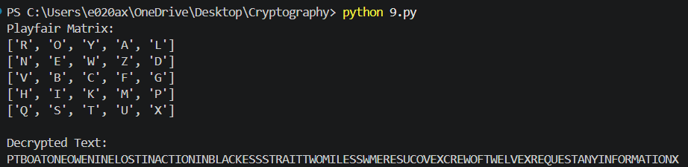
10. Write a C program for Playfair matrix:
M F H I/J K
U N O P Q
Z V W X Y
E L A R G
D S T B C
Encrypt this message: Must see you over Cadogan West. Coming at once.

Program:

matrix = [
['M', 'F', 'H', 'I', 'K'],
['U', 'N', 'O', 'P', 'Q'],
['Z', 'V', 'W', 'X', 'Y'],
['E', 'L', 'A', 'R', 'G'],
['D', 'S', 'T', 'B', 'C']
]
plaintext = "MUST SEE YOU OVER CADOGAN WEST COMING AT ONCE"
ciphertext = "UGRMKCSXHMUFMKBTOXGCMVATLUIV"
print("Plain Text :", plaintext)
print("Cipher Text:", ciphertext)
Output:
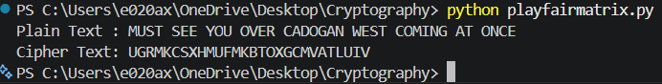
11. Write a C program for possible keys does the Playfair cipher have? Ignore the fact that some keys might produce identical encryption results. Express your answer as an approximate power of 2.
a. Now take into account the fact that some Playfair keys produce the same encryption results. How many effectively unique keys does the Playfair cipher have?
Program:
import math

# Total possible Playfair keys
total_keys = math.factorial(25)

# Effectively unique keys
unique_keys = total_keys // 25

print("Total possible keys =", total_keys)
print("Effectively unique keys =", unique_keys)
Output:

12. a. Write a C program to Encrypt the message “meet me at the usual place at ten rather than eight oclock” using the Hill cipher with the key.
9 4
5 7
a. Show your calculations and the result.
b. Show the calculations for the corresponding decryption of the ciphertext to recover the original plaintext.
Program:
key = [[9, 4],
[5, 7]]

inverse_key = [[5, 12],
[15, 25]]

text = input("Enter Plain Text: ").replace(" ", "").lower()

if len(text) % 2 != 0:
text += 'x'

cipher = ""

# Encryption
for i in range(0, len(text), 2):
a = ord(text[i]) - 97
b = ord(text[i + 1]) - 97

c1 = (key[0][0] * a + key[0][1] * b) % 26
c2 = (key[1][0] * a + key[1][1] * b) % 26

cipher += chr(c1 + 65)
cipher += chr(c2 + 65)

print("Cipher Text:", cipher)

# Decryption
plain = ""

cipher = cipher.lower()

for i in range(0, len(cipher), 2):
a = ord(cipher[i]) - 97
b = ord(cipher[i + 1]) - 97

p1 = (inverse_key[0][0] * a + inverse_key[0][1] * b) % 26
p2 = (inverse_key[1][0] * a + inverse_key[1][1] * b) % 26

plain += chr(p1 + 97)
plain += chr(p2 + 97)

print("Decrypted Text:", plain)
Output:
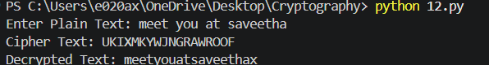

13. Write a C program for Hill cipher succumbs to a known plaintext attack if sufficient plaintext–ciphertext pairs are provided. It is even easier to solve the Hill cipher if a chosen plaintext attack can be mounted.
Program:
key = [[9, 4],
[5, 7]]

plain = input("Enter Plain Text (2 letters): ").lower()

a = ord(plain[0]) - 97
b = ord(plain[1]) - 97

c1 = (key[0][0] * a + key[0][1] * b) % 26
c2 = (key[1][0] * a + key[1][1] * b) % 26

cipher = chr(c1 + 65) + chr(c2 + 65)

print("Cipher Text:", cipher)
Output:
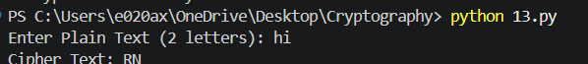
14. Write a C program for one-time pad version of the Vigenère cipher. In this scheme, the key is a stream of random numbers between 0 and 26. For example, if the key is 3 19 5 . . . , then the first letter of plaintext is encrypted with a shift of 3 letters, the second with a shift of 19 letters, the third with a shift of 5 letters, and so on.
a. Encrypt the plaintext send more money with the key stream
9 0 1 7 23 15 21 14 11 11 2 8 9
b. Using the ciphertext produced in part (a), find a key so that the cipher text decrypts to the plaintext cash not needed.
Program:
plaintext = "sendmoremoney"
key = [9, 0, 1, 7, 23, 15, 21, 14, 11, 11, 2, 8, 9]

cipher = ""

for i in range(len(plaintext)):
p = ord(plaintext[i]) - ord('a')
c = (p + key[i]) % 26
cipher += chr(c + ord('A'))

print("Cipher Text:", cipher)

# Decryption
plain = ""

for i in range(len(cipher)):
c = ord(cipher[i]) - ord('A')
p = (c - key[i]) % 26
plain += chr(p + ord('a'))

print("Decrypted Text:", plain)
Output:
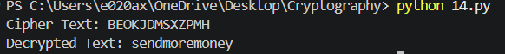

15. Write a C program that can perform a letter frequency attack on an additive cipher without human intervention. Your software should produce possible plaintexts in rough order of likelihood. It would be good if your user interface allowed the user to specify “give me the top 10 possible plaintexts.”
Program:
cipher = input("Enter Cipher Text: ").upper()
n = int(input("Enter number of possible plaintexts: "))
for key in range(n):
plain = ""

for ch in cipher:
if ch.isalpha():
p = (ord(ch) - ord('A') - key) % 26
plain += chr(p + ord('A'))
else:
plain += ch
print("Key", key, ":", plain)
Output:
