- Secure CI/CD Authentication Using GitHub Actions OIDC and AWS IAM Identity Provider

Architecture

GitHub Repository
│
▼
GitHub Actions Workflow
│
▼
GitHub OIDC Token
│
▼
AWS IAM OIDC Identity Provider
│
▼
IAM Role (Trust Policy)
│
▼
Temporary AWS Credentials (STS)
│
▼
Deploy Resources
(ECR, ECS, EKS, S3, EC2, Lambda...)

What is OpenID Connect (OIDC)?
OpenID Connect (OIDC) is an identity authentication protocol built on top of the OAuth 2.0 framework. It allows applications and services to verify a user's identity without requiring them to store or manage long-term credentials.
In the context of GitHub Actions and AWS, OIDC enables GitHub to securely authenticate with AWS by exchanging a short-lived identity token for temporary AWS credentials. This eliminates the need to store AWS Access Keys in GitHub Secrets.

Why Use OIDC?
Traditionally, GitHub Actions accessed AWS using long-term credentials stored as GitHub Secrets.
Traditional Authentication
GitHub Actions
│
▼
AWS Access Key ID
AWS Secret Access Key
│
▼
Stored in GitHub Secrets
│
▼
AWS
Limitations
- Long-term credentials must be securely managed.
- Secrets can be accidentally exposed.
- Manual key rotation is required.
- Higher security risk if credentials are compromised.

Prerequisites
- AWS Account
- GitHub Repository
- Administrator access to AWS IAM
- GitHub Actions enabled
- AWS CLI installed (optional)

Step 1: Create an OIDC Identity Provider in AWS
1. Login to AWS Console.
2. Navigate to:
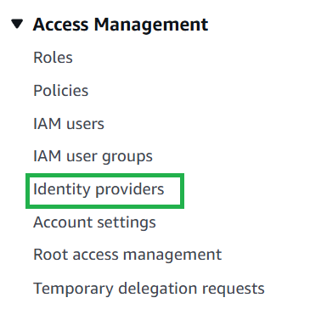
- Click on Add Provider
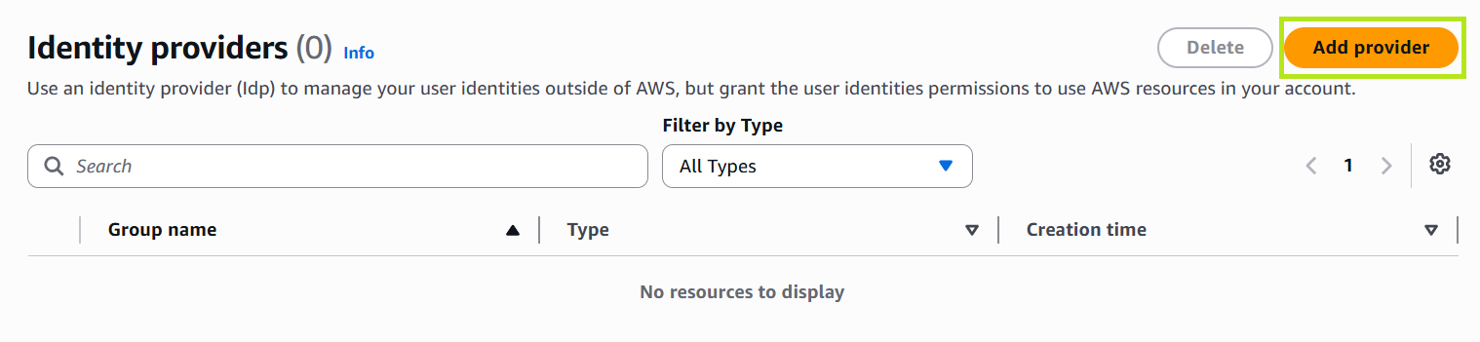

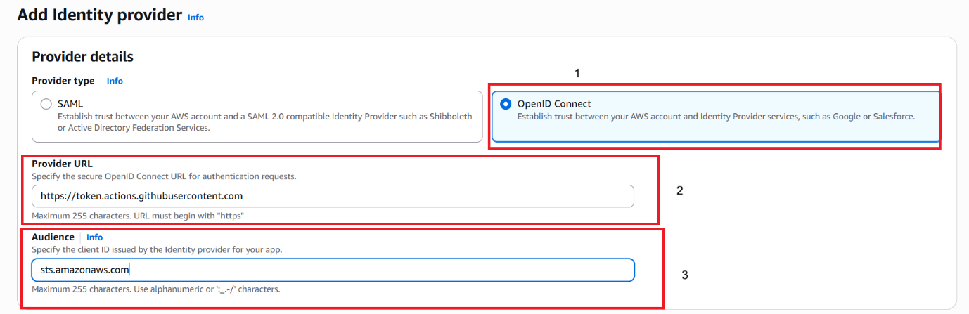

Step 2: Create an IAM Role
Navigate to
IAM
↓
Roles
↓
Create Role

Choose
Web Identity :-
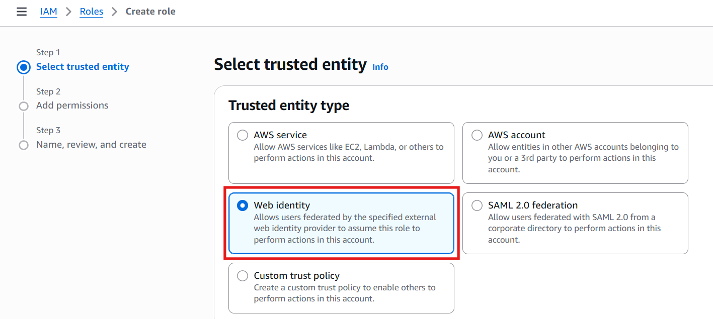

- Select to token.actions
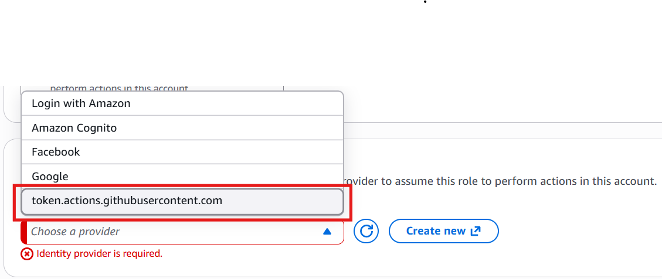
Example :-
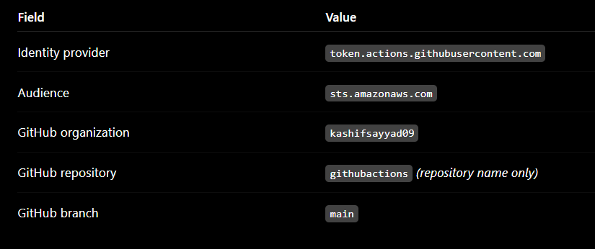
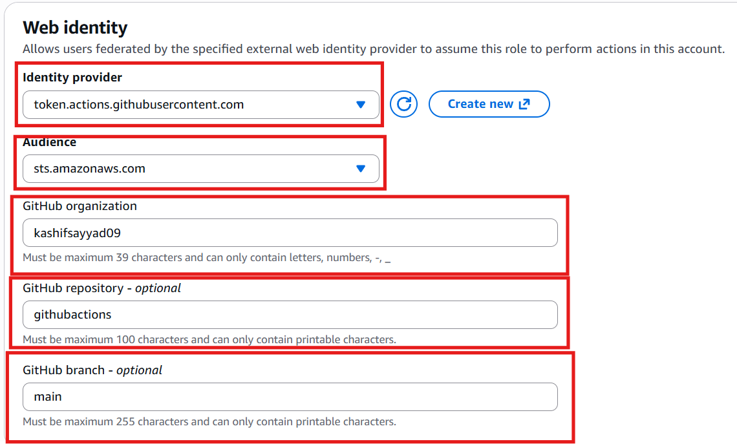

- Attach Policy Admin Access otherwise create own policy and attach it.

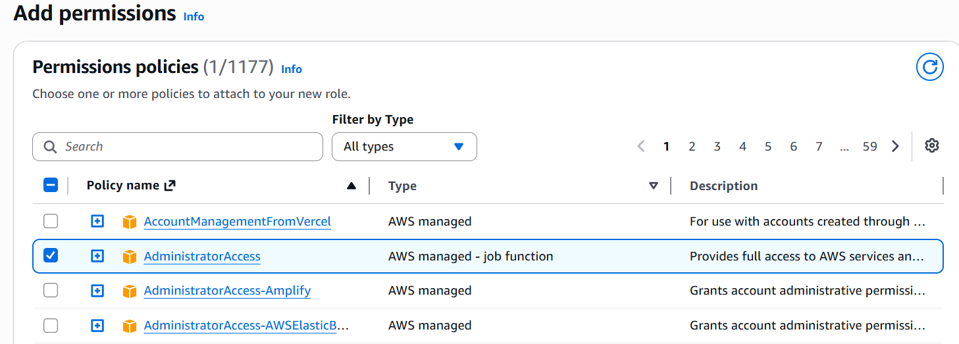

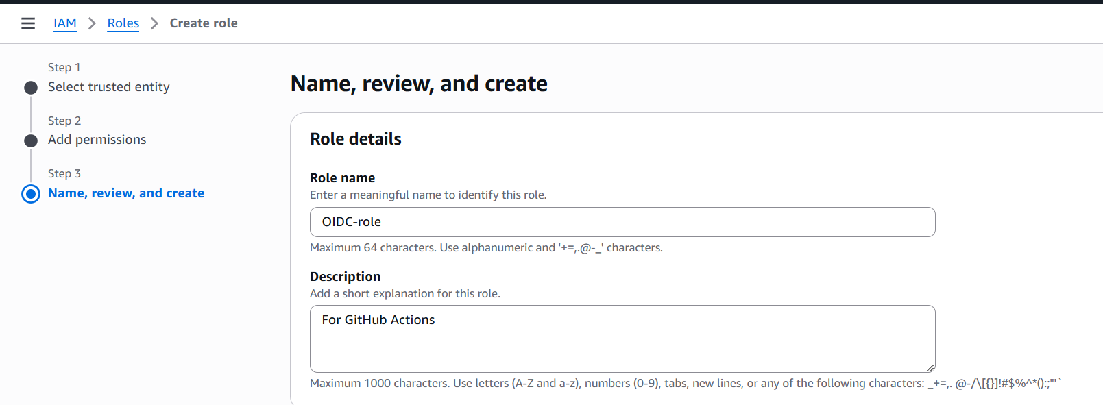

Change Trust Relation Policy
Go to Settings of repo click on Action OIDC Use Claim prefix

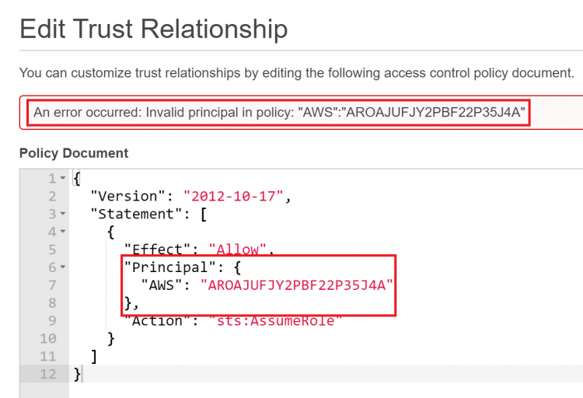

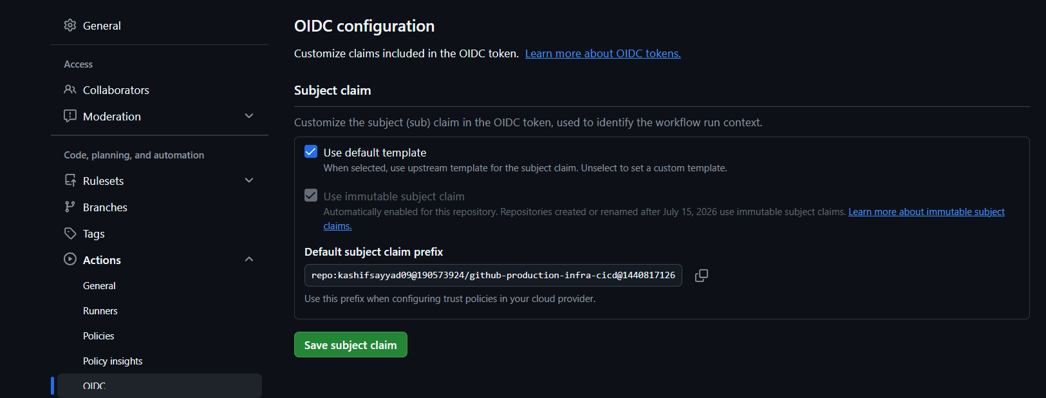

Use this trusted relation Policy

{
"Version": "2012-10-17",
"Statement": [
{
"Effect": "Allow",
"Principal": {
"Federated": "arn:aws:iam::253405560946:oidc-provider/token.actions.githubusercontent.com"
},
"Action": "sts:AssumeRoleWithWebIdentity",
"Condition": {
"StringEquals": {
"token.actions.githubusercontent.com:aud": "sts.amazonaws.com",
"token.actions.githubusercontent.com:sub": [
"repo:kashifsayyad09@190573924/github-production-infra-cicd@1440817126:ref:refs/heads/main",
"repo:kashifsayyad09@190573924/github-production-infra-cicd@1440817126:environment:production"
]
}
}
}
]
}

After creating the role, the next steps are:
- Attach the required IAM permissions (for example, ECR, EKS, S3, EC2, etc.).
- Copy the Role ARN.

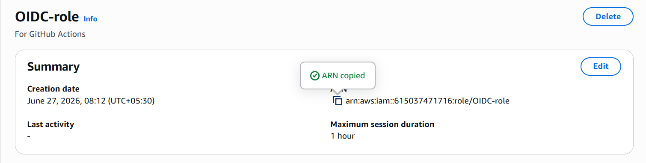

- Github Actions
yaml file path



3. final Configure your GitHub Actions workflow with:

name: Terraform Deployment

on:
push:
branches:
- main

# Required for GitHub OIDC
permissions:
id-token: write
contents: read

jobs:
deploy:
runs-on: ubuntu-latest

steps:
- name: Checkout Code
uses: actions/checkout@v4

- name: Configure AWS Credentials
uses: aws-actions/configure-aws-credentials@v4
with:
role-to-assume: arn:aws:iam::615037471716:role/OIDC-role
aws-region: us-east-1

