SRM INSTITUTE OF SCIENCE AND TECHNOLOGY
Tiruchirappalli

COMPUTER NETWORKS LABORATORY
LAB REPORT
Experiment 3 and Experiment 4

Field | Details
Name | VENKAT ROSHAN K M
Reg. No. | RA2411030050027
Class / Section | BTECH CSE CYBERSECURITY- A
Date of Experiment | 23/10/26
Software Used | Cisco Packet Tracer

Contents
Lab | Title
Lab 3 | Router Configuration (Passwords and Interfaces)
Lab 4 | IP Addressing and Subnetting using VLSM

Experiment 3: Router Configuration (Passwords and Interfaces)

1. Aim
To protect router access with console, privileged-mode and VTY passwords, configure two router interfaces with IPv4 addresses, and check communication between two separate networks using ping.

Objectives
- Practice moving between Cisco IOS command-line configuration modes.
- Set passwords for console access, privileged EXEC access and remote VTY sessions.
- Assign IPv4 addresses to router interfaces and activate the interfaces.
- Verify that the router and connected network respond to ping tests.

2. Introduction
A router connects different IP networks and forwards packets between them. In this experiment, one router links the 192.168.1.0/24 network with the 192.168.2.0/24 network. Passwords are configured to limit access to the device, while interface addresses act as the default gateways for the connected PCs.

3. Topology and IP Addressing
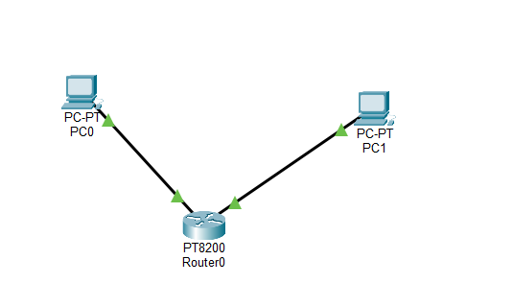
Figure 1. Topology illustration for the router configuration experiment.
Device | Interface | IPv4 address | Default gateway
Router1 | G0/0/0 | 192.168.1.1/24 | —
Router1 | G0/0/1 | 192.168.2.1/24 | —
PC0 | FastEthernet0 | 192.168.1.2/24 | 192.168.1.1
PC1 | FastEthernet0 | 192.168.2.2/24 | 192.168.2.1

4. Procedure
- Open Cisco Packet Tracer and place one router and two PCs on the logical workspace.
- Connect each PC to a separate router Ethernet interface using copper straight-through cables.
- Open the router CLI and enter privileged EXEC mode with enable, then enter global configuration mode.
- Configure console, enable and VTY passwords. Use login under the console and VTY line settings so the lines request a password.
- Assign 192.168.1.1/24 to GigabitEthernet0/0/0 and 192.168.2.1/24 to GigabitEthernet0/0/1. Enter no shutdown on both interfaces.
- Configure PC0 as 192.168.1.2/24 with gateway 192.168.1.1. Configure PC1 as 192.168.2.2/24 with gateway 192.168.2.1.
- Use show ip interface brief to inspect interface status, then ping the remote PC and the router interface from a PC.

5. Router Commands
Router> enable
Router# configure terminal
Router(config)# line console 0
Router(config-line)# password cisco
Router(config-line)# login
Router(config-line)# exit
Router(config)# enable password cisco
Router(config)# line vty 0 4
Router(config-line)# password cisco
Router(config-line)# login
Router(config-line)# exit
Router(config)# interface gigabitEthernet 0/0/0
Router(config-if)# ip address 192.168.1.1 255.255.255.0
Router(config-if)# no shutdown
Router(config-if)# exit
Router(config)# interface gigabitEthernet 0/0/1
Router(config-if)# ip address 192.168.2.1 255.255.255.0
Router(config-if)# no shutdown
Router(config-if)# end
Router# show ip interface brief

6. Screenshots
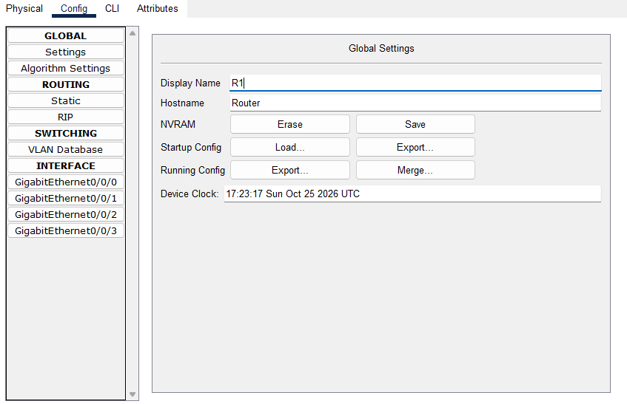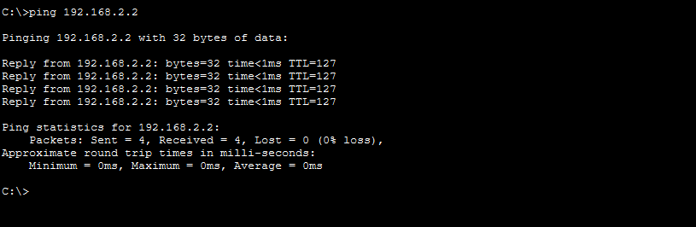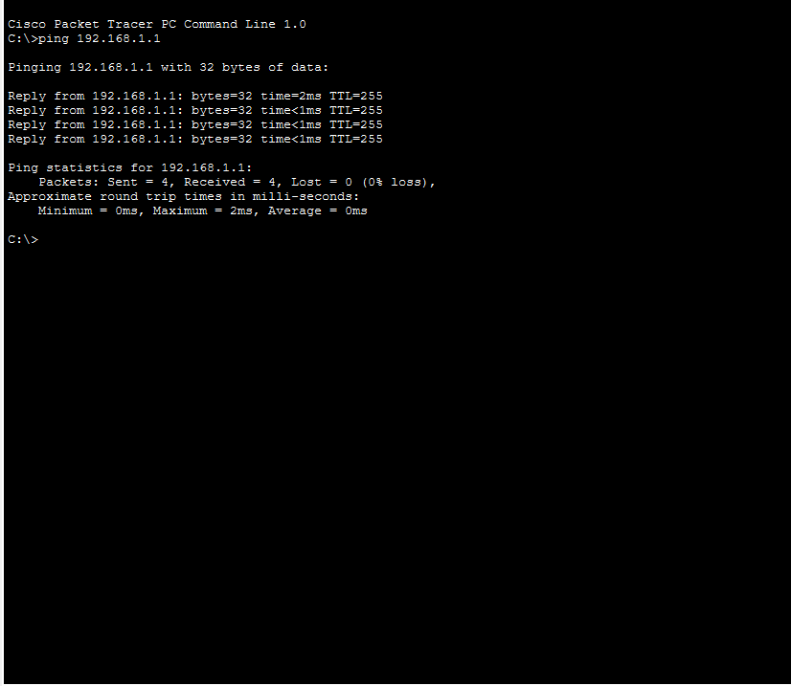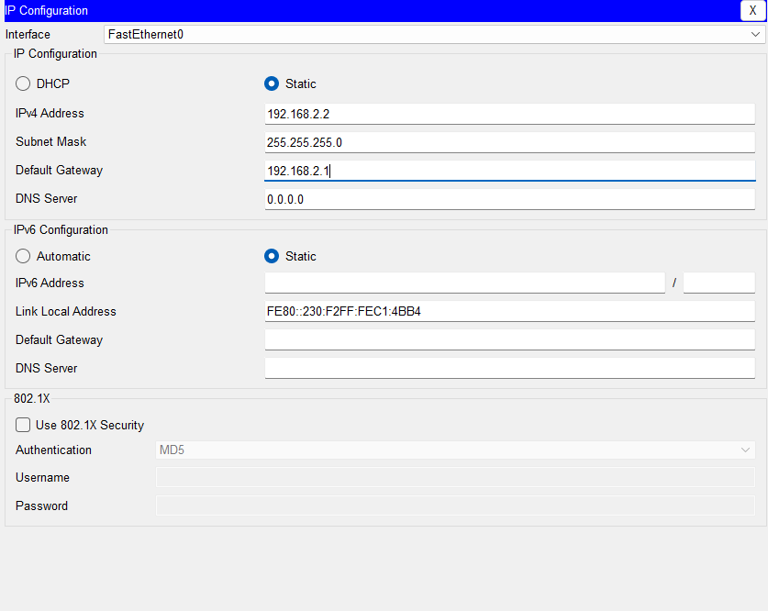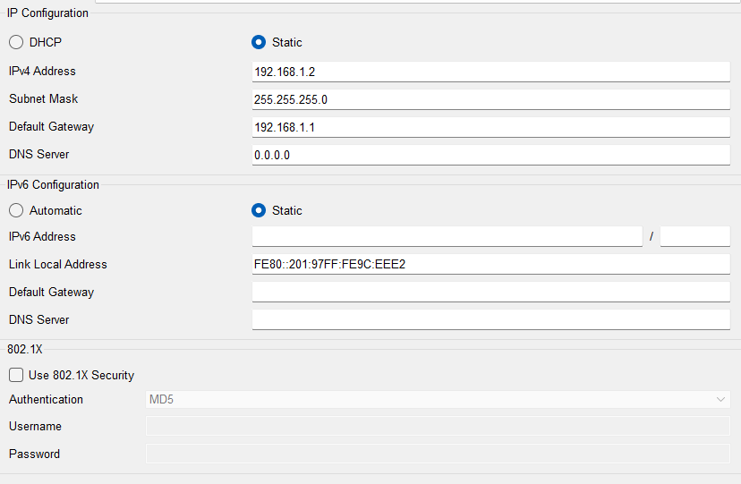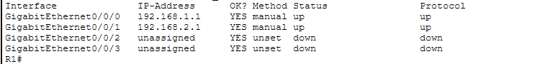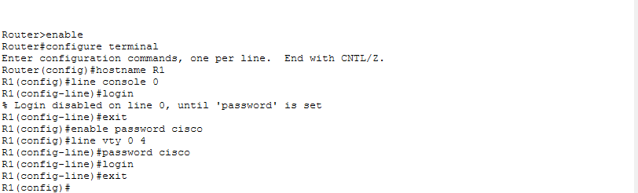
Figure 2. Illustration showing the configuration command sequence.

7. Result and Conclusion
The router configuration uses separate /24 networks on its two Ethernet interfaces. Console, enable and VTY password settings are included, and no shutdown is applied to bring the interfaces up. Successful ping replies should confirm connectivity after both PCs and the router are configured correctly. Actual ping results must be recorded from the Packet Tracer session.

Experiment 4: IP Addressing and Subnetting using VLSM

1. Aim
To plan IPv4 subnets using Variable Length Subnet Masking (VLSM), assign address blocks to three point-to-point router links, configure router interfaces, and verify connectivity with ping.

Objectives
- Understand how a network can be divided into smaller subnets.
- Select an appropriate prefix and subnet mask for point-to-point links.
- Create a triangular topology using three routers.
- Assign usable addresses to router interfaces and test the links.

2. Introduction
VLSM allows a network to be divided into subnets of different sizes according to host requirements. The supplied procedure uses three /30 subnets for the links between three routers. A /30 subnet contains four addresses: a network address, two usable host addresses and a broadcast address.

3. Network Topology
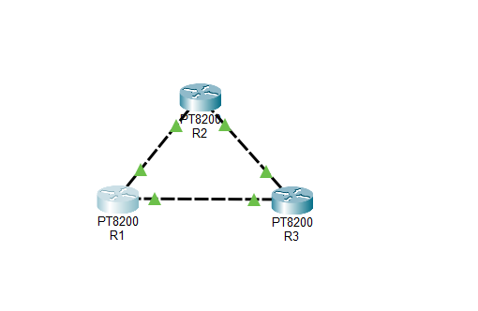

Figure 3. Illustration of the three-router triangular topology.

4. Subnet Calculation and Address Plan
The example below follows the network blocks specified in the supplied lab procedure. Each /30 subnet uses mask 255.255.255.252 and provides two usable IPv4 addresses for the two ends of a point-to-point link.
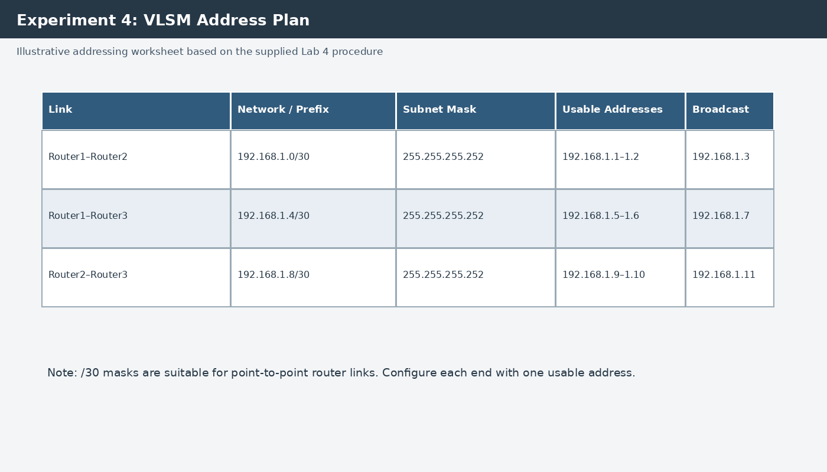
Figure 4. VLSM address-planning worksheet.

5. Procedure
- Launch Cisco Packet Tracer and place three routers on the logical workspace.
- Connect Router1 to Router2, Router1 to Router3, and Router2 to Router3 to form a triangle. Select suitable interfaces and connection types supported by the chosen router models.
- Allocate 192.168.1.0/30 to the Router1–Router2 link, 192.168.1.4/30 to the Router1–Router3 link, and 192.168.1.8/30 to the Router2–Router3 link.
- For each link, assign one usable address to each end. Use subnet mask 255.255.255.252 and enable the interfaces with no shutdown.
- If serial interfaces are used, set clock rate on the DCE side when required by Packet Tracer.
- Run show ip interface brief on each router to check interface addresses and status.
- Ping the neighbouring router address on each link. If a test fails, check cabling, interface state, IP address and subnet mask.

6. Example Interface Address Assignments
Link | Router end A | Router end B
Router1–Router2 | Router1: 192.168.1.1/30 | Router2: 192.168.1.2/30
Router1–Router3 | Router1: 192.168.1.5/30 | Router3: 192.168.1.6/30
Router2–Router3 | Router2: 192.168.1.9/30 | Router3: 192.168.1.10/30

7. Screenshots
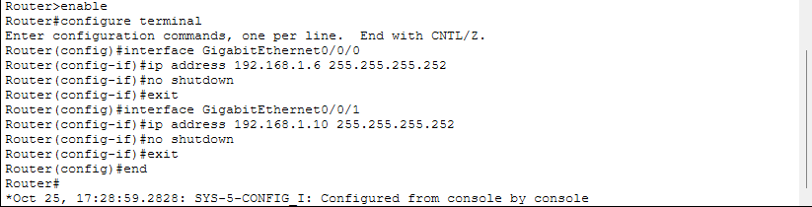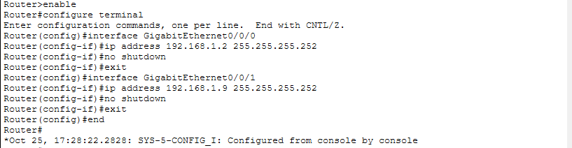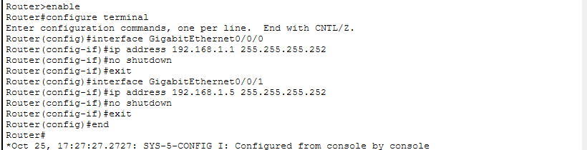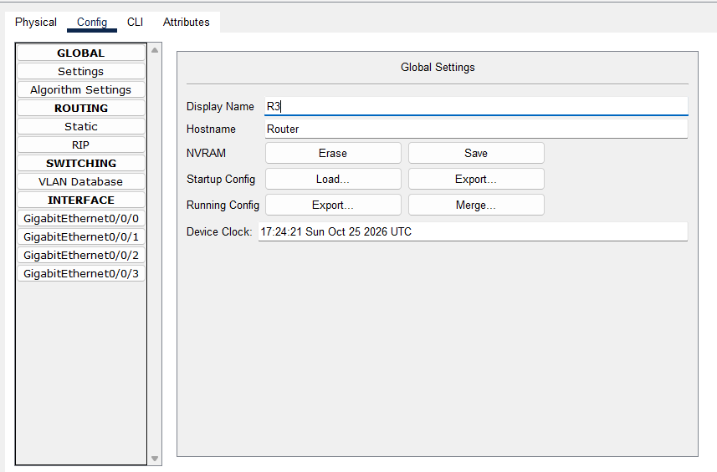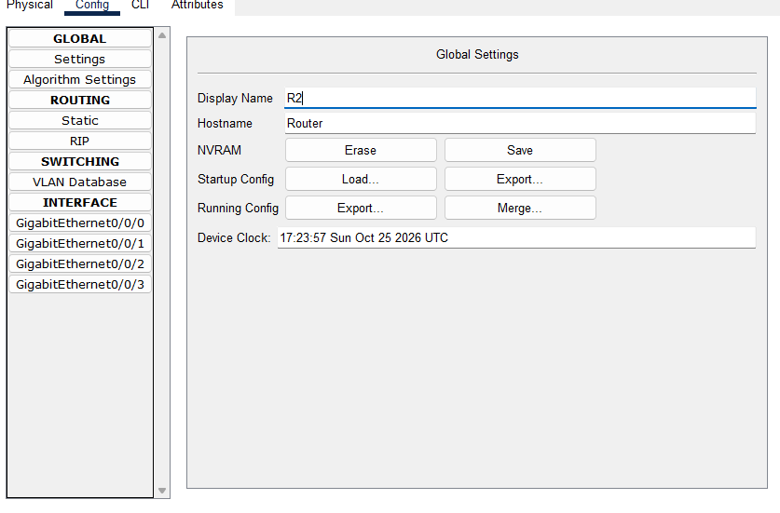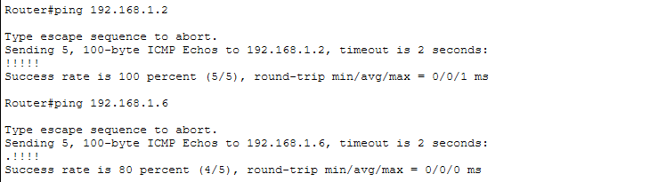
Figure 5. Generated addressing illustration for use as a report visual; replace with a real Packet Tracer capture if your instructor requires application screenshots.

8. Result and Conclusion
Three /30 subnets were planned for the links in the triangular router topology. The address plan identifies the network, usable host range and broadcast address for each link. After the interface addresses are entered and the interfaces are enabled, ping tests can be used to confirm neighbouring-router connectivity. Record the actual test output from Packet Tracer after performing the experiment.

