Calculator
Aim
To design and develop a simple calculator application using JavaScript that can perform basic arithmetic operations such as addition, subtraction, multiplication, and division with a user-friendly interface.
Abstract
The JavaScript calculator mini project is a web-based application developed to perform basic mathematical calculations quickly and accurately. The project is created using HTML for structure, CSS for styling, and JavaScript for implementing calculator functionality.
Algorithm
Html
<!DOCTYPE html>
<html lang="en">
<head>
<title>Calculator</title>
<link rel="stylesheet" href="style2.css" />
</head>
<body>

<div class="calculator">
<input type="text" id="display" disabled />

<div class="buttons">
<button class="clear">C</button>
<button class="bracket">(</button>
<button class="bracket">)</button>
<button class="operator">÷</button>

<button>7</button>
<button>8</button>
<button>9</button>
<button class="operator">×</button>

<button>4</button>
<button>5</button>
<button>6</button>
<button class="operator">−</button>

<button>1</button>
<button>2</button>
<button>3</button>
<button class="operator">+</button>

<button class="zero">0</button>
<button>.</button>
<button class="equal">=</button>
</div>
</div>

<script src="script2.js"></script>
</body>
</html>
Css
body{
height:100vh;
display:flex;
justify-content:center;
align-items:center;
background:linear-gradient(135deg, #F6EA41,#F048C6);
font-family:Arial, Helvetica, sans-serif;
}

.calculator{
background:#1e1e1e;
padding:20px;
border-radius:15px;
cursor:pointer;
box-shadow:0 0 25px #010c05;
width:280px;
}

#display{
width:100%;
height:55px;
border:none;
border-radius:8px;
margin-bottom:15px;
font-size:22px;
padding:10px;
text-align:right;
background:#eeecec;
}

.buttons{
display:grid;
grid-template-columns:repeat(4,1fr);
gap:10px;
}

button{
height:55px;
border:none;
border-radius:8px;
font-size:18px;
cursor:pointer;
background:#f1f1f1;
transition:0.2s;
}

button:hover{
transform:scale(1.05);
background:linear-gradient(135deg, #0c8cc2, #d214af);
}

.operator{
background:#f5a300;
color:#fff;
}

.clear{
background:#ff0000;
color:#fff;
}

.equal{
background:#008000;
color:#fff;
grid-column: span 2;
}

.zero{
grid-column: span 1;
}

javaScript
const display = document.getElementById("display");
const buttons = document.querySelectorAll("button");

let currentInput = "";

buttons.forEach(button => {
button.addEventListener("click", () => {
const value = button.textContent;

if (value === "C") {
currentInput = "";
display.value = "";
}
else if (value === "=") {
try {
let expression = currentInput
.replace(/×/g, "*")
.replace(/÷/g, "/")
.replace(/−/g, "-");

display.value = eval(expression);
currentInput = display.value;
} catch {
display.value = "Error";
}
}
else {
currentInput += value;
display.value = currentInput;
}
});
});
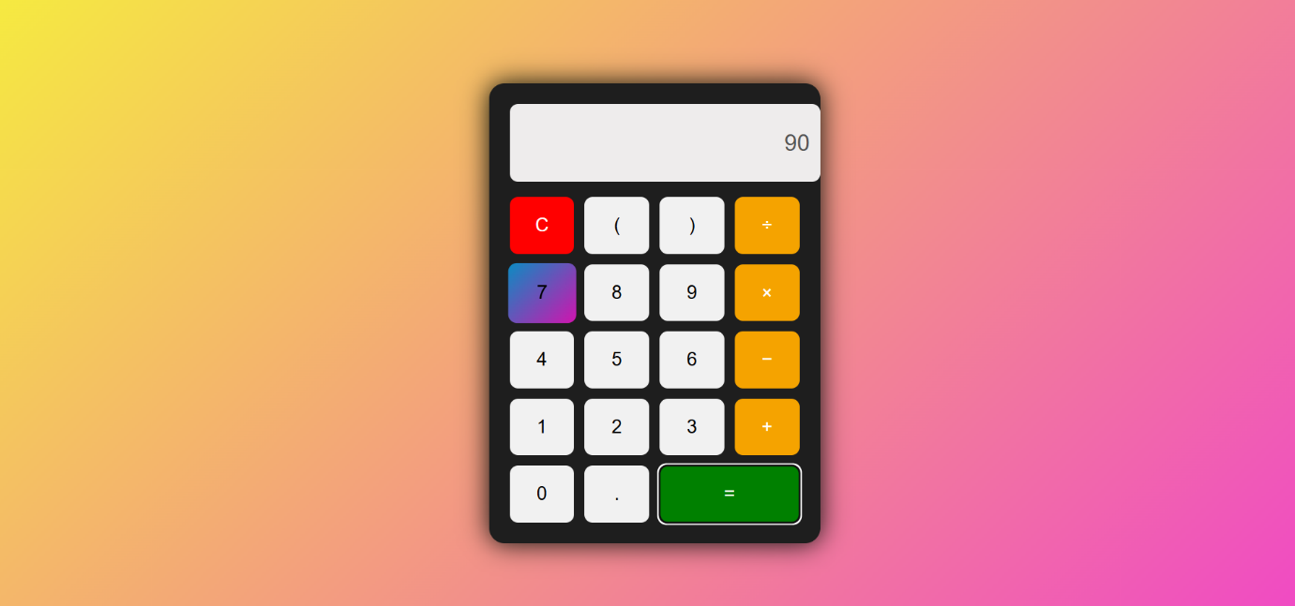
Result
The calculator mini project was successfully developed and tested. The application performs all basic arithmetic operations accurately and provides quick results through an interactive user interface. The project achieved its objective of creating a responsive and easy-to-use calculator using JavaScript. It enhanced understanding of web technologies, programming logic, and user interaction in web applications.

