**Introduction:**

In this project, we have designed Laser Light Security System Using Arduino with Alarm with the application of Laser Diode Module KY-008. The project idea revolves around creating a security system. Whenever any object will obstruct the LASER ray the buzzer alarm will start ringing.

This project can be implemented anywhere, not only buildings or premises but many precious things like jewelry, diamonds, precious antique items in the museum, etc many other things are also secured using such an invisible LASER beam. Many people secure their home, office, shops, warehouses, etc with the LASER beam security system.

### ****Laser Light Security System Using Arduino with Alarm :****

#### **Components Required:**

1. Arduino UNO Board
2. LASER Diode Module KY-008
3. Buzzer
4. LDR
5. Resistors (10k)
6. Push Button Switch
7. Bread Board
8. Connecting Wires

#### **Circuit Diagram:**

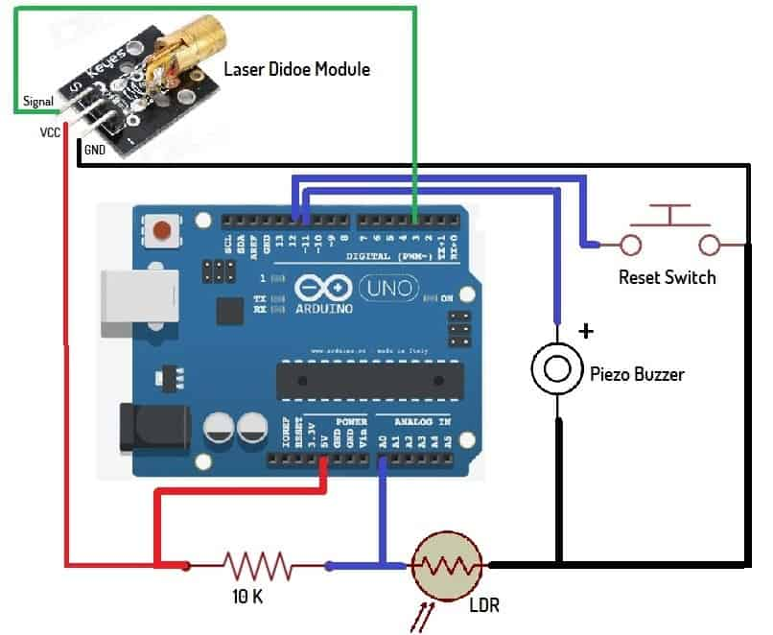

## **Laser Diode Module KY-008:**

[](https://how2electronics.com/wp-content/uploads/2018/06/laser-module.jpg)

Laser Transmitter module KY-008 for Arduino emits a dot-shaped, red laser beam. The KY-008 Laser transmitter module consists of a 650nm red laser diode head and a resistor. Handle with caution, do not look directly into the laser head.

The specification of Laser Transmitter Module KY-008 is as follows:

Operating Voltage – 5V  
Output Power – 5m

Wavelength – 650nm  
Operating Current – less than 40mA  
Working Temperature – -10°C ~ 40°C [14°F to 104°F]  
Dimensions – 18.5mm x 15mm [0.728in x 0.591in]

## **Working of the Laser Light Security System Using Arduino**

The project basically works on the principle of interruption. If by any means the LASER light is interrupted the alarm will start unless it is reset with push-button. The laser is a concentrated light source that puts out a straight beam of light of a single color.

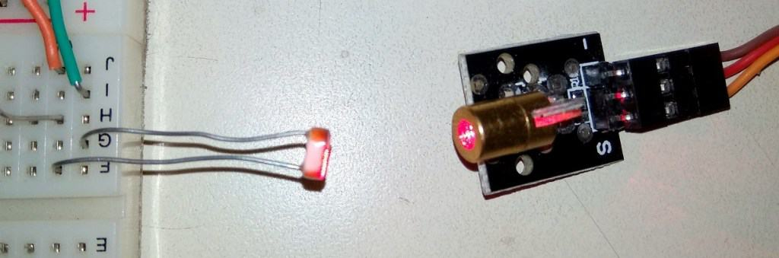

The LDR is sensitive to light and puts out a voltage when the laser light hits it. When the laser beam is interrupted and can’t reach LDR, its voltage output changes, and eventually the alarm will ring.

### ****Source Code/Program:****

int laserPin = 3;

int sensorPin = A0;

int buttonPin = 12;

int buzzerPin = 11;

int laserThreshold = 10;

void setup() {

pinMode(laserPin, OUTPUT);

pinMode(buttonPin, INPUT_PULLUP);

Serial.begin(9600);

}

boolean alarmState = false;

void loop() {

if (! alarmState) {

delay(1000);

digitalWrite(laserPin, HIGH);

delay(10);

unsigned long startTime = millis();

while (millis() – startTime < 1000) {

int sensorValue = analogRead(sensorPin);

Serial.println(sensorValue);

if (sensorValue > laserThreshold) {

alarmState = true;

break;

}

delay(10);

}

digitalWrite(laserPin, LOW);

} else {

tone(buzzerPin, 440);

if (! digitalRead(buttonPin)) {

alarmState = false;

noTone(buzzerPin);

}

delay(10);

}

}

### Conclusion:

The Laser Light Security System using Arduino with an integrated alarm presents an effective and accessible solution for home and small business security needs. Through the use of laser modules and light-dependent resistors (LDRs), the system provides accurate intrusion detection, bolstered by an audible alarm for immediate notification. Its modular design allows for easy expansion and customization, while Arduino's open-source platform encourages further innovation. This project has provided valuable insights into electronics, programming, and security systems, offering a solid foundation for future enhancements. Overall, it stands as a reliable, user-friendly, and cost-effective option for enhancing security measures.