**1.Создание таблицы Pets.**

CREATE TABLE Pets ( id INT AUTO_INCREMENT PRIMORY KEY,

Name VARCHAR(20),

TYPE VARCHAR(20),

BirthDate DATE,

Commands VARCHAR(50)

);

INSERT INTO Pets (Name, Type, BirthDate, Commands)

VALUES (‘Bella’, ‘ Dog’, 2019-11-11, 'Sit, Stay, Roll'),

(‘Smudge’, ‘Cat’ , 2020-02-20, 'SIT, Pounce, Seratch'),

(‘Peanut’, ‘Hmster’, 2021-08-01, 'Roll, Spin');

SELECT * FROM Pets;

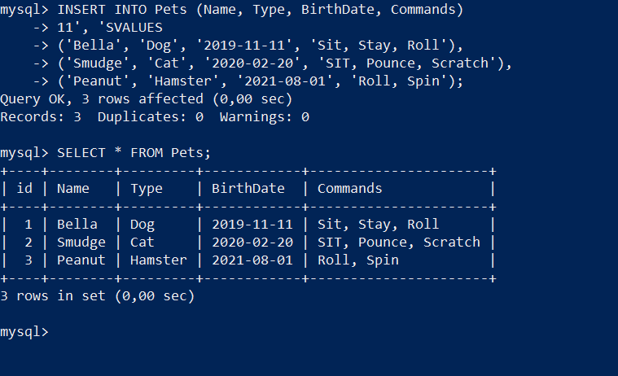

**2.Создание таблицы PackAnimals**

CREATE TABLE PackAnimals (

id INT AUTO_INCREMENT PRIMARY KEY,

Name VARCHAR(20),

TYPE VARCHAR(20),

BirthDate DATE,

Commands VARCHAR(50)

);

INSERT INTO PackAnimals (Name, Type, BirthDate, Commands)

VALUES

('Thunder', 'Horse', '2015-07-21', 'Trot, Canter, Gallop'),

('Sandy', 'Camel', '2016-11-03', 'Walk, Carry Load'),

('Eeyore', 'Donkey', '2017-09-18', 'Walk, Carry Load, Bray');

SELECT * FROM P PackAnimals;

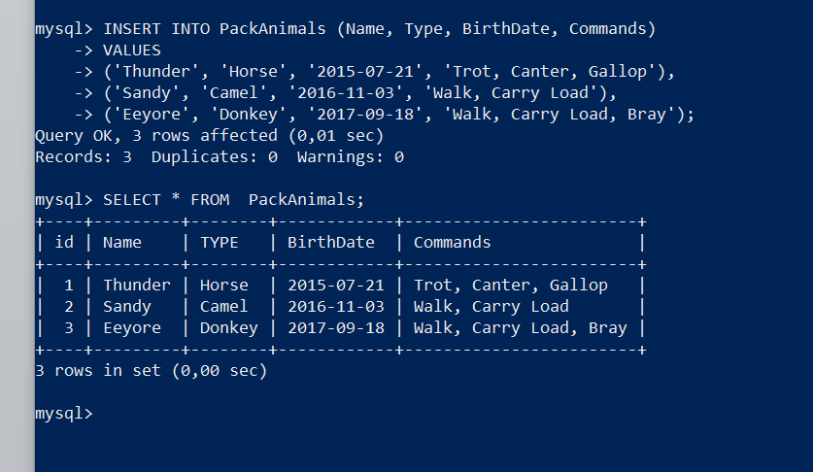

3. Удалить записи о верблюдах и объединить таблицы лошадей и ослов.

DELETE FROM PackAnimals WHERE Type = 'Camel';

SELECT * FROM P PackAnimals;

INSERT INTO PackAnimals (Name, Type, BirthDate, Commands)

SELECT Name, Type, BirthDate, Commands

FROM PackAnimals

WHERE Type IN ('Horse', 'Donkey');

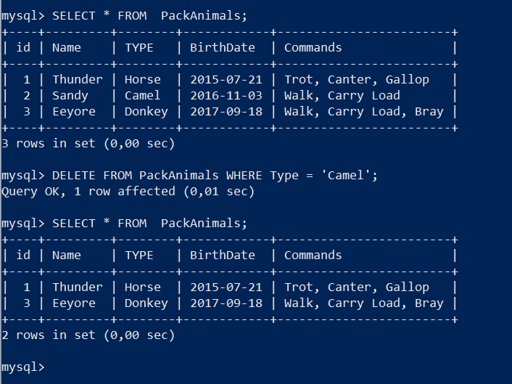

**4.Создать новую таблицу для животных в возрасте от 4 до 7 лет и вычислить их возраст с точностью до месяца.**

CREATE TABLE AnimalsAge4to7 (

id INT AUTO_INCREMENT PRIMARY KEY,

Name VARCHAR(100),

Type VARCHAR(100),

BirthDate DATE,

Commands VARCHAR(255),

AgeInMonths INT

);

INSERT INTO AnimalsAge4to7 (Name, Type, BirthDate, Commands, AgeInMonths)

SELECT

Name, Type, BirthDate, Commands,

TIMESTAMPDIFF(MONTH, BirthDate, CURDATE()) AS AgeInMonths

FROM

Pets

WHERE

TIMESTAMPDIFF(YEAR, BirthDate, CURDATE()) BETWEEN 4 AND 7;

INSERT INTO AnimalsAge4to7 (Name, Type, BirthDate, Commands, AgeInMonths)

SELECT

Name, Type, BirthDate, Commands,

TIMESTAMPDIFF(MONTH, BirthDate, CURDATE()) AS AgeInMonths

FROM

PackAnimals

WHERE

TIMESTAMPDIFF(YEAR, BirthDate, CURDATE()) BETWEEN 4 AND 7;

SELECT * FROM AnimalsAge4to7;

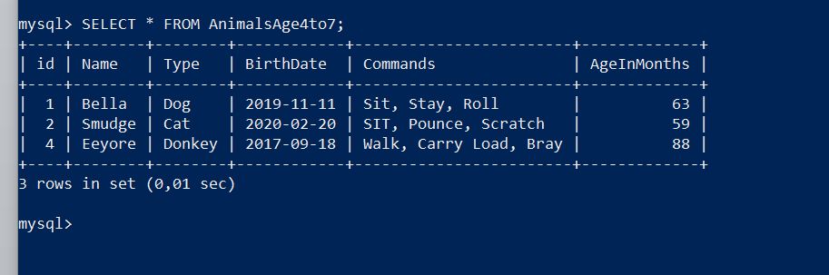

**5.Объединить все созданные таблицы в одну, сохраняя информацию о принадлежности к исходным таблицам.**

CREATE TABLE CombinedAnimals (

id INT AUTO_INCREMENT PRIMARY KEY,

Name VARCHAR(100),

Type VARCHAR(100),

BirthDate DATE,

Commands VARCHAR(255),

SourceTable VARCHAR(30)

);

INSERT INTO CombinedAnimals (Name, Type, BirthDate, Commands, SourceTable)

SELECT Name, Type, BirthDate, Commands, 'Pets' AS SourceTable

FROM Pets

UNION ALL

SELECT Name, Type, BirthDate, Commands, 'PackAnimals' AS SourceTable

FROM PackAnimals

UNION ALL

SELECT Name, Type, BirthDate, Commands, 'AnimalsAge4to7' AS SourceTable

FROM AnimalsAge4to7;

SELECT * FROM CombinedAnimals;

