**README ODT**

**Overview**

Tram 1013 operating in revenue service in Florence tramway system is equipped with a set of sensors (RADAR, LiDAR, Cameras) and collects datasets from relevant measurements.

The first and second dataset associated to ODT system is made of the all sensors’ outputs.

* RADAR: used in cluster mode
* LiDAR: to collect a dots cloud
* Cameras: to collect videos. This dataset contains sensitive information and is not included in this dataset.

Though first and second dataset associated to ODT refer to different measurement sessions and are in the following data format:

* .csv files

ODT system processes data from sensor with many complex algorithms which detect and track position and trajectory of many objects standing still or moving in front of tram 1013.

**Dataset Contents/Dataset Description**

The files that compose the ODT dataset are:

*ThalesARS_CompleteObjectsFrame.csv*

*ThalesIMU_GetDataFE_response.csv*

*ThalesQM8_All3Returns_Packet.csv*

The following tables report the fields and meaning of the content of the above files.

Table 1 ThalesARS_CompleteObjectsFrame.csv file structure (ODT RADAR)

|  |  |  |
| --- | --- | --- |
| **Item** | **Type** | **Description** |
| numberOfObjects | int64 | Number of objects detected by the RADAR. |
| measurementCycleCounter | int64 | Number of cycles or pulses that have been emitted and received, indicating the sequencing of measurement cycles in a radar operation. |
| interfaceVersion | uint8 | Version of the interface. |
| objectListReceptionTime_ns | int64 | Timestamp in nanoseconds at which a list of detected objects |
| objectFullInfos | ARS_  ObjectFullInformation[ ] | Refers to the detailed set of information about each detected cluster, including position, velocity, size, and other attributes, which are crucial for understanding and analyzing the RADAR's observations of objects in its vicinity. |
| id | uint8 | ID of the acquired object |
| longitudinalDistance_m | float64 | Longitudinal distance of the acquired object expressed in meters. |
| lateralDistance_m | float64 | Lateral distance of the acquired cluster expressed in meters. |
| dynamicProperty | uint8 | Dynamic property of the message: stationary cluster, moving cluster, etc.. |
| radarCrossSection_dBm2 | float32 | Radar cross section of the acquired cluster. |
| longitudinalDistance_  rms | float32 | Longitudinal distance of the acquired cluster expressed in rms. |
| lateralDistance_  rms | float32 | Lateral distance of the acquired cluster expressed in rms. |
| longitudinalRelativeVelocity_  rms | float32 | rms of longitudinal relative velocity |
| lateralRelativeVelocity_  rms | float32 | rms of lateral relative velocity |
| longitudinalRelativeAcceleration_  rms | float32 | rms of longitudinal relative acceleration |
| lateralRelativeAcceleration_  rms | float32 | rms of lateral relative acceleration |
| orientationAngle_  rms | float32 | rms of orientation angle |
| probabilityOfExistance | uint8 | 0x00: invalid; 0x01: <25%; 0x02: <50%; 0x03: <75%; 0x04: <90%; 0x05: <99%; 0x06: <99.9%; 0x07: <=100% |
| measurementState | uint8 | 0x0: deleted; 0x1: new; 0x2: measured; 0x3: predicted; 0x4: deleted for merge; 0x5: new from merge |
| longitudinalRelativeAcceleration_m_s2 | float32 | Longitudinal relative acceleration ms^-2 |
| lateralRelativeAcceleration_m_s2 | float32 | Lateral relative acceleration in ms^-2 |
| objectClass | uint8 | 0x0: point; 0x1: car; 0x2: truck; 0x3: unused; 0x4: motorcycle; 0x5: bicycle; 0x6: wide; 0x7: reserved |
| orientationAngle_deg | float32 | orientation angle |
| objectLength_m | float32 | object length |
| objectWidth_m | float32 | object width |

Frequency is 12.5 Hz.

Table 2 ThalesQM8_All3Returns_Packet.csv dataset (ODT LiDAR)

|  |  |  |
| --- | --- | --- |
| **Item** | **Type** | **Description** |
| timestamp_seconds | uint32 | timestamp in seconds |
| timestamp_nanoseconds | uint32 | fractional part of the timestamp, in nanoseconds |
| firingData | QM8_All3Returns_FiringData[50] | A vector of 50 firing data, each specified as follows: |
| position | uint16 | a number in [0; 10399] encoding the radial position of the sampled points. |
| distancesIntensities | QM8_LaserDistancesIntensities[3] | A vector of 3 data structure, one for each return, specified as follows: |
| distances | uint32[8] | a vector of 8 distances, one for each layer |
| intensities | uint8[8] | a vector of 8 intensities, one for each layer |

Table 3 - ThalesIMU_GetDataFE_response.csv dataset (ODT IMU)

|  |  |  |
| --- | --- | --- |
| **Item** | **Type** | **Description** |
| rosbagTimestamp | uint64 | Epoch timestamp in nanoseconds. |
| epoch_ms | float64 | Epoch timestamp in ms. |
| packetCounter | uint64 | Packet counter used to count the received IMU messages. |
| quaternionW | float64 | QuaternionW component that represents the cosine of half the rotation angle, indicating the magnitude of the rotation about a specific axis in 3D space. |
| quaternionX | float64 | QuaternionX component that represents the cosine of half the rotation angle, indicating the magnitude of the rotation about a specific axis in 3D space. |
| quaternionY | float64 | QuaternionY component that represents the cosine of half the rotation angle, indicating the magnitude of the rotation about a specific axis in 3D space. |
| quaternionZ | float64 | QuaternionZ component that represents the cosine of half the rotation angle, indicating the magnitude of the rotation about a specific axis in 3D space. |
| euler_yaw_angle_deg | float64 | Euler yaw angle of an IMU, expressed in degrees: defines the object's rotation around its vertical axis, representing its heading or direction relative to a reference direction like north. |
| euler_pitch_angle_deg | float64 | Euler pitch angle of an IMU, expressed in degrees, measures the object's tilt forward or backward around its lateral axis, indicating its inclination relative the horizontal plane. |
| euler_roll_angle_deg | float64 | Euler roll angle of an IMU, expressed in degrees, describes the object's rotation around its longitudinal axis, indicating its sideways tilt relative to the horizontal plane. |
| accelerometerX_g | float64 | Acceleration along X axis expressed in g. |
| accelerometerY_g | float64 | Acceleration along Y axis expressed in g. |
| accelerometerZ_g | float64 | Acceleration along Z axis expressed in g. |
| magnetometerX_Gauss | float64 | Measures the magnetic field's strength along the device's X-axis in Gauss, helping to determine orientation relative to Earth's magnetic field. |
| magnetometerY_Gauss | float64 | Measures the magnetic field's strength along the device's Y-axis in Gauss, helping to determine orientation relative to Earth's magnetic field. |
| magnetometerZ_Gauss | float64 | Measures the magnetic field's strength along the device's Z-axis in Gauss, helping to determine orientation relative to Earth's magnetic field. |
| gyroscopeX_dps | float64 | Measures the rate of rotation around the device's X-axis in degrees per second, tracking angular velocity. |
| gyroscopeY_dps | float64 | Measures the rate of rotation around the device's Y-axis in degrees per second, tracking angular velocity. |
| gyroscopeZ_dps | float64 | Measures the rate of rotation around the device's Z-axis in degrees per second, tracking angular velocity. |
| temperature_C | float64 | Temperature in °C detected by the sensor. |

The following is a geometrical info about the LiDAR measurement system

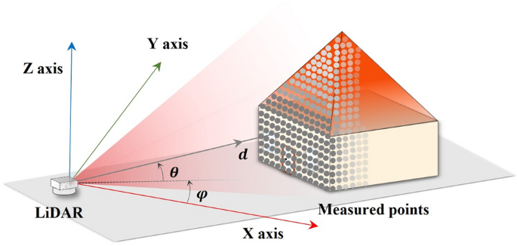

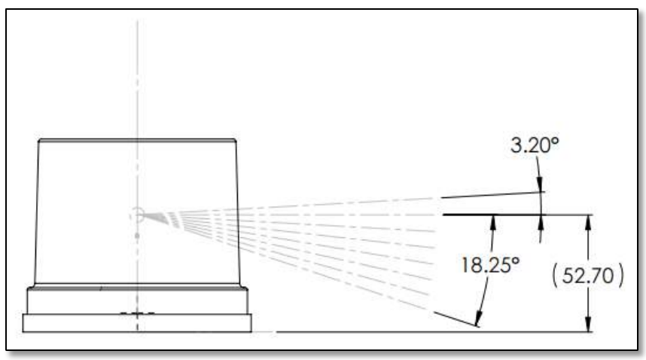

**Getting Started**

The dataset is provided in .csv format, so no special software or prerequisites are required to access or use it.

**Download & Usage**

* git clone https://github.com/VERGE-PROJECT/GTSI-HITACHI-ODT-dataset

The files are zipped, divided per folder and, because github limitation (file size less than 25MB), splitted in several files.

**Citation**

NA