VIETNAM GENERAL CONFEDERATION OF LABOR
TON DUC THANG UNIVERSITY
FACULTY OF INFORMATION TECHNOLOGY



Nguyen Thanh Dat- 722I0004
Tran Thi The Nhan– 523K0047

Lab Assignment 1

Software Engineering
Advised by
Mr. Pham Thai Ky Trung

HO CHI MINH CITY, 2025

ACKNOWLEDGEMENT

Our sincerest thanks go to Mr. Pham Thai Ky Trung, our dedicated instructor for Software Engineering. This undertaking would not have been possible without his continuous support and professional guidance.
Throughout the semester, Mr. Trung offered critical insights and constructive criticism that significantly elevated the quality of our work. We are particularly thankful for his detailed explanations of complex engineering concepts and his patience in guiding us through the software development lifecycle. His deep expertise and real-world experience provided us with a clear roadmap for success. We feel fortunate to have had the opportunity to be his students.
Ho Chi Minh city, 13th November 2025
Author
(Signature and full name)

Thanh Dat
Nguyen Thanh Dat

The Nhan
Tran Thi The Nhan

Task 1:
ID | Question | Clarified Answer
1 | Which transport modes does the kiosk cover at launch? | Bus and MRT at launch. Other modes (water bus, bicycles) are future options.
2 | Can a user buy multiple tickets in one transaction? | Yes. The user can select ticket quantity for group travel in a single payment.
3 | Is user login required? | No. Anonymous purchase by default. Optional “registered account” is future work.
4 | What payment methods are in scope? | Credit/debit card and QR e-wallets (MoMo, VNPay, ZaloPay). Cash is out of scope for this assignment.
5 | What happens if payment fails or is cancelled? | The transaction is cancelled, no ticket is printed, and the user returns to the main menu with a clear error message and retry option.
6 | How long is the QR code valid and what if it expires? | QR is valid for 60 seconds. If it expires, the user can generate a new QR or change payment method.
7 | What ticket format is issued? | A printed paper ticket with a QR barcode. The QR encodes ticket ID, origin, destination, fare, timestamp, and a simple checksum/signature.
8 | Is the ticket linked to a user profile? | No. Tickets are anonymous. If a logged-in option is added later, it remains optional.
9 | How are destinations shown? | All available destinations are listed. The kiosk highlights nearby or frequent destinations based on kiosk location.
10 | Which languages must the UI support? | Vietnamese and English at minimum. The app auto-starts in Vietnamese with a clear language toggle.
11 | What are the basic timing targets? | Max total purchase time: 2 minutes. Screen response within 300 ms. Card auth target < 5 s p95.
12 | Can users get a receipt? | Yes. A printed receipt on request. If the user enters a phone/email, an SMS/email receipt can be sent; otherwise skip.
13 | What if the printer jams or paper runs out? | The app pauses, shows a “printing issue” screen, and offers auto-reprint after staff resolves it. If printing cannot complete, payment is voided/refunded.
14 | Are refunds or cancellations allowed after payment? | Only if no ticket was printed or the ticket is unreadable. Otherwise, refunds are out of scope and handled by customer service.

Task 2: Functional, non-functional and domain requirements for a Ticket Vendor Machine
FUNCTIONAL REQUIREMENT
ID | Requirement Description
FR-01 | When the user presses Start, the system opens the Destination screen.
FR-02 | The system lets the user switch language (VN/EN) from any screen; default is Vietnamese.
FR-03 | The system lets the user choose a destination from a displayed list.
FR-04 | The system lets the user set ticket quantity (1–10) before payment.
FR-05 | After destination and quantity, the system shows the total fare and available payment methods.
FR-06 | The system offers exactly two payment methods: Credit/Debit Card and QR e-wallet (MoMo, VNPay, ZaloPay). Cash is out of scope.
FR-07 | If Card is chosen, the system prompts for insert/tap (EMV). No magstripe swipe.
FR-08 | The system sends an authorization request to the payment gateway and receives Approved/Declined/Timeout.
FR-09 | On card Approval, the system issues printed paper ticket(s) with QR barcode and shows a success screen.
FR-10 | If QR is chosen, the system displays a payment QR with amount and a visible 60-second countdown.
FR-11 | The system checks wallet payment status (paid/expired/cancelled). On expiry, user can generate a new QR or change method.
FR-12 | On QR payment Success, the system issues printed paper ticket(s) with QR barcode and shows a success screen.
FR-13 | The system offers an optional receipt: print by default; SMS/email only if the user enters details.
FR-14 | The user can cancel any time before payment approval; the system voids any pending payment and returns to Home.
FR-15 | Inactivity timeout (45 s on interactive screens) cancels the session and returns to Home.
FR-16 | The system detects printer errors (jam/out of paper). If payment succeeded but printing failed, it retries reprint; if still failing, it marks the ticket “not issued” and requests refund/void.
FR-17 | The system logs every transaction event (start, selection, payment result, print result) with timestamp and kiosk ID for audit and reporting.
FR-18 | At end of transaction or cancel, the system clears session data and returns to the Attract screen.
FR-19 | The system provides a protected Admin screen (PIN) for paper level, printer test, and network status; not available to passengers.

NON- FUNCTIONAL REQUIREMENT
ID | Requirement Description
NFR-01 | UI responsiveness: any screen change or control feedback ≤ 300 ms (p95). The Destination screen appears ≤ 2 s after Start.
NFR-02 | Fare quote time: showing total price after destination/quantity change ≤ 1 s (p95).
NFR-03 | QR flow latency: create order and display QR ≤ 2 s (p95).
NFR-04 | Card authorization round-trip ≤ 5 s (p95) and ≤ 10 s (p99). If >10 s, show progress with cancel option.
NFR-05 | From payment approval to print start ≤ 2 s; physical print completes ≤ 5 s per ticket (80×30 mm thermal).
NFR-06 | End-to-end purchase time target ≤ 120 s for a typical single ticket.
NFR-07 | Monthly availability ≥ 99.5% (error budget ≤ 3.6 h/month).
NFR-08 | Auto-recovery: on transient faults (network, gateway 5xx, device hiccup) the app retries with exponential backoff and returns to Ready state in ≤ 2 min without staff action.
NFR-09 | Power loss resilience: after restart ≤ 90 s to Ready; the last in-flight transaction is reconciled exactly once (no double charge, no lost ticket).
NFR-10 | Payment-path isolation: failure of one payment method (card or QR) does not disable the other; users can switch methods in the same session.
NFR-11 | Security: all external calls use TLS 1.2+; no PAN is stored; tokens only; kiosk is operated within PCI scope for the card path.
NFR-12 | Data integrity: each ticket has a unique ID and signed/checksummed payload; sales and payment records are written atomically and never partially stored.
NFR-13 | Logging/observability: structured logs for every step (selection, auth result, print result) with kiosk ID and timestamps; health heartbeat sent every 60 s; printer status and paper level exposed as metrics.
NFR-14 | Printer reliability: detect jam/out-of-paper; auto-reprint up to 2 times; unresolved print failures < 1 per 1,000 tickets and raise a service alert.
NFR-15 | Maintainability: fare tables and destination lists are reloadable at runtime without app restart; config change applies in ≤ 30 s.
NFR-16 | Degraded mode: if the payment gateway is unreachable for >30 s, show an “Out of service” screen and block new sessions while diagnostics remain available to staff.

Revised Domain Requirements
ID | Requirement Description
DR-01 | Compliance: the kiosk must follow the operator’s rules for Bus/MRT ticketing and applicable payment regulations from the central bank and providers (card and e-wallet).
DR-02 | Fare policy: fares are loaded from an operator-supplied table or API. The MVP sells a Standard Adult Single-Ride ticket. Other products (child/senior/transfer/return) are enabled only if present in the fare data.
DR-03 | Origin binding: each kiosk is configured with a fixed origin station/stop code. Destinations and fares are computed from that origin.
DR-04 | Currency and rounding: VND only. Any rounding follows the operator’s fare table (e.g., to the nearest 1,000 VND if specified).
DR-05 | Ticket content: printed ticket must include unique Ticket ID, kiosk ID, origin, destination, fare, issue timestamp, validity window, and payment method.
DR-06 | Ticket barcode: the printed QR code must be readable by station validators and encode the ticket payload (at minimum Ticket ID, origin, destination, issue time, validity, checksum/signature).
DR-07 | QR standard: wallet QR must follow accepted specifications (EMVCo merchant-presented QR or the national scheme such as VietQR), as required by MoMo/VNPay/ZaloPay.
DR-08 | Validity rules: a single-ride ticket is valid for one entry within a configured time window (e.g., 60 minutes from issue). Exact window is configurable per operator policy.
DR-09 | Transfer/discount rules: if the operator provides transfer or discount entitlements, the system must apply them exactly as defined in the fare data and encode any entitlement in the ticket payload. If none are provided, no transfer/discount applies.
DR-10 | Refund/void policy: refunds at the kiosk are allowed only when payment succeeded but printing failed and no valid ticket was issued. All other refunds/exchanges are handled by customer service.
DR-11 | Receipts: printed receipts are available on request. Optional SMS/email receipts are sent only when the user provides contact details. No PII is stored beyond the receipt action.
DR-12 | Logging and retention: every transaction is logged with timestamps (Asia/Ho_Chi_Minh), kiosk ID, payment reference, and result. Logs are kept online ≥ 30 days and archived for up to 12 months. Clock is NTP-synchronized.
DR-13 | Quantity limits: per transaction, up to 10 tickets may be purchased to support small groups and reduce queue time.
DR-14 | Lost/damaged tickets: the kiosk does not reissue lost or damaged tickets after a completed sale. Such cases are handled by the operator’s service desk.

Task 3: Use Case modelling for Ticket Vendor Machine
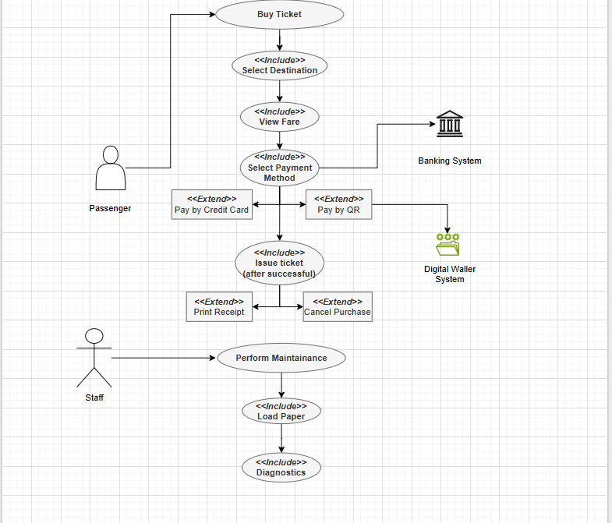

Use Case Descriptions:

UC-01 Buy Ticket
- Primary actor: Passenger
- Supporting: Banking System, Digital Wallet System
- Trigger: User presses Start.
- Preconditions: Kiosk online; printer ready or serviceable.
- Main flow:
  - System shows destinations (UC-02).
  - User selects destination → system shows fare (UC-03) and payment options (UC-04).
  - User chooses Card (UC-05) or QR (UC-06).
  - On payment success, system issues ticket(s) (UC-07).
  - System offers receipt (UC-08). Session ends.
- Alternates:
A1) User cancels or timeout → UC-09.
A2) Payment fails/QR expires → user may retry method or cancel.
- Postconditions: Ticket issued and transaction logged, or clean cancel with no charge.

UC-02 Select Destination
- Actor: Passenger
- Pre: UC-01 started.
- Post: A destination is stored in session.
- Steps: Display list; optional search; user picks one; system confirms selection.

UC-03 View Fare
- Actor: Passenger
- Pre: Destination selected.
- Post: Total price for quantity shown.
- Steps: System calculates fare; user may change quantity (1–10); system updates total.

UC-04 Choose Payment Method
- Actor: Passenger
- Pre: Fare displayed.
- Post: Selected method stored.
- Steps: System shows Card and QR; user selects one.

UC-05 Pay by Card (<<extend>> of UC-01)
- Actors: Passenger; Banking System
- Pre: Card method chosen.
- Post: Payment Approved/Declined/Timeout captured.
- Steps: Prompt insert/tap; send auth; receive result; show status; on approval return to UC-01.

UC-06 Pay by QR (<<extend>> of UC-01)
- Actors: Passenger; Digital Wallet System
- Pre: QR method chosen.
- Post: Payment Success/Expired/Cancelled captured.
- Steps: Create order; display QR with 60-s timer; poll status; on success return to UC-01.

UC-07 Issue Ticket (<<include>> of UC-01)
- Actor: Passenger
- Pre: Payment successful.
- Post: Ticket printed or UC-10 triggered.
- Steps: Generate ticket payload and QR barcode; print ticket(s); confirm print; log result.

UC-08 Print Receipt (optional, <<extend>> of UC-01)
- Actor: Passenger
- Pre: Ticket issued.
- Post: Receipt printed or sent if contact provided.
- Steps: Offer print; optional phone/email entry; print or send; return to end screen.

UC-09 Cancel Purchase (<<extend>> of UC-01)
- Actor: Passenger
- Pre: Session in progress before ticket issuance.
- Post: Session cleared; any pending auth voided; no ticket produced.
- Steps: User taps Cancel or timeout occurs; system voids/abandons payment; returns to Home.

UC-10 Perform Maintenance
- Actor: Maintenance Staff
- Pre: Staff logged in with PIN.
- Post: Kiosk healthy or flagged for service.
- Steps: Open Admin; run Diagnostics (UC-12); Load Paper (UC-13); view network/printer status; exit Admin.

UC-11 Diagnostics (<<include>> of UC-11)
- Actor: Maintenance Staff
- Steps: Printer test, connectivity test, view logs, clear paper-jam counter.

UC-12 Load Paper (<<include>> of UC-11)
- Actor: Maintenance Staff
- Steps: Open printer door, replace roll, close, print test ticket, mark paper level OK.

Task 4:
Process of passenger’s buying a ticket from ticket Vendor
Machine

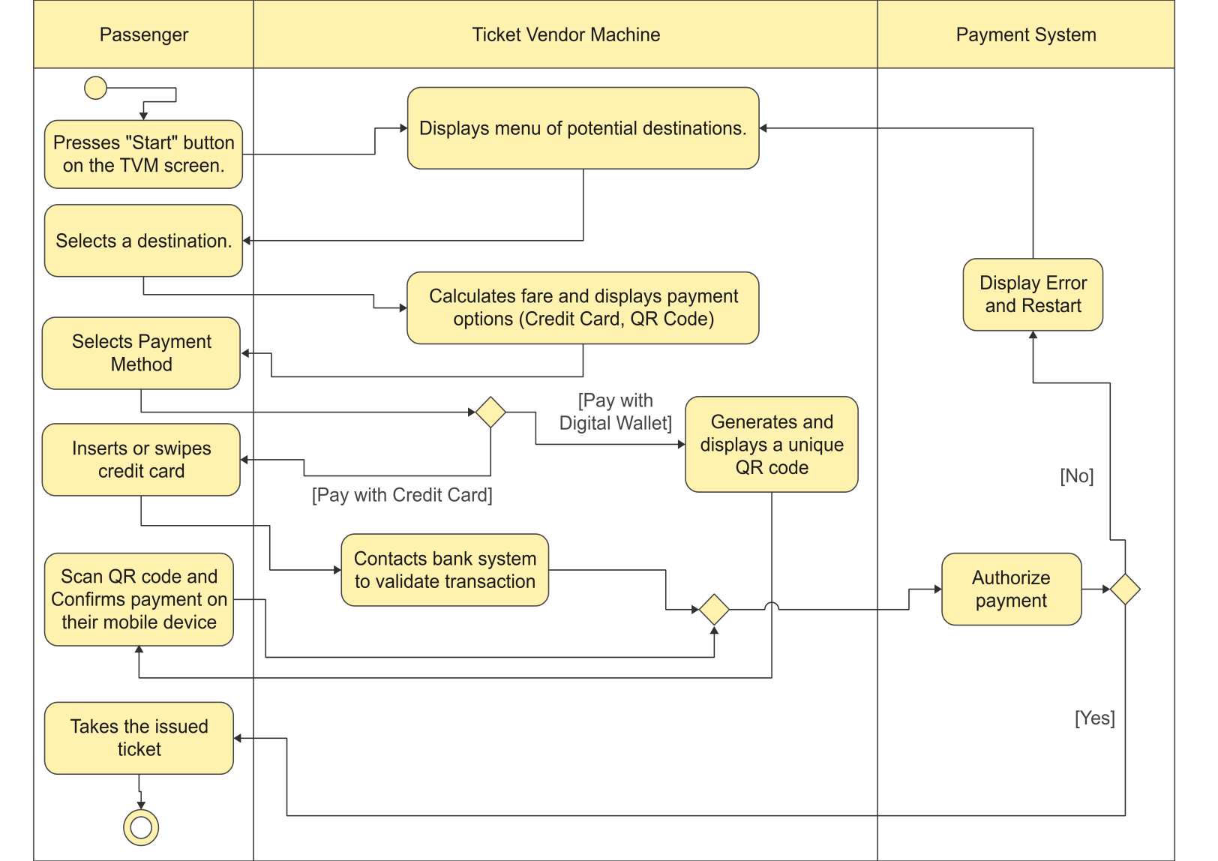

Inter-System Communication Of External Payment Systems

This diagram illustrates the communication for a QR code payment (e.g., via VNPay, Momo). The credit card flow is similar but communicates directly with a bank acquirer or gateway.

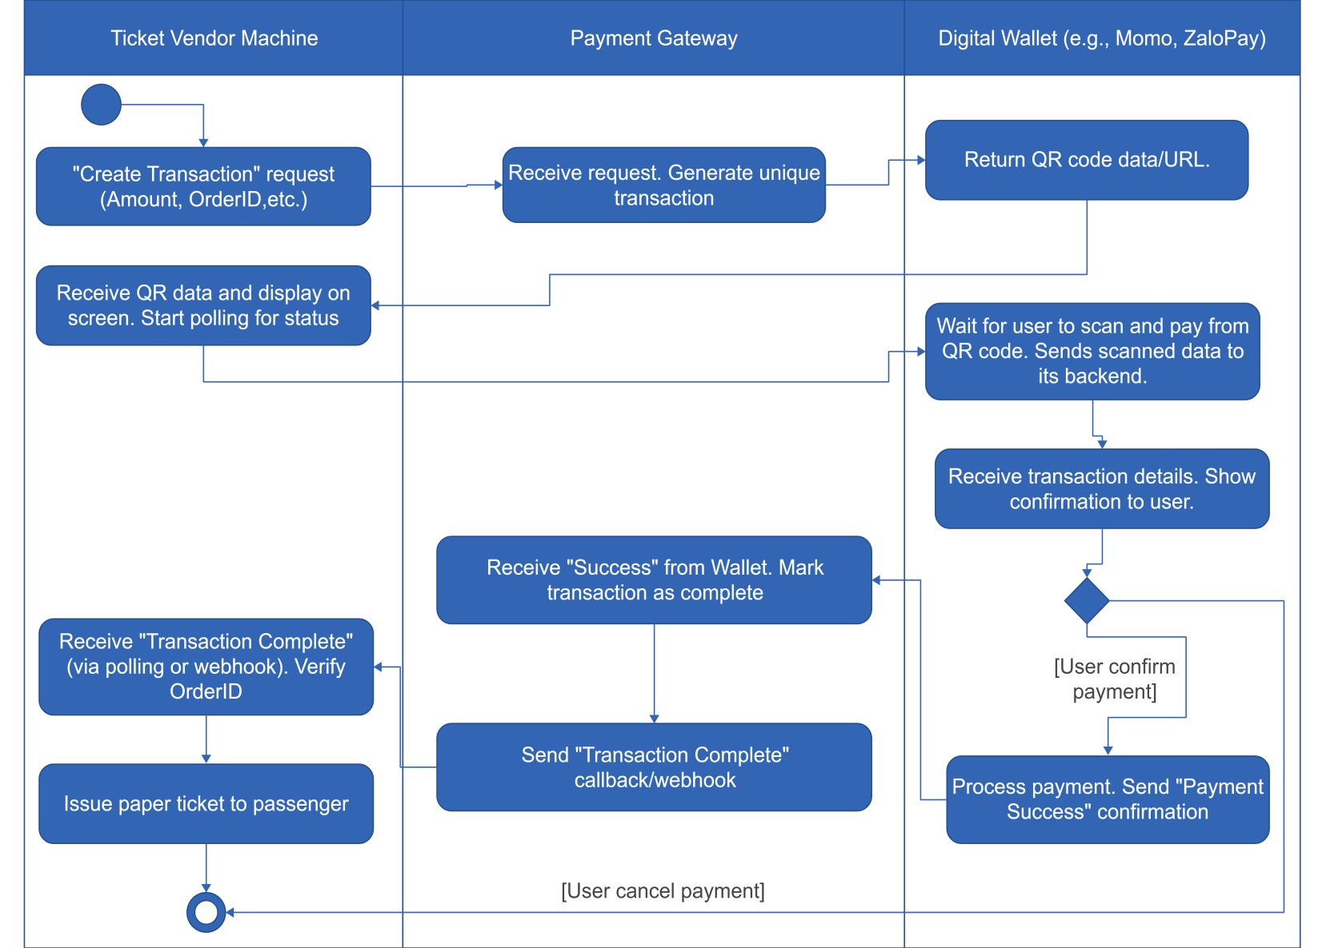
Task 5:
The sequence diagram of the Ticketing Vendor Machine have main use case is buy a ticket
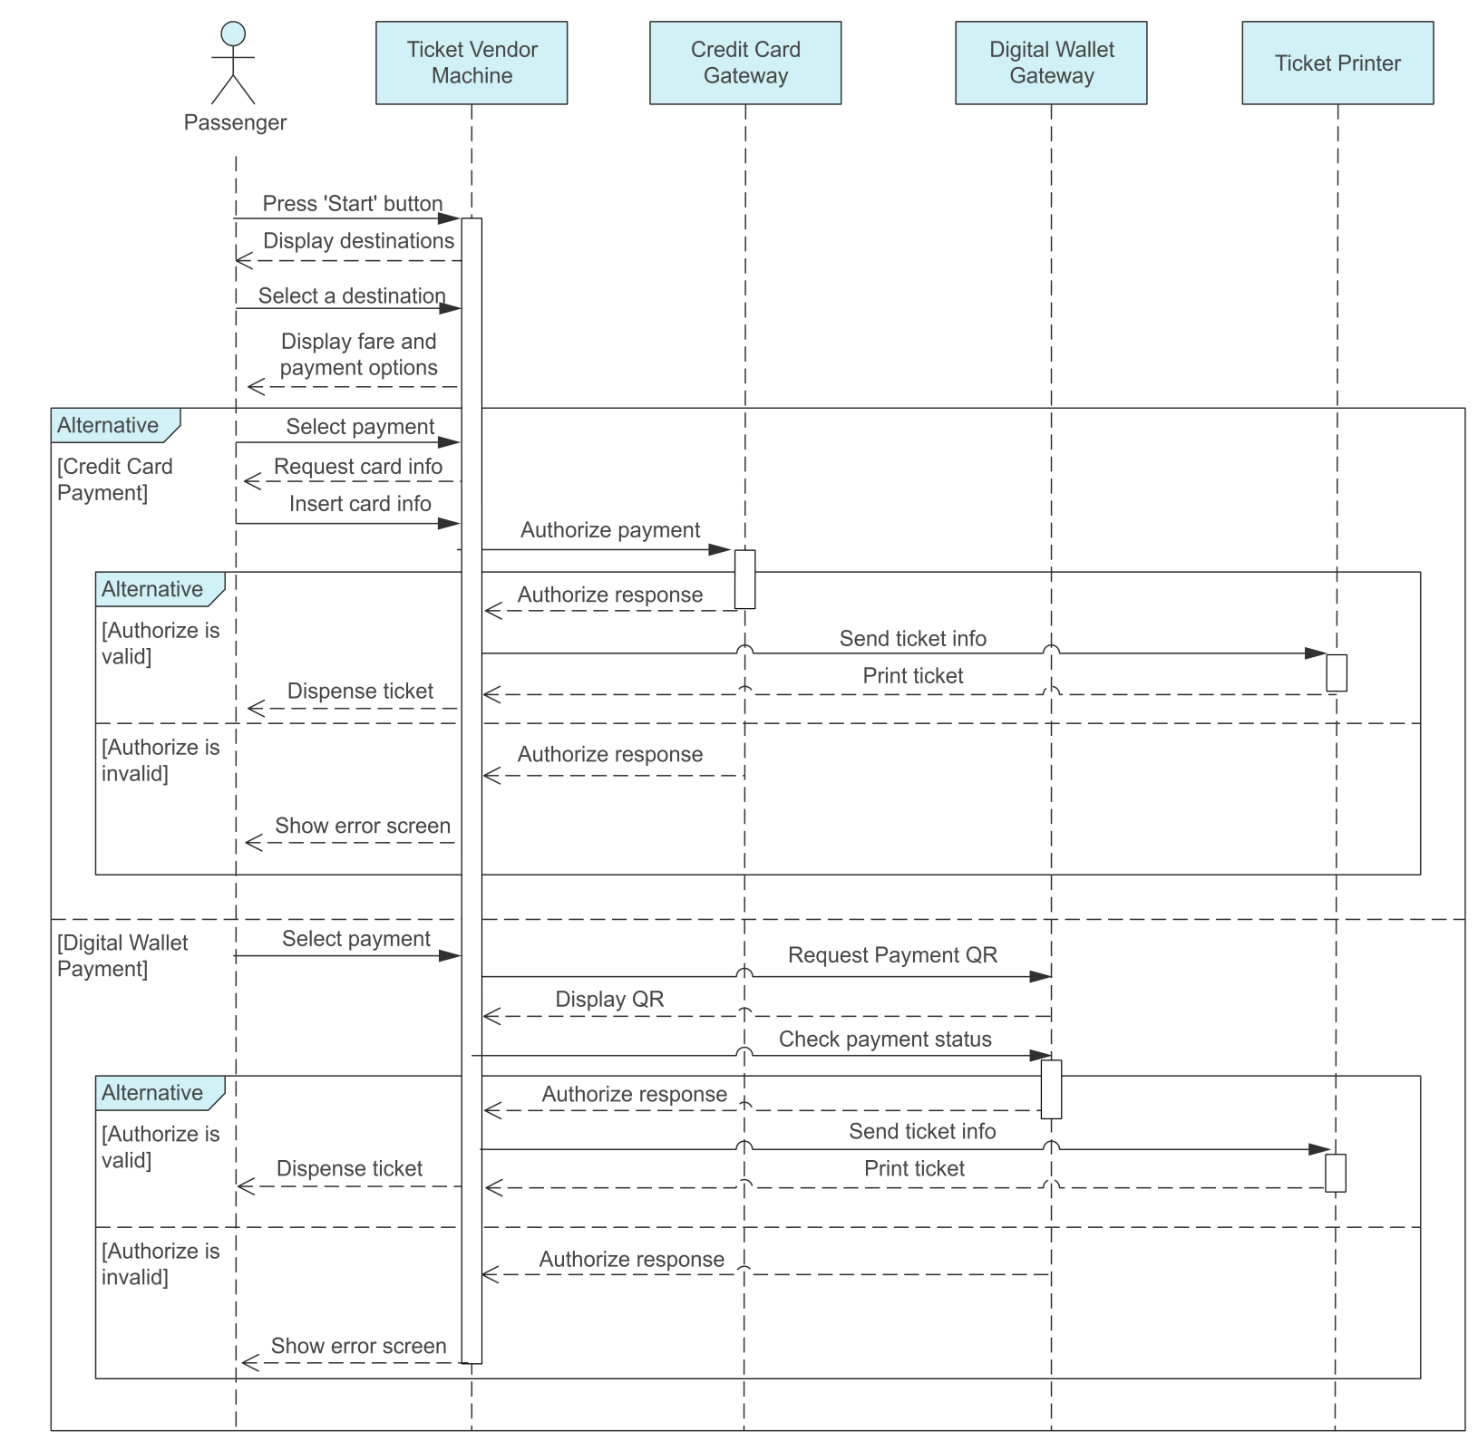

State chart diagram of the Ticketing Vendor Machine have main use case is buy a ticket
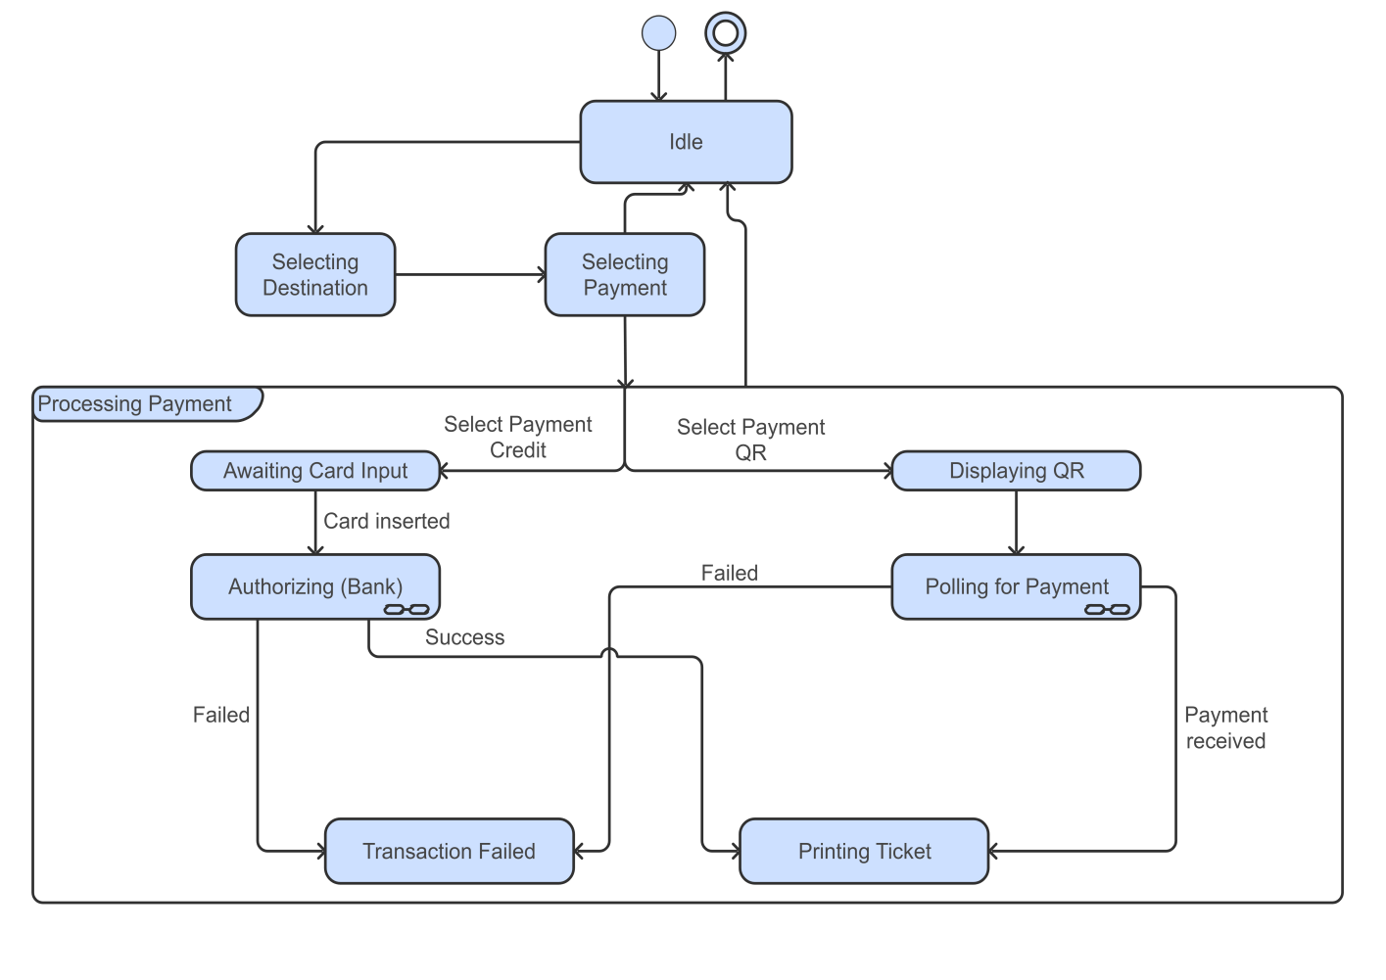

Class diagram of the Ticketing Vendor Machine have main use case is buy a ticket

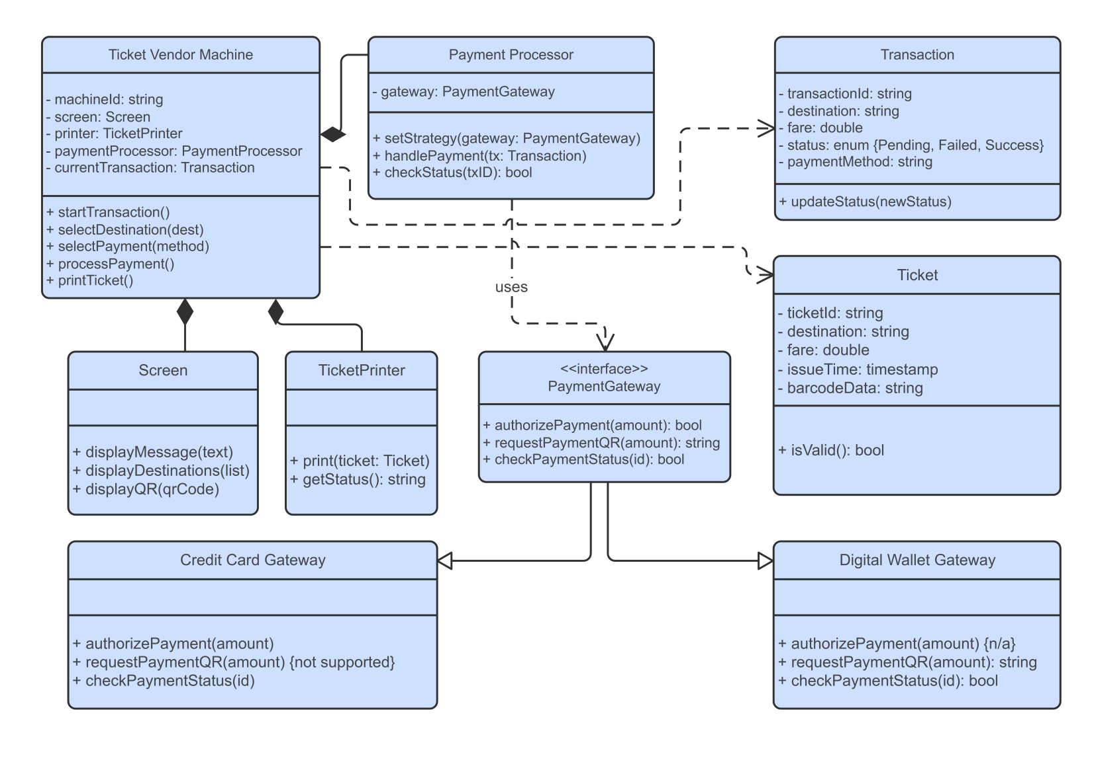
Task 6:
Prototype For Use Cases
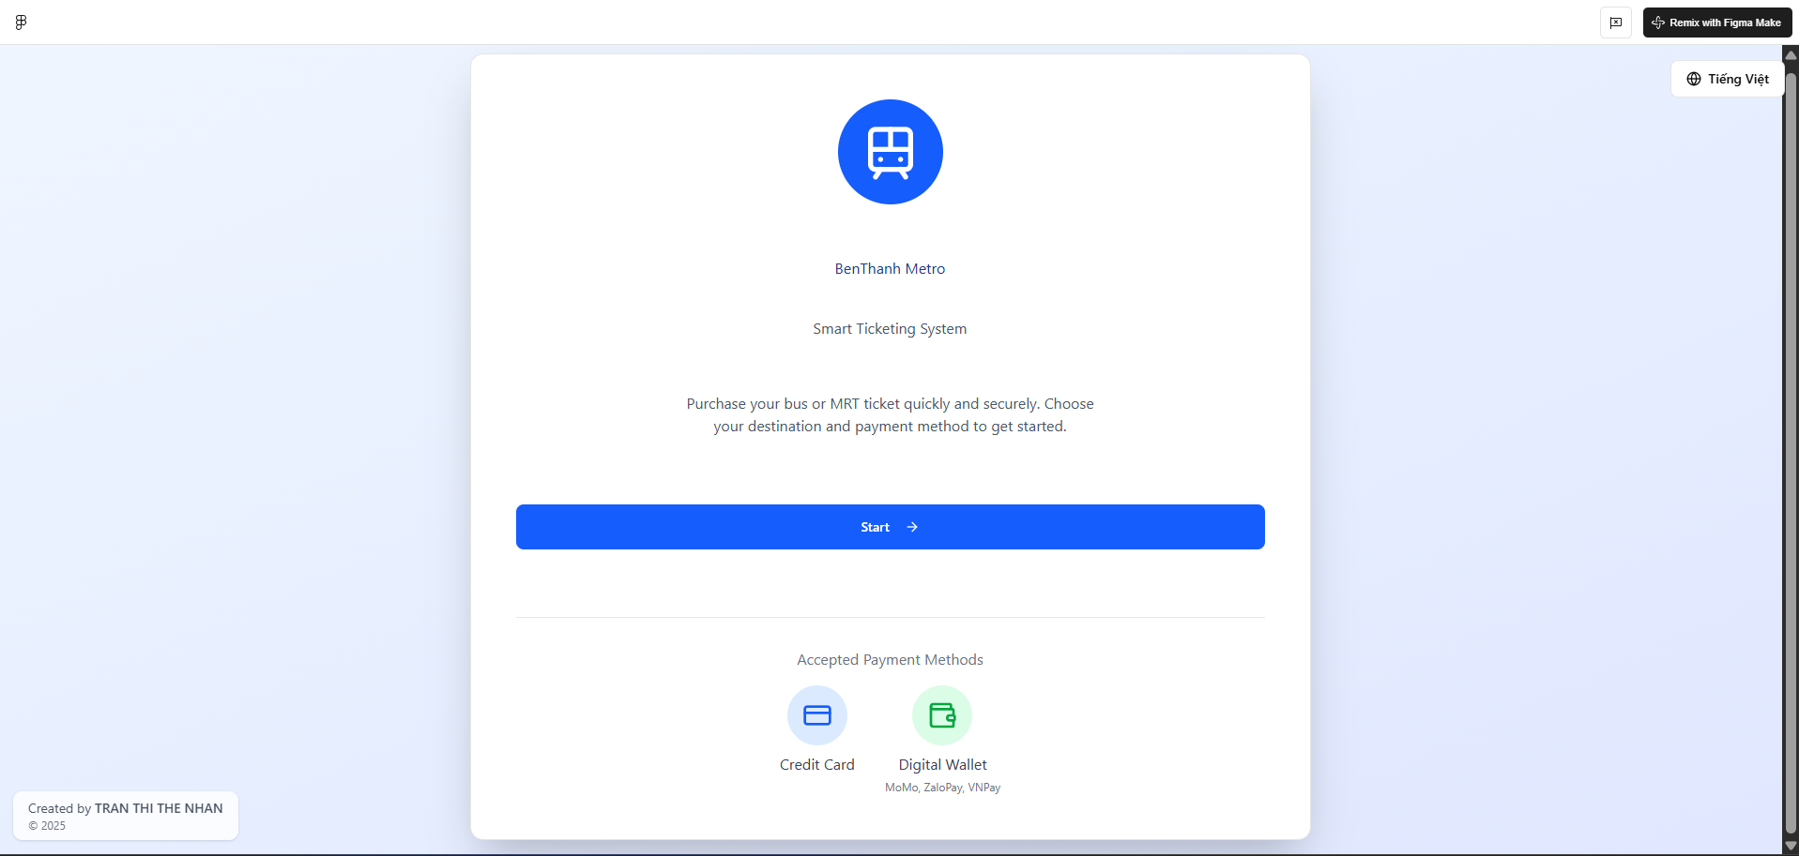
Home Screen
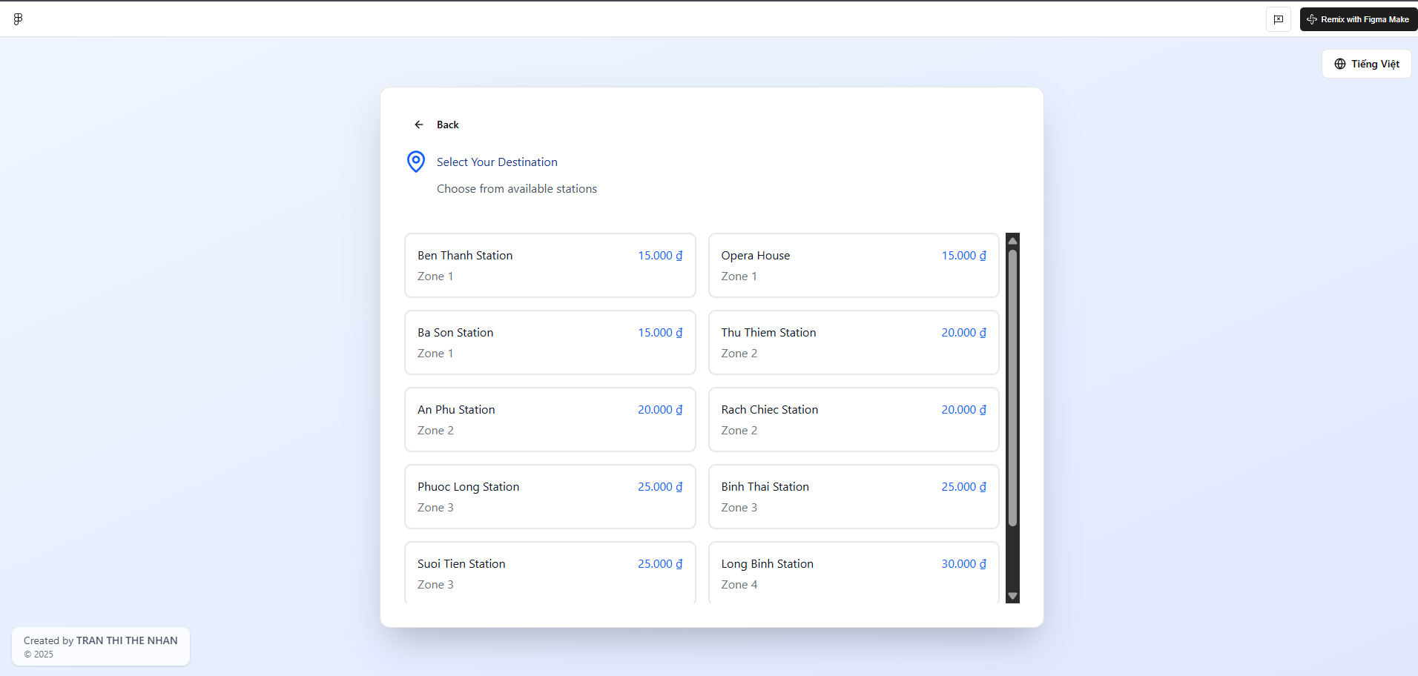
Choose a Destination Screen

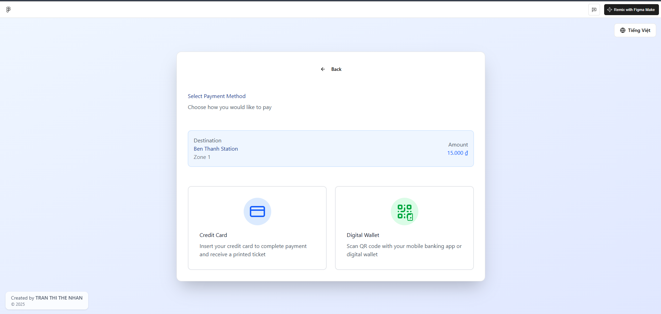
Choose a Payment method Screen

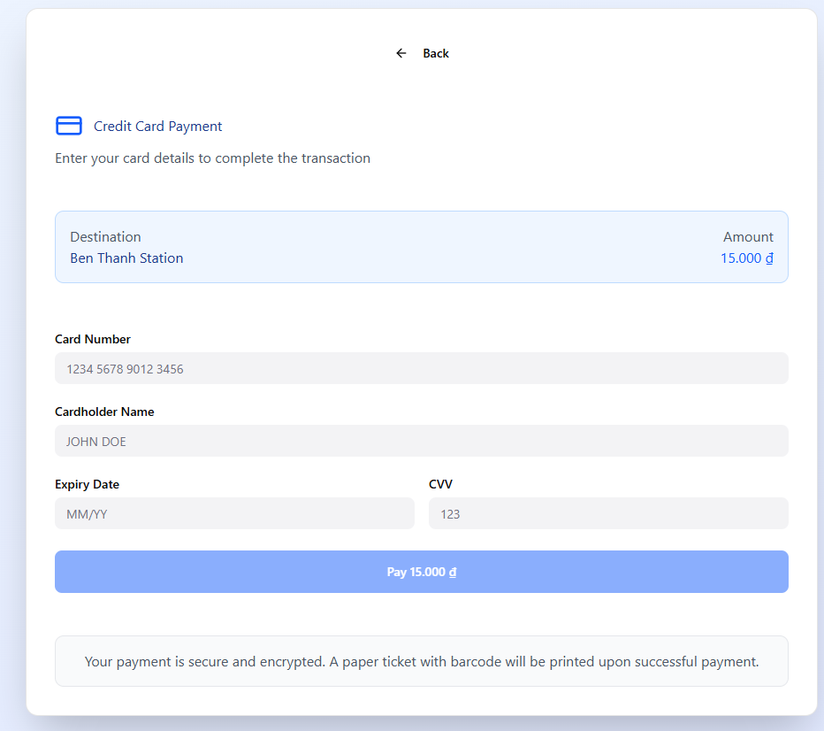
Card Payment Option

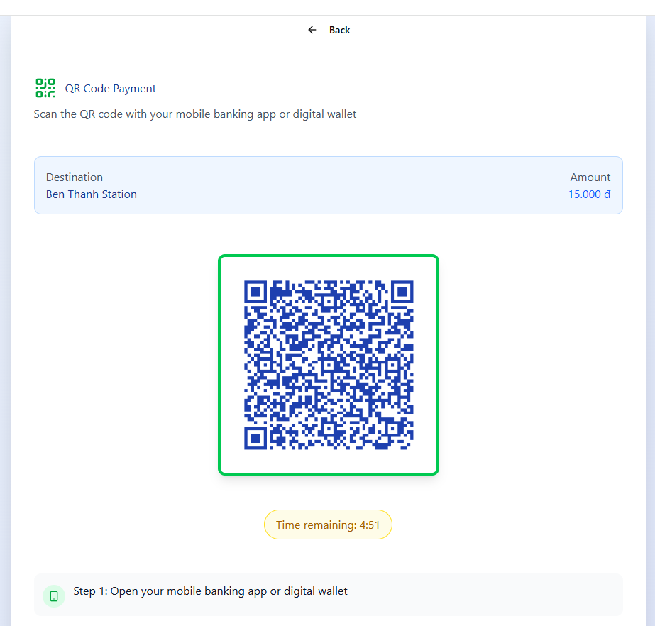
QR Payment Option (Digital Wallet)

Task 7:
MVC Architecture Design of the Ticketing Vendor Machine
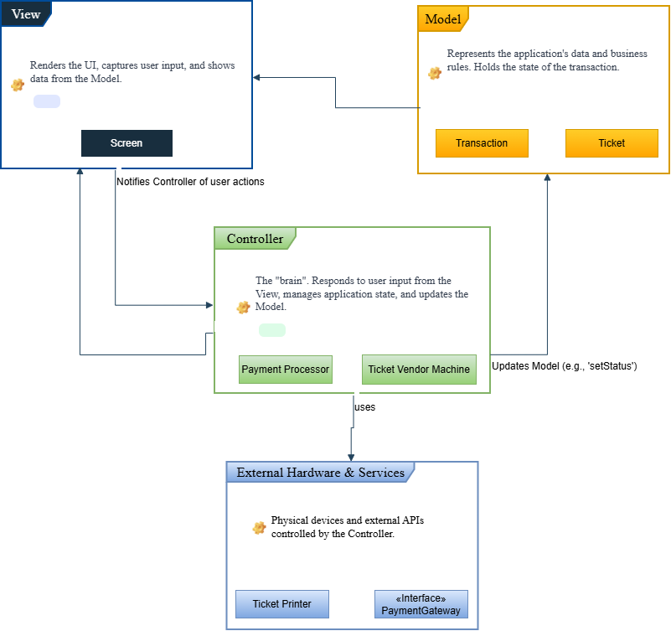

Deployment diagram of the Ticketing Vendor Machine
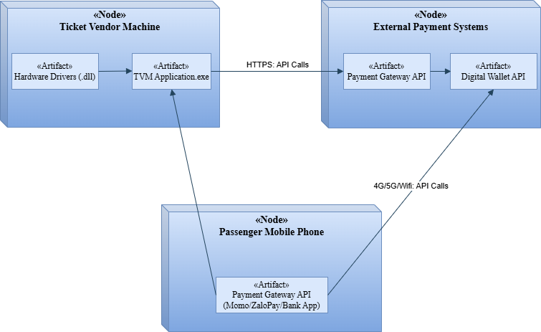
Task 8: Demo Software
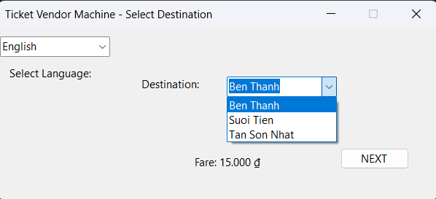

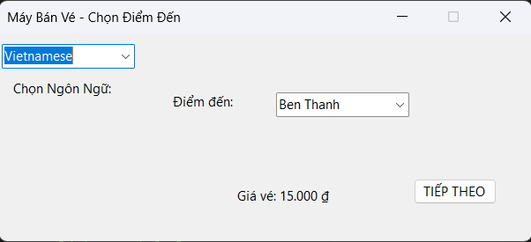

Two images of Home screen to select destinations with 2 languages version
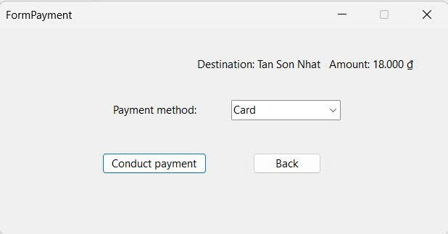

Payment Form to choose Payment Methods

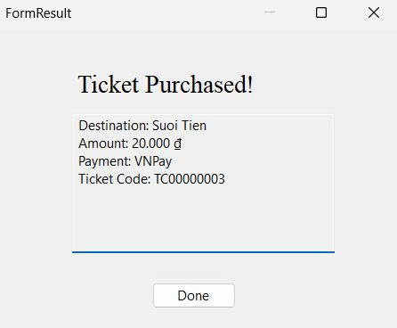
Payment Successfull Form

