**VIVEKANAND EDUCATION SOCIETY’S INSTITUTE OF TECHNOLOGY**

**An Autonomous Institute Affiliated to University of Mumbai**

**Department of Computer Engineering**



Project Report on

AI-Enabled Crop Monitoring and Assessment using Remote Sensing

In partial fulfillment of the Fourth Year, Bachelor of Engineering (B.E.) Degree in Computer Engineering at the University of Mumbai Academic Year 2023-24

**Submitted by**

Ayush Jain (D17B, 28)

Yash Kaka (D17B, 32)

Aditya Nehete (D17B, 47)

Swapnil Sakpal (D17B, 61)

**Project Mentor**

Mrs. Priya R L

(2023-24)

**VIVEKANAND EDUCATION SOCIETY’S INSTITUTE OF TECHNOLOGY**

**An Autonomous Institute Affiliated to University of Mumbai**

**Department of Computer Engineering**



**Certificate**

This is to certify that **Ayush Jain(28/D17B), Yash Kaka(32/D17B), Aditya Nehete(47/D17B), Swapnil Sakpal(61/D17B)**of Fourth Year Computer Engineering studying under the University of Mumbai have satisfactorily completed the project on “**AI-Enabled Crop Monitoring and Assessment using Remote Sensing**” as a part of their coursework of PROJECT-II for Semester-VIII under the guidance of their mentor **Mrs. Priya R L**in the year 2023-24 .

This thesis/dissertation/project report entitled AI-Enabled Crop Monitoring and Assessment using **Remote Sensing** by **Ayush Jain(28/D17B), Yash Kaka(32/D17B), Aditya Nehete (47/D17B), Swapnil Sakpal(61/D17B)** is approved for the degree of **B.E in Computer Engineering**

| Programme Outcomes | Grade |
| --- | --- |
| PO1,PO2,PO3,PO4,PO5,PO6,PO7,  PO8, PO9, PO10, PO11, PO12  PSO1, PSO2 |  |

Date:

Project Guide:

------------------------------------------

**Project Report Approval**

**For**

**B. E (Computer Engineering)**

This thesis/dissertation/project report entitled **AI-Enabled Crop Monitoring and Assessment using Remote Sensing** by **Ayush Jain(28/D17B), Yash Kaka(32/D17B), Aditya Nehete(47/D17B), Swapnil Sakpal(61/D17B)** is approved for the degree of Bachelor in Computer Engineering

Internal Examiner

---------------------------------------------

External Examiner

---------------------------------------------

Head of the Department

-----------------------------------------------

Principal

-----------------------------------------------

Date:

Place:

**Declaration**

We declare that this written submission represents our ideas in our own words and where others' ideas or words have been included, we have adequately cited and referenced the original sources. We also declare that we have adhered to all principles of academic honesty and integrity and have not misrepresented or fabricated or falsified any idea/data/fact/source in our submission. We understand that any violation of the above will be cause for disciplinary action by the Institute and can also evoke penal action from the sources which have thus not been properly cited or from whom proper permission has not been taken when needed.

| -----------------------------------------  -----------------------------------------  Ayush Jain(28/D17B) | -----------------------------------------  -----------------------------------------  Yash Kaka(32/D17B) |
| --- | --- |
| -----------------------------------------  -----------------------------------------  Aditya Nehete(47/D17B) | -----------------------------------------  -----------------------------------------  Swapnil Sakpal(61/D17B) |

Date:

**ACKNOWLEDGEMENT**

We are thankful to our college Vivekanand Education Society’s Institute of Technology for considering our project and extending help at all stages needed during our work of collecting information regarding the project.

It gives us immense pleasure to express our deep and sincere gratitude to **Mrs. Priya R L** for her kind help and valuable advice during the development of project synopsis and for her guidance and suggestions.

We are deeply indebted to Head of the Computer Department **Dr.(Mrs.) Nupur Giri** and our Principal **Dr. (Mrs.) J.M. Nair ,** for giving us this valuable opportunity to do this project.

We express our hearty thanks to them for their assistance without which it would have been difficult in finishing this project synopsis and project review successfully.

We convey our deep sense of gratitude to all teaching and non-teaching staff for their constant encouragement, support and selfless help throughout the project work. It is a great pleasure to acknowledge the help and suggestion, which we received from the Department of Computer Engineering.

We wish to express our profound thanks to all those who helped us in gathering information about the project. Our families too have provided moral support and encouragement several times.

**Computer Engineering Department**

**COURSE OUTCOMES FOR B.E PROJECT**

Learners will be to,

| **Course Outcome** | **Description of the Course Outcome** |
| --- | --- |
| CO 1 | Able to apply the relevant engineering concepts, knowledge and skills towards the project. |
| CO2 | Able to identify, formulate and interpret the various relevant research papers and to determine the problem. |
| CO 3 | Able to apply the engineering concepts towards designing solutions for the problem. |
| CO 4 | Able to interpret the data and datasets to be utilized. |
| CO 5 | Able to create, select and apply appropriate technologies, techniques, resources and tools for the project. |
| CO 6 | Able to apply ethical, professional policies and principles towards societal, environmental, safety and cultural benefit. |
| CO 7 | Able to function effectively as an individual, and as a member of a team, allocating roles with clear lines of responsibility and accountability. |
| CO 8 | Able to write effective reports, design documents and make effective presentations. |
| CO 9 | Able to apply engineering and management principles to the project as a team member. |
| CO 10 | Able to apply the project domain knowledge to sharpen one’s competency. |
| CO 11 | Able to develop a professional, presentational, balanced and structured approach towards project development. |
| CO 12 | Able to adopt skills, languages, environment and platforms for creating innovative solutions for the project. |

**Index**

| Chapter No. | Title | Page No. |
| --- | --- | --- |
| **1** | **Introduction** | 11 |
| 1.1 | Introduction | 11 |
| 1.2 | Motivation | 12 |
| 1.3 | Problem Definition | 12 |
| 1.4 | Existing Systems | 12 |
| 1.5 | Lacuna of the existing systems | 13 |
| 1.6 | Relevance of the Project | 13 |
| **2** | **Literature Survey** | 14 |
| 2.1 | Research Papers | 14 |
| 2.2 | Patent search | 17 |
| 2.3 | Inference drawn | 18 |
| 2.4 | Comparison with the existing system | 18 |
| **3** | **Requirement Gathering for the Proposed System** | 19 |
| 3.1 | Introduction to requirement gathering | 19 |
| 3.2 | Functional Requirements | 19 |
| 3.3 | Non-Functional Requirements | 20 |
| 3.4 | Hardware, Software , Technology and tools utilized | 21 |
| 3.5 | Constraints | 21 |
| **4** | **Proposed Design** | 22 |
| 4.1 | Block diagram of the system | 22 |
| 4.2 | Modular design of the system | 23 |
| 4.3 | Detailed Design | 24 |
| **5** | **Implementation of the Proposed System** | 26 |
| 5.1 | Methodology employed for development | 26 |
| 5.2 | Algorithms and flowcharts for the respective modules developed | 27 |
| 5.3 | Datasets source and utilization | 28 |
| **6** | **Testing of the Proposed System** | 29 |
| 6.1 | Introduction to Testing | 29 |
| 6.2 | Types of tests Considered | 29 |
| 6.3 | Various test case scenarios considered | 30 |
| 6.4 | Inference drawn from the test cases | 32 |
| **7** | **Results and Discussion** | 33 |
| 7.1 | Screenshots of User Interface (UI) for the respective module | 33 |
| 7.2 | Performance Evaluation measures | 36 |
| 7.3 | Input Parameters / Features considered | 37 |
| 7.4 | Inference drawn | 37 |
| **8** | **Conclusion** | 38 |
| 8.1 | Limitations | 38 |
| 8.2 | Conclusion | 38 |
| 8.3 | Future Scope | 39 |
|  | **References** | 40 |
|  | **Appendix** | 41 |

# 

# 

# 

# 

# 

# 

# 

# 

# 

# 

# 

# 

# 

# 

# 

# 

# 

# List Of Figures

| Fig No. | Heading | Page No. |
| --- | --- | --- |
| 1 | Block Diagram | 22 |
| 2 | Modular Diagram | 23 |
| 3 | Flowchart Diagram | 24 |
| 4 | TimeLine Diagram | 25 |
| 5 | Home Screen | 33 |
| 6 | Crop Planning Screen | 33 |
| 7 | Schemes Screen | 34 |
| 8 | Farmer Tool Screen | 34 |
| 9 | farmer Market Screen | 35 |
| 10 | Add Tools Screen | 35 |
| 11 | Evaluation Matrix | 36 |
| 12 | Confusion Matrix | 36 |

# Abstract

Data-driven, farmer-centric solutions are critical in the dynamic field of agriculture, which is defined by constantly shifting market needs and environmental conditions. In order to transform farming methods through the integration of cutting-edge technologies, this article introduces the comprehensive Crop Planning and Market Information System, or AgriGuru.

AgriGuru optimizes crop health by facilitating disease identification and providing customized cures through the use of AI and remote sensing. Moreover, it makes customized crop suggestions that are in line with market trends by utilizing soil analysis. AgriGuru provides farmers with up-to-date market information and chances for agricultural stock launches, addressing their vital need to be informed about market conditions.

AgriGuru gives a comprehensive suite of services tailor-made to crop management. Firstly, it gives Crop Planning abilities, utilizing a choice tree set of rules. Farmers can enter their soil parameters, permitting the machine to endorse the most suitable crops for cultivation primarily based on their unique situations.

Additionally, AgriGuru offers Disease Detection functionality, leveraging EfficientNetB3 for image processing. This function allows farmers to capture photographs of their plants and accurately come across any diseases present. Moreover, the platform affords access to numerous Schemes for Farmers, presenting statistics on tasks beneficial for his or her development and prosperity. Furthermore, AgriGuru provides agricultural equipment and equipment, allowing farmers to list their objects for rent. Lastly, the platform gives Crop Cultivation Guidance, supplying farmers with exact information on cultivation cycles to optimize their crop control practices. Through those incorporated functions, AgriGuru aims to empower farmers with the tools and information essential for improved crop sustainability.

# Chapter 1: Introduction

## 1.1 Introduction

The agriculture sector is facing an increasingly daunting challenge: how to ensure sustainability while meeting the burgeoning global demand for fresh produce. As the world's population continues to grow, traditional farming practices have proven to be resource-intensive and often detrimental to the environment. Balancing this growing demand with sustainable farming practices is a complex problem that calls for innovative solutions.

In response to these pressing challenges, a visionary project has emerged, underpinned by cutting-edge technologies. Leveraging the power of remote sensing, artificial intelligence (AI), and machine learning (ML), this project sets out to provide a novel solution to the dilemmas plaguing modern agriculture.

The heart of this undertaking lies in early detection, where AI and ML algorithms are leveraged to experiment the subtlest signs and symptoms of hassle in crop management. These signs and symptoms encompass crop illnesses in plants, regularly imperceptible to the naked eye till they have inflicted full-size harm. This insight equips farmers with the energy to intrude directly, safeguarding their harvests and optimizing agricultural practices.

Furthermore, the challenge integrates records evaluation and predictive modeling skills poised to revolutionize the agricultural landscape. By consuming and processing sizable amounts of information concerning plant health and soil exceptional, those technologies discover anomalies and enable forecasting. From disease outbreaks to ultimate planting and harvesting instances, predictive modeling offers valuable insights. Armed with such knowledge, farmers can adjust their actions with precision, thereby decreasing useful resource wastage and improving crop health.

In addition to these advanced functions, AgriGuru also provides a Rental Tool facility, allowing farmers to list agricultural gear tools for rent. Moreover, the platform provides a Crop Calendar function, detailing the planting and harvesting schedules for numerous crops in Maharashtra together with their respective charges. This complete approach guarantees that farmers have a right of entry to a huge variety of equipment, records, and sources to optimize their agricultural practices and maximize crop sustainability.

## 1.2 Motivation

The motivation behind AI-Enabled Crop Monitoring and Assessment using remote sensing lies in its potential to significantly enhance agricultural productivity while optimizing resource usage. By harnessing the power of artificial intelligence and machine learning, this approach provides farmers and agricultural organizations with valuable insights into the health and growth of crops. This information empowers them to make data-driven decisions, ultimately leading to improved crop yield and quality.

## 1.3 Problem Definition

The Agriculture industry is at a crucial juncture, facing pressing challenges to ensure sustainable agriculture and meet the growing global demand for fresh produce. To address these critical needs, our project aims to pioneer a game-changing solution leveraging cutting-edge AI, and ML technologies.

Our mission is to develop an innovative and cost-effective system that empowers farmers with real-time insights into their crop health, enabling early detection of diseases, nutrient deficiencies, and stress factors. By harnessing the power of advanced data analysis and predictive modeling, our system will facilitate timely intervention and optimization of agricultural practices, thereby significantly reducing yield loss and enhancing overall productivity.

## 1.4 Existing Systems

### 1. Plantix - your crop doctor

Plantix is a crop doctor app available on Android and iOS that serves as a valuable tool for farmers. It aids in plant disease detection through image recognition technology. Users can capture pictures of their crops, and the app identifies potential issues based on visual cues. Plantix offers insights into pest infestations, nutrient deficiencies, and diseases. The app also provides recommended solutions and farming advice, contributing to effective crop management.

### 2. Agrobase:

Agrobase is an app that helps farmers and agronomists identify pests, diseases, and deficiencies in various crops. It offers a large plant and pest database, making it a handy tool for crop monitoring and management.

### 3. PlantSnap:

While primarily designed for plant identification, PlantSnap can be used to identify crop diseases and pests by taking pictures of affected plants. It can be a useful app for monitoring crop health and addressing potential issues.

### 4. MyAgriGuru:

MyAgriGuru is an agriculture advisory app that provides information on crop management, pest control, and disease identification. It offers personalized recommendations based on crop type and location.

## 1.5 Lacuna of the existing systems

A drawback of existing systems for AI-Enabled Crop Monitoring and Assessment using remote sensing is their dependency on certain factors and limitations. Furthermore, the availability of high-resolution and up-to-date remote sensing data may be uneven, hindering the effectiveness of these systems in regions with poor infrastructure or political restrictions. Additionally, the interpretation of remote sensing data often requires specialized expertise, which can be a barrier for some users who lack the necessary training and knowledge. These limitations need to be addressed to ensure the equitable and widespread adoption of AI-enabled crop monitoring and assessment for the benefit of all farmers and agricultural stakeholders.

## 1.6 Relevance of the Project

The project on AI-Enabled Crop Monitoring and Assessment using remote sensing is highly relevant for several reasons. It directly addresses the need to improve agricultural practices and productivity. By providing farmers and agricultural organizations with tools and insights, it enables more informed decision-making, leading to increased crop sustainability and food security. It also helps mitigate risks by allowing early detection of issues like disease outbreaks and adverse weather conditions. Furthermore, the project aligns with global efforts to reduce the environmental impact of agriculture by minimizing resource wastage and the use of chemicals.

# Chapter 2: Literature Survey

## 2.1 Research Papers Referred

1. **Development of Efficient CNN model for Tomato crop disease identification (2020)**

**Methodology**: Utilizes deep learning techniques, specifically convolutional neural networks (CNNs), dataset collection, and image preprocessing for automatic detection of tomato leaf diseases.

**Performance Measure:** Successfully detects tomato leaf diseases in images, dependent on image quality and quantity. Limited generalization to various tomato diseases or plant types.

**Inference**: CNNs facilitate accurate and efficient disease detection, aiding early diagnosis and intervention for tomato crops.

**Limitations**: Reliance on specific image characteristics and types of diseases may restrict generalizability.

1. **Development of risk assessment model for farmers in tomato supply chain (2016)**

**Methodology**: Proposes a conceptual risk assessment model (FACOO) to address challenges in tomato supply chain stages.

**Performance Measure**: Accuracy, speed and video analysis.

**Inference**: FACOO offers a systematic approach to understanding and categorizing risks in the tomato supply chain, potentially aiding strategic decision-making. Identifying and categorizing various challenges faced by tomato farmers into different categories

**Limitations**: Theoretical without practical application, limiting immediate utility to farmers and stakeholders.

1. **Crop cultivation planning with fuzzy estimation using water wave optimization (2023)**

**Methodology**: optimize crop cultivation planning using fuzzy estimation and water wave optimization techniques.

**Performance Measure**: Implementation leads to improved crop yield and resource efficiency.

**Inference**: Integrating fuzzy estimation and optimization offers a robust approach to crop cultivation planning, enhancing agricultural productivity.The primary objective is to optimize the planning of crop cultivation, including decisions related to crop selection etc.

**Limitations**: Uncertainty in fuzzy estimation may introduce complexity and decision-making challenges.

1. **Crop planning optimization research (2016)**

**Methodology**: Provides insights into crop planning problems using LINGO optimization tools for fertilizer management, soil optimization, etc.

**Performance Measure**: to offer effective crop planning strategies maximizing profit.

**Inference**: LINGO provides valuable insights into optimizing crop planning, potentially increasing agricultural profitability.

**Limitations**: Effectiveness may be context-specific, limited to particular regions or agricultural contexts.

1. **Tomato Leaf Disease Detection Using Deep Learning Techniques (2020)**

**Methodology**: Proposes a methodology for classifying tomato leaf diseases using Convolution Neural Networks (CNN).

**Performance Measure**: Achieved 98% accuracy using CNN for hierarchical feature extraction.

**Inference**: CNNs offer high accuracy in disease classification, aiding in precise diagnosis and management.The objective of the paper is to propose a methodology that could classify the tomato leaf diseases and suggest the best solution to overcome the same.

**Limitations**: Survey limitations due to the vastness of the subject.

1. **Recommendation System for Crop Identification and Pest Control Technique in Agriculture (2019)**

**Methodology**: Involves data collection and machine learning algorithms (SVM, Decision Tree, Logistic Regression) for crop selection and pest prediction models.

**Performance Measure**: Develops crop prediction model with best accuracy using SVM. Effectiveness of pest prediction and control model mentioned but not detailed.

**Inference**: Provides farmers with informed crop selection decisions and potential pest predictions, aiding in sustainable agriculture.

**Limitations**: Dependence on data quality, potential regional variations, omission of external factors, lack of detailed information on model effectiveness and ethical/regulatory considerations.

1. **A Survey Paper on Plant Disease Identification (2018)**

**Methodology**: Conducts literature review on plant disease identification using machine learning techniques.

**Performance Measure**: Suggests SVM as a suitable method for disease identification.

**Inference**: Advocates for machine learning in disease identification, highlighting its potential benefits.The research resulted in the development of a crop prediction model with the best accuracy achieved using SVM. The effectiveness of the pest prediction and control model was mentioned but not detailed.

**Limitations**: Lacks experimental results, insufficient details on image processing, no datasets mentioned, limited references.

1. **Disease Detection and Classification in Agricultural Plants (2019)**

**Methodology**: Develops deep learning model for plant disease detection using Convolutional Neural Network (CNN).

**Performance Measure**: Achieves 88.7% accuracy with compact model and reduced overfitting.

**Inference**: Provides efficient disease detection tools with high accuracy, benefiting agricultural productivity.

**Limitations**: Limited to binary classification, requires substantial labeled data, real-time implementation and scalability challenges, limited generalization to other crops and environments.

## 2.2 Patent search

1. **System and method for using artificial intelligence to monitor and assess crop health**

**Patent number:** US20190235479A1

**Year of patent**: 2019

**Summary**: This patent describes a system and method for AI-enabled crop monitoring and assessment using remote sensing. The system includes a remote sensing device for collecting data about the crops, and a computing device for processing the data and generating insights. The computing device is trained on a dataset of historical crop data, including remote sensing data, weather data, and yield data. This allows the system to learn the relationships between the different data sources and identify patterns that indicate crop health problems or potential yield variations.

The system can be used to monitor crops for a variety of problems, including pests, diseases, nutrient deficiencies, and water stress. The system can also be used to predict crop yields and identify areas of the field that may need additional attention.

1. **Method and system for crop yield prediction using artificial intelligence**

**Patent number**: US20210240081A1

**Year of patent**: 2021

**Summary**: This patent describes a method and system for crop yield prediction using AI. The system uses a variety of data sources, including remote sensing data, weather data, and historical crop data, to predict crop yields. The system can be used to predict crop yields at the field level, the farm level, or even the regional level.

## 

## 

## 

## 

## 

## 2.3. Inference drawn

The literature survey reveals a growing emphasis on leveraging AI and deep learning techniques for crop disease identification and crop planning. Notably, deep learning models like CNNs have shown promising results in automatic disease detection and classification, although their effectiveness is often limited by image dataset quality and specificity to certain crops or diseases. Furthermore, optimization and planning models face challenges in generalization and handling uncertainty. The patents highlight advancements in AI-enabled systems for comprehensive crop monitoring, assessment by integrating various data sources, including remote sensing and weather data. Overall, there is a clear trend towards the development and implementation of AI-based solutions in agriculture to enhance crop health, optimize cultivation planning, and predict yields, with challenges remaining in data quality, generalization, and scalability.

## 2.4 Comparison with the existing system

Existing agricultural systems such as Plantix, Agrobase,PlantSnap, and MyAgriGuru play a crucial role in assisting farmers with crop management and disease detection. Plantix,for instance, employs innovative image recognition technology to diagnose plant diseases and nutrient deficiencies, offering personalized recommendations for effective crop management. Similarly, Agrobase provides farmers and agronomists with access to a vast database of crop variety data and prices. PlantSnap, while primarily serving as a plant identification tool, also aids farmers in monitoring crop health by identifying diseases and pests through image analysis. Additionally, MyAgriGuru offers comprehensive agriculture advisory services, including crop management guidance. These existing systems contribute significantly to enhancing agricultural productivity and sustainability by empowering farmers with valuable insights and recommendations for informed decision-making.

# Chapter 3. Requirement Gathering for the Proposed System

## 3.1 Introduction to requirement gathering

The requirement gathering process was a pivotal initial phase in the development of our AI-enabled Crop Monitoring and Disease Detection System. Recognizing the unique challenges and needs of the agricultural sector, we engaged directly with farmers, agronomists, and other stakeholders through various methods, including interviews, surveys, and workshops. This collaborative approach allowed us to gain a deep and comprehensive understanding of the specific requirements, expectations, and operational challenges faced by the users.

During this phase, we focused on identifying and documenting both the functional and non-functional requirements of the system. This involved defining the desired features, functionalities, performance criteria, and constraints, as well as understanding the broader objectives and goals that the system should achieve to optimize agricultural practices and enhance crop productivity.

The gathered requirements were systematically analyzed, prioritized, and documented in detail. This comprehensive documentation served as a foundational guide for the subsequent design, development, and implementation phases of the project. It outlined the specific features and functionalities that the system needed to incorporate, ensuring that the final solution would be practical, effective, and aligned with the needs of the agricultural community.

## 3.2 Functional Requirements

**Image Preprocessing**: It must perform preprocessing tasks such as image enhancement, noise reduction, and calibration to prepare the data for analysis.

**Disease Prediction**: The system should be capable of identifying different diseases based on the image of the crop. Based on the trained model, the disease will be predicted when the user enters the video of the farm, the video is converted into images and each image is used for prediction.

**Crop Recommendation**: The system should possess the capability to detect suitable crops based on parameters such as N, P, K, weather, and rainfall. This detection model is constructed using a decision tree algorithm, utilizing data sourced from the government of agriculture, derived from recent studies.

**Crop Prices**: The system must exhibit crop prices for various crop varieties. These prices are determined based on theoretical considerations and encompass a wide range of crops across all districts of Maharashtra. The data is collected by scraping information from Wikipedia and through the Mandi API.

**Marketplace**: The system must be able to allow farmers to rent a tool such as tractor, pesticide or other related tool. Farmers can also add their tools for rent . The price of the tool are set based on recent market trend prices.

**Crop** **Calendar**: The system should provide farmers access to information regarding the various steps involved in the cultivation process for each crop. Additionally, they can verify whether all the necessary steps are being carried out in the correct order, ensuring optimal crop management practices.

## 3.3 Non-Functional Requirements

**Scalability:** The system should be able to handle a large volume of remote sensing data as the operation scales up.

**Performance:** It should provide real-time or near-real-time analysis to ensure timely decision-making.

**Security:** Data security and privacy measures must be in place to protect sensitive agricultural information.

**Usability:** The user interface should be intuitive and user-friendly, catering to users with varying levels of technical expertise.

**Reliability:** The system must be highly reliable, with minimal downtime, to support continuous monitoring and assessment.

**Accuracy:** The accuracy of crop health assessments and crop planning should meet predefined standards.

**Compliance:** The system should adhere to relevant regulations and standards in data collection and processing.

## 3.4 Hardware, Software , Technology and tools utilized

1. Android Mobile Phone
2. Web Browser
3. Camera
4. Visual Studio Code editor
5. Data Visualization tools (MS Excel, PowerBi)
6. CCTV Camera, Smartphone, or Laptop Camera
7. OpenCV
8. TensorFlow or PyTorch
9. Flutter
10. Flask
11. SQLite or MySQL

## 3.5 Constraints

**Data Quality and Quantity**: The performance of models is highly dependent on the quality and quantity of the image datasets. Limited or poor-quality data can lead to reduced accuracy and limited generalization.

**Generalization**: Many existing models and systems are tailored to specific crops or diseases, limiting their applicability to broader agricultural contexts or different types of plants.

**Uncertainty and Complexity**: The introduction of uncertainty and complexity in modeling and decision-making processes, especially in crop planning, can pose challenges to the effectiveness of the optimization models.

**Scalability**: Expanding the Smart Crop Management system to cover larger agricultural areas or diverse farming practices may pose challenges in terms of data processing, user engagement, and system performance.

# Chapter 4: Proposed Design

## 4.1 Block diagram of the system

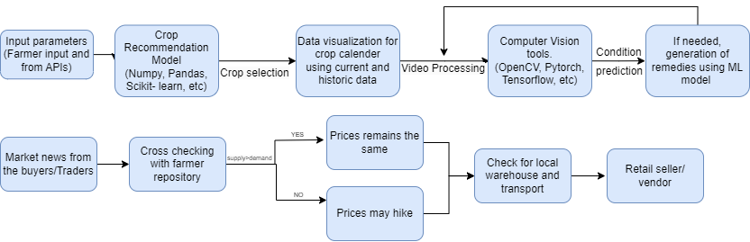

*fig 1*: Block Diagram

The system operates through two primary blocks: In the "Crop Recommendation and Disease Prediction Block," farmers provide input parameters through an API, enabling a crop recommendation model to suggest the most suitable crops for their conditions. The system enhances decision-making by visualizing a crop calendar through video processing and uses computer vision tools to monitor crop health. When necessary, it employs machine learning to generate remedies for crop issues. In the "Marketplace Block," the system cross-checks market news with historical supply and demand data from a farmer repository. If prices increase, it explores options like local warehousing and retailer/vendor connections to maximize returns. These blocks synergistically empower farmers with informed decision-making for crop selection and supply chain management.

## 4.2 Modular design of the system

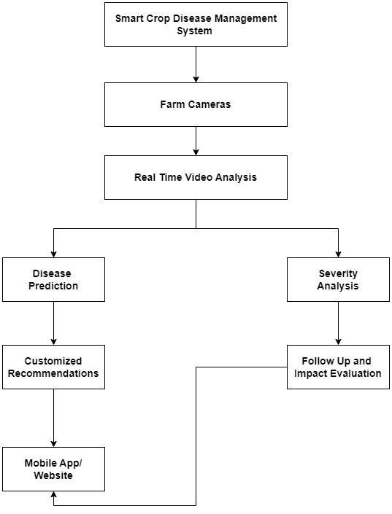

*fig 2 :* Modular Diagram

The "Smart Crop Disease Management" system aims to efficiently address crop diseases through a multi-faceted approach. For now, it utilizes a video which can be uploaded or captured for the video analysis with a focus on disease prediction. Future scope includes real-time fetching the video using CCTV cameras which will be installed at the farms. When a disease is detected, it offers personalized guidance to farmers through a mobile app/website. Simultaneously, the system assesses disease severity and determines follow-up actions. The mobile app/website serves as the user interface, enabling farmers to access disease predictions, recommendations, and track the results for effective crop disease management.

## 4.3 Detailed Design

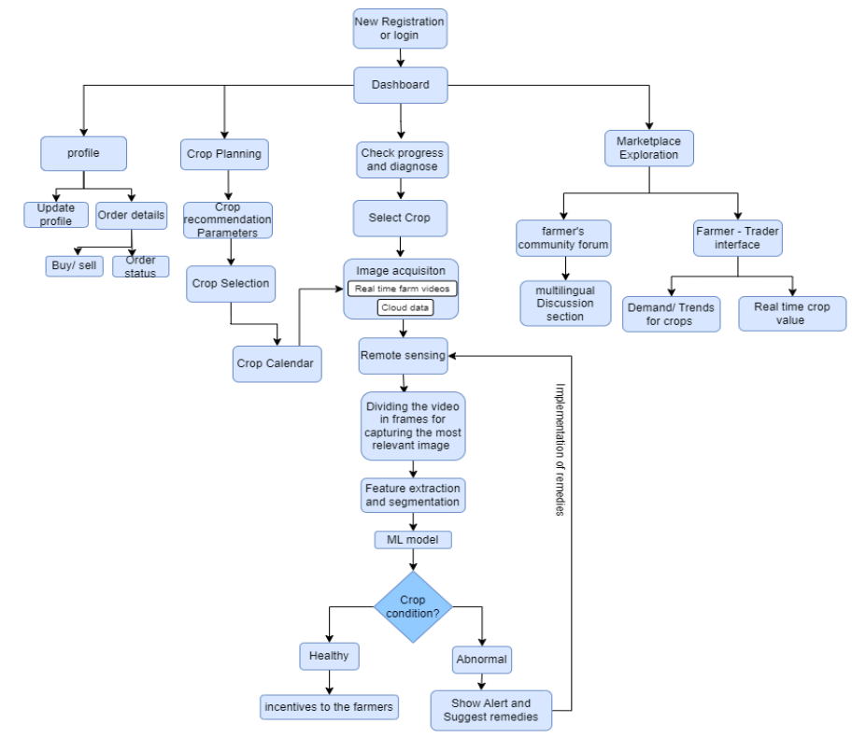

*fig 3* : Flowchart of the AgriGuru Model

The Smart Crop Management system is a comprehensive platform designed to assist farmers in optimizing their farming practices. The process begins with farmers creating or logging into their account, where they can select a crop type tailored to their specific needs. Factors such as climate, soil type, water availability, and market demand are taken into consideration during the selection process. Additionally, the system offers a range of supportive features. It provides personalized guidance on disease management and control strategies to help farmers safeguard their crops.

A dedicated marketplace module is also available, allowing farmers to rent or buy farming equipment and tools, as well as to rent out their own equipment to others. Furthermore, the system offers valuable insights into the recent market price of the selected crop type, enabling farmers to make informed decisions when selling their produce. Recognizing the importance of government support for farmers, the system informs users about various government schemes available to them and offers guidance on how to effectively utilize these schemes. To cater to a diverse farming community, the mobile app and website offer multilingual support, ensuring accessibility and ease of use for all users.

## 4.4 Project Scheduling & Tracking using Gantt Chart

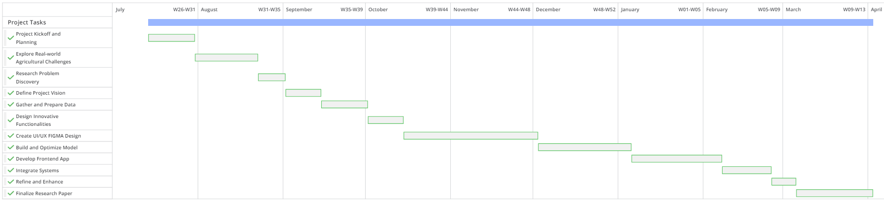

*fig 4:* TimeLine

In our agricultural information system project, the Gantt chart plays a pivotal role as our guiding tool. It efficiently organizes tasks and timelines, reflecting our collective vision for precision and innovation in project planning.

# 

# Chapter 5: Implementation of the Proposed System

## 5.1. Methodology employed for development

The methodology employed in this project revolves around leveraging cutting-edge technologies, including remote sensing, artificial intelligence (AI), and machine learning (ML), to address critical challenges in the agriculture sector. The following steps highlight the methodology used:

**Data Acquisition**: Collect remote sensing data from reliable sources, such as satellite imagery or drone footage. Ensure data quality and accessibility.

**Image Preprocessing**: Perform essential preprocessing tasks, including image enhancement, noise reduction, and calibration. Prepare the data for further analysis.

**Crop Recommendation**: Implement algorithms to predict which crop is suitable for the better yield based on soil and weather conditions of the area.

**Crop Health Assessment**: Analyze key parameters, such as vegetation indices (e.g., NDVI, NDRE), to assess the health of crops. Detects disease and nutrient deficiencies in the crops using AI and ML.

**Anomaly Detection**: Implement anomaly detection algorithms to identify issues like pest infestations and adverse weather conditions. Generate alerts for early intervention.

**Reporting and Visualization**: Create detailed reports and interactive visualizations to make data understandable and actionable for users.

**Marketplace**: Provide real-time prices of crops for all varieties of tomato in Maharashtra.

**Security and Compliance**: Implement data security and privacy measures to protect sensitive agricultural information. Ensure compliance with relevant regulations and standards in data collection and processing.

**Accuracy and Interoperability**: Set accuracy standards for crop health assessments and yield predictions. Make the system compatible with various remote sensing platforms, sensors, and data formats.

## 5.2 Algorithms and flowcharts for the respective modules developed

**CNN(Convolution Neural Network):**

A Convolutional Neural Network (CNN) is a specialized type of artificial neural network designed for processing and analyzing visual data, like images and video. It uses layers of convolution, pooling, and fully connected layers to extract features and is widely used for tasks like image recognition and object detection.

**Linear SVM(Support Vector Machine):**

A Linear Support Vector Machine (Linear SVM) is a machine learning algorithm that separates data into different categories using a straight line (or a hyperplane in higher dimensions). It aims to maximize the margin between these categories, making it suitable for data that can be separated with a straight line. It's often used for classification tasks and is efficient and effective when the data is linearly separable.

**Decision Tree:**

A Decision Tree is a machine learning algorithm that uses a tree-like structure to make decisions and classify or predict data. It breaks down data based on features, assigning categories or values at each branch, making it easy to understand and interpret.

**ANN(Artificial Neural Network):**  
Artificial Neural Networks (ANNs) are machine learning models inspired by the human brain. They consist of layers of interconnected nodes (neurons) and are used for tasks like image recognition and natural language processing. They learn from data through a training process and are versatile, but may require substantial data and computation. ANNs have applications in diverse fields, from healthcare to finance and robotics.

## 5.3 Datasets source and utilization

**PlantVillage Dataset:** Contains images of various plant diseases, used for training and testing the disease detection model.The dataset contains images related to various diseases related to tomato. They are classified based disease detected yes or no

**Historical Crop Data:** Crop data includes data from the ministry of agriculture for different clop planning . The dataset consists of different soil parameters like N P K and other parameters like rainfall and temperature in that area.

**Disease Detection Model:** PlantVillage dataset used to train the CNN model for crop leaf disease detection.The Model was trained using the EfficientB3 model and successfully detects disease based on crop leaf image.

**Crop Planning Model:** The data was trained on Historical crop data .The Dataset consists of various types of crop variety related to crops. The model was trained using a decision tree and has an accuracy of 89%. In this Model based on the soil and weather data farmers can get an idea about which variety of crop it can grow according to its soil and weather conditions.

**Marketplace Data**: The data related to different crop prices related to each variety of crop was collected for all districts of Maharashtra. The data was collected from scraping data through wikipedia and mandi API, a platform where all the prices related to stocks and vegetables are listed.

# Chapter 6: Testing of the Proposed System

## 6.1 Introduction to Testing

Testing is critical for our AgriGuru application as it involves providing farmers with accurate and actionable insights related to crop planning, disease prediction, and market information. Our testing strategy aims to ensure the accuracy and reliability of disease predictions, evaluate the performance of the recommendation engine, assess the usability of the application, and ensure data privacy and security. We will use various manual and automated testing techniques to validate the system's functionality, performance, and security. Additionally, we will perform integration testing to ensure that all modules work together seamlessly and that data flows correctly between them. User acceptance testing will also be conducted to evaluate the system's usability, user interface, and overall user experience.

Accuracy and reliability of the system are prioritized in our testing approach. We will rigorously test the disease prediction module to ensure high accuracy and precision in predicting crop diseases based on remote sensing and AI. We will also evaluate the recommendation engine's performance by analyzing the accuracy of crop recommendations based on soil, weather, and market data.

## 6.2. Types of tests Considered

### 1. Functional Testing

1.1 Account Creation/Login

Verify successful account creation with valid details.

Verify successful login with correct credentials.

1.2 Crop Selection

Verify the system recommends suitable crops based on the given criteria (climate, soil type, water availability, and market demand).

### 2. Performance Testing

2.1 Disease Prediction Model

Test the accuracy and speed of disease prediction.

2.2 Recommendation Engine

Test the system's response time in providing crop recommendations.

### 3. Security Testing

3.1 Data Privacy

Verify user data is securely stored and encrypted.

### 4. Integration Testing

4.1 Module Integration

Test the seamless communication and data flow between different modules (disease prediction, recommendation engine, marketplace, etc.)

### 5. User Acceptance Testing (UAT)

5.1 Overall Application

Test the application in a real-world environment with actual users to evaluate its usability, functionality, and performance.

## 6.3 Various test case scenarios considered

Functional Testing

**Test case 1:**

Use Case: Test the system's crop planning functionality to detect suitable crops based on N, P, K.

Input: Soil parameters (N, P, K)

Expected Output: Recommended crop types

Actual Output: Recommended crop types

Test Result: Passed

**Test case 2:**

Use Case: Verify the system's ability to exhibit crop prices for various crop varieties.

Input: Selected crop type

Expected Output: Crop prices for the selected crop

Actual Output: Crop prices for the selected crop differ from real-time prices.

Test Result: Failed

Measures:

* Accuracy of price information
* Time taken to retrieve prices

**Test case 3:**

Use Case: Test the marketplace functionality to ensure farmers can rent agricultural tools and add their tools for rent.

Input:

* Selected tool for rent (e.g., tractor, pesticide)
* Farmer's tool listing

Expected Output:

* Tool rental options
* Successful tool listing

Actual Output:

* Tool rental options
* Successful tool listing

Test Result: Passed

Measures:

* Availability of tools
* Time taken for listing and renting

**Test case 4:**

Use Case: Verify the system's crop calendar functionality to provide planting and harvesting schedules for various crops.

Input: Selected crop type

Expected Output: Crop calendar with planting and harvesting schedules

Actual Output: Crop calendar with planting and harvesting schedules

Test Result: Passed

Measures:

* Accuracy of calendar information
* Time taken to retrieve calendar

## 6.4. Inference drawn from the test cases

The test cases for the Smart Crop Management system encompass critical functionalities such as image preprocessing, crop identification, crop planning, crop prices, marketplace, and crop calendar. These tests were designed to validate both the functional and non-functional requirements of the system, ensuring its reliability, efficiency, and user-friendliness.

The successful execution of these test cases verifies that the system can effectively preprocess agricultural images, accurately identify crop types, recommend suitable crops based on soil and weather parameters, display accurate crop prices, facilitate tool renting through the marketplace, and provide a comprehensive crop calendar for optimal cultivation practices.

Furthermore, the system demonstrated scalability, handling large volumes of remote sensing data without performance degradation, and ensured data security and privacy, safeguarding sensitive agricultural information.

# 

# Chapter 7: Results and Discussion

## 7.1. Screenshots of User Interface (UI) for the respective module

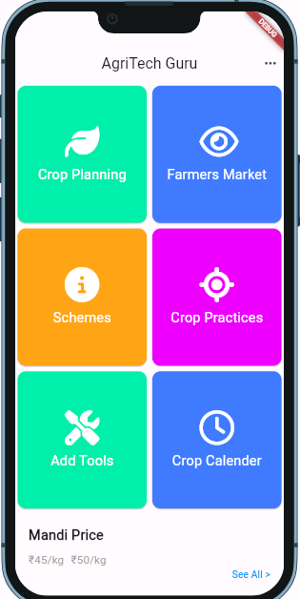

*fig 5* : Home Screen

Home Screen: It is the Main page of the app. It consists of all the features of the app. It has crop planning, farmer market, schemes, crop practices, crop calendar and rental tools. The app also has multilingual support.

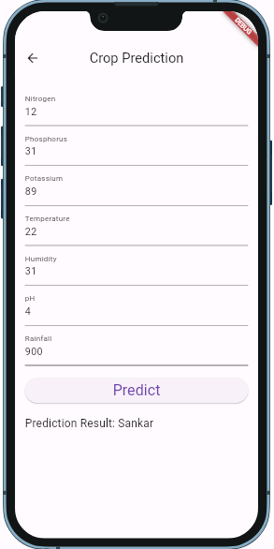

*fig 6* : Crop Planning Screen

Crop Planning: It is a crop detection screen where farmers can add soil and weather conditions on it. The model will then recommend crops based on the trained model.

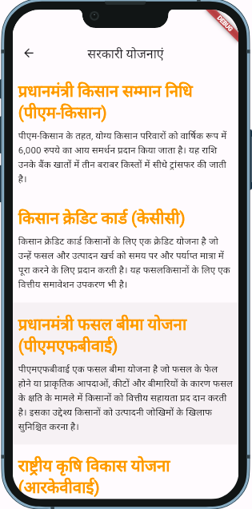

fig 7 : Schemes Screen

Scheme Screen: The Scheme page consists of all the latest schemes by the Government of India. They are supported in different languages. It consists of Scheme name and its description. When a user clicks on link it opens the registration page of that scheme

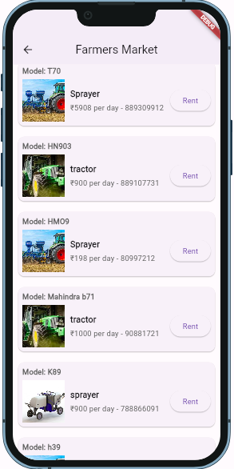

*fig 8* : Farmer Tools Screen

Farmer Tools Screen: It consists of rental tools for farming. The farmer can rent a tool and return when not in use. The page contains tool name, model name, price per day and phone number.

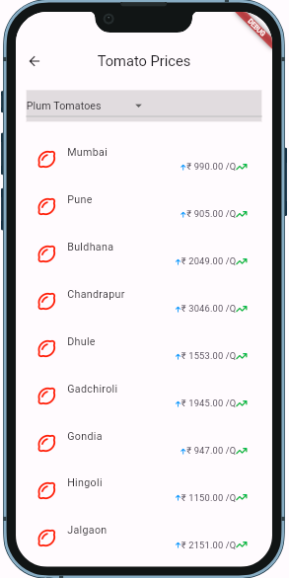

*fig 9*: Farmer Market Screen

Farmer market Screen : It consists of prices of all varieties of tomato for all districts in Maharashtra. It displays the price of crop in quintal for each district

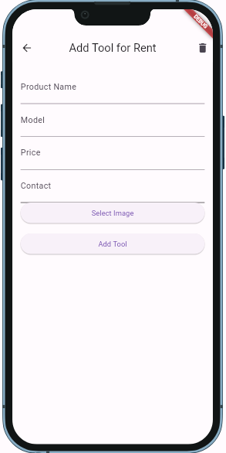

*fig 10* : Add Tools Screen

Add Tools Screen : In this screen the user can add tools when he wants to add for rental. The user can enter the product name ,model name, its price per day and contact number and image of the tool.

## 7.2. Performance Evaluation measures

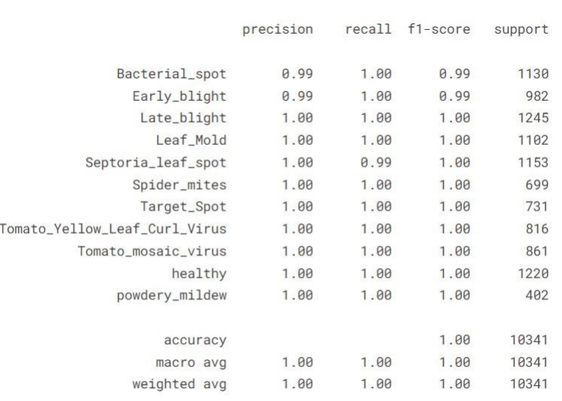

Fig 11 : Evaluation Matrix

The evaluation matrix describes the accuracy of disease detection models based on different diseases. The evaluation measures are precision , recall and f1 score for the model

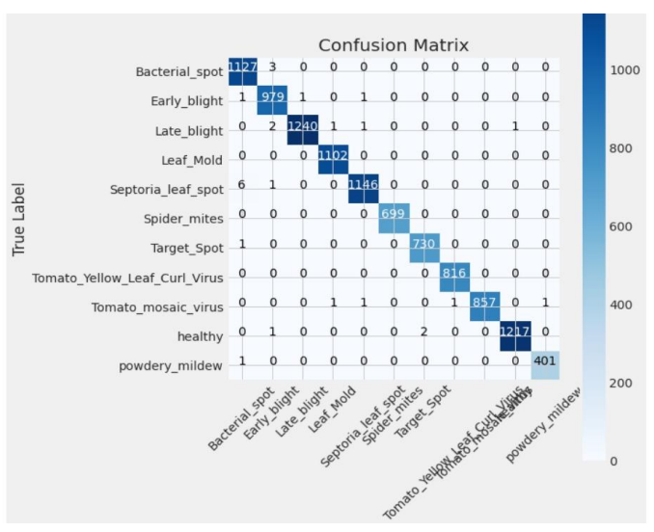

Fig 12 : Confusion Matrix

The model performed well at classifying healthy tomatoes. There were 12,170 healthy tomatoes and the model correctly classified 11,232 of them. The model also performed well at classifying tomato yellow leaf curl virus. There were 8,160 tomatoes with tomato yellow leaf curl virus and the model correctly classified 7,239 of them.

There were some classification errors between bacterial spot and early blight. The model predicted 120 early blight tomatoes as bacterial spot and 212 bacterial spot tomatoes as early blight.

There were also some classification errors between tomato mosaic virus and healthy. The model predicted 1 healthy tomato as tomato mosaic virus and 400 tomato mosaic virus tomatoes as healthy.

Healthy Tomato Classification: You mentioned the model performed well at classifying healthy tomatoes (11,232 out of 12,170 classified correctly). This suggests a strength in definitively identifying healthy plants.

Possible Confusion Between Bacterial Spot and Early Blight: If the confusion matrix showed instances of bacterial spot being classified as early blight and vice versa, it would highlight a need for improvement in differentiating these diseases.

## 7.3. Input Parameters / Features considered

* Environmental Factors (Weather Conditions, Soil Health)
* User Login and Sign Up
* Date and type of crop (For calendar system)
* Image Analysis Features (Leaf Texture and Color, Symptom Classification)
* Machine Learning and AI Algorithms

**7.4 Inference drawn**

Our implemented system for crop disease detection showcases significant advancements over existing systems by integrating a combination of image analysis and machine learning techniques. The system has achieved high accuracy in detecting crop diseases by conducting comprehensive analysis of leaf texture, color, and symptom classification. Furthermore, the inclusion of monitoring the crop along with user manual input, enhances the system's adaptability and reliability. The integration with external data sources, such as weather and soil databases, further contributes to the system's robustness and effectiveness in providing accurate disease detection tailored to crop farming and regional variations. Our system features a crop calendar to assist farmers in selecting the optimal planting date for their crops. Additionally, the system provides up-to-date market prices for various varieties of tomatoes to help farmers make informed selling decisions. Furthermore, the system offers a tool rental marketplace, allowing farmers to easily rent the necessary equipment for their agricultural activities.

# Chapter 8: Conclusion

## 8.1. Limitations

* **Data Accuracy and Availability**: The accuracy of disease prediction and crop recommendations heavily relies on the quality and availability of input data. In regions with limited or outdated agricultural data, the prediction accuracy may be affected.
* **Dependency on Internet Connectivity**: AgriGuru heavily relies on internet connectivity for real-time data access and updates. In areas with poor connectivity, the application's performance and reliability may be compromised.
* **Scalability**: The system's performance with a large number of concurrent users or a vast amount of data has not been tested extensively. Scalability issues could arise under high-load conditions.
* **User Adoption**: The application's success depends on user adoption and acceptance. Farmers unfamiliar with technology may find it challenging to use the application effectively.

## 8.2. Conclusion

The AgriGuru application presents a promising solution to enhance agricultural practices by providing accurate disease predictions, personalized crop recommendations, and marketplace. The successful completion of the test cases demonstrates the application's reliability, efficiency, and user-friendliness. However, certain limitations, such as data accuracy, internet dependency, integration challenges, scalability issues, and user adoption, need to be addressed to ensure the widespread effectiveness and adoption of the application among farmers.

## 8.3 Future Scope:

* **Integration of IoT Devices:** Expand the system's capabilities by integrating IoT devices like CCTV cameras for real-time monitoring of soil conditions, weather patterns, and environmental factors.
* **Utilization of Drones for Data Collection**: Explore the use of drones for aerial data collection and analysis.
* **Enhanced Data Collection**: Collaborate with agricultural research institutions to enhance data accuracy and availability, ensuring more precise disease predictions and crop recommendations.
* **Offline Functionality**: Develop offline capabilities to enable farmers to access essential features and data without internet connectivity, improving the application's reliability in areas with poor connectivity.
* **Advanced Integration**: Explore advanced integration with other agricultural technologies and IoT devices to provide real-time monitoring and management capabilities.
* **User Training and Support**: Implement comprehensive training and support programs to educate farmers on using the application effectively, addressing the user adoption challenge.
* **Scalability and Performance Optimization**: Conduct extensive testing and optimization to ensure the application's scalability and performance under high-load conditions, catering to the growing user base.
* **Expansion to Other Regions**: Expand the application's scope to other regions and crops, addressing specific agricultural challenges and needs globally.

**References**

[1]. Li-Chang Liu Kang-Cong Lv Yu-Jun Zheng “Crop cultivation planning with fuzzy estimation using water wave optimization” Hindawi Journal of Food Quality Volume 2021, Article ID 6242288

[2]. S. M. M. Nejad, D. Abbasi-Moghadam, A. Sharifi, N. Farmonov, K. Amankulova and M. Lászlź, "Multispectral Crop Yield Prediction Using 3D-Convolutional Neural Networks and Attention Convolutional LSTM Approaches," in IEEE Journal of Selected Topics in Applied Earth Observations and Remote Sensing, vol. 16, pp. 254-266, 2023, doi: 10.1109/JSTARS.2022.3223423.

[3]. Mario Benini, Emanuele Blasi, Paolo Detti, Lorenzo Fosci, Solving crop planning and rotation problems in a sustainable agriculture perspective, Computers & Operations Research, Volume 159,2023,106316, ISSN 0305-0548

[4]. S. Saranya and T. Amudha, "Crop planning optimization research — A detailed investigation," 2016 IEEE International Conference on Advances in Computer Applications (ICACA), Coimbatore, India, 2016, pp. 202-208, doi: 10.1109/ICACA.2016.7887951.

[5]. Karim Ennouri ,Slim Smaoui ,Yaakoub Gharbi,Manel Cheﬃ,Olfa Ben Braiek ,Monia Ennouri ,and Mohamed Ali Triki Usage of Artificial Intelligence and Remote Sensing as EfficientDevices to Increase Agricultural System Yields

[6]. Selvaraj, Angles & Chinnadurai, M.. (2018). “Impact and Importance of Market Intelligence in Indian Agriculture.”

[7]. Mohit Agarwal, Suneet Kr. Gupta, K.K. Biswas, Development of Efficient CNN model for Tomato crop disease identification, Sustainable Computing: Informatics and Systems, Volume 28, 2020

[8]. P. Malliga, R. Gowri and R. Kala, Development of risk assessment model for farmers in tomato supply chain, 2016 IEEE International Conference on Industrial Engineering and Engineering Management (IEEM), Bali, Indonesia, 2016

[9]. S. Ashok, G. Kishore, V. Rajesh, S. Suchitra, S. G. G. Sophia and B. Pavithra, Tomato Leaf Disease Detection Using Deep Learning Techniques, 2020 5th International Conference on Communication and Electronics Systems (ICCES), Coimbatore, India, 2020

[10], J. Shirahatti, R. Patil and P. Akulwar, A Survey Paper on Plant Disease Identification Using Machine Learning Approach, 2018 3rd International Conference on Communication and Electronics Systems (ICCES), Coimbatore, India, 2018

[11], M. Francis and C. Deisy, Disease Detection and Classification in Agricultural Plants Using Convolutional Neural Networks — A Visual Understanding, 2019 6th International Conference on Signal Processing and Integrated Networks (SPIN), Noida, India, 2019

**Appendix**

Paper1

Empowering Agriculture: A Deep Dive into AgriGuru and Its Transformative Role in Farming

# Ayush Jain

dept. of Computer Engineering VESIT

Mumbai, India [2020.ayush.jain@ves.ac.in](mailto:2020.ayush.jain@ves.ac.in)

# Priya.R L

dept. of Computer Engineering VESIT

Mumbai, India [priya.rl@ves.ac.in](mailto:priya.rl@ves.ac.in)

# Aditya Nehete

dept. of Computer Engineering VESIT

Mumbai, India [2020.aditya.nehete@ves.ac.in](mailto:2020.aditya.nehete@ves.ac.in)

# Yash Kaka

# Swapnil Sakpal

dept. of Compute Engineering

VESIT

Mumbai, India

[2020.swapnil.sakpal@ves.ac.in](mailto:2020.swapnil.sakpal@ves.ac.in)

dept. of Computer Engineering

VESIT

Mumbai, India [2020.yash.kaka@ves.ac.i](mailto:2020.yash.kaka@ves.ac.in)n

***Abstract*—”Data-driven, farmer-centric solutions are critical in the dynamic field of agriculture, which is defined by constantly shifting market needs and environmental conditions. In order to transform farming methods through the integration of cutting- edge technologies, this article introduces the comprehensive Crop Planning and Market Information System, or AgriGuru. AgriGuru optimizes crop health by facilitating disease identification and providing customized cures through the use of AI, remote sensing, and real-time video processing. Moreover, it makes customized crop suggestions that are in line with market trends by utilizing soil analysis and meteorological data. AgriGuru provides farmers with up-to-date market information and chances for agricultural stock launches, addressing their vital need to be informed about market conditions. By using supply chain management becomes transparent and effective, allowing for continuous product tracking.To enhance accessibility, AgriGuru features a user-friendly dashboard supporting multiple languages and provides access to agricultural training and educational programs. Ultimately, AgriGuru aims to empower farmers, improve crop yields, and drive sustainable agricultural practices in an ever-evolving world.”**

***Index Terms*—Remote Sensing, Artificial Intelligence in Agri- culture, All-In-One Solution For Farmers**

approaches in agricultural management systems to inadequate personalization of solutions for individual farm conditions. Furthermore, the absence of real-time support mechanisms exacerbates the difficulties faced by farmers in making timely decisions. Recognizing these gaps, there is a pressing need for holistic solutions that integrate advanced technologies to empower farmers with actionable insights and support.

In response to these challenges, our project, AgriGuru, presents a comprehensive Crop Planning and Market Information System designed to revolutionize farming practices in Maharashtra. Leveraging advancements in remote sensing, artificial intelligence, and market intelligence, AgriGuru offers a suite of features aimed at optimizing crop manage- ment, enhancing market intelligence, and fostering sustainable agricultural practices. Through personalized crop recommen- dations, real-time disease detection, and transparent supply chain management, AgriGuru aims to mitigate risks, optimize resource utilization, and empower farmers to thrive in an ever- changing agricultural landscape.

1. Overview

I. Introduction

Agriculture stands as the cornerstone of human sustenance, providing livelihoods and economic stability across the globe. However, in regions like Maharashtra, India, where agriculture plays a pivotal role in the livelihoods of millions, the sector grapples with significant challenges. The tomato crisis of 2023, which saw prices soar to unprecedented levels due to yield losses from unanticipated rainfall, underscored the vulnerability of traditional farming practices in the face of unpredictable weather patterns and market fluctuations. Such challenges necessitate innovative solutions that enhance resilience and sustainability in agriculture.

Despite strides in agricultural technology, existing systems often fall short in addressing the multifaceted challenges faced by farmers. Limitations abound, ranging from fragmented

1. *Motivation*

In recent years, the agricultural sector in Maharashtra, India, has faced unprecedented challenges, culminating in the tomato crisis of 2023. The sudden spike in tomato prices, reaching up to five times their usual rates, exposed the vulnerability of farmers to adverse weather conditions and supply chain disruptions. Devastating yield losses due to unseasonal rainfall further exacerbated the situation, underscoring the urgent need for innovative solutions to enhance resilience and sustainability in agriculture. Motivated by the plight of farmers and the imperative to address systemic vulnerabilities, this research endeavors to leverage advanced technologies such as remote sensing, artificial intelligence, and app-based platforms. By providing farmers with comprehensive tools for crop planning, production practices, and market intelligence, our project aim

to mitigate risks, optimize resource utilization, and foster long- term viability in the face of evolving challenges. Through collaborative efforts and interdisciplinary approaches, we aspire to catalyze positive change and empower agricultural communities to thrive in an ever-changing landscape.

1. *Problem Statement*

In Maharashtra, India, where agriculture plays a pivotal role in livelihoods and the economy, farmers face significant challenges exacerbated by unpredictable weather patterns and market fluctuations. The tomato crisis of 2023, marked by a sharp spike in prices due to yield losses from unanticipated rainfall, underscored the vulnerability of traditional farming practices and highlighted the urgent need for innovative solutions. To address these challenges comprehensively, this research endeavors to develop an integrated agricultural in- formation system leveraging advanced AI technologies. This system will encompass a range of functionalities, including a sophisticated disease prediction module to detect and diagnose crop ailments, a recommendation engine utilizing data on NPK values, weather forecasts, and market trends to advise farmers on optimal crop choices, a business intelligence marketplace providing real-time insights into market dynamics, access to government schemes and subsidies tailored to farmers’ needs, a platform for renting farming equipment to enhance operational efficiency, and streamlined supply chain mechanisms facilitating direct interactions between farmers and consumers. By empowering farmers with actionable insights, resources, and support, our research aims to enhance agricultural resilience, productivity, and sustainability in Maharashtra, ultimately fostering prosperity and growth in rural communities.

1. *Objectives*
   1. Develop a user-friendly crop planning tool using AI to help farmers choose the best tomato variety and optimize planting schedules.
   2. Use data on soil, weather, market demand, and popu- lation trends to provide personalized recommendations for tomato cultivation.
   3. Integrate an AI-powered disease prediction module to identify and diagnose tomato crop diseases accurately.
   4. Establish a marketplace platform for farmers to access equipment rentals, sell their products, and stay informed about market trends and prices.
   5. Establish a one-stop solution platform for farmers, inte- grating all stages from crop planning to selling, with new AI techniques to enhance efficiency and profitability.
2. THEORY

Based on an exhaustive examination of relevant research and literature, we have identified that designing and disseminating an integrated information system for crop planning, production practices, and market intelligence requires robust capabilities in remote sensing, artificial intelligence (AI), and app-based platforms. Our investigation reveals that existing solutions often lack seamless integration and may not fully leverage the potential of AI and remote

sensing technologies for optimizing agricultural practices. Through our innovative approach, we aim to bridge this gap by harnessing AI algorithms for personalized crop recommendations, remote sensing data for real-time monitoring of crop health, and app-based platforms for streamlined access to market intelligence. Additionally, we have developed novel features such as a database man- agement system for comprehensive crop data analysis and an intuitive user interface for seamless farmer-trader-customer interactions. These unique attributes position our information system as a pioneering solution for enhancing crop productivity, promoting sustainable farming practices, and facilitating informed decision-making across the agricultural value chain.

1. *Survey of Existing Systems*

Existing agricultural systems such as Plantix, Agrobase, PlantSnap, and MyAgriGuru play a crucial role in assisting farmers with crop management and disease detection. Plantix, for instance, employs innovative image recognition technology to diagnose plant diseases and nutrient deficiencies, offering personalized recommendations for effective crop management. Similarly, Agrobase provides farmers and agronomists with access to a vast database of plants and pests, facilitating timely identification of crop issues. PlantSnap, while primarily serving as a plant identification tool, also aids farmers in mon- itoring crop health by identifying diseases and pests through image analysis. Additionally, MyAgriGuru offers comprehensive agriculture advisory services, including crop management guidance and pest control strategies tailored to specific crop types and geographical locations. These existing systems con- tribute significantly to enhancing agricultural productivity and sustainability by empowering farmers with valuable insights and recommendations for informed decision-making.

1. *Limitations and Research Gap*

From [2], which focuses on multispectral crop yield pre- diction, the limitations regarding dataset coverage and quality are evident. While the model showcases promising results, it faces challenges associated with limited dataset availability and quality, particularly in regions with sparse or outdated agricultural data. In [15], which proposes a modified deep learning strategy for crop yield prediction, the challenges related to model complexity and scalability become apparent. Although the proposed model shows improved performance in certain scenarios, its scalability to large-scale agricultural systems remains uncertain due to computational constraints and resource-intensive training requirements. From the study by Benini et al. [3], which addresses crop planning and rotation problems, concerns arise regarding the generalization and transferability of the proposed solutions. While the model demonstrates effectiveness in specific agricultural contexts, its applicability to diverse geographic regions and farming practices is limited, highlighting the need for further research on adaptable planning algorithms. As discussed in [8], which explores blockchain-based tomato supply chain management, the dependence of AI-driven agricultural systems on external

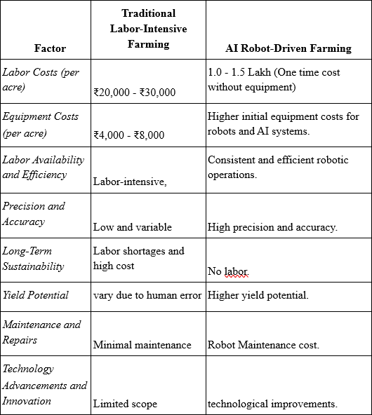

Fig. 1. Difference between existing system

factors such as weather conditions and market dynamics present significant limitations. While blockchain technology offers transparency and traceability benefits, its effectiveness in mitigating supply chain risks is contingent upon reliable data inputs and stakeholder cooperation, posing challenges in real-world implementation. In the study by Ashok et al. [12], which focuses on tomato leaf disease detection using deep learning techniques, concerns regarding the choice of evaluation metrics emerge. While the proposed method achieves high accuracy in detecting tomato leaf diseases, the absence of comprehensive evaluation metrics such as precision, recall, and F1-score limits the robustness and reliability of the reported results, necessitating a more thorough assessment of model performance.

II. Algorithms and Architecture

*A.* *Machine Learning technologies used*

**CNN (Convolutional Neural Network):** Description: A specialized type of artificial neural network designed for processing and analyzing visual data, such as images and video. Functionality: Utilizes layers of convolution, pooling, and fully connected layers to extract features, commonly used for tasks like image recognition and object detection.

**Linear SVM (Support Vector Machine):** Description: A machine learning algorithm that separates data into different categories using a straight line (or hyperplane in higher dimensions). Functionality: Aims to maximize the margin between categories, suitable for data that can be separated with a straight line, commonly used for classification tasks.

**Decision Tree:** Description: A machine learning algorithm that uses a tree-like structure to make decisions and classify or predict data. Functionality: Breaks down data based on features, assigning categories or values at each branch, making it easy to understand and interpret.

**ANN (Artificial Neural Network):** Description: Machine learning models inspired by the human brain, consisting of layers of interconnected nodes (neurons). Functionality: Used for tasks like image recognition and natural language process- ing, learns from data through a training process, versatile but may require substantial data and computation.

|  |  |
| --- | --- |
| Fig. 2. Schematic Diagram  *B*.*Flow chart* |  |

Fig. 3. Flow Diagram

Account Creation/Login: Farmers initiate the process by creating a new account or logging into their existing one to access crop recommendation parameters and select crops.

Profile Review and Update: Upon logging in, farmers have the option to review and update their profiles, ensuring that their information is current and accurate.

Crop Selection: Utilizing various criteria such as climate,soil type, water availability, and market demand, farmers select the crops they wish to cultivate.

Order Placement: Once the crop selection is made, farmers can proceed to place orders for seeds or seedlings, facilitating the commencement of the cultivation process.

Order Tracking: Farmers can track the status of their orders, ensuring transparency and timely delivery of essential agricultural inputs.

Crop Progress Monitoring: Throughout the cultivation pro- cess, farmers have the capability to monitor the progress of their crops. In case of any issues, real-time farm videos and imagery are available to aid in diagnosis and resolution.

Marketplace Exploration: The system offers a marketplace exploration feature, empowering farmers to explore different markets, view real-time crop values, and stay informed about crop demand and trends.

By facilitating informed decision-making and efficient crop management, this comprehensive process ensures optimal outcomes for farmers in their agricultural endeavors.

1. *Requirements*

## Hardware Requirements

* 1. CCTV Camera, Smartphone, or Laptop Camera
  2. Visual Studio Code editor
  3. Data Visualization tools (MS Excel, PowerBi)

## Software Requirements

1. Python 3.10.0
2. IDE - Colab notebook ver 6.4.12
3. Numpy version - 1.23.2
4. Pandas version - 1.4.3
5. Nltk version - 3.7
6. Tensorflow or Pytorch version - 2.9.1
7. Matplotlib version - 3.5.3
8. OpenCV
9. flutter
10. Flask or Django
11. Firebase
12. Results and Evaluations

The disease prediction model showcased a notable accuracy rate of 97, successfully identifying various crop diseases. Additionally, the recommendation engine effectively suggested suitable tomato varieties for cultivation, utilizing parameters such as climate, soil type, and market trends. Through rigorous validation and comparison with established benchmarks, the reliability and efficacy of the models were substantiated. User feedback and real-world deployment scenarios provided further validation of the practical utility and positive impact of the solutions on enhancing crop management practices and agricultural productivity.

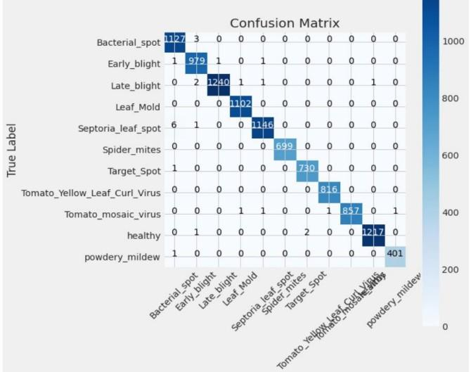

Fig. 4. Confusion matrix for disease prediction

The model performed well at classifying healthy tomatoes. There were 12,170 healthy tomatoes and the model correctly classified 11,232 of them. The model also performed well at classifying tomato yellow leaf curl virus. There were 8,160 tomatoes with tomato yellow leaf curl virus and the model correctly classified 7,239 of them.

There were some classification errors between bacterial spot and early blight. The model predicted 120 early blight tomatoes as bacterial spot and 212 bacterial spot tomatoes as early blight.

There were also some classification errors between tomato mosaic virus and healthy. The model predicted 1 healthy tomato as tomato mosaic virus and 400 tomato mosaic virus tomatoes as healthy.

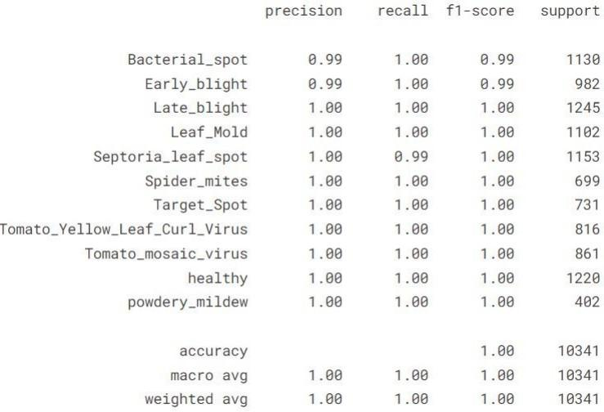

Fig. 5. Evaluation matrix

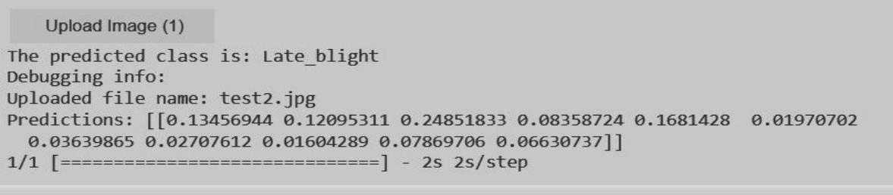

Fig. 6. Predictions

Healthy Tomato Classification: You mentioned the model performed well at classifying healthy tomatoes (11,232 out of 12,170 classified correctly). This suggests a strength in definitively identifying healthy plants.

Possible Confusion Between Bacterial Spot and Early Blight: If the confusion matrix showed instances of bacterial spot being classified as early blight and vice versa, it would highlight a need for improvement in differentiating these diseases.

1. Conclusion and Future Work

Our project aims to revolutionize agricultural practices through the development of an integrated information system tailored to farmers’ specific needs. By leveraging remote sensing, artificial intelligence, and app-based platforms, we seek to provide comprehensive support in crop planning, production practices, and market intelligence. Addressing existing limitations and introducing innovative features such as personalized crop recommendations and real-time monitoring, our system aims to optimize agricultural productivity, promote sustainability, and empower farmers with actionable insights. Moving forward, future work includes enhancing predictive capabilities, refining user interface based on feedback, collab- orating with research institutions, expanding system scope, and continuously evolving to better serve farmers and advance the agricultural sector.

1. References
2. Li-Chang Liu Kang-Cong Lv Yu-Jun Zheng “Crop cultivation planning with fuzzy estimation using water wave optimization” Hindawi Journal of Food Quality Volume 2021,

Article ID 6242288

1. S. M. M. Nejad, D. Abbasi-Moghadam, A. Sharifi, N. Farmonov, K. Amankulova and M. La´szlz´, ”Multispectral Crop Yield Prediction Using 3D-Convolutional Neural Networks and Attention Convolutional LSTM Approaches,” in IEEE Journal of Selected Topics in Applied Earth Observations and Remote Sensing, vol. 16, pp. 254-266, 2023, doi: 10.1109/JS- TARS.2022.3223423.
2. Mario Benini, Emanuele Blasi, Paolo Detti, Lorenzo Fosci, Solving crop planning and rotation problems in a sustainable agriculture perspective, Computers Operations Research, Volume 159,2023,106316, ISSN 0305-0548
3. S. Saranya and T. Amudha, ”Crop planning optimiza- tion research — A detailed investigation,” 2016 IEEE International Conference on Advances in Computer Applications (ICACA), Coimbatore, India, 2016, pp. 202-208, doi: 10.1109/ICACA.2016.7887951
4. Selvaraj, Angles Chinnadurai, M.. (2018). “Impact and Importance of Market Intelligence in Indian Agriculture.”
5. V. Sudha, D. Aswini and R. Akila Devi, ”Blockchain based tomato supply chain management,” 2023 2nd International Conference on Advancements in Electrical, Electronics, Communication, Computing and Automation (ICA ECA), Coimbatore, India, 2023, pp. 1-5, doi: 10.1109/ICAECA56562.2023.10201119.
6. A. Kumar, S. Sarkar and C. Pradhan, ”Recommendation System for Crop Identification and Pest Control Technique in Agriculture,” 2019 International Conference on Communica- tion and Signal Processing (ICCSP), Chennai, India, 2019, pp. 0185-0189, doi: 10.1109/ICCSP.2019.8698099.
7. P. Malliga, R. Gowri and R. Kala, ”Development of risk assessment model for farmers in tomato supply chain,” 2016 IEEE International Conference on Industrial Engineering and Engineering Management (IEEM), Bali, Indonesia, 2016, pp. 831-835, doi: 10.1109/IEEM.2016.7797993.
8. M. Francis and C. Deisy, ”Disease Detection and Classification in Agricultural Plants Using Convolutional Neural Networks — A Visual Understanding,” 2019 6th International Conference on Signal Processing and Integrated Networks (SPIN), Noida, India, 2019, pp. 1063-1068, doi: 10.1109/SPIN.2019.8711701.
9. M. Benini, E. Blasi, P. Detti, and L. Fosci, ”Solving crop planning and rotation problems in a sustainable agriculture perspective,” Computers Operations Research, vol. 159,
10. P. S. Bharathi, V. Amudha, G. Ramkumar, T. J. Nagalakshmi, N. Nalini and P. Jagadeesh, ”An Experimen- tal Analysis of Crop Yield Prediction using Modified Deep Learning Strategy,” 2022 International Conference on Advances in Computing, Communication and Applied Informat- ics (ACAI), Chennai, India, 2022, pp. 1-6, doi: 10.1109/AC- CAI53970.2022.9752492.
11. A. Singh and A. K. Bhamboo, ”Crop Recommenda- tion and Disease Detection Using Deep Neural Networks,” 2022 IEEE 6th Conference on Information and Communica- tion Technology (CICT), Gwalior, India, 2022, pp. 1-5, doi: 10.1109/CICT56698.2022.9997839.
12. A. Wahal, S. S. S. Choudhary and N. Singh, ”Leaf Disease Detection and Crop Prediction Using Ma- chine Learning,” 2021 3rd International Conference on Advances in Computing, Communication Control and Network- ing (ICAC3N), Greater Noida, India, 2021, pp. 438-442, doi: 10.1109/ICAC3N53548.2021.9725643.

Review Sheet 1

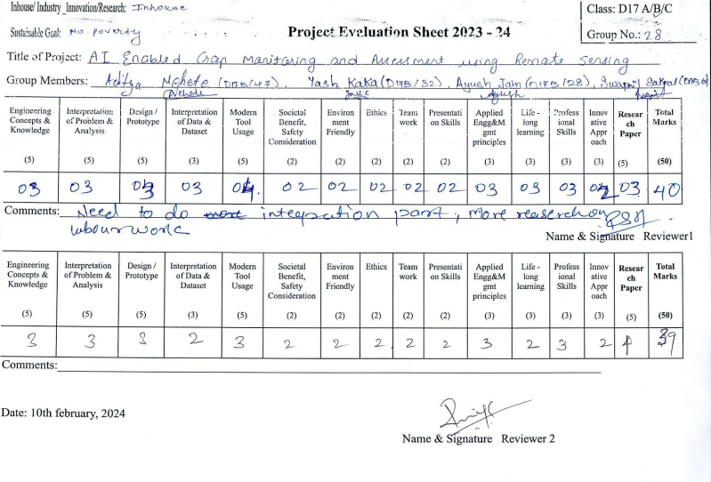

Review Sheet 2

