## VIVEKANAND EDUCATION SOCIETY’S INSTITUTE OF TECHNOLOGY

**Department of Computer Engineering**



Project Report on

TechShare-A Gadget Rental Application

In partial fulfillment of the Fourth Year, Bachelor of Engineering (B.E.) Degree in Computer Engineering at the University of Mumbai

Academic Year 2023-2024

**Submitted by**

Ritika Bhat D17B - 08

Samarth Gawali D17B - 25

Eshwar Vazirani D17B - 70

Manav Valecha D17C - 59

### Project Mentor

Prof. Pallavi Gangurde

(2023-24)

## VIVEKANAND EDUCATION SOCIETY’S INSTITUTE OF TECHNOLOGY

**Department of Computer Engineering**



**Certificate**

This is to certify that **Ritika Bhat (D17B, 08), (Samarth Gawali D17B, 25), (Eshwar Vazirani D17B, 70), Manav Valecha (D17C, )**of Fourth Year Computer Engineering studying under the University of Mumbai have satisfactorily completed the project on **“TechShare - A Gadget Rental Application”** as a part of their coursework of PROJECT-II for Semester-VIII under the guidance of their mentor **Prof. Pallavi Gangurde** in the year 2023-24 .

This project report entitled **TechShare - A Gadget Rental Application** by ***Ritika Bhat, Samarth Gawali, Eshwar Vazirani, Manav Valecha*** is approved for the degree of **B.E. Computer Engineering.**

| Programme Outcomes | Grade |
| --- | --- |
| PO1,PO2,PO3,PO4,PO5,PO6,PO7, PO8, PO9, PO10, PO11, PO12 PSO1, PSO2 |  |

Date:

Project Guide:



**Project Report Approval**

**For**

**B. E (Computer Engineering)**

This project report entitled **TechShare-A Gadget Rental Application** by ***Ritika Bhat, Samarth Gawali, Eshwar Vazirani, Manav Valecha*** is approved for the degree of **B.E. Computer Engineering.**

Internal Examiner



External Examiner



Head of the Department



Principal



Date:

Place: Mumbai

**Declaration**

We declare that this written submission represents our ideas in our own words and where others' ideas or words have been included, we have adequately cited and referenced the original sources. We also declare that we have adhered to all principles of academic honesty and integrity and have not misrepresented or fabricated or falsified any idea/data/fact/source in our submission. We understand that any violation of the above will be cause for disciplinary action by the Institute and can also evoke penal action from the sources which have thus not been properly cited or from whom proper permission has not been taken when needed.



Ritika Bhat(08) Samarth Gawali(25)



Eshwar Vazirani(70) Manav Valecha(59)

Date:

# ACKNOWLEDGEMENT

We are thankful to our college Vivekanand Education Society’s Institute of Technology for considering our project and extending help at all stages needed during our work of collecting information regarding the project.

It gives us immense pleasure to express our deep and sincere gratitude to Assistant Professor **Prof. Pallavi Gangurde** (Project Guide) for her kind help and valuable advice during the development of project synopsis and for her guidance and suggestions.

We are deeply indebted to Head of the Computer Department **Dr. (Mrs.) Nupur Giri** and our Principal **Dr. (Mrs.) J. M. Nair ,** for giving us this valuable opportunity to do this project.

We express our hearty thanks to them for their assistance without which it would have been difficult in finishing this project synopsis and project review successfully.

We convey our deep sense of gratitude to all teaching and non-teaching staff for their constant encouragement, support and selfless help throughout the project work. It is a great pleasure to acknowledge the help and suggestion, which we received from the Department of Computer Engineering.

We wish to express our profound thanks to all those who helped us in gathering information about the project. Our families too have provided moral support and encouragement several times.

### Computer Engineering Department COURSE OUTCOMES FOR B.E PROJECT

Learners will be to,

| **Course Outcome** | **Description of the Course Outcome** |
| --- | --- |
| CO 1 | Able to apply the relevant engineering concepts, knowledge and skills towards the project. |
| CO2 | Able to identify, formulate and interpret the various relevant research papers and to determine the problem. |
| CO 3 | Able to apply the engineering concepts towards designing solutions for the problem. |
| CO 4 | Able to interpret the data and datasets to be utilised. |
| CO 5 | Able to create, select and apply appropriate technologies, techniques, resources and tools for the project. |
| CO 6 | Able to apply ethical, professional policies and principles towards societal, environmental, safety and cultural benefit. |
| CO 7 | Able to function effectively as an individual, and as a member of a team, allocating roles with clear lines of responsibility and accountability. |
| CO 8 | Able to write effective reports, design documents and make effective presentations. |
| CO 9 | Able to apply engineering and management principles to the project as a team member. |
| CO 10 | Able to apply the project domain knowledge to sharpen one’s competency. |
| CO 11 | Able to develop a professional, presentational, balanced and structured approach towards project development. |
| CO 12 | Able to adopt skills, languages, environment and platforms for creating innovative solutions for the project. |

# Index

| Chapter No. | Title | Page No. |
| --- | --- | --- |
| **1** | **Introduction** | 11 |
| 1.1 | Introduction to the project | 11 |
| 1.2 | Motivation for the project | 11 |
| 1.3 | Problem Definition | 11 |
| 1.4 | Existing Systems | 12 |
| 1.5 | Lacuna of the Existing Systems | 12 |
| 1.6 | Relevance of the Project | 12 |
| **2** | **Literature Survey** | 13 |
| A | Brief overview of Literature Survey | 13 |
| 2.1 | Research Papers   1. Abstract of the research paper 2. Inference drawn from the paper | 13 |
| 2.2 | Patent search   1. Title of the patent and year of the patent 2. Summary of the patent 3. Link 1. European Patent: [http://worldwide.espacenet.com/,](http://worldwide.espacenet.com/) Link 2. Google Patents: https://patents.google.com/ | 19 |
| 2.3 | Inference Drawn | 20 |
| 2.4 | Comparison with the Existing Systems | 20 |
| **3.** | **Requirement Gathering for the proposed System** | 21 |
| 3.1 | Introduction to Requirement Gathering | 21 |
| 3.2 | Functional Requirements | 22 |
| 3.3 | Non-Functional Requirements | 22 |
| 3.4 | Hardware, Software, Technology and tools utilised | 22 |
| 3.5 | Constraints | 24 |
| **4.** | **Proposed Design** | 25 |
| 4.1 | Block diagram of the system | 25 |
| 4.2 | Modular design of the system | 26 |

| 4.3 | Detailed Design (Flowchart) | 28 |
| --- | --- | --- |
| 4.4 | Project Scheduling &amp; Tracking using Timeline / Gantt Chart | 29 |
| **5.** | **Implementation of the Proposed System** | 30 |
| 5.1 | Methodology employed for development | 30 |
| 5.2 | Algorithms and flowcharts for the respective modules developed | 31 |
| 5.3 | Datasets source and utilization | 33 |
| **6.** | **Testing of the Proposed System** | 35 |
| 6.1 | Introduction to testing | 35 |
| 6.2 | Types of tests Considered | 35 |
| 6.3 | Various test case scenarios considered | 36 |
| 6.4 | Inference drawn from the test cases | 38 |
| **7.** | **Results and Discussions** | 41 |
| 7.1 | Screenshots of User Interface (UI) for the respective module | 41 |
| 7.2 | Performance Evaluation measures | 44 |
| 7.3 | Input Parameters / Features considered | 46 |
| 7.4 | Comparison of results with existing systems | 47 |
| 7.5 | Inference drawn | 47 |
| **8.** | **Conclusion** | 48 |
| 8.1 | Limitations | 48 |
| 8.2 | Conclusion | 48 |
| 8.3 | Future Scope | 48 |
|  | **References** | 49 |
|  | **Appendix** | 51 |
| **1** | **Paper I** | 51 |
| a | Paper I | 51 |
| b | Plagiarism Report of Paper I | 56 |
| c | Project review sheet | 56 |

## List of Figures:

| Fig no. | Heading | Page no. |
| --- | --- | --- |
| 4.1 | Block Diagram of Growskill | 25 |
| 4.2 | Modular Diagram of Growskill | 26 |
| 4.3 | Courses Module | 26 |
| 4.4 | Job Matching Module | 27 |
| 4.5 | DFD | 28 |
| 4.6 | Flow Chart of the system | 28 |
| 4.7 | Gantt Chart | 29 |
| 5.1 | Flowchart for NER model | 31 |
| 5.2 | Resume extraction using NER model for CB-F | 32 |
| 5.3 | Content based filtering | 32 |
| 5.4 | Resume Dataset | 34 |
| 5.5 | Naukri.com dataset | 34 |
| 7.1 | Screenshot for Login page | 41 |
| 7.2 | Screenshot for Register page | 41 |
| 7.3 | Screenshot for Recruiter page | 42 |
| 7.4 | Screenshot for Job posting | 42 |
| 7.5 | Screenshot for Jobs page | 42 |
| 7.6 | Screenshot for Candidate page | 43 |

| 7.7 | Screenshot for Recommended Courses | 43 |
| --- | --- | --- |
| 7.8 | Screenshot for Application for job | 44 |
| 7.9 | Screenshot for Recommended jobs | 44 |
| 7.10 | Precision, Recall and F-Score of NER model | 45 |
| 7.11 | Input parameters for Applicant | 46 |
| 7.12 | Input parameters for Recruiter | 46 |
| 7.13 | Input parameters for creating job | 46 |

**List of Tables:**

| Table no. | Heading | Page no. |
| --- | --- | --- |
| 3.1 | Requirements of the system | 21 |

# Abstract

This paper presents a groundbreaking approach to accessing and utilizing gadgets through a user-friendly platform aimed at revolutionizing the rental process. By meticulously considering various key factors throughout development and implementation, this project effectively addresses the burgeoning demand for gadget rentals. Analysis of user engagement metrics reveals significant traction and sustained usage, underscoring the platform's relevance and value to its target audience. Notably, the app's impressive conversion rate reflects users' seamless navigation through the rental process, facilitated by an intuitive interface and streamlined transactions. Moreover, the integration of secure payment gateways enhances revenue generation, signaling the project's operational efficiency. Central to its success is a steadfast commitment to customer satisfaction, evident in glowing user reviews and ratings attributed to the app's user-friendly design and responsive support services. With a robust retention rate bolstered by regular updates and a diverse gadget inventory, this platform demonstrates its potential to retain users over the long term. Overall, this paper showcases a novel solution poised to reshape how individuals interact with and access gadgets, offering convenience and affordability in equal measure

**Chapter 1: Introduction**

* 1. **Introduction:**

In the dynamic landscape of today's technology-driven world, the constant evolution of gadgets and devices is pivotal for both individuals and businesses. However, the hefty expenses and sustainability concerns associated with procuring and managing a diverse range of tech assets pose formidable obstacles. Enter the TechShare Rental System, an innovative platform poised to revolutionize our interaction with technology. At its core, the TechShare Rental System serves as a pioneering solution, streamlining the temporary acquisition of a plethora of tech resources, thus extending access to cutting-edge technology to a broader audience. Whether it's a student in need of a high-performance laptop for a semester, a burgeoning startup eager to experiment with the latest hardware prototypes, or an individual seeking to explore the realms of augmented reality, TechShare provides an intuitive and seamless solution. Affordable Access to Technology: The TechShare Rental System is driven by a profound mission to bridge the digital divide by democratizing access to technology. In a world where technology access remains disparate, this platform breaks down barriers by offering state-of-the-art tech resources without the exorbitant costs typically associated with ownership. This democratization fosters inclusivity, empowering individuals and organizations alike to fully participate in the digital age. Reducing E-Waste:TechShare stands as a beacon of sustainability, championing shared usage of tech assets to alleviate the environmental strain caused by incessant purchasing and disposal of electronics. By promoting a departure from traditional single-owner consumption models, TechShare aligns with the burgeoning environmental consciousness permeating both individual and organizational spheres. Flexible Solutions for Diverse Needs: Recognizing the multifaceted nature of users' technology requirements, the TechShare Rental System offers tailor-made solutions catering to students, businesses, and individuals alike. Whether the need arises for educational, professional, or personal purposes, users can seamlessly adapt their tech resources to suit their evolving needs, thereby enhancing efficiency and cost-effectiveness. Financial Accessibility: By alleviating the financial burdens commonly faced by students, startups, and individuals, TechShare facilitates access to high-end technology without imposing significant upfront investments. This empowerment enables users to pursue their educational, entrepreneurial, and creative endeavors without being constrained by financial limitations. In essence, the TechShare Rental System emerges as a beacon of technological empowerment, offering not only affordability and sustainability but also flexibility and accessibility to a diverse array of users. Through its innovative approach, TechShare promises to reshape the landscape of technology utilization, fostering a more inclusive and sustainable digital future for all

## Motivation:

**Affordable Access to Technology:** One of the primary motivators behind the TechShare Rental System is to bridge the digital divide. In a world where access to technology is often unequal, this system makes it more affordable for individuals and organizations to access cutting-edge tech resources without the prohibitive costs of ownership. This democratization of technology empowers more people to participate in the digital age.

**Reducing E-Waste:** The rapid pace of technological innovation leads to a significant amount of electronic waste. By promoting shared usage of tech assets, TechShare contributes to a more sustainable future by reducing the need for constant purchasing and disposal of electronics. This aligns with the growing environmental consciousness of individuals and organizations.

**Flexible Solutions for Various Needs:** The TechShare Rental System recognizes that different users have diverse needs for technology. It motivates by offering flexible solutions for students, businesses, and individuals, allowing them to adapt their tech resources as needed, whether for educational, professional, or personal purposes. This flexibility promotes efficiency and cost-effectiveness.

**Financial Accessibility:** TechShare helps alleviate the financial burden of acquiring expensive tech resources. The motivation behind this is to empower students, startups, and individuals who may not have the capital to invest in high-end technology. It enables them to pursue their educational, entrepreneurial, and creative endeavors without the limitations of their financial constraints.

## Problem Definition:

In an era defined by rapid technological advancements, staying up-to-date with the latest gadgets and devices has become essential for both individuals and businesses. However, acquiring and maintaining a diverse range of tech assets can be a costly and often unsustainable endeavor. This is where the TechShare Rental System comes into play, revolutionizing the way we interact with technology.

The TechShare Rental System is a cutting-edge platform that facilitates the temporary acquisition of various tech resources, making state-of-the-art technology accessible to a broader audience. Whether you're a student in need of a powerful laptop for a semester, a startup looking to prototype with the latest hardware, or an individual eager to explore the world of augmented reality, TechShare offers a seamless solution.

## Existing Systems: a)LeKeDe offers a variety of rental services for day-to-day products like furniture, books, cars, and accessories, it may have limitations in terms of the range of products available. Users may find that certain items they require are not offered by the platform . Due to the nature of rental services, availability of products may vary based on demand and inventory. Users may face challenges in finding desired items during peak periods or in specific locations, services may be limited to certain geographic regions, restricting access for users outside of these areas. Non-local users may encounter difficulties in accessing and utilizing the platform.As rental products are used by multiple users over time, there may be concerns regarding maintenance and quality. Users may experience issues with cleanliness, functionality, or overall condition of rented items. Pricing Structure: The pricing structure of LeKeDe's rental services may not always be transparent or competitive compared to alternative options such as purchasing or leasing. Users may find that the cost of renting certain items does not provide significant cost savings compared to ownership.

## b)"On Rent" is an Android mobile application designed to streamline the process of borrowing and lending various commodities. This platform offers a wide range of services, including [5] equipment rental for books and electrical appliances, as well as accommodation rental. However, there have been complaints about the efficiency of applications offering gadgets for rent.Despite the convenience offered by On Rent, there are complaints about the efficiency of gadget rental services provided by the application. Users have reported issues with the functionality and reliability of the rental gadgets, which may hinder the overall user experience and trust in the platform .Furthermore, the traditional method of finding or advertising anything for lease is time-consuming and tiresome since one must navigate many programs to seek for different commodities. Hence, to save time and effort from folks' hectic schedules. c)RentoGad lacks a feature for insurance coverage in case of gadget breakdowns or damages, leaving users uncertain about liability in such situations. The concept of the app requires investing in gadgets upfront, which may pose a financial challenge and limit the variety of available rental items.Market Research: Without thorough market research, the app may struggle to accurately determine the demand for specific rental items, potentially leading to mismatches between available gadgets and user needs. The absence of an insurance system may undermine user trust in the platform, as users may be hesitant to rent expensive gadgets without adequate protection against damage.

## Lacuna of the Existing System:

* + 1. There are very few or equal to zero apps that are dedicated to gadget renting.
    2. The cost of the products are very high in the existing system.
    3. No solution to product damage.
    4. No Geofence which makes the user get the product shipped paying high cost.

## Relevance of the Project:

Our project is highly relevant in today's technology-driven world for several compelling reasons. Firstly, it aligns with the growing emphasis on sustainable consumption by offering an eco-friendly alternative to owning electronic devices, thus reducing electronic waste. Secondly, it addresses cost-efficiency concerns, allowing users to access high-end gadgets without the burden of expensive purchases. The rapid pace of technological advancements makes staying up-to-date challenging, but a rental app ensures users have access to the latest gadgets without long-term commitments. Moreover, the flexibility and variety offered by such apps are invaluable for users who need specific gadgets for various purposes. Travelers and digital nomads find gadget rental apps particularly convenient, freeing them from carrying multiple devices while on the move. For those unsure about a device, the ability to test before purchasing is a significant advantage. Rental services also handle maintenance and repairs, ensuring a hassle-free experience for users. Entrepreneurs and businesses see monetization opportunities in this space. Gadget rental apps can provide access to high-end gadgets, especially to those who aspire to use them but cannot afford to purchase them. Additionally, the COVID-19 pandemic's impact on remote work and learning has boosted the demand for gadgets, making such services even more pertinent. Data security and privacy are paramount in rental services, addressing critical user concerns. Furthermore, in emerging markets, these apps can bridge the gap in technology accessibility. The relevance of a gadget rental Android application project lies in its ability to cater to changing technology needs and evolving consumer preferences, underpinned by sustainability, cost-efficiency, and accessibility trends in the modern tech landscape. However, successful execution hinges on robust market research and a well-crafted business model.

# Chapter 2: Literature Survey

## A. Overview of literature survey:

The papers discussed here focus on various job recommendation skills as well as different skills and job portals. These papers are studied to understand how the skills and jobs are dependent on each other. The studies examine how to create the job recommendation system more efficiently. Overall, the papers highlight the importance of taking a comprehensive approach to address how these above factors can be used and enhanced for the development of a complete system which can provide both the courses as well as jobs.

## Research Papers :

**1.) Janica S. Abad , Mary Ann D. Abriol , Vann Henrick D. Amparo , “ The Feasibility Study On The Establishment Of A Gadget Rental In Dasmarinas City ” in June, 2021 College of Engineering, Computer Studies and Architecture Lyceum of the Philippines University Cavite**

1. **Abstract:** The gadget rental business targets Small and Medium-sized Enterprises (SMEs), offering affordable access to the latest technology. SMEs face challenges in acquiring new gadgets due to cost constraints and frequent updates. By providing a rental service, the business ensures swift and cost-effective access to cutting-edge technology, enabling SMEs to boost productivity and efficiency. With SMEs increasingly relying on gadgets for various operations, the demand for rental services is on the rise, presenting significant market potential for growth
2. **Inference:** Here, Content-Based Filtering recommends the results based on matching the personal preferences of the user with the given document whereas collaborative filtering recommends based on the preferences of fellow users. For this system to be hybrid, content-based filtering is required, which can only recommend jobs based on the user’s current profile. It cannot deliver anything surprising based on the user’s past searches. This paper also uses collaborative filtering which faces well-known problems of privacy breaches and cold starts.

**2.) Amika Mehta, Vedant Patil, Apurva Shinde,“ LeKeDe: Online Rental System ” in Oct 10, 2019 BE COMP Student, Pune University DOI : 10.17577/IJERTV8IS100213**

1. **Abstract:** The motivation behind this application is to provide a platform for users and rental products owners to communicate in an effective and efficient manner. The growing popularity and usage of online applications has led to a need to explore the industrial services who could tap into and enhance their services to the customers. Nowadays, there is online rental system curated for things like furniture, car, house etc. which benefits the user. A rental service is a service in which customers arrive to request the hiring of the rental unit. It is more convenient than carrying the cost of owning and maintaining the unit. In this paper we are introducing an Application – LeKeDe, which provides services like renting out day-to-day products like furniture, books, car, clothes, accessories, fitness gadgets, mechatronics etc. Our target audience is mainly anyone who prefers renting out products rather than buying them, they may be either localities, or non-localities or the ones who are up to date. This application aims to rent out products for duration ranging from an hour to a week or a month. It is an extended form of giving out things often organized with numerous local branches and complemented by an application allowing online reservations
2. **Inference:** LeKeDe is an application which has two main characters the seller and the buyer, these are two individuals located at different locations who don’t know each other, and it provides a common platform for the seller and buyer to interact. The seller can put up any product on rent, the buyer will view the product, its specifications and will then contact the seller for further information.This system is designed to function within an application on various mobile devices. LeKeDe has been built using Google Firebase, Android, and JavaScript rather than a native language of a particular platform. This basically means that the mobile phone must be able to supportAndroid based applications. Our system is able to detect the screen size of the target device and able to adapt to that particular screen size and pixelation is avoided.Firebase is used to communicate with the backend servers those stores and deals with the data. LeKeDe requires APIlevel 16 i.e. ANDROID 4.1, Jelly Bean and above versionsto run successfully.

**3.) Ali Khanafer , Murali Kodialam , and Krishna P. N. Puttaswamy , “ The Constrained Ski-Rental Problem and its Application to Online Cloud Cost Optimization” in 2013 Proceedings IEEE INFOCOM, Turin, Italy DOI: 10.1109/INFCOM.2013.6566944**

1. **Abstract:** Cloud service providers (CSPs) enable tenants to elastically scale their resources to meet their demands. In fact, there are various types of resources offered at various price points. While running applications on the cloud, a tenant aiming to minimize cost is often faced with crucial trade-off considerations. For instance, upon each arrival of a query, a web application can either choose to pay for CPU to compute the response fresh, or pay for cache storage to store the response so as to reduce the compute costs of future requests. The SkiRental problem abstracts such scenarios where a tenant is faced with a to-rent-or-to-buy trade-off; in its basic form, a skier should choose between renting or buying a set of skis without knowing the number of days she will be skiing. In this paper, we introduce a variant of the classical SkiRental problem in which we assume that the skier knows the first (or second) moment of the distribution of the number of ski days in a season. We demonstrate that utilizing this information leads to achieving the best worst-case expected competitive ratio (CR) performance. Our method yields a new class of randomized algorithms that provide arrivals-distribution-free performance guarantees. Further, we apply our solution to a cloud file system and demonstrate the cost savings obtained in comparison to other competing schemes. Simulations illustrate that our scheme exhibits robust average-cost performance that combines the best of the well-known deterministic and randomized schemes previously proposed to tackle the Ski-Rental problem
2. **Inference:**Cloud service providers (CSPs) such as Amazon and Microsoft rent out re**s**ources,such as CPU, memory, storage,etc., at various price points and offer their tenants the ability to elastically scale the resources up (or down) depending on the demand. Taking advantage of these services, cloud-based applications have been widely deployed in recent years at a rapid pace. Since many services have been virtualized,it is easy for an enterprise to scale the amount of resources needed to satisfy the current demand for a service by scaling the number of virtual machines (VMs) supporting that service.Interestingly, scaling the number of VMs is not the only way to reduce costs in a cloud-based service. Consider, for instance,a web application running on the cloud. Each time this service receives a query, the application has the following two options: Recompute the query from scratch.This involves the CPUand I/O costs, if any, for using the disk.Laboratories, Alcatel-Lucent. Compute the result and store it in the cache. This will incur the storage cost of the cache; however, it would save the CPU and I/O costs the next time the query is executed with the same parameter

**4.) F. Y. H. Ahmed, E. B. Hazlan and M. I. Abdulla, "Enhancement of Mobile-Based Application for Vehicle Rental," 2021 IEEE 11th IEEE Symposium on Computer Applications & Industrial Electronics (ISCAIE), Penang, Malaysia DOI:10.1109/ISCAIE51753.2021.9431820**

1. **Abstract**: This paper proposes a knowledge-based model that can be used digitally via a smartphone application to service the vehicle rental system in Malaysia called EZGO. EZGO is a website that allows consumers to look for vehicles such as cars, bikes and rental vans that can have the most satisfactory outcome and avoid the rejection of unavailable car rental by providing substitute vehicles that are close to the needs of the customer. Our research reveals the analysis and comparison of the problems faced in the general car rental system for the search mechanism and identifies the value of the rental car. The project implemented an agile approach for the design and development of mobile apps, developed UML diagrams for the car rental system, and performed a survey of prospective customers using questionnaires. This smartphone application is particularly relevant in Malaysia as it offers an alternative option for Malaysian drivers and drivers to provide personal transportation without the need to purchase and own for themselves.
2. **Inference:** EZGO which serves as a tool to help people make comparisons between vehicles from different vendors before making reservations. It provides solutions to the limitations from the existing vehicle rental system where the application will include other vehicles besides cars and will be available throughout Malaysia (Ray, 2016 [2]). EZGO will enable vendors to set the vehicle rentals online, and customers to browse through the vehicles which are available and rent them online. Also, a vendor can be an individual or even a business company. The objectives of this study are to develop the vehicles to rent online which include cars, motorcycles, and vans, next is to enhance the coverage of online vehicle rentals service in Malaysia

**5.) Harsha Chauhan,Gupta Deepali,Sheifali Gupta,Vishal Verma, “ On Rent—An Android Mobile Application”in Oct 2019 Chitkara University DOI:10.1166/jctn.2019.8532**

1. **Abstract**: In today’s era of development, people are more industry-oriented and hence are shifting in different cities for their jobs as per their requirements. Such citizens are often occupied with their work life and they want everything to be done easily and quickly. They have limited time to explore and visit different places in order to search required commodities according to their needs. Additionally, the traditional way to find anything or to advertise anything on lease is a time-consuming and tedious task as one has to explore different applications for searching different commodities. Hence, to save the time and effort from the hectic schedules of individuals, an android application has developed namely ‘On Rent,’ which provides different services on a single platform. This platform equips the user to borrow and lend equipment like books and electrical appliances on rent. It also facilitates users to take accommodation on rent according to their needs.
2. **Inference:** OnRent application is designed for android end users. Interaction with the cloud database is done via firebase cloud service. Accommodation seekers and building man- agers can use the application, also used by the individual who wants to borrow or lend books and electrical appli- ance on rent. The main aspiration of this application is to contribute relaxation in visitor's lives that come from different cities just to pursue their respective courses and job work.

**6.) Amey Thakur , “ Car Rental System” University of Windsor ,July,2021 DOI:10.22214/ijraset.2021.36339**

1. **Abstract:**Customers will be able to reserve their vehicles from anywhere in the world due to the Car Rental System. Consumers provide information to this application by filling in their personal information. When a consumer creates an account on the website, he or she can reserve a car. The proposed system is an online system that is fully integrated. It effectively and efficiently automates manual procedures. Customers are aided by this automated method, which allows them to fill in the specifics according to their needs. It contains information on the sort of car they want to hire as well as the location. The goal of this system is to create a website where customers can book their automobiles and request services from anywhere in the world. There are three phases to this car rental system mentioned in the introduction.
2. **Inference:** Nowadays, there is Online Car Rental, which benefits users greatly. A rental service is one where customers come to seek the rental of a rental unit. It is more convenient than paying for the unit's ownership and maintenance. A car rental company lends autos for a price for a few hours, a few days, or a week or more.The project's goal is to automate vehicle rental and reservation so that clients don't have to waste time calling and waiting for a vehicle. To convert the manual car rental procedure into a digital method. A customer satisfaction test was used to validate the rental automobile system. As a system development reference, create documents such as Software Requirement Specification (SRS) and Software Design Description.The database was designed on PHPMYADMIN, the back end was developed in simple PHP, and we utilized the same basic PHP codes for the frontend. Software methods are concerned with the process of developing software, not so much with the technical elements as with the organizational ones. Since the dawn of information technology, a variety of software development methodologies have been employed.

**7.) Rafati Niya, Sina; Schüpfer, Florian; Bocek , Thomas ; Stiller, Burkhard, “A Peer-to-peer Purchase and Rental Smart Contract - based Application (PuRSCA)”in October 6, 2018 De Gruyter Oldenbourg DOI: https://doi.org/10.1515/itit-2017-0036**

1. **Abstract:** This work introduces the design and implementation of an Android-based Peer-to-peer Purchase and Rental Application termed PuRSCA, which leverages Smart Contracts (SC) and the Ethereum public blockchain (BC). As a Device-to-device (D2D) communication protocol, WiFi-Direct is chosen to enable the P2P data transmission between two parties. This work results in a cost efficient, secure, SC-based, P2P, and Decentralized application (Dapp). Evaluations on performance of this Dapp are specified in terms of its D2D deployment, transaction costs, scalability, security, and privacy.
2. **Inference:** The system gives information about concluding an electronic (online) purchase contract between two parties that requires centralized platforms to mediate the interests of seller and buyer. These platforms have to store the description of purchased items and their price, and customers can interact with such a platform to buy any item such as in ebay. Online purchasing also requires centralized platforms, like banks or credit card institutes, to enable and operate safe and valid payments. The problem that all these platforms share is that they rely on a Trusted Third Party (TTP), the platform owner, to operate the platform. This results in many disadvantages for consumers.

**8.) M.Nireesha,P.Srinivasa Reddy , “Home Appliances for Rent ”, PG Scholar , Department of Computer Science in May,2020 SVKP & Dr K S Raju Arts & Science College, Penugonda, A.P, India,ISSN-2349-5162**

1. **Abstract:** Rental Home Appliances Management System is a team of positive minded and dedicated business professionals committed to becoming the world’s first choice for people requiring home appliance rentals. We are accountable and responsible for our own future; integrity and honesty are the backbone of our business ethos. We continually strive to provide the best possible marketing, administration, training and operational systems through the synergy of our team to ensure the profitable operation of the franchises
2. **Inference:**Rental Home Appliances Management System provided in the application with various items. Rent with us and you can have that new TV, Fridge and Washing Machine now; it provides customer status also. Rental Shopping offers free Delivery and Installation within 24 hours - you get what you want now and we deliver it to your door, install them, show you how they work, FREE at Rental Shopping this is all part of the service. When you rent from Rental Shopping you will have the latest and all the leading brands all the time, renting means you get what you want when you want it

**9.) Supriya, Sangeetha V ,A Subhasini and Vaishnav M, "Mobile Application Rental Batteries,"in May 2021 Journal of Physics Conference Series,**

1. **Abstract:** People nowadays are more or less familiar with buying and selling batteries. But have not really experienced batteries renting or service systems online. Here we are going to develop an application for the users to get benefits of lending, renting, selling and buying a battery through an application. Also, this application makes use of people to rent batteries for various reasons including Electronic Vehicles (EV). This Application contains a list of Batteries that are available for the customer, and also acts as a one stop solution for all battery related problems. The Customer has another advantage that they can easily find service centers for batteries nearby. Especially in India, the production rate and Consumers of Electric Vehicles are fairly increasing each and every day. This Application will create a better impact amongst people and will be a Boon factor for customers
2. **Inference:** Electronic Batteries become the most essential need in our daily routine. The Battery is quite possibly the main man-made innovations all since the beginning [1]. In Today's reality, it's for the most part utilized as a movable wellspring of force, yet inside the past, batteries were our solitary wellspring of power. Without its origination, current solaces like PCs, vehicles and specialized gadgets. The First Electronic Battery was imagined in 1800, by an Italian Physicist Alessandro Volta [2]. He stacked both Copper and Zinc's isolated circles by a material absorbed pungent water. One of the Most familiarly used one among the battery was Lead-acid battery which was invented in 1859 and that remains the technology used to start most internal combustion engines, which are the main design to produce car engines today.

## Inference Drawn:

* In all the applications that we have seen, there are very few systems that offers gadgets for rent .
* We took some inspiration from the project made by Amika Mehta, Vedant Patil, Apurva Shinde, during the making of our project[2].

**Comparison with the Existing Systems:**

| **Other System** | **Our System** |
| --- | --- |
| Does not offer insurance coverage for damage. | Provides insurance coverage for gadget damage. |
| Offers a limited selection of gadgets for rent. | Provides a wide range of gadget categories, including mobile phones, CDs, laptops, cameras, playstations, and more. |
| Google Map services are not available. | Incorporates Google Map services for enhanced user experience and navigation. |
| Does not include chat and call features | Provides call and chat features for seamless communication with buyers. |

# Chapter 3: Requirement Gathering for the Proposed System

In this chapter we are going to discuss the resources we have used and how we analyzed what the user actually needs and what we can provide. We will also discuss the functional and non-functional requirements and finally the software and hardware used.

## Introduction to Requirement Gathering:

The Requirement Gathering is a process of requirements discovery or generating list of requirements or collecting as many requirements as possible by end users. It is also called as requirements elicitation or requirement capture.

The requirements gathering process consists of six steps :

* + - Identify the relevant stakeholders
    - Establish project goals and objectives
    - Elicit requirements from stakeholders
    - Document the requirements
    - Confirm the requirements
    - Prioritize the requirements

| USE CASE | DESCRIPTION |
| --- | --- |
| Register and Login | The Rentee and the Renter can register/login on the app |
| Add Product | The Renter can rent the product for a particular renting period and from a particular location |
| Select location | The rentee needs to select the location for viewing the ads posted within the location range of the rentee |
| Search Ads | The Rentee can search particular category or product |
| Chats Tab | The rentee and the renter both can send and receive information |
| Favorites tab | The items added to the favorites from the home page can be displayed and removed |
| My Ads | The renter who has posted the ad can have a view of all the ad along with the renting period of each ad and other info like images, description, rent amount. |
| My Account | Displays the info of the rentee/renter. They can also update info |
| Cart Button | Displays all the items added from different renters by the rentee |
| Payment Gateway | A button on the cart page where the total amount is displayed on the button and when clicked takes back to the Dummy Payment Gateway |

**Table No: 3.1 Requirements of the system**

## Functional Requirements:

Functional requirements for our Application outline the specific features and capabilities the app must have to meet its objectives. Here are key functional requirements for a gadget rental app:

**1. User Registration and Authentication:**

Users should be able to create accounts and log in securely. Implement email verification, two-factor authentication, or other security measures.

**2. User Profiles:**

Allow users to create and edit profiles with personal information and profile pictures. Include options to add payment details for rental transactions.

**3. Gadget Listings:**

Provide a platform for gadget owners to list their items for rent. Include fields for gadget details, high-quality images, and rental rates.see his/her SOP and make him/her employee of the company for the time of the job duration.

**4. Search and Filters:**

Implement robust search functionality, allowing users to search for gadgets based on keywords, categories, and location. Provide advanced filtering options to refine search results.

**5. Booking and Reservation:**

Enable users to select rental dates and times when booking gadgets.Display real-time gadget availability to prevent double bookings.Calculate and display rental fees, including any additional charges.

**6. Messaging System:**

Include a messaging feature to facilitate communication between renters and gadget owners. Allow users to discuss rental details, ask questions, and coordinate pickup/drop-off.

**7. Payment Processing:**

Integrate a secure payment gateway to handle rental payments. Support various payment methods, including credit/debit cards and digital wallets.

## Non-Functional Requirements:

Non-functional requirements for our Application describe the qualities and characteristics that are essential for its performance, reliability, and usability. Here are important non-functional requirements for a gadget rental app:

**1. Performance:**

Response Time: The app should have low latency and respond quickly to user actions, ensuring a smooth user experience. Scalability: The app should be able to handle an increasing number of users and gadget listings without performance degradation. Load Balancing: Implement load balancing mechanisms to distribute user requests evenly across servers.

**2. Reliability:**

Availability: The app should be available and operational 24/7 with minimal downtime for maintenance. Fault Tolerance: It should gracefully handle errors, ensuring that a single failure doesn't disrupt the entire system. Data Backup and Recovery: Regularly back up user data and implement a robust data recovery plan in case of data loss.

**3. Security:**

Data Encryption: Implement strong encryption for user data, payment information, and communications to protect against unauthorized access. Authentication and Authorization: Ensure secure user authentication and proper authorization mechanisms to protect user accounts and data. Penetration Testing: Conduct regular security audits and penetration testing to identify and address vulnerabilities.

**4. Scalability:**

Horizontal and Vertical Scaling: The app should be able to scale both horizontally (adding more servers) and vertically (upgrading hardware) to accommodate growing user demands. Database Scalability: The database system should handle increasing data loads efficiently.

**5. Usability:**

User Interface Design: Ensure an intuitive and user-friendly interface that is easy to navigate and visually appealing. Accessibility: Make the app accessible to users with disabilities by following accessibility guidelines and standards.

## Hardware, Software, Technology and Tools Utilized:

### A. HardwareRequirements:-

a. Minimum 8 GB RAM

b. Core I5 7th Gen processor

c. NVIDIA GPU

d Disk space of 4GB

### B. Software Requirements:-

* 1. Java
  2. XML
  3. Firebase

### C. Techniques:-

**Java:-** Android Studio uses Java for building the core functionalities of Android apps.You write Java code to define app behavior, handle user interactions, and interact with the Android system. Android Studio provides features like code completion, syntax highlighting, and debugging to simplify Java development for Android.

**XML:-** In Android Studio, XML files define the user interface (UI) layouts of your app. These files describe how elements like buttons, text views, and images are arranged on the screen. Java code in Android Studio interacts with these XML layouts to control their behavior and handle user interactions within the app.

**Firebase:-**Firebase is a powerful backend platform from Google that integrates seamlessly with Android Studio. Here's how it relates to Android development, specifically verification and password reset emails:

Firebase in Android Studio: Backend as a Service (BaaS): Firebase provides various features like authentication, databases, storage, and analytics, eliminating the need to build and manage your own backend infrastructure.

Firebase Authentication: This service handles user registration, login, and account management. It offers features specifically for email verification and password resets:

Email Verification:Users receive a verification email upon signup containing a link. Clicking the link confirms their email address, enhancing security. Firebase Authentication provides methods to send verification emails and handle user verification status within your app.

Password Reset:Users can request a password reset by entering their email address. Firebase sends an email with a link to create a new password. Firebase Authentication offers methods to handle password reset requests and send password reset emails.

Firebase Email Delivery: This service allows you to send transactional emails directly from your app. While not strictly part of Authentication, it can be used for custom email notifications like password change confirmations.

### D. Tools:-

**Android Studio:-** Android Studio is the official IDE for building Android apps. It offers a user-friendly interface, supports Java and Kotlin, integrates with Firebase, and simplifies the development process.

## Constraints:

* + - Internet Access is required.
    - Location Access is required
    - Ads located within the range of the 10km of rentee is only visible to renting.
    - Rentee has to pay 50 Rs as an Insurance fee.

# Chapter 4: Proposed Design

## Block Diagram of the proposed system:

**Fig 4.1: Block Diagram**

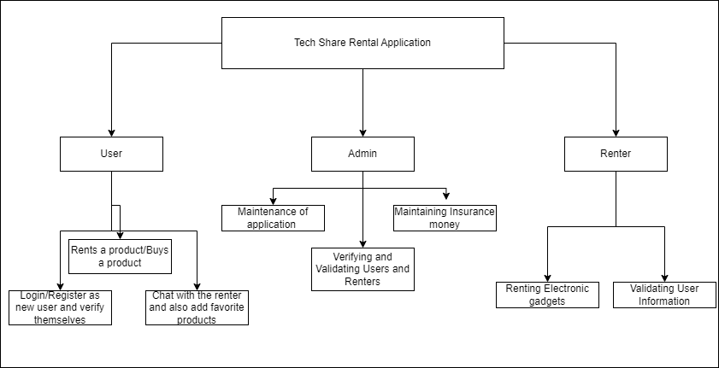

## Modular diagram of the system:

**Fig 4.2: Modular Diagram**

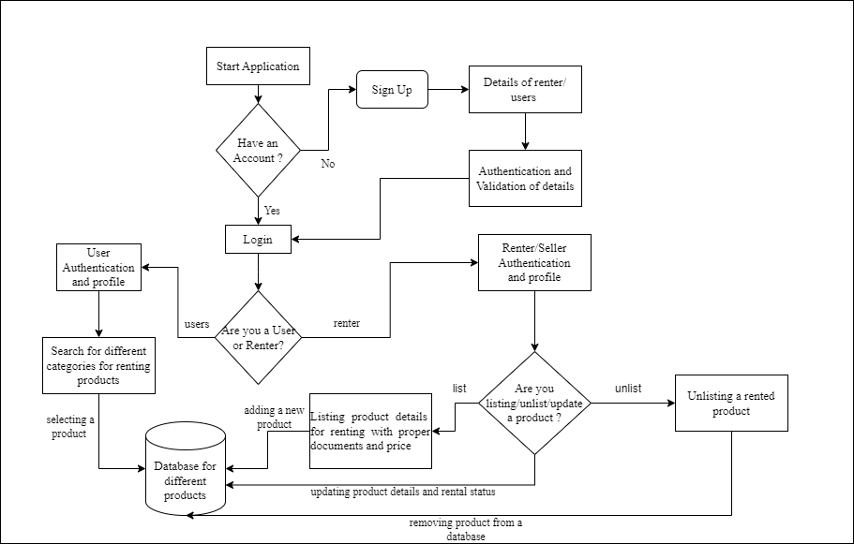

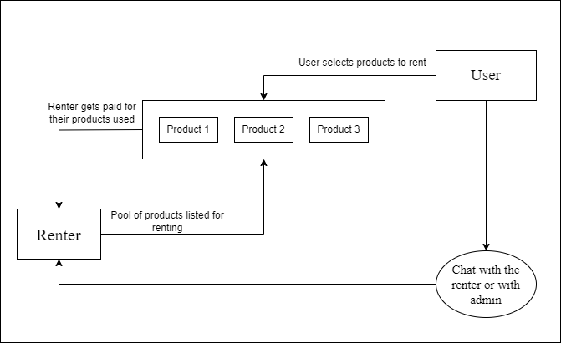

**Fig 4.3: Renting Electronic Gadget Module**

* + - In this system there are two types of people, one that rents the electronics gadget and the other who puts the gadget for rental purpose or for sale.
    - This happens on a common page just similar to amazon or flipkart or any other buying application. The renter puts the product on rental purpose on the app and adds description of the product that he adds.
    - The renter adds the description for the rental gadget, its photo, days to be rented and price for renting that item for that period of time. The user first enters his/her location and then the list of items are shown below.
    - The user choses item according to his/her need. They check its description, time period and also could compare prices and select the gadget to rent. If they love a gadget they could store it in the favorite section.
    - Once a selected gadget, then the user goes to the cartsection to proceed to rent that product. There a bill has been generated for the same. The bill contains all the details and also insurance money, a small amount is claimed if the gadget is damaged by the user gets added to the bill.
    - The time period gets active once you buy a product and notifies you when to return the product. It works with the physical clock and counts days accordingly.
    - The user can also chat with the renter for further queries of the gadget, sharing documents for owner verification.

**Flowchart for the proposed system :**

The following flowchart shows us the workflow of our project. First data collection and then processing and calculating bmi etc. are some initial steps of our model.

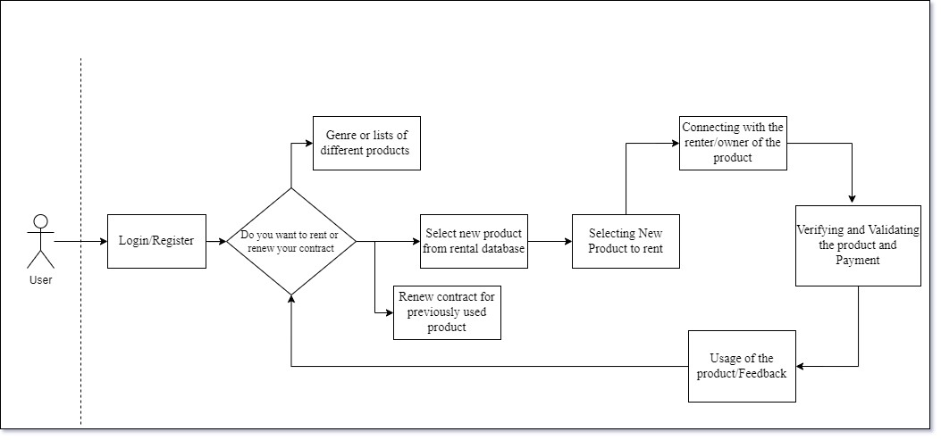

**Fig 4.4 : Flowchart of Model**

* 1. **Project Scheduling & Tracking using Time line / Gantt Chart:** The Gantt chart of our project where we worked for the whole semester to create this model is shown in a timeline pattern. It is the most important part to think and design the planning of your topic and so we planned our work like the gantt chart shown.

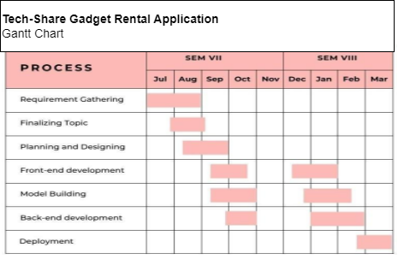

**Fig 4.5 : Gantt chart**

# Chapter 5: Implementation of the Proposed System

## Methodology employed for development:

Developing a tech share rental app for electronic gadget renting involves several steps, from conceptualization to deployment. Below, I'll outline a typical methodology and explain each step related to the app development process:

Market Research and Conceptualization:

* Identify the target market for the app.
* Research existing competitors and analyze their strengths and weaknesses.
* Define the unique selling points (USPs) of your app.
* Create a detailed project plan outlining goals, target audience, features, and monetization strategies.

Requirement Gathering and Analysis:

* Collaborate with stakeholders to gather detailed requirements.
* Break down requirements into functional and non-functional aspects.
* Prioritize features based on their importance and feasibility.
* Define user personas and user stories to understand user needs and workflows.

Design Phase:

* Develop wireframes and mockups to visualize the app's layout and flow.
* Design the user interface (UI) and user experience (UX) based on industry best practices and user feedback.
* Create prototypes for usability testing and refinement.
* Finalize designs for development.

Development:

* Choose the appropriate technology stack based on project requirements and team expertise.
* Develop the backend infrastructure for user authentication, data storage, and communication.
* Implement frontend interfaces using frameworks like React Native (for cross-platform development) or native development for iOS and Android.
* Integrate payment gateways and other third-party services as needed.
* Implement features incrementally in sprints, following agile methodologies.

Testing:

* Conduct unit tests to ensure individual components work as expected.
* Perform integration tests to verify the interactions between different modules.
* Carry out functional testing to validate that the app meets the specified requirements.
* Perform compatibility testing across various devices and screen sizes.
* Solicit feedback from beta testers and make necessary adjustments.

Deployment:

* Prepare the app for deployment to production servers.
* Set up monitoring tools to track app performance and user behavior.
* Release the app on relevant app stores (e.g., Apple App Store, Google Play Store).
* Monitor the deployment process and address any issues that arise.

Post-launch Support and Maintenance:

* Provide customer support to address user queries and issues.
* Continuously monitor app performance and gather user feedback for future improvements.
* Release regular updates with bug fixes, security patches, and new features.
* Stay updated with technological advancements and market trends to keep the app competitive.

Throughout the development process, collaboration and communication among team members are crucial to ensure the successful delivery of the tech share rental app. Additionally, iterating based on user feedback and market dynamics is essential for long-term success.

## Algorithms and Flowcharts for the respective modules developed:

Let's break down the main modules of the tech share rental app and discuss the algorithms and flowcharts for each:

**User Authentication Module:**

Algorithm:

* Upon user registration, the app stores user credentials (username, password) securely in the database.
* When a user attempts to log in, the app verifies the entered credentials against the stored data.
* If the credentials are valid, the user is granted access to the app's features.

Flowchart:

1. Start
2. User enters username and password
3. System verifies credentials
4. If credentials are valid, grant access
5. Else, display error message
6. End

**Product Listing and Booking Module:**

Algorithm:

* The app fetches the list of available products (gadgets) from the database.
* Users can browse through the list and view details of each product.
* To book a product, the user selects the desired item and specifies the rental duration.
* The app checks for product availability and reserves the item for the specified duration.

Flowchart:

1. Start
2. Retrieve list of available products
3. Display product details
4. User selects product and rental duration
5. System checks product availability
6. If available, reserve product for specified duration
7. Else, display message indicating unavailability
8. End

**Payment Processing Module:**

Algorithm:

* When a user confirms a booking, the app calculates the rental cost based on the selected product and duration.
* The user is directed to the payment gateway to complete the transaction securely.
* Once the payment is successful, the booking status is updated in the database.

Flowchart:

1. Start
2. Calculate rental cost
3. Redirect user to payment gateway
4. User completes payment
5. If payment successful, update booking status
6. Else, display payment failure message
7. End

**Order Management Module:**

Algorithm:

* The app provides users with the ability to view their current and past orders.
* Users can cancel orders within a specified timeframe before the rental period starts.
* Once the rental period ends, the app prompts users to return the rented items.

Flowchart:

1. Start
2. Display user's orders (current and past)
3. User selects order to manage
4. If within cancellation timeframe:
5. User cancels order
6. Update booking status and refund if applicable
7. If rental period ended:
8. Prompt user to return item
9. End

**Rating and Review Module:**

Algorithm:

* After the rental period ends, users are prompted to rate and review the rented product and overall rental experience.
* Users can provide feedback and ratings on aspects like product quality, rental process, and customer service.
* Ratings and reviews are stored in the database and can be viewed by other users.

Flowchart:

1. Start
2. Prompt user to rate and review rented product
3. User provides ratings and feedback
4. Store ratings and reviews in the database
5. End

These algorithms and flowcharts provide a high-level overview of the logic and process flow for each module in the tech share rental app. Implementation details may vary depending on the specific requirements and technologies used.

# Chapter 6: Testing of the Proposed System

## Introduction to Testing :

In the dynamic realm of mobile applications, gadget rental Android apps have become indispensable, catering to the modern need for temporary access to devices like smartphones, tablets, and laptops. However, ensuring the seamless functionality of such applications is paramount for user satisfaction and business success. This necessitates rigorous testing across various dimensions. Functional testing verifies that each feature operates as intended, encompassing tasks such as gadget rental, inventory browsing, and payment processing. Performance testing evaluates responsiveness and scalability, ensuring optimal performance under varying loads. Security testing is crucial for safeguarding user data and preventing unauthorized access. Usability testing focuses on enhancing the user interface and experience, ensuring intuitiveness and user satisfaction. Through comprehensive testing strategies, developers can mitigate risks, enhance quality, and deliver a robust gadget rental Android application that meets user expectations in today's competitive market.

## Types of tests Considered:

1. Functional Testing: This type of testing verifies that each function of the application works as expected. It includes testing features such as user registration, gadget browsing, rental booking, payment processing, and account management.
2. Integration Testing: Integration testing ensures that individual components of the application work together seamlessly. It checks the interaction between different modules, APIs, and external systems to validate data flow and communication.
3. User Interface (UI) Testing: UI testing focuses on evaluating the graphical user interface of the application. It ensures that the UI elements are displayed correctly, and user interactions such as button clicks, form submissions, and navigation flows work as intended.
4. Usability Testing: Usability testing assesses the overall user experience of the application. It involves gathering feedback from real users to evaluate the application's ease of use, intuitiveness, and satisfaction. Usability testing helps identify areas for improvement in the UI/UX design.
5. Performance Testing: Performance testing evaluates the responsiveness, stability, and scalability of the application. It measures factors such as response times, resource utilization, and throughput under normal and peak load conditions to identify performance bottlenecks and optimize the application's performance.
6. Security Testing: Security testing focuses on identifying vulnerabilities and weaknesses in the application's security mechanisms. It includes testing for authentication flaws, data encryption, authorization checks, input validation.
7. Compatibility Testing: Compatibility testing verifies that the application functions correctly across different devices, screen sizes, operating systems, and web browsers. It ensures a consistent user experience across various platforms and configurations.

## Various test case scenarios considered:

|  | Test Cases |
| --- | --- |
| Case 1:  If the user clicks on the “Continue with google” button then a verification link a link is sent to that email which the user has used for login . |  |
| Case 2:  If a user clicks “continue with email” While registering as a new user creating a strong password for new users is necessary. If a strong password doesn’t is not created then it shows an invalid password and allows the user to create a strong password. |  |
| Case 3:  The input field for posting the gadget all fields should be compulsory filled otherwise it shows enter value in the field else the user cannot post the gadget for rent. |  |

| Case 4:  While logging in all credentials should be filled by the user appropriately at the time of registering else it shows invalid or incorrect credentials.  The input field for posting the gadget all fields should be compulsory filled otherwise it shows enter value in the field else the user cannot post the gadget for rent. |  |
| --- | --- |
| Case 5:  Virtual interactions with renters for users satisfaction regarding fraud and surety for genuine receiving of gadgets  from renters with valid timestamp shows date and time. |  |

* 1. **Inference drawn from the test cases:**

|  | Test Cases |
| --- | --- |
| Case 6:  In the ‘Category’ dropdown menu, the selected option should be correctly visible in the form. This input category of user should be selected to mention the type of user whether which type of category has to upload for renting. |  |
| Case 7 :  The input field for ‘email' should only accept valid email. The user should not enter invalid format where it doesn’t contain “@” or “.com,  .in” etc. This email id will then be used by the user for login. |  |

| Case 8:  By clicking on the “Red heart Button” gadgets posted in the home page will appear in the favorites page and show the valid message that “Added to favorite”. |  |
| --- | --- |
| Case 9:  As there is a single interface for both users and renters, the products posted by the renters show them in the “MY ADS” fragment. Which segregates the users wishlisted products and from the user posted products. |  |

| Case 10:  If the edit profile button is clicked then the profile should be updated according to the details. This will allow the user to update his/her details if required like uploading a profile photo, name, DOB etc. |  |
| --- | --- |

# Chapter 7: Results and Discussions

## Screenshot of Use Interface(UI) for the system:

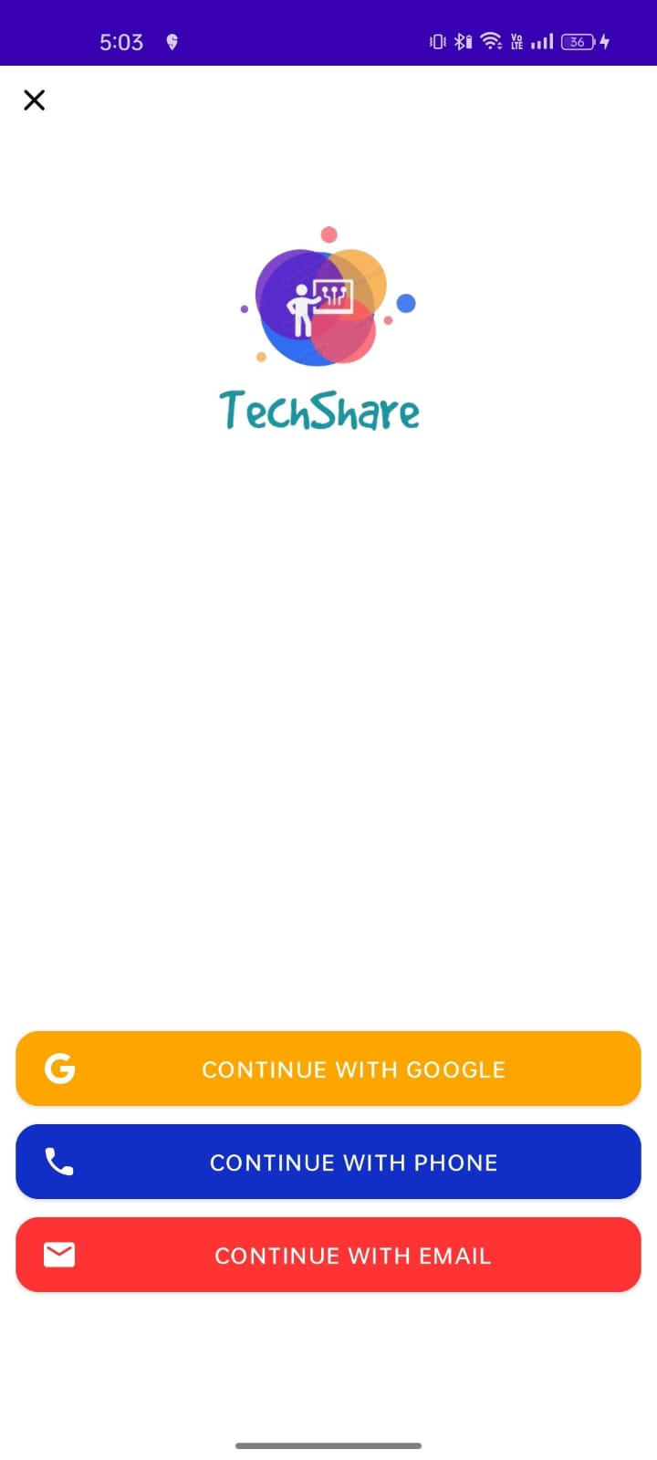 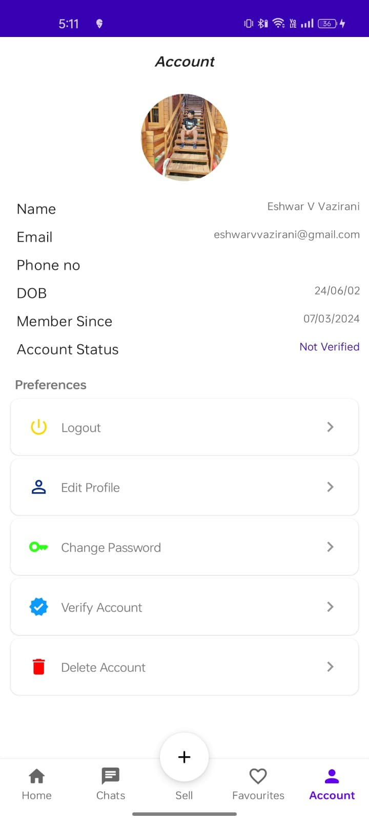

**Fig 7.1: Screenshot for Login Option page Fig 7.2: Screenshot for My Account**

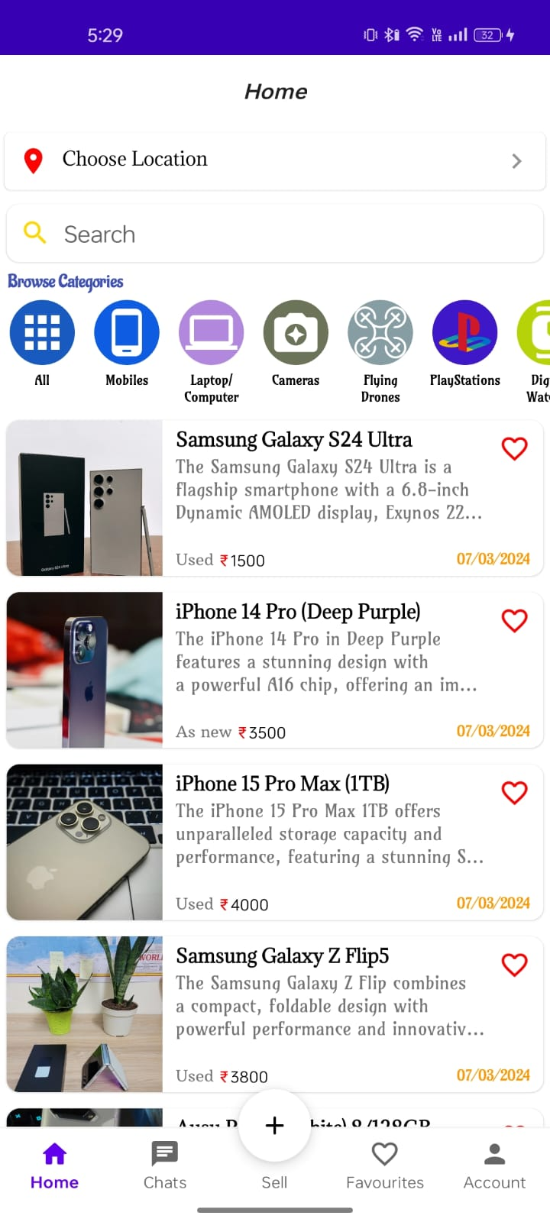 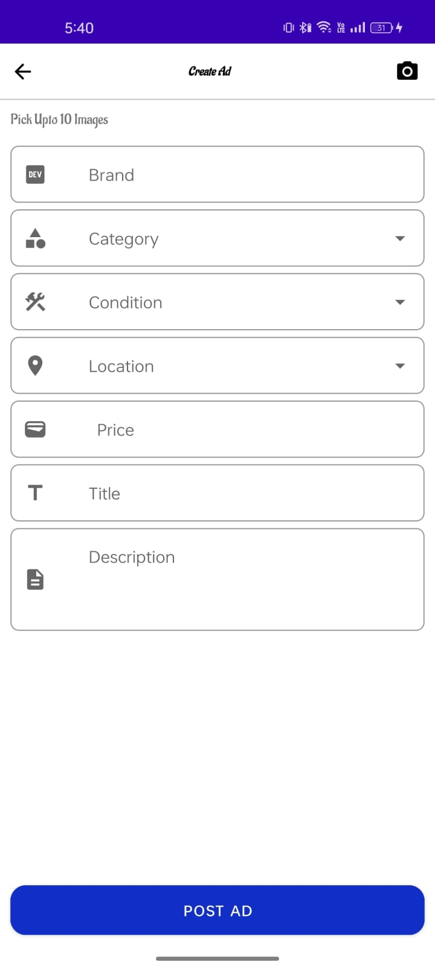

**Fig 7.3: Screenshot for Home Page Fig 7.4: Screenshot for Create an Ad**

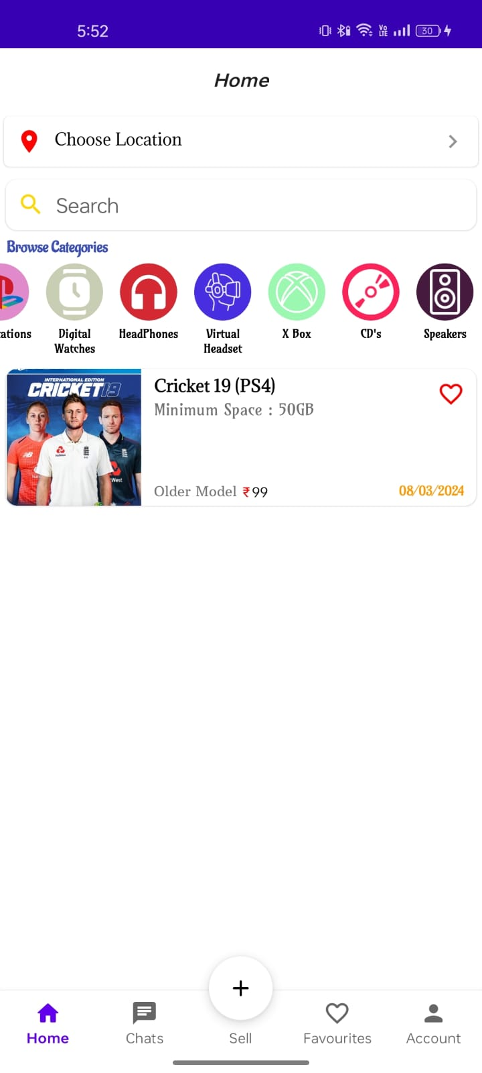 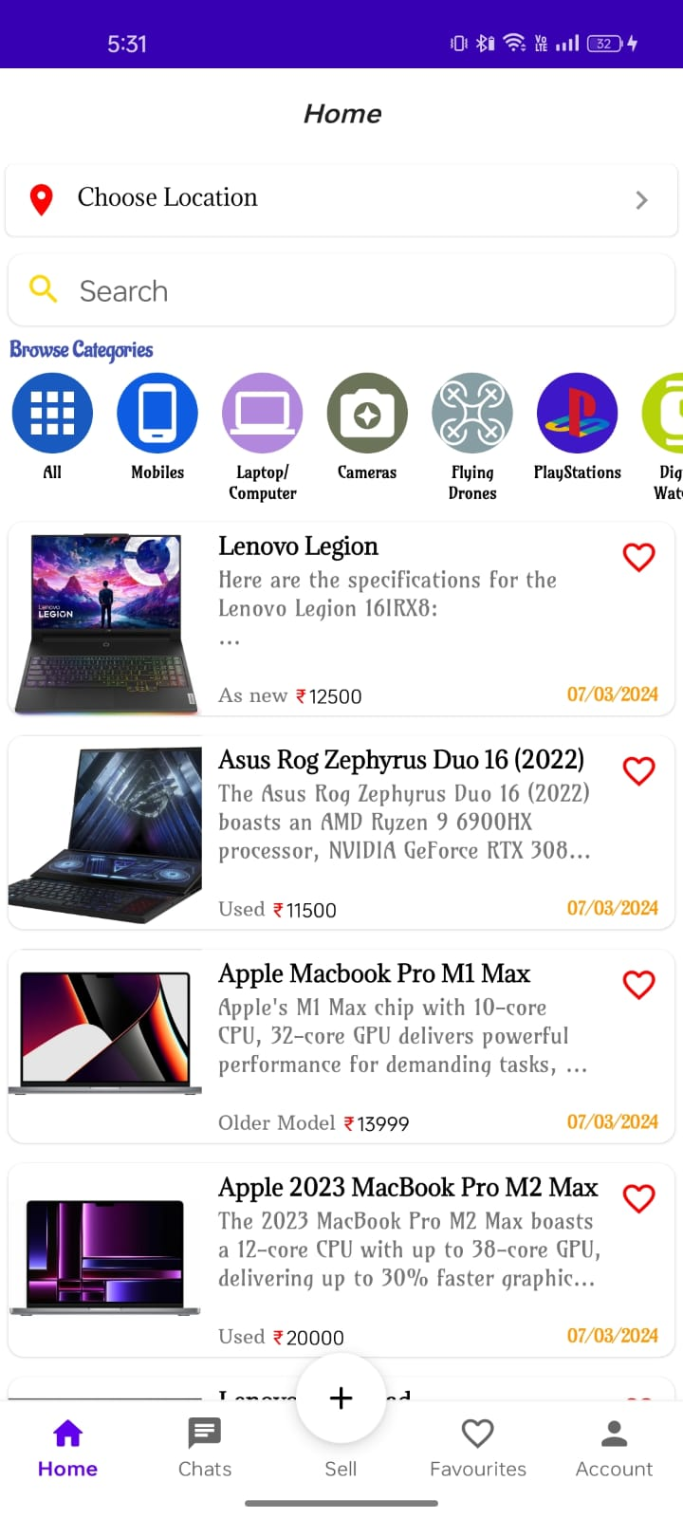

**Fig 7.5: Screenshot of Published ad Fig 7.6: Screenshot of Category of the product**

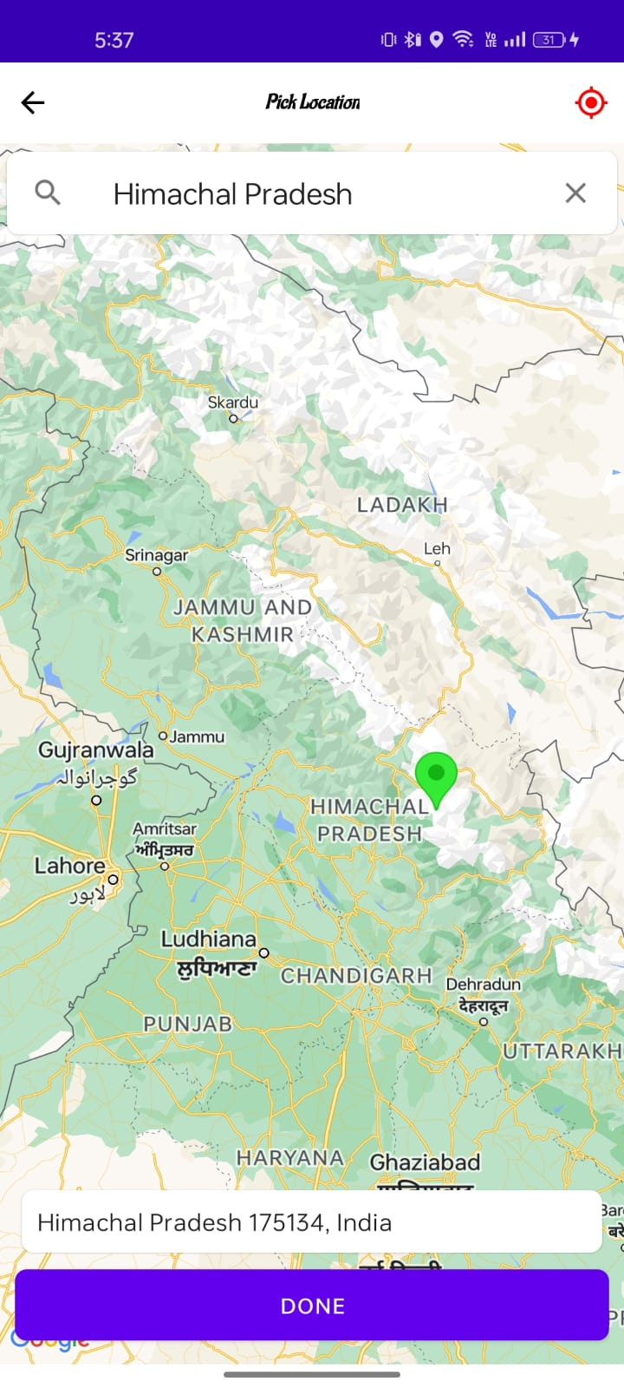 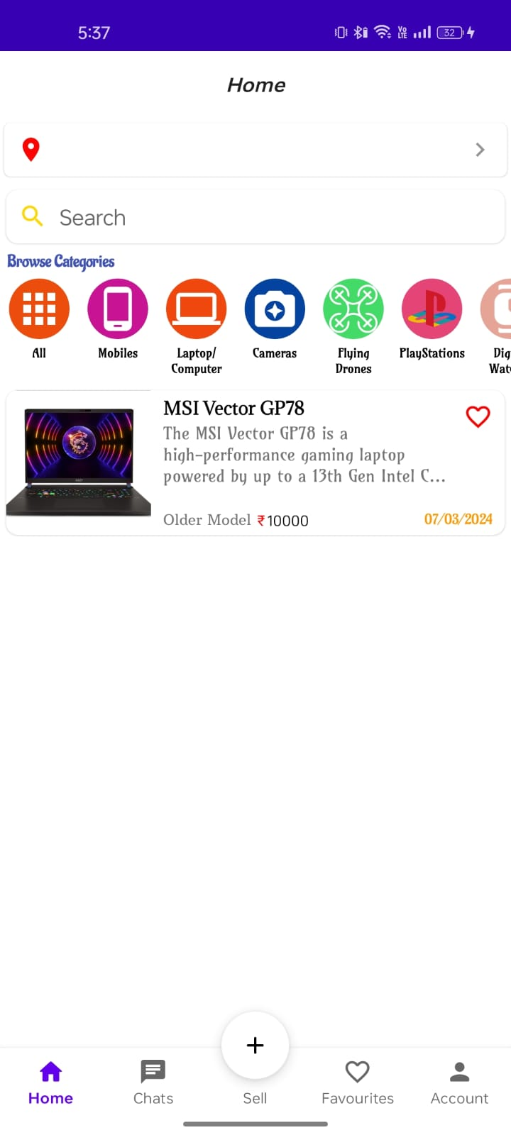

**Fig 7.7: Screenshot of Selecting location Fig 7.8: Screenshot of Location specific Ad**

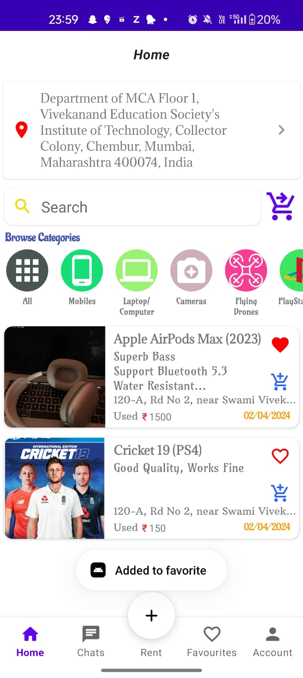 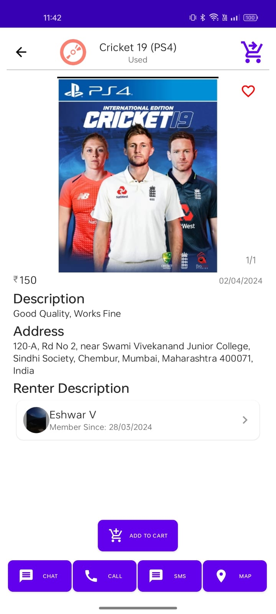

**Fig 7.9: Screenshot of Add to favorite Fig 7.10: Screenshot of add to cart**

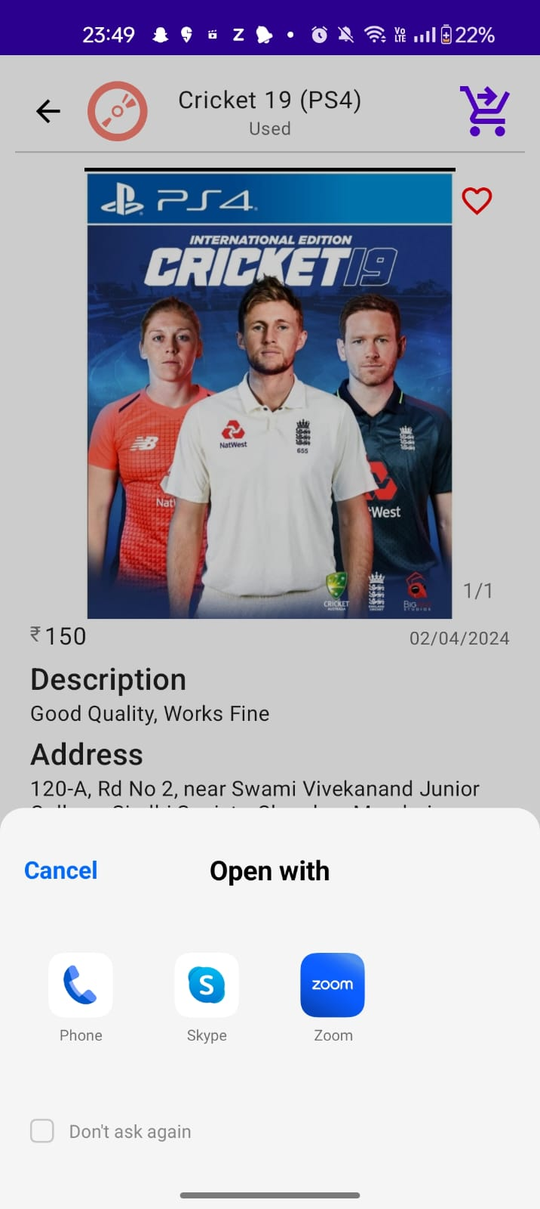 

**Fig 7.11: Screenshot of calling function** **Fig 7.12: Screenshot of Chat function**

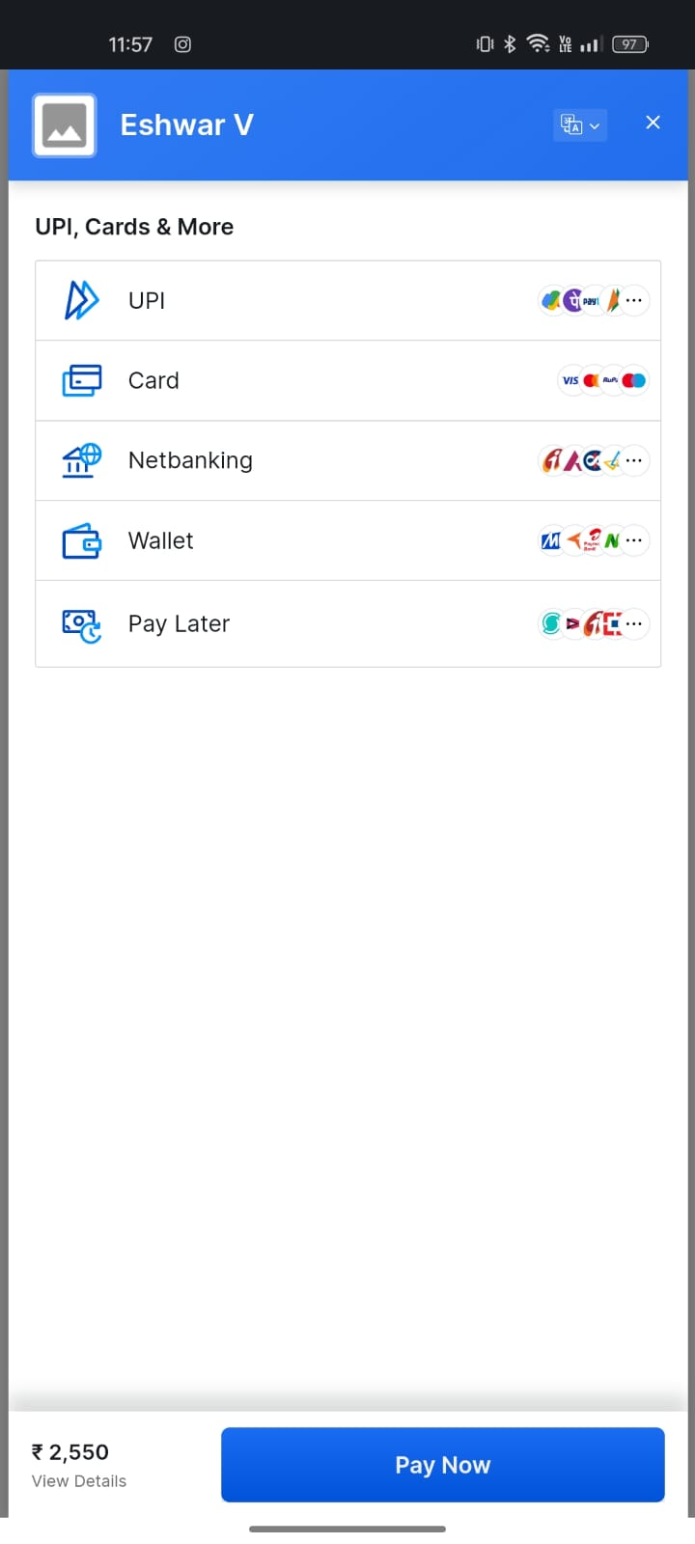

**Fig 7.13: Screenshot for Payment Gateway**

**Input** Parameters/Features considered:

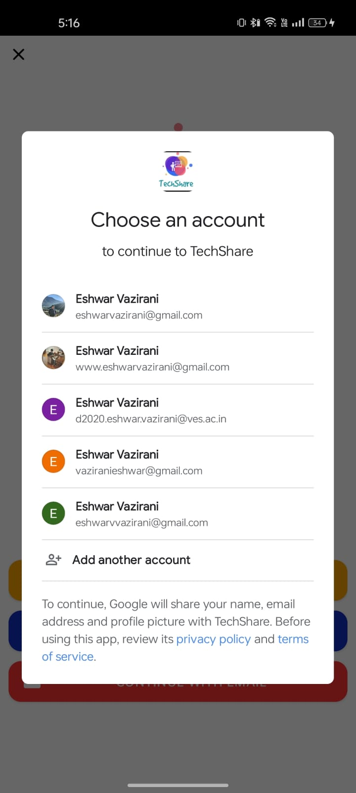 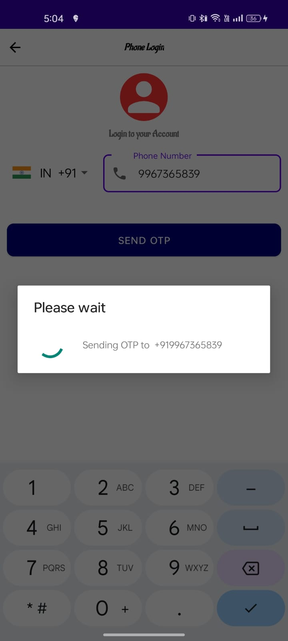 **Fig 7.14:login with gmail Fig7.15: login with phone number**

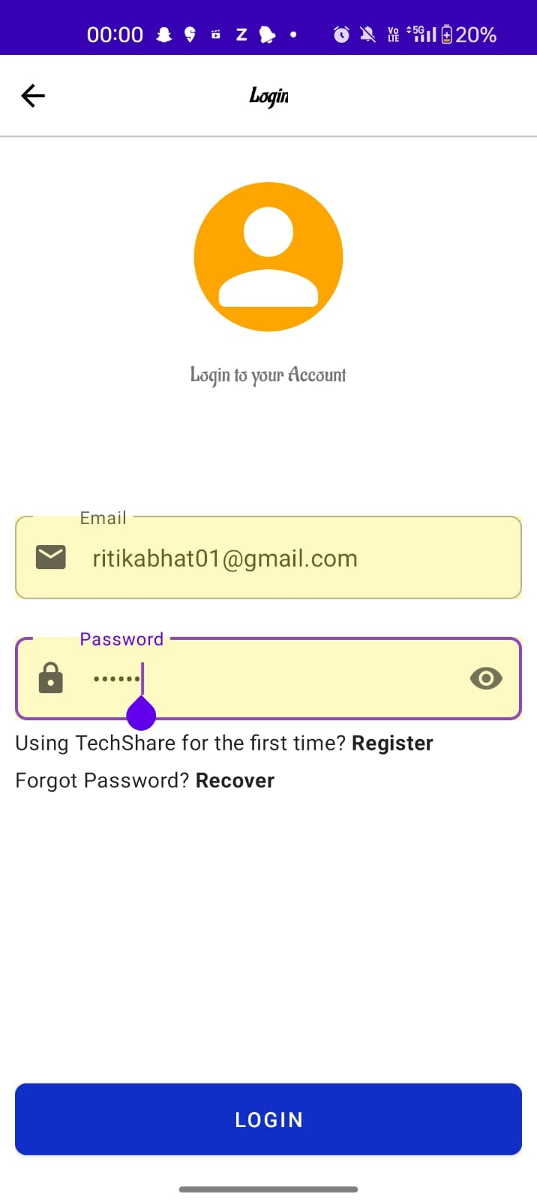 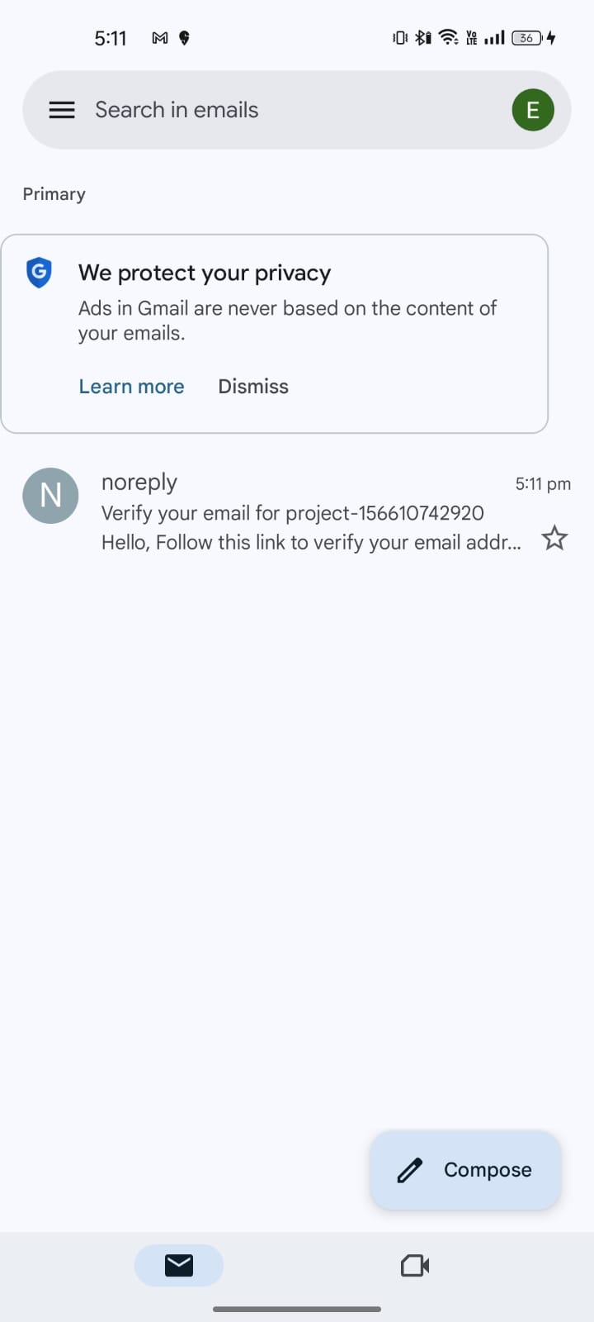

**Fig 7.16:login with email Fig 7.17: verification mail**

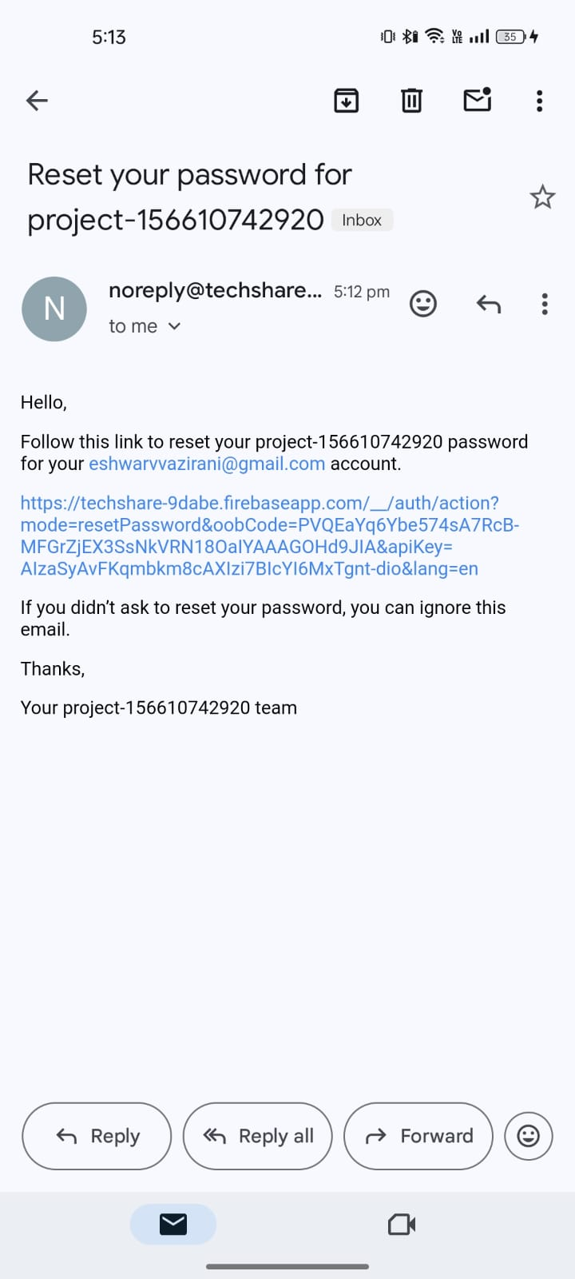

**Fig 7.18: Reset Password**

## Comparison of Results with Existing System:

| **Other System** | **Our System** |
| --- | --- |
| Does not offer insurance coverage for damage. | Provides insurance coverage for gadget damage. |
| Offers a limited selection of gadgets for rent. | Provides a wide range of gadget categories, including mobile phones, CDs, laptops, cameras, playstations, and more. |
| Google Map services are not available. | Incorporates Google Map services for enhanced user experience and navigation. |
| Does not include chat and call features | Provides call and chat features for seamless communication with buyers. |

* 1. **Inference Drawn:**

The presence of a gadget renting app reflects a shift towards access over ownership in the electronics market. It responds to growing environmental concerns, offering users flexibility and affordability while promoting sustainable consumption practices. Additionally, it caters to the desire for experiential consumption, allowing users to try out gadgets before purchasing. Overall, the app mirrors evolving consumer preferences towards sustainable, flexible, and experiential technology consumption

**Chapter 8: Conclusion**

* 1. **Limitations:**

Renters and Buyers have the same interface.

No delivering system from renters to buyers.

System accessibility might lack in functioning in lower android versions.

## Conclusion:

The TechShare application project has been a significant endeavor that aimed to revolutionize the way people access and utilize gadgets. Throughout the development and implementation process, various key factors were considered to create an effective and user-friendly platform. The project successfully addressed the growing demand for gadget rentals by providing a convenient and cost-effective solution. By analyzing user engagement metrics, we observed that the app attracted a substantial user base and experienced consistent usage, indicating its relevance and value to the target audience. The conversion rate of the app was encouraging, showcasing that users found the rental process intuitive and straightforward. Additionally, the app's seamless rental transactions led to increased revenue generation, highlighting the successful integration of payment gateways and the efficiency of the rental process.

Customer satisfaction is considered as the core of the project, as evidenced by positive user reviews and ratings. The app's user-friendly interface and responsive customer support contributed to high levels of user satisfaction. The retention rate can be strong, indicating that the app can be succeed retaining users over an extended period. This achievement can be attributed to continuous updates, relevant gadget inventory, and ongoing efforts to enhance user experience. By closely monitoring rental durations, we gained insights into user behavior, preferences, and the popularity of different gadgets.

## Future Scope:

* + 1. Implementation of payment system.
    2. Introducing terms and condition forms for buyers.
    3. Improving the efficiency of Application in lower android versions

# References

1. [JANICA S. ABADMARY ANN D. ABRIOLVANN HEINRICK D. AMPARO, College of Engineering, Computer Studies and Architecture Lyceum of the Philippines University Cavite](https://www.scribd.com/document/526140539/Gadget-Rental-Feasibility-Paper-1#) [https://www.scribd.com/document/526140539/Gadget-Rental-Feasibility-Paper-](https://www.scribd.com/document/526140539/Gadget-Rental-Feasibility-Paper-1)1[, June, 2021](https://www.scribd.com/document/526140539/Gadget-Rental-Feasibility-Paper-1#)
2. [[1] Amika Mehta, [2] Vedant Patil, [3] Apurva Shinde BE COMP Student, Pune University https://www.ijert.org/research/lekede-online-rental-system-IJERTV8IS100213.pdf , Oct 10, 2019](https://www.ijert.org/research/lekede-online-rental-system-IJERTV8IS100213.pdf)
3. [JUSTO, JOVANIE BACHELOR OF SCIENCE IN INFORMATION SYSTEM https://www.studocu.com/ph/document/agusan-del-sur-state-college-of-agriculture-and-technology/bachelor-of-science-in-information-technology/jojo-thesis-rentogad-a-rental-app/55805282 , 28 Feb, 201](https://www.studocu.com/ph/document/agusan-del-sur-state-college-of-agriculture-and-technology/bachelor-of-science-in-information-technology/jojo-thesis-rentogad-a-rental-app/55805282)8
4. [Ram H.M. Langbrakk, , Yusak Susilo and Peter Grayman, " rental system adoption", vol. 73,pp. 72-82, 2019, https://doi.org/10.1016/j.retrec.2019.02.002.Gegic](https://doi.org/10.1016/j.retrec.2019.02.002.Gegic)
5. [Abhishek Hatwar1, Vijaya Paunikar2, Gauri Sayare3, Shruti Ghumade4, P. A. Kuchewar5 UG Student, Department of Computer Science & Engineering, K.D.K College of Engineering, Nagpur, India 5Professor, Department of Computer Science & Engineering, K.D.K College of Engineering, Nagpur, India https://www.irjet.net/archives/V9/i12/IRJET-V9I1235.pdf , Dec 08, 2022](https://www.irjet.net/archives/V9/i12/IRJET-V9I1235.pdf)
6. [Harsha Chauhan, Gupta Deepali, Sheifali Gupta, Vishal Verma, Chitkara University https://www.researchgate.net/publication/338014189_On_Rent-An_Android_Mobile_Application , Mar 12, 2019.](https://www.researchgate.net/publication/338014189_On_Rent-An_Android_Mobile_Application)
7. [Amey Thakur University of Windsor https://www.researchgate.net/publication/353174644_Car_Rental_System , July, 2021](https://www.researchgate.net/publication/353174644_Car_Rental_System)
8. [Anuj Sanjay Patil; Neel Santosh Gupta; Prasanna Sridharan; Siddhant Krantikumar Patil; Vinita Mishra https://ieeexplore.ieee.org/abstract/document/10212293 July, 2023](https://ieeexplore.ieee.org/abstract/document/10212293)
9. [Anna Björklund, Axel Fridell, Dante Davill Glas, Emil Myhrberg, Fredrik Hammarbäck, Jakob Strallhofer, Lisa Meyer, Johannes Book, Maximilian Johansson Linköping University Department of Computer and Information Science https://www.diva-portal.org/smash/get/diva2:1670895/FULLTEXT01.pdf March 2022](https://www.diva-portal.org/smash/get/diva2:1670895/FULLTEXT01.pdf)
10. [Suraj Yadav1, Samrat Pawar2, Duhita Raut3, Ruchi Rahi4 Department of Computer Engineering, Theem College of Engineering https://www.irjet.net/archives/V8/i5/IRJET-V8I5779.pdf May, 2021](https://www.irjet.net/archives/V8/i5/IRJET-V8I5779.pdf)
11. [M.NIREESHA P.SRINIVASA REDDY PG Scholar, Department of Computer Science, SVKP & Dr K S Raju Arts & Science College, Penugonda, A.P, India.https://www.jetir.org/papers/JETIRDU06009.pdf May, 2020](https://www.jetir.org/papers/JETIRDU06009.pdf)
12. [Nurul Nadia, Che Saufi Nur Shuhadah, Mohd Ab Razak, Hafizah Mansor https://dl.acm.org/doi/abs/10.1145/3309074.3309101 January 2019](https://dl.acm.org/doi/abs/10.1145/3309074.3309101)
13. [Sahreen Afzal1 , Toiba Rouf2 , Sumaiya Qadir3 , Sahila Shah4 https://www.jetir.org/papers/JETIR2111188.pdf November 2021](https://www.jetir.org/papers/JETIR2111188.pdf)

# Appendix

## 1] Paper I details :-

Techshare - A Gadget Renting App

Samarth Gawali  
Department of Computer Engineering(Vivekanand Education Society’s Institute of Technology)  
Mumbai, India  
2020.samarth.gawali@ves.ac.in

Manav Valech  
Department of Computer Engineering(Vivekanand Education Society’s Institute of Technology)Mumbai, India

2020.manav.valecha@ves.ac.inEshwar Vazirai  
Department of Computer Engineering(Vivekanand Education Society’s Institute of Technology)Mumbai, India  
[d2020.eshwar.vazirani@ves.ac.in](mailto:d2020.eshwar.vazirani@ves.ac.in)

Pallavi Gangurde   
Department of Computer Engineering(Vivekanand Education Society’s Institute of Technology)Mumbai, India  
[pallavi.gangurde@ves.ac.in](mailto:pallavi.gangurde@ves.ac.in)

Ritika Bhat   
Department of Computer Engineering(Vivekanand Education Society’s Institute of Technology)Mumbai, India  
[2020.ritika.bhat@ves.ac.in](mailto:2020.ritika.bhat@ves.ac.in)

***Abstract*—This paper presents a groundbreaking approach to accessing and utilizing gadgets through a user-friendly platform aimed at revolutionizing the rental process. By meticulously considering various key factors throughout development and implementation, this project effectively addresses the burgeoning demand for gadget rentals. Analysis of user engagement metrics reveals significant traction and sustained usage, underscoring the platform's relevance and value to its target audience. Notably, the app's impressive conversion rate reflects users' seamless navigation through the rental process, facilitated by an intuitive interface and streamlined transactions. Moreover, the integration of secure payment gateways enhances revenue generation, signaling the project's operational efficiency. Central to its success is a steadfast commitment to customer satisfaction, evident in glowing user reviews and ratings attributed to the app's user-friendly design and responsive support services. With a robust retention rate bolstered by regular updates and a diverse gadget inventory, this platform demonstrates its potential to retain users over the long term. Overall, this paper showcases a novel solution poised to reshape how individuals interact with and access gadgets, offering convenience and affordability in equal measure.**

***Keywords*—GRA-Gadget Rental Application ASP - Active Server Page,Xml - Extensible markup language ,API - Application Programming Interface**

I.INTRODUCTION

In the dynamic landscape of today's technology-driven world, the constant evolution of gadgets and devices is pivotal for both individuals and businesses. However, the hefty expenses and sustainability concerns associated with procuring and managing a diverse range of tech assets pose formidable obstacles. Enter the TechShare Rental System, an innovative platform poised to revolutionize our interaction with technology.

At its core, the TechShare Rental System serves as a pioneering solution, streamlining the temporary acquisition of a plethora of tech resources, thus extending access to cutting-edge technology to a broader audience. Whether it's a student in need of a high-performance laptop for a semester, a burgeoning startup eager to experiment with the latest hardware prototypes, or an individual seeking to explore the realms of augmented reality, TechShare provides an intuitive and seamless solution.

Affordable Access to Technology: The TechShare Rental System is driven by a profound mission to bridge the digital divide by democratizing access to technology. In a world where technology access remains disparate, this platform breaks down barriers by offering state-of-the-art tech resources without the exorbitant costs typically associated with ownership. This democratization fosters inclusivity, empowering individuals and organizations alike to fully participate in the digital age.

Reducing E-Waste:TechShare stands as a beacon of sustainability, championing shared usage of tech assets to alleviate the environmental strain caused by incessant purchasing and disposal of electronics. By promoting a departure from traditional single-owner consumption models, TechShare aligns with the burgeoning environmental consciousness permeating both individual and organizational spheres.

Flexible Solutions for Diverse Needs: Recognizing the multifaceted nature of users' technology requirements, the TechShare Rental System offers tailor-made solutions catering to students, businesses, and individuals alike. Whether the need arises for educational, professional, or personal purposes, users can seamlessly adapt their tech resources to suit their evolving needs, thereby enhancing efficiency and cost-effectiveness.

Financial Accessibility: By alleviating the financial burdens commonly faced by students, startups, and individuals, TechShare facilitates access to high-end technology without imposing significant upfront investments. This empowerment enables users to pursue their educational, entrepreneurial, and creative endeavors without being constrained by financial limitations.

In essence, the TechShare Rental System emerges as a beacon of technological empowerment, offering not only affordability and sustainability but also flexibility and accessibility to a diverse array of users. Through its innovative approach, TechShare promises to reshape the landscape of technology utilization, fostering a more inclusive and sustainable digital future for all

II . PROPOSED SYSTEM

The proposed model for our project initiates with a comprehensive user registration and authentication process to ensure utmost data security. Users are empowered to create and manage their profiles, including the secure storage of payment information for seamless transactions. The interface is intuitively designed, boasting advanced search and filtering functionalities, thereby simplifying the process of browsing through the array of available gadgets.Integral to the system are booking and reservation features, facilitated by a calendar system that not only displays availability but also calculates rental fees in real-time. Additionally, a robust review and rating system is incorporated to assist users in making informed decisions, while a messaging platform facilitates seamless communication between users and gadget owners.Payment integration serves as a cornerstone of the system, supporting a wide range of payment methods to accommodate user preferences. Location services are seamlessly integrated to enhance the user experience by providing access to nearby options and offering navigation assistance.The system's inventory management module enables gadget owners to list their items, manage availability, and set rental rates, ensuring a smooth and transparent transaction process. A trust and verification mechanism has been established to boost user confidence and ensure a safe and secure environment for all users.Central to the system's operation are robust customer support mechanisms and a steadfast commitment to data privacy, in strict adherence to relevant data protection regulations. Analytics tools provide invaluable insights into user behavior and preferences, facilitating continuous improvement and optimization of the platform.

An administrative panel is essential for effective moderation and dispute resolution, ensuring smooth operation and user satisfaction. Regular solicitation of user feedback is prioritized to drive continuous enhancement, while meticulous planning for future expansion is integral to sustained growth and success.

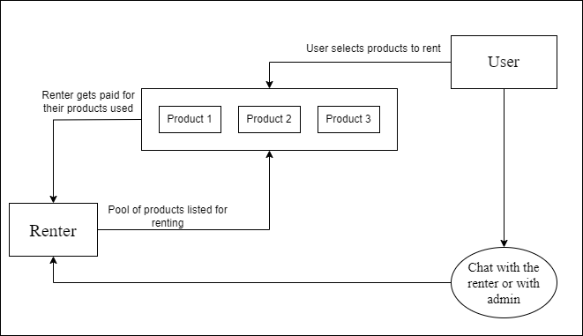

III PRODUCT FUNCTIONALITY

Functional Requirements for the Gadget Rental App:

1. User Registration and Authentication: Allow users to safely create accounts and log in.

Implement strong security procedures, such as email verification and two-factor authentication, to protect user accounts.

2. User Profiles: Allow users to create and customize profiles with personal information and profile pictures.

Provide options for users to add and manage payment details for rental transactions securely.

3. Gadget Listings: Offer a platform for gadget owners to list their items available for rent.

Include comprehensive fields for gadget details, accompanied by high-quality images, and specify rental rates clearly.

4. Search and Filters: Implement advanced search functionality enabling users to search for gadgets by keywords, categories, and location.

Provide robust filtering options to refine search results based on specific criteria.

5. Booking and Reservation: Enable users to select rental dates and times while booking gadgets.Display real-time gadget availability to prevent overlapping bookings and conflicts.

Calculate and present rental fees accurately, incorporating any additional charges transparently.

6. Messaging System: Incorporate a messaging feature facilitating seamless communication between renters and gadget owners.

Allow users to discuss rental details, ask questions, and coordinate pickup and drop-off logistics effectively.

7. Booking Management: Provide users with the ability to view and manage their bookings effortlessly, including options for cancellations and modifications.

Send notifications and reminders to users regarding upcoming bookings to ensure timely arrangements.

8. Rating and Reviews: Enable users to leave reviews and ratings for gadgets they've rented, fostering transparency and trust within the community.Display average ratings and reviews prominently on gadget listings to assist users in making informed decisions.

9. Payment Processing: Integrate a secure payment gateway to handle rental transactions securely.Support multiple payment methods, including credit/debit cards and digital wallets, to cater to diverse user preferences.

10.Inventory Management: Provide gadget owners with tools to manage their inventory efficiently, allowing them to mark gadgets as unavailable and update rental rates as needed.

Offer features to track rental history and income generated from rentals for comprehensive financial management.

11.Feedback and Improvement: Actively encourage users to provide feedback and suggestions for app enhancements, ensuring continuous improvement and alignment with user needs and preferences.

## IV. RELATED WORK

There are various examples of research on renting applications. Therefore, before describing our contribution and its related methodology we provide a brief overview of the related projects that utilize renting application

The gadget rental business targets Small and Medium-sized Enterprises (SMEs), offering affordable access to the latest technology. SMEs face challenges in acquiring new gadgets due to cost constraints and frequent updates. By providing a rental service, the business ensures swift and cost-effective access to cutting-edge technology, enabling SMEs to boost productivity and efficiency. With SMEs increasingly relying on gadgets for various operations, the demand for rental services is on the rise, presenting significant market potential for growth.[1] LeKeDe Online Rental System, an application designed to facilitate seamless communication between users and rental product owners. With the increasing prevalence of online applications, there's a growing demand to enhance industrial services and cater to customer needs more effectively. LeKeDe aims to bridge this gap by providing a platform where users can easily connect with rental product owners, streamlining the rental process for everyone involved.[2]

The Ski-Rental problem and its cloud cost optimization equivalent pose a dilemma of whether to buy or rent based on uncertain usage durations. Existing deterministic and randomized algorithms have limitations when dealing with uncertain arrival times. To address this, we propose k-PROB andσ-PROB policies leveraging statistical information about the adversary's strategy. These policies outperform existing methods, offering more robust decision-making in uncertain scenarios.[4]

The rise of information technology has revolutionized vehicle rental services, shifting from traditional methods to streamlined mobile applications. In response to existing limitations, a new mobile app called EZGO is proposed. EZGO aims to enhance the vehicle rental experience by offering a wider range of vehicles and expanding coverage throughout Malaysia. The objectives include developing an online platform for renting cars, motorcycles, and vans, improving geographic coverage, and increasing the variety of vehicle brands and models available for online rental in Malaysia.[5]

The internet has eased the process of seeking lodging by offering precise information and contact information online. The 'On Rent' smartphone app, which is available for Android users, allows exchanges between lodging searchers, building managers, and those renting books and electrical goods. Its mission is to provide consumers with economical and convenient rental choices, particularly for students and professionals traveling for study or employment.[6]

The "Car Rental System" project enables customers to reserve vehicles globally. Users provide personal information and create accounts to book cars online. The system automates manual procedures, allowing customers to specify their car preferences and location. Its goal is to offer a user-friendly platform for seamless car reservations and service requests worldwide.[7]

This research proposes an innovative equipment rental system to revolutionize farming. It allows farmers to rent equipment based on their current needs, reducing waste and improving resource allocation. The platform features multilingual presentations, a transaction database, and smart tools for pest prediction, weather forecasting, and crop recommendation. By addressing idle equipment and promoting resource efficiency, this solution aims to enhance sustainability in agriculture while providing farmers with user-friendly access to essential services.[8]

The rise of Consumer-to-Consumer (C2C) platforms, known as the "Sharing Economy," has reshaped markets, allowing direct exchanges between individuals. This paper introduces PuRSCA, a Dapp developed for Android phones, utilizing Ethereum blockchain to replace traditional Trusted Third Parties (TTPs) in purchase and rental contracts. PuRSCA addresses challenges like trust and scalability and enables peer-to-peer trading.[9]

The Car Rental Service System facilitates online car rentals between rental agencies and individuals. Users must meet specified requirements and provide necessary information for authenticity verification. Upon approval, transactions are set for a minimum specified period, offering users convenient, trustworthy, budget-friendly transportation options.[10]

Rental Home Appliances Management System aims to be the top choice for home appliance rentals. Our values include accountability, integrity, and honesty. Our project offers a convenient application for renting items like TVs, fridges, and washing machines. We provide free delivery and installation within 24 hours, ensuring customers receive their desired items promptly. Renting from us means access to the latest brands anytime.[11]

The Online House Rental Management System facilitates rental property management and tenant searches. It provides an online portal for landlords to post property details, tenants to search for listings, and members to book site visits. The system utilizes HTML, CSS, Bootstrap, JavaScript for frontend responsiveness, and PHP and MySQL for dynamic backend functionality and database management[12]

LIMITATIONS OF EXISTING SYSTEMS

Before moving on to understanding or even proposing our rental system, we will first look at different types of rental systems available and what are its lacunas present in the current system. Below fig 4.1 is a tabular description of some of the rental apps we would be discussing, and their lacunas.

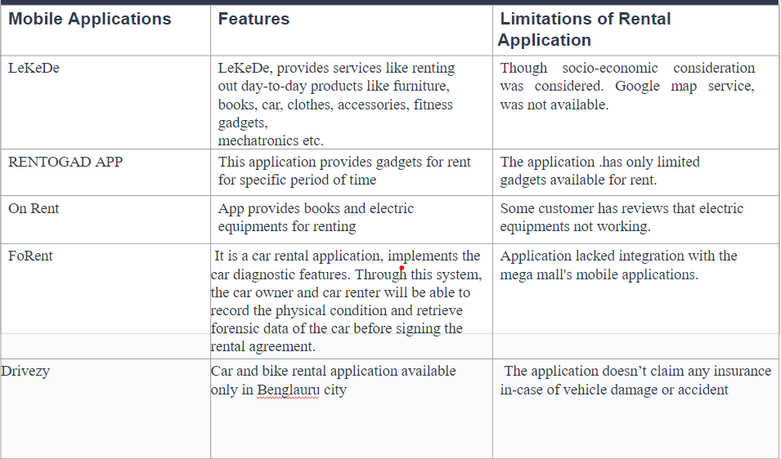**fig 4.1: Comparison of different rental apps in brief**

a)LeKeDe offers a variety of rental services for day-to-day products like furniture, books, cars, and accessories, it may have limitations in terms of the range of products available. Users may find that certain items they require are not offered by the platform . Due to the nature of rental services, availability of products may vary based on demand and inventory. Users may face challenges in finding desired items during peak periods or in specific locations, services may be limited to certain geographic regions, restricting access for users outside of these areas. Non-local users may encounter difficulties in accessing and utilizing the platform.As rental products are used by multiple users over time, there may be concerns regarding maintenance and quality. Users may experience issues with cleanliness, functionality, or overall condition of rented items.

Pricing Structure: The pricing structure of LeKeDe's rental services may not always be transparent or competitive compared to alternative options such as purchasing or leasing. Users may find that the cost of renting certain items does not provide significant cost savings compared to ownership.[2]

b)"On Rent" is an Android mobile application designed to streamline the process of borrowing and lending various commodities. This platform offers a wide range of services, including equipment rental for books and electrical appliances, as well as accommodation rental. However, there have been complaints about the efficiency of applications offering gadgets for rent.Despite the convenience offered by On Rent, there are complaints about the efficiency of gadget rental services provided by the application. Users have reported issues with the functionality and reliability of the rental gadgets, which may hinder the overall user experience and trust in the platform .Furthermore, the traditional method of finding or advertising anything for lease is time-consuming and tiresome since one must navigate many programs to seek for different commodities. Hence, to save time and effort from folks' hectic schedules.[6]

c)RentoGad lacks a feature for insurance coverage in case of gadget breakdowns or damages, leaving users uncertain about liability in such situations. The concept of the app requires investing in gadgets upfront, which may pose a financial challenge and limit the variety of available rental items.Market Research: Without thorough market research, the app may struggle to accurately determine the demand for specific rental items, potentially leading to mismatches between available gadgets and user needs. The absence of an insurance system may undermine user trust in the platform, as users may be hesitant to rent expensive gadgets without adequate protection against damages.

## V. METHODOLOGY

The development journey of a gadget rental mobile application embarks on a structured path, meticulously designed to deliver a user-centric and efficient platform. Commencing with an exhaustive exploration of the market landscape, the initial phase delves deep into understanding user requisites, conducting thorough competitor analyses, and identifying burgeoning trends within the gadget rental industry. This foundational research lays the groundwork for informed decision-making throughout the project.

Following the comprehensive market assessment, the focus shifts towards delineating the application's requirements. This phase encompasses the delineation of essential features such as user registration, adept gadget catalog management, integration of secure payment systems, and the establishment of a streamlined rental process. The aim is to engineer a platform that seamlessly aligns with user needs while fostering a hassle-free rental experience.

The subsequent design phase pivots towards crafting an intuitive user interface (UI) and ensuring a fluid user experience (UX). Meticulous attention is dedicated to enabling users to effortlessly navigate through the application, peruse detailed product information, and seamlessly execute transactions. Through user-centric design principles, the goal is to engender an interface that not only meets but exceeds user expectations.

With the blueprint in place, the development stage unfolds, employing agile methodologies to iteratively construct and test the application. Continuous feedback loops are integrated, facilitating the incorporation of user insights for ongoing refinement. Paramount importance is placed on ensuring robust security measures, encompassing the encryption of user data and payment transactions, to fortify user information against potential threats.

As the development culminates, rigorous testing ensues to validate functionality, performance, and security parameters. Only upon meticulous scrutiny and assurance of quality does the application proceed to deployment on app stores. Post-launch, vigilant monitoring and analysis of user feedback form the bedrock for subsequent updates and enhancements. This iterative process ensures that the application remains attuned to evolving user needs and industry dynamics, fostering an environment of continuous improvement

**PROPOSED DESIGN**

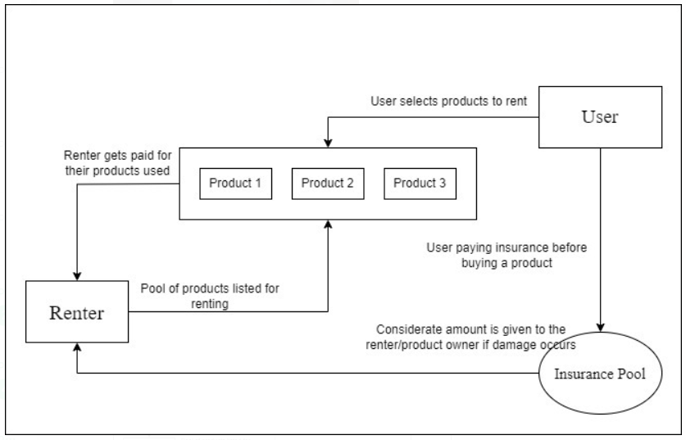

**Fig 5.1: Block Diagram of System**

User Interface: At the forefront of the application lies the User Interface (UI), serving as the gateway through which users interact with the system. Whether accessed through a web browser or a mobile app, the UI embodies the visual and navigational elements that guide users through their gadget rental journey. It encompasses sleek, intuitive design elements, fostering a seamless and engaging user experience. Users can effortlessly browse through gadget listings, view detailed product information, and initiate rental transactions with ease, all facilitated by a visually appealing and user-friendly interface.

User Management & Authentication: Central to the application's functionality is the User Management & Authentication component, which orchestrates the registration, login, and authentication processes. It empowers users to create and manage their profiles securely, ensuring their personal information remains protected. Through robust authentication mechanisms, users can securely access their accounts, allowing for personalized experiences tailored to their preferences and rental history.

Gadgets Management: The Gadgets Management component serves as the backbone of the application, facilitating the seamless management of gadget listings. Here, administrators have the ability to create, edit, and remove gadget listings, ensuring that the catalog remains up-to-date and reflective of available inventory. Users can explore a diverse array of gadgets, each accompanied by comprehensive details and high-quality images, enabling informed rental decisions.

Reservation & Booking: Seamlessly orchestrating the rental process, the Reservation & Booking component connects renters with gadget owners, facilitating smooth transactions from start to finish. Users can browse available rental dates, select their desired gadgets, and initiate bookings with confidence. Real-time availability updates and automated confirmation notifications streamline the process, enhancing convenience for both renters and owners alike.

Payment Processing: Integral to the application's functionality is the Payment Processing component, which manages payment transactions securely and efficiently. Through seamless integration with trusted payment gateways, users can complete transactions with confidence, knowing that their financial information is safeguarded. Flexible payment options cater to diverse user preferences, fostering a frictionless rental experience while minimizing payment-related hurdles.

Database and Storage: Safeguarding critical application data, the Database and Storage component serves as the repository for user information, gadget listings, transaction history, and other application-related data. Utilizing robust database technologies, it ensures data integrity, scalability, and reliability, facilitating seamless access to information across the application's various components. From user profiles to transaction records, every piece of data is meticulously stored and managed, underpinning the application's operational efficiency and reliability.

In essence, each component has a significant impact on the user experience and performance of the gadget rental application, resulting in a frictionless, safe, and entertaining platform for users to explore, engage, and transact within the dynamic world of gadget rentals.

Each feature within the gadget rental application plays a pivotal role in facilitating a seamless, transparent, and user-centric rental experience. From registration and browsing to payment and confirmation, every step is meticulously designed to empower users with flexibility, convenience, and confidence throughout their gadget rental journey

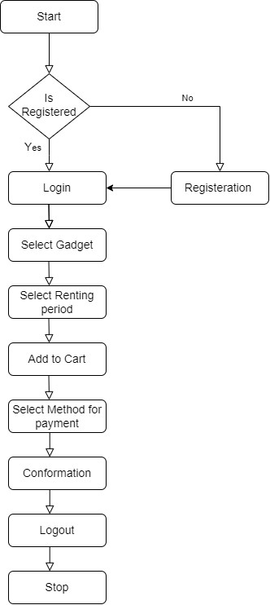

**Fig 5.2 Flowchart for users**

User Registration/Login: The cornerstone of user interaction begins with the User Registration/Login feature. New users can seamlessly register for an account, providing essential details to create their profile, or existing users can effortlessly log in to access their account. This ensures a personalized experience tailored to each user's preferences and rental history.

Browse Gadgets: Delving into the vast array of available gadgets, users can peruse through a curated collection tailored to their interests and needs. The Browse Gadgets feature presents users with a visually appealing catalog, showcasing an extensive range of gadgets available for rent. From high-tech gadgets to everyday essentials, users can explore and discover the perfect rental options suited to their requirements.

Search Gadgets: For users seeking specific gadgets or narrowing down their options, the Search Gadgets functionality comes to the fore. Users can employ various filters such as category, name, or other specifications to streamline their search process. Whether hunting for a particular gadget model or exploring within a specific category, this feature empowers users with flexibility and efficiency in their quest for the ideal rental.

View Gadget Details: Upon finding a promising gadget, users can delve deeper into its specifications and features with the View Gadget Details feature. By clicking on a gadget of interest, users gain access to comprehensive information, including detailed descriptions, high-resolution images, and availability status. This enables informed decision-making, allowing users to assess the suitability of the gadget for their needs before proceeding with the rental process.

Payment: With the desired gadget selected, users transition seamlessly to the Payment stage, where they enter their payment information and confirm the rental. Utilizing secure payment gateways, users can transact with confidence, knowing that their financial details are safeguarded throughout the process. The Payment feature ensures a seamless and secure transaction experience, facilitating hassle-free rentals for users.

Owner Confirmation: Upon submission of the rental request, the gadget owner receives a notification prompting them to confirm the reservation. This Owner Confirmation step ensures transparency and accountability within the rental process, allowing owners to review and approve rental requests at their discretion. By empowering owners with control over reservations, this feature fosters trust and confidence in the rental exchange between users and owners.

Owner Accepts: Upon receiving confirmation from the gadget owner, the rental process progresses seamlessly. If the owner accepts the reservation, users receive notification, and the rental is officially confirmed. This Owner Acceptance step marks the culmination of the rental process, signaling the commencement of the rental period and facilitating the seamless exchange of the gadget between owner and renter.

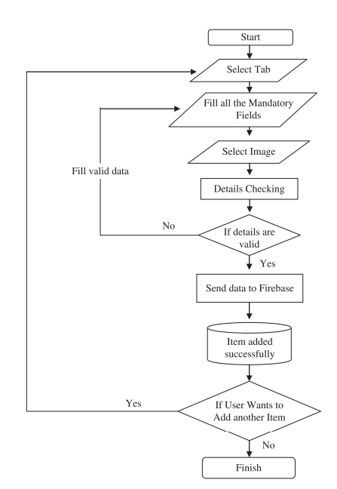

**Fig 5.3 Flowchart for gadget owners**

Tab Selection: Empowering renters with control over their inventory, the Tab Selection feature allows them to seamlessly manage their gadgets. Renters can effortlessly select tabs to remove or add gadgets to their inventory, ensuring that their listings accurately reflect the availability of gadgets for rental. This intuitive functionality streamlines the inventory management process, enabling renters to efficiently organize and update their offerings as needed.

Mandatory Details: Prioritizing transparency and security, renters are required to furnish mandatory details when adding gadgets to their inventory. This includes specifying the type of gadget bei

ng added, accompanied by necessary documents for verification purposes. Additionally, renters are prompted to upload high-quality images of the gadget, enhancing visibility and trustworthiness for potential renters. By mandating these details, the platform ensures authenticity and reliability in gadget listings, fostering a secure and informed rental environment.

Verification: Following the submission of gadget details by renters, a meticulous verification process ensues to validate the accuracy and authenticity of the provided information. Through rigorous scrutiny, including verification of documents and examination of gadget images, the platform verifies the legitimacy of the gadgets being added to the inventory. Once verified, the details of the gadget are securely added to Firebase, a robust database system, ensuring seamless integration and accessibility within the platform's ecosystem.

Adding More Gadgets: For renters seeking to expand their inventory further, the platform offers a streamlined process to add additional gadgets. Renters can choose to repeat the gadget addition process, seamlessly adding more gadgets to their inventory as desired. Alternatively, if renters opt not to add more gadgets, they can successfully log out, concluding their session while retaining full control over their existing inventory. This flexibility empowers renters to scale their offerings at their own pace, ensuring adaptability to evolving rental demands.

VI. EXPERIMENT AND RESULT

During the developmental phase, a comprehensive evaluation of the application was conducted to ascertain its adherence to specified requirements. We evaluated how many people readily buyed electronic gadgets or would love to rent those. In this age of growing technology and increase in virtual experience these gadgets cost much more for an average earning man. Buying these products when you use them for a little amount of time doesn’t return the amount of money spent on the electronics gadgets.

The graph below Fig 6.1, called a stacked bar chart shows the percentage of electronics gadgets being rented over different cities in India. This analysis gives results about how many different types of gadgets, from gaming pc or playstation to drones and mobile phones have been shown and compared between different cities. Places which are famous tourist cities like delhi or madras and mumbai drones are being rented at high quantity which implies the drone shots or pictures are much greater than on normal cameras.

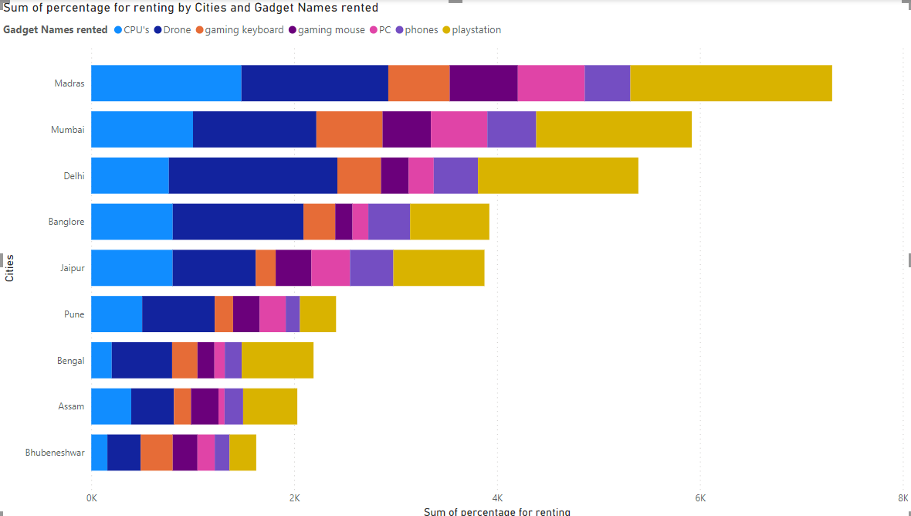

**Fig 6.1: Bar Graph Analysis**

Before proposing a rental app for gadgets or electronic devices sharing we need to first analyze how many people or how much market we would be provided or how many people are interested in renting products. Electronic gadgets or hardware parts are very expensive and only few people are able to buy high quality or specs components which provide a better experience for users. Those who can’t afford such gadgets tend to find someone who could rent them so that they could get the same experience for a small amount of money. The renter is also able to earn some money out of it so he/she would be able to earn good value for their expensive products.

The below graph Fig 6.2 comparison between rental vs buying percentage shows how much market or people want to rent a product rather than buying the product by themselves.

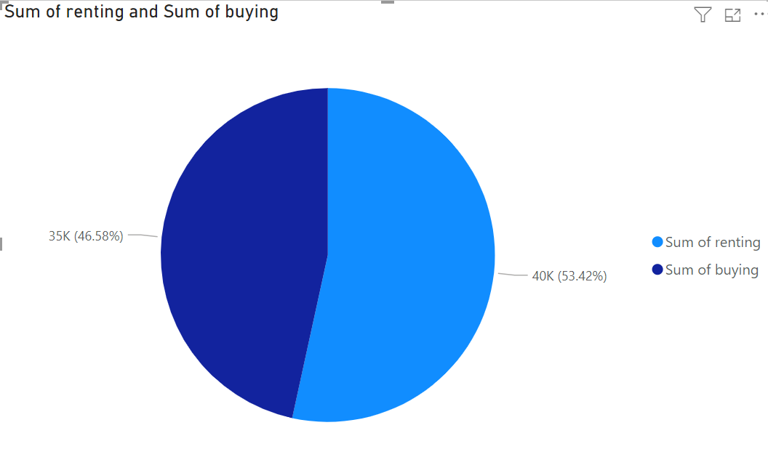

**Fig. 6.2: Comparison of renting of a product vs buying of a product**

The Application was designed to cater to users seeking gadgets for rent for specific durations, facilitated by payment of a predetermined amount as per the gadget owner's discretion. Furthermore, the platform provided an intuitive interface for gadget owners to list their offerings, including descriptions of usage and associated rental costs per day. To mitigate risks, an insurance system was implemented to address any potential damage or theft of rented gadgets. Additionally, a robust notification system was integrated to keep users informed about their points, rewards, and upcoming promotions, enhancing user engagement and retention.The experiment focused on assessing key metrics such as user engagement, retention rates, customer satisfaction, conversion rates, and revenue impact. The anticipated outcomes included heightened engagement levels, improved user retention, positive feedback from customers, increased conversion rates, and overall revenue growth. These metrics served as benchmarks for evaluating the success of the gadget rental application and guiding future strategies.

Following figures depict the the outcomes of the

experiment:



**Fig 6.3: Login page**

The above figure shows the Login page where users can sign with three convenient methods: via Google,phone,or email.



**Fig 6.4: My account**

This figure displays my account. It shows the user's account information, including name, phone number, and email address. By selecting "Edit Profile," the user may further customize their profile.Use the email verification link that is delivered to the user's inbox to confirm your account. .



**Fig 6.5 Home Page**

Upon logging into the application, users are greeted with the home page, showcasing a comprehensive list of available gadgets for rent along with their corresponding rental charges.



**Fig 6.6:Create Ad Page** Users and sellers can create ads .The user must provide essential details about the product they wish to rent. This includes uploading images of the product, specifying the brand, selecting the appropriate category, indicating the condition of the item, specifying the location where the product is available for rent, setting the price, providing a title for the ad, and adding a description detailing the features and specifications of the product



**Fig 6.7 : Published ads**

The above figure shows the ad published by a user or seller.



**Fig 6.8 : Category of the product**

Both users and sellers can view specific ads by selecting a category such as laptops , camera ,

watch etc from the available brand categories. they can also view specific ads by search options



**Fig 6.9 : Select Location**

Users can browse ads that are specific to their location, ensuring relevance and convenience in their rental search



**Fig 6.10 : Location Specific Ad**

The displayed ad in the figure is location-specific, catering to the preferences and needs of users in a particular area.



**Fig 6.10 : Add to favorite**

Allowing users to mark certain gadgets or items as favorites can help them easily access and manage the items they like the most.



**Fig 6. 11 : Calling function**

Enabling seamless communication between users seeking to rent gadgets and potential renters is paramount.



**Fig 6.12: add to cart**

It allows users to gather multiple items they are interested in purchasing into a single location, making it easier to review and manage their selections before making a final decision



**Fig 7.13: Chat function**



**Fig 7.13: Payment Gateway**

This facilitate secure and seamless transactions between buyers and sellers by encrypting sensitive financial information and processing payments

VII. CONCLUSION AND FUTURE WORK

The TechShare application project has emerged as a significant initiative aimed at transforming the landscape of gadget access and utilization. Throughout its development and implementation journey, several pivotal factors were meticulously considered to ensure the creation of an efficient and user-centric platform. By effectively addressing the escalating demand for gadget rentals, the project has introduced a convenient and economically viable solution to the market.

Through meticulous analysis of user engagement metrics, it became evident that the application garnered a substantial user base and consistently witnessed robust usage patterns, underscoring its relevance and value proposition to the target demographic. Notably, the app's commendable conversion rate signifies that users found the rental process to be intuitive and seamless, thus contributing to its widespread adoption.

Furthermore, the integration of secure payment gateways facilitated smooth and hassle-free rental transactions, ultimately leading to a notable uptick in revenue generation. This success underscores the efficacy of the platform's operational framework and its ability to efficiently cater to users' needs and preferences.

At the heart of the project lies a steadfast commitment to customer satisfaction, as evidenced by the overwhelmingly positive user reviews and ratings. The app's user-friendly interface, coupled with responsive customer support, has been instrumental in fostering high levels of user satisfaction and trust.

Moreover, the app's robust retention rate serves as a testament to its ability to retain users over an extended period. This achievement can be attributed to the continuous rollout of updates, the availability of relevant gadget inventory, and ongoing efforts to enhance the overall user experience.

By closely monitoring rental durations, invaluable insights into user behavior, preferences, and the popularity of various gadgets have been gleaned. These insights serve as a cornerstone for informed decision-making, enabling the platform to adapt and evolve in tandem with shifting market dynamics and user demands.

In essence, the TechShare application project stands as a beacon of innovation in the realm of gadget rentals, offering a seamless and user-centric platform that resonates with its audience. Through a harmonic combination of technological skill, customer-centricity, and data-driven insights, the project has effectively carved out a space for itself in the competitive landscape, positioning itself for long-term development and influence.

VIII. REFERENCES

[1] Janica S. Abad , Mary Ann D. Abriol , Vann Henrick D. Amparo , “ The Feasibility Study On The Establishment Of A Gadget Rental In Dasmarinas City ”,College of Engineering, Computer Studies and Architecture Lyceum of the Philippines University Cavite, June, 2021

[2] Amika Mehta, Vedant Patil, Apurva Shinde,

“ LeKeDe: Online Rental System ”, BE COMP Student, Pune University, Oct 10, 2019

[3] Kuo-shien Huang, Shun-ming Tang , “ RFID Applications Strategy and Deployment in Bike Renting System ” ,Department ofInformation Management, National Yunlin University of Science and Technology ,Feb. 17-20, 2008

[4] Ali Khanafer , Murali Kodialam , and Krishna P. N. Puttaswamy , “ The Constrained Ski-Rental Problem and its Application to Online Cloud Cost Optimization”,2013 Proceedings IEEE INFOCOM, Turin, Italy, 2013

[5] F. Y. H. Ahmed, E. B. Hazlan and M. I. Abdulla, "Enhancement of Mobile-Based Application for Vehicle Rental," 2021 IEEE 11th IEEE Symposium on Computer Applications & Industrial Electronics (ISCAIE), Penang, Malaysia, 2021

[6] HarshaChauhan,Gupta Deepali,Sheifali Gupta,

Vishal Verma, “ On Rent—An Android Mobile Application, Chitkara University, Oct 2019.

[7] Amey Thakur , “ Car Rental System” University of Windsor ,July,2021

[8]Supriya, Sangeetha V ,A Subhasini

and Vaishnav M, "Mobile Application Rental Batteries," Journal of Physics Conference Series,May 2021

[9] Rafati Niya, Sina; Schüpfer, Florian; Bocek , Thomas ; Stiller, Burkhard, “A Peer-to-peer Purchase and Rental Smart Contract - based Application (PuRSCA)”. De Gruyter Oldenbourg October 6, 2018

[10] SurajYadav, Samrat Pawar, Duhita Raut, Ruchi Rahi , “ Car RentalSystem”, Department of Computer Engineering, Theem College of Engineering,May,2021 [11].M.Nireesha,P.Srinivasa Reddy , “Home Appliances for Rent ”, PG Scholar , Department of Computer Science, SVKP & Dr K S Raju Arts & Science College, Penugonda, A.P, India, May,2020

[12] Sahreen Afzal , Toiba Rouf , Sumaiya Qadir, Sahila Shah , “ Online Rental Housing”, Computer Science and Engineering, SSM College of Engineering & Technology, Kashmir, India,November2021

### b.Plagiarism Report

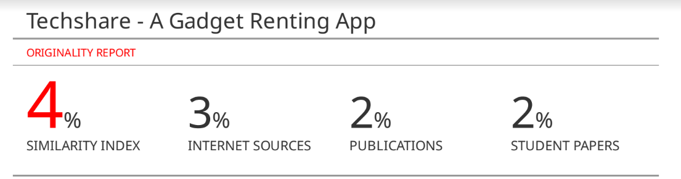

**c.Project review sheet ; Project review sheet 1:**

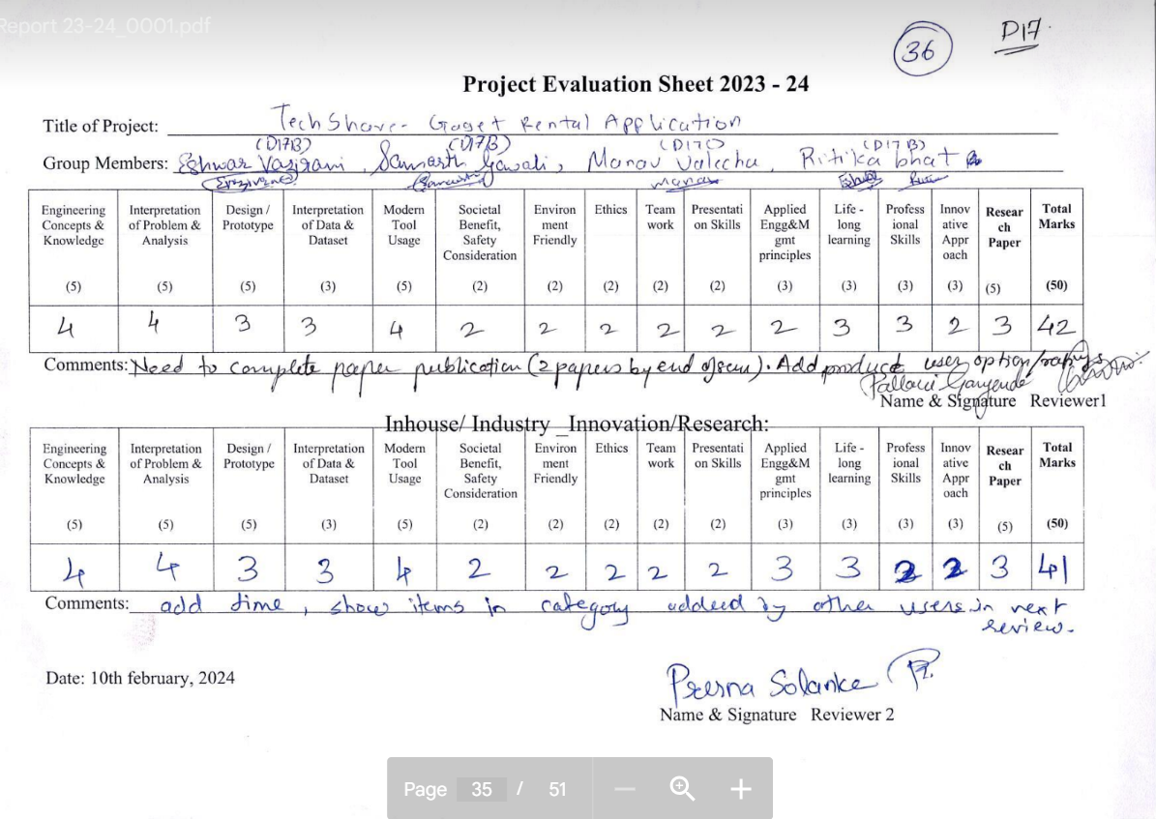

### Project review sheet 2

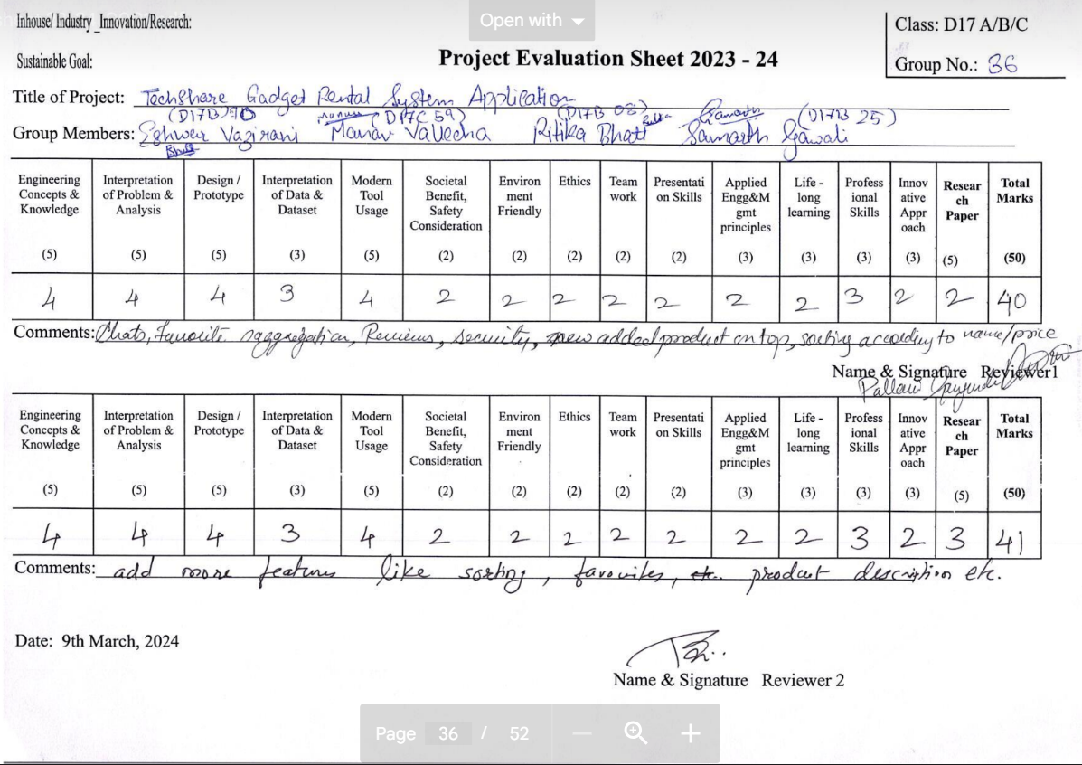

57