**Second year Mini Project Report**

Submitted in partial fulfillment of the requirements of the degree

**BACHELOR OF ENGINEERING IN COMPUTER**

**ENGINEERING**

By

**Mohit Vaidya /D7A 60**

**Abhirat More/D7A 44**

**Ved Waje /D7A 64**

**Joel Dias /D7A 19**

**Vidhit Navani/D7C 72**

Supervisor

**Prof.**  **Mannat Doultani**



# Department of Computer Engineering

**Vivekanand Education Society’s Institute of Technology**

**HAMC, Collector’s Colony, Chembur,**

**Mumbai-400074**

**University of Mumbai**

**(AY 2023-24)**

# CERTIFICATE

This is to certify that the Mini Project entitled **“GateGuardian (Residential**

**Entry Logging System) ”** is a bonafide work of **Mohit Vaidya /D7A 60**

**Abhirat More/D7A 44,Ved Waje /D7A 64, Joel Dias /D7A 19, Vidhit Navani /D7C 72** submitted to the University of Mumbai in partial fulfillment of the requirement for the award of the degree of **“Bachelor of Engineering”** in

**“Computer Engineering” .**

**(Prof. Mannat Doultani )**

Supervisor

**(Prof. Nupur Giri ) (Prof. J.M. Nair )**

Head of Department Principal

# Mini Project Approval

This Mini Project entitled “ **GateGuardian (Residential Entry Logging**

**System)”** by **Mohit Vaidya /D7A 60 Abhirat More/D7A 44,Ved Waje /D7A 64, Joel Dias /D7A 19, Vidhit Navani /D7C 72** is approved for the degree of

**Bachelor of Engineering** in **Computer Engineering.**

## Examiners

**1………………………………………**

(Internal Examiner Name & Sign)

**2…………………………………………**

(External Examiner name & Sign)

Date:

Place:

# Contents

### Abstract ii

### Acknowledgments iii

### List of Abbreviations iv

### List of Figures v

### List of Tables vi

### List of Symbols vii

1. **Introduction 1** 
   1. Introduction
   2. Motivation
   3. Problem Statement & Objectives
   4. Organization of the Report

1. **Literature Survey 3**

* 1. Survey of Existing System
  2. Limitation Existing system or research gap
  3. Mini Project Contribution

1. **Proposed System (eg New Approach of Data Summarization) 6**

* 1. Introduction
  2. Architecture/ Framework
  3. Algorithm and Process Design
  4. Details of Hardware & Software
  5. Experiment and Results
  6. Conclusion and Future work.

**1) INTRODUCTION:**

## 1.1 Introduction

We are embarking on the development of an application tailored for the efficient management of housing society data. Our primary goal is to simplify the maintenance and storage of essential information, ensuring easy access to this data. By leveraging the power of the internet and an Android application, we aim to enhance accessibility, making technology an integral part of everyday life within the housing society.

In addition to streamlining data management, we are committed to bolstering security for society members. This involves maintaining comprehensive records of visitors and domestic help, such as maids, which will contribute to a safer living environment and help in reducing fraudulent activities.

Our main objective is to design an efficient and user-friendly management system that caters to the diverse needs of both individual homeowners and businesses within the housing society. By embracing technology, we aspire to make life within society easier and more convenient, all while promoting a sense of security and trust among its members.

## 1.2 Motivation

Daily living in urban regions has significant implications for housing society administration. In most circumstances society management communicates in a conventional manner. This does have constraints and drawbacks. Everyday announcements, entry and exit of visitors, monthly gatherings, occasional events, security warnings, and a lot more could fail to be delivered correctly in the present circumstances because most activities are managed by manual means. To tackle the challenges caused by this time-consuming manual approach process; An automatic solution that reduces people’s efforts must be devised. The major goal of the GateGuardian application is to integrate several programs into only one smartphone application for handling entry and exit of visitors. It also assists in event management and provides information about them in the application’s interface. It alerts users to critical concerns and complaints regarding current problems.

**1.3 Problem Statement and Objectives:**

Problem Definition:

The housing society currently faces multiple operational challenges, including difficulty in retrieving information from paper logs, error-prone manual data entry, an inefficient and outdated visitor registration process, inadequate security measures within the paper-based systems, a risk of unauthorized access due to limited tracking capabilities, and the absence of real-time monitoring and reporting. These issues collectively hinder the effective management of society data and the assurance of security for its members.

Objectives:

1. Efficient Data Retrieval: Develop a digital system that allows quick and easy access to essential information, eliminating the need for time-consuming paper log searches.

2. Enhanced Security Measures: Upgrade the system's security to protect society members by implementing robust access control and data encryption.

3. Unauthorized Access Prevention: Reduce the risk of unauthorized access through comprehensive tracking and monitoring capabilities, ensuring the security of sensitive data.

4 Real-time Monitoring and Reporting: Enable real-time monitoring and reporting features to enhance the society's ability to respond promptly to security threats and operational issues, improving overall safety and management efficiency.

**1.4 Organization of the Report:**

The introduction serves as the starting point of the report, providing a broad overview (1.1 Introduction) of the subject. The motivation (1.2) clarifies the reasons behind conducting the research or project, followed by the Problem Statement & Objectives (1.3) that define the issue being addressed and the intended goals. We also outline the report's structure (1.4) to give readers an idea of what to expect.

The Literature Survey dives into the existing knowledge on the topic. It starts with a Survey of Existing System (2.1), giving an overview of the current state of the subject. It discusses the limitations of the current system or areas where further research is needed (2.2), pointing out the gaps in knowledge. This section also highlights the contribution of the project (2.3) by explaining how it intends to address these identified gaps.

The Proposed System introduces a fresh approach or system. It begins with an Introduction (3.1) that provides a comprehensive overview. The Architecture/Framework (3.2) section offers insights into the structure and framework of the proposed system, while the Algorithm and Process Design (3.3) explain the methodologies used. Details about the Hardware & Software (3.4) shed light on the technological aspects. Experiments and Results (3.5) present the findings, and the Conclusion and Future Work (3.6) summarize the outcomes and suggest future research directions.

.

**2) LITERATURE SURVEY:**

**1)**  **MyGate app**

## Features

* Utilizing digital communication, residents can access notice boards and important updates from the comfort of their devices, eliminating the need for physical visits to common areas. 
* The platform enables an efficient system for raising complaints, ensuring timely and systematic issue resolution with just a few clicks. 
* Residents can easily manage daily help, such as scheduling tasks and coordinating with domestic staff, promoting a more organized and efficient living environment. 
* The "Leave at Gate" feature streamlines the delivery of packages and items by allowing residents to designate a specific location, reducing the need for in-person interactions and enhancing convenience and security.

## Limitations

* Visitor Verification Delays:

The issue of visitor verification delays impacts the smooth flow of access within the housing society. These delays often lead to inconvenience for residents and their guests, emphasizing the need for an efficient solution to expedite the process.

* 3rd Party Advertisements:

The presence of third-party advertisements can be intrusive and disruptive, affecting the user experience of the application or platform. Addressing this concern is essential to maintain a clean and user-friendly interface.

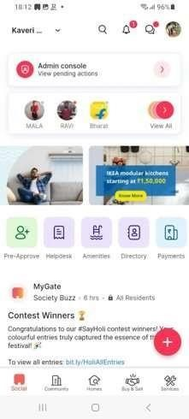

***Fig 2.1: MyGate application***

**2) NoBrokerHood**

## Features

* Interface for Society Payments

Developing a user-friendly interface for society payments is essential to facilitate convenient and secure transactions for residents, allowing them to pay their dues and fees hassle-free.

* Servicemen Facility:

The servicemen facility should provide residents with a streamlined process to hire, manage, and coordinate domestic help and service providers, ensuring that their household needs are efficiently met.

* Marketplace:

The marketplace feature can serve as a digital platform within the housing society for residents to buy and sell goods or services, promoting a sense of community and providing a convenient way to meet their needs within the local market.

## Limitations

* Visitor Verification Delays:

The issue of visitor verification delays impacts the smooth flow of access within the housing society. These delays often lead to inconvenience for residents and their guests, emphasizing the need for an efficient solution to expedite the process.

* 3rd Party Advertisements:

The presence of third-party advertisements can be intrusive and disruptive, affecting the user experience of the application or platform. Addressing this concern is essential to maintain a clean and user-friendly interface.

* Requirement of Paid Subscription:

The introduction of a mandatory paid subscription can pose a challenge for users who prefer free

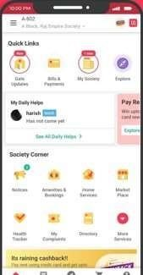

***Fig 2.2: NoBrokerHood application***

**3) ADDA:**

## Features

* Share Stories with Neighbors: 

Facilitating the sharing of stories with neighbors creates a sense of community and connection. It allows residents to share experiences, announcements, and updates, fostering a stronger bond among neighbors.

* Create Polls and Gather Opinions on Any Event: 

The ability to create polls and gather opinions on various events or decisions within the housing society encourages community engagement. It provides a democratic platform for residents to have a say in matters that affect them directly.

* Book Household Related Services:

Offering the capability to book household-related services simplifies the process of obtaining essential services such as repairs, maintenance, or domestic help, enhancing the convenience and efficiency of daily life within the housing society.

## Limitations

* Lengthy Registration Process:

A lengthy registration process can deter potential users and lead to drop-offs. It's important to streamline and simplify the registration steps to provide a more user-friendly experience.

* No Feature to Add Other Flat Members:

The absence of a feature to add other flat members can be inconvenient for households with multiple residents. Implementing this feature allows for more comprehensive and accurate user profiles.

* No Option to Disapprove a Visitor:

The inability to disapprove a visitor can raise security concerns and limit control over who enters the housing society. Including an option to disapprove visitors provides residents with a necessary security measure and peace of mind.

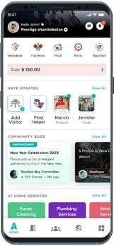

***Fig 2.3: Adda application***

**3) PROPOSED SYSTEM**

### 3.1 Introduction

The proposed housing society management system is a comprehensive and efficient solution designed to streamline and enhance the management and communication within residential communities. With distinct modules catering to the needs of administrators, residents, and security personnel, this system is poised to significantly reduce manual workloads while fostering seamless communication. The Admin Module empowers administrators with tools for user, house, security personnel, maids, notices, events, and visitors' management, providing them with the means to efficiently oversee all aspects of the housing society. Meanwhile, the User Module ensures that residents can readily access important information about events and notices. Finally, the Security Module equips security personnel with features to manage visitors, monitor maids, access notices, and stay updated on upcoming events. This system promises to revolutionize housing society management by simplifying tasks and facilitating effective communication among all stakeholders.

For security personnel, the Security Module provides an essential set of features, including visitor management, maid attendance tracking, and access to notices and event details. These tools enable them to maintain a safe and secure environment while staying updated on relevant community announcements.

In essence, this proposed system leverages technology to create a well-organized and interconnected housing society. By automating various management tasks and improving communication channels, it promises to enhance the quality of life for residents and the efficiency of administrators and security personnel

Residents, on the other hand, are provided with a dedicated User Module, which grants them easy access to critical information such as upcoming events and community notices. This accessibility enhances their connection with the community and keeps them informed about the latest happenings within their housing society.

### 3.2 Architecture/Framework

We use the MVVM (Model-View-ViewModel) architectural pattern to develop the app. This facilitates efficient data management and a clean separation of concerns.

The View is primarily made up of the user interface and only contains components that appear on the screen with which the user can interact directly. The Model is responsible for fetching data either from a local database or a web service. The ViewModel acts as an intermediary between the Model and View. It provides data for the UI components and includes an observable data holder called LiveData that allows it to update the View in real time. It is also responsible for keeping our app from reloading on configuration changes, providing a great user experience.

There are several reasons why MVVM is ideal:

* Makes the project loosely coupled
* Easier to maintain
* Simple to add a new feature or remove an existing one
* Makes the code readable and easy to navigate

### 3.3 Algorithm and Process Design

The algorithm and process design for the housing society management system is structured around the seamless coordination of residents, security personnel, and management. Initially, the management is responsible for the registration of both security personnel and residents into the database, creating a foundational user database. Once registered, members are required to log in to the application, gaining access to specific utilities based on their designation.

The core functionality of the system revolves around the Resident Dashboard, which empowers residents to proactively pre-register expected visitors and deliveries. This data is then integrated into the Security Dashboard, offering security personnel immediate access to crucial information regarding incoming visitors. When a visitor arrives, security verifies the details provided by the resident, allowing entry upon confirmation.

For unregistered visitors, security sends the visitor's information to the respective resident for approval, ensuring security and convenience. Residents are promptly notified of visitor arrivals through SMS or other preferred communication channels. Once confirmation is received from the resident, security permits entry.

Departures from the building are efficiently logged, providing real-time monitoring for the security team to track outsiders entering and exiting the premises. Additionally, residents are afforded a user-friendly system to register frequent visitors like housemaids, milk or newspaper deliverers, streamlining the process and eliminating the need for repeated registrations.

### 3.4 Details and Hardware & Software

Kotlin, a versatile and modern programming language, will drive the business logic, enabling developers to write concise and expressive code. It is a multiplatform and server-side language based on JVM technology.

For the user interface, Jetpack Compose offers a powerful and flexible toolset for building intuitive and dynamic UIs. Its declarative nature simplifies and accelerates UI development, thus fostering a more immersive user experience. It further simplifies the design process as it is built into Android Studio and written in Kotlin.

Dagger Hilt, a dependency injection framework, ensures efficient and modular code by managing the injection of dependencies and promoting code reusability. It decreases boilerplate code, provides decoupled build dependencies and standardized components, thus making the application more maintainable and testable.

Firebase, a cloud-based platform, serves as the backend for the housing society management system, offering features like real-time databases, authentication, and hosting, enabling seamless data storage, user management, and scalability. This choice ensures the system's data is secure and always accessible.

In terms of testing, Espresso is a valuable tool, allowing for the automated testing of the user interface. It ensures that the UI behaves as expected, providing confidence in the system's reliability and user experience.

**3.5 Experiment and Results**

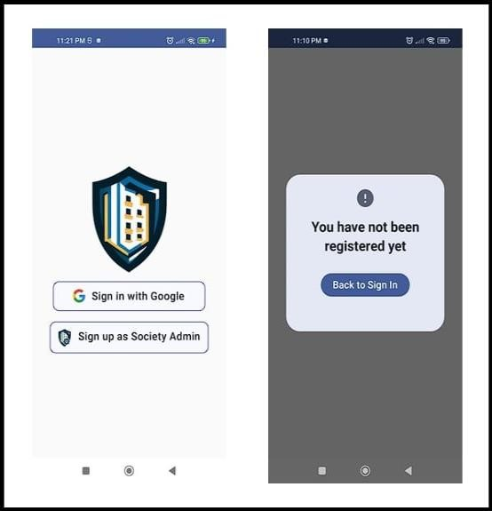

***Fig 3.1: Implementation of Sign in Screens***

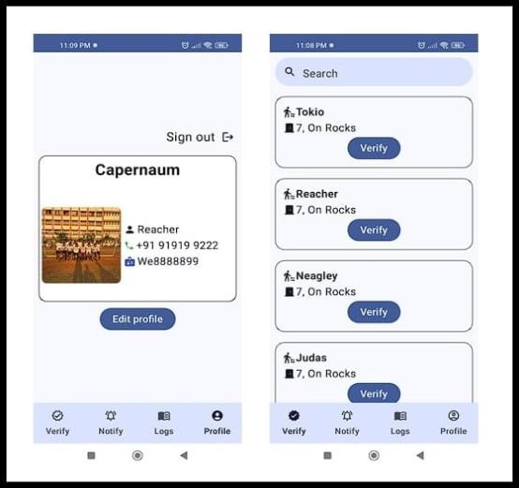

***Fig 3.2: Implementation of Security Screens***

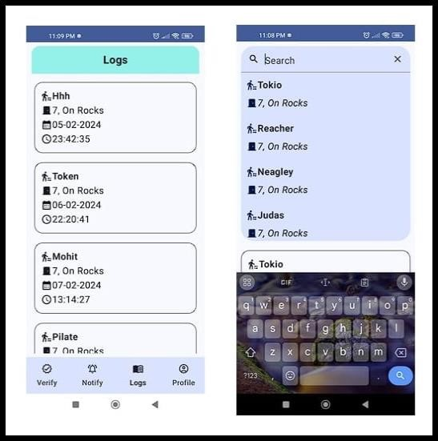

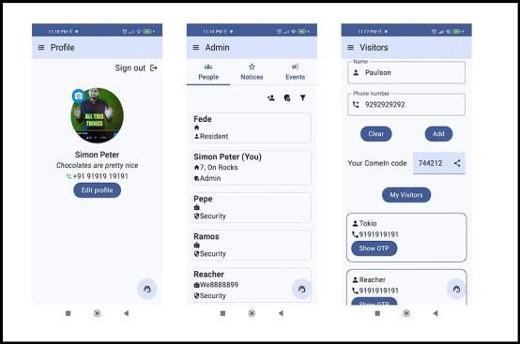

***Fig 3.4: Implementation of Security Screens***

***Fig 3.3: Logs on Security Screens***

### 3.6 Conclusion and Future Work

In conclusion, the development of our housing society data management application represents a significant step towards simplifying data maintenance, enhancing accessibility, and strengthening security for society members. Our primary goal is to seamlessly integrate technology into the daily lives of residents, promoting convenience and trust. As we move forward, we will continue to refine the user interface, expand features, and actively seek feedback from the community to better cater to their evolving needs. Our commitment remains unwavering, with the aim of fostering a sense of unity and security within the housing society while staying at the forefront of technological advancements. This project seeks to create a more connected, secure, and harmonious community living experience for all members.

1. **Continuous User Interface Enhancement**: We will consistently work on refining the user interface to make it even more intuitive and user-friendly. This will include improvements in design and navigation to ensure a seamless user experience.

1. **Feature Expansion**: Our application will undergo ongoing feature expansion. We plan to add functionalities that address the evolving needs and preferences of housing society members. This could include features such as online payment options, event scheduling, or even integration with smart home technologies for added convenience.

1. **Community Feedback Integration**: We are committed to actively seeking and incorporating feedback from the housing society community. User feedback is invaluable in shaping the application's development, and we will ensure that their suggestions and concerns are taken into account.

1. **Security Enhancements**: Security will remain a top priority. We will continue to update and improve the security measures, including data encryption, access controls, and visitor management, to provide an even safer living environment for all members.

1. **Technology Adaptation**: As technology evolves, so will our application. We will stay at the forefront of technological advancements, ensuring compatibility with emerging devices, operating systems, and communication protocols.

1. **Community Building**: In the long term, our goal is to not only provide a functional tool but also to foster a stronger sense of community among housing society members. This may involve integrating social features that encourage interaction and cooperation within the society.