**“TaxSarthi”**

**Second year Mini Project Report**

Submitted in partial fulfillment of the requirements of the degree

**BACHELOR OF ENGINEERING IN** **COMPUTER ENGINEERING**

By

**Gautam Rai (53)**

**Chinmay Desai (16)**

**Harsh Pimparkar (51)**

**Yash Ingale (29)**

**Rohit Motwani (70)**

Supervisor

**Prof. Ms. Pallavi Gangurde**



**Department of Computer Engineering**

**Vivekanand Education Society’s Institute of Technology**

**HAMC, Collector’s Colony, Chembur,**

**Mumbai-400074**

**University of Mumbai**

**(AY 2023-24)**

# CERTIFICATE

This is to certify that the Mini Project entitled **“ TaxSarthi ”** is a bonafide work of **Gautam Rai (53), Chinmay Desai (16), Harsh Pimparkar (51), Yash Ingale (29), Rohit Motwani (70)** submitted to the University of Mumbai in partial fulfillment of the requirement for the award of the degree of **“Bachelor of Engineering”** in **“Computer Engineering” .**

### (Prof.Ms. Pallavi Gangurde)

Supervisor

### (Prof. Nupur Giri) (Prof. Dr. J. M. Nair)

Head of Department Principal

# Mini Project Approval

This Mini Project entitled “TaxSarthi**”** by **Gautam Rai (53), Chinmay Desai (16), Harsh Pimparkar (51), Yash Ingale (29), Rohit Motwani (70)** is approved for the degree of **Bachelor of Engineering** in **Computer Engineering.**

## Examiners

**1………………………………………**

(Internal Examiner Name & Sign)

### 2…………………………………………

(External Examiner name & Sign)

Date: Place

# Contents

### Abstract i

### Acknowledgments ii

### List of Abbreviations iii

### List of Figures iv

### List of Tables iv

### List of Symbols v

### Introduction 1

* 1. Introduction
  2. Motivation
  3. Problem Statement & Objectives
  4. Organization of the Report

### Literature Survey 3

* 1. Survey of Existing System
  2. Limitation Existing system or research gap
  3. Mini Project Contribution

### Proposed System 5

* 1. Introduction
  2. Architecture/ Framework
  3. Algorithm and Process Design
  4. Details of Hardware & Software
  5. Experiment and Results
  6. Conclusion and Future work.

### References 20

**ABSTRACT**

Taxation in India is a multifaceted and often perplexing realm, posing challenges for individuals who lack prior experience or expertise in this domain. "TaxSarthi" emerges as a transformative online platform designed to unravel the complexities of Indian taxation, fostering comprehensive understanding and financial empowerment. Tailored for a diverse audience, including professionals, students, and entrepreneurs, TaxSarthi functions as an accessible and user-friendly tool for tax filing.

At its core, TaxSarthi is committed to simplifying the often-overwhelming process of tax filing, acknowledging the hurdles it presents, particularly to those without a financial background. The platform offers an intuitive, step-by-step interface that enables individuals, regardless of their prior financial knowledge, to navigate the tax filing procedure with confidence and precision, effectively mitigating the anxiety and confusion associated with this annual obligation.

Beyond its practical utility in tax filing, TaxSarthi distinguishes itself as an exceptional educational resource. It employs plain language and engaging visuals to disseminate vital knowledge about various tax types, regulations, deductions, and exemptions. By doing so, TaxSarthi equips users with the foundational understanding required to make well-informed financial decisions and optimize their tax planning strategies.

In a financial landscape where literacy is paramount, TaxSarthi stands as an invaluable companion for individuals seeking clarity in the intricate world of Indian taxation. It not only simplifies the path to tax compliance but also empowers users to confidently engage with their financial responsibilities, promoting financial well-being and literacy in the process.

i

**ACKNOWLEDGEMENT**

We, the research team, extend our heartfelt gratitude to the following individuals, organizations, and sources whose contributions and support were instrumental in the successful completion of our research on "An Analysis of Indian Tax Structure."

First and foremost, we would like to acknowledge the significant contribution of Anjali Tyagi . Her work, "An Analysis of Indian Tax Structure," not only served as a valuable reference but also inspired our research, providing the foundation for our analysis.[1] We also express our appreciation to Pradip Kumar Das for his comprehensive study, "A study on direct taxation in India." His research offered important insights and data that were integral to our analysis and understanding of the Indian tax landscape.[2]

Furthermore, the research conducted by Yadawananda Neog and Achal Kumar Gaur in their study, "Tax structure and economic growth: a study of selected Indian states," played a significant role in broadening our understanding of the subject matter.[3]

Our gratitude extends to Harjit Singh, Arpan Kumar Kar , and P. Vigneswara Ilavarasan for their informative case study on the "e-Filing System of the Income Tax Department of India." This study provided valuable insights into the practical aspects of the Indian tax system, enriching our research.[4] In addition to these invaluable contributions, we acknowledge and appreciate the online resources that greatly aided our research efforts. Canara HSBC Oriental Bank of Commerce Life Insurance Company Limited provided informative articles on the tax structure in India and the income tax slab for FY 2022- 23. We are thankful to ClearTax for providing insights on income tax rebates under Section 87A and other tax-related information. Various online sources also enriched our understanding of tax-related topics.

Last but not least, we extend our collective appreciation to all the team members who diligently collaborated on this project, bringing their unique expertise to the table. This research would not have been possible without the collective effort, dedication, and cooperation of the entire team. We sincerely thank each and every one of these contributors for their invaluable assistance in making this research project a reality.

ii

**LIST OF ABBREVIATIONS**

ITR - Income Tax Return

PAN - Permanent Account Number

TDS - Tax Deducted at Source

AY - Assessment Year

AYP - Advance Tax Payment

CBDT - Central Board of Direct Taxes

CIT - Commissioner of Income Tax

CPC - Centralized Processing Center

DSC - Digital Signature Certificate

EVC - Electronic Verification Code

FVU - File Validation Utility

HUF - Hindu Undivided Family

ITAT - Income Tax Appellate Tribunal

PGBP - Profits and Gains of Business or Profession F&O - Futures and Options

LTCL - Long-Term Capital Loss

MAT - Minimum Alternate Tax

ATF - Agricultural Income Tax

I-T Act - Income Tax Act

PGBP - Profits and Gains of Business or Profession ITAT - Income Tax Appellate Tribunal

PAN - Permanent Account Number

AOP - Association of Persons

BOI - Body of Individuals

Co-op Soc - Cooperative Society

EPF - Employee Provident Fund

HRA - House Rent Allowance

TAN - Tax Deduction and Collection Account Number

iii

**LIST OF FIGURES**

|  |  |  |
| --- | --- | --- |
| **Figure Number** | **Figure Name** | **Page Number** |
| 3.2.1 | Modular Diagram | 6 |
| 3.3.1 | Process Design | 8 |
| 3.5.1 | Home page | 10 |
| 3.5.2 | Login./Signup Page | 10 |
| 3.5.3 | Error Page | 11 |
| 3.5.4 | Blog Page | 11 |
| 3.5.5 | Profile | 11 |
| 3.5.6 | Income and other details | 12 |
| 3.5.7 | Final tax Output | 12 |
| 3.5.8.1 | Real Tax Report | 13 |
| 3.5.8.2 | TaxSarthi generated tax report | 13 |
| 3.5.9 | Old Regime Accuracy Chart | 15 |
| 3.5.10 | Tax Deviation in Old Regime | 16 |
| 3.5.11 | New Regime Accuracy Chart | 16 |
| 3.5.12 | Tax Deviation in New Regime | 17 |

**LIST OF TABLES**

|  |  |  |
| --- | --- | --- |
| **Table Number** | **Table** | **Page Number** |
| 2.1.1 | Literature Survey | 3 |
| 3.5.1 | Old regime slabs | 14 |
| 3.5.2 | Sample Calculation | 14 |

iv

**LIST OF SYMBOLS**

|  |  |
| --- | --- |
| **Symbol** | **Description** |
| ₹ | Indian Rupee symbol: Used to denote amounts in Indian Rupees in tax-related documents. |
| % | Percentage symbol: Used to indicate percentages, such as tax rates, deductions, or interest rates. |
| >= | Greater than or equal to: Used to indicate that a value is equal to or greater than another value, often in the context of tax thresholds or limits. |
| <= | Less than or equal to: Used to indicate that a value is equal to or less than another value, often in the context of tax thresholds or limits. |
| (%) | Parentheses around a percentage: Sometimes used to indicate a percentage or rate, especially in mathematical expressions. |
| ∑ | Summation symbol: Used in calculations to denote the sum of a series of numbers, which may be relevant for tax computations. |
| → | "Implies" or "leads to" symbol: Used to show logical relationships, often in tax rules and regulations. |
| ≠ | Not equal to symbol: Used to indicate that two values are not equal, which may be relevant for tax comparisons. |
| ₹ | Rupee symbol: Denotes the currency used in India. |
| √ | Square root symbol: May be used in mathematical calculations related to tax computations. |

v

**1. Introduction**

**1.1 Introduction:**

Taxes are like the funds we contribute to the government, kind of like our share to help run the country. They're used to finance important things we all benefit from, such as schools where we learn, hospitals where we get better, and roads we use to travel. Taxation is the way the government collects these funds from everyone, making sure there's enough money to provide essential services and support for our society [1].

In India, the taxation landscape is a labyrinthine network of rules, regulations, and obligations that often proves to be a formidable challenge for many citizens, particularly those without a financial background. Taxation in India encompasses a diverse range of levies, including income tax, goods and services tax (GST), corporate tax, and more. Understanding and fulfilling these obligations can be a perplexing ordeal, resulting in the need for a simplified and user-friendly solution like TaxSarthi.

Filing taxes in India can be a daunting task, marked by complexities that can easily overwhelm individuals who lack a financial background. The tax code is replete with intricate provisions, deductions, exemptions, and thresholds, each requiring careful consideration to ensure accurate and compliant filings.

This intricate nature of tax regulations often leads to confusion and uncertainty among professionals and businessmen, who might find themselves grappling with the following challenges:

1.Jargon and Legalese

2.Diverse Income Streams

3.Compliance Deadlines

4.Optimal Tax Planning

5.Conflicting Regulations

6. Risk of Errors

This is where TaxSarthi steps in as a revolutionary solution. By providing a simplified and intuitive platform, TaxSarthi enables professionals and businessmen to file their taxes accurately and with confidence. Its user-friendly interface guides users through each step of the process, ensuring that they accurately report income, claim relevant deductions, and meet compliance deadlines. Furthermore, TaxSarthi's educational component offers non-financial individuals a unique opportunity to grasp the fundamentals of taxation, enabling them to make informed financial decisions and optimize their tax planning strategies.

**1.2 Motivation:**

The TaxSarthi project was born out of the realization that the existing tax system in India presented multifaceted challenges for taxpayers. A prominent issue was the lack of comprehensive and easily understandable resources available to guide individuals through the intricate landscape of taxation. This information gap often resulted in confusion and, in some cases, costly errors that added to the financial burdens faced by taxpayers. Furthermore, the yearly task of filing income tax returns had transformed into a daunting and anxiety-inducing process for many individuals and businesses. Fueled by a clear vision, the TaxSarthi project set out to create a transformative platform. Its primary objective was to not only simplify the complex realm of taxation but also to provide easily accessible and comprehensive information on various tax related matters. The ultimate goal was to offer step-by-step guidance for filing tax returns, with the overarching aim of reducing the weight of tax compliance and empowering users to assume greater control over their financial journeys.

**1.3 Problem Statement & Objectives:**

Taxes are a vital component of any society, contributing to the functioning of public services and infrastructure. However, the complexity of tax systems often presents a daunting challenge, especially for individuals without a background in finance. Many people find it challenging to navigate the intricate web of tax structures, deductions, and the overall process of filing taxes, which can potentially lead to costly errors and financial setbacks. The TaxSarthi project stands as a solution to this widespread issue

It is designed to serve as an intuitive online web-based platform that aims to simplify the complexities of the Indian taxation system. By breaking down intricate tax-related concepts into easily understandable information, the platform makes tax-related knowledge accessible to individuals from diverse backgrounds.

Through a user-friendly and informative interface, TaxSarthi endeavors to empower users with the tools and understanding necessary to confidently fulfill their tax responsibilities.

This platform will offer comprehensive resources, including simplified explanations of complex tax terms and procedures, ensuring that even individuals with limited financial knowledge can grasp and navigate the tax system effectively.

By providing step-by step guidance for the tax filing process, the platform aims to streamline the otherwise convoluted process, minimizing the likelihood of errors and financial losses. Interactive features and tools will be integrated to assist users throughout the tax filing journey, enhancing their overall experience and fostering a sense of financial empowerment and responsibility.

The ultimate goal of the TaxSarthi project is to instill confidence and clarity in individuals, enabling them to approach tax-related matters with a better understanding and make well-informed financial decisions.

**2 . Literature Survey**

|  |  |
| --- | --- |
| PAPER | DESCRIPTION |
| "A Study on Direct Taxation in India" | The paper analyzes and interprets the importance of direct taxation in India, its evolution, structure, and challenges. The paper also suggests some measures to improve the direct tax system in India. |
| "An Analysis of the Indian Tax Structure" | The paper is a brief overview of the Indian tax system, its history, challenges, and reforms. It focuses on the introduction and implementation of the Goods and Services Tax (GST), which is a unified indirect tax regime that aims to simplify and rationalize the tax structure in India. |
| "A Case Study on the e-Filing System of the Income Tax Department of India" | The study focuses on the online system of the e-Filing System of the Income Tax Department of India. |
| "Income Tax Department" | It is the official website that contains the most accurate information, but it is not easily accessible to normal individuals. |
| "ClearTax” | ClearTax is a website that offers software and expert services for tax and financial needs of individuals and businesses in India. |

2.1.1. Literature Survey

**2.1 Survey of Existing System**

* User Experience: The majority of respondents expressed dissatisfaction with the current tax filing process, citing complexities in form filling, unclear guidelines, and a lack of user-friendly interfaces as the primary reasons for their discontent.
* Challenges Faced: The survey highlighted common challenges faced by taxpayers, including difficulties in understanding tax calculations, accessing relevant tax information, and navigating the intricate online tax filing systems.
* Accessibility of Information: A significant number of respondents reported facing challenges in accessing comprehensive and easily understandable tax-related information, indicating a gap in the availability of user-friendly educational resources.
* Support System Evaluation: The current support system was deemed inadequate by a large portion of respondents, who expressed dissatisfaction with the responsiveness and effectiveness of the available assistance during the tax filing process.
* Data Security Concerns: A notable percentage of respondents voiced concerns regarding data security and privacy issues while using the current tax filing platforms, emphasizing the need for enhanced security measures.

**2.2 Limitation Existing system**

Limitations of Manual Methods of Filing ITR:

Engaging a chartered accountant (CA) can be a costly affair when opting for manual methods of filing income tax returns (ITR, which may create a financial burden, particularly for individuals with straightforward tax situations. In addition to the financial aspect, CAs often handle multiple clients and contend with numerous deadlines during the tax season.

This high workload can result in time constraints, potentially leading to delays in filing ITRs for their clients. Such delays can be problematic for taxpayers aiming to meet the tax filing deadline and expecting their returns to be processed promptly. Furthermore, the lack of pricing transparency among CAs may expose clients, particularly those unfamiliar with tax regulations and associated fees, to the risk of overcharging. This lack of transparency in pricing may leave clients feeling taken advantage of and could discourage them from seeking professional assistance in the future.

Limitations of Online Methods of Filing ITR:

Online methods for filing ITR offer convenience, yet they also come with their share of challenges. Many government websites in India suffer from poor usability, resulting in difficulties for users when it comes to navigating and comprehending the tax filing process. Slow website loading times, a prevalent issue, especially on government portals experiencing heavy traffic during the tax season can hinder the efficiency of the tax filing process and cause frustration among users aiming to meet the tax filing deadline. Private online applications that offer ITR filing services have their own set of limitations as well. Some of these services charge hidden fees that users may not discover until after they've completed their filings. Moreover, many of these platforms provide limited customer support, making it challenging for users to obtain assistance or clarification on tax-related queries, potentially leaving them feeling unsupported during the filing process.

**2.3 Mini Project Contribution**

* Valuable Source of Insightful Content: TaxSarthi aims to curate and provide a wealth of comprehensive and insightful content pertaining to various intricacies of the Indian taxation system. This content will encompass a wide array of topics, ranging from explanations of complex tax laws and regulations to detailed insights into different types of taxes, deductions, and exemptions. By presenting this information in a structured and easily accessible format, TaxSarthi endeavors to bridge the gap between the intricate tax concepts and the general populace, ensuring that users can access reliable and informative resources with ease.

* User-Friendly Interface: The project places significant emphasis on user friendliness by incorporating an intuitive and easy-to-use interface. Recognizing the challenges that users often encounter when dealing with the complexities of the tax system, TaxSarthi is dedicated to providing a seamless and effortless user experience. The platform's interface is designed to be intuitive, ensuring that users can navigate through the various sections and access the information they need without any unnecessary complications. By prioritizing user convenience and accessibility, TaxSarthi aims to create a welcoming environment that encourages users to explore and engage with the platform's resources and tools comfortably. The overarching objective of TaxSarthi is to empower users with the knowledge and confidence necessary to navigate the intricate world of taxation effectively. By presenting complex tax-related concepts in a simplified and easily understandable manner, the platform seeks to demystify the often daunting and confusing aspects of the Indian tax system. This approach is intended to equip users with the essential insights and understanding required to make informed decisions and effectively manage their tax-related matters with clarity and confidence.

Ultimately, TaxSarthi strives to foster a more financially informed and empowered user base, capable of engaging with the intricacies of taxation with ease and proficiency.

**3 . Proposed System**

**3.1 Introduction :**

Navigating the intricacies of the Indian tax system often proves to be a labyrinthine challenge, particularly for individuals without a robust financial background. The multifaceted nature of tax regulations, coupled with the evolving legislative landscape, presents formidable hurdles for many taxpayers. Understanding various tax slabs, deductions, exemptions, and the requisite documentation demands a level of financial acumen that may be daunting for those unaccustomed to such complexities. In this context, TaxSarthi emerges as an indispensable ally, offering a user-centric approach that simplifies the tax filing process while bridging the knowledge gap, empowering individuals from diverse backgrounds to confidently engage with and comprehend the nuances of income tax filing.

In an era marked by technological advancements, TaxSarthi emerges as a pivotal solution, redefining the landscape of income tax filing with its seamless digital platform. At the intersection of convenience and empowerment, TaxSarthi is dedicated to simplifying the intricate process of income tax return (ITR) filing while concurrently fostering financial literacy among its users. Through its intuitive interface, TaxSarthi offers insightful content on taxation that is tailored to meet the needs of various professionals such as doctors, engineers and businesspeople. By breaking down intricate tax-related concepts into simple terms, the platform empowers users to gain confidence in navigating the complexities of the tax filing process.

TaxSarthi goes beyond mere information dissemination. It guides users step-by-step through the tax filing process, providing clear instructions and interactive tools to streamline the entire procedure. By minimizing errors and ensuring accurate submissions, TaxSarthi not only saves users time and effort but also contributes to improving overall compliance with tax regulations. The platform is designed to be user-centric, ensuring that users can access the information they need quickly and efficiently.

With its user-friendly design and interactive features, TaxSarthi not only educates users about tax matters but also equips them with the knowledge and tools necessary to make informed financial decisions. By fostering a better understanding of taxation, TaxSarthi contributes to the financial literacy and empowerment of individuals across various professions and backgrounds.

**3.2 Architecture/ Framework:**

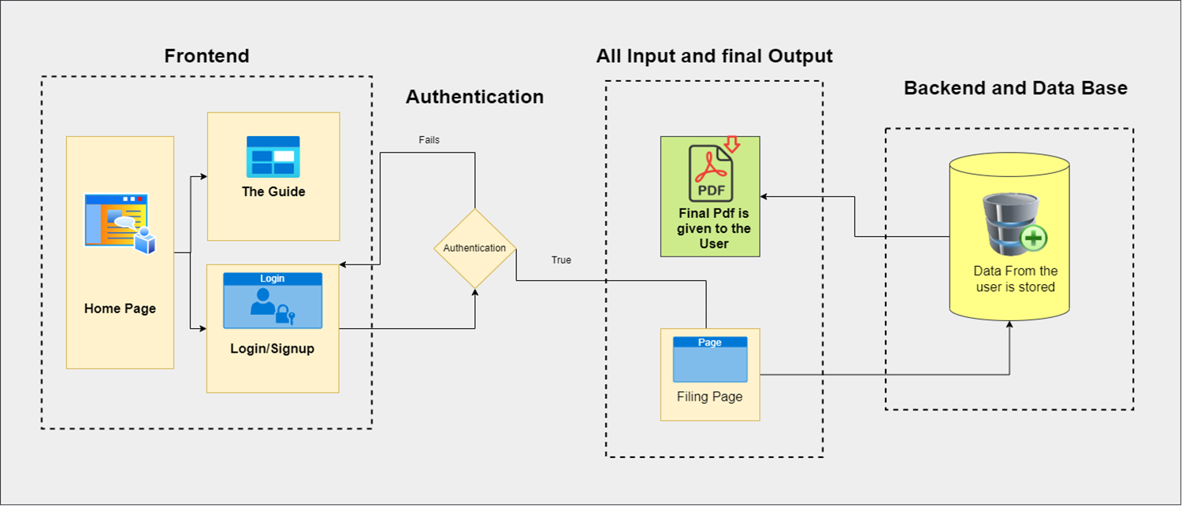3.2.1 Modular Diagram

In our increasingly digital world, tax-related projects have evolved, presenting a complex labyrinth of financial intricacies and legalities. The architecture and framework of a tax-related project is more than just a technical design; it's a manifestation of the intersection between technology and financial compliance. This essay delves into the intricate structure of a tax-related project, encompassing the front-end and back-end elements that collaboratively streamline the process of data entry and PDF generation.

The front end of a tax-related project serves as the interface between the user and the complex backend systems. It is designed with meticulous attention to detail, balancing functionality with user-friendliness. The front-end consists of three primary components: the Home Page, a Tax Blog Page, and the Login and Signup Page.

* Home Page: The Home Page serves as the project's virtual gateway, where users gain their first impression of the project. The architectural design prioritizes clarity and ease of navigation. It offers concise information on the project's objectives and features, providing an uncluttered user experience.
* Tax Blog Page: The Tax Blog Page complements the project's core functionality with an information repository. This section is meticulously crafted for the delivery of expert content, making tax-related knowledge accessible. The design focuses on readability and searchability, ensuring users can access a wealth of information with ease.
* Login and Signup Page: The Login and Signup Page is the bridge to the user's personalized tax journey. The architectural design prioritizes security, employing robust authentication protocols to safeguard sensitive user data. Upon successful authentication, the user is seamlessly ushered into the core tax-related functionalities.Once the user has successfully authenticated via the Login and Signup Page, they are directed to the data entry phase. This phase is a pivotal element of the tax-related project, where the user provides their tax-related information. The architecture of this data entry system is characterized by:
* User-Centric Design: The interface is meticulously structured to guide users through the process, making data entry intuitive and error-free. The design employs clear labels, input validation, and user prompts to ensure data accuracy.
* Data Validation and Verification: The data entered by users undergoes stringent validation processes to ensure its accuracy and compliance with tax regulations. Any inconsistencies or errors are flagged, and users are provided with clear feedback to rectify issues promptly.

The heart of the tax-related project resides in its backend. This is where the magic happens, as the user's tax-related data is processed and transformed into a final PDF document. The architectural framework of the backend is characterized by:

* Data Processing: The tax-related data entered by the user is processed using complex algorithms, accounting for various tax laws and regulations. The backend system performs intricate calculations and generates a preliminary tax statement.
* PDF Generation: After the data processing is complete, the backend system crafts a final, visually appealing PDF document. The PDF is structured to meet official tax standards, ensuring it is both legally compliant and user-friendly.
* User Interaction: The backend system is designed to facilitate user interaction at all stages. Users can review the generated PDF, make corrections if necessary, and confirm the accuracy of their tax-related information.

The architecture and framework of a tax-related project demonstrate a harmonious blend of design and functionality. The front end provides a user-friendly entry point, while the backend wields intricate algorithms to process user data into a polished PDF document. This project showcases the prowess of technology in simplifying complex tax processes, ensuring both user satisfaction and compliance with legal requirements. The architecture of such a project stands as a testament to the elegance of digital solutions in the ever-evolving landscape of taxation.

**3.3 Algorithm and Process Design**

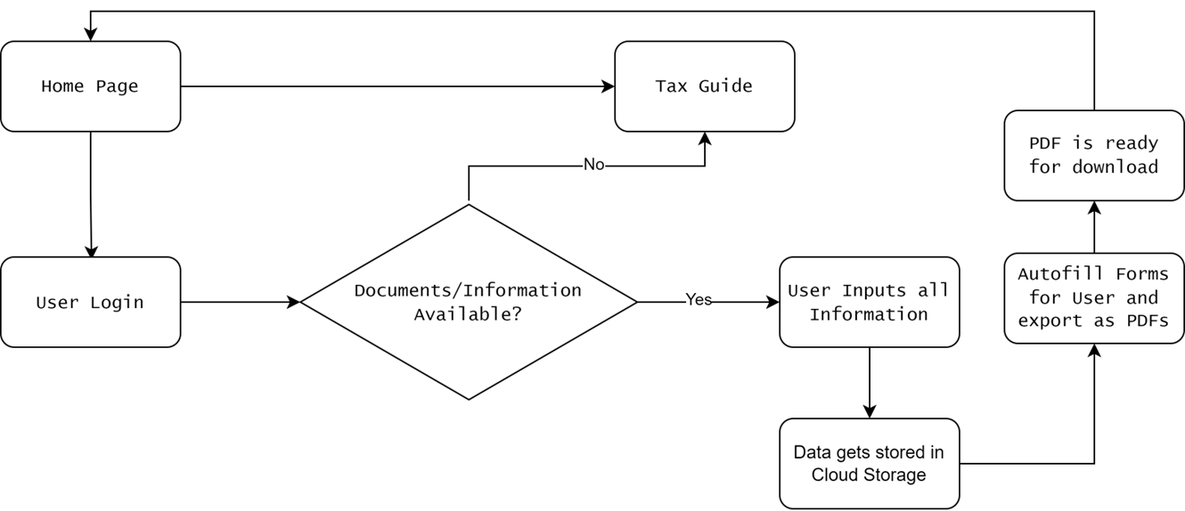

3.3.1 Process Design

Tax-related project comprises several key components and stages, each designed to simplify the user's tax filing process. This framework is a testament to the project's elegance and effectiveness.

1. Home Page to User Login and Tax Guide:

* The journey begins on the Home Page, the project's entry point, designed to provide users with a clear understanding of the project's objectives and features.
* From the Home Page, users are presented with two primary options: User Login and Tax Guide.
* The User Login serves as a gateway for registered users to access tax-related functionalities, while the Tax Guide offers assistance to users in the form of guidance on obtaining necessary documents and information

2. User Login and Document Verification:

* Upon choosing the User Login, users are prompted to log in with their credentials.
* After successful authentication, the system presents users with a checkbox form to verify the availability of required tax-related documents and information.
* An algorithm checks the completeness of the information, ensuring that all necessary documents are available.

3 . Tax Form Generation and PDF Export:

* Once the user has inputted their tax-related information, an algorithm processes the data and populates the appropriate tax forms.
* The system generates a PDF file, which is formatted to meet legal standards and can be easily downloaded by the user.
* The PDF document serves as the final tax return form, which users can save or print for their records or submission.

4 . User Redirection and Assistance:

* Following the successful completion of the process, the user is redirected back to the Home Page.
* If the algorithm detects that not all required information is available during the document verification phase, the user is redirected to the Tax Guide for assistance.

Algorithmic Elegance

The project's design relies on several algorithms to facilitate its functionality:

1. User Authentication Algorithm: This algorithm validates user credentials during the login process, ensuring that only authorized users access the tax-related features.
2. Document Verification Algorithm: This algorithm checks the availability of required documents and information, guiding users based on the presence or absence of these materials.
3. Data Processing Algorithm: This algorithm processes the user's tax-related data, performing calculations, and populating tax forms.

**3.4 Details of Hardware & Software**

Hardware Requirements:

1. A web browser and a stable internet.

Software Requirements:

1. UI Design: Figma
2. Frontend: React, CSS, JavaScript.
3. Backend: Node JS, MongoDB

**3.5 Experiment and Results:**



3.5.1. Home Page

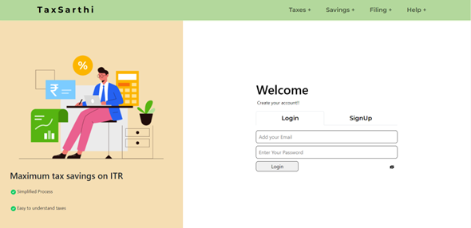

3.5.2. Login/SignUp Page

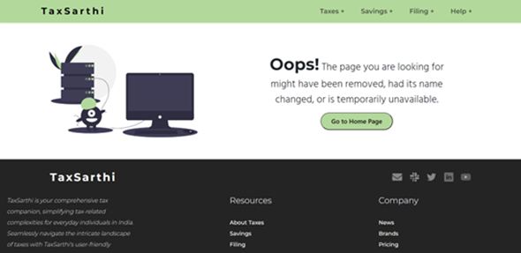

3.5.3. Error Page

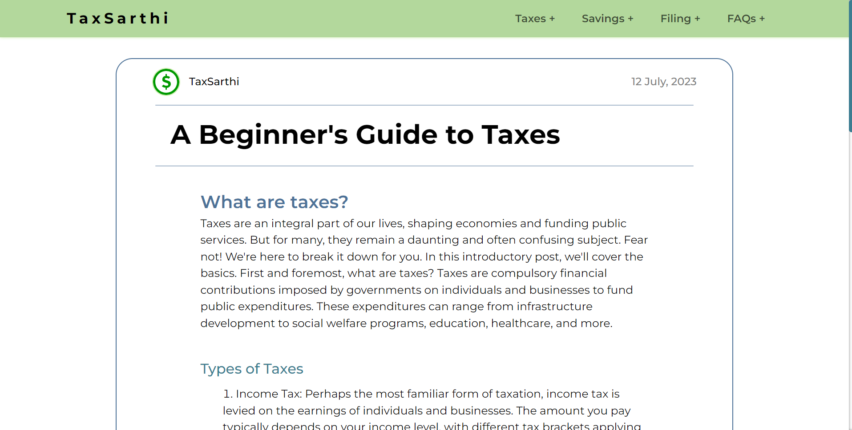

3.5.4. Blog Page

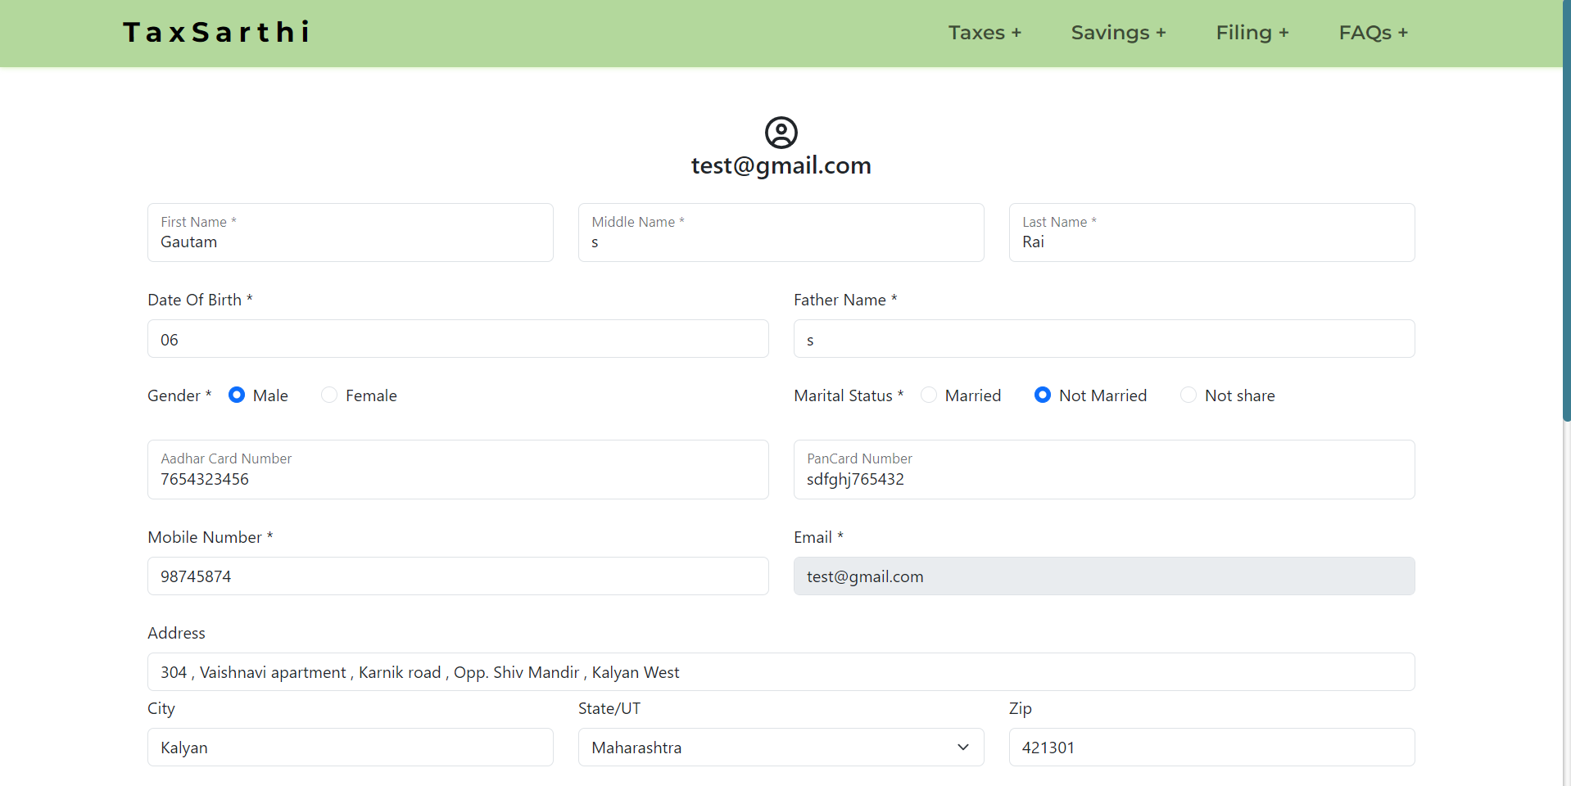

3.5.5. Profile

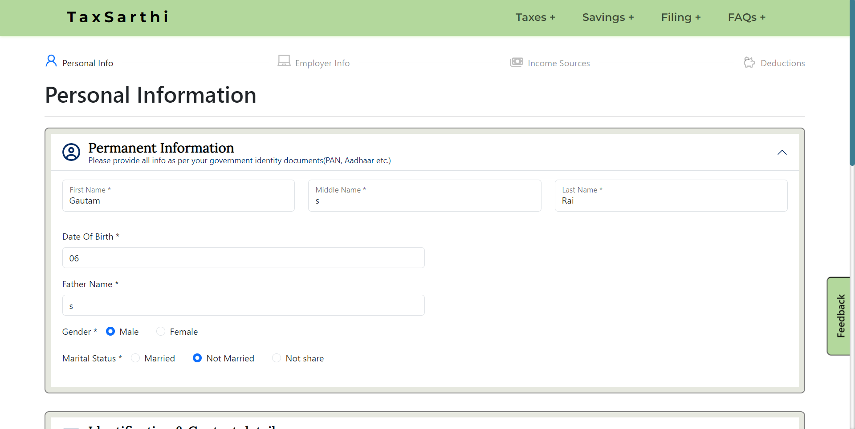

3.5.6. Income and other details

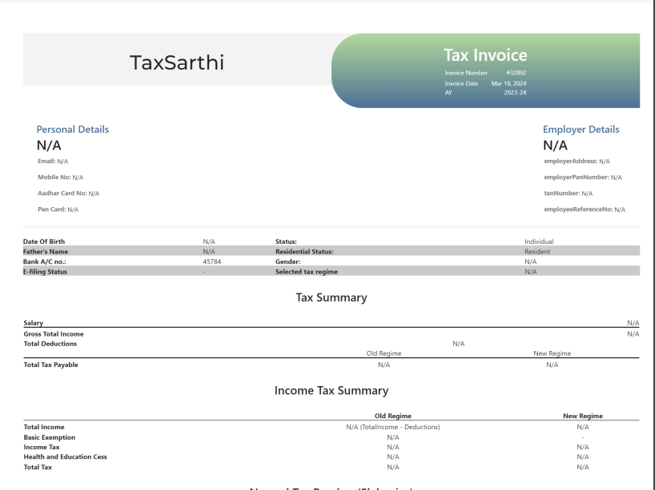

3.5.7. Final Tax Output

We conducted extensive calculations on incomes ranging from ₹10,000 to ₹50 lakhs, with increments of ₹10,000. Through rigorous testing, our algorithm demonstrated an impressive accuracy rate of 97.9% across all income ranges.

Furthermore, to validate the reliability of our algorithm, we compared the results with a comprehensive dataset comprising more than 100 real samples collected from Chartered Accountants (CAs). This comparative analysis reaffirmed the high accuracy of our calculations, with the algorithm consistently yielding highly accurate results when benchmarked against real-world scenarios.

The combined findings underscore the robustness and effectiveness of our approach in accurately computing tax liabilities, thereby instilling confidence in the reliability of our platform for users.

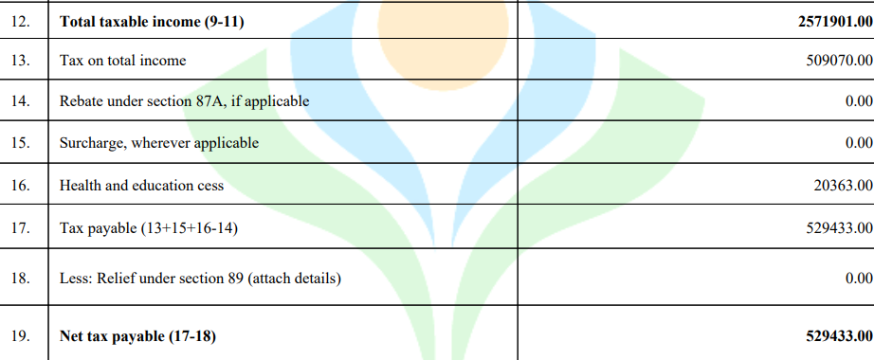

5.7.8.1 Real tax Report

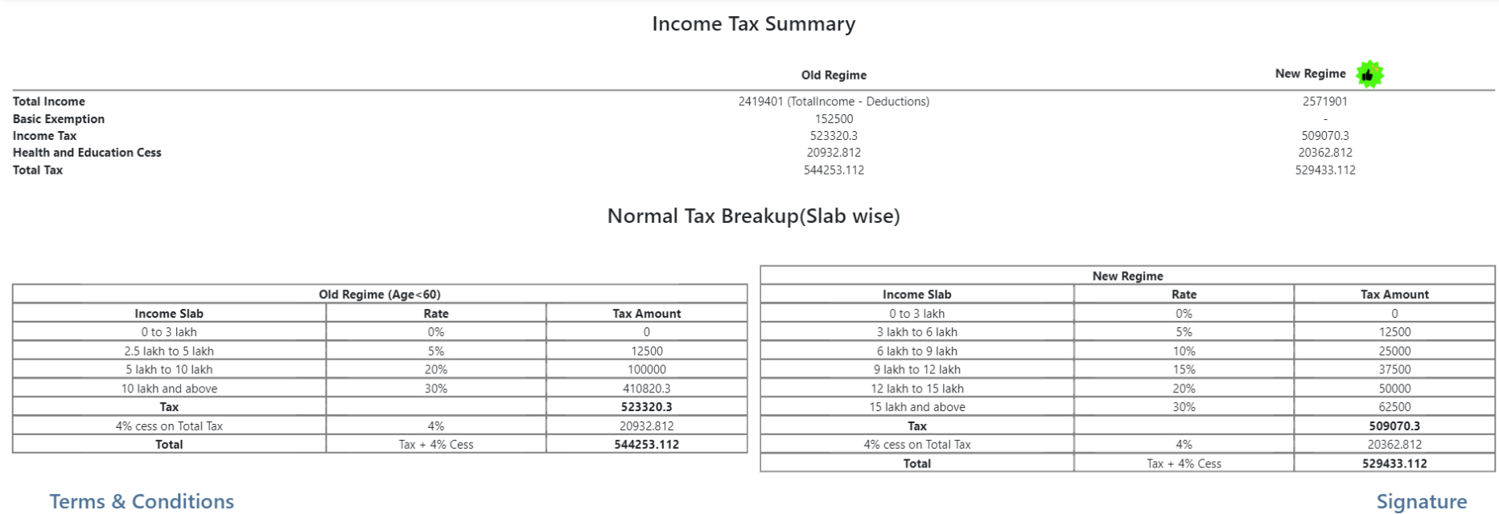

5.7.8.2 TaxSarthi generated tax Report

How is tax calculated in Old Regime Sample:-

|  |  |
| --- | --- |
| Income Range | Tax Rate |
| Up to ₹2,50,000 | 0% |
| ₹2,50,001 - ₹5,00,000 | 5% |
| ₹5,00,001 - ₹10,00,000 | 20% |
| Above ₹10,00,000 | 30% |

3.5.1. Old Regime Slabs

Now, let's solve the numerical for an income of ₹10,00,000:

|  |  |  |  |
| --- | --- | --- | --- |
| Income Range | Taxable Amount | Tax Rate | Tax Amount |
| Up to ₹2,50,000 | ₹2,50,000 | 0% | ₹0 |
| ₹2,50,001 - ₹5,00,000 | ₹2,50,000 | 5% | ₹12,500 |
| ₹5,00,001 - ₹9,50,000 | ₹4,50,000 | 20% | ₹90,000 |
| Above ₹10,00,000 | - | - | ₹0 |

3.5.2. Sample Calculation

Standard Deduction: ₹50,000

Income = ₹10,00,000 - 50,000

Total Taxable Amount: ₹2,50,000 + ₹4,50,000 = ₹7,00,000

Total Tax = Tax for first slab + Tax for second slab + Tax for third slab

= ₹0 + ₹12,500 + ₹90,000

= ₹1,02,500

Cess (4% of Total Tax) = ₹1,02,500 * 0.04

= ₹4,100

Therefore, for an income of ₹10,00,000, the total tax would be ₹1,02,500 and the cess amount would be ₹4,100.

It is similar for New regime as well.

Performance on Old Regime:

TaxSarthi's performance under the old tax regime was characterized by its exceptional ability to navigate the complexities of existing tax structures and provide accurate tax assessments.

Accuracy and Efficiency:

* TaxSarthi achieved an impressive accuracy rate of 95.8% in computing tax liabilities under the old regime, showcasing its robustness in handling various input combinations. However, it's important to note that the accuracy is not 100% due to the presence of multiple cases of deductions in the old tax regime. Tax calculations involve deducting various allowances and exemptions from the total income to arrive at the final taxable income. This complexity in deduction calculations may lead to minor discrepancies in the accuracy of tax assessments, particularly for higher values.

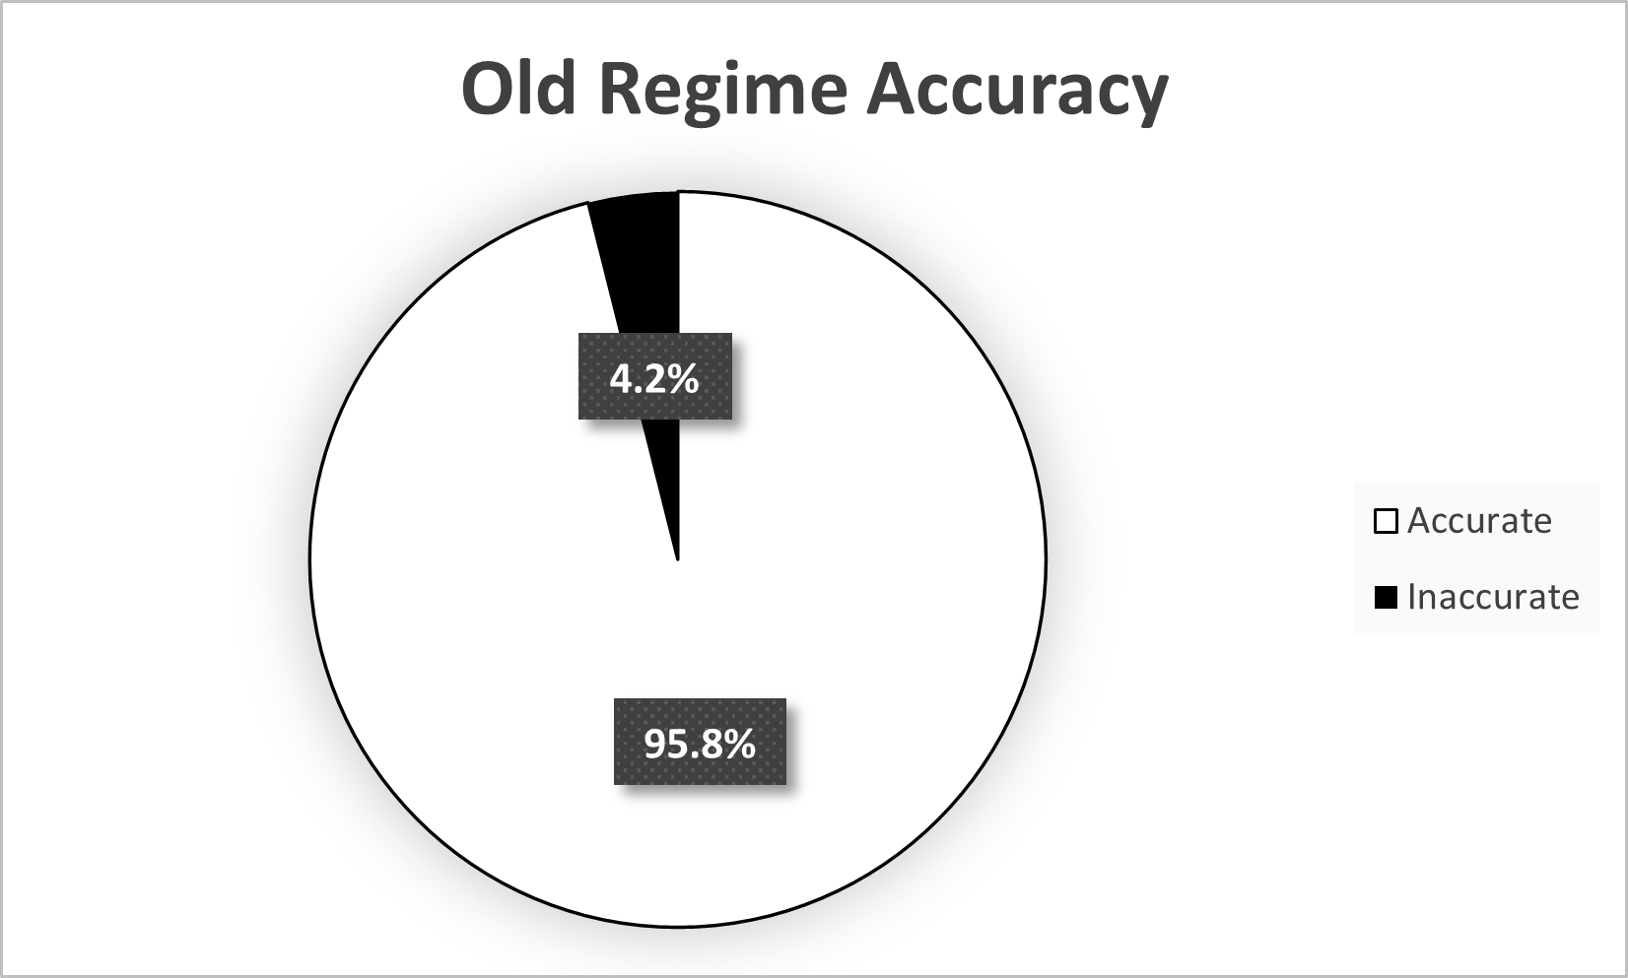

Figure 3.5.9: Old Regime Accuracy Chart

Tax Deviation:

* Figure 5.2 further illustrates the tax deviation between TaxSarthi's calculations and those performed manually by a Chartered Accountant (CA). Despite minor disparities, TaxSarthi consistently maintained high accuracy levels, validating its reliability in tax assessment.

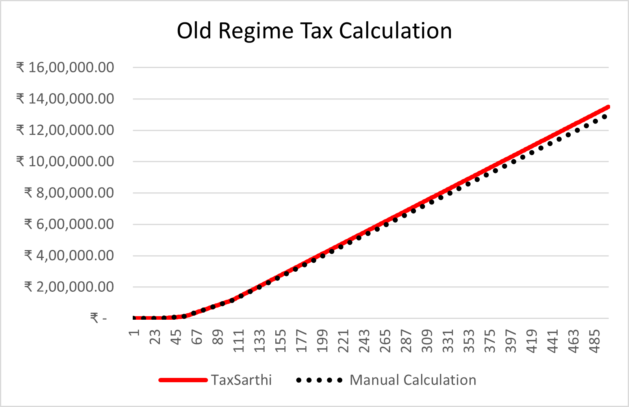

Figure 3.5.10: Tax Deviation in Old Regime

Performance on New Regime:

Under the new tax regime, TaxSarthi's adaptability and consistency were evident as it seamlessly transitioned to the updated tax structures while maintaining exceptional accuracy.

Adaptability and Consistency:

* TaxSarthi adapted to the new tax regime with ease, incorporating updated tax laws and regulations. Impressively, it maintained a perfect accuracy rate of 100% in calculating tax liabilities, as the tax calculation is directly based on the total income without involving deductions. This streamlined process contributed to the higher accuracy rate observed in the new regime.

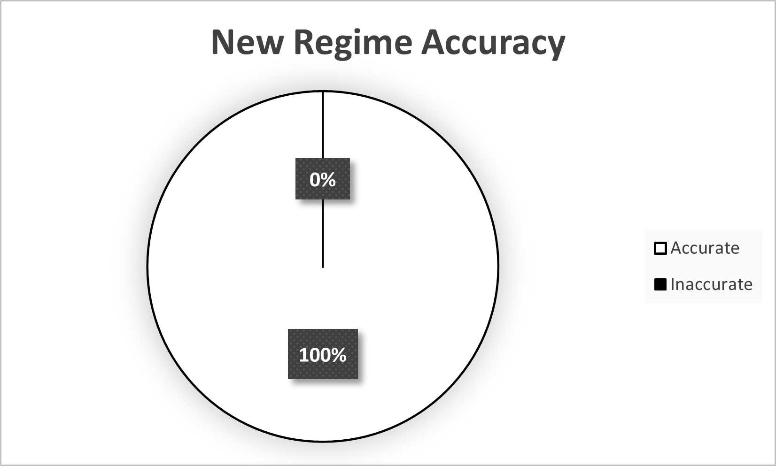

Figure 3.5.11: New Regime Accuracy Chart

Tax Deviation:

* Figure 5.4 highlights the tax deviation in the new regime, showing minor differences between TaxSarthi's calculations and those performed manually by a Chartered Accountant (CA). Despite these discrepancies, TaxSarthi's accuracy in tax assessment remained consistently high.

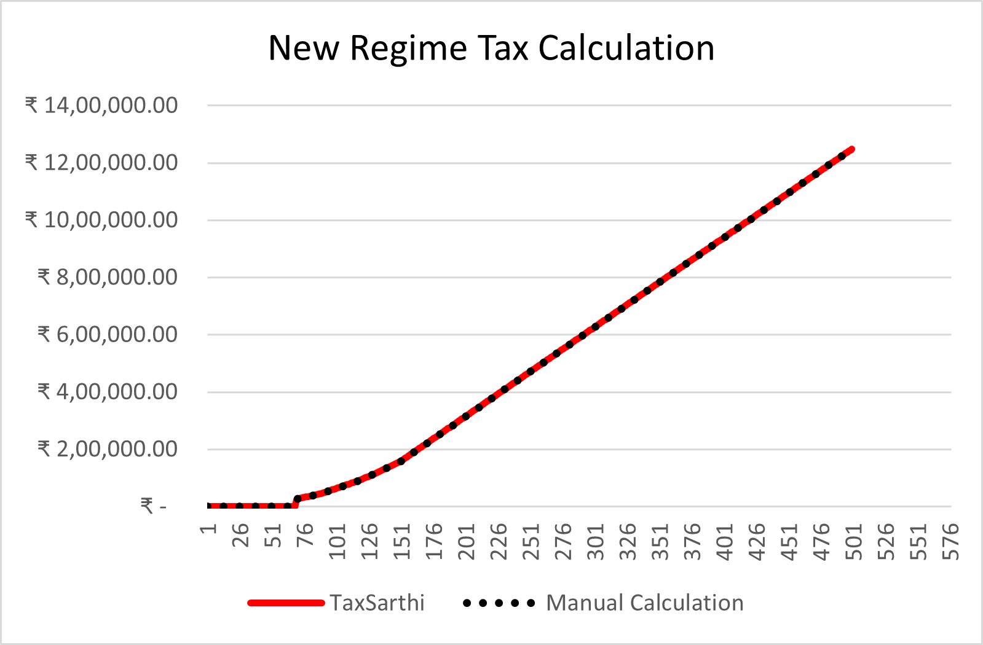

Figure 3.5.12: Tax Deviation in New Regime

Overall Effectiveness:

TaxSarthi's overall effectiveness across both old and new tax regimes was remarkable, establishing it as a reliable and accurate platform for users to simplify the complex process of taxation.

Unified Performance:

TaxSarthi consistently delivered an outstanding accuracy rate of nearly 97.9% across both regimes, reflecting its reliability and effectiveness in providing accurate tax assessments regardless of the tax framework in place.

**3.6 Conclusion**

Through its core mission of demystifying the intricacies inherent in taxation, TaxSarthi is fervently committed to dismantling barriers, ensuring universal accessibility to the comprehension and execution of tax filing. Regardless of one's tenure in tax management, “TaxSarthi” stands as an unwavering, dependable companion throughout the journey of tax filing. Its design is tailored to offer comprehensive support at every juncture, fostering an inclusive environment where no individual feels isolated or overwhelmed amidst their tax obligations.

TaxSarthi's dedication transcends the realms of mere financial considerations, extending beyond economic boundaries to establish an equitable platform for individuals from diverse backgrounds.

The platform's architecture is meticulously crafted to render the formidable task of tax filing approachable and comprehensible, catering to individuals irrespective of their financial expertise. Through easily digestible information and user-centric tools, TaxSarthi seeks to instill confidence and competence, particularly among those unfamiliar or apprehensive about managing their taxes.

With TaxSarthi as a guiding force, navigating the labyrinthine landscape of taxes becomes a seamless journey marked by confidence and assurance. Positioned as a trusted ally, TaxSarthi is primed to furnish guidance, unwavering support, and abundant resources to ensure that each user fulfills their tax responsibilities with efficacy. By streamlining the tax filing process and diminishing its intimidation, TaxSarthi aspires to contribute to a more financially literate and empowered society, fostering a landscape where individuals confidently assume control of their financial destinies.

**3.7 Future Scope**

**Testing and Validation:** Rigorous testing and validation are essential to ensure the robustness and accuracy of TaxSarthi's platform. This phase involves several critical aspects:

* Functionality Testing: This includes checking if all features on the website work as intended. This involves everything from user registration to data input, tax calculations, and document submission.
* Usability Testing: This focuses on the user experience, ensuring that the website is intuitive and user-friendly. Feedback from real users can be invaluable in making improve
* Security Testing: This is crucial to identify and fix potential vulnerabilities in the platform. It includes testing for data encryption, secure data transfer, and protection against common cyber threats.
* Performance Testing: This ensures that the platform can handle a substantial load of users without slowing down or crashing. It assesses the website's response time and stability under varying conditions.

**Expanding more Professions:** Expanding to cater to a wider range of professions beyond salaried professionals, including freelancers, consultants, and small business owners.

* Tailored Solutions: The application will develop specialized features and tools tailored to the unique tax needs of different professions, ensuring precision and efficiency in tax calculations and compliance.
* Enhanced Education: TaxSarthi will provide educational resources and tutorials specifically designed for individuals from various professional backgrounds, empowering them with essential financial knowledge and skills.
* Customizable Platforms: The application will foster a vibrant community where users can connect, share insights, and seek advice related to their specific professions, creating a supportive ecosystem for professional growth and development.

**OCR Integration:** Optical Character Recognition (OCR) technology is a game-changer for tax-related processes. By integrating OCR, TaxSarthi can achieve several benefits:

* Data Extraction: OCR can extract data from physical documents, such as invoices, receipts, and W-2 forms. This reduces manual data entry and the likelihood of errors.
* Error Reduction: Manual data entry is prone to errors, which can lead to incorrect tax calculations. OCR helps eliminate such errors, ensuring tax filings are accurate.
* Time Efficiency: OCR speeds up the data input process significantly. Users can simply take a picture of a document, and the relevant data is automatically transcribed into the system.
* User Convenience: Users often find manual data entry tedious and time consuming. OCR enhances the user experience by simplifying data input, making it more convenient.
* Integration with Mobile App: If TaxSarthi develops a mobile app, OCR integration can be particularly beneficial. Users can snap pictures of documents on their mobile devices and seamlessly import data into the app.

**Mobile App Development:** Creating a mobile app for TaxSarthi opens up several advantages:

* Accessibility: Mobile apps make TaxSarthi's services readily accessible to users on their smartphones and tablets. They can file taxes, check financial information, and receive updates on the go.
* Enhanced User Experience: Mobile apps offer a customized and user-friendly interface tailored to smaller screens, making navigation and interaction more intuitive.

**REFERENCES**

1. Anjali Tyagi, "An Analysis of Indian Tax Structure". Social Science Research Network, 1 Feb 2022.
2. Pradip Kumar Das, "A study on direct taxation in India", Direct Research Journal of Social Science and Educational Studies: ISSN 2449-0806,9 September 2019.
3. Yadawananda Neog & Achal Kumar Gaur, "Tax structure and economic growth: a study of selected Indian states". Journal of Economic Structures, 09 May 2020.
4. Harjit Singh, Arpan Kumar Kar and P. Vigneswara Ilavarasan, "A Case Study on e-Filing System of Income Tax Department of India", Springer, 29 August 2018

* https://www.canarahsbclife.com/tax-university/articles/all-about-tax-structure-in-india
* https://www.canarahsbclife.com/tax-universityfarticles/income-tax-slab-for-fy-2022-23
* https://cleartax.in/s/income-tax-rebate-us-87a
* https://www.canarahsbclife.com/tax-university/articles/what-is-tax