**MINIPROJECT LOGBOOK**

GROUP MEMBERS

1.Rahul Kithani

2.Manish Motwani

3.Mohit Advani

4.Varun Dulani

Supervisor

Prof.Manisha Mathur



**Department of Computer Engineering**

**Vivekanand Education Society’s Institute of Technology**

**HAMC, Collector’s Colony, Chembur,**

**Mumbai-400074**

**University of Mumbai**

**(AY 2023-24)**

# INSTITUTE VISION & MISSION

**Vision:**

To create a vibrant knowledge oriented environment with innovative teaching practices and to inculcate a tradition of socially conscious application of technology.

**Mission:**

* To inculcate a culture of value based education.
* To enthuse students to develop in an ambient environment of caring and of sharing information.
* To enable students to work towards excellence in their chosen field with a professional bent of mind.

# DEPARTMENT OF COMPUTER ENGINEERING

**Vision:**

To create a center of excellence in computing by imparting quality education for developing competent professionals.

**Mission:**

* To provide an enabling environment through excellence in teaching & learning to contribute towards industry and society.
* To promote and strengthen interdisciplinary approach in innovation, creativity and research. ● To facilitate productive employment and higher studies with entrepreneurial attitude and professional ethics.

# PROGRAM EDUCATIONAL OBJECTIVES (PEO's)

| I | To provide students with a solid foundation in their core concepts of mathematical, scientific and computer engineering fundamentals required to comprehend, analyze and design solutions for real life problems. |
| --- | --- |
| II | To inculcate in students, a balanced outlook with professional and ethical attitude, develop effective communication skills, teamwork and leadership qualities with multidisciplinary approach. |
| III | To prepare students to excel in postgraduate programs through an excellent academic environment and make them ready for productive employment in the public or private sectors and provide lifelong learning experience. |
| IV | To provide broad educational and research experience through interdisciplinary and industry centric programs. |

# PROGRAM OUTCOMES (POs)

| **Progra**  **m**  **Outco me**  **Code** | **Program Outcome Description** |
| --- | --- |
| PO1 | Basic Engineering knowledge: An ability to apply the fundamental knowledge in mathematics, science and engineering to solve problems in Computer Engineering. |
| PO2 | Problem Analysis: Identify, formulate, research literature and analyze computer engineering problems reaching substantiated conclusions using first principles of mathematics, natural sciences and computer engineering and science. |
| PO3 | Design/ Development of Solutions: Design solutions for complex computer engineering problems and design system components or processes that meet specified needs with appropriate consideration for public health and safety, cultural, societal and environmental considerations. |
| PO4 | Conduct investigations of complex engineering problems using research-based knowledge and research methods including design of experiments, analysis and interpretation of data and synthesis of information to provide valid conclusions. |
| PO5  PO6 | Modern Tool Usage: Create, select and apply appropriate techniques, resources and modern computer engineering and IT tools including prediction and modeling to complex engineering activities with an understanding of the limitations.  The Engineer and Society: Apply reasoning informed by contextual knowledge to assess societal, health, safety, legal and cultural issues and the consequent responsibilities relevant to computer engineering practice. |
| PO7 | Environment and Sustainability: Understand the impact of professional computer engineering solutions in societal and environmental contexts and demonstrate knowledge of and need for sustainable development. |
| PO8 | Ethics: Apply ethical principles and commit to professional ethics and responsibilities and norms of computer engineering practice. |
| PO9 | Individual and Team Work: Function effectively as an individual, and as a member or leader in diverse teams and in multidisciplinary settings. |
| PO10 | Communication: Communicate effectively on complex engineering activities with the engineering community and with society at large, such as being able to comprehend and write effective reports and design documentation, make effective presentations and give and receive clear instructions. |
| PO11 | Project Management and Finance: Demonstrate knowledge and understanding of computer engineering and management principles and apply these to one's own work, as a member and leader in a team, to manage projects and in multidisciplinary environments. |
| PO12 | Life-long Learning: Recognize the need for and have the preparation and ability engage in independent and lifelong learning in the broadest context of technological change. |

# PROGRAM SPECIFIC OUTCOMES (PSOs)

| PSO1 | Professional Skills - The ability to develop programs for computer based systems of varying complexity and domains using standard practices. |
| --- | --- |
| PSO2 | Successful Career - The ability to adopt skills, languages, environment and platforms for entrepreneurs or for pursuing higher studies. creating innovative career paths, being successful |

## STUDENT INFORMATION

**Project Title:** Hema Link-connecting life savers

|  | **Student 1** | **Student 2** | **Student 3** | **Student 4** |
| --- | --- | --- | --- | --- |
| **UID/ERP**  **NORoll no** | 40 | 31 | 02 | 21 |
| **Name** | Rahul Kithani | Manish Motwani | Mohit Advani | Varun Dulani |
| **Class with Division** | CMPN-D7C | CMPN-D7B | CMPN-D7C | CMPN-D7A |
| **Contact No.** | 8007424884 | 9527248983 | 8446336039 | 8369729963 |
| **EMAIL** | 2022.rahul.kithani @ves.ac.in | 2022.manish.motwa ni@ves.ac.in | 2022.mohit.advani@ves  .ac.in | 2022.varun.dulani@ves. ac.in |

**INSTRUCTIONS TO STUDENTS:**

1. The logbook must be submitted to the Guide or Co-Guide for verification and evaluation of project activities at least once in a week.
2. Log books duly signed by the guide must be submitted with a project report for evaluation at the end of semester to the department.

## DECLARATION :

I declare that this project represents my ideas in my own words and wherever others' ideas or words have been included, I have adequately cited and referenced the original sources. I also declare that I have adhered to all principles of academic honesty and integrity and have not misrepresented or fabricated or falsified any idea/data/fact/source in my project work. I promise to maintain minimum 75% attendance, as per the University of Mumbai norms. I understand that any violation of the above will be cause for disciplinary action by the Institute.

Yours Faithfully,

1. Rahul Kithani(40)
2. Manish Motwani(31)
3. Mohit Advani(02)
4. Varun Dulani(21)
5. (Signature of Students)

### Letter of Acceptance

I undersigned, Prof.Manisha Mathur working in the Computer Engineering department, willing to guide the project titled HemaLink:connecting Lifesavers! for the mini project-I Semester III / IV respectively for the academic year 2023-24.

The names of the students are:

1. Rahul Kithani
2. Manish Motwani
3. Mohit Advani
4. Varun Dulani

(Project Guide) (Mini Project Coordinator) (HOD Computer)

.

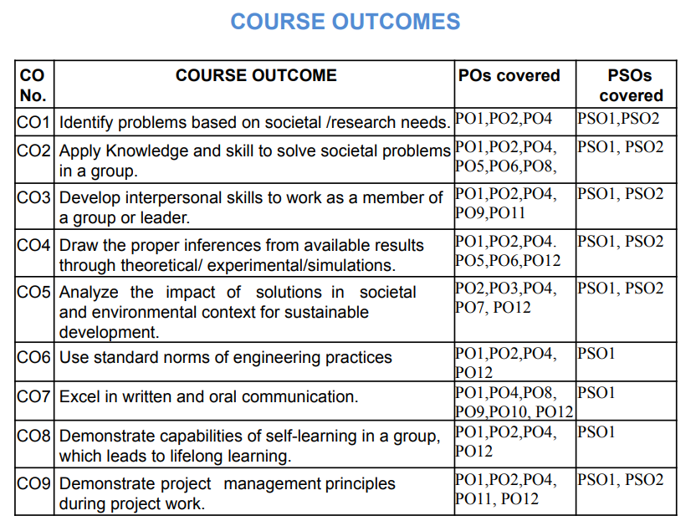

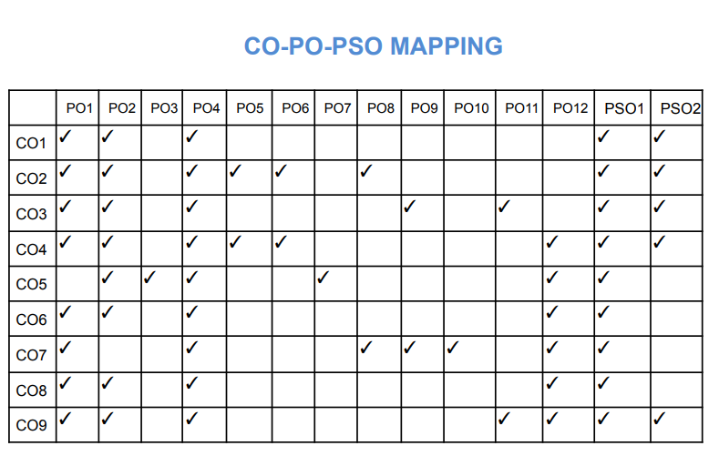

**SCHEDULE FOR MINI PROJECT**

| **Date** | **week** | **Contents** | **Guide**  **Sign** |
| --- | --- | --- | --- |
| 10/01/2024 | 1 | Regarding ppt for project review 1 |  |
| 20/01/2024 | 2 | Finalized the ppt |  |
| 10/02/2024 | 4 | Gathering information about tech. |  |
| 17/02/2024 | 5 | Started making the frontend part of project. |  |
| 25/03/2024 | 10 | Submitting the miniproject on final review |  |

**PROGRESS/ATTENDANCE REPORT**

**Title of the Project:Hema Link-connecting life savers**

| Group No. : 42 | Name of Student 1:Rahul Kithani |
| --- | --- |
| Name of Student 2:Manish Motwani |
| Name of Student 3:Mohit Advani |
| Name of Student 4:Varun Dulani |

Name of the Supervisor:Manisha Mathur

| Sr.  No | Date | | Attendance | | | | | | | | Progress/Suggestion |  | | | Mappings | |  |
| --- | --- | --- | --- | --- | --- | --- | --- | --- | --- | --- | --- | --- | --- | --- | --- | --- | --- |
|  | Add dates in this column | | 1 | 2 | | 3 | | 4 | | | 5 | CO | | | PO | | PS O |
| 1 | 05/01/2024 | | ✓ | ✓ | | ✓ | | ✓ | | | Understanding and finalization of problem statements.  Started learning the required text stack | CO1 | | | PO1,P  O2,  PO4 | | PSO  1  ,PSO  2 |
| 2 | 7/1/2024 | | ✓ | ✓ | | ✓ | | ✓ | | | Miniproject synopsis preparation |  | | |  | |  |
| 3 | 15/01/2024 | | ✓ | ✓ | | ✓ | | ✓ | | | Synopsis Submission |  | | |  | |  |
| 4 | 21/01/2024 | | ✓ | ✓ | | ✓ | | ✓ | | | Gathering information about tech stacks required for project |  | | |  | |  |
| 6 | | 5/2/2024 | ✓ | | ✓ | | ✓ | | ✓ | Created the login,signup and forgot password page for project  (frontend) | | |  |  | |  | | |
| 7 | | 6/02/2024 | ✓ | | ✓ | | ✓ | | ✓ | First Project Review | | |  |  | |  | | |
| 10 | | 13/04/2024 | ✓ | | ✓ | | ✓ | | ✓ | Submitting the miniproject on final review | | |  |  | |  | | |

Sign of the Supervisor

### EXAMINER'S FEEDBACK FORM

Name of External examiner:

College of External examiner:

Name of Internal examiner: Date of Examination :21 / 10/2023 No. of students in project team:

Availability of separate lab for the project: Yes / No

**Student Performance Analysis** (Put Tick as per your Observation)

| Excellent (3) Very Good (2) Good (1) | |  |  |  |
| --- | --- | --- | --- | --- |
| **Sr.**  **No.** | **Observation** | **(3)** | **(2)** | **(1)** |
| 1 | Quality of problem and Clarity |  |  |  |
| 2 | Innovativeness in solutions |  |  |  |
| 3 | Cost effectiveness and Societal impact |  |  |  |
| 4 | Full functioning of working model as per stated requirements |  |  |  |
| 5 | Effective use of skill sets |  |  |  |
| 6 | Effective use of standard engineering norms |  |  |  |
| 7 | Contribution of an individual’s as member or leader |  |  |  |
| 8 | Clarity in written and oral communication |  |  |  |

9 Overall performance o Can the same mini project extend to next semester by adding new objectives/ideas?

( Yes/ No) o If yes, suggest new Innovative Technique/Idea/ objectives related to this project.









**Signature of External Examiner Signature of Internal Examiner**