**VIVEKANAND EDUCATION SOCIETY’S INSTITUTE OF TECHNOLOGY**

**(An Autonomous Institute Affiliated to University of Mumbai)**

**Department of Computer Engineering**



Project Report on

**Neurocare-A personalized mobile application for migraine patients**

Submitted in partial fulfillment of the requirements of the degree

**BACHELOR OF ENGINEERING** IN **COMPUTER ENGINEERING**

By

**Arya Banavali D12A 01**

**Sanika Hadap D12C 22**

**Ajay Iyer D12C 26**

**Tanvi Naik D12C 48**

Name of the Mentor

**Prof. Priya R.L**

**University of Mumbai**

**(AY 2023-24)**

**VIVEKANAND EDUCATION SOCIETY’S INSTITUTE OF TECHNOLOGY**

**(An Autonomous Institute Affiliated to University of Mumbai)**

**Department of Computer Engineering**



# CERTIFICATE

This is to certify that the Mini Project entitled **“Neurocare-A personalized mobile application for migraine patients”** is a bonafide work of **Arya Banavali (D12A 01), Sanika Hadap (D12C 22), Ajay Iyer (D12C 26), Tanvi Naik (D12C 48)** submitted to the University of Mumbai in partial fulfillment of the requirement for the award of the degree of **“Bachelor of Engineering”** in **“Computer Engineering” .**

## (Prof.Priya R.L )

Mentor

## (Prof.Nupur Giri ) (Dr.J.M Nair )

Head of Department Principal

**Mini Project Approval**

This Mini Project entitled “Neurocare-A personalized mobile application for migraine patients**”** by **Arya Banavali (D12A 01), Sanika Hadap (D12C 22), Ajay Iyer (D12C 26), Tanvi Naik (D12C 48)** is approved for the degree of **Bachelor of Engineering** in **Computer Engineering.**

**Examiners**

**1………………………………………**

(Internal Examiner Name & Sign)

## 2…………………………………………

(External Examiner name & Sign)

Date: Place:

**DECLARATION**

We declare that this written submission represents our ideas in our own words and where others' ideas or words have been included, we have adequately cited and referenced the original sources. We also declare that we have adhered to all principles of academic honesty and integrity and have not misrepresented or fabricated or falsified any idea/data/fact/source in our submission. We understand that any violation of the above will be cause for disciplinary action by the Institute and can also evoke penal action from the sources which have thus not been properly cited or from whom proper permission has not been taken when needed.

| -----------------------------------------  Arya Banavali, D12A 01 | -----------------------------------------  Ajay Iyer, D12C 26 |
| --- | --- |
| -----------------------------------------  Sanika Hadap, D12C 22 | -----------------------------------------  Tanvi Naik, D12C 48 |

Date:

**ACKNOWLEDGEMENT**

We are thankful to our college Vivekanand Education Society’s Institute of Technology for considering our project and extending help at all stages needed during our work of collecting information regarding the project.

It gives us immense pleasure to express our deep and sincere gratitude to **Mrs. Priya R.L** (Project Mentor) for her kind help and valuable advice during the development of project synopsis and for her guidance and suggestions.

We are deeply indebted to the Head of the Computer Department, **Dr.(Mrs.) Nupur Giri** and our Principal **Dr. (Mrs.) J.M. Nair**, for giving us this valuable opportunity to do this project.

We express our hearty thanks to them for their assistance, without which it would have been difficult to finish this project synopsis and project review successfully. We convey our deep sense of gratitude to all teaching and non-teaching staff for their constant encouragement, support and selfless help throughout the project work. It is a great pleasure to acknowledge the help and suggestion, which we received from the Department of Computer Engineering.

We wish to express our profound thanks to all those who helped us in gathering information about the project. Our families too have provided moral support and encouragement several times.

**TABLE OF CONTENTS**

**Chapter Index**

**Title**

**Abstract**

**Chapter 1: Introduction**

1.1 Introduction

1.2 Motivation

1.3 Problem Definition

1.4 Existing Systems

1.5 Lacuna of the existing systems

1.6 Relevance of the Project

**Chapter 2: Literature Survey**

A. Brief Overview of Literature Survey

B. Related Works

2.1 Research Papers Referred

a. Abstract of the research paper

b. Inference drawn

2.2 Comparison with the existing system

**Chapter 3: Requirement Gathering for the Proposed System**

3.1 Introduction to requirement gathering

3.2 Functional Requirements

3.3 Non-Functional Requirements

3.4.Hardware, Software, Technology and tools utilized

3.5 Constraints

**Chapter** 4**: Proposed Design**

4.1 Block diagram of the system

4.2 Modular design of the system

4.3 Detailed Design

4.4 Project Scheduling & Tracking using Timeline / Gantt Chart

**Chapter 5: Implementation of the Proposed System**

5.1. Methodology employed for development

5.2 Algorithms and flowcharts for the respective modules developed

5.3 Datasets source and utilization

**Chapter 6: Testing of the Proposed System**

6.1. Introduction to testing

6.2. Types of tests Considered

6.3 Various test case scenarios considered

6.4. Inference drawn from the test cases

**Chapter 7: Results and Discussion**

7.1. Screenshots of User Interface (UI) for the respective module

7.2. Performance Evaluation measures

7.3. Input Parameters / Features considered

7.4. Graphical and statistical output

7.5. Comparison of results with existing systems

7.6. Inference drawn

**Chapter 8: Conclusion**

8.1 Limitations

8.2 Conclusion

8.3 Future Scope

**References**

**Annexure**

**List of Figures**

| **Sr no.** | **Title of the figure** | **Pg no** |
| --- | --- | --- |
| 1. | Block diagram | 20 |
| 2. | Modular diagram | 21 |
| 3,4. | Gantt chart and project schedule | 23 |
| 5. | Onboarding pages | 30 |
| 6 | Home page | 30 |
| 7. | MIDAS Assessment and Migraine Logs | 31 |
| 8. | PDF Uploader & FAQs | 31 |

**Neurocare-A mobile application for personalized migraine care**

**ABSTRACT**

Existing migraine management apps often fall short in providing comprehensive care, lacking real-time insights into migraine severity and failing to follow essential assessment tools like the MIDAS questionnaire. Additionally, these apps typically track only a limited number of triggers, such as weather changes, and do not capture patients' complete migraine history. This gap underscores the pressing need for more integrated and thorough solutions for migraine care.

In response to these limitations, NeuroCare, a personalized mobile application for migraine assistance tailored to both patients and doctors. NeuroCare will use the MIDAS score test criteria to assess migraine impact on daily life, providing valuable insights into migraine triggers and severity levels. The app will feature migraine logs for tracking episodes and triggers, a health record display for doctors, and a calendar for monitoring migraines over time. By offering a comprehensive approach to migraine management, NeuroCare seeks to enhance patient outcomes and support healthcare providers in delivering more effective care for this prevalent and impactful health condition.

**CHAPTER 1: INTRODUCTION**

**1.1 Introduction**

Migraine is a neurological condition characterized by recurrent, severe headaches often accompanied by symptoms such as nausea, vomiting, and sensitivity to light and sound. These headaches typically occur on one side of the head and can last from a few hours to several days, significantly impacting an individual's quality of life. Migraine affects approximately 1 in 7 people worldwide, with women being more prone to experiencing migraines than men. According to the World Health Organization (WHO), migraine is among the top 20 causes of disability globally, leading to significant economic burdens due to healthcare costs and lost productivity. The exact cause of migraine is not fully understood, but genetic and environmental factors are believed to play a role. Migraine treatment often involves a combination of lifestyle changes, medication, and, in some cases, preventive therapies to reduce the frequency and severity of attacks.

NeuroCare is an innovative mobile application designed to assist individuals experiencing migraines. The app features a Migraine Disability Assessment (MIDAS) questionnaire, a validated tool used to quantify the impact of migraines on daily life. This questionnaire helps users understand the intensity of their migraines and provides valuable insights for managing them effectively. NeuroCare also includes a personal diary section where users can track potential triggers for their migraines, enabling them to identify patterns and make informed lifestyle changes. Additionally, the app offers a migraine log, allowing users to record their migraine episodes, including the duration, severity, and associated symptoms, thus creating a comprehensive history for better management. NeuroCare features a frequently asked questions (FAQ) section to address common queries and provide additional support, offering valuable information and guidance for migraine sufferers.

**1.2 Motivation**

The motivation behind our app is to revolutionize migraine care by providing individuals with a comprehensive and personalized tool for managing their condition. Migraines can have a profound impact on daily life, often going unnoticed or misunderstood, leading to underdiagnosis and undertreatment. By offering features such as the MIDAS questionnaire for assessing migraine intensity, a personal diary section for tracking triggers, and a migraine log for recording episodes, our app empowers users to take control of their migraines. Additionally, by enabling users to share their health records with doctors and providing a calendar for tracking migraines over time, the app aims to improve communication between patients and healthcare providers, leading to more effective treatment plans. Overall, our app seeks to enhance the quality of life for individuals with migraines by providing them the tools and support they need to manage their condition effectively.

**1.3 Problem Definition**

Migraine, a complex neurological condition, can significantly impact individuals’ daily lives, yet it often goes unnoticed or misunderstood. The condition's symptoms include severe headaches, nausea, vomiting, and sensitivity to light and sound. Identifying the precise triggers for migraines is crucial for effective management, as is ensuring the use of reliable medications and appropriate precautions. Our app plays a pivotal role in achieving these objectives by facilitating accurate trigger identification and providing guidance on selecting reliable treatments and preventive measures.

**1.4 Existing Systems**

There are several existing systems related to neurocare such as Migraine Buddy, Migraine Monitor, etc that assist patients during migraine episodes. These systems include migraine trackers, tools for monitoring migraine triggers, platforms for raising awareness about triggers, and tools for assessing the severity levels of migraines.

**1.5 Lacuna of the existing systems**

The existing apps for migraine management have several limitations that create a gap in providing comprehensive care. These apps do not offer real-time insights into the severity levels of migraines because they do not follow the MIDAS (Migraine Disability Assessment) questionnaire, which is crucial for assessing migraine's impact on daily life. Additionally, these apps have a limited number of triggers that they track, often focusing solely on weather changes as a trigger for migraines. Moreover, they fail to record patients' complete medical history of migraines, which is essential for understanding and managing their condition effectively. This lacuna highlights the need for more comprehensive and integrated systems for migraine care.

**1.6 Relevance of the Project**

The project's relevance stems from its targeted approach to addressing the global health issue of migraines through the development of the NeuroCare mobile application. By empowering individuals with migraines through comprehensive tools for self-management and fostering improved doctor-patient communication, NeuroCare fills critical gaps in existing systems. Through features like the MIDAS questionnaire, trigger tracking, and real-time monitoring, the app promotes early intervention and treatment while also providing valuable data for research. Ultimately, NeuroCare has the potential to significantly enhance the lives of migraine sufferers, improve healthcare outcomes, and contribute to advancing understanding and management of migraines on a broader scale.

**CHAPTER 2: LITERATURE SURVEY**

**A. Brief Overview of Literature Survey**

The literature survey covers a broad spectrum of topics related to headache and migraine management. It begins with a study comparing the efficacy of nerve deactivation surgery for migraines, focusing on outcomes such as frequency, duration, and intensity, and highlighting its effectiveness in improving migraine outcomes. Moving on, the survey discusses the Migraine Disability Assessment (MIDAS) questionnaire, which plays a crucial role in evaluating how migraines impact daily life and improving communication between patients and healthcare providers. Additionally, it addresses the differences between migraines and tension headaches, emphasizing the varying symptoms, triggers, and effects on daily activities. Furthermore, the survey delves into the privacy concerns surrounding smartphone applications designed for headache and migraine management. It reveals that while many of these apps have visible privacy policies, there are still concerns about data collection and targeted advertisements. Overall, the literature survey underscores the importance of tailored treatment plans, understanding the social impact of headaches, and ensuring patient privacy in healthcare applications.

**B. Related Works**

**2.1 Research Papers Referred**

**a. Abstract of the research paper**

1]Comparing Migraine Headache Index vs. Monthly Migraine Days Following Nerve Deactivation for Headache: A Systematic Review and Meta-Analysis

Author: Ormseth, B., ElHawary, H., Huayllani, M. T., Weber, K.Blake, P. G., & Janis

Publishing year 2023

Abstract:

* Nerve deactivation surgery for migraine focuses on outcomes like frequency, duration, and intensity.
* Neurology literature emphasizes monthly migraine days (MMD).
* This study reviews 19 articles to assess surgery's impact on MMD.
* Results show significant reductions in MMD (MD 14.11, 95% CI 10.95 to 17.27).
* There were also reductions in total monthly attacks (MD 8.65, 95% CI 7.84 to 9.46), migraine headache index (MD 76.59, 95% CI 60.85 to 92.32), attack intensity (MD 3.84, 95% CI 3.35 to 4.33), and attack duration (MD 11.80, 95% CI 6.44 to 17.16) over 6-38 months.
* The study highlights surgery's efficacy in improving migraine outcomes, consistent with plastic surgery and neurology literature.

2] The social impact and burden of headache

Author: Lipton, R. B., & Bigal, M. E.

Publishing year: 2010

Abstract:

* The Migraine Disability Assessment (MIDAS) questionnaire measures the impact of migraines on daily life.
* It comprises five questions assessing missed days or reduced productivity by at least 50% over three months.
* The MIDAS score is calculated based on missed days in three domains: work or school, household work, and social or leisure activities.
* Grades range from 1 (little to no disability) to 4 (severe disability), providing a quick assessment of migraine impact.

3] Outcomes, efficacy, and complications of headache management

Author : Silberstein, S. D.

Publishing year: 2008

Abstract:

* The Migraine Disability Assessment (MIDAS) evaluates how migraines affect daily life and improves patient-provider communication.
* It consists of five questions about migraine's impact on work or school, household chores, and social activities.
* The questionnaire is quick and easy to complete, suitable for various healthcare settings.
* MIDAS categorizes migraine-related disability into three levels: little to no disability (scores 5-10), moderate disability (scores 11-20), and severe disability (scores >20).
* This categorization helps healthcare providers understand the impact of migraines and tailor treatment plans accordingly.

4] Migraines Headaches vs. Tension Headaches

Author: Greater Austin Pain Center

Abstract:

* Migraines cause throbbing head pain, nausea, and dizziness, hindering daily tasks.
* Triggers include light, exercise, smells, and certain foods, but the exact cause is unknown.
* Headaches are classified into primary (like tension headaches and migraines) and secondary (caused by another medical condition).
* Migraines are severe, recurring headaches often affecting one side of the head.
* Migraines can include visual disturbances called auras, present in about a third of sufferers.
* Migraines differ from tension headaches, which are more common but less severe.

5] Privacy Issues in Smartphone Applications: An Analysis of Headache/Migraine Applications

Author : Minen, M., Stieglitz, E. J., Sciortino, R., & Torous, J

.Publishing year : 2018

Abstract:

* Headache diaries are crucial for migraine management.
* The study aimed to assess privacy issues in headache and migraine apps to inform patients and physicians.
* A systematic search of popular headache and migraine apps was conducted, on data input requirements and privacy policies.
* 29 apps were examined (14 diary apps, 15 relaxation apps).
* 79% of diary apps had visible privacy policies, with all stating whether they collect and store information remotely.
* 55% of diary apps with privacy policies admitted to using user data for targeted advertisements.
* 73% of relaxation apps had privacy policies.

**b. Inference drawn**

MIDAS Assessment:

* The Migraine Disability Assessment (MIDAS) questionnaire is a tool designed to assess the impact of migraines on a person's daily life quickly and effectively.
* The questionnaire provides a score that categorizes migraine-related disability into three levels: little to no disability, moderate disability, or severe disability.
* This scoring system helps healthcare providers understand the severity of a person's migraines and tailor treatment plans accordingly.

Migraines vs. Tension Headaches:

* Migraines are severe, recurring headaches that can cause throbbing pain, nausea, and sensitivity to light and sound.
* They often affect one side of the head and can be accompanied by visual disturbances known as auras.
* In contrast, tension headaches are more common and less severe, typically causing a dull, aching pain on both sides of the head.
* While tension headaches may also be associated with stress or tension, migraines are more debilitating and can significantly impact a person's quality of life.

Privacy Concerns in apps:

* Privacy issues are associated with apps, particularly those that collect user data.
* A study found that a significant percentage of headache diary apps use user data for ads, raising concerns about the privacy and security of personal health information.

**2.2. Comparison with the existing system**

* Real-time Insights: Neurocare provides real-time insights into migraine severity levels by following the MIDAS questionnaire, offering a comprehensive assessment of migraine's impact on daily life. Existing apps need this feature, leading to a gap in providing holistic care.
* Trigger Tracking: This includes personal triggers specific to each patient, providing doctors with valuable insights to prescribe medication accordingly. This personalized approach enhances the effectiveness of migraine management, addressing a key limitation of current systems.
* Medical History: Neurocare records patients' complete medical history of migraines, enabling healthcare providers to understand and manage their condition more effectively. Existing apps must capture this crucial information, limiting their ability to provide personalized care.

**CHAPTER 3: REQUIREMENT GATHERING FOR THE PROPOSED SYSTEM**

**3.1 Introduction to requirement gathering**

Requirement gathering is obtaining, documenting, and analyzing stakeholders' needs and expectations for a software project. It entails identifying the software's features, functionalities, and limits to meet user needs. To obtain information, this procedure often includes conducting interviews, questionnaires, and workshops, as well as evaluating existing documents. The purpose of requirement collecting is to guarantee that the software development team and stakeholders understand what needs to be built, resulting in the effective delivery of a solution that satisfies user needs and expectations.

**3.2 Functional Requirements**

The functional requirements of Neurocare are as follows:

1. **User Authentication:**

Our system requires users to log in with a username and password to ensure that only authorized users can access the app and its features.

1. **Migraine Disability Assessment (MIDAS):**

Neurocare includes a MIDAS questionnaire to quantify the impact of migraines on daily life. This questionnaire will help users understand the severity of their migraines and provide valuable insights for managing them effectively.

1. **Personal Diary:**

Neurocare’s diary allows users to track potential triggers for migraines, such as stress, diet, and sleep patterns. Users will be able to record details of migraine episodes, including the duration, severity, and associated symptoms. This feature will help users identify patterns and make informed lifestyle changes to manage their migraines better.

1. **Migraine Log:**

The migraine log is a vital tool for documenting migraine experiences. It helps track the date, time, severity, triggers, symptoms, and comments for each episode.

1. **Health Record Display:**

This app allows users to share their health records with doctors and other healthcare providers. This feature will enable healthcare providers to have access to the user's migraine history and provide personalized treatment plans.

1. **Calendar:**

This app provides a calendar for users to track their migraines over time. Users will be able to view past migraine episodes, upcoming appointments, and any other relevant events related to their migraines.

**3.3 Non-Functional Requirements**

1. **Performance**: Neurocare responds to user interactions quickly and efficiently. This requirement ensures that users can use this app smoothly without experiencing delays or lag.
2. **Security:** It ensures data is encrypted and protected from unauthorized access. This requirement is essential to protect user privacy and ensure the confidentiality of sensitive information.
3. **Usability:** Neurocare has a user-friendly interface with intuitive navigation. Users can easily access and use all the features without extensive instructions or guidance.

**3.4.Hardware, Software, Technology and tools utilized**

**Hardware**:

* Computer capable of running Flutter development tools
* Sufficient RAM (at least 8GB recommended)
* Adequate storage space
* Mobile device for testing (optional but recommended)
* Stable internet connection

**Software**:

* Operating System: Windows 7 or later, macOS 10.12 or later, or Linux (64-bit)
* Flutter SDK
* Integrated Development Environment (IDE): Android Studio, Visual Studio Code, or IntelliJ IDEA with Flutter and Dart plugins
* Firebase Account
* Text Editor: Notepad++ / Sublime Text
* Web Browser: Google Chrome, Mozilla Firefox, or Safari
* Emulator or Physical Device: Android Emulator or iOS Simulator, or physical Android or iOS device
* Firebase CLI

**3.5 Constraints**

Neurocare is currently accessible on Android and iOS mobile devices, allowing users to manage their migraines effectively through the app's features. However, the app is unavailable on laptops or PCs, limiting its usability to mobile platforms. Future updates may include considerations for making Neurocare compatible with laptops or PCs, but the current priority is to enhance the app's performance and features on mobile devices.

**CHAPTER 4: PROPOSED DESIGN**

**4.1 Block diagram of the system**

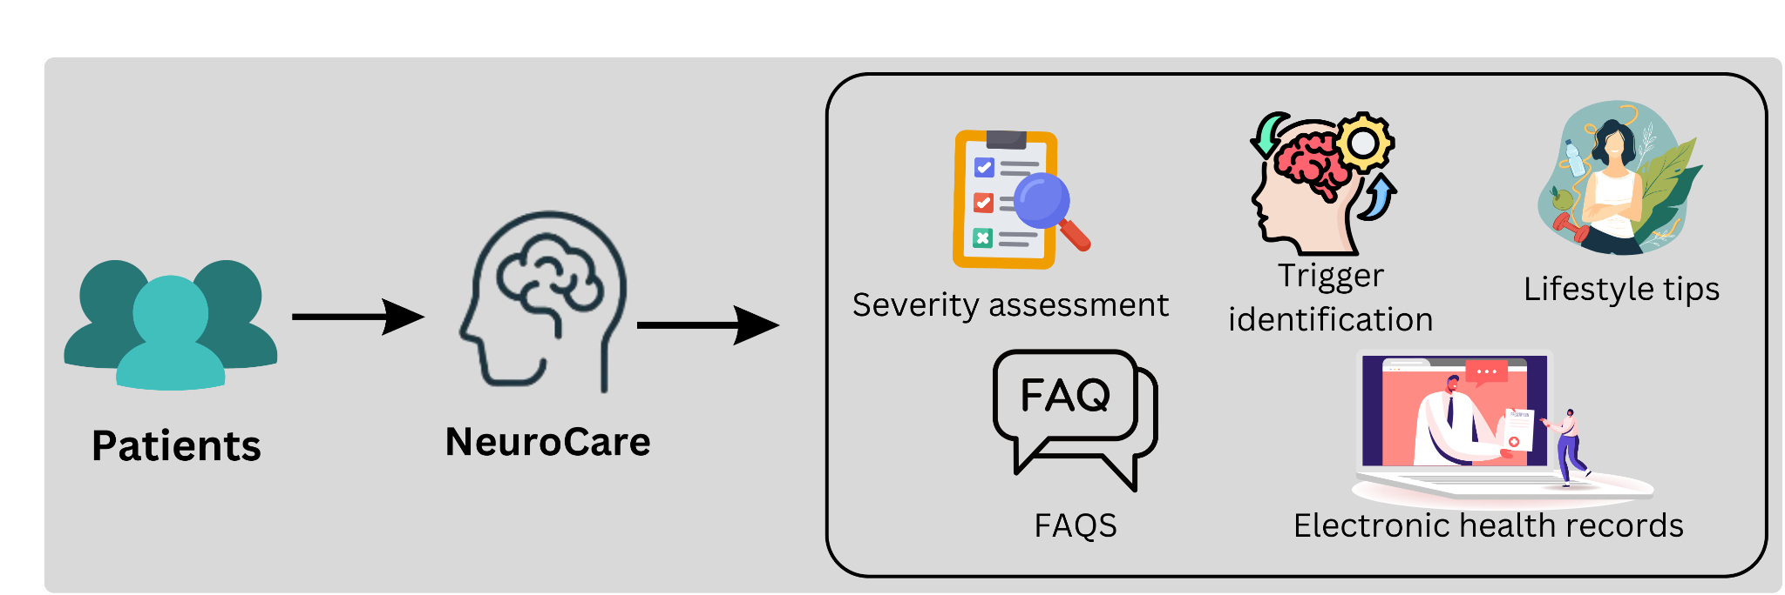

Fig. 1 : Block diagram of the system

The diagram showcases the NeuroCare mobile app, designed to empower patients in managing their health and fostering better communication with healthcare providers. Patients can utilize the app to assess the severity of their condition, identify potential triggers, and access lifestyle tips to optimize their well-being. This information is securely stored in electronic health records (EHR), which healthcare providers can access to gain a comprehensive view of their patients' health. This two-way flow of information through the app allows patients to be more proactive in their healthcare journey while enabling providers to make informed decisions and deliver better care. Additionally, the app likely incorporates a FAQ section to address common questions and provide patients with a sense of control and knowledge regarding their condition. Overall, the NeuroCare mobile app appears to create a patient-centric healthcare ecosystem that promotes informed decision-making, improved communication, and ultimately, better health outcomes.

**4.2 Modular design of the system**

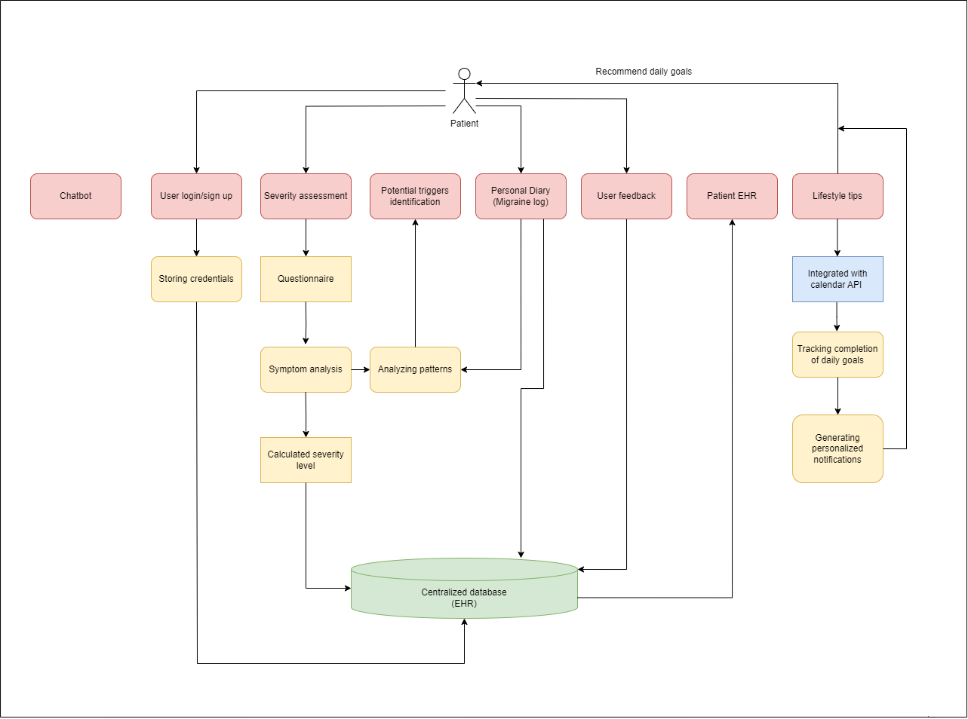

Fig. 2 : Modular diagram of the system

Our app integrates several key features to provide users with comprehensive support. Authenticated user login/signup through Firebase ensures data security, while a Severity Assessment tool aids in understanding migraine intensity. Machine learning algorithms identify potential triggers, and a Personal Diary allows users to record detailed migraine episodes. User Feedback fosters app improvement, while Patient EHR offers access to health records. The Lifestyle Tips Module provides tailored guidance for prevention and management, collectively empowering users to effectively navigate their migraine experiences and improve overall well-being.

**4.3 Detailed Design**

**User Login/Signup Authenticated with Firebase:** User authentication ensures secure login/signup processes for accessing the application's features and the user’s personal data.

**Severity Assessment:** A questionnaire-based system, sourced from the neurologist, designed to assess the severity level of migraines. It would help in categorizing and understanding the intensity of migraine episodes.

**Potential Trigger Identification:** Implementation of machine learning algorithms analyzing recorded user data to identify potential triggers associated with migraine episodes, aiding in understanding patterns and correlations.

**Personal Diary (Migraine Log):** A feature allowing users to record essential details of migraine episodes, including date, time, severity, triggers, symptoms, and any additional notes, creating a comprehensive migraine diary.

**User Feedback:** A feedback system enabling users to share their experiences and suggestions, fostering app improvement and maintenance for enhanced user satisfaction.

**Patient EHR (Electronic Health Records):** A secure space for users to review and access their recorded health data, providing a comprehensive overview of their migraine history and management.

**Lifestyle Tips Module:** This module would offer tailored lifestyle tips and guidance based on user data, promoting healthy habits and aiding in migraine prevention and management.

**FAQs (Frequently Asked Questions) :** A set of commonly asked questions and their corresponding answers designed to provide guidance, address queries, and offer information on migraine management based on data provided by the neurologist. Users can refer to these FAQs to find answers to their queries and gain insights into managing their migraines effectively.

**4.4 Project Scheduling & Tracking using Timeline / Gantt Chart**

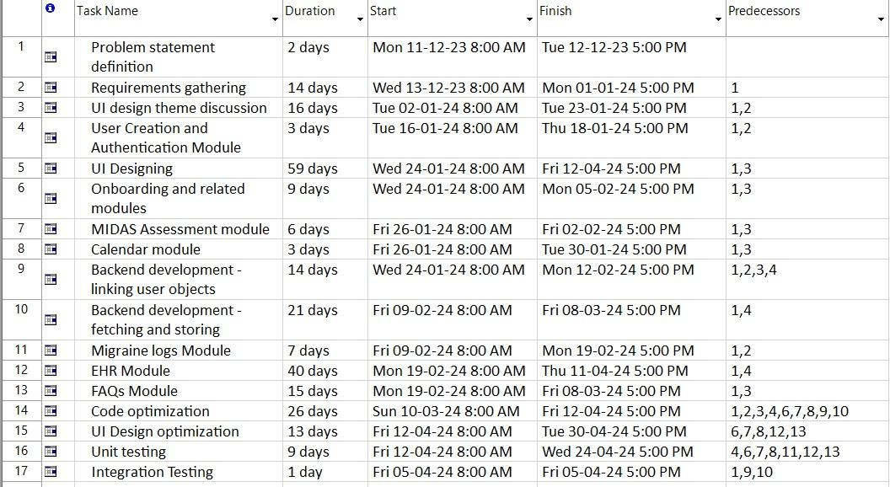

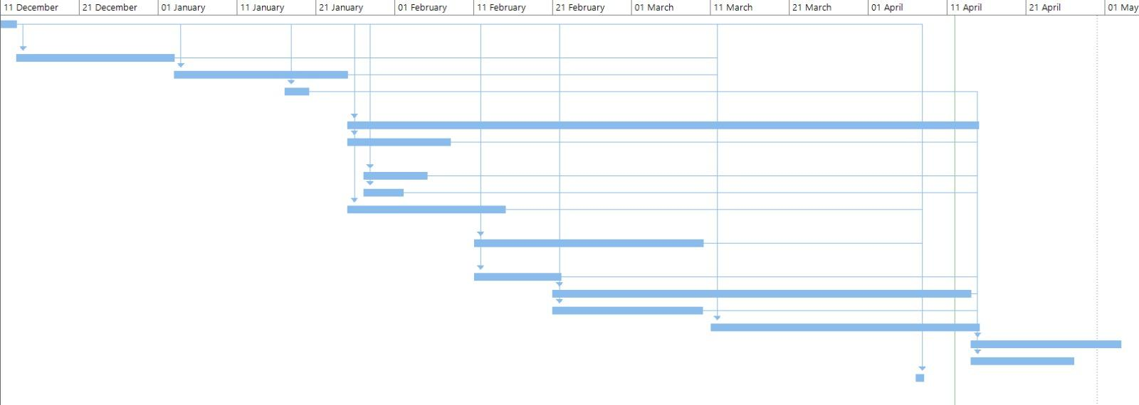

Fig 3,4. Gantt chart and project schedule

The Gantt chart depicts the project schedule that commenced on December 11, 2023, and is currently ongoing. The chart provides a visual representation of the project timeline, outlining the various tasks and their durations. Each task is represented by a horizontal bar, with its length indicating the duration of the task. The chart is divided into time intervals, with the x-axis representing the timeline from December 11, 2023, to the present day. The y-axis lists the different tasks or phases of the project. Each task is labeled accordingly for clarity. The Gantt chart serves as a tool for project management, allowing stakeholders to track progress, identify dependencies, and manage resources effectively. It provides a clear overview of the project's timeline, helping to ensure that tasks are completed on schedule and within budget.

**CHAPTER 5: IMPLEMENTATION OF THE PROPOSED SYSTEM**

**5.1. Methodology employed for development**

1. **Collaboration with neurologist:**

Engaged in extensive collaboration with the neurologist to gather insights and data on migraine management, leveraging their expertise for the development process.

1. **User authentication with Firebase:**

Implement user authentication using Firebase to ensure secure access to the application and user data.

1. **MIDAS Severity Assessment system:**

Discussed the MIDAS questionnaire-based system, sourced from the neurologist, to accurately assess the severity level of migraines.

1. **Personal Diary feature:**

Create a feature allowing users to record essential details of migraine episodes, including date, time, severity, triggers, symptoms, and additional notes, based on recommendations from the neurologist to facilitate comprehensive migraine tracking.

1. **User Feedback system:**

Integrate a feedback system enabling users to share experiences and suggestions, fostering continual app improvement and maintenance for enhanced user satisfaction, with input from the neurologist to prioritize features.

1. **Patient EHR space:**

Establish a secure space for users to review and access their recorded health data, with input from the neurologist to ensure it provides a comprehensive overview of their migraine history and management.

1. **Lifestyle Tips Module:**

Develop a module offering tailored lifestyle tips and guidance based on user data, incorporating recommendations from the neurologist to promote healthy habits and aid in migraine prevention and management strategies.

1. **Iterative approach:**

Employ an iterative development approach, incorporating feedback from the neurologist and users to refine and enhance the application continuously.

1. **User-centric design:**

Ensured the development process focused on creating a user-friendly interface and effective migraine management tools, with guidance from the neurologist to meet the needs of users dealing with migraines.

**5.2 Algorithms and flowcharts for the respective modules developed**

**MIDAS Output**

1. Begin

2. Define the MIDASOutputPage class as a StatelessWidget with a final int score parameter.

3. Create a constructor for the MIDASOutputPage class that takes the score parameter as input.

4. Define a method named getSeverityLevel(score) within the MIDASOutputPage class:

a. Take the score as input.

b. Check the score against predefined ranges to determine the severity level:

- If the score is between 0 and 5 (inclusive), return 'Little or No Disability'.

- If the score is between 6 and 10 (inclusive), return 'Mild Disability'.

- If the score is between 11 and 20 (inclusive), return 'Moderate Disability'.

- If the score is greater than 20, return 'Severe Disability'.

5. End

**MigraineLogsPageState Class**

1. Begin:

2.State Initialization:

a. Initialize various state variables to track different aspects of migraine logs, such as duration, pain severity, symptoms, etc.

b. Initialize a list of duration options.

3. Submit Migraine Log:

a. Define a method _submitMigraineLog() to handle the submission of migraine log data to Firestore.

b. Create a map containing the log data.

c. Attempt to add the data to the Firestore collection 'migraine_logs'.

d. Navigate to the log response page upon successful submission.

e. Handle any errors that occur during the submission process.

6. Build Method:

a. Override the build method to construct the UI for the Migraine Logs page.

b. Implement various UI elements such as text fields, dropdowns, checkboxes, radio buttons, sliders, etc., to collect information about migraine episodes.

c. Utilize setState() to manage the state of UI elements and trigger UI updates when necessary.

7. End:

**Personal diary :**

1. Begin

2. State Initialization:

1. Declare state variables to track diary entries.
2. Implement a method to submit diary entries to Firestore.

3. Build Method:

1. Construct UI elements to collect daily activity data.
2. Use setState() to update the UI based on user input.

4. Include an elevated button to submit diary entries.

5. Submission Confirmation Page:

1. Define a stateless widget SubmissionConfirmationPage to confirm submission.
2. Provide a button to navigate back to the home page.

6. Submission Confirmation Page:

1. Define a stateless widget SubmissionConfirmationPage to confirm submission.
2. Provide a button to navigate back to the home page.

7. End

**5.3 Datasets source and utilization**

The data for the questions included in various modules of the application namely, MIDAS Assessment, Migraine logs, Personal Diary, etc was provided and reviewed by the doctor.

**CHAPTER 6: TESTING OF THE PROPOSED SYSTEM**

**6.1. Introduction to testing**

Testing is an essential aspect of software development, encompassing various techniques and methodologies aimed at verifying that the software meets its requirements, functions correctly, and satisfies user expectations. Through systematic examination and validation of software components, testing helps detect and rectify defects, ensuring the quality and reliability of the final product. By conducting functional and non-functional tests, employing manual and automated approaches, and performing regression testing to safeguard against unintended consequences of changes, software teams can mitigate risks, enhance user satisfaction, and deliver robust, high-quality software solutions to meet the needs of stakeholders

**6.2. Types of tests Considered**

**Unit Testing :**

* In the unit testing process for NeuroCare, individual units or components are identified, including functions or methods responsible for authentication, calendar display, event creation, data storage, and integration with external services.
* Test cases are developed for each unit, covering various scenarios such as successful login with valid credentials, error handling for incorrect passwords, and ensuring proper navigation within the calendar module.
* Test data is prepared to simulate different scenarios and edge cases, such as login attempts under various network conditions and events with different attributes in the calendar.
* Tests are executed using Flutter's inbuilt command "flutter test", with results monitored to identify any failures or unexpected behavior, which are then debugged and resolved to ensure all test cases pass successfully.
* This comprehensive approach to unit testing helps validate the behavior of individual components and ensures the reliability and stability of the NeuroCare mobile application.

**Integration Testing:**

* Test cases: Develop test cases to verify the seamless integration of different features, such as ensuring that data entered in the personal diary reflects accurately in the migraine log and vice versa.
* API testing: If the app relies on external APIs for functionalities like weather data or health record sharing, ensure thorough testing of API integrations.

**Performance Testing:**

* Load testing: Simulate varying levels of user traffic to assess how the app performs under different load conditions, ensuring scalability and responsiveness.
* Network conditions: Test the app's performance under different network conditions, including 3G, 4G, and Wi-Fi, to identify any performance bottlenecks.

**6.3 Various test case scenarios considered**

**Test Case for Login page :**

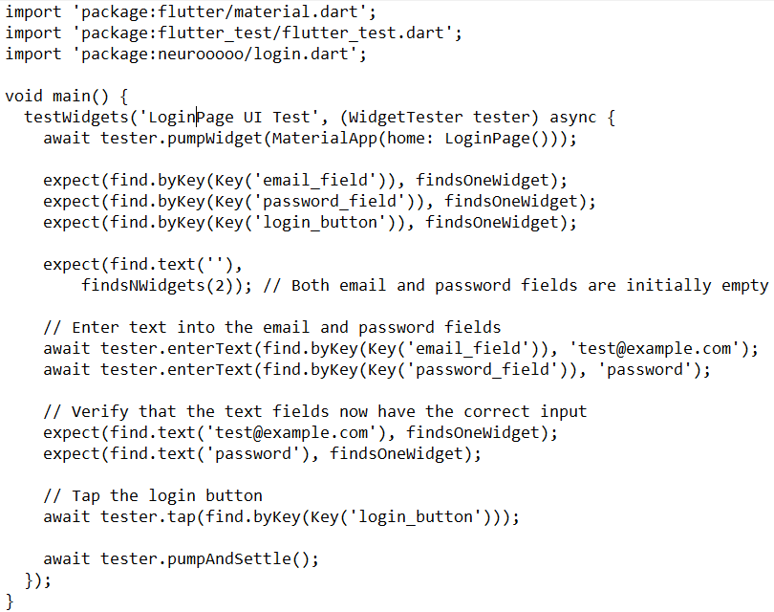

**Output :**

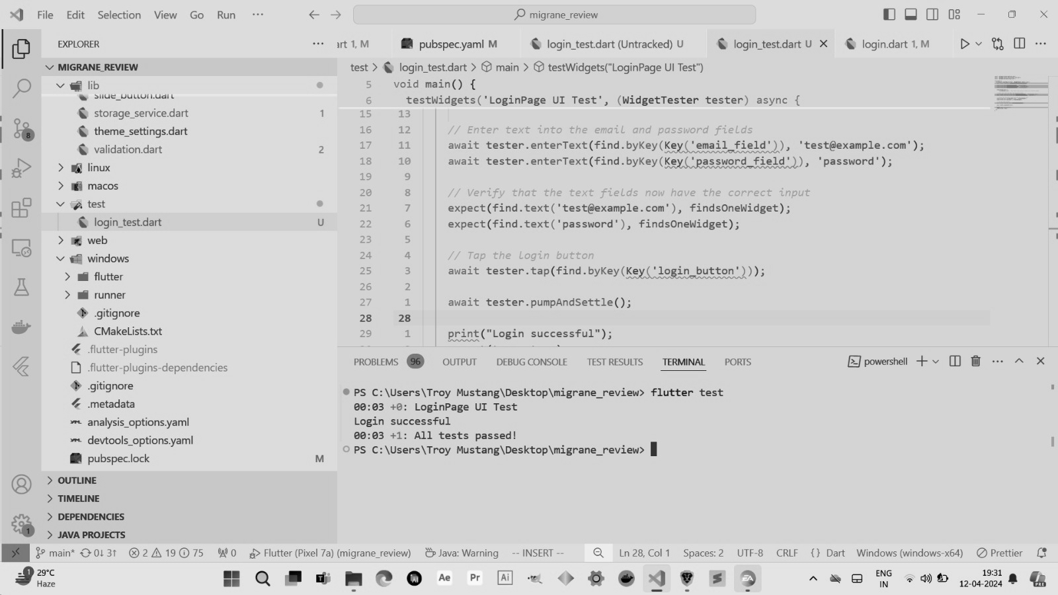

**Test Case for Calendar page :**

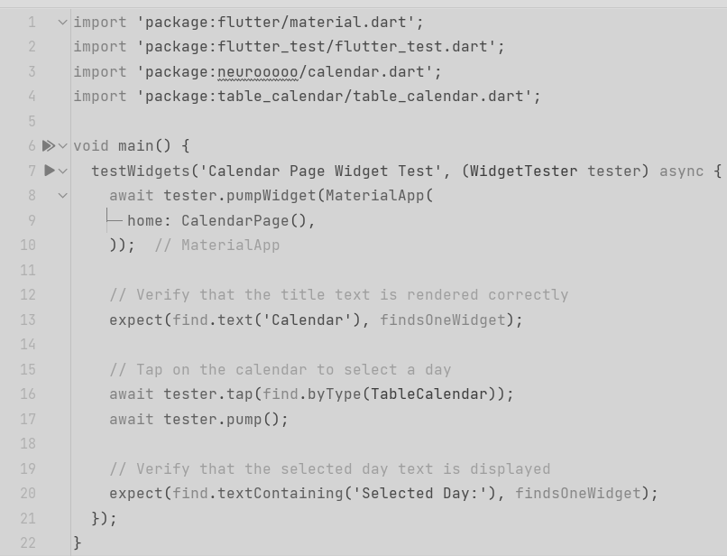

**Output :**

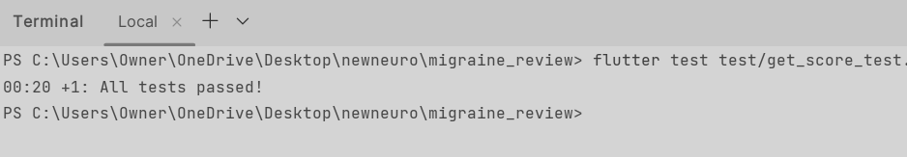

**6.4. Inference drawn from the test cases**

Inferences drawn from unit test cases provide insights into the reliability, functionality, error handling, and integration of individual components within the NeuroCare app. Successful tests confirm proper functionality and robustness, while failures indicate areas for improvement. Additionally, test cases indirectly reflect performance and efficiency, guiding developers in optimizing code and ensuring a stable app.

**CHAPTER 7: RESULTS AND DISCUSSION**

**7.1. Screenshots of User Interface (UI) for the respective module**

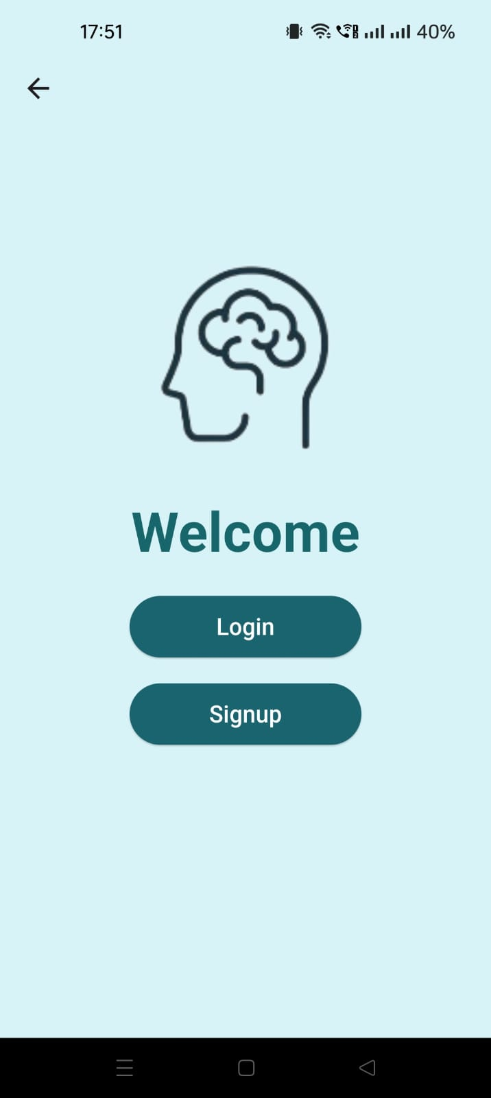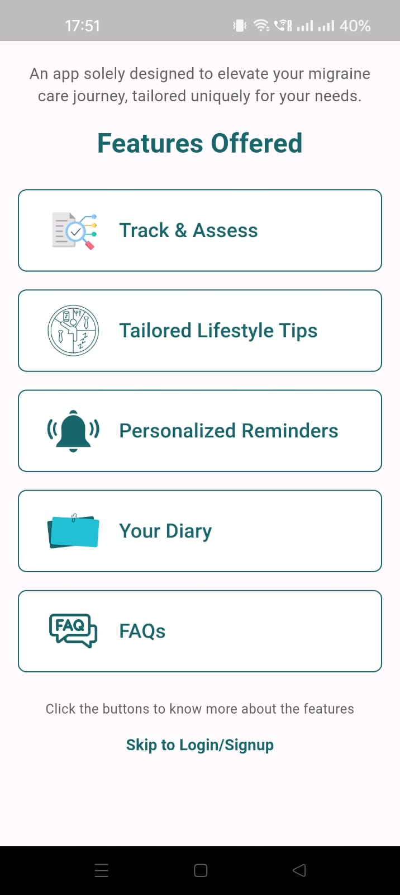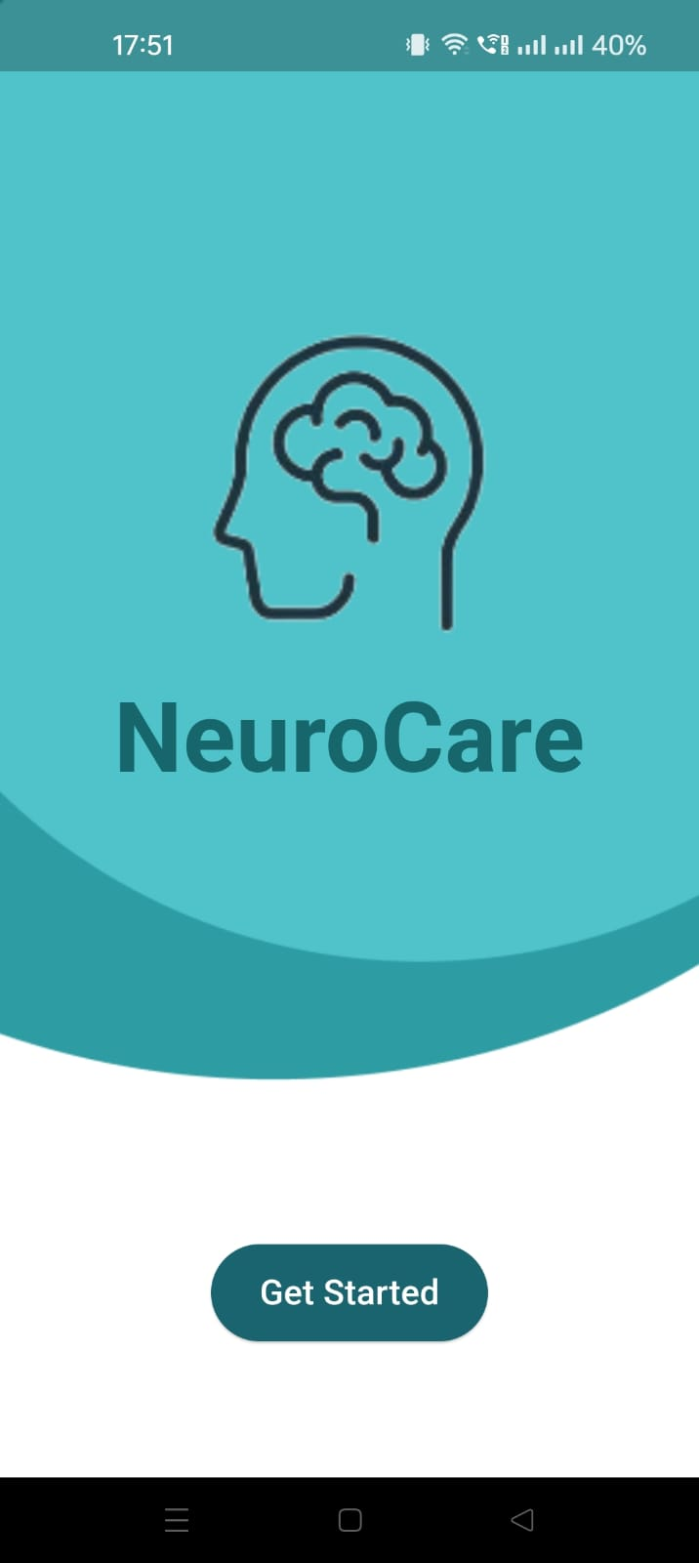

Fig 5. Onboarding pages

The onboarding pages of our application provide users with a concise overview of key features, a basic getting started guide, and a seamless signup process. Users are introduced to the app's capabilities, encouraged to explore its functionalities, and guided through account creation with intuitive signup logic. This streamlined onboarding experience ensures users can quickly familiarize themselves with the app and begin their journey.

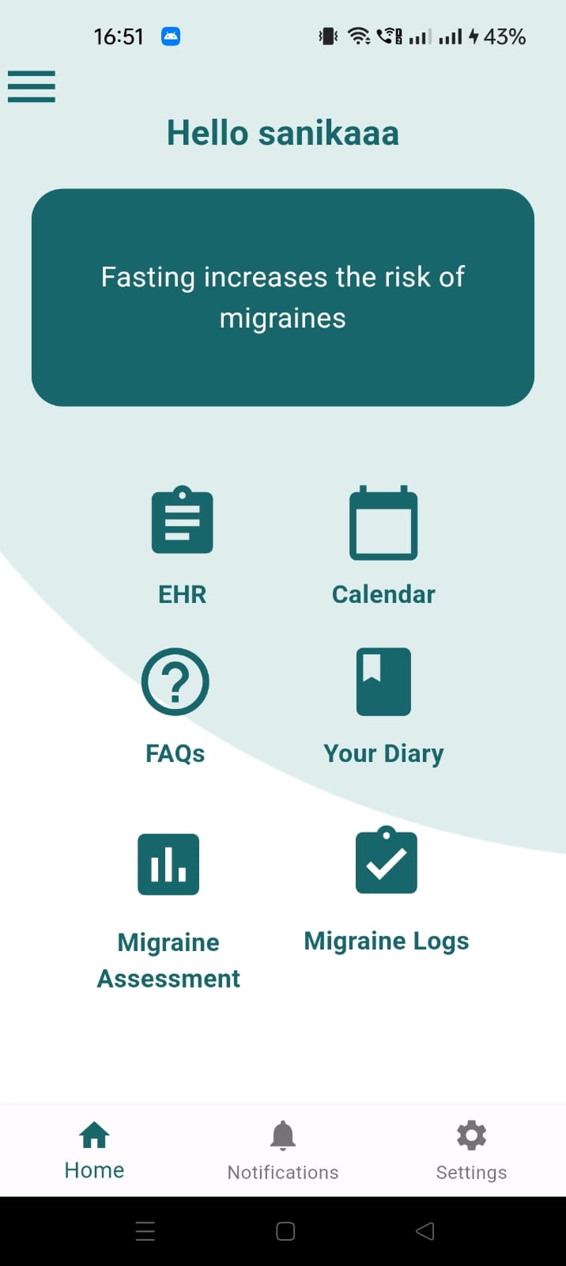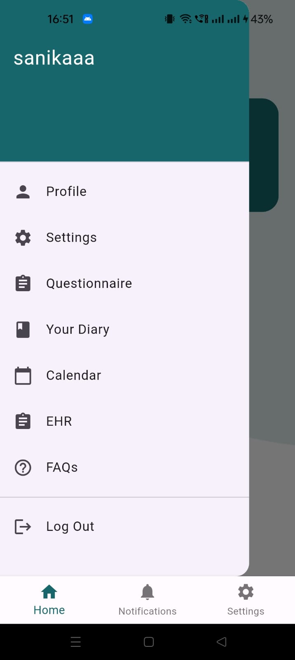

Fig 6. Home page

These images include the home page and sidebar menu which allows users to access the features of the application.

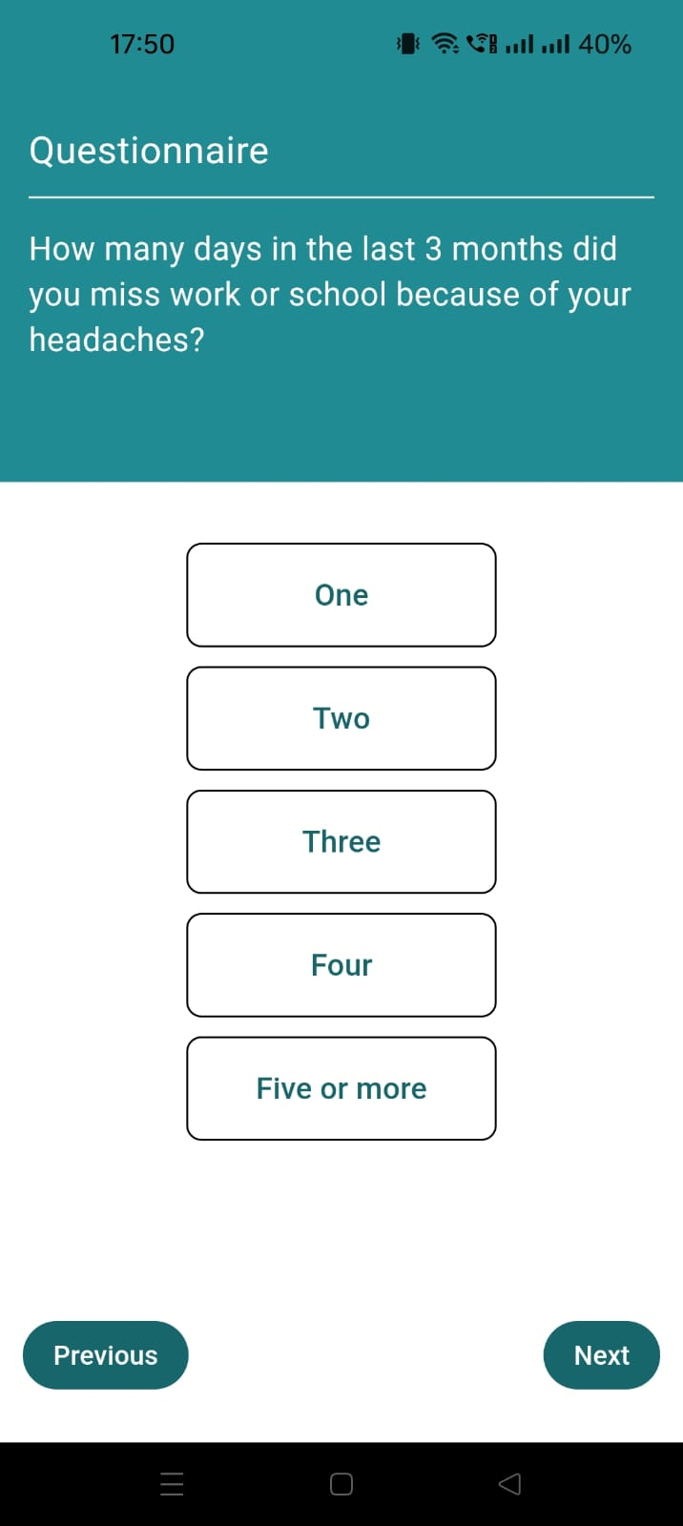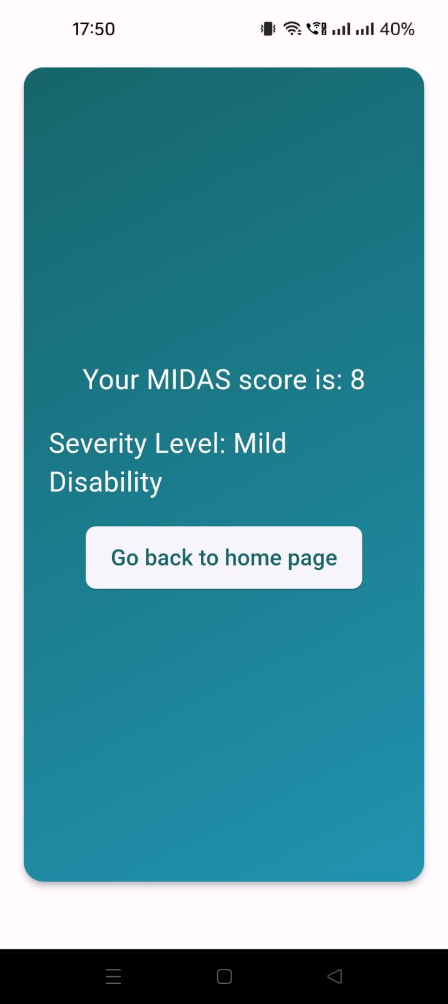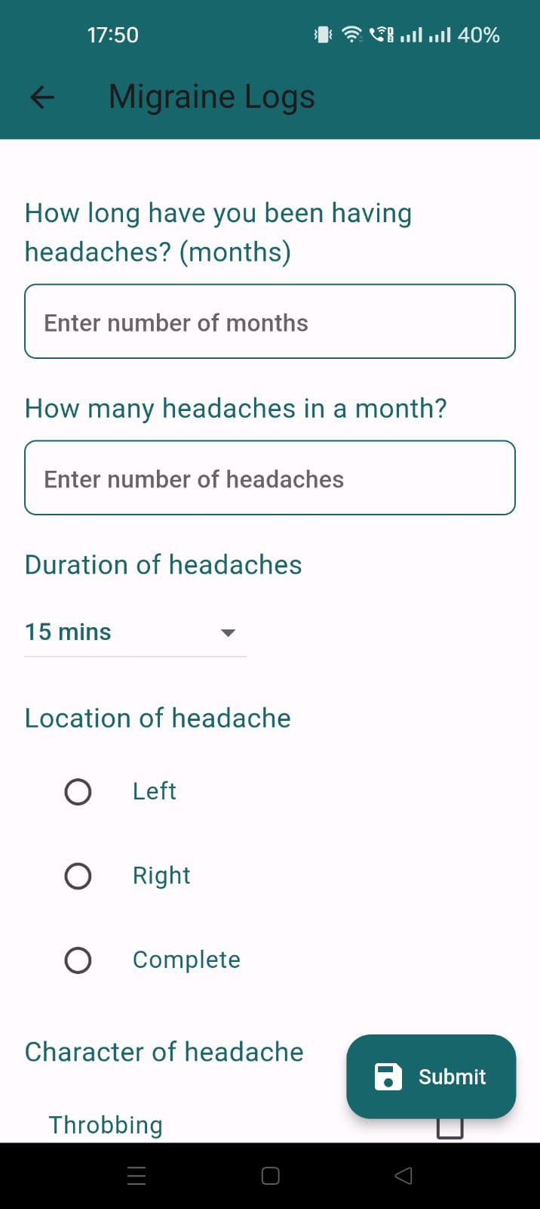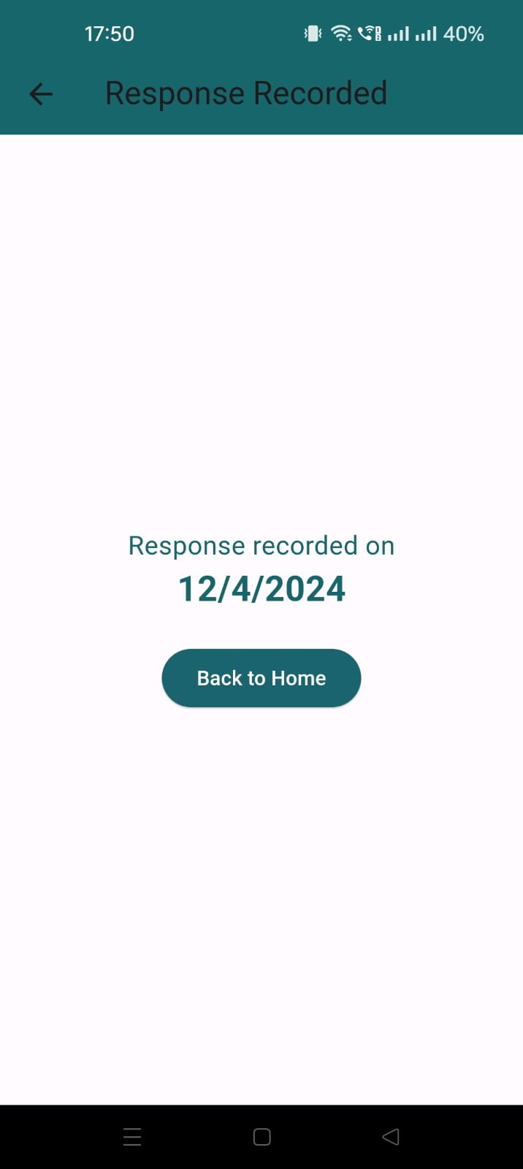

Fig 7. MIDAS Assessment and Migraine Logs

The UI pages for MIDAS Assessment and Migraine Logs are designed to efficiently collect and manage user data. Users can easily input relevant information regarding migraine severity and daily activities, enabling effective assessment and tracking of migraine symptoms. The Migraine Logs section provides a straightforward interface for users to log detailed records of migraine episodes, including triggers, symptoms, and duration. Overall, these UI pages prioritize functionality and usability to support users in managing their migraine condition effectively.

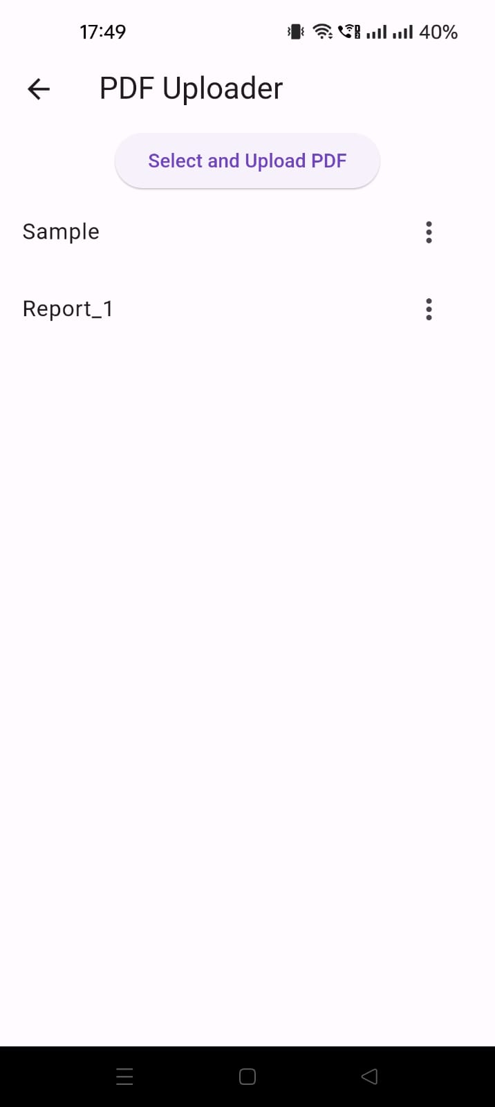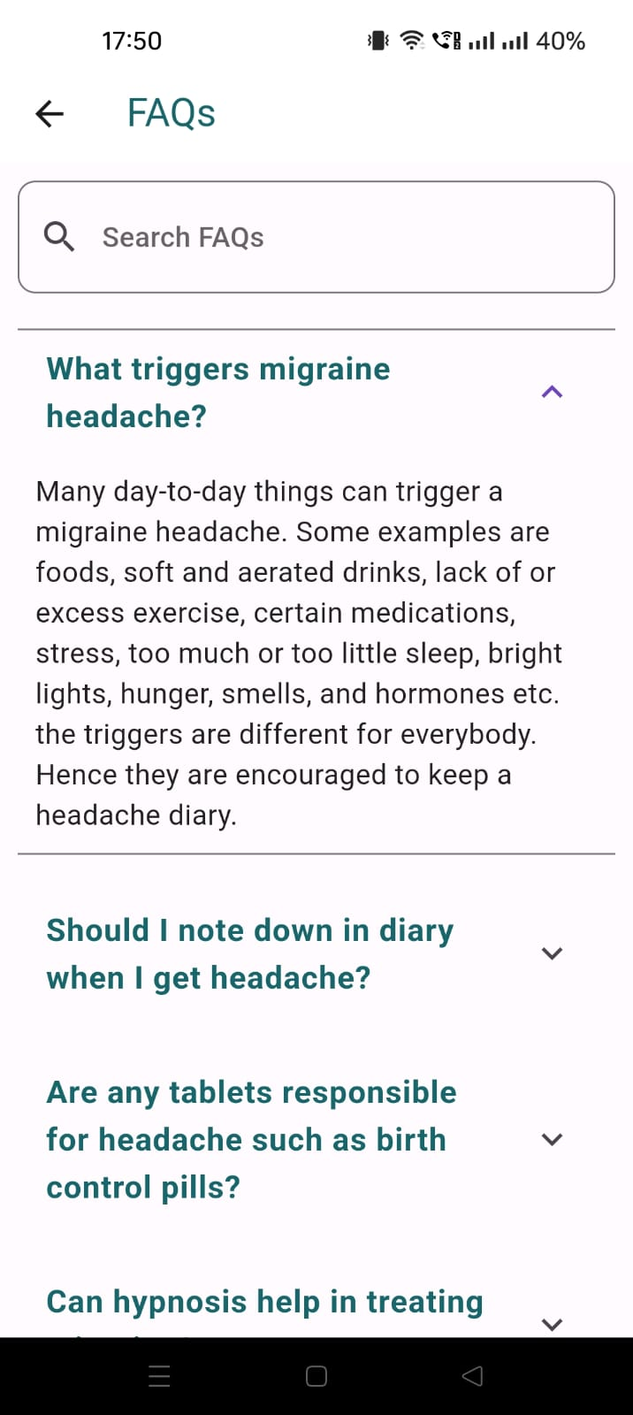

Fig 8. PDF Uploader & FAQs

The PDF uploader feature simplifies the process of securely uploading medical reports, ensuring convenient sharing of essential documents with healthcare providers. Meanwhile, the FAQ page offers users a comprehensive resource to search for and access answers to frequently asked questions, empowering them with valuable insights and information about various health-related topics.

**7.2. Performance Evaluation measures**

* User Engagement Metrics: Active users, session duration, and frequency of app usage.
* Completion Rates: Logging migraine episodes, lifestyle assessments, and feedback submissions.
* Accuracy of Trigger Identification: Precision and recall rates in identifying migraine triggers.
* Effectiveness of Personalized Insights: Impact on migraine management and well-being.
* App Performance: Loading time, responsiveness, and stability.
* Data Security and Privacy: Compliance with GDPR, HIPAA, and security audits.
* User Satisfaction: Ratings, reviews, and feedback surveys.

**7.3. Input Parameters / Features considered**

**Input Parameters**:

* Severity Assessment Scores: Allow users to input their severity assessment scores obtained from the MIDAS questionnaire.
* Migraine Episode Details: Enable users to input detailed information about their migraine episodes, including duration, pain severity, symptoms, triggers, and any additional notes.
* Daily Activity Data: Provide fields for users to record their daily activities, such as sleep patterns, diet, exercise, stress levels, and medication intake, in the personal diary section.
* User Feedback: Incorporate a feedback system where users can provide suggestions, report issues, and share their experiences with the app.
* User Preferences: Allow users to set preferences for receiving lifestyle tips, notifications, and reminders tailored to their needs and preferences.

**Features**:

* Severity Assessment Tool: Implement a questionnaire-based system to assess the severity level of migraines based on user inputs.
* Migraine Diary: Offer a feature-rich migraine diary allowing users to record and track detailed information about their migraine episodes over time.
* User Authentication: Ensure secure user authentication with Firebase to safeguard user data and provide personalized experiences.
* Feedback System: Integrate a user feedback mechanism to gather insights, suggestions, and feedback for continuous app improvement.
* Lifestyle Tips Module: Develop a module offering personalized lifestyle tips, recommendations, and preventive measures based on user data and preferences.
* Electronic Health Records (EHR): Provide users with access to their recorded health data, including migraine history and management information, stored securely in the app.
* FAQ Section: Include a comprehensive FAQ section where users can search for answers to common questions and gain insights into managing migraines effectively.
* Seamless Navigation: Ensure intuitive navigation and user-friendly interface design to enhance user experience and usability.

**7.4. Inference drawn**

The user engagement metrics and completion rates demonstrate the NeuroCare app's effectiveness in facilitating active user participation and completion of essential tasks like logging migraine episodes. By prioritizing accuracy in trigger identification and personalized insights, the app ensures tailored recommendations for improved migraine management. With a focus on app performance, data security, and user satisfaction, NeuroCare provides a seamless and secure experience. Key features such as severity assessment tools, migraine diaries, and user feedback mechanisms enhance usability and empower users to take proactive steps towards better migraine management.

**CHAPTER 8: CONCLUSION**

**8.1 Limitations**

One potential limitation of the Neurocare app is its tailored development to specifically cater to the needs of the affiliated neurologist, potentially resulting in limited features compared to standalone migraine management applications. As the app is primarily designed to function as a virtual assistant for the neurologist, its scope may be constrained to meet her preferences and workflow, which could restrict its appeal to a broader audience seeking more comprehensive migraine management tools. While this focused approach ensures alignment with the neurologist's requirements, it may pose challenges in terms of scalability and versatility for users outside of her practice. To mitigate this limitation, ongoing feedback collection from both the neurologist and app users could inform iterative improvements and the potential addition of features to enhance usability and broaden the app's utility beyond its original scope.

**8.2 Conclusion**

In conclusion, NeuroCare emerges as a promising solution in the realm of migraine care and lifestyle management. Through its user-friendly interface and personalized features, it empowers users to track migraine episodes effectively while offering tailored strategies to enhance overall well-being. Our proposed mobile application for migraine management addresses the critical need for personalized care by leveraging daily habit tracking to offer tailored insights and strategies. With comprehensive tracking, analysis, and empowerment features, our app promises to revolutionize migraine care, empowering users to take control of their health and well-being. By bridging the gap between migraine management and lifestyle improvement, NeuroCare provides users with the tools they need to navigate their migraine journey effectively. Moving forward, continual refinement and adaptation based on user feedback will be key to ensuring NeuroCare remains a valuable companion in the journey towards healthier living with migraines.

**8.3 Future Scope**

The future scope of NeuroCare includes potential enhancements and expansions to further elevate its effectiveness and reach. This could involve incorporating advanced machine learning algorithms to improve the accuracy of trigger identification and provide more personalized insights. Additionally, integration with wearable devices could offer real-time data tracking and analysis, enabling proactive migraine management. Expanding the app's features to include social support networks and telemedicine options may foster a more holistic approach to migraine care. Furthermore, collaborations with research institutions could lead to the development of innovative treatment modalities and contribute to ongoing advancements in migraine management. Overall, NeuroCare holds significant potential for continuous evolution and innovation to better serve the needs of individuals living with migraines.

**REFERENCES**

* “Migraines Headaches vs. Tension Headaches | Greater Austin Pain Center,” www.greateraustinpain.com. <https://www.greateraustinpain.com/blog/migraine-vs-headache>
* Silberstein, S. D. (2008). Outcomes, efficacy, and complications of headache management. In Elsevier eBooks (pp. 1261–1279). <https://doi.org/10.1016/b978-032304184-3.50075-3>
* Lipton, R. B., & Bigal, M. E. (2010). The social impact and burden of headache. In Handbook of Clinical Neurology (pp. 23–32). <https://doi.org/10.1016/s0072-9752(10)97002-4>
* Ormseth, B., ElHawary, H., Huayllani, M. T., Weber, K., Blake, P. G., & Janis, J. E. (2023). Comparing Migraine Headache Index vs. Monthly Migraine Days Following Nerve Deactivation for Headache: A Systematic Review and Meta-Analysis. Plastic and Reconstructive Surgery (1963), Publish Ahead of Print. <https://doi.org/10.1097/prs.0000000000010800>
* Minen, M., Stieglitz, E. J., Sciortino, R., & Torous, J. (2018). Privacy issues in Smartphone applications: An analysis of Headache/Migraine Applications. *Headache: The Journal of Head and Face Pain*, *58*(7), 1014–1027. <https://doi.org/10.1111/head.13341>

**ANNEXURE**

**Review marks**

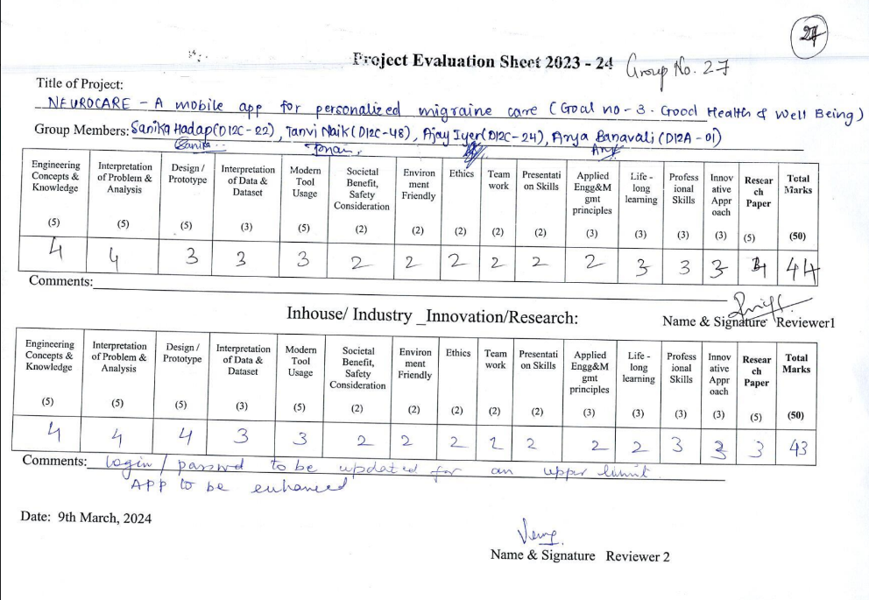

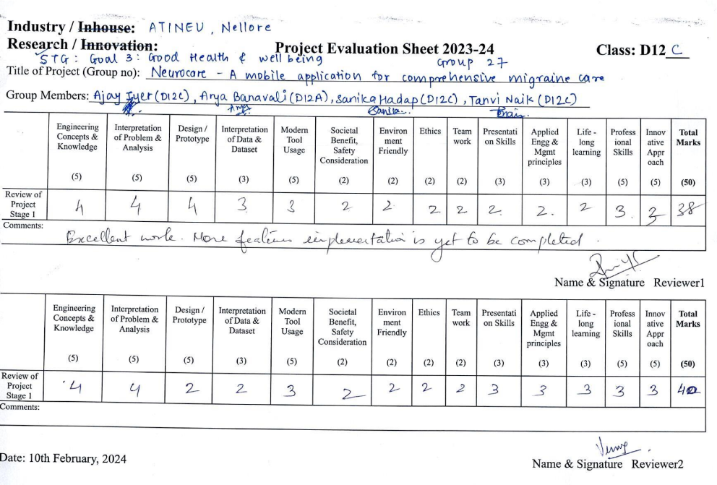

**PRADARSHINI Certificates**







