# **Patient Record System Using Blockchain**

Mrs. Lifna CS

Assistant Professor

Department of Computer Engineering

Vivekanand Education Society’s Institute of Technology, Mumbai , India

[lifna.cs@ves.ac.in](mailto:lifna.cs@ves.ac.in)

Harsh Tuli   
Department of Computer Engineering  
Vivekanand Education Society’s Institute of TechnologyMumbai , India   
[2021.harsh.tulii@ves.ac.in](mailto:2021.harsh.tulii@ves.ac.in)

Jeet Dalal

Department of Computer Engineering

Vivekanand Education Society’s Institute of Technology

Mumbai , India

[2021.jeet.dalal@ves.ac.in](mailto:2021.jeet.dalal@ves.ac.in)

Mayuresh Sawant

Department of Computer Engineering

Vivekanand Education Society’s Institute of

Technology

Mumbai, India

[2021.mayuresh.sawant@ves.ac.in](mailto:2021.mayuresh.sawant@ves.ac.in)

Swaraj Khadge

Department of Computer Engineering  
Vivekanand Education Society’s Institute of Technology, Mumbai , India   
[2021.swaraj.khadge@ves.ac.in](mailto:2021.lintomon.chirrakara@ves.ac.in)

***Abstract*-** Data-sharing in healthcare is critical for a complete patient care experience. A patient goes to multiple hospitals/ clinicians in their healthcare journey but their medical data is not being recorded in a confidential and integral way by any authority. Doctors at some different clinics might need to refer to a patient's medical history to make good decisions for treatment. We aim to build a blockchain solution using hyperledger fabric that can offer a way to share the patient's medical data with various healthcare-related organizations while maintaining data integrity, confidentiality and patient privacy. Hyperledger blockchain technology addresses the challenges of data security, privacy, and interoperability in the healthcare sector. Hyperledger Fabric, with its permissioned blockchain network and robust privacy controls, offers a promising solution for securely managing and sharing sensitive health information while ensuring compliance with regulatory requirements. The proposed EHR system leverages Hyperledger Fabric's features such as fine-grained access control, immutable ledger, and smart contracts to enable patient-centric data management, transparent auditability, and seamless interoperability between healthcare providers. By employing Hyperledger blockchain technology, this study aims to enhance trust, transparency, and efficiency in healthcare data management, ultimately improving patient outcomes and healthcare delivery.

# **I. INTRODUCTION**

The project focuses on harnessing the power of blockchain technology to revolutionize Electronic Health Records (EHR) management. In today's rapidly evolving healthcare landscape, Electronic Health Records play a pivotal role in facilitating efficient patient care, clinical decision-making, and healthcare operations. However, traditional EHR systems often encounter significant challenges that hinder their effectiveness and potential. Issues such as data fragmentation across disparate systems, security vulnerabilities leading to data breaches, and lack of interoperability between healthcare providers and systems have emerged as pressing concerns. These challenges not only impede the seamless exchange of critical patient information but also compromise the integrity, privacy, and security of sensitive health data. Furthermore, the siloed nature of existing EHR systems inhibits comprehensive patient care coordination and prevents healthcare providers from accessing a holistic view of a patient's medical history and treatment journey.

# **II. LITERATURE REVIEW**

Research papers [1] and [2] explore the practical deployment of blockchain-based electronic health record (EHR) systems, emphasizing the criticality of safeguarding data security, integrity, and patient confidentiality. They illustrate how blockchain technology ensures the secure storage of medical records, implements precise access controls, and enhances data integrity, aligning with patient-centric care principles and regulatory requirements.

One specific study [3] investigates the operational challenges encountered by existing EHR systems and proposes strategies for seamlessly integrating blockchain technology. It emphasizes the transformative potential of blockchain in EHR management, offering avenues for bolstering security, fostering interoperability, and engaging patients more actively.

Additional scholarly works [4] and [5] analyze the performance aspects of blockchain-driven EHR implementations, presenting encouraging findings such as increased availability rates and reduced susceptibility to cyber threats. They highlight how blockchain stands poised to revolutionize healthcare data management, ultimately leading to improved patient care and healthcare service delivery.

Lastly, an academic article [6] scrutinizes the utilization of HyperLedger Fabric, a blockchain framework, in healthcare contexts. It focuses on Fabric's confidentiality mechanisms, which empower patients to exercise greater control over their EHRs and efficiently manage access permissions.

.

# **III. EXISTING SYSTEM**

The current system relies on centralized databases and conventional security measures, which often leave data vulnerable and hinder interoperability. Patients' control over their data and consent processes is limited, affecting transparency and confidentiality. Conversely, blockchain implementation in electronic health records (EHRs) employs decentralized ledger technology to ensure robust data security, seamless interoperability, and enhanced patient empowerment. Smart contracts facilitate secure data exchange and consent management, fostering transparency and giving patients greater authority over their health information. In summary, blockchain-based EHR implementation offers significant advancements in data security, interoperability, and patient empowerment compared to traditional systems.

The challenges encountered by traditional patient record systems include reliance on manual procedures, centralized storage practices, limited accessibility, and susceptibility to security risks. These obstacles highlight the significance of adopting more sophisticated solutions like electronic health record (EHR) systems. EHR systems present advantages such as enhanced efficiency, heightened security measures, improved interoperability, and features that promote patient engagement. These advancements seek to streamline the management of healthcare data and elevate the delivery of patient care, thereby overcoming the constraints associated with conventional methods of record-keeping.

# **IV. PROPOSED SYSTEM**

The proposed EHR system leveraging Hyperledger Fabric technology offers patients a secure and efficient platform for managing their electronic medical records. By granting access control to healthcare providers and enabling collaborative interaction between patients and doctors, the system aims to enhance healthcare management and decision-making. Through careful planning, development, and deployment, the system ensures data security, privacy, and integrity, providing a robust solution for electronic health record management.

Our system provides the following features:

*1. User Registration and Authentication:*

Patients can initiate registration and authenticate securely, ensuring that only authorized individuals access the system, thus upholding data security.

*2. EMR Management:*

Patients retain control over their EMR records, being able to create, view, and update them as necessary, ensuring that their medical information is accurate and up to date.

*3. Control:*

Patients have the autonomy to manage access permissions for their EMR records, determining which healthcare providers can view or edit their records, thus safeguarding data privacy.

*4. Doctor Interaction:*

Healthcare providers, upon patient authorization, can access and make appropriate modifications to patient EMR records, facilitating collaborative healthcare management.

*5.Patient EMR Maintenance:*

Patients are responsible for maintaining and updating their EMR records, ensuring the completeness and accuracy of the information stored in the system, thereby aiding informed decision-making by healthcare providers.

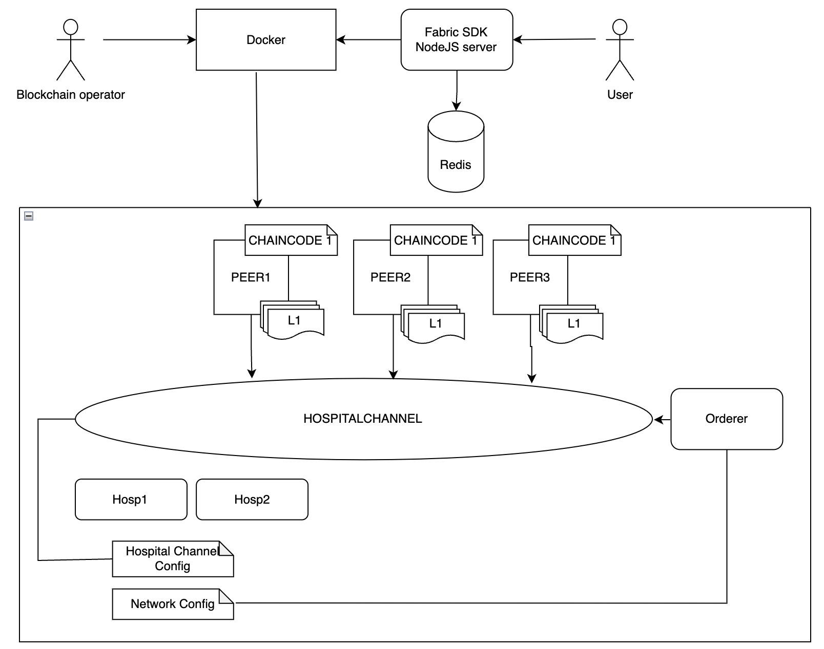

Fig 1:- The Basic Project Architecture Diagram

**V. ALGORITHM AND PROCESS DESIGN**

In our project, the Raft consensus algorithm serves as the backbone of the blockchain-based Patient Record System (PRS) by ensuring reliable data consistency across distributed nodes. Raft’s straightforward method of achieving consensus supports the accurate and consistent maintenance of medical records, which is critical for secure and efficient healthcare data management. Its swift and low-latency consensus approach enables real-time data sharing and access, which are vital for providing effective patient care. By integrating Raft, our PRS benefits from a robust foundation that enhances both system security and performance.

### I. RAFT Consensus Algorithm :

The Raft consensus algorithm [1] is a protocol designed to achieve agreement in a distributed system, particularly among a cluster of servers. Its main goal is to manage replicated logs and maintain data consistency across network nodes. Raft is recognized for its straightforwardness and its application in various distributed systems.

#### A. Components and Roles

Raft defines three primary roles for servers:

**Leader**: The leader server manages log entries and oversees coordination with other servers (followers) to ensure data consistency. It handles client requests and replicates log entries across followers.

**Follower**: Followers are passive participants in the network, receiving log entries from the leader and applying them. They maintain their status by acknowledging heartbeats from the leader.

**Candidate**: If the leader fails, a follower can become a candidate and initiate an election. The candidate seeks votes from other servers to be elected as the new leader.

#### 

#### B. Raft Mechanisms

**Leader Election**: When the leader experiences a failure, followers may timeout and transition to candidates to initiate a new election. The candidate that secures the majority of votes becomes the new leader.

**Log Replication**: The leader oversees the replication of log entries to followers. Upon receiving a client request, the leader appends the request to its log and replicates it to the followers. Once a majority of followers acknowledge the replication, the leader can commit the log entry.

**Safety and Consistency**: Raft ensures consistency and prevents conflicting states across servers by committing logs in a sequential and linear order. The algorithm guarantees the presence of only one leader at any given time.

*C. Implementation and Use in Blockchain :*

Raft's structural design and protocols make it a viable choice for blockchain applications. Its efficient leader election process and commitment methods facilitate rapid consensus achievement and minimized latency in blockchain networks.

# **VI. COMPARATIVE ANALYSIS WITH EXISTING SYSTEM**

| Aspect | Traditional Systems Tend to... | Blockchain Systems Typically... |
| --- | --- | --- |
| Data Security | Rely on physical safeguards, leaving vulnerability to breaches. | Employ encryption and decentralization for heightened data integrity. |
| Interoperability | Experience limited interoperability among providers, leading to fragmented records. | Enhance interoperability through decentralized structures and standardized formats. |
| Accessibility | Restrict access, often requiring formal requests or procedures for retrieval. | Empower patients with greater control and remote access to their records. |
| Transparency and Auditability | Encounter challenges in tracking changes and lack transparency. | Offer transparent and immutable record-keeping for thorough auditing. |
| Scalability and Performance | Face scalability issues with costly scaling efforts. | Encounter scalability challenges, necessitating optimization measures. |

**VII. USER INTERFACE :**

*A. Registration Screen :*

This registration page allows admin to add new users to the Network, we need to enter username, Email ID and password for registration process.

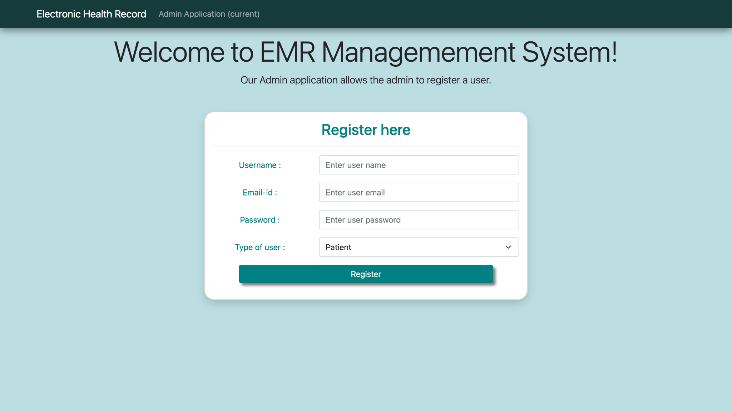

*B. Patient Dashboard:*

The figure showcases a patient dashboard, offering easy access to Electronic Medical Records (EMRs). Users can view all their EMRs, grant access to healthcare providers, and manage permissions for doctors, fostering seamless collaboration and 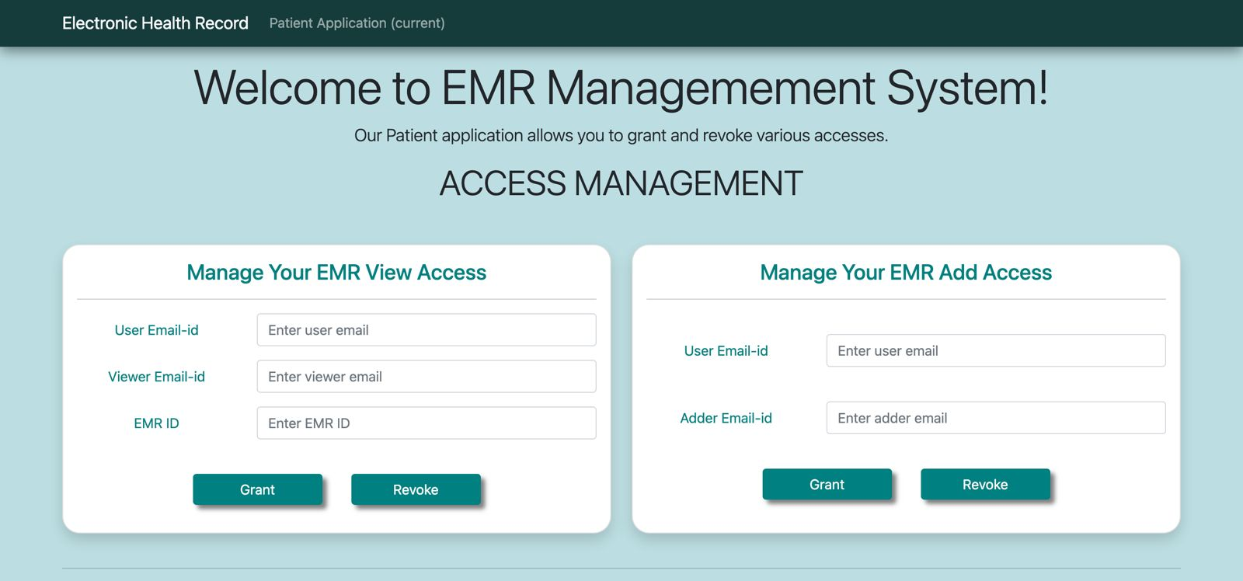patient control over their medical data.

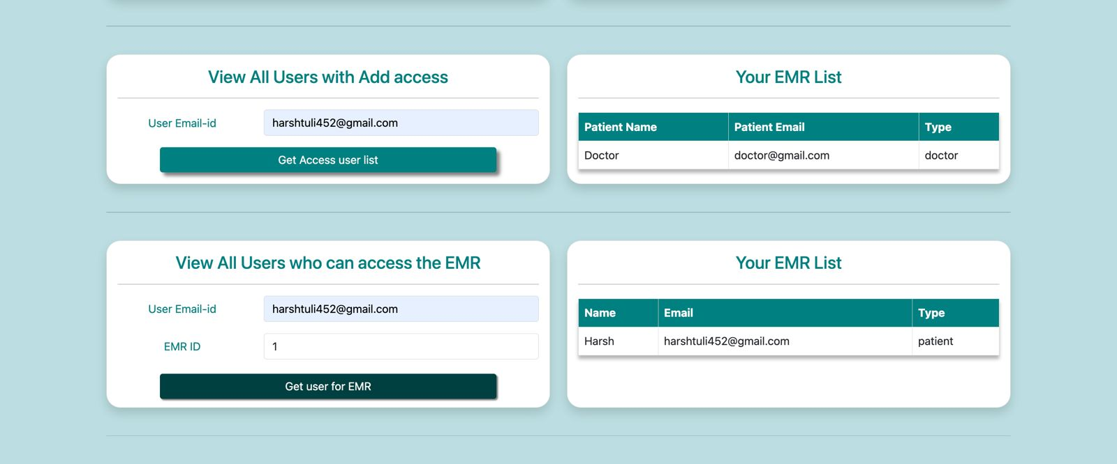

C. *Doctor Dashboard:*

The image depicts a doctor dashboard designed for accessing Electronic Medical Records (EMRs) efficiently. Through this interface, doctors can quickly review existing EMRs and update them as needed, facilitating streamlined patient care and informed decision-making.

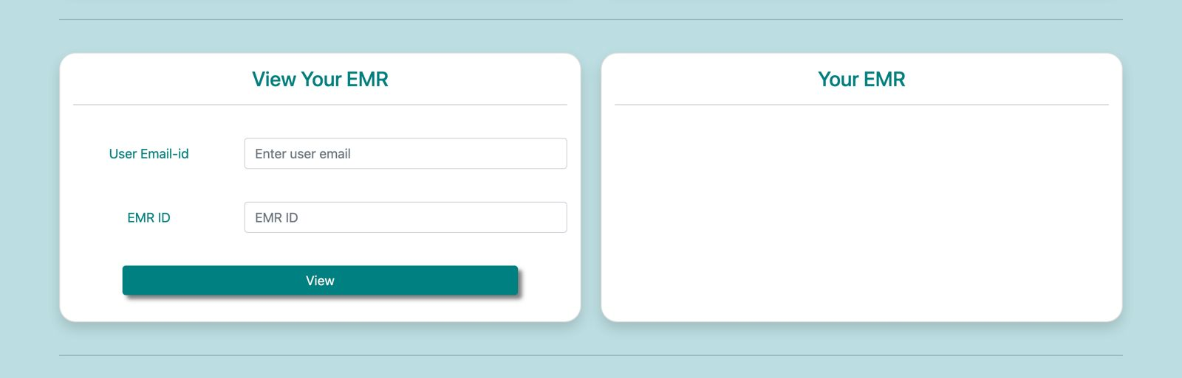

*D. Patient viewing his EMRs :*

This page allows the patient to view his EMRs, by user EmailID and EMR ID, also all the EMRs of a user can be viewed in the EMR List using User Email-ID.

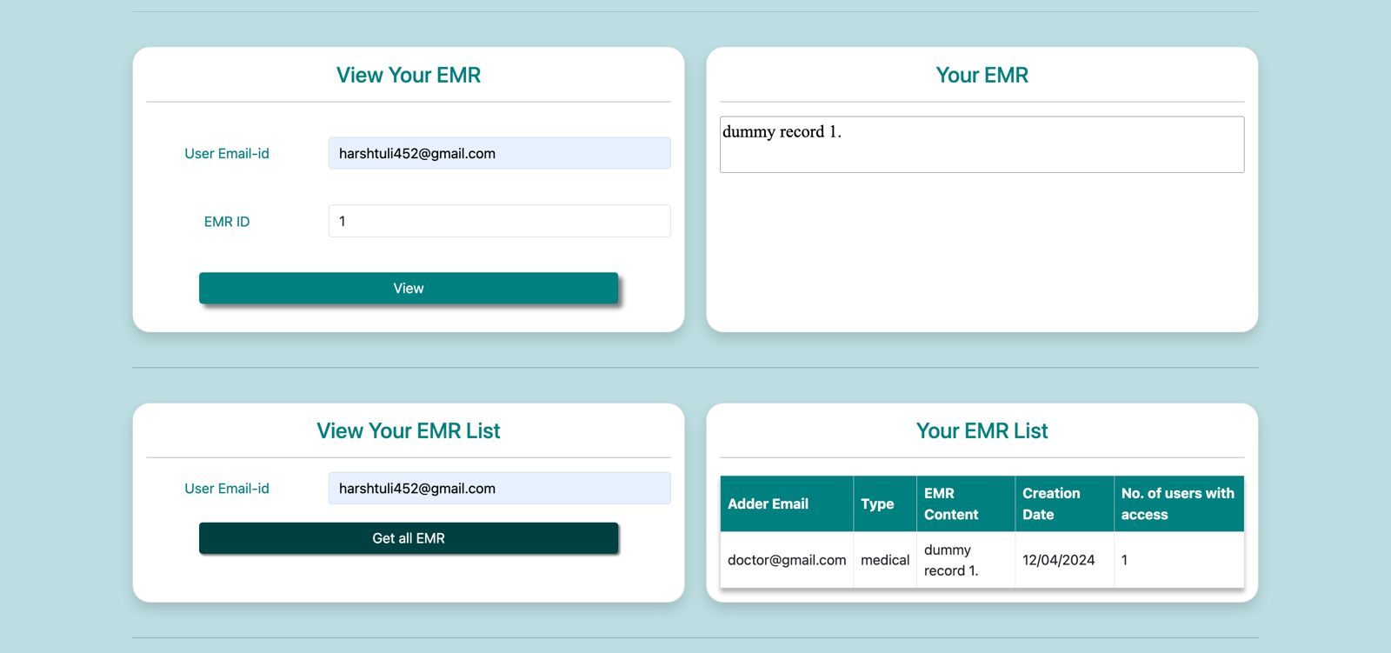

**VIII. CONCLUSION**

In the future, we envision a progression in blockchain-driven Electronic Health Record (EHR) applications, where they evolve into sophisticated platforms integrating advanced artificial intelligence and machine learning algorithms. This advancement aims to provide predictive analytics, personalized health insights, and proactive health management recommendations. Our objective extends beyond secure data storage to include seamless interoperability, facilitating efficient data exchange between healthcare providers and enhancing patient outcomes. Additionally, user experience takes precedence, with emphasis on intuitive interfaces and customizable features empowering individuals to manage their health information actively. Ultimately, we envision these advanced EHR applications as essential tools in healthcare, advocating preventive care and fostering improved well-being globally.

**IX. REFERENCES**

[1] Sudeep Tanwar , Karan Parekha , Richard Evans, Blockchain-based electronic healthcare record system for healthcare 4.0 applications,Journal of Information Security and Applications <https://www.sciencedirect.com/science/article/pii/S2214212619306155>

[2] Ibrar Yaqoob , Khaled Salah,Raja Jayaraman , Yousof Al - Hammadi, Blockchain for healthcare data management: opportunities, challenges, and future recommendations,Neural Computing and Applications <https://link.springer.com/article/10.1007/s00521-020-05519-w>

[3] Ayesha Shahnaz, Usman Qamar, Ayesha Khalid - Using Blockchain for Electronic Health Records, IEEE Access Volume <https://ieeexplore.ieee.org/abstract/document/8863359>

[4] Iris Cathrina Abacan Pilares, Sami Azam, Serkan Akbulut, Mirjam Jonkman and Bharanidharan Shanmugam - Addressing the Challenges of Electronic Health Records Using Blockchain and IPFS : <https://www.mdpi.com/1424-8220/22/11/4032>

[5] Iris Cathrina Abacan Pilares, Sami Azam,, Serkan Akbulut, Mirjam Jonkman and Bharanidharan Shanmugam - Applications of blockchain in ensuring the security and privacy of electronic health record systems: A survey

<https://www.sciencedirect.com/science/article/pii/S016740482030239X>

[6] Alex Roehrs , Cristiano André da Costa , Analyzing the performance of a blockchain-based personal health record implementation,Journal of Biomedical Informatics <https://www.sciencedirect.com/science/article/pii/S1532046419300589>

[7] Shuyun Shi , Debiao He , Li Li , Neeraj Kumar , Muhammad Khurram Khan , Kim-Kwang Raymond Choo - The case of HyperLedger Fabric as a blockchain solution for healthcare applications. <https://www.sciencedirect.com/science/article/pii/S1532046419300589>