**SafeGuard: Enhancing Safety Assessments for vulnerable children through EQ/SQ integration using AI**

**Sakshi Valecha, Mrs. Sharmila SenGupta, Tanya Lilani, Vaibhavi Shetty, Chirag Mangtani**

Sakshi Valecha,Vivekanand Education Society's Institute of Technology,Chembur

Mrs.Sharmila SenGupta,Vivekanand Education Society's Institute of Technology,Chembur

Tanya Lilani,Vivekanand Education Society's Institute of Technology,Chembur

Vaibhavi Shetty,Vivekanand Education Society's Institute of Technology,Chembur

Chirag Mangtani,Vivekanand Education Society's Institute of Technology,Chembur

Email: [2021.sakshi.valecha@ves.ac.in](mailto:2021.sakshi.valecha@ves.ac.in), [sharmila.sengupta@ves.ac.in](mailto:sharmila.sengupta@ves.ac.in), [2021.tanya.lilani@ves.ac.in](mailto:2021.tanya.lilani@ves.ac.in), [2021.vaibhavi.shetty@ves.ac.in](mailto:2021.vaibhavi.shetty@ves.ac.in), [d2021.chirag.mangtani@ves.ac.in](mailto:d2021.chirag.mangtani@ves.ac.in)

Contact: 7821811052, 9819030946, 7666788800, 8369905527, 9028908070

**Abstract:**. Child safety in India remains a significant concern, with prevailing solutions predominantly limited to reactive and location-based tracking via basic wearable technologies. These systems often lack the intelligence to assess behavioral anomalies or provide timely intervention. This research presents an integrated, AI-driven framework designed to offer a comprehensive, proactive approach to child protection. The proposed system combines IoT-enabled wearable devices with cloud-based real-time monitoring and machine learning algorithms and natural language processing that is capable of detecting behavioral deviations, empathy detection, social intelligence, sentiment analysis and physiological distress. It uniquely incorporates Social Quotient (SQ) and Emotional Quotient (EQ) assessments to evaluate a child's emotional and social well-being alongside judging physical safety. Furthermore, automated alert mechanisms ensure rapid communication with caregivers and authorities when risk thresholds are exceeded. By integrating real-time anomaly detection and psychological evaluation into a unified platform, this research advances the field of intelligent child safety systems, providing a scalable, context-aware, and ethically grounded solution for vulnerable populations.

***Index******terms:***Child safety, AI-driven behavioral assessment, IoT-enabled wearables, machine learning (ML), Natural Language Processing (NLP), anomaly detection, Social Quotient (SQ), Emotional Quotient (EQ)

1. **INTRODUCTION**

According to UNICEF India, over 30% of young adults face significant safety and security risks, especially across rural and urban areas. Aligned with the UN Sustainable Development Goals (SDGs), there is a critical need for stakeholders to create solutions that address these issues. Between 2011 and 2020, most child fatalities from hyperthermia in India involved children aged 4–6, accidentally locked inside unattended vehicles.

While Intelligence Quotient (IQ) has traditionally been emphasized, recent research highlights the importance of Adversity Quotient (AQ) in building resilience and coping abilities in children. Safety threats such as abduction, neglect, accidents, and unsafe environments are rising. Existing measures like CCTV surveillance and GPS tracking lack real-time emotional and behavioral analysis, leaving children — especially those with physical or mental challenges — vulnerable to abuse and isolation.

Current systems focus only on location but fail to assess Social Quotient (SQ) and Emotional Quotient (EQ), both critical in understanding a child’s decision-making, emotional health, and social responses. Moreover, bullying, peer pressure, emotional struggles, academic stress, digital threats like cyberbullying, and unsafe environments further impact children's psychological well-being.

Children with learning or physical disabilities face challenges like communication barriers, educational hurdles, physical inaccessibility, social stigma, emotional distress, and lack of specialized support. These factors emphasize the urgent need for early diagnosis, continuous monitoring, and holistic support systems.

In India, children with autism, ADHD, intellectual disabilities, and physical impairments are particularly vulnerable, requiring tailored AI-driven safety mechanisms that monitor both physical movements and emotional well-being in real-time.

## II. IMPLEMENTATION

The SafeGuard system integrates three key modules: Safety, SQ, and EQ, each utilizing AI-based techniques to provide real-time tracking, behavioral assessment, and emotional analysis for the stakeholders of the system which includes children with or without special needs parents, caregivers, teachers medical practitioners, psychologists and all those directly or indirectly involved in the system. The dataset required for SafeGuard is collected through verbal analysis, meetings taken with stakeholders and interviewing children of special schools.

**2.1 Safety Module: Real-Time Monitoring and Alerts**

Children are vulnerable not only in the open but also in closed environments. They may be left unattended inside play or study rooms, parked vehicles, elevators or may be lost or misguided due to negligence or some unavoidable reasons. Therefore there is a necessity to track their discomfort level inside closed environments and to even track their travel patterns to school, playgrounds etc. to detect any anomaly for providing support and guidance. This kind of support is usually required by or provided to certain stakeholders of this system which may include parents, grandparents, instructors, caregivers, nurses or to anybody assisting the child. The safety module ensures continuous supervision of children through a wearable device empowered with sensors that track real-time location, ambient environmental conditions, and movement patterns. The system utilizes:

1. GPS-based tracking: Monitors the child's live location and alerts caregivers in case of deviation from regular paths.
2. Environmental sensors: Detect changes in temperature, air quality, and oxygen levels.
3. AI-driven anomaly detection: Identifies unusual movement patterns and potential threats such as kidnapping or prolonged inactivity.

The SafeGuard system is an intelligent, wearable safety solution designed to ensure the real-time protection and health monitoring of children. It leverages a combination of embedded hardware components, IoT technology, and cloud computing to collect, analyze, and transmit critical data for continuous safety tracking as shown in Fig.1 which gives an overview of each component and its role in the system.

### Fig. 1: Prototype Design of IOT Enabled Device

### The central hub of the SafeGuard device is the Raspberry Pi which handles the critical task of data collection and processing. It coordinates the input from all the sensors connected to the system and runs the core logic required to assess environmental safety and location tracking.The BME680 sensor is responsible for monitoring environmental parameters such as temperature, humidity, barometric pressure, and air quality. These readings are essential in detecting whether the child is exposed to harsh weather conditions, poor ventilation, or hazardous environments. The sensor feeds this data to the Raspberry Pi, which then analyzes it to determine if any safety thresholds have been breached, ensuring that alerts can be sent in a timely manner. The MIX8410 sensor plays a critical role in assessing the oxygen concentration in the surrounding air. This is particularly important in scenarios where the child may be in a confined or polluted space. A drop in oxygen levels could be dangerous, especially for children with respiratory conditions or disabilities, and it helps preempt such risks by enabling the system to generate real-time warnings if unhealthy levels are detected. The GPS HAT module provides accurate, real-time tracking of the child's location by capturing latitude and longitude coordinates continuously. This feature allows the system to map the child's movements, detect deviations from pre-set safe zones or routes, and provide immediate location updates to guardians. The integration of GPS ensures not only outdoor but also route-specific monitoring, which is crucial in situations involving field trips, commutes, or high-risk locations. The Wi-Fi Module (802.11) enables wireless data transmission between the Raspberry Pi and the cloud server. It acts as the bridge that connects the hardware to the internet, allowing all processed sensor and location data to be sent securely and in real time. This ensures that the system remains constantly in sync with the online dashboard, enabling live updates and remote access for authorized users such as parents or caretakers. The Cloud Server functions as a centralized storage and processing platform. It receives data from the device, stores it securely, and makes it accessible through the web interface using an interactive dashboard. The cloud infrastructure also supports advanced analytics and long-term data logging, paving the way for pattern recognition, behavioral analysis, and AI-driven decision support in future iterations of the project. It displays real-time information including the child’s location, environmental readings, and alerts. Designed to be simple and intuitive, this dashboard allows parents and guardians to view current data, historical trends, and notifications with ease. It acts as the command center through which they can supervise the child’s safety remotely.

### The data collected is processed and stored on a cloud-based server, allowing parents and caregivers to access real-time insights via a secure web interface.Following are a few test cases where the system can be incorporated. For example, when the child is in school typically considered as safe zones, but risks like bullying, emotional distress, or unexpected medical emergencies may occur. SafeGuard aims to monitor a child's physical and emotional well-being during school hours through wearable devices and AI-based behavior analysis. The system can alert guardians in case of irregularities such as sudden movement patterns, elevated stress levels, or unusual interactions.

### There may be a requirement of this system while the child is travelling; for example whether commuting to school, visiting relatives, or going on a trip, travel introduces risks such as getting lost, accidents, or interaction with strangers. SafeGuard utilizes GPS tracking, movement sensors to provide real-time location updates and route history. In case of deviation from predefined safe zones, the system triggers immediate alerts to guardians and emergency contacts. Children often spend time under the supervision of caretakers or babysitters. SafeGuard ensures accountability by monitoring interactions, ambient sound, and video feeds (if consented), along with periodic status updates. AI algorithms can detect signs of neglect, stress, or inappropriate behavior, thus offering peace of mind to working parents. Even at home, accidents or emotional distress can occur. The system ensures that safety continues by monitoring indoor movement, identifying unusual patterns (e.g., prolonged inactivity or restricted movement), and recognizing emotions using speech or facial analysis. It also checks for environmental hazards like fire, gas leaks, or unsecured access points. Outdoor play is crucial for a child's development but poses risks like falls, stranger interaction, or getting lost. SafeGuard monitors vital signs, location, and behavior while also analyzing environmental conditions (heat, air quality, etc.). Parents receive real-time updates and alerts if any anomaly is detected during unsupervised or semi-supervised outdoor activities.Whether natural disasters, medical emergencies, or attempted abductions, quick response time is critical. SafeGuard incorporates emergency protocols such as automatic SOS triggers, and rapid alert systems that notify guardians and emergency services with the child’s location, status, and recent activity logs.

### 2.2 Social Quotient (SQ) Module: Interactive Learning and Behavioral Assessment

The evaluation of SQ is achieved by identifying a comprehensive list of behavioral and emotional parameters that directly reflect social development in children. These parameters were selected based on a blend of educational psychology standards and real-life classroom behavioral indicators, ensuring relevance to the developmental stage of students from early grades of education. The required data about the children is gathered through teacher observations and their day-to-day classroom and social interactions. which To provide a detailed and multi-dimensional view of a child's social behavior a set of twenty-one parameters are required which include communication, cooperation, responsibility, empathy, self-control, locomotion, socialisation, self-direction, self-help, dream role, conceptual skills, social skills, practical skills, sharing, complimenting others, aggression, withdrawal, emotional problems, conduct problems, hyperactivity and prosocial behaviour. In this system, the identified parameters have been seamlessly integrated into the features of the SQ module, enabling an interactive and data-driven assessment of a child’s social adaptability and cognitive development. This module goes beyond static evaluations and incorporates a series AI-powered interactive activities, each designed to reflect and measure specific behavioral traits aligned with our chosen parameters. For instance, the “Memory Match” activity sharpens memory retention, concentration, and cognitive recall subtly maps to parameters like self-control and conceptual skills. The “Create Your Story” activity fosters communication, creativity, and self-expression, providing insights into a child's socialisation, empathy, and self-direction. The “Think Sphere”, a comprehension-based gaming environment, challenges the child's critical thinking and decision-making capabilities, linking directly to practical and conceptual skill parameters. Further, the “Self-Help” Interactive Game introduces scenarios that require the child to demonstrate responsibility, problem-solving, and independence, mirroring real-life social expectations and helping assess parameters such as self-help, responsibility, and emotional regulation. Finally, the “Dream Role” module encourages children to explore various professions through simulated role-play, which contributes to identity building while measuring social imagination and aspiration, correlating with parameters like cooperation, and prosocial behavior. Each interaction within the module is logged and analyzed, allowing the system to derive meaningful patterns that contribute to an accurate estimation of the child’s SQ. These activities are analyzed using machine learning models, which assess the child's engagement levels, response accuracy, and cognitive improvements. The system then computes an SQ score, which helps parents and educators identify strengths and areas requiring intervention. The SQ is classified as low, average and high percentage if it falls below 100, equal to and greater than 100 respectively.

Formula used to calculate Social quotient : SQ = (1)

The Social Age as shown in eq.(1) is calculated by summing up all the parameters that assess an individual's social development. From the SQ score dataset in Fig. 2, the evaluations of each of the 21 parameters can be assessed and considering the social age of individual children, the final score can be calculated through the above formula.

### Fig: 2 : Dataset collected from the stakeholders to collect SQ

### 2.3 Emotional Quotient (EQ) Module: Psychological Well-Being Analysis

The EQ Module in this system is designed to assess and support a child's emotional intelligence through AI-driven methodologies that simulate real-world emotional interactions. The foundation of this module lies in evaluating how a child understands, processes, and responds to various emotional and social situations. To achieve this, we first implement a deep learning pipeline that processes video inputs based on predefined emotional scenarios. These videos, often involving role-plays or situational prompts, are broken down into individual frames, allowing the system to capture subtle facial cues and body language indicators. Simultaneously, the audio component of the child’s interaction is processed using speech-to-text conversion techniques. Once the speech is transcribed, we apply Natural Language Processing (NLP) algorithms, including sentiment analysis and tone detection, to interpret the emotional undertones present in the child’s spoken responses.

Through this multimodal analysis, the system identifies emotional markers such as stress, empathy, social responsiveness, and behavioral cues. For example, a child’s tone, choice of words, and reaction time in emotionally charged scenarios can indicate their level of emotional regulation and sensitivity toward others. By analyzing these aspects, the module generates an EQ score that reflects the child's ability to empathize, self-regulate, and adapt to social environments. These insights are not just diagnostic but also serve as a foundation for providing targeted support, enabling educators and caregivers to tailor emotional development interventions specific to each child’s needs. The integration of AI ensures that this assessment is dynamic, personalized, and capable of evolving with each interaction, offering a comprehensive view of a child’s emotional well-being.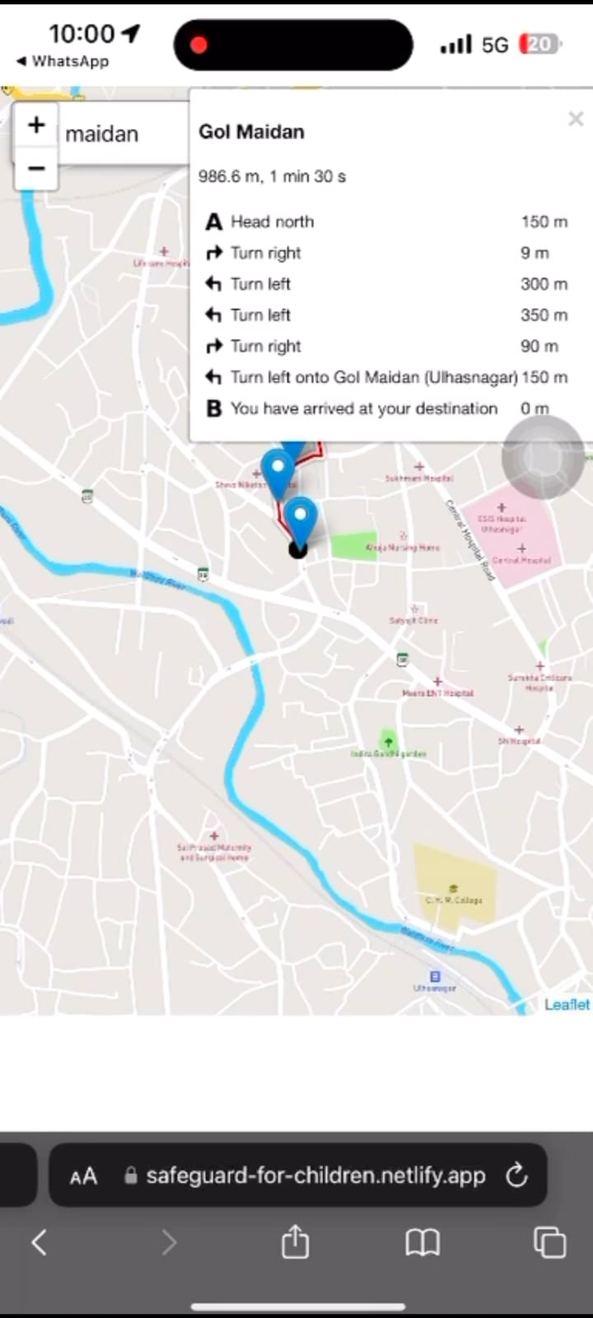

Formula used to calculate Emotional quotient = ( (2)

The Emotional Age (EA) in eq.2 is calculated by summing up all the parameters that assess an individual child’s emotional development.

**III. SIMULATIONS AND EXPERIMENTAL RESULTS**

The SafeGuard dashboard shown in fig. 3 offers intuitive options for live tracking from source to destination and navigation to various predefined safe locations. In cases where a different destination needs to be selected, users can simply choose the **‘**Other**’** option to input a new location for travel. Once the destination is set, the GPS system begins tracking the child's real-time location along a predefined path marked with optimal waypoints. These optimal markers represent safe intervals that a child can travel without supervision, ensuring continuous safety and effective monitoring throughout the journey. The route assigned for tracking is accompanied by directional prompts, functioning like a virtual signboard to guide the child while moving along the path, ensuring they follow the correct and safe route at every step. The figure also illustrates the live movement of the child, represented by a black dot, accurately following the designated route towards the destination, confirming that the child is on the correct and safe path.

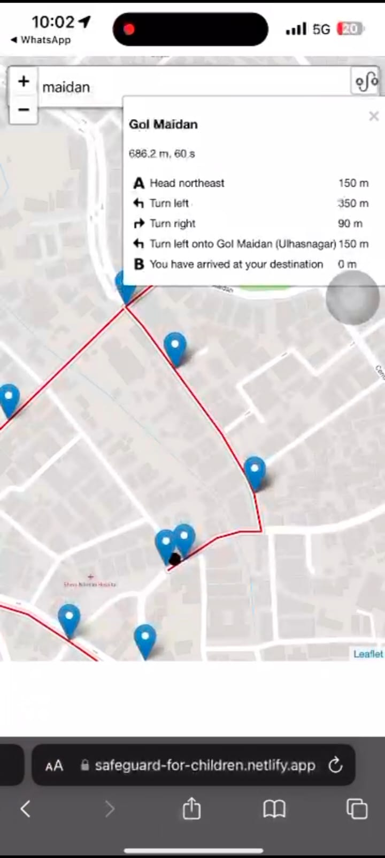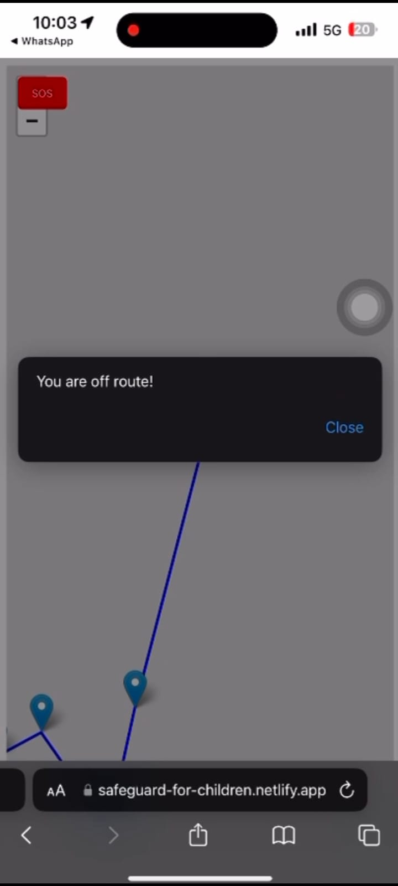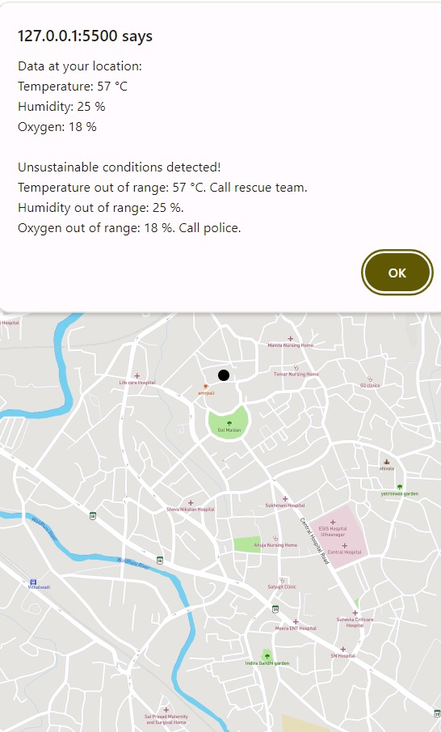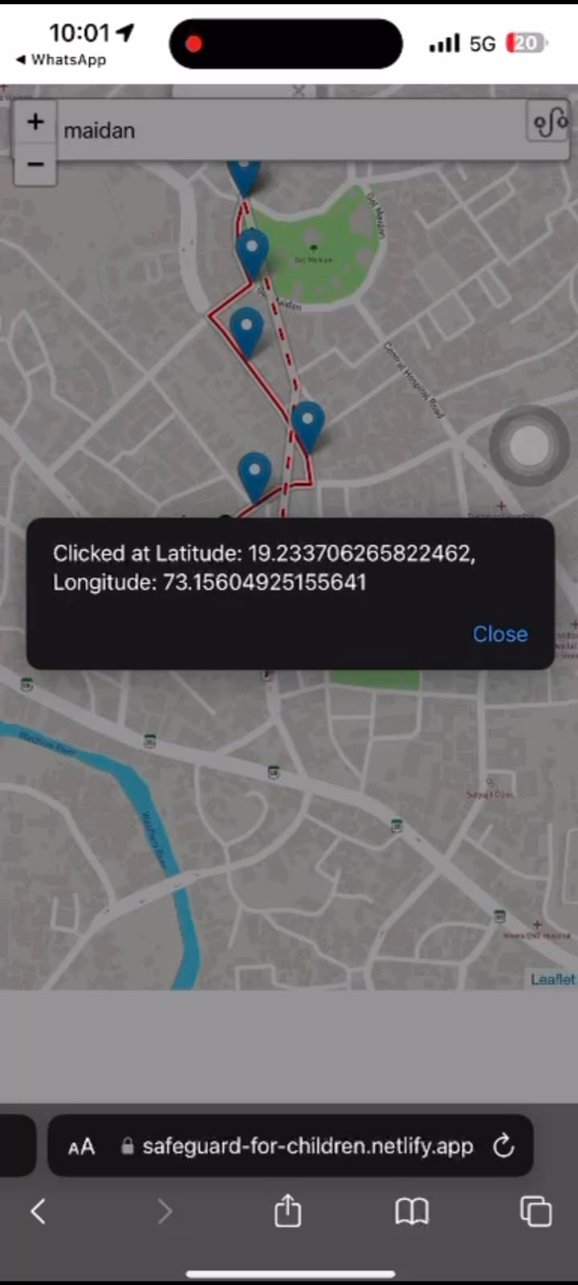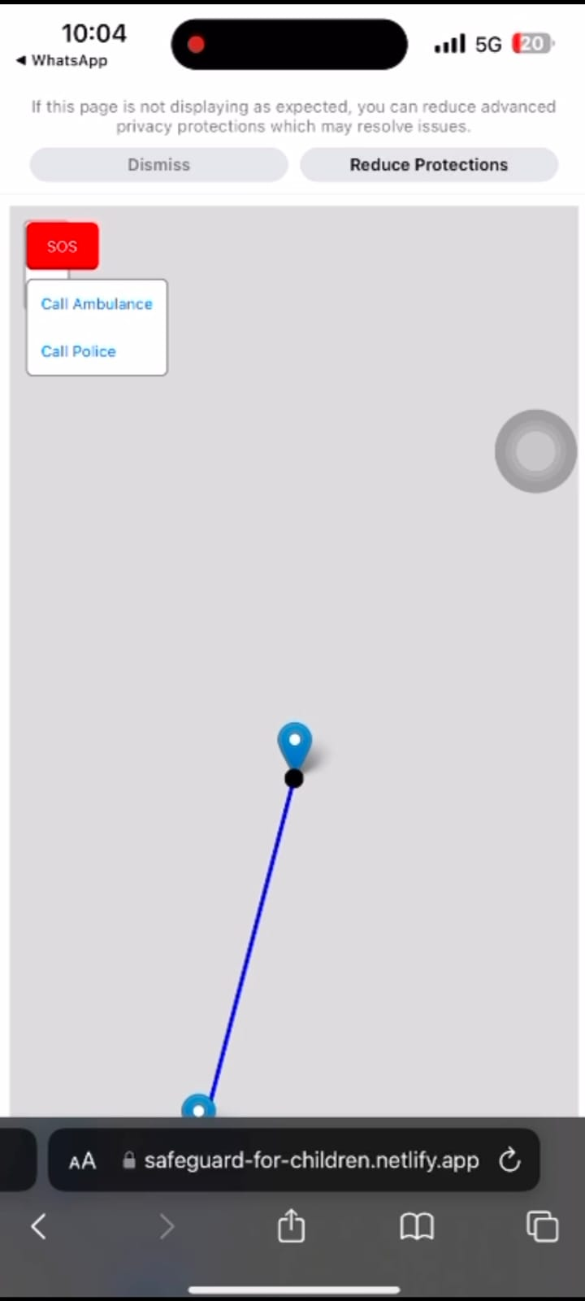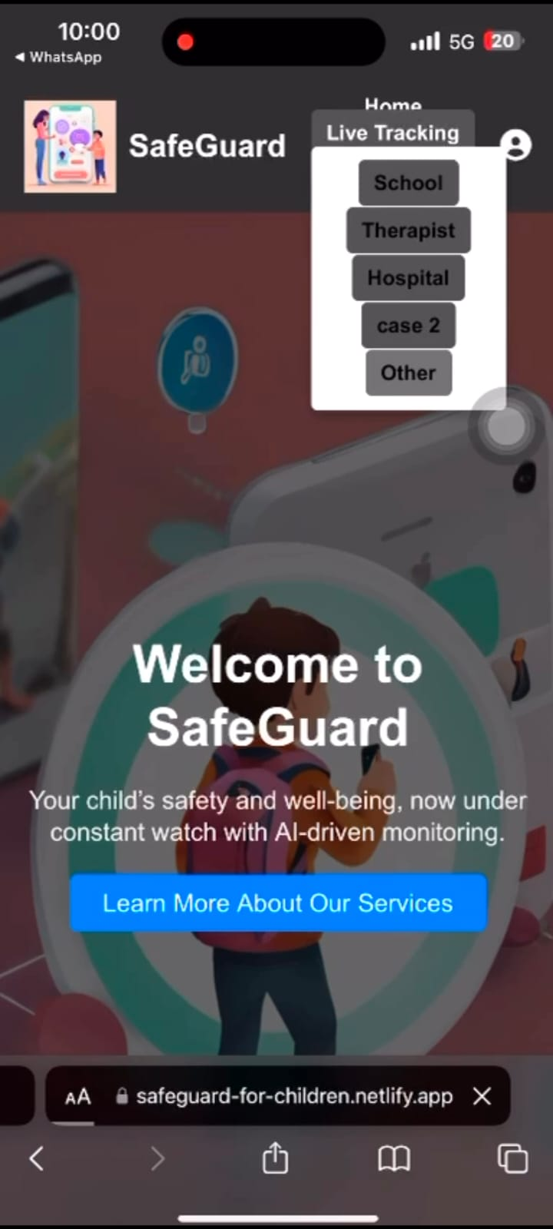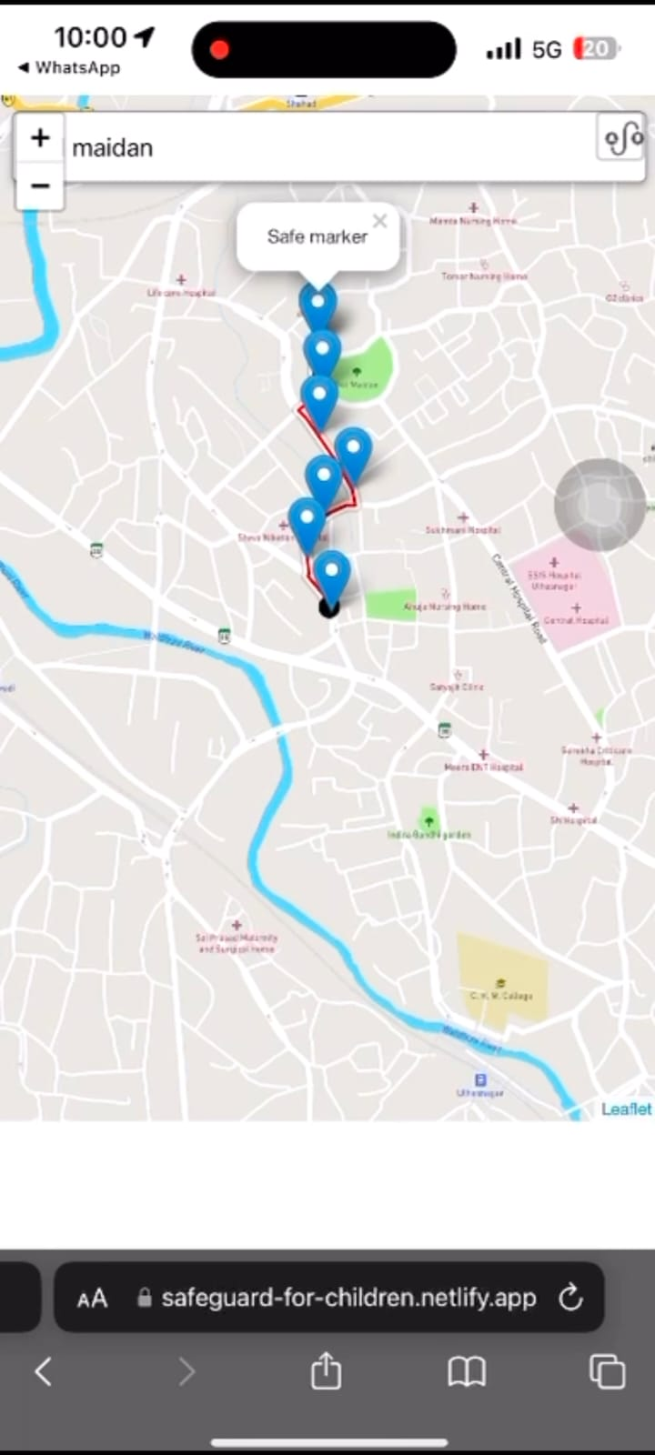

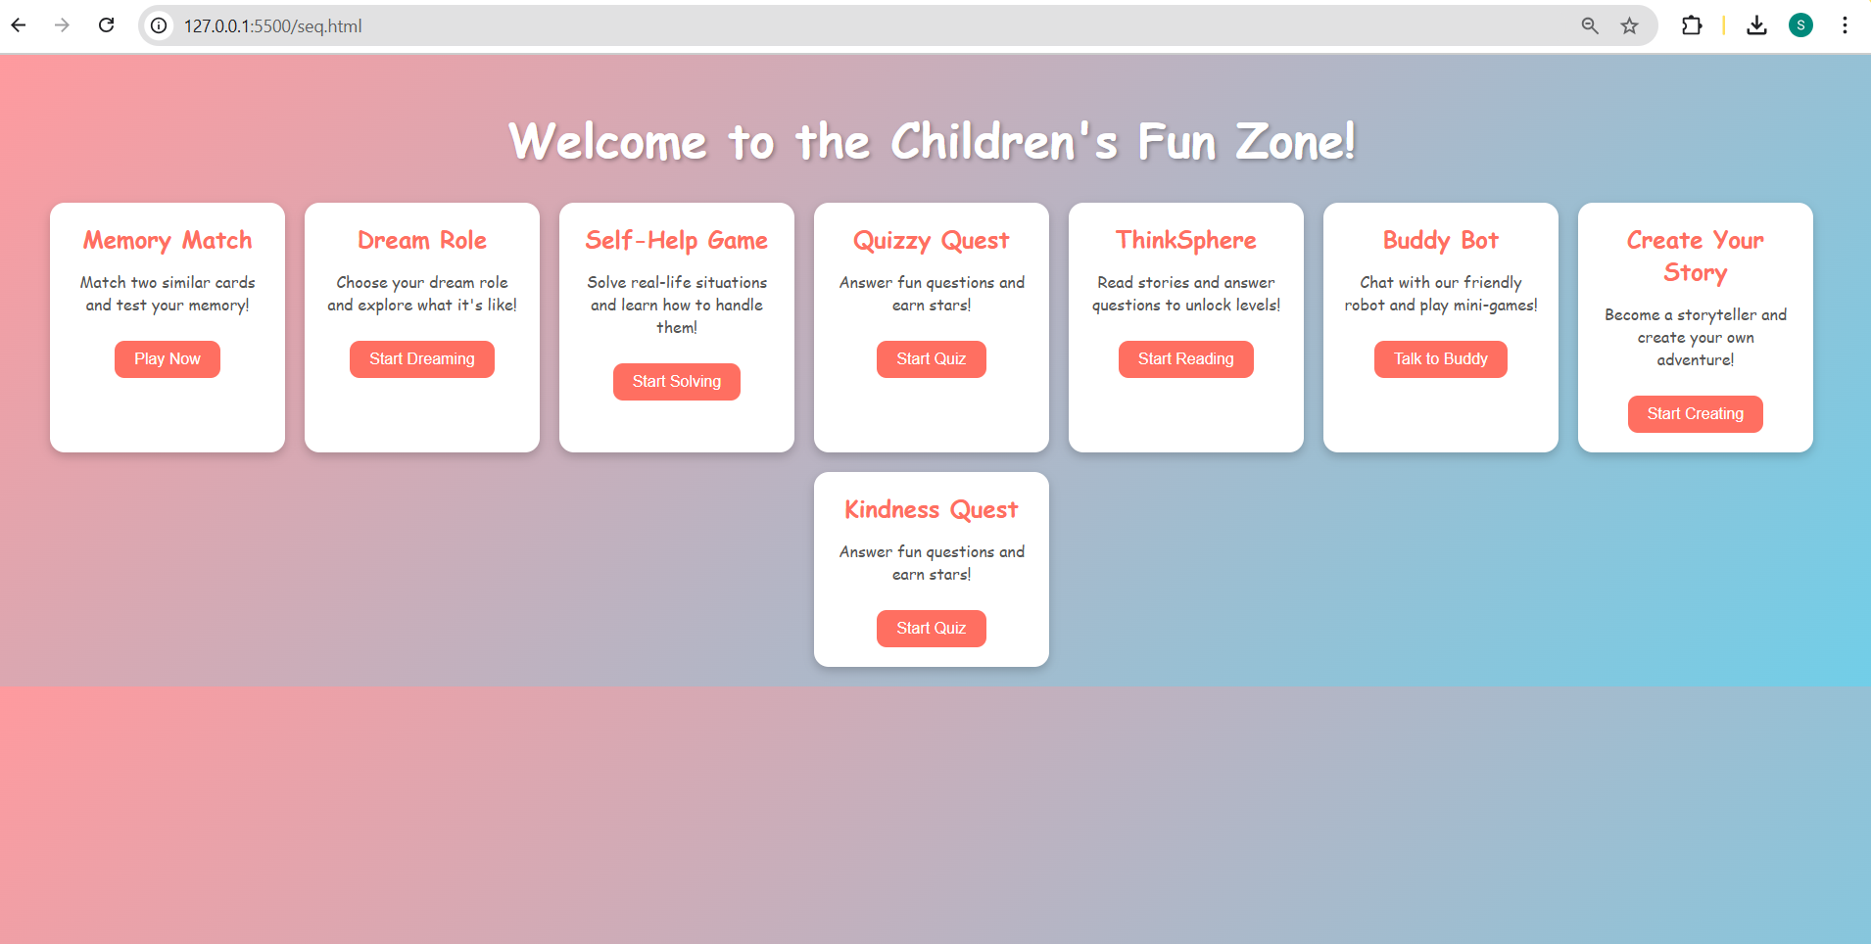

Fig. 5 Features of SQ and the example scenario of “Dream Role”

The colorful, interactive dashboard presents multiple gamified learning and behavior-assessing modules designed for children. Each module targets specific areas like memory, imagination, kindness, and communication, creating an engaging environment while collecting valuable psychological data. In the DReam Role Game,

children pick a dream profession ( like doctor, pilot, or artist), which reflects their interests and aspirational thinking. This insight contributes to analyzing a child’s social orientation, creativity, and self perception.

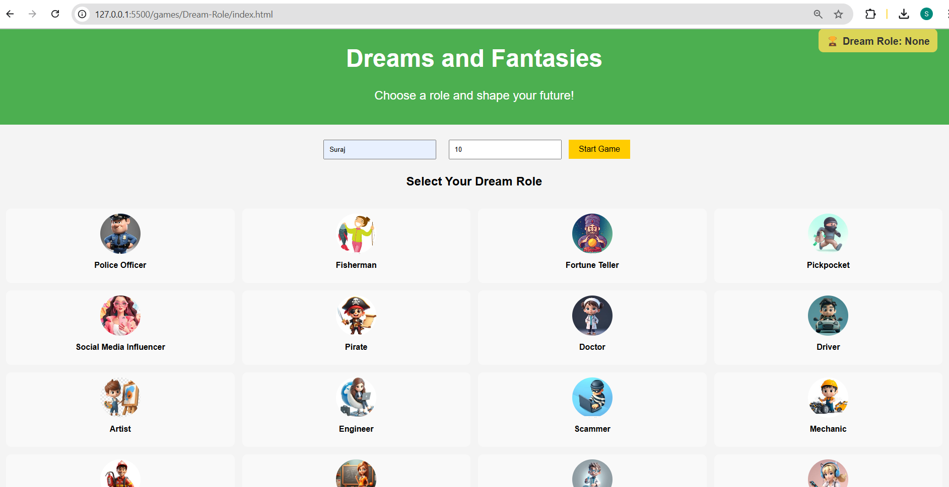

Fig. 3 Screenshot of SafeGuard dashboard, Optimal marker distance, directional prompts and real- time tracking When any marker on the route is clicked, it displays the corresponding latitude and longitude of that specific position, providing precise location details for better tracking and verification. shows user deviation from the actual predefined path, and hence the system alert with “off-route” message.

When the child’s ambient temperature is detected to be outside a safe and sustainable range, the system once again triggers an alarm and sends an instant notification to the parent, ensuring timely awareness. The last figure shows the follow-up page after extreme unsustainable conditions are detected and gives options to make an SOS call.

Fig. Screenshot of SafeGuard showing Positional latitude and longitude coordinates, Off-route detection alert, Unsustainable environmental conditions alert, SOS (ambulance/police) call optionWhen any *marker* on the route is clicked, it displays the corresponding *latitude and* *longitude* of that specific position, providing precise location details for better tracking and verification When the child’sambient temperature is detected to be outside a safe and sustainable range, the system once again triggers an alarm and sends an instant notification to the parent, ensuring timely awareness.

Fig. 6 Example scenarios of Buddy Bot, Self-Help interactive game, Kindness Quest. The Happy helper Chatbot, or Buddy Bot, encourages children to converse freely. It records their responses to analyze tone and keywords others. Similarly, “Quizzy Quest” is a form to be filled by stakeholders which captures essential behavioural data like self-control, sociability and hyperactivity from parents to guardians. The grading of SQ as high and low is done by applying SVM to the dataset presented in figure. The classification and feature- wise performance of the ML model shown in the figure with an accuracy around 73% and canbe improved gradually with more training examples.

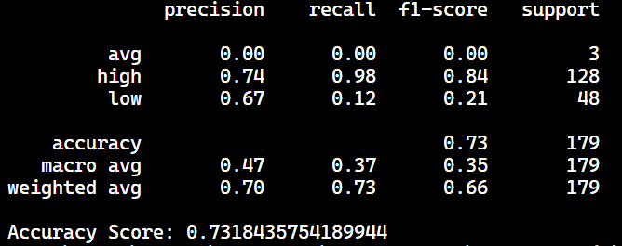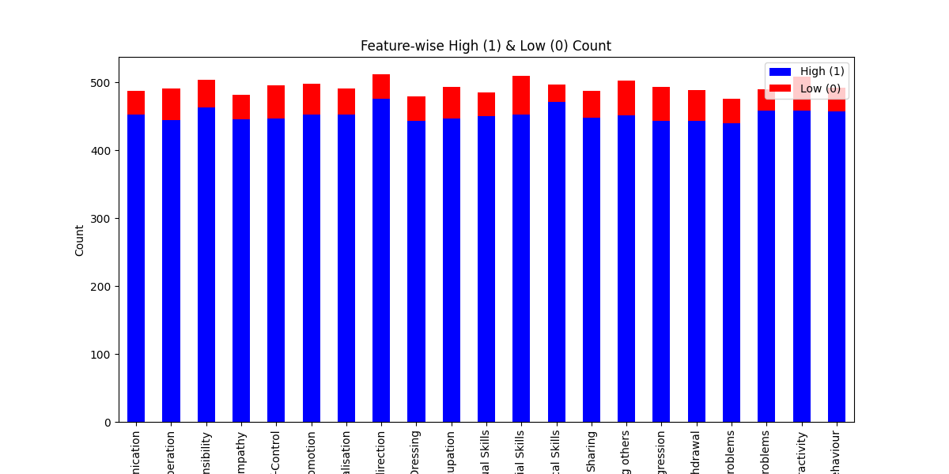

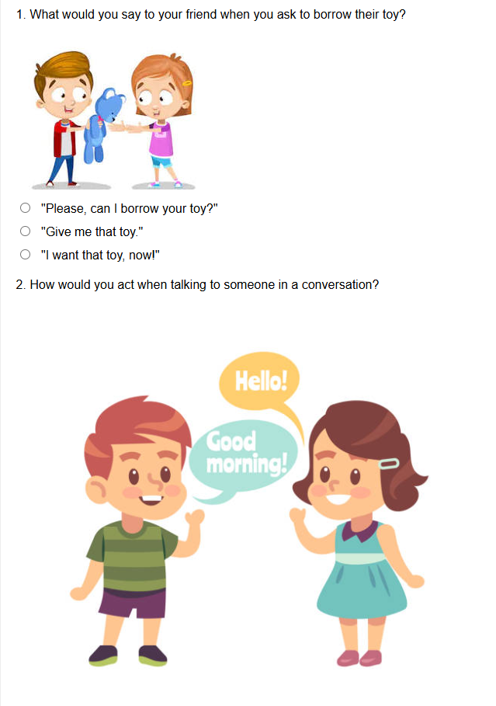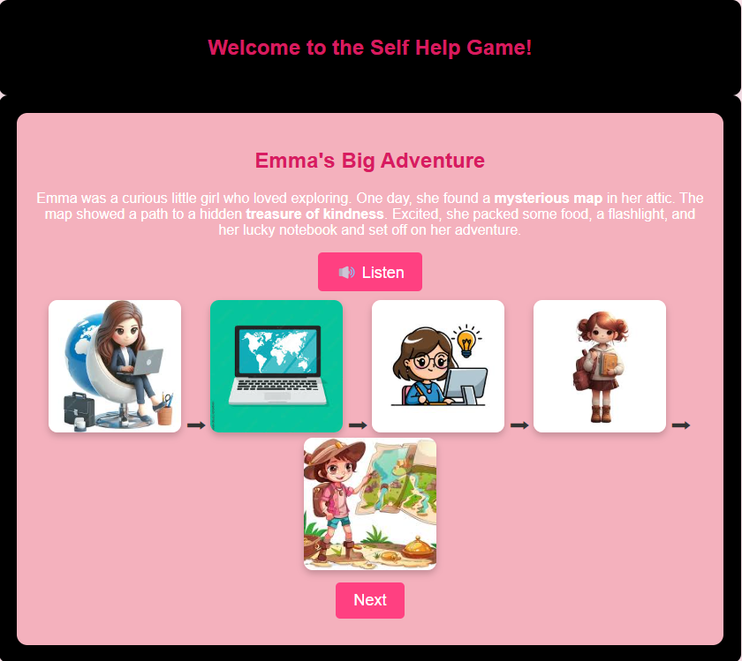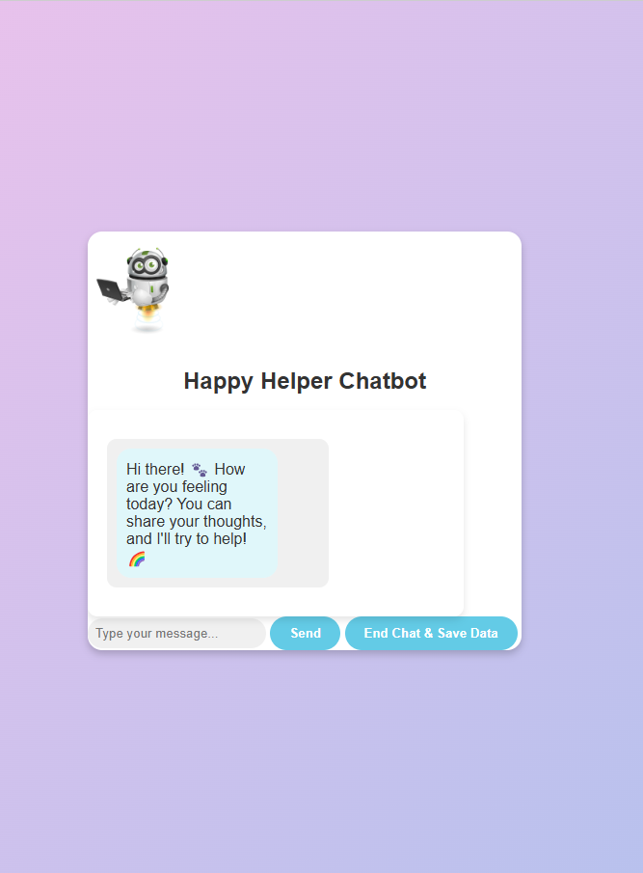

sentiment, which are crucial in understanding social behavior, emotional awareness, and conversational confidence. Emma’s Big Adventure” is a story-based, decision-making game that teaches children about self-help and making the right choices. It builds emotional intelligence by presenting scenarios that encourage empathy, courage, and problem-solving. This interactive quiz asks situational questions to gauge how empathetic, considerate, and socially aware the child is. Their responses are analyzed to understand their moral reasoning, compassion, and readiness to help

Fig. 7 Feature-wise high and low SQ, overall performance measure Every child is asked questions based on a set of predefined graded questionnaires on empathy, sentiments, helpfulness, social adjustment measuring EQ. The system analyzes videos of the child answering these questions by extracting frames and audio, performing OCR and speech transcription using openCV. The sentiment analysis is performed using NLP on the text extracted from the audio. Further the significant frames extracted from the video are manually labelled based on normal conditions of any child by marking as neutral, negative and positive body language shown while answering the questions. The applied sentiment, empathy, and social analysis aids to generate comprehensive insights from both visual and audio content as shown in figure 8 and 9. The audio transcription reveals a negative sentiment with low empathy and social adjustment scores, indicating feelings of nervousness, loneliness, and limited social response or engagement. 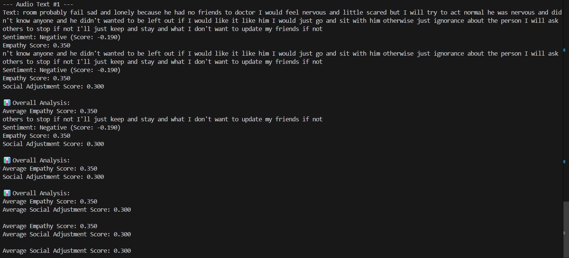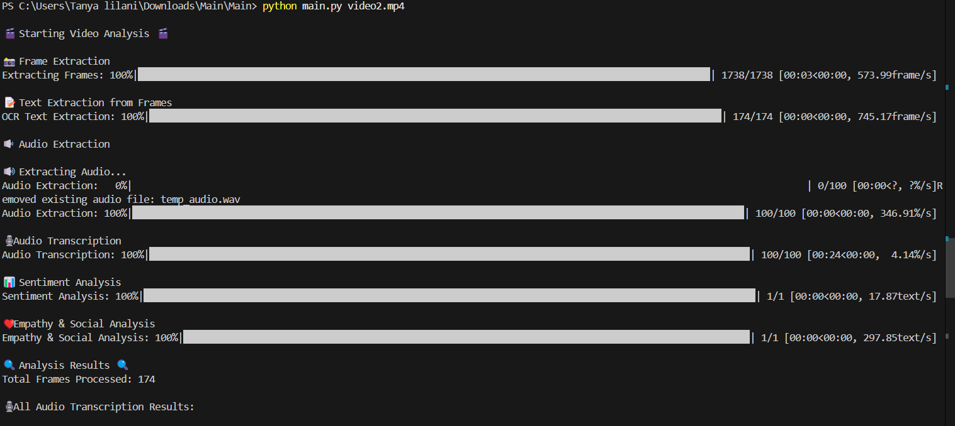

**IV. CONCLUSION**

SafeGuard redefines the concept of child safety by introducing an intelligent, AI-powered framework that goes far beyond conventional GPS-based tracking. This system unifies real-time environmental monitoring, SQ and EQ assessments, and behavioral intelligence to offer a deeply responsive and multidimensional protective solution. At its core is an IoT-enabled wearable device, seamlessly integrated into the child’s clothing, which monitors environmental parameters including temperature, oxygen levels, and precise geolocation and transmits this data securely to the cloud for continuous analysis and real-time tracking. These insights empower caregivers to intervene promptly, making child safety both preventive and personalized. In addition, the system will provide a curated dataset to medical practitioners for research, guidance and analysis of certain behaviours for specially abled children as well as analysing overall child psychology.

**V. REFERENCES**

[1] Fatima Siddiqui G, Fatima Siddiqui G.: Children Left Unattended in Parked Vehicles in India: An Analysis of 40 Fatalities from 2011 to 2020.(2021)

[2] Why kids should be taught to have a high Adversity Quotient (AQ) and not just good IQ.(2020)

[3] Panth, R., Sharma, K., Rathi, A.: A Comparative Study of Emotional Intelligence and Intelligence Quotient and Social Intelligence Between Undergraduate Students. (2023)

[4] Mohamed, Z., Shirazi, R.: A Study on Measuring Emotional Quotient on Overall Performance of the Students. International Journal of Multidisciplinary Research & Reviews (2024)

[5] Marwaha, S.: Analysis of Emotional Quotient and Intelligence Quotient among ‘High Achievers’ and ‘Low Performers’ in School Academics. (2023)

[6] Kumar, P., Katkar, A.: Smart Device for Child Safety with Parental Alerts. (March 22, 2024)

[7] Indelicato, R.: Artificial Intelligence and Social-Emotional Learning: What Relationship?. (December 2024)

[8] Biernacki, P., Bigman, M.: Four Surveillance Technologies Creating Challenges for Education. (November 27, 2023)

[9] —: GPS and GSM Based Wearable Devices for Real-Time Child Tracking and Emergency Alerts. (Author and publication date not provided — please update this entry accordingly)

[10] Simon, P., Grosbois, N.: How Do Children with Intellectual Disabilities Empathize in Comparison to Typically Developing Children?. (April 12, 2024)

[11] Bhakar, S.R.: A Study of Social Intelligence of Secondary School Students in Relation to Their Social Attitude. (October 10, 2022)

[12] Sharma, R., Verma, L.: Emotional Intelligence in Children(March 22, 2005)