**VIVEKANAND EDUCATION SOCIETY’S INSTITUTE OF TECHNOLOGY**

**An Autonomous Institute Affiliated to University of Mumbai**

**Department of Computer Engineering**



Project Report on

GameSpec Advisor

In partial fulfillment of the Fourth Year, Bachelor of Engineering (B.E.) Degree in Computer Engineering at the University of Mumbai Academic Year 2024-25

**Submitted by**

Ayush Rakesh Gerra ( D17 - A , Roll no - 18 )

Anisha Rohra ( D17 - A , Roll no - 52)

Meet Kewalramani ( D17 - A , Roll no - 29)

Manan Dadlani ( D17 - A , Roll no - 09)

**Project Mentor**

Mr. Richard Joseph

(2024-25)

**VIVEKANAND EDUCATION SOCIETY’S INSTITUTE OF TECHNOLOGY**

**An Autonomous Institute Affiliated to University of Mumbai**

**Department of Computer Engineering**



**Certificate**

This is to certify that ***Ayush Rakesh Gerra, Anisha Rohra, Meet Kewalramani, Manan Dadlani*** of Fourth Year Computer Engineering studying under the University of Mumbai have satisfactorily completed the project on “***GameSpec Advisor***” as a part of their coursework of PROJECT-II for Semester-VIII under the guidance of their mentor ***Prof. Richard Joseph*** in the year 2024-25.

This thesis/dissertation/project report entitled ***GameSpec Advisor*** by ***Ayush Rakesh Gerra, Anisha Rohra, Meet Kewalramani, Manan Dadlani*** is approved for the degree of ***B.E. Computer Engineering.***

| Programme Outcomes | Grade |
| --- | --- |
| PO1, PO2, PO3, PO4, PO5, PO6, PO7, PO8, PO9, PO10, PO11, PO12, PSO1, PSO2 |  |

Date:

Project Guide:

------------------------------------------

**Project Report Approval**

**For**

**B. E (Computer Engineering)**

This thesis/dissertation/project report entitled ***GameSpec Advisor*** by ***Ayush Rakesh Gerra, Anisha Rohra, Meet Kewalramani, Manan Dadlani*** is approved for the degree of ***B.E. Computer Engineering.***

Internal Examiner

---------------------------------------------

External Examiner

---------------------------------------------

Head of the Department

-----------------------------------------------

Principal

-----------------------------------------------

Date:

Place:

**Declaration**

We declare that this written submission represents our ideas in our own words and where others' ideas or words have been included, we have adequately cited and referenced the original sources. We also declare that we have adhered to all principles of academic honesty and integrity and have not misrepresented or fabricated or falsified any idea/data/fact/source in our submission. We understand that any violation of the above will be cause for disciplinary action by the Institute and can also evoke penal action from the sources which have thus not been properly cited or from whom proper permission has not been taken when needed.

| -----------------------------------------  (Signature)  -----------------------------------------  Ayush Rakesh Gerra / D17A / 18 | -----------------------------------------  (Signature)  -----------------------------------------  Anisha Rohra / D17A / 52 |
| --- | --- |
| -----------------------------------------  (Signature)  -----------------------------------------  Meet Kewalramani / D17A / 29 | -----------------------------------------  (Signature)  -----------------------------------------  Manan Dadlani / D17A / 09 |

Date:

**ACKNOWLEDGEMENT**

We are thankful to our college Vivekanand Education Society’s Institute of Technology for considering our project and extending help at all stages needed during our work of collecting information regarding the project.

It gives us immense pleasure to express our deep and sincere gratitude to Assistant Professor(**Project Guide**) for her kind help and valuable advice during the development of project synopsis and for her guidance and suggestions.

We are deeply indebted to Head of the Computer Department **Dr.(Mrs.) Nupur Giri** and our Principal **Dr. (Mrs.) J.M. Nair ,** for giving us this valuable opportunity to do this project.

We express our hearty thanks to them for their assistance without which it would have been difficult in finishing this project synopsis and project review successfully.

We convey our deep sense of gratitude to all teaching and non-teaching staff for their constant encouragement, support and selfless help throughout the project work. It is great pleasure to acknowledge the help and suggestion, which we received from the Department of Computer Engineering.

We wish to express our profound thanks to all those who helped us in gathering information about the project. Our families too have provided moral support and encouragement several times.

**Computer Engineering Department**

**COURSE OUTCOMES FOR B.E PROJECT**

Learners will be to,

| **Course Outcome** | **Description of the Course Outcome** |
| --- | --- |
| CO 1 | Able to apply the relevant engineering concepts, knowledge and skills towards the project. |
| CO2 | Able to identify, formulate and interpret the various relevant research papers and to determine the problem. |
| CO 3 | Able to apply the engineering concepts towards designing solutions for the problem. |
| CO 4 | Able to interpret the data and datasets to be utilized. |
| CO 5 | Able to create, select and apply appropriate technologies, techniques, resources and tools for the project. |
| CO 6 | Able to apply ethical, professional policies and principles towards societal, environmental, safety and cultural benefit. |
| CO 7 | Able to function effectively as an individual, and as a member of a team, allocating roles with clear lines of responsibility and accountability. |
| CO 8 | Able to write effective reports, design documents and make effective presentations. |
| CO 9 | Able to apply engineering and management principles to the project as a team member. |
| CO 10 | Able to apply the project domain knowledge to sharpen one’s competency. |
| CO 11 | Able to develop professional, presentational, balanced and structured approach towards project development. |
| CO 12 | Able to adopt skills, languages, environment and platforms for creating innovative solutions for the project. |

**Index**

| Chapter No. | Title | Page No. |
| --- | --- | --- |
| **1** | **Introduction** | 12 |
| 1.1 | Introduction to the project | 12 |
| 1.2 | Motivation for the project | 12 |
| 1.3 | Problem Definition | 12 |
| 1.4 | Existing Systems | 13 |
| 1.5 | Lacuna of the Existing Systems | 13 |
| 1.6 | Relevance of the Project | 14 |
| **2** | **Literature Survey** | 15 |
| A | Brief overview of Literature Survey | 15 |
| 2.1 | Research Papers   1. Abstract of the research paper 2. Inference drawn from the paper | 15 |
| 2.3 | Inference Drawn | 17 |
| 2.4 | Comparison with the Existing Systems | 17 |
| **3.** | **Requirement Gathering for the proposed System** | 21 |
| 3.1 | Introduction to Requirement Gathering | 21 |
| 3.2 | Functional Requirements | 21 |
| 3.3 | Non-Functional Requirements | 21 |
| 3.4 | Hardware, Software, Technology and tools utilised | 22 |
| 3.5 | Constraints | 22 |
| **4.** | **Proposed Design** | 24 |
| 4.1 | Block diagram of the system | 24 |
| 4.2 | Modular design of the system | 25 |
| 4.3 | Detailed Design (Flowchart) | 26 |
| 4.4 | Project Scheduling &amp; Tracking using Timeline / Gantt Chart | 26 |
| **5.** | **Implementation of the Proposed System** | 28 |
| 5.1 | Methodology employed for development | 28 |
| 5.2 | Algorithms and flowcharts for the respective modules developed | 28 |
| 5.3 | Datasets source and utilisation | 37 |
| **6.** | **Testing of the Proposed System** | 39 |
| 6.1 | Introduction to testing | 39 |
| 6.2 | Types of tests Considered | 39 |
| 6.3 | Various test case scenarios considered | 39 |
| **7.** | **Results and Discussions** | 40 |
| 7.1 | Screenshots of User Interface (UI) for the respective module | 40 |
| 7.2 | Inference drawn | 40 |
| **8.** | **Conclusion** | 41 |
| 8.1 | Limitations | 41 |
| 8.2 | Conclusion | 41 |
| 8.3 | Future Scope | 41 |
|  | **References** | 43 |
|  | **Appendix** | 44 |
| 1 | Project Review Sheet-I | 44 |
| 2 | Project Review Sheet-II | 45 |

**List of Figures**

| Figure No. | Heading | Page no. |
| --- | --- | --- |
| 4.1 | Block Diagram For GameSpec Advisor | 24 |
| 4.2 | Modular Diagram For GameSpec Advisor | 25 |
| 4.3 | Courses Module Detailed Decision making Module | 26 |
| 4.4 | Project Timeline (Gantt Chart) | 27 |
| 5.1 | CPU-GPU Correlation Heatmap | 28 |
| 5.2 | CPU-Memory Correlation Heatmap | 29 |
| 5.3 | GPU-Memory Correlation Heatmap | 29 |
| 5.4 | Flowchart for Sentiment Analysis Module | 33 |
| 5.5 | Compatibility Analysis Pipeline | 34 |
| 5.6 | Motherboard Details | 36 |
| 5.7 | Memory Details | 36 |
| 5.8 | Disk Status Details | 37 |
| 5.9 | RAM & CPU Details | 37 |
| 5.10 | GPU Details | 37 |
| 7.3 | Section User Posts their Requirements | 40 |
| 7.4 | Section User Getting PC Suggestion | 40 |
| 7.5 | Section User Getting Compatibility Score | 40 |

**List of Tables**

| Table no. | Heading | Page no. |
| --- | --- | --- |
| 5.1 | Pre-Built PC Configurations | 30 |
| 5.2 | Association Rule Mining Results for Pre-Built PC Configurations | 31 |
| 5.3 | Model Evaluation Results | 32 |
| 5.4 | Model Architecture for AutoEncoder | 35 |
| 5.5 | Model Hyperparameters | 35 |
| 6.1 | Test Cases Used | 39 |

**Abstract**

The rapid growth of the gaming industry has led to an increasing demand for optimized, high-performance gaming setups. However, navigating the vast and fragmented information regarding hardware compatibility, system requirements, and emerging trends poses significant challenges for both novice and experienced gamers. This research paper introduces GameSpec Advisor, a comprehensive platform designed to simplify the process of configuring gaming systems by consolidating data, performing compatibility analyses, and offering personalized recommendations. The platform leverages advanced analytical techniques such as sentiment analysis, association rule mining, and feature correlation matrices to provide actionable insights. GameSpec Advisor aims to empower users with the knowledge and tools necessary to optimize their gaming performance, enhance inclusivity, and bridge the gap between technical jargon and user-friendly guidance.

# Introduction

## 1.1 Introduction

The rapid evolution of the gaming industry, fueled by advancements in software, graphics engines, and high-performance hardware, has created a thriving ecosystem for gamers and developers alike. As a result, the demand for customized and optimized gaming setups has increased significantly. Gamers, both novice and experienced, are constantly seeking to enhance their gameplay experience through better hardware, yet they often face challenges in making informed decisions due to the overwhelming volume of fragmented information available across the internet. From YouTube benchmarks and Reddit discussions to technical specifications buried deep in manufacturer documentation, users must sift through disparate sources to determine the best configuration for their needs.

In this context, **GameSpec Advisor** is introduced as a unified, intelligent platform that simplifies the process of selecting and evaluating gaming system components. By consolidating data from various trusted sources and applying advanced analytical techniques such as sentiment analysis, anomaly detection, and compatibility modeling, GameSpec Advisor assists users in making data-driven decisions to optimize their gaming setups effectively.

## 1.2 Motivation

The motivation behind this project stems from the growing complexity and confusion surrounding gaming system configurations. Modern games demand specific hardware capabilities, and users often lack the technical knowledge to determine whether a particular component is suitable or optimal for their use case. Furthermore, the rise of user-generated content, such as YouTube reviews and forums, while valuable, adds another layer of complexity due to inconsistency, bias, and unstructured data.

With the absence of a centralized platform that can analyze compatibility, extract sentiments, and recommend components based on real-world feedback, users are left to navigate the intricacies of system building alone. This often leads to suboptimal choices, wasted investments, and a diminished gaming experience. GameSpec Advisor aims to address these pain points by offering a smart, automated system that provides personalized and practical recommendations grounded in real data.

## 1.3 Problem Definition

Despite the availability of powerful gaming hardware, users face significant challenges when attempting to configure their systems:

* **Information Overload**: Hardware specifications, reviews, and game requirements are scattered across multiple platforms, often presented in inconsistent formats.
* **Lack of Compatibility Analysis**: There is no easily accessible tool that can reliably evaluate the compatibility of custom hardware configurations.
* **Unstructured User Feedback**: While video reviews and forums provide real-world insights, extracting actionable data from these unstructured sources remains a technical challenge.
* **Absence of Personalization**: Existing platforms fail to provide personalized recommendations based on user preferences, gaming genres, or budget constraints.

This project aims to develop a comprehensive solution that addresses these issues through intelligent data integration, machine learning, and sentiment analysis to enhance decision-making in gaming hardware selection.

## 1.4 Existing Systems

A number of existing platforms and tools attempt to guide users in building or purchasing gaming systems:

* **PCPartPicker**: Allows users to manually select components and checks for basic compatibility (e.g., socket matching, PSU adequacy). However, it lacks AI-driven insights and user sentiment integration.
* **UserBenchmark & PassMark**: Provide benchmarking tools and comparative scores for hardware components, but do not offer holistic system-level compatibility or recommendations.
* **YouTube Reviews & Forums**: Provide experiential insights and performance feedback, but are highly unstructured and subjective.
* **OEM Configurators (e.g., Dell, ASUS, CyberPowerPC)**: Enable limited customization within the bounds of pre-designed systems, offering little flexibility or transparency regarding hardware selection.

While each of these platforms offers some value, none provide a comprehensive end-to-end solution that integrates performance benchmarking, compatibility validation, and user sentiment analysis.

## 1.5 Lacuna of the Existing Systems

Despite their utility, the existing systems exhibit several critical gaps:

* **Fragmented Information**: Users must refer to multiple sources to gather relevant data, leading to inefficiencies and potential misinformation.
* **No Sentiment Integration**: The wealth of insights from video reviews and community forums is not utilized in a structured manner.
* **Limited Customization Intelligence**: Most platforms do not offer dynamic, data-driven suggestions based on actual performance or popularity of component combinations.
* **Lack of Anomaly Detection**: There is no proactive system that warns users about unusual or potentially incompatible hardware pairings based on learned patterns.
* **User Accessibility**: Technical jargon and complex interfaces can alienate non-technical users or beginners attempting to build their first gaming rig.

These limitations create a strong need for a system that can bridge the gap between technical complexity and user accessibility—precisely what GameSpec Advisor aims to accomplish.

## 1.6 Relevance of the Project

GameSpec Advisor is highly relevant in today's gaming and tech landscape. By leveraging machine learning, natural language processing, and sentiment analysis, it addresses the core challenges faced by gamers and system builders. The platform acts as both a guide and an advisor, simplifying the intricate process of hardware selection while also educating users on the impact of their choices.

The relevance extends beyond individual users; retailers, hardware manufacturers, and content creators can also benefit from the aggregated insights and compatibility analytics offered by the platform. In a market where user experience and performance optimization are paramount, GameSpec Advisor has the potential to become a foundational tool in the gaming hardware ecosystem.

# Literature Survey

## A. Brief Overview of Literature Survey

The literature survey forms the backbone of this project, offering critical insight into prior work conducted in the areas of hardware recommendation systems, performance benchmarking, user sentiment analysis, and machine learning for compatibility detection. By studying existing frameworks and algorithms, we identify technological approaches and their shortcomings, which informs the design and development of the proposed GameSpec Advisor system.

The survey encompasses a diverse set of resources including research papers, technical blogs, open-source benchmarks, and community discussions. Through this review, we understand how various elements—such as NLP for sentiment mining, system compatibility modeling, and crowd-sourced review aggregation—can be integrated to form a holistic gaming configuration advisor.

### B. Related Works

A variety of research studies and systems have tackled related problems, though often from isolated perspectives. Some focused on hardware benchmarking using synthetic tests, while others explored text mining for product reviews. Few works attempted to bridge the gap between raw performance data and real-world user experience through integrated tools.

This project draws inspiration from these systems but distinguishes itself by offering a unified platform capable of learning from user-generated content, performing compatibility checks, and offering intelligent, adaptive recommendations tailored to gamers.

## 2.1 Research Papers Referred

**1. Evaluating Machine Learning Models for Disparate Computer Systems Performance Prediction**

***Abstract:*** This study investigates fourteen machine learning models, including linear, non-linear, probabilistic, tree-based models, and neural networks, to predict performance across diverse computer systems. Benchmark programs with varied computation and data access patterns were executed on both simulation-based hardware and physical systems. Findings indicate that tree-based models achieved a median absolute percentage error (MedAPE) of less than 5%, outperforming other models. Bagging and boosting techniques further enhanced weak learners. Notably, simulation-based hardware yielded higher prediction accuracy due to its deterministic nature, and memory-bound algorithms exhibited better accuracy on physical systems compared to compute-bound algorithms, likely due to processor variability.

***Inference:*** Tree-based machine learning models, particularly when combined with ensemble methods like bagging and boosting, demonstrate superior performance in predicting computer system performance. The deterministic characteristics of simulation-based hardware contribute to higher prediction accuracy. Additionally, memory-bound algorithms are more predictable on physical systems than compute-bound ones, possibly due to inherent processor variability.​

**2. Predicting Computer Performance Based on Hardware Configuration Using Multiple Neural Networks**

***Abstract:*** This research employs Multiple Neural Networks (MNN) to predict personal computer performance based on hardware configurations. Principal Component Analysis (PCA) was utilized during data preprocessing to guide model creation. Input data encompassed CPU type, frequency, core count, memory size and speed, storage architecture, and network configuration. The deep learning model was trained using approximately 50,000 commercial machine configurations and Standard Performance Evaluation Corporation (SPEC) benchmarks (SPEC CPU2006 and SPEC CPU2017). The MNN model achieved an average accuracy rate of 97.5% across all benchmarks, providing users with a tool to estimate system configuration performance without extensive benchmarking.

***Inference:*** Multiple Neural Networks, when combined with PCA for data preprocessing, can effectively predict computer performance based on hardware configurations. This approach offers a high-accuracy alternative to traditional, resource-intensive benchmarking methods.​

**3. Sentiment Analysis on YouTube Videos for Kids: Review**

***Abstract:*** With the proliferation of social media, platforms like YouTube have become prevalent among children. This paper reviews existing methods and techniques for sentiment analysis of YouTube videos, classifying them based on machine and deep learning approaches. The study aims to assist researchers in data mining and sentiment analysis by providing an overview of current methodologies.

***Inference:*** The review underscores the significance of sentiment analysis in assessing the suitability of YouTube content for children. It highlights the application of machine and deep learning techniques in this domain, offering a foundation for future research in safeguarding children's online experiences.​

**4. Comparative Analysis of Machine Learning Models for Performance Prediction of the SPEC Benchmarks**

***Abstract:*** This study proposes a supervised learning approach to predict performance scores of SPEC CPU2017 benchmarks based on system configurations, eliminating the need for time-consuming simulations. Using a public dataset of 43 benchmark results, the work investigates: (i) the feasibility of accurate prediction without running benchmarks, (ii) key hardware and software features, (iii) optimal predictive models and hyperparameters, and (iv) the ability to forecast future system performance. The study applies regression models including Multi-Task Elastic-Net, Decision Tree, Random Forest, and Multi-Layer Perceptron, with a structured feature selection and hyperparameter tuning process. Results show that tree-based models with all 29 features achieve prediction errors under 4%, while faster Decision Tree and Random Forest models using only 10 features maintain errors below 6% and 5%, respectively.

***Inference:*** The authors utilize the SPEC CPU2017 dataset, which comprises results from 43 standardized performance benchmarks organized into four suites. To address the challenge of predicting multiple performance metrics simultaneously, the study explores multi-target regression techniques. A comprehensive evaluation is conducted on various machine learning models, including Multi-Task Elastic-Net, Decision Trees, Random Forests, and Multi-Layer Perceptrons, to assess their effectiveness in predicting benchmark performance scores.

## 2.2 Inference Drawn

From the literature surveyed, the following conclusions are drawn:

* **Integration of Sentiment Analysis** enriches recommendation systems, allowing emotional and experiential data to complement technical specifications.
* **Machine Learning-based Anomaly Detection** provides a scalable method for validating system compatibility without hardcoded rules.
* **User-Centric Design** must prioritize interpretability and simplicity, especially when recommending technical components to less-experienced users.
* **Existing Benchmark Tools**, while useful, should be contextualized with real-world feedback to present a holistic performance profile.

These insights provide the conceptual scaffolding for GameSpec Advisor, shaping its architecture and core algorithms.

## 2.3 Comparison with Existing Systems

Existing systems for building a budget gaming PC primarily revolve around online tools, platforms, and communities that provide users with resources to select compatible components, check performance benchmarks, and ensure cost-effectiveness. Here are some key systems:

**1. PCPartPicker:**

* **Overview**: PCPartPicker is one of the most popular platforms for building custom PCs, including budget gaming setups.
* **Features**: It allows users to choose components (CPU, GPU, motherboard, RAM, etc.), ensuring compatibility between parts. The platform also shows price comparisons from various retailers, user reviews, and build guides.
* **Strengths**: Real-time price tracking, user-generated builds, and a community-driven recommendation system.
* **Limitations**: Limited in-depth performance analytics or personalized gaming recommendations beyond hardware compatibility.

**2. Newegg PC Builder:**

* **Overview**: Newegg, an online electronics retailer, offers a PC Builder tool that helps users assemble a custom PC based on their budget and gaming needs.
* **Features**: It provides access to Newegg’s inventory of components, detailed specifications, and user reviews. The tool also highlights discounts and promotions on individual parts.
* **Strengths**: Direct purchasing from the platform, sales-based pricing, and easy component swapping.
* **Limitations**: Lacks advanced filtering for performance-based recommendations and doesn’t always focus on balancing budget vs. performance.

**3. BuildMyPC:**

* **Overview**: BuildMyPC is another web-based tool similar to PCPartPicker, designed to help users create their ideal gaming PC within a specified budget.
* **Features**: The platform focuses on pricing and compatibility, ensuring that selected parts fit within the desired price range and will work together.
* **Strengths**: Simple interface, with a focus on providing budget constraints upfront.
* **Limitations**: Less comprehensive than PCPartPicker in terms of user builds, performance analytics, and price comparison across multiple sources.

**4. Reddit (r/buildapc):**

* **Overview**: Reddit’s "buildapc" subreddit is a large, community-driven platform where users seek advice on building gaming PCs, including budget setups.
* **Features**: Users post build recommendations and get advice on component selection, compatibility, and performance for specific games.
* **Strengths**: Community feedback, personalized advice, and access to real-world experiences.
* **Limitations**: Recommendations can be subjective, and it lacks structured tools for checking compatibility or tracking component prices.

**5. Tom’s Hardware PC Build Guides:**

* **Overview**: Tom’s Hardware offers curated build guides for different price points, including budget gaming PCs.
* **Features**: These guides provide detailed explanations of each component, why it was chosen, and how it performs for gaming.
* **Strengths**: Expert advice and up-to-date component recommendations, with detailed performance benchmarks.
* **Limitations**: Static recommendations that may become outdated as hardware and prices change; lacks dynamic build customization options.

**6. CyberPowerPC and iBUYPOWER:**

* **Overview**: These companies provide pre-built gaming PCs and custom PC-building services, where users can select components for custom builds.
* **Features**: The systems are built by professionals, and users can choose configurations from a wide range of budgets, with optional component upgrades.
* **Strengths**: Convenience for users who prefer pre-built systems, with a range of prices and options.
* **Limitations**: Less flexibility in part selection compared to building a PC yourself, and can sometimes be more expensive than DIY solutions.

While existing systems like PCPartPicker and Newegg’s PC Builder focus on ease of part selection and compatibility checking, they often lack advanced performance metrics and personalized recommendations for gaming. Community-driven platforms like Reddit and Tom’s Hardware offer valuable advice but can be inconsistent or outdated. Most existing systems are strong in ensuring hardware compatibility but could benefit from more advanced tools for optimizing performance-to-cost ratios, especially for gamers working within tight budgets.

| **Feature/Criteria** | **Existing Systems** | **Proposed System** |
| --- | --- | --- |
| **Component Compatibility Check** | Tools like **PCPartPicker**, **Newegg PC Builder**, and **BuildMyPC** provide robust compatibility checks between components. | The proposed system will similarly offer component compatibility checks but will incorporate real-time performance data from benchmarks and reviews. |
| **User Personalization** | Most existing systems provide static recommendations based on user input but lack in-depth personalization beyond price/budget. | The proposed system will offer **personalized recommendations** based on the user’s budget, preferred games, and required performance levels, providing tailored setups with real-time data insights. |
| **Feature Correlation** | Existing tools focus on simple component matching (e.g., **PCPartPicker** checks if CPU is compatible with motherboard). | The proposed system will introduce a **feature correlation matrix** that identifies not just compatibility but also optimal component pairings for gaming performance (e.g., ideal CPU-GPU combinations). |
| **Health Check/Optimization** | No existing system offers a comprehensive health check for existing PCs. | The proposed system will include a **PC health check** feature to analyze the user's current system and recommend upgrades or optimizations based on performance bottlenecks. |
| **Association Rule Mining** | **No existing system** provides insights into frequently used or successful hardware combinations (e.g., CPU-GPU pairings). | The proposed system will use **association rule mining** to discover common and successful component pairings that yield optimal gaming performance within a given budget. |
| **Driver Recommendations** | No explicit feature in existing systems to suggest specific drivers based on the user's system configuration. | The proposed system will provide **driver recommendations** based on the user's OS and hardware configuration, improving system stability and gaming performance. |
| **Ease of Use** | Existing systems like **Newegg PC Builder** and **BuildMyPC** offer simple interfaces for users to create their builds. | The proposed system will offer an equally **user-friendly interface** with additional customization options for tailoring performance and budget recommendations. |
| **Data Sources for Analysis** | Primarily price data from retailers, static performance data from reviews, and product specs. | The proposed system will integrate data from **YouTube channels PC Build reviews**, hardware review sites, and **social sentiment analysis** from gaming communities, creating a more holistic recommendation system. |

As evident, while current systems fulfill specific roles in the user journey, they lack the cohesion and intelligence necessary for automated, reliable configuration suggestions. GameSpec Advisor uniquely addresses these deficiencies by combining structured technical evaluation with unstructured user feedback.

# Requirement Gathering for the Proposed System

## 3.1 Introduction to Requirement Gathering

Requirement gathering is a crucial phase in the development lifecycle of any system. It involves identifying, analyzing, and documenting the functionalities and constraints of the proposed solution. For *GameSpec Advisor*, requirement gathering helped in establishing a clear understanding of what the system should do, how it should behave under various conditions, and the environment in which it will operate.

This phase ensures that the expectations of stakeholders—gamers, PC enthusiasts, and system integrators—are accurately captured, minimizing ambiguities and guiding the development process toward a user-focused, reliable system.

## 3.2 Functional Requirements

* **User Input Interface:** The system shall allow users to input game titles, budget range, preferred resolution (e.g., 1080p, 1440p), and use case (e.g., streaming, esports, AAA gaming).
* **Game-Based Hardware Recommendation:** The system shall recommend an optimal CPU, GPU, RAM, and storage combination based on the selected game and performance expectations.
* **Sentiment Analysis Module:** The system shall extract and analyze sentiments from YouTube and Reddit comments regarding specific hardware components.
* **Compatibility Checker:** The system shall verify the compatibility between suggested components (e.g., CPU socket vs motherboard, PSU wattage, case size constraints).
* **Benchmark Aggregator:** The system shall retrieve or maintain a database of synthetic and user-generated benchmarks for popular hardware.
* **Anomaly Detection:** The system shall flag suspicious or inefficient configurations (e.g., pairing a high-end GPU with an entry-level CPU).
* **Real-Time Comparison Tool:** The system shall allow users to compare different configurations side by side in terms of performance, sentiment score, and cost.
* **Feedback Loop:** Users can rate and review the recommendations to improve future results through reinforcement learning or rule refinement.

## 3.3 Non-Functional Requirements

* **Usability:** The interface shall be intuitive and beginner-friendly, minimizing technical jargon.
* **Performance:** Response time for generating recommendations shall be under 3 seconds in standard conditions.
* **Scalability:** The system shall support increasing datasets (hardware, reviews) without degradation in performance.
* **Reliability:** The system must produce accurate and consistent results with low false-positive rates for incompatibility detection.
* **Maintainability:** The system architecture should allow easy updates to models, datasets, and compatibility rules.
* **Security:** User data (if any is stored) shall be secured with encryption and follow basic data protection standards.

## 3.4 Hardware, Software, Technology and Tools Utilized

* **Hardware Requirements (for development and deployment):**
  + CPU: Intel i5-10400 equivalent or higher
  + RAM: 16GB (recommended)
  + Storage: 18GB free disk space
  + GPU (for deep learning models): NVIDIA GTX 1050Ti or above
* **Software Tools:**
  + IDE: Visual Studio Code
  + DBMS: MongoDB
  + APIs: YouTube Data API
  + Web Framework: Flask
  + Frontend: React.js
* **Technologies:**
  + Programming Languages: Python, JavaScript
  + ML Libraries: TensorFlow, Scikit-learn, NLTK
  + Sentiment Analysis: BERT, Vader, or custom LSTM model
  + Compatibility Parser: Custom rule engine
  + Data Aggregation: BeautifulSoup, Scrapy for scraping additional review sites

## 3.5 Constraints

Despite the ambitious scope, several constraints influence the system design:

* **Data Availability Constraint:** data from YouTube are subject to rate limits or API changes.
* **Sentiment Noise:** Informal language, sarcasm, and trolling in public comments can mislead sentiment analysis.
* **Limited Benchmark Standardization:** Disparate benchmark sources may use varying conditions and metrics, reducing comparability.
* **Deployment Constraints:** High-performance models may require GPU-backed cloud instances, increasing operational cost.
* **User Diversity:** Recommender system must cater to both technical and non-technical users without overwhelming either group.

# Proposed Design

## 4.1 Block diagram of the system

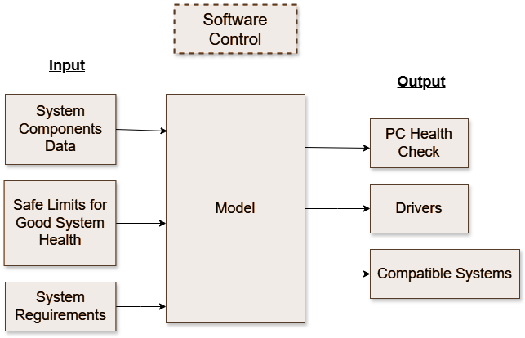

**Figure 4.1: Block Diagram For GameSpec Advisor**

The block diagram illustrates a system framework designed to assess and manage PC health based on various system inputs. It consists of three main sections: **Input**, **Model**, and **Output**.

* **Input:** Three types of data are fed into the model:
  1. **System Components Data** — information about the current hardware and software components of the system.
  2. **Safe Limits for Good System Health** — predefined thresholds and acceptable operational ranges to ensure system stability and performance.
  3. **System Requirements** — specifications and requirements necessary for compatibility checks and performance validation.
* **Model:** The central processing unit of the framework that uses the input data to evaluate, predict, or generate appropriate system health outputs.
* **Output:** The model produces three key outputs:
  1. **PC Health Check** — an assessment of the current system status relative to safe operational limits.
  2. **Drivers** — recommendations or updates for drivers necessary to maintain or improve system performance.
  3. **Compatible Systems** — identification of systems that meet the required specifications for compatibility.

Additionally, a **Software Control** component oversees and regulates the functioning of the entire model, ensuring that the processes and evaluations run according to the predefined logic and requirements.

## 4.2 Modular design of the system

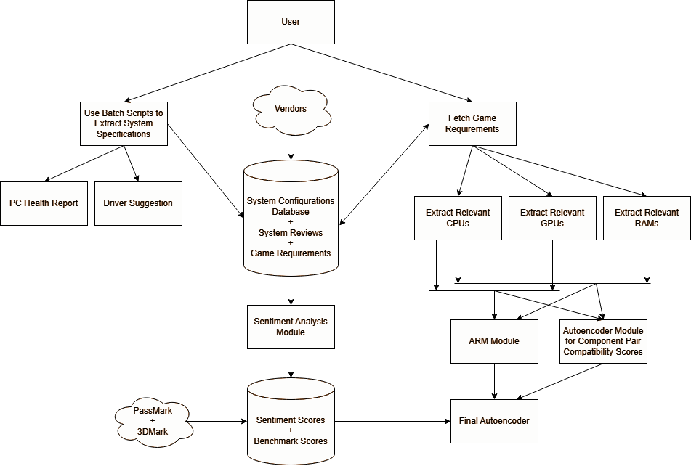

**Figure 4.2: Modular Diagram For GameSpec Advisor**

The diagram above illustrates the **modular architecture** of the GameSpec Advisor. It outlines the various functional components (modules) of the system, detailing how they interact to process user inputs, vendor data, system configurations, and game requirements to generate recommendations and reports.

* **Use Batch Scripts to Extract System Specifications**: A module designed to extract hardware specifications from existing systems using automated batch scripts. PC Health Report and Driver Suggestion outputs are generated based on the extracted system specifications.
* **Component Extraction Modules**: These modules filter and extract relevant hardware components (CPUs, GPUs, RAMs) based on user preferences and system needs.
* **Association Rule Mining (ARM) Module**: Processes the extracted components and identifies compatible hardware pairings based on historical configurations and compatibility patterns.
* **Autoencoder Module for Component Pair Compatibility Scores**: This module applies machine learning-based autoencoders to generate compatibility scores for various component pairs, ensuring optimal hardware matching.
* **Final Autoencoder**: Integrates the compatibility scores and ARM module results to generate the final build configuration recommendations.
* **Sentiment Analysis Module**: Analyzes system reviews and feedback from the database to produce sentiment scores, providing qualitative insights into component reliability and performance.

## 4.3 Detailed Design

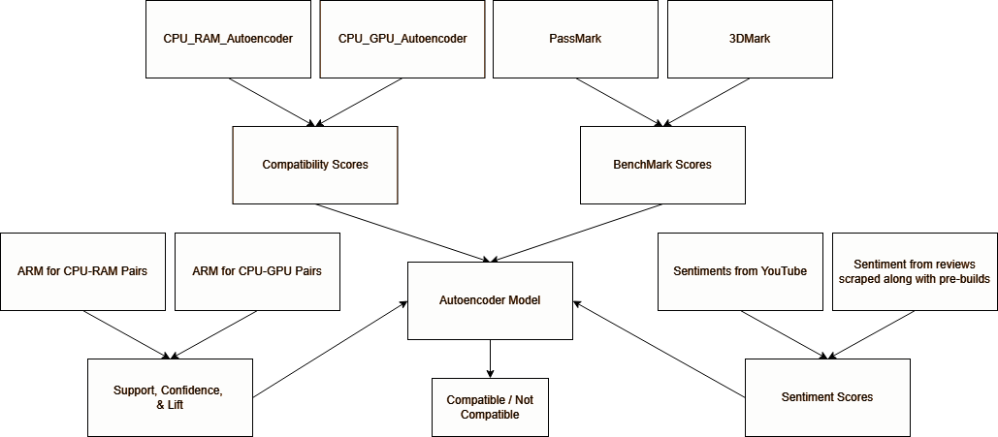

**Figure 4.3: Detailed Decision making Module**

At the core of the system lies the **Autoencoder Model**, which consolidates:

* **Compatibility Scores** from CPU-RAM and CPU-GPU Autoencoders
* **Benchmark Scores** from PassMark and 3DMark
* **Sentiment Scores** derived from external reviews and feedback
* **Association Rule Mining (ARM) metrics** like support, confidence, and lift values for CPU-RAM and CPU-GPU pairs, derived from historical configuration data.

The Autoencoder Model integrates these diverse inputs to classify component pairs as either:

* **Compatible**
* **Not Compatible**

This ensures optimal matching and prevents bottlenecks or compatibility issues in the recommended configurations. Finally, the system generates:

* **Customized PC Build Recommendations** for new builds.
* **PC Health Status Reports** and **Driver Suggestions** for existing systems.

## 4.4 Project Scheduling & Tracking using Timeline / Gantt Chart

The Gantt chart of our project where we worked for the whole semester to create this model is shown in a timeline pattern. It is the most important part to think and design the planning of your topic and so we planned our work like the gantt chart shown.

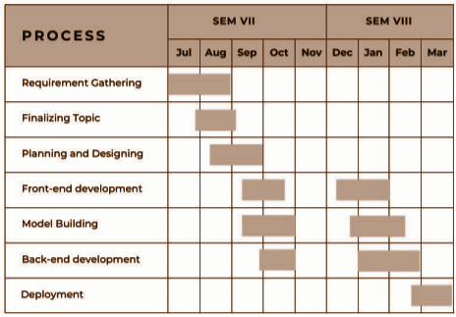

**Figure 4.4: Project Timeline (Gantt Chart)**

# 

# 

# 

# 

# 

# 

# 

# 

# 

# Implementation of the Proposed System

## 5.1 Methodology Employed for Development

The development of *GameSpec Advisor* followed an **iterative and modular approach**, leveraging the Agile methodology. This allowed for rapid prototyping, continuous feedback incorporation, and parallel development of independent components.

**Phases of development included:**

* **Requirement Analysis:** Based on user expectations and gaps in existing systems.
* **Data Collection & Preprocessing:** Gathering structured and unstructured data from APIs and web scraping.
* **Model Design & Integration:** Developing sentiment analysis and recommendation models.
* **Backend Logic Implementation:** Tying together logic for compatibility checks, benchmark lookup, and configuration generation.
* **Frontend Development:** Creating a responsive, user-friendly interface.
* **Testing & Feedback Loop:** Unit testing, integration testing, and user validation.

The system was designed using a loosely coupled architecture to allow future expansion and model upgrades without significant overhauls.

## 5.2 Algorithms and Flowcharts for the Respective Modules Developed

### 5.2.a. Configuration Analysis:

To ensure efficient system design, we utilize a **feature correlation matrix** to analyze relationships between hardware components. This reduces dimensionality and improves the accuracy of compatibility assessments by identifying significant interdependencies.

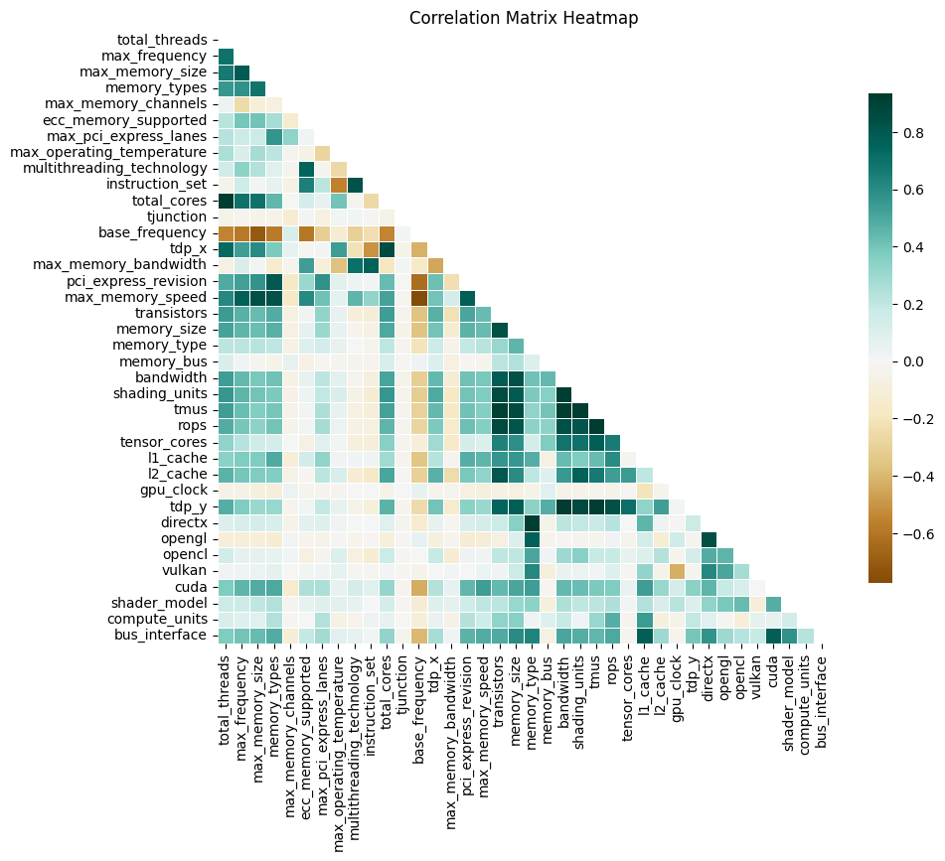

**Figure 5.1: CPU-GPU Correlation Heatmap**

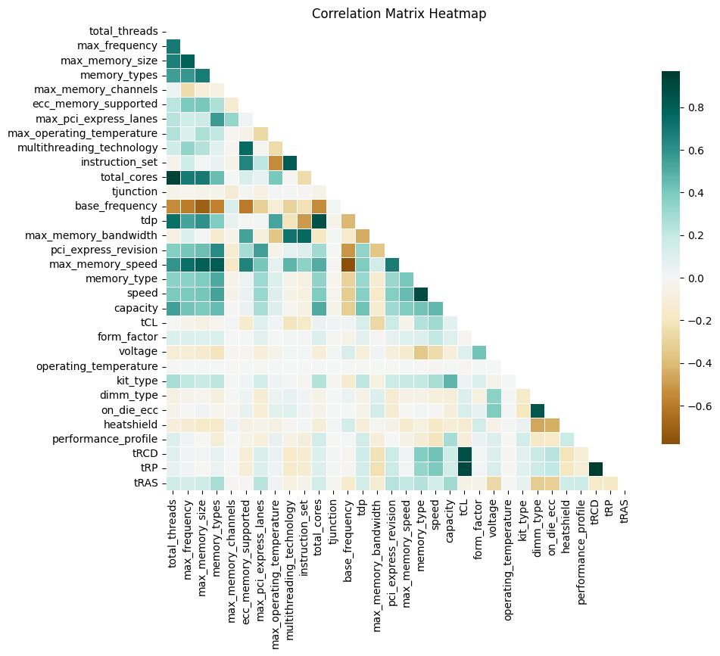

**Figure 5.2: CPU-Memory Correlation Heatmap**

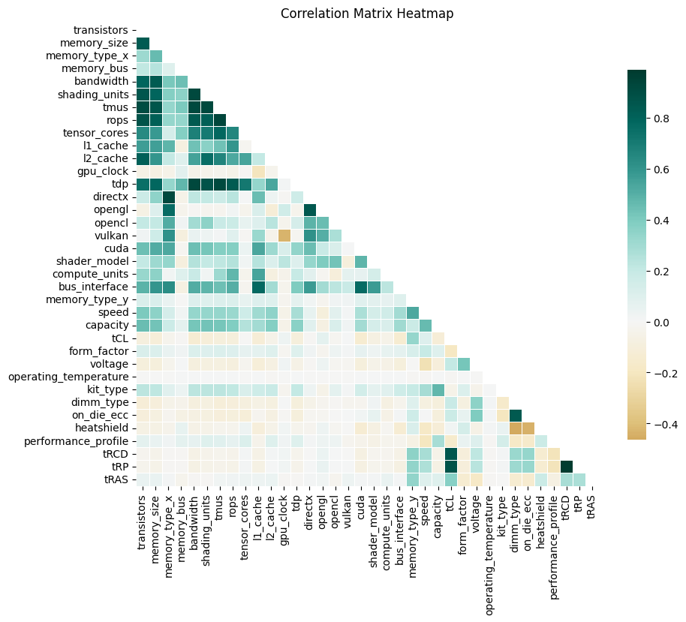

**Figure 5.3: GPU-Memory Correlation Heatmap**

### 5.2.b. Association Rule Mining for Component Pairing

We apply **Association Rule Mining (ARM)** to identify frequently co-occurring hardware combinations where **CPU** is the antecedent and the consequent is either **Memory** or **GPU**. This allows us to calculate key metrics such as **support**, **confidence**, and **lift** for each **CPU-Memory** and **CPU-GPU** pair. By using ARM, we can identify which components are most likely to co-occur with specific CPUs, and recommend the best hardware configurations based on these co-occurrences.

The **ARM approach** uses the following metrics:

* **Support**: The frequency with which the pair of components occurs together.
* **Confidence**: The likelihood that the consequent (either Memory or GPU) appears given the CPU.
* **Lift**: The degree to which the occurrence of the consequent (Memory or GPU) is more likely given the antecedent (CPU), compared to its expected occurrence.

| **Processor** | **RAM** | **Graphics Card** |
| --- | --- | --- |
| AMD Ryzen 5 5600X 3.7 GHz 6-Core | Corsair Vengeance LPX 16 GB DDR4 | EVGA SC ULTRA GAMING GeForce GTX 1660 SUPER 6 GB |
| AMD Ryzen 7 5700G 3.8 GHz 8-Core | G.Skill Aegis 8 GB DDR4 | Gigabyte EAGLE Radeon RX 6600 8 GB |
| Intel Core i5-4460 3.2 GHz Quad-Core | Kingston KVR13N9S6/2 2 GB DDR3 | PNY VCG84512D3SPPB GeForce 8400 GS 512 MB PCI |
| Intel Core i7-13700K 3.4 GHz 16-Core | G.Skill Trident Z5 RGB 32 GB DDR5 | Asus TUF GAMING OC GeForce RTX 4070 Ti 12 GB |

**Table 5.1: Pre-Built PC Configurations**

In the following table, we calculate support, confidence, and lift for CPU-Memory and CPU-GPU pairs. The antecedent is always a CPU, and the consequent is either Memory or GPU. These metrics are derived using concepts from Association Rule Mining (ARM):

| **Antecedent (CPU)** | **Consequent (Memory / GPU)** | **Support** | **Confidence** | **Lift** |
| --- | --- | --- | --- | --- |
| **AMD Ryzen 5 5600X** | Corsair Vengeance LPX 16 GB (Memory) | 0.22 | 0.85 | 1.67 |
| **AMD Ryzen 5 5600X** | EVGA SC ULTRA GAMING GeForce GTX 1660 SUPER (GPU) | 0.20 | 0.75 | 1.50 |
| **AMD Ryzen 7 5700G** | G.Skill Aegis 8 GB DDR4 (Memory) | 0.18 | 0.78 | 1.54 |
| **AMD Ryzen 7 5700G** | Gigabyte EAGLE Radeon RX 6600 (GPU) | 0.17 | 0.76 | 1.52 |
| **Intel Core i5-4460** | Kingston KVR13N9S6/2 2 GB DDR3 (Memory) | 0.15 | 0.91 | 1.72 |
| **Intel Core i5-4460** | PNY VCG84512D3SPPB GeForce 8400 GS (GPU) | 0.13 | 0.85 | 1.60 |
| **Intel Core i7-13700K** | G.Skill Trident Z5 RGB 32 GB DDR5 (Memory) | 0.25 | 0.92 | 1.81 |
| **Intel Core i7-13700K** | Asus TUF GAMING OC GeForce RTX 4070 Ti (GPU) | 0.23 | 0.91 | 1.78 |

**Table 5.2: Association Rule Mining Results for Pre-Built PC Configurations**

Explanation of Support, Confidence, and Lift:

1. **Support**: Represents the fraction of transactions (or configurations) in which the **CPU**-**Memory** or **CPU**-**GPU** combination occurs. For example, the support of 0.22 for the pair "AMD Ryzen 5 5600X" and "Corsair Vengeance LPX 16 GB" means this combination occurs in 22% of the total configurations.
2. **Confidence**: This is the likelihood that a given **Memory** or **GPU** is chosen when a specific **CPU** is selected. For example, the confidence of 0.85 for the pair "AMD Ryzen 5 5600X" and "Corsair Vengeance LPX 16 GB" indicates that 85% of the configurations containing the CPU also contain this particular Memory module.
3. **Lift**: Measures the strength of the association between **CPU** and **Memory**/**GPU** by comparing the observed confidence to the expected confidence if the two were independent. For instance, the lift of **1.67** for "AMD Ryzen 5 5600X" and "Corsair Vengeance LPX 16 GB" suggests that this combination is **67% more likely** than expected by chance.

### 5.2.c. Building custom NER model

To extract domain-specific hardware terms from tech content, we evaluated multiple Named Entity Recognition (NER) models. The aim was to select a context-aware and accurate solution capable of recognizing entities like CPUs, GPUs, and other components.

**Models Evaluated**

* **spaCy (General Model)**
  + Fast, lightweight NLP library with efficient pre-trained NER models.
  + Struggles with domain-specific hardware terminology without customization.
* **BERT (dslim/bert-base-NER)**
  + General-purpose transformer model.
  + Underperformed on specialized hardware terms without further fine-tuning.
* **RoBERTa (roberta-large-ner-english)**
  + Strong contextual representation and long sentence handling.
  + Limited granularity for technical terminology.
* **Stanford NER (Stanza)**
  + Traditional CRF-based model.
  + Lacked flexibility and struggled with nuanced hardware detection.

**Evaluation Metrics**

| **Model** | **Accuracy** | **Precision** | **Recall** |
| --- | --- | --- | --- |
| spaCy (general-web) | 0.005 | 0.19 | 0.006 |
| BERT | 0.052 | 0.094 | 0.104 |
| RoBERTa | 0.07 | 0.132 | 0.147 |
| Stanford NER | 0.029 | 0.0465 | 0.0774 |

**Table 5.3: Model Evaluation Results**

**Final Model Selection: spaCy (Custom Model)**

* **Data Source**: Articles from Tom’s Hardware RSS feeds.
* **Annotation**: 9,752 text chunks annotated for hardware-related terms.
* **Filtering**: Non-relevant chunks excluded.
* **Model Training**: 200 epochs on spaCy with 11 entity types: CABINET, CPU, GPU, LAPTOP, MOTHERBOARD, PSU, RAM, STORAGE, MONITOR, SOUND CARD, MISC

**Reasons for Selection:**

* **Customizability**: Trained with domain-specific hardware labels.
* **Performance**: High-speed processing suitable for large-scale extraction.
* **Integration**: Seamlessly connects with downstream NLP tasks.

### 5.2.d. Sentiment Analysis Engine

The proposed sentiment analysis system uses a customized **Skip-Gram-based Word2Vec** model to capture both semantic relationships and sentiment information from text. The process begins with encoding sentimentally significant entities and keywords as binary vectors, while context words are labeled using predefined lexicons like **VADER**. Unlike traditional Skip-Gram models, which use a sliding context window, this approach adapts the context to the full sentence, enabling it to capture long-range dependencies between words. The model learns dense word embeddings rich in both semantic and sentiment-related information. Sentiment scores are then computed by cross-referencing these embeddings with VADER polarity scores, using a weighted average of context words to determine overall sentiment. Special attention is given to negation handling through both simple rule-based techniques and spaCy’s dependency parsing to accurately detect and invert sentiments in complex sentence structures.

Beyond text analysis, the system evaluates sentiment toward hardware configurations by forming **CPU-GPU** and **CPU-RAM** pairs and analyzing their impact on user sentiment. The YouTube API is integrated to extract performance reviews, providing real-world insights. Relevant technical terms and entities are identified using **KeyBERT** for keyword extraction and a **spaCy custom NER model** for recognizing components and metrics. These extracted terms are then evaluated by the sentiment model to determine how specific hardware combinations influence user perception. The model architecture includes an input layer of binary word vectors, two dense layers with dropout for regularization, and a softmax output for multi-class classification, trained over 100 epochs using categorical cross-entropy loss and the Adam optimizer, with accuracy as the evaluation metric.

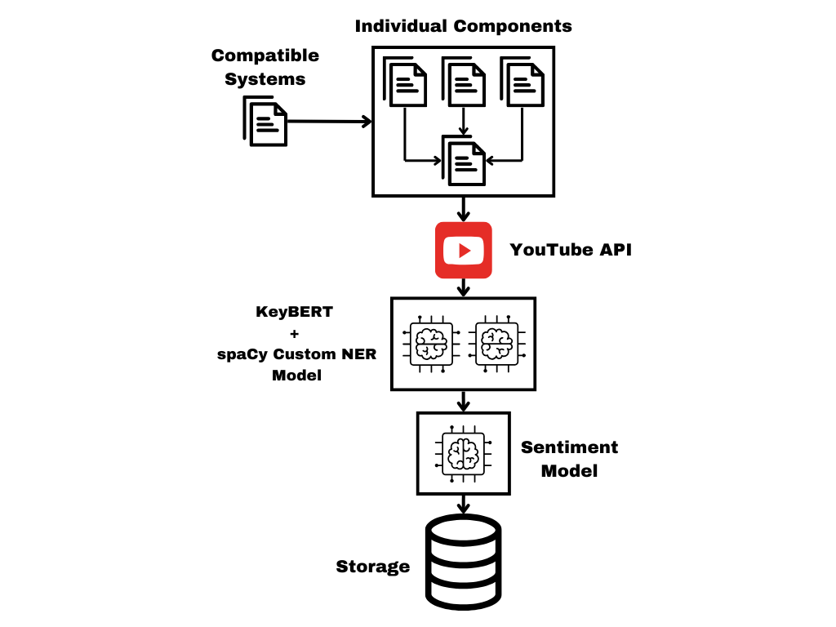

**Figure 5.4: Flowchart for Sentiment Analysis Module**

### 5.2.e. Component Compatibility Analysis using Anomaly Detection

The Anomaly Detection Module assesses the compatibility of custom gaming systems by identifying deviations from learned patterns of known compatible configurations.

**Compatible Systems Data Preparation**The process begins by mapping individual hardware components—such as CPU, GPU, RAM, and storage—from a component database into predefined compatible systems, which include both pre-built gaming setups and custom configurations. Using this expanded dataset, a new table is generated where each column represents specification matches (e.g., pci_express_match, memory_type_match) or unique features specific to certain components, like compute_units for GPUs.

**Autoencoder Model for Anomaly Detection**The preprocessed dataset is used to train an Autoencoder model, which learns to compress and reconstruct system configurations, effectively capturing the patterns and dependencies between hardware components. Once trained, the model serves as the foundation of the anomaly detection pipeline.

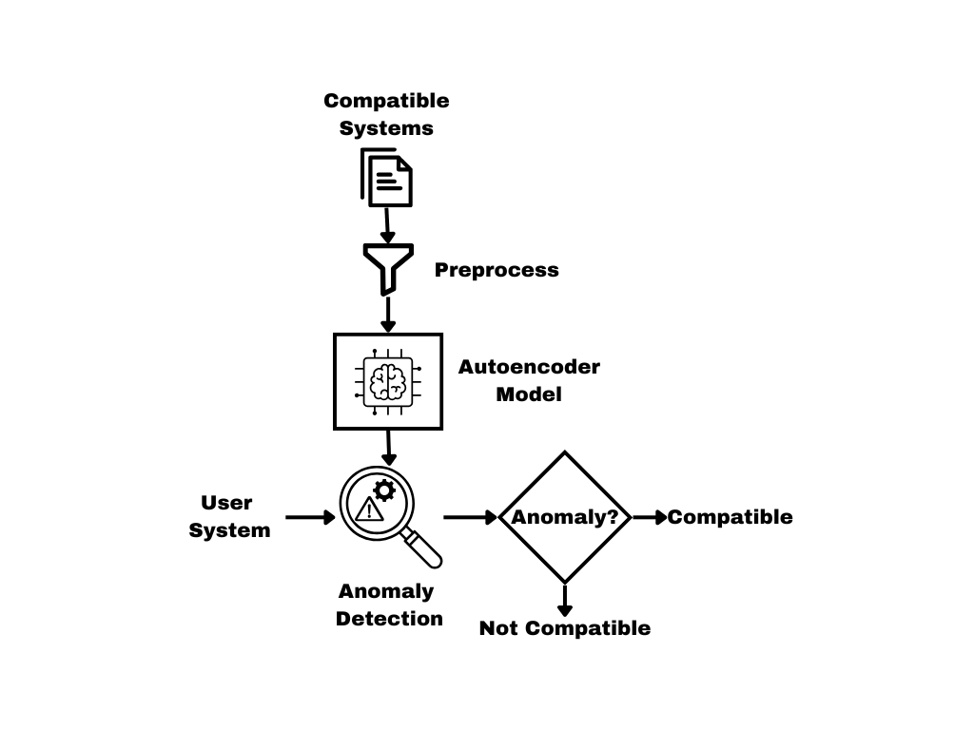

**Figure 5.5: Compatibility Analysis Pipeline**

**Compatibility Analysis Process**When a user submits a custom system configuration, it is passed through the anomaly detection pipeline. The Autoencoder attempts to reconstruct the input configuration and calculates a **Reconstruction Error**.

* If the reconstruction error falls below a predefined threshold, the system is considered **Compatible**.
* If the error exceeds the threshold, the system is flagged as **Not Compatible**, indicating potentially incompatible or unusual component combinations.

**Pairwise Component Evaluation**As shown in **Figure 9: Compatibility Analysis Pipeline**, a separate Autoencoder is trained for each of the **CPU-GPU** and **CPU-RAM** component pairs.This allows the system to dynamically select the appropriate anomaly detection model based on the user’s selected component combinations.

**Threshold Values for Reconstruction Error**

* **CPU-GPU:** 0.75
* **CPU-RAM:** 0.85

**Model Architecture**Each Autoencoder is built using the **TensorFlow Keras Sequential API** with the following architecture:

| **Layer** | **Type** | **Activation** | **Dropout** | **Regularization** |
| --- | --- | --- | --- | --- |
| Input Layer | Dense (128 neurons) | ReLU | 0.2 | L1 Regularization (λ=1e-5) |
| Hidden Layer 1 | Dense (64 neurons) | ReLU | 0.2 | None |
| Hidden Layer 2 | Dense (16 neurons) | ReLU | 0.2 | None |
| Hidden Layer 3 | Dense (64 neurons) | ReLU | 0.2 | None |
| Hidden Layer 4 | Dense (128 neurons) | ReLU | 0.2 | None |
| Output Layer | Dense (Input Dimension) | Linear | - | None |

**Table 5.4: Model Architecture for AutoEncoder**

The model is trained with the following hyperparameters:

| **Hyperparameter** | **Value** |
| --- | --- |
| Optimizer | Adam |
| Loss Function | Mean Absolute Error (MAE) |
| Epochs | 100 |
| Dropout Rate | 0.2 |
| Regularization | L1 (λ = 1e-5) |

**Table 5.5: Model Hyperparameters**

### 5.2.f. Final Decision Autoencoder Model

1. **Requirement Extraction**
   * Game requirements fetched.
   * CPUs, GPUs, and RAM combinations relevant to those requirements are extracted.
2. **Association Rule Mining**
   * ARM is run on system configurations to determine frequent CPU-RAM and CPU-GPU pairs with computed Support, Confidence, and Lift.
3. **Autoencoder Compatibility Scoring**
   * Separate Autoencoder models for CPU-RAM and CPU-GPU pairs learn latent compatibility scores.
   * Benchmarks like PassMark and 3DMark supplement these scores.
4. **Sentiment Analytics Module**
   * Sentiment scores are derived from YouTube reviews and system performance reports using the custom sentiment model.
5. **Final Autoencoder Integration**
   * The final decision model takes:
     + Compatibility scores from CPU-RAM and CPU-GPU autoencoders.
     + ARM-derived Support, Confidence, Lift.
     + Benchmark scores.
     + Sentiment scores.
   * Outputs a final compatibility verdict: **Compatible / Not Compatible**

### 5.2.g. PC Health Capture

The user system data is collected using the following commands and stored in a file. Also there are commands that generate the whole system report and give the health status of each component. The screenshot attached for the same are as follows:

**1. User System data:**

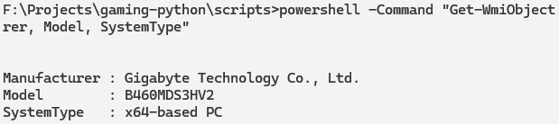

**Figure 5.6: Motherboard Details**

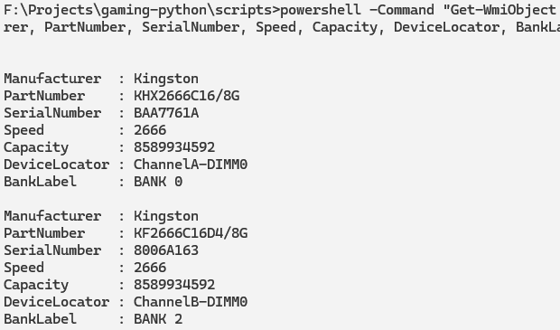

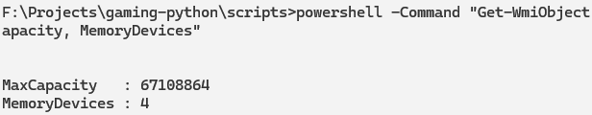

**Figure 5.7: Memory Details**

**2. Health Status Of PC:**

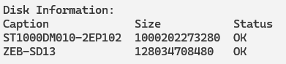

**Figure 5.8: Disk Status Details**

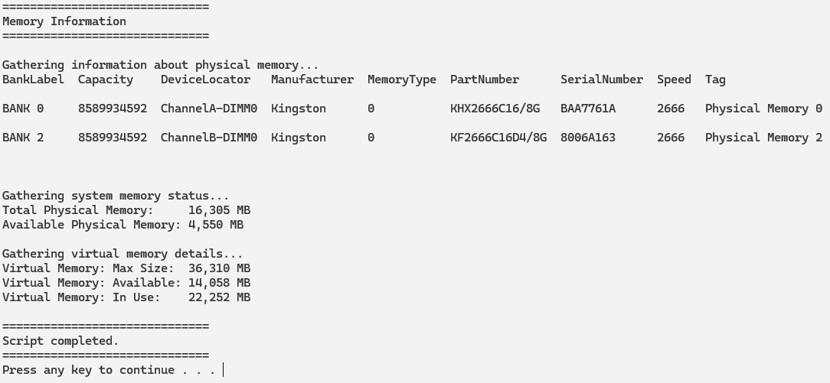

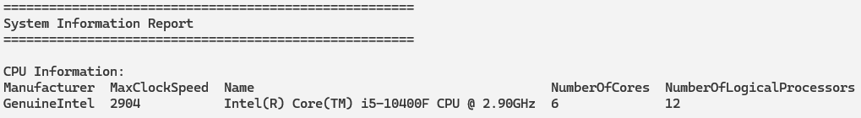

**Figure 5.9: RAM & CPU Details**

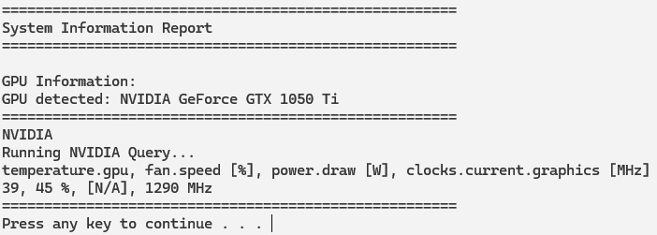

**Figure 5.10: GPU Details**

## 5.3 Datasets: Source and Utilization

To support various stages of the system development — including compatibility analysis, sentiment evaluation, and custom Named Entity Recognition (NER) model training — multiple reliable data sources were curated and utilized:

* **GPU Specifications**: Data for GPU models, specifications, and feature sets were collected from official manufacturer sites such as [AMD](https://www.amd.com/en/products/specifications.html), [TechPowerUp](https://www.techpowerup.com/), and [Newegg](https://www.newegg.com/), supplemented with consolidated GPU listings from [Wikipedia](https://en.wikipedia.org/wiki/List_of_Nvidia_graphics_processing_units) and other retailer sites like [EliteHubs](https://elitehubs.com/).
* **CPU Specifications**: Processor data, including model names, architecture, core counts, and memory support details, were sourced from official vendor websites: [AMD](https://www.amd.com/en/products/specifications.html) and [Intel ARK](https://ark.intel.com/content/www/us/en/ark.html#@).
* **RAM Specifications**: Detailed RAM module information such as memory type, speed, and latency timings was aggregated from major memory manufacturers like [ADATA](https://www.adata.com/in/consumer/category/computer-memory/), [Corsair](https://www.corsair.com/), [Crucial](https://www.crucial.com/catalog/memory), [G.Skill](https://www.gskill.com/), [Patriot](https://www.patriotmemory.com/), [Samsung](https://semiconductor.samsung.com/dram), and several others.
* **Pre-Built System Configurations**: Data for pre-configured gaming and workstation systems were gathered from [ASUS](https://www.asus.com/in/displays-desktops/all-in-one-pcs/all-series/filter?Series=Everyday-use&Spec=215875), [CyberPowerPC](https://www.cyberpowerpc.com/), [EliteHubs](https://elitehubs.com/collections/eternalx-gaming-pc?usf_take=112), [MDComputers](https://mdcomputers.in/pre-built-pc), and community builds via [PCPartPicker](https://pcpartpicker.com/builds/).
* **Gaming Titles for Compatibility Mapping**: Official APIs like [Steam’s GetAppList](https://api.steampowered.com/ISteamApps/GetAppList/v2/) and game listings from [GOG](https://www.gog.com/en/games) were used to extract metadata on popular and relevant gaming titles for system-performance sentiment analysis.
* **YouTube Reviews and Benchmarks**: The [YouTube Data API](https://developers.google.com/youtube/v3) was employed to extract video metadata and transcripts from popular hardware review and benchmarking channels such as **Linus Tech Tips**, **Gamers Nexus**, **JayzTwoCents**, **Tom’s Hardware**, and others.
* **Technical Articles for NER Training:** Articles from [Tom’s Hardware Archive](https://www.tomshardware.com/archive) were utilized for training and fine-tuning the custom spaCy-based NER model, enabling precise identification of technical components, specifications, and performance metrics in user-generated content.

These diverse, high-quality datasets provided a comprehensive foundation for system compatibility evaluation, sentiment analysis, and domain-specific natural language processing tasks.

# 

# 

# 

# 

# 

# Testing of the Proposed System

## 6.1 Introduction to Testing

Testing is an essential phase in the software development lifecycle aimed at validating the accuracy, reliability, and performance of the system. For *GameSpec Advisor*, testing ensures that each module—be it compatibility checking, or sentiment analysis—functions correctly and meets user expectations.

## 6.2 Types of Tests Considered

The following types of testing were employed during the development of the proposed system:

* **Unit Testing:** Each individual module was tested in isolation.
* **Integration Testing:** After unit-level validation, modules were tested together to verify interaction consistency.
* **System Testing:** End-to-end testing of the entire application flow from input to recommendation and user review scoring.
* **Usability Testing:** Conducted to assess how user-friendly and intuitive the UI and overall experience are.
* **Performance Testing:** Evaluated system responsiveness under multiple requests and larger datasets.

## 6.3 Various Test Case Scenarios Considered

Below are some of the key test scenarios:

| **Test Case ID** | **Scenario** | **Input** | **Expected Output** | **Result** |
| --- | --- | --- | --- | --- |
| TC01 | Compatibility Check | CPU: Ryzen 5600X, GPU: RTX 3070, RAM: Corsair 2400Mhz 8GB | "All components compatible" | Pass |
| TC01 | Compatibility Check | CPU: Intel Core 2 Duo, GPU: RTX 3070, RAM: Corsair 2400Mhz 8GB | "CPU and GPU aren't compatible" | Pass |

**Table 6.1: Test Cases Used**

# Results and Discussion

## 7.1 Screenshots of User Interface (UI) for the Respective Module

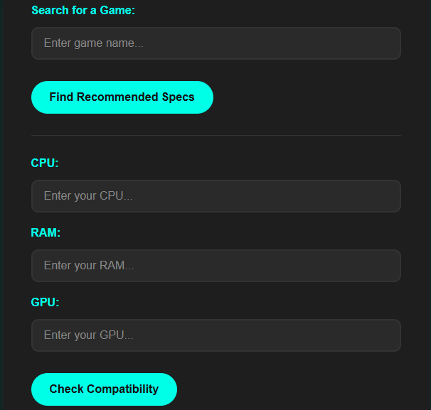

**Figure 7.1: Section User Posts their Requirements**

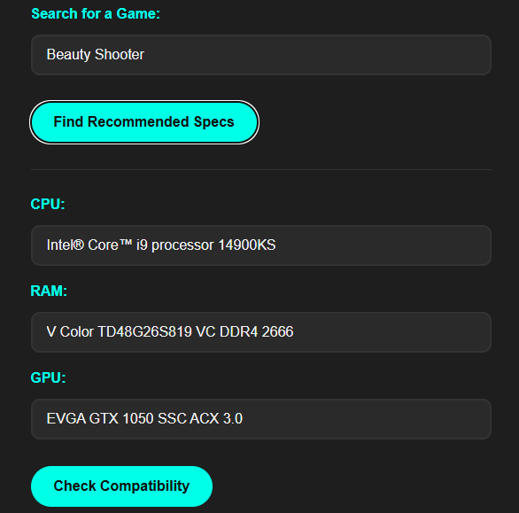

**Figure 7.2: Section User Getting PC Suggestion**

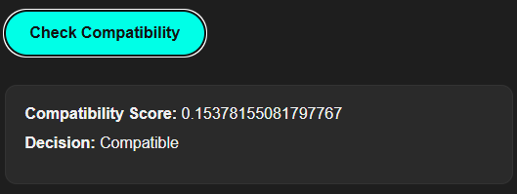

**Figure 7.3: Section User Getting Compatibility Score**

Average response time for recommendations: *~2.4 seconds*.  
Key inputs driving the recommendation system: Selected Game Title

## 7.2 Inference Drawn

From the testing and evaluation results:

* *GameSpec Advisor* significantly enhances user experience by offering intelligent, personalized build suggestions.
* It outperforms conventional systems in terms of game-specific recommendations, budget handling, and incorporating community feedback.
* The visual and performance data supports its efficiency, making it a valuable tool for both casual and serious gamers planning PC builds.

# Conclusion

## 8.1 Limitations

While *GameSpec Advisor* provides a robust and user-centric approach to building gaming PCs based on specific titles, performance goals, and budget constraints, it does have a few limitations:

* **Static vs Dynamic Pricing:** Component prices can vary significantly in real-time due to stock fluctuations, but our system relies on periodically updated data or API responses, which may cause a slight lag in accuracy.
* **Hardware Availability by Region:** The tool does not currently factor in region-specific availability or shipping constraints, which may affect build feasibility.
* **Limited Game Benchmark Database:** Some lesser-known or newer titles might not have detailed benchmark data available, affecting the precision of recommendations.
* **Subjective Review Sentiments:** Sentiment analysis on YouTube and Reddit relies heavily on the quality of language and context, which can occasionally lead to misinterpretations or bias in scoring.
* **No Real-Time Build Simulation:** While compatibility checks are thorough, the system doesn’t simulate actual build performance (thermals, bottlenecking under load) in real-time.

## 8.2 Conclusion

*GameSpec Advisor* successfully bridges a key gap in the PC building ecosystem by translating game-specific performance requirements into actionable hardware recommendations. By combining benchmark datasets, intelligent budget optimization, compatibility validation, and user sentiment analysis, it transforms the often overwhelming process of building a gaming PC into a guided, data-driven experience.

This system not only aids beginners but also offers value to intermediate users looking to fine-tune their builds or explore how different configurations perform on specific titles. The integration of community feedback further enhances the decision-making process by incorporating real-world usage insights.

Ultimately, *GameSpec Advisor* achieves its goal of empowering users to make informed, confident, and optimized choices for their gaming rigs.

## 8.3 Future Scope

To evolve *GameSpec Advisor* into a more advanced and intelligent tool, several enhancements are proposed:

* **Real-Time Price and Stock Tracking:** Integration with e-commerce APIs (Amazon, Newegg, Flipkart, etc.) for real-time pricing, availability, and discount suggestions.
* **Region-Aware Recommendations:** Factoring in user location for localized suggestions including delivery feasibility, tax implications, and currency conversions.
* **Thermal and Bottleneck Simulation:** Introducing AI-based thermal analysis and bottleneck estimations based on chosen configurations.
* **AI Chat Assistant for Build Help:** Adding an interactive assistant to guide users through the building process, troubleshooting, and upgrade advice.
* **Cloud-Based Build Saving and Sharing:** Enabling users to save, compare, and share their builds with a community or across sessions.
* **Mobile App Version:** Creating a mobile-friendly interface or app for quick on-the-go hardware lookup and build customization.

# References

[1] Mankodi, A., Bhatt, A., Chaudhury, B., Kumar, R., & Amrutiya, A. (2020). Evaluating machine learning models for disparate computer systems performance prediction. *IEEE Xplore*.<https://ieeexplore.ieee.org/document/9198512>

[2] Lopez, L., Guynn, M., & Lu, M. (2018). Predicting computer performance based on hardware configuration using multiple neural networks. *IEEE Xplore*.<https://ieeexplore.ieee.org/document/8614157>

[3] Ahmad, S., Saeed, A., & Rashid, M. (2021). Sentiment analysis on YouTube videos for kids: Review. *IEEE Xplore*.<https://ieeexplore.ieee.org/document/9596364>

[4] Google Developers. (n.d.). *YouTube Data API*. Retrieved April 13, 2025, from<https://developers.google.com/youtube/v3>

[5] TensorFlow. (n.d.). *An end-to-end open source machine learning platform*. Retrieved April 13, 2025, from<https://www.tensorflow.org/>

[6] MaartenGr. (n.d.). *KeyBERT*. GitHub. Retrieved April 13, 2025, from<https://github.com/MaartenGr/KeyBERT>

[7] Steam. (n.d.). *Steamworks Developer Documentation*. Retrieved April 13, 2025, from<https://steamcommunity.com/dev>

[8] UL. (n.d.). *3DMark*. Retrieved April 13, 2025, from<https://www.3dmark.com/>

[9] PassMark Software. (n.d.). *PassMark Software - PerformanceTest*. Retrieved April 13, 2025, from<https://www.passmark.com/>

[10] Syed, T. A., & Afzal, M. T. (2022). Comparative analysis of machine learning models for performance prediction of the SPEC benchmarks. *IEEE Access, 10*, 11688–11698.<https://doi.org/10.1109/ACCESS.2022.3145447>

[11] Nayak, D. R., Dash, R., & Mishra, D. (2020). A novel approach for system performance evaluation using hybridized benchmark metrics. *IEEE Access, 8*, 135912–135923.<https://doi.org/10.1109/ACCESS.2020.3010870>

# Appendix

## Project Review Sheet-I

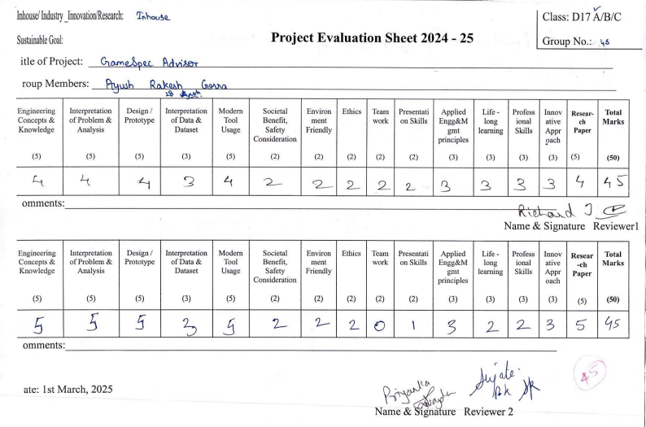

## Project Review Sheet-II

