**VIVEKANAND EDUCATION SOCIETY’S INSTITUTE OF TECHNOLOGY**

**An Autonomous Institute Affiliated to University of Mumbai**

## Department of Computer Engineering



#### Project Report on

“FinChores - Manage Life, Master Finances”

In partial fulfillment of the Fourth Year, Bachelor of Engineering (B.E.) Degree in Computer Engineering at the University of Mumbai Academic Year 2024-25

### Submitted by

Anchal Motwani (D17 - B , Roll no - 31) Anjala Goreja (D17 - A , Roll no - 20) Darpan Moorpani (D17 - A , Roll no - 42) Karan Kewalramani(D17 - C , Roll no - 35)

### Project Mentor

Mrs. Priti Joshi

(2024-25)

**VIVEKANAND EDUCATION SOCIETY’S INSTITUTE OF TECHNOLOGY**

**An Autonomous Institute Affiliated to University of Mumbai**

## Department of Computer Engineering



**Certificate**

This is to certify that ***Anchal Motwani(D17B/31), Anjala Goreja(D17A/20), Darpan Moorpani(D17A/42), Karan Kewalramani(D17C/35)*** of Fourth Year Computer Engineering studying under the University of Mumbai have satisfactorily completed the project on “***FinChores - Manage Life, Master Finances*** ” as a part of their coursework of PROJECT-II for Semester-VIII under the guidance of their mentor ***Prof. Mrs. Priti Joshi*** in the year 2024-25 .

This thesis/dissertation/project report entitled “***FinChores - Manage Life, Master Finances*** ” by ***Anchal Motwani(D17B/31), Anjala Goreja(D17A/20), Darpan Moorpani(D17A/42), Karan Kewalramani(D17C/35)*** is approved for the degree of ***BE in Computer Engineering***.

|  |  |
| --- | --- |
| Programme Outcomes | Grade |
| PO1,PO2,PO3,PO4,PO5,PO6,PO7, PO8, PO9, PO10, PO11, PO12 PSO1, PSO2 |  |

**Project Report Approval For**

**B. E (Computer Engineering)**

This thesis/dissertation/project report entitled “***FinChores - Manage Life, Master Finances*** ” by ***Anchal Motwani(D17B/31), Anjala Goreja(D17A/20), Darpan Moorpani(D17A/42), Karan Kewalramani(D17C/35)*** is approved for the degree of ***BE in Computer Engineering***

Internal Examiner

External Examiner

Head of the Department

Principal

**Declaration**

We declare that this written submission represents our ideas in our own words and where others' ideas or words have been included, we have adequately cited and referenced the original sources. We also declare that we have adhered to all principles of academic honesty and integrity and have not misrepresented or fabricated or falsified any idea/data/fact/source in our submission. We understand that any violation of the above will be cause for disciplinary action by the Institute and can also evoke penal action from the sources which have thus not been properly cited or from whom proper permission has not been taken when needed.

|  |  |
| --- | --- |
| Anchal Motwani (D17B/31) | Anjala Goreja (D17A/20) |
| Darpan Moorpani (D17A/42) | Karan Kewalramani (D17C/35) |

Date: 28/04/2025

# ACKNOWLEDGEMENT

We are thankful to our college Vivekanand Education Society’s Institute of Technology for considering our project and extending help at all stages needed during our work of collecting information regarding the project.

It gives us immense pleasure to express our deep and sincere gratitude to Assistant Professor **Mrs. Priti Joshi** for her kind help and valuable advice during the development of project synopsis and for her guidance and suggestions.

We are deeply indebted to Head of the Computer Department **Dr.(Mrs.) Nupur Giri** and our Principal

**Dr. (Mrs.) J.M. Nair ,** for giving us this valuable opportunity to do this project.

We express our hearty thanks to them for their assistance without which it would have been difficult in finishing this project synopsis and project review successfully.

We convey our deep sense of gratitude to all teaching and non-teaching staff for their constant encouragement, support and selfless help throughout the project work. It is great pleasure to acknowledge the help and suggestion, which we received from the Department of Computer Engineering.

We wish to express our profound thanks to all those who helped us in gathering information about the project. Our families too have provided moral support and encouragement several times.

### Computer Engineering Department COURSE OUTCOMES FOR B.E PROJECT

Learners will be to,

|  |  |
| --- | --- |
| **Course Outcome** | **Description of the Course Outcome** |
| CO 1 | Able to apply the relevant engineering concepts, knowledge and skills towards the project. |
| CO2 | Able to identify, formulate and interpret the various relevant research papers and to determine the problem. |
| CO 3 | Able to apply the engineering concepts towards designing solutions for the problem. |
| CO 4 | Able to interpret the data and datasets to be utilized. |
| CO 5 | Able to create, select and apply appropriate technologies, techniques, resources and tools for the project. |
| CO 6 | Able to apply ethical, professional policies and principles towards societal, environmental, safety and cultural benefit. |
| CO 7 | Able to function effectively as an individual, and as a member of a team, allocating roles with clear lines of responsibility and accountability. |
| CO 8 | Able to write effective reports, design documents and make effective presentations. |
| CO 9 | Able to apply engineering and management principles to the project as a team member. |
| CO 10 | Able to apply the project domain knowledge to sharpen one’s competency. |
| CO 11 | Able to develop professional, presentational, balanced and structured approach towards project development. |
| CO 12 | Able to adopt skills, languages, environment and platforms for creating innovative solutions for the project. |

**Index**

|  |  |  |
| --- | --- | --- |
| **Sr. No.** | **Title** | **Pg. No.** |
|  | **Abstract** |  |
| **1.** | **Introduction** | 1 |
| 1.1 | Introduction | 1 |
| 1.2 | Motivation | 1 |
| 1.3 | Problem Definition | 2 |
| 1.4 | Existing Systems | 2 |
| 1.5 | Lacuna of the existing systems | 3 |
| 1.6 | Relevance of the Project | 3 |
| **2.** | **Literature Survey** | 4 |
| A. | Brief Overview of Literature Survey | 4 |
| B. | Related Works | 4 |
| 2.1 | Research Papers Referred | 5 |
| a. | Abstract of the research paper | 5 |
| b. | Inference drawn | 5 |
| 2.2 | Patent search | 8 |
| 1. | European Patent | 8 |
| 2. | US patent | 8 |
| 2.3 | Inference drawn | 9 |
| 2.4 | Comparison with the existing system | 10 |
| **3.** | **Requirement Gathering for the Proposed System** | 11 |
| 3.1 | Introduction to requirement gathering | 11 |
| 3.2 | Functional Requirements | 11 |
| 3.3 | Non-Functional Requirements | 12 |
| 3.4 | Hardware, Software , Technology and tools utilized | 12 |
| 3.5 | Constraints | 13 |
| **4.** | **Proposed Design** | 14 |
| 4.1 | Block diagram of the system | 14 |

|  |  |  |
| --- | --- | --- |
| 4.2 | Modular design of the system | 15 |
| 4.3 | Detailed Design | 16 |
| 4.4 | Project Scheduling & Tracking using Timeline / Gantt Chart | 16 |
| **5.** | **Implementation of the Proposed System** | 17 |
| 5.1 | Methodology employed for development | 17 |
| 5.2 | Algorithms and flowcharts for the respective modules developed | 18 |
| 5.3 | Datasets source and utilization | 19 |
| **6.** | **Testing of the Proposed System** | 20 |
| 6.1 | Introduction to testing | 20 |
| 6.2 | Types of tests Considered | 20 |
| 6.3 | Various test case scenarios considered | 23 |
| 6.4 | Inference drawn from the test cases | 24 |
| **7.** | **Results and Discussion** | 26 |
| 7.1 | Screenshots of User Interface (UI) for the respective module | 26 |
| 7.2 | Performance Evaluation measures | 27 |
| 7.3 | Input Parameters / Features considered | 28 |
| 7.4 | Graphical and statistical output | 29 |
| 7.5 | Comparison of results with existing systems | 30 |
| 7.6 | Inference drawn | 30 |
| **8.** | **Conclusion** | 32 |
| 8.1 | Limitations | 32 |
| 8.2 | Conclusion | 32 |
| 8.3 | Future Scope | 33 |
|  | **References** | 34 |
|  | **Paper I & II Details** |  |
|  | Paper published | 35 |
|  | Certificate of publication |  |
|  | Plagiarism report | 42 |
|  | Project review sheet | 43 |

**Figures and Tables**

|  |  |  |
| --- | --- | --- |
| **Figures** | **1** | **Block Diagram** |
|  | **2** | **Modular Diagram** |
|  | **3** | **Flowchart** |
|  | **4** | **Project Scheduling & Tracking using Gantt Chart** |
|  | **5** | **Dataset** |
|  | **6** | **Testing** |
|  | **7** | **Login Page** |
|  | **8** | **Sign Up Page** |
|  | **9** | **Home Page** |
|  | **10** | **Add Expense Page** |
|  | **11** | **Add Budget Page** |
|  | **12** | **Fetch Budget Page** |
|  | **13** | **Add Note Page** |
|  | **14** | **Fetch Note Page** |
|  | **15** | **Bulk Upload Page** |
|  | **16** | **Add Expenses Using Receipt Page** |
|  | **17** | **Expense Prediction Using ARIMA Page** |
|  | **18** | **Splitwise** |
|  | **19** | **Graphical Output (1)** |
|  | **20** | **Graphical Output (2)** |
| **Tables** | **1** | **Comparison With Existing Systems** |

**Abstract**

In an age where financial literacy and efficient personal finance management are increasingly vital, this platform offers a comprehensive solution that integrates multiple aspects of day-to-day financial and household planning. The system begins with a centralized hub that branches into four key modules: Expense Tracking, Chores Management, Budget Management, and Goal-Based Investment.

The **Expense Tracking** module empowers users to manage and analyze their expenditures by adding or deleting categorized expenses, splitting costs with friends or groups, and even transferring money directly. Real-time financial insights are delivered through interactive graphs and charts for informed decision-making. Complementing this is the ability to upload and store receipts for transparent bookkeeping.

The **Chores Management** module allows users to create and maintain a chore list while also storing receipts related to task-related expenses. This section supports building discipline and collaboration in shared spaces.

**Budget Management** is enhanced with financial literacy lessons and quizzes, helping users deepen their understanding of money management. An integrated Machine Learning model analyzes user income and provides personalized saving recommendations, ensuring smarter budgeting practices.

The **Goal-Based Investment** module leverages Machine Learning to suggest tailored investment options based on the user’s financial goals, enabling better long-term financial planning.

Altogether, this platform is a versatile tool designed to simplify financial life through smart tracking, collaborative tools, and intelligent recommendations—making it ideal for individuals and groups seeking a holistic financial wellness solution.

# Chapter 1: Introduction

## Introduction

In today’s dynamic and increasingly digital world, effectively managing personal finances and daily responsibilities has become both essential and challenging. With an abundance of expenses, financial goals, and routine tasks to juggle, individuals often struggle to maintain a balanced and well-organized lifestyle. Recognizing this need, our platform introduces a unified solution that combines financial tracking, chore management, budgeting tools, and goal-based investment planning—all within a single, user-friendly interface.

This comprehensive system is designed to assist users in gaining full control over their financial health and daily routines. The **Expense Tracking** module allows users to effortlessly log and categorize their expenses, split bills with friends or groups, and even perform direct money transfers. Real-time insights through interactive charts and graphs help users visualize their spending habits and make informed decisions. For added transparency, users can upload and store receipts linked to their expenditures.

To help users plan for the future, the **Goal-Based Investment** module utilizes another ML model(ARIMA) to suggest tailored investment opportunities based on individual financial goals. This empowers users to make strategic investment decisions and build long-term wealth.

By integrating these diverse functionalities into a seamless experience, the platform not only simplifies financial management but also promotes responsible habits, strategic planning, and a more organized lifestyle. Whether for individuals or groups, it serves as a powerful tool to navigate the complexities of modern life with clarity and confidence.

## Motivation

In the modern era, managing finances is no longer limited to just balancing a checkbook or maintaining a savings account. With the rising cost of living, diversified spending options, and increased financial responsibilities, individuals are constantly faced with the challenge of staying financially organized and informed. Many people, especially young adults and working professionals, lack structured financial habits, leading to overspending, insufficient savings, and poor investment decisions.

At the same time, managing daily chores and responsibilities—especially in shared households or busy lifestyles—can become overwhelming without a proper system in place. Often, these two critical aspects of life—financial management and task organization—are treated separately, which adds to the chaos and inefficiency.

This project was driven by the idea of creating an all-in-one platform that simplifies personal finance management while also addressing everyday organizational needs. Our aim is to offer users more than just a basic expense tracker; we wanted to build a smart, interactive, and intelligent system that not only records and analyzes expenses but also encourages better financial habits through insights, recommendations, and educational content.

The inclusion of Machine Learning-based forecasting and investment suggestions adds a forward-looking dimension to the platform, helping users not only understand their current financial situation but also prepare for the future. Integrating chores and receipt management adds practical utility, making the system a holistic solution for everyday life management.

Ultimately, the motivation behind this project is to empower users to take control of their finances, develop financial literacy, stay organized, and make informed decisions that lead to a more secure and balanced lifestyle.

## Problem Definition

In today’s fast-paced world, individuals face increasing difficulty in managing their personal finances and daily responsibilities effectively. Despite the availability of various financial tools and budgeting apps, most solutions focus on a single aspect—be it expense tracking, budgeting, or investing—without offering a unified approach. As a result, users often find themselves switching between multiple platforms to manage their money, track chores, and plan future goals, which leads to fragmentation and inefficiency.

Several key challenges exist:

* + - **Lack of Centralization**: Users need to track income, categorize expenses, manage chores, and plan investments, but no single platform integrates all these functions seamlessly.
    - **Limited Predictive Insights:** Most tools provide only historical data analysis. Users lack intelligent forecasting to anticipate future expenses and income trends.
    - **Poor Financial Awareness**: A large section of the population, especially youth, lacks financial literacy and does not receive timely guidance on saving or investing.
    - **Inadequate Visualization & Planning Tools**: Users often struggle to understand their financial health due to limited or ineffective visualizations and goal-setting features.
    - **Absence of Daily Life Integration**: Managing chores, storing receipts, and tracking personal responsibilities are overlooked in most financial applications, yet they play a vital role in everyday financial decisions.

To address these gaps, this project introduces a comprehensive financial and organizational assistant. It leverages **Tesseract OCR** to scan and extract data from physical receipts, minimizing manual effort and increasing accuracy in expense logging. Furthermore, it utilizes the **ARIMA (AutoRegressive Integrated Moving Average)** model to predict future income and expenditure trends, enabling smart **goal-based investment planning**. The platform also supports real-time visualizations, bill splitting, task tracking, and machine learning-based savings recommendations, making it a holistic solution for modern personal finance management.

## Existing Systems

Several applications currently dominate the personal finance management space, each offering unique features to help users track and control their financial activities. **Mint**, developed by Intuit, is a widely used platform that automatically tracks income and expenses, categorizes transactions, sends bill reminders, and provides users with visual financial summaries through graphs. It also includes credit score monitoring, making it a one-stop solution for basic financial oversight.

Another popular tool, **YNAB (You Need A Budget)**, focuses on zero-based budgeting, allowing users to assign every dollar a purpose. It includes features such as goal setting, transaction syncing with bank accounts, detailed spending reports, and collaborative budgeting for households, making it ideal for users committed to hands-on financial planning.

**Splitwise** serves a more social need by offering features to track and split expenses between friends and groups. It helps simplify shared payments, especially for roommates or travel groups, and includes functionalities like payment reminders and basic expense summaries.

Lastly, **Goodbudget** uses the envelope budgeting system, allowing users to allocate funds to specific spending categories. It offers goal tracking, spending reports, and supports shared budgeting across multiple devices, enabling couples or families to manage finances collaboratively.

Each of these systems brings valuable capabilities to the table, particularly in expense tracking and budgeting, laying a foundation for more intelligent and integrated financial tools like the one proposed in this project.

## Lacuna in existing systems

### Mint

Mint excels in basic financial tracking with features like bill reminders and credit score monitoring. However, it lacks OCR-based receipt scanning, making it difficult to automatically capture and categorize purchases from physical receipts. Additionally, Mint does not offer predictive analytics for future financial trends, limiting users' ability to plan ahead based on their spending habits. There’s also no integration with task or chore management, leaving users without a way to combine financial tracking with daily tasks or goal management. These gaps hinder its potential as an all-in-one financial planning tool.

### YNAB (You Need A Budget)

YNAB offers a zero-based budgeting system with detailed goal-setting and spending reports, but it comes with its own limitations. The app lacks OCR-based receipt scanning, which would automate expense tracking for users. It also does not provide AI-driven forecasting, leaving users with limited predictive insights on future financial trends. Another significant issue is the steep learning curve, especially for new users who may struggle with the system's structure. This can make it less accessible for those unfamiliar with budgeting principles or technology.

### Splitwise

Splitwise focuses on simplifying shared expenses between friends and groups, but its capabilities are limited to just that: expense splitting. It lacks any budgeting or investment planning features, which would allow users to track their overall financial health. Additionally, it offers no visualization tools to help users see where their money is going over time. The absence of these features means Splitwise falls short as a comprehensive personal finance tool, instead functioning more as a niche solution for group financial activities.

### Goodbudget

Goodbudget is based on the envelope budgeting system, allowing users to allocate funds to specific categories. However, it lacks real-time receipt scanning, which would help users automatically track their spending and avoid manual entry. Furthermore, Goodbudget does not offer investment or predictive analytics, limiting its ability to provide insights into future financial trends. The app also lacks features for financial education, which could guide users in improving their money management skills. These gaps reduce the app's potential to support users in making well-rounded financial decisions.

## Relevance of Project

This project addresses the growing need for individuals to efficiently manage their **personal finances and daily responsibilities** through a unified digital platform. By integrating **expense tracking**, **budget management**, **goal-based investments**, and **chore organization**, the system offers a holistic solution tailored for modern lifestyles. Key components like **expense tracking with receipt scanning (using Tesseract OCR)** simplify data entry and ensure accurate financial records.

The **budget management module**, enhanced with **machine learning**, recommends savings plans based on a user’s income and spending habits. Additionally, the **goal-based investment system** utilizes the **ARIMA model** to forecast potential returns, allowing users to make informed decisions aligned with their future financial goals. In essence, the project is highly relevant as it combines automation, machine learning, and user-friendly interfaces to empower individuals in managing both their **finances and daily routines**, all within a single, accessible application.

# Chapter 2: Literature Survey

## Brief Overview of Literature Survey

### Expense Tracking and OCR Integration:

Several studies highlight the importance of digitizing receipts for automated expense management. Optical Character Recognition (OCR), particularly using open-source engines like **Tesseract**, has been widely adopted for extracting textual data from physical receipts to reduce manual entry and improve accuracy.

### Machine Learning in Financial Planning:

The use of **time-series forecasting models** such as **ARIMA** has been explored for predicting financial trends and planning goal-based investments. Literature supports its effectiveness in modeling historical data and projecting future values, aiding users in making data-driven investment decisions.

### Budget Management Tools:

Various tools have emerged that help users categorize expenses and receive saving suggestions. Recent studies focus on the integration of **ML algorithms** to personalize financial recommendations based on income and spending patterns.

## Related Works

### Receipt Digitization using OCR

Research by **Süzen et al. (2020)** explored the application of Tesseract OCR for extracting data from supermarket receipts. Their study demonstrated that open-source OCR engines could effectively digitize text from complex receipt formats with high accuracy after preprocessing steps such as noise removal and image thresholding.

### Automated Expense Tracking Systems

**Agarwal et al. (2019)** proposed an intelligent expense tracker that combines OCR with keyword classification techniques to categorize receipts into relevant expense types. Their system reduced manual effort by over 60% and highlighted OCR’s role in reducing user dependency on manual logging.

### Financial Forecasting using ARIMA

**Zhang and Qi (2018)** presented a financial time-series forecasting model using ARIMA for household budgeting. The model achieved good accuracy in short-term predictions and was considered suitable for personal financial planning due to its simplicity and interpretability.

### Machine Learning for Expense Prediction

In a study by **Patel and Mehta (2021)**, ML models including ARIMA and LSTM were used to predict monthly expenditures based on previous data. Their work concluded that ARIMA was highly effective for linear, seasonal expense data and could be implemented in lightweight applications for individual users.

### Budgeting and Financial Recommendation Systems

A system developed by **Kumar et al. (2022)** introduced a budget manager that leverages ML techniques to analyze user transactions and generate personalized savings tips. The research emphasized that personalized recommendations based on spending patterns improved financial discipline and user engagement.

## Research Papers Referred

### Design and Implement of Real time Expense tracker using ML

* 1. Abstract: This research paper presents the design and implementation of a real-time expense tracker using machine learning algorithms, specifically Support Vector Machines (SVM) and Random Forest, to predict users' future expenses based on their salary data. The system aims to assist users in managing personal finances more effectively by providing accurate expense forecasts and recommending life insurance policies tailored to their financial profiles. The paper highlights the importance of data-driven financial planning and demonstrates the system's ability to improve financial decision-making through predictive analytics and real-time tracking.
  2. Inference: The inference drawn from this research is that integrating machine learning algorithms like Support Vector Machines (SVM) and Random Forest into personal finance management systems can significantly enhance the accuracy of expense predictions and offer valuable insights for financial decision-making. The real-time expense tracker, combined with tailored life insurance recommendations, provides users with a proactive tool for better financial planning and security. The system's effectiveness is reflected in its ability to identify spending patterns, predict future expenses, and assist users in making informed choices that safeguard their financial well-being.

### eExpense: A Smart Approach to Track Everyday Expense

* 1. Abstract: Tracking regular expenses is a key factor to maintain a budget. People often track expenses using pen and paper methods or take notes on a mobile phone or a computer. These processes of storing expense require further computations and processing for these data to be used as a trackable record. In this work, we are proposing an automated system named eExpense to store and calculate these data. eExpnese is an application that runs on Android smartphones. By using this application, users can save their expense by simply scanning the bills or receipt copies. This application extracts the textual information from the receipts and saves the amount and descriptions for further processing. It also monitors user's income by tracking the received SMS's from the user's saving accounts. By calculating income and expense it produces the user's balance on a monthly and yearly basis. Overall, this is a smart automated solution for tracking expenses.
  2. Inference: The inference from this work is that the proposed eExpense system offers a smart, automated solution for tracking expenses more efficiently than traditional manual methods. By allowing users to scan receipts and automatically extracting financial information, the system streamlines the process of recording expenses. Additionally, eExpense tracks income through SMS notifications from bank accounts, providing a comprehensive view of a user's financial status. By calculating income and expenses, the application helps users monitor the ir balance on a monthly and yearly basis, making financial management more accurate and convenient

### Splitwise: Efficient Generative LLM Inference Using Phase Splitting

* 1. Abstract: Generative large language model (LLM) applications are growing rapidly, leading to large-scale deployments of expensive and power-hungry GPUs. Our characterization of LLM inference shows that each inference request undergoes two phases: a compute-intensive prompt computation phase and a memory intensive token generation phase, each with distinct latency, throughput, memory, and power characteristics. Despite state-of-the-art batching and scheduling, the token generation phase underutilized compute resources. Unlike prompt computation, token generation does not need the compute capability of the latest GPUs and can be run with lower power and cost. Based on these insights, we propose Splitwise, a model deployment and scheduling technique that splits the two phases of LLM inference requests on to separate machines. Splitwise enables phase-specific resource management using hardware that is well suited for each phase.

Request state is transferred efficiently between machines using optimized network libraries on the fast back-plane interconnects available in today’s GPU clusters.

* 1. Inference: The inference from this work is that the proposed Splitwise technique offers a more efficient and cost-effective approach to deploying large language model (LLM) applications. By separating the compute-intensive prompt computation phase and the memory-intensive token generation phase onto different machines, Splitwise optimizes resource utilization. This phase-specific management allows for more tailored use of hardware, reducing power consumption and overall costs. The results demonstrate that Splitwise improves throughput and efficiency, achieving up to 1.4× higher throughput at 20% lower cost, or up to 2.35× higher throughput within the same power and cost budgets.

### Online Income and Expense Tracker

* 1. Abstract: Income and Expense Tracker will maintain data of daily, weekly, monthly, yearly expenses, Manages your expenses and earnings in a simple and intuitive way. Users can select the category of expense, enter other information like the user can capture a photo, add location, select amount of expense etc. And this will save to the local database. Users can view and sort expenses as per weekly, monthly, yearly. By using this, we can reduce the manual calculations for their expenses and keep track of the expenditure. In this, the user can provide his income to calculate his total expenses per day and these results will be stored for unique users. People who usually go for trips or movies with friends can use this tracker to maintain their expenses. It will be easy for them to share the bill in this tracker. This will display a graph as per selected view. And a user can enter his monthly income or limit of monthly Expense in this tr. This tracker system provides an integrated set of features to help you to manage your expenses and cash flow.
  2. Inference: The inference from this work is that the Income and Expense Tracker provides a user-friendly and efficient way to manage personal finances by automating the tracking of expenses and income. By offering features such as categorization, location tagging, and graphical representations, the system reduces the need for manual calculations and enhances financial visibility. Users can set income and expense limits, track their expenditures over different timeframes, and even use the tracker for group activities like trips or outings. Overall, the system simplifies expense management and helps users maintain better control over their finances.

### An innovation in paper receipts: the electronic receipt management system

* 1. Abstract: The problem our team addresses is best communicated in the following question: Given the number of merchants, consumers, and financial institutions in the U.S., how can we build a record-keeping system that improves the usability, accessibility, and sustainability of consumer transaction records? A recent study shows that 80% of the U.S. population receives one to three receipts a day, 11% of which immediately get thrown away. With America's retailers generating approximately 228.7 million pounds of receipt paper per year, this translates to 22.87 million pounds of paper that instantly becomes trash. Further, the current system does not make receipts readily accessible to merchants and consumers when they need them. In this project, our team aims to improve the management of consumer transaction records while reducing the number of receipts printed in the United States. A solution to this problem will also provide consumers with a more convenient way to monitor their spending habits. The system is composed of four parts: a web-based user interface, a mock cash register, a receipt management database, and an XML protocol that communicates between the cash register and the receipt database. If implemented on a national scale, this electronic receipt management system would allow users (merchants, consumers, and financial institutions) access to all receipt data in one location and in one consistent format, thereby eliminating the need for paper receipts.
  2. Inference: The inference from this project is that implementing a centralized electronic receipt management system can significantly reduce the environmental impact of paper receipts and improve the accessibility and usability of transaction records for merchants, consumers, and financial institutions. By eliminating the need for printed receipts, this system addresses the waste generated by millions of pounds of receipt paper each year, while also providing users with a convenient way to access and manage their transaction data. The proposed system's integration of a web-based interface, receipt database, and XML communication protocol enhances record-keeping efficiency and sustainability on a national scale.

### Expense Tracker Application using Naive Bayes

* 1. Abstract: This research discusses the enhancement of disease prediction accuracy through advanced machine learning techniques, focusing on chronic diseases such as diabetes, heart disease, and asthma. The study employs various algorithms, including Random Forest, SVM, and Gradient Boosting, each selected for its distinct predictive capabilities. The methodology emphasizes data preprocessing, including feature engineering and normalization, to improve model accuracy. The performance evaluation highlights the strengths and weaknesses of each algorithm, providing a comparative analysis based on accuracy, F1 score, and computational efficiency.
  2. Inference: This study introduces an Expense Tracker mobile application that utilizes the Naive Bayes algorithm for automated expense tracking. The app, developed for Android users using Kotlin and XML in Android Studio, allows manual entry of expenses and automatic detection of bank messages. The Naive Bayes algorithm is employed to classify these messages. The app provides visual representations of expenses through Pie Charts for multiple time frames such as monthly,weekly, yearly etc. It helps users gain insights into their spending habits. With Firebase as the online database, data persistence is ensured even if the app is uninstalled. Overall, the Expense Tracker app offers a user-friendly solution for individuals to manage their finances effectively and make informed decisions about their expenses.

### Expense Tracker and Budget Planner

* 1. Abstract: The Expense Tracker And Budget Planner Project is a dynamic and innovative solution designed to revolutionize personal and business financial management by offering a user-friendly online platform for tracking, analyzing, and optimizing expenses. With the increasing importance of financial awareness and responsible spending, this project addresses the need for a streamlined and accessible tool that empowers users to take control of their finances. This web-based platform is developed to cater to individuals, families, and small businesses, providing them with a comprehensive suite of features for managing their expenses effectively. Users can effortlessly log their expenditures, categorize transactions, and set budgets to monitor their spending habits. The system provides visual representations of financial data to enable users to gain insights into their financial patterns.
  2. Inference: The inference from the Expense Tracker and Budget Planner Project is that creating a user-friendly online platform for tracking and managing expenses can significantly enhance financial literacy and responsibility among individuals and businesses. By offering features such as expense logging, transaction categorization, and budgeting tools, the platform empowers users to gain better control over their finances. The inclusion of visual data representations further aids in understanding spending patterns, promoting informed decision-making. Overall, this project addresses the growing need for accessible financial management tools, making it easier for users to adopt responsible spending habits and optimize their financial resources.

### An ARIMA model for the forecasting of healthcare waste generation in the Garhwal region of Uttarakhand, India

* 1. Abstract: This study has been carried out to analyse and forecast the quantities of healthcare waste generated from the hospitals of Garhwal region of Uttarakhand, India. In this study, a suitable autoregressive integrated moving average (ARIMA) model has been developed, on the basis of different statistical parameters, for the forecasting of healthcare waste. The analysis of results on the basis of the statistical parameters such as adjusted R-square value, mean square error and mean absolute percentage error; the ARIMA model has been found as the best model for the forecasting of healthcare waste generation. The daily data of healthcare waste generation has been used to develop the ARIMA model in this study. The ARIMA model developed in this study would help the waste disposal firm to plan its waste collection and disposal strategy-related decisions in future.
  2. Inference: The study demonstrates the effective application of the ARIMA model, specifically the ARIMA configuration, for forecasting daily healthcare waste generation in the Garhwal region of Uttarakhand, India. Using statistical evaluation metrics such as adjusted R-squared, mean squared error, and mean absolute percentage error, the model was validated for its accuracy and reliability. This forecasting approach enables waste management firms to make informed decisions regarding waste collection and disposal planning. The success of ARIMA in this context highlights its potential for broader applications, including financial forecasting and goal-based investment predictions, as seen in systems like Finchores.
  3. **Patent search**
     1. **European Patent**

#### Patent 1

* Title: System and Method for Tracking Expenses and Billing
* Year: 2021
* Summary: This patent outlines a comprehensive expense tracking and billing system. It supports features like vendor management, automatic identification of pricing or quantity discrepancies, and employee feedback on goods or services. Users can scan or text receipts, and the system categorizes and bills expenses to respective clients or departments.

#### Patent 2

* Title: Device, System, and Method for Processing Images Including Amounts.
* Year: 2021
* Summary: This patent describes a method for processing receipt images to extract and highlight monetary amounts. The system identifies the region of interest containing the total expense from scanned receipts and associates it with a submission field for validation and reimbursement processes.

#### Patent 3

* Title: System and Method for Building a Time Series Model
* Year: 2023
* Summary: This patent describes a method for automatically constructing a time series model, including univariate and multivariate ARIMA models. It involves determining differencing orders, applying data transformations, and using iterative estimation and diagnostic checks to refine the model. The system enhances forecasting accuracy through structured, automated model development.

### US patent

#### Patent 1

* Title: Smart Expense Management System Using Machine Learning Algorithms
* Year: 2024
* Summary: This patent describes a smart expense management system that employs machine learning algorithms, including SVM and Random Forest, to predict user expenses and optimize budgeting. The application captures and analyzes financial data in real-time, allowing users to set budgets and track spending. It emphasizes user customization and provides insights into spending patterns, enhancing users' financial literacy and decision-making capabilities.
* Patent 2
* Title: Automated Expense Tracking System Using Optical Character Recognition (OCR)
* Year: 2023
* Summary: This patent outlines an automated expense tracking system named eExpense that utilizes Optical Character Recognition (OCR) to capture and process financial data from scanned bills and receipts. The application is designed for Android smartphones, enabling users to record expenses effortlessly by simply scanning their documents. It features an integrated income monitoring system that tracks user income through SMS notifications from bank accounts.

#### Patent 3

* Title: Online Income and Expense Tracking System with Integrated Features
* Year: 2024
* Summary: This patent outlines an innovative online income and expense tracking system designed to simplify financial management for users. The system allows users to maintain detailed records of 22 daily, weekly, monthly, and yearly expenses, providing an intuitive interface for managing both income and expenditures. Key features include categorization of expenses, the ability to capture photos of receipts, geolocation tagging, and manual input of expense amounts.
  1. **Inference drawn**

From the above research papers and patents, several key insights have been observed:

* **Integration of Machine Learning Models** such as SVM, Random Forest, Naive Bayes, and ARIMA in expense tracking systems significantly improves prediction accuracy for future expenses and budget planning.
* **Optical Character Recognition (OCR)**, particularly through open-source tools like Tesseract, is effectively used to digitize receipts and reduce manual input errors, leading to enhanced automation in expense logging.
* **Mobile and Web-Based Platforms** provide flexibility and ease of access to users, making financial management more user-friendly and efficient.
* **Smart Notifications and Income Tracking via SMS Parsing** represent a novel way to keep users updated about their financial status without requiring constant manual input.
* **Visualization Techniques**, such as pie charts and graphical timelines, enhance user understanding of spending patterns, promoting financial literacy.
* **Patents** showcase industry efforts toward building structured systems combining OCR, machine learning, and web-based interfaces for real-time and automated financial record-keeping.
* **Environmental Awareness** through innovations in electronic receipt systems demonstrates the growing shift toward sustainable finance tools.
  1. **Comparison with the existing system**

The proposed system offers several enhancements over existing expense tracking applications. In terms of manual data entry, while existing systems often require users to manually input their expenses, the proposed system automates this process using **OCR and SMS extraction**, thus significantly improving convenience. When it comes to predictive capabilities, most existing applications either lack prediction features or have limited ones. In contrast, the proposed system leverages machine learning models like **SVM, Random Forest, and ARIMA** to forecast expenses, providing users with insightful financial foresight. Regarding visual representation, although some current applications provide basic charts, the proposed system includes advanced visualizations like pie charts and trend lines to help users better understand their spending habits.

From a data storage perspective, while many applications store data locally or on third-party servers, the proposed system ensures secure cloud-based storage with Firebase, improving data accessibility and security. Moreover, the proposed solution is uniquely multi-functional, not only tracking and predicting expenses but also recommending life insurance options tailored to user financial profiles—something not commonly found in existing systems. Additionally, **automated receipt scanning using OCR** simplifies record-keeping compared to the manual entry method used in many applications. The system’s **income tracking via SMS** and **ARIMA-based time series analysis** for forecasting also stand out as innovative features. Finally, while existing applications may focus solely on expense tracking, the proposed system supports **goal-based financial planning**, positioning it as a comprehensive solution for personal financial management.

# Chapter 3: Requirement Gathering for the Proposed System

## Introduction to requirement gathering

Requirement gathering is a critical phase in the development lifecycle of any software project. For our personal finance management platform **Finchores** this process involves understanding the core needs of users in managing their income, expenses, savings, and overall financial behavior in an increasingly complex and fast-paced world. The primary objective of this phase was to identify what users expect from a comprehensive financial tool that not only tracks daily transactions but also assists with budgeting, goal-setting, predictive analysis, and even task management.

To build a truly user-centric system, it was essential to gather both **functional** and **non-functional** requirements by engaging in methods such as user interviews, competitor analysis, questionnaires, and brainstorming sessions. This helped in identifying key features like expense tracking, ARIMA-based forecasting for investments, receipt scanning via OCR, machine learning-driven budget recommendations, and chore management—all integrated into a single platform.

The requirement gathering process ensured that the solution not only meets user expectations but also addresses the limitations found in existing financial management tools. It laid a strong foundation for the system’s architecture and design, ensuring that every feature is purposeful, scalable, and user-friendly.

## Functional Requirements

### User Registration and Authentication

* + - Users should be able to register, log in, and securely manage their accounts.

##### Expense Tracking

* + - Users can add, edit, or delete expenses.
    - Expenses should be categorized (e.g., food, transport, bills).
    - Real-time analysis using graphs and charts should be available.
    - Users should be able to split expenses with friends or groups.
    - Money transfer functionality for settling shared expenses.

### Income Management

* + - Users can log income entries with sources and dates.
    - View monthly/annual income summaries.

##### Budget Management

* + - Users can set monthly budgets and financial goals.
    - Progress tracking toward budgeting goals.

### Goal-Based Investment

* + - Users can define financial goals (e.g., travel, emergency fund).
    - ARIMA model forecasts and recommends investment strategies tailored to user goals.

### Receipt Management

* + - Users can upload and store receipts.
    - Tesseract OCR extracts and logs relevant data from scanned receipts automatically.

## Non-Functional Requirements

### Performance

* + - The system should respond to user actions within 2 seconds for most operations.
    - Real-time analytics should process data efficiently for seamless experience.

### Scalability

* + - The application should handle increasing users and data volume without degradation in performance.

### Security

* + - All sensitive user data must be encrypted.
    - Secure login and logout mechanisms with session management should be implemented.

##### Reliability

* + - The platform must be highly available with minimal downtime.
    - Data loss should be prevented using reliable backup systems.

### Usability

* + - User interface should be intuitive and easy to navigate.
    - Visualizations and dashboards should be clean and informative.

### Compatibility

* + - The application should be accessible across multiple devices and browsers (responsive design).

### Maintainability

* + - The system should follow modular and clean coding practices for easy updates and maintenance.

### Accuracy

* + - Forecasts from the ARIMA model and OCR data extraction should maintain a high level of precision.

## Hardware, Software , Technology and tools utilized

### Hardware Requirements:

* + - Processor: Core i3/i5/i7
    - RAM:4-8GB
    - HDD:500GB

### Software Requirements:

* + - Platform: Windows 10/11, macOS
    - Coding Language: Java
    - Technologies: Angular, SpringBoot
    - Database: SQL (e.g., MySQL, SSMS)
    - IDE/Editor: VS Code, IntelliJ
    - ML: Google Colab

## Constraints

### Platform Dependency

* + The application is initially designed for web-based access. Mobile platform support may be considered in later phases.

### Limited Dataset for Predictive Models

* + The ARIMA model's accuracy for investment recommendations depends on the availability and quality of historical financial data, which may be limited or vary per user.

### OCR Accuracy

* + Tesseract OCR performance may be affected by image quality, handwriting, or non-standard receipt formats, potentially leading to inaccuracies in data extraction.

### Third-party Integration Limitations

* + Integration with external services (e.g., banks, UPI platforms, or email for bill retrieval) may be restricted due to API availability or access limitations.

### Data Storage and Privacy

* + All personal financial data must comply with local data protection laws (e.g., GDPR, Indian IT Act), which can impose constraints on data storage, processing, and transfer.

### User Dependence on Manual Input

* + Many features (e.g., expense logging, chore creation) rely on consistent and accurate user input, which may affect the platform’s effectiveness if not maintained.

### Hardware/Device Limitations

* + Users with low-end devices or unstable internet connections may experience reduced performance or delays in data visualization and model-based forecasting.

### Development Time and Resources

* + The scope of the project may be constrained by available development time, team size, and computing resources—especially for training ML models and deploying analytics.

### Security Implementation

* + Advanced security features such as multi-factor authentication, end-to-end encryption, and intrusion detection might not be fully implemented in the early stages due to time and complexity.

### Scalability at Launch

* + Initial deployment may not be optimized for handling a large number of concurrent users, which could affect performance under heavy load.

# Chapter 4:Proposed Design

## Block Diagram of the System

Fig. 1 Block Diagram

The block diagram illustrates the working flow of the FinChores system, designed to help users manage, track, and optimize their financial health through **intelligent automation**. The system begins by accepting user inputs such as expense entries, receipt uploads, income details, and financial goals. Based on the input type, the data undergoes appropriate preprocessing:

* + - Expense data is categorized by type (e.g., food, travel, utilities) to streamline financial tracking and reporting.
    - Receipt images are processed using **Tesseract OCR** to automatically extract and validate expense details.
    - Income and goal-related information is structured to ensure compatibility with **machine learning** models.

After the preprocessing stage:

* + - The Expense Tracking module handles all expense-related operations. It enables users to split expenses with groups or friends, add or delete categorized expenses, upload receipts for record-keeping, and visualize spending through **real-time graphs and charts.**
    - The Budget Management module uses an **ARIMA**-based machine learning model to analyze past income and spending patterns. Based on this analysis, it recommends optimal monthly savings targets and helps users balance their spending and saving habits dynamically.
    - The Goal-Based Investment module leverages another ML model to recommend personalized investment plans. These recommendations are tailored based on the user’s income, savings goals, risk appetite, and progress toward achieving defined milestones. The system updates goals and suggestions as user data evolves.

Finally, the system provides the user with:

* + - Comprehensive expense reports categorized by type and time period.
    - **Visual dashboards** offering insights into budget health, savings potential, and spending trends.
    - **Personalized** budget and saving recommendations aligned with current financial behavior.
    - Tailored investment plans to help users reach short-term and long-term financial goals effectively.

By integrating tracking, budgeting, and investment management into a single intelligent platform, FinChores ensures users maintain a clear view of their financial journey while receiving proactive recommendations to improve their financial well-being.

## Modular Diagram of the System

Fig. 2 Modular Diagram

## Detailed Design

Fig. 3 Flowchart

## Project Scheduling & Tracking using Timeline / Gantt Chart

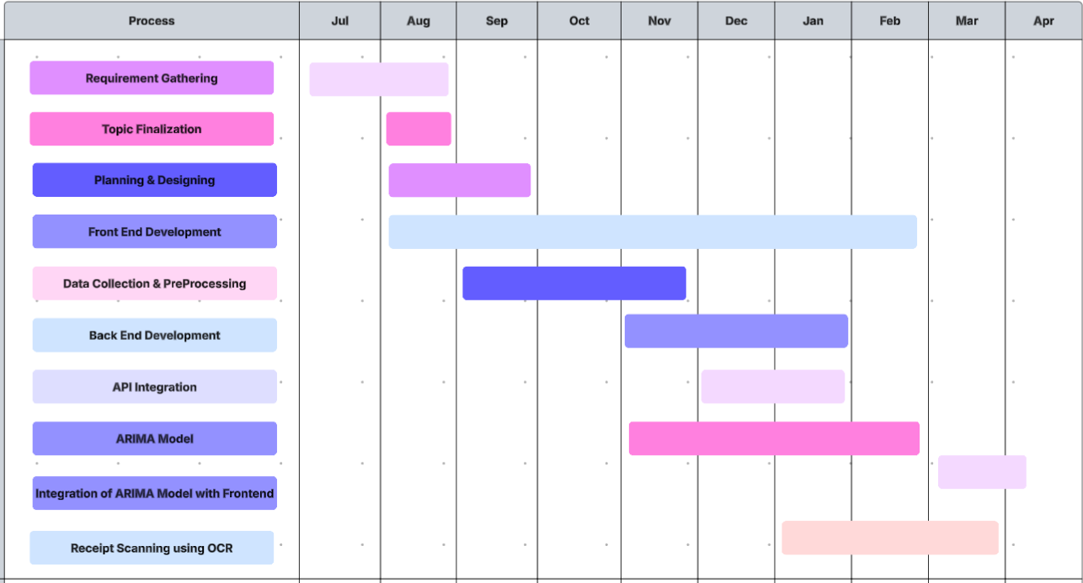

Fig. 4 Project Scheduling & Tracking using Gantt Chart

# Chapter 5: Implementation of the Proposed System

## Methodology Employed for Development

The development of the **Finchores** website followed a systematic, full-stack web development approach to ensure a seamless, scalable, and user-friendly financial management system. The steps included:

### Requirement Gathering and Analysis:

The initial phase focused on identifying user needs like tracking income, expenses, budgets, and predicting future spending. Feature requirements were finalized accordingly.

### Frontend Development:

* + - * **HTML**, **CSS**, and **Bootstrap** were used to design a clean and responsive UI.
      * **Angular** was employed to build a dynamic single-page application (SPA) structure, enhancing user experience through real-time updates without full page reloads.
      * Interactive elements like expense charts were incorporated using Angular libraries.

### Backend Development:

* + - * **Spring Boot** was used to create RESTful APIs, handling all business logic related to user income, expenses, budgets, and receipt uploads.
      * APIs were designed following proper HTTP methods (GET, POST, PUT, DELETE) and secured for basic data protection.

##### Database Management:

* + - * **SQL Server Management Studio (SSMS)** was used to manage structured storage of user data like transactions, budgets, notes, and receipts.
      * The database design included normalized tables to reduce redundancy and improve query performance.

### Integration and Connectivity:

* + - * **Ngrok** was used to expose the local Spring Boot server to the public, allowing seamless frontend-backend integration during development and testing phases.

### Receipt-Based Expense Upload and Prediction:

* + - * Google **Colab** was used to run machine learning models.
      * **Tesseract OCR** was utilized in Colab to extract text data from receipts.
      * **ARIMA** models were implemented for monthly expense forecasting based on historical transaction data.

### Testing:

* + - * Unit testing and manual end-to-end testing were performed for each module, ensuring correct functioning of income addition, expense tracking, budget management, and predictions.

## Algorithms and flowcharts for the respective modules developed

### Start

* + The user begins their interaction with the platform.

### Login/Signup

* + The user is prompted to either log into an existing account or register as a new user, ensuring secure and personalized access to services.

### Choose Feature (Decision Node)

* + After authentication, the user selects one of the three primary services:
    - Expense Tracking
    - Budget Management
    - Goal-Based Investment

### Path 1: Expense Tracking

* + Expense Tracking enables users to manage daily expenditures with multiple features:
    - Splitwise: Users can split expenses among friends or groups, aiding easy settlement.
    - Real-time Analysis (Graphs and Charts): Users receive visual insights into spending patterns for better financial decisions.
    - Add/Delete Expenses: Users can dynamically add or remove expenses under appropriate categories.
    - Upload/Store Receipts (Tesseract OCR): Users upload receipts, which are processed through OCR (Optical Character Recognition) to auto-fetch expense data.
  + After completing any of these actions, users are directed towards the end of the process.

### Path 2: Budget Management

* + Under Budget Management, the platform offers ML-based financial advice:

#### ML Model to Recommend Savings (based on Income):

* + - * Using the user’s income data, a machine learning model suggests an optimized saving plan.
  + This path also includes:
    - Upload/Store Receipts (Tesseract OCR): To automatically track additional expenditures that influence budget calculations.
  + Once done, users proceed toward the end.

### Path 3: Goal-Based Investment

#### Goal-Based Investment leverages an advanced prediction model:

* + - ARIMA Model to Predict Future Expenses:
      * Time-series forecasting (ARIMA) helps predict future expenses based on historical data, allowing better investment planning.
  + This predictive capability aligns users' financial goals with potential savings and investments. End
  + Regardless of the chosen path, all user journeys converge at the "End" node, indicating the completion of the selected service cycle.

## Datasets source and utilization

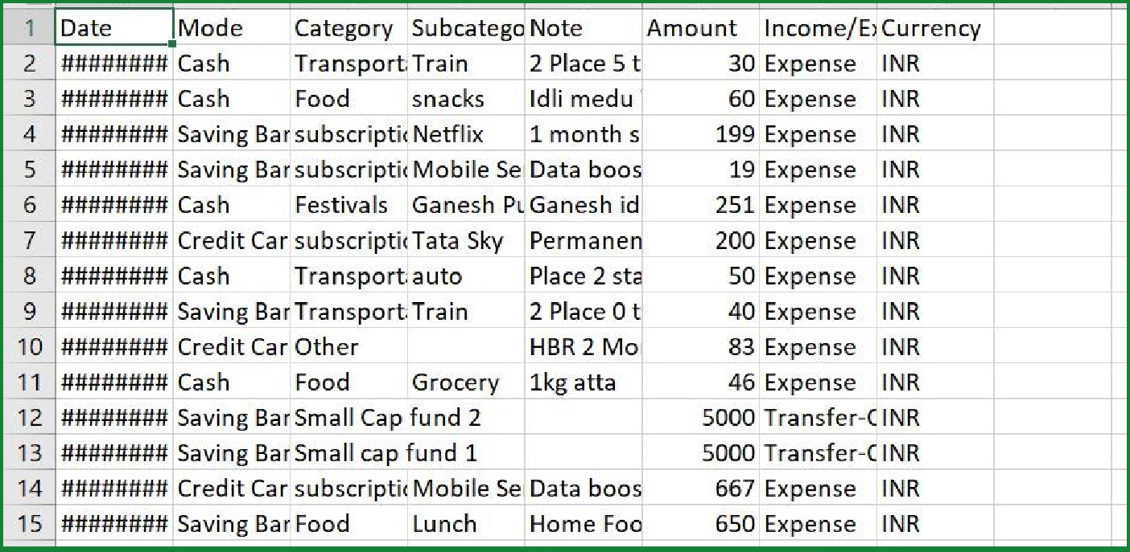

Fig. 5 Dataset

The dataset titled "Daily Household Transactions" captures everyday financial activities, including expenses, incomes, and transfers, categorized by payment mode, category, and subcategory. Each entry logs the amount spent or received along with contextual notes, offering a granular view of domestic financial behavior. Despite the obfuscated date column, the structured nature of the data makes it ideal for time series analysis. This dataset was utilized to build ARIMA models to forecast future household expenses, enabling better budgeting and financial planning through data-driven predictions.

### Data Utilization:

* Training: 80% of the dataset is used for model training.
* Validation: 10% is utilized for tuning hyperparameters.
* Testing: 10% is reserved for final model evaluation.
* Augmentation: Data augmentation techniques such as flipping, rotation, and contrast adjustments are applied to improve model generalization.

# Chapter 6: Testing of the Proposed System

## . Introduction to testing

Testing is a crucial phase in the software development life cycle that ensures the reliability, functionality, and usability of a web application before it reaches end-users. In the Finchores project, testing was employed to validate both the frontend and backend functionalities, ensuring that users have a smooth and error-free experience when managing their personal finances.

To automate the testing process and simulate real-user interactions, **Selenium WebDriver** was used. Selenium allows automated control over browser actions such as navigating pages, inputting data, clicking buttons, and verifying results — making it ideal for functional and UI testing of web applications like Finchores.

### The primary goals of testing the Finchores application were:

* + - To ensure that users can successfully log in and out of the application.
    - To verify that expenses can be added and displayed correctly in the dashboard.
    - To confirm that monthly expense predictions and graphs are rendered accurately.
    - To test invalid scenarios, such as incorrect login credentials or empty inputs.
    - To perform regression testing, ensuring that recent updates did not break existing features.

By incorporating automated Selenium tests, we aimed to improve test coverage, minimize human errors, and speed up the quality assurance process. Screenshots and logs were also captured during testing to help verify visual outputs and assist in debugging.

## 6.2. Types of tests Considered

### Functional Tests

These tests focus on ensuring that the application's core features work as expected. They check whether the application behaves according to the specified requirements.

* Login with Valid Credentials: This test ensures that when a user enters valid credentials (email and password), they are logged in successfully and redirected to the dashboard. The core functionality being tested here is the login mechanism and the proper redirection to the dashboard page.
* Login with Invalid Credentials: This test checks if the application handles invalid login attempts properly. When a user enters incorrect login details (either email or password), the application should display an appropriate error message (e.g., "Invalid credentials") and prevent the user from accessing the dashboard. The focus is on ensuring that error handling works correctly.
* Adding an Expense: This test verifies that a user can add an expense to their account. It checks whether the system properly accepts the expense data (amount and category) and updates the expense table on the dashboard. The functionality tested here is the expense addition process and whether the new expense is displayed correctly.
* Prediction Graph Visibility: This test confirms that the prediction graph is visible on the dashboard. It checks whether the graph element is displayed properly, ensuring the visual representation of the prediction data is available for the user. The focus is on ensuring that the graph's display functionality works correctly.

### Regression Tests

Regression tests are conducted to ensure that new code changes do not negatively affect existing functionality. The following tests would be part of the regression suite:

* Login Tests: Both the valid and invalid login tests ensure that the login functionality is working as intended, even after new updates or changes to the application.
* Expense Addition Tests: Ensures that the feature to add expenses continues to work correctly after updates to the app.

### Smoke Tests

Smoke tests are high-level tests designed to ensure that the application’s basic functionality is working. These tests are typically run to verify that the application is stable enough for more detailed testing.

* Login Test: The login test verifies that users can log in with valid credentials and handle invalid login attempts. This basic functionality is essential to accessing the rest of the features in the application.

### User Interface (UI) Tests

UI tests are focused on ensuring that the application’s user interface elements are rendered correctly and behave as expected.

* Prediction Graph Visibility: This test checks if the prediction graph is correctly displayed to the user. This ensures the UI element is present and visible on the dashboard, confirming that the graphical interface is correctly integrated into the page layout.
* Expense Table: Although not explicitly tested here, adding an expense would indirectly confirm the correct rendering and display of the expense table on the dashboard.

### Performance Tests

Although not directly included in the provided test cases, performance tests could be considered for ensuring that the system performs efficiently, especially for features like adding expenses or rendering prediction graphs. These tests would focus on checking:

* Login Performance: Ensuring that the login process completes within an acceptable time frame.
* Expense Addition Performance: Verifying that expenses are added without significant delay, ensuring smooth user experience.
* Graph Rendering Performance: Ensuring that the prediction graph renders quickly and does not cause performance issues, especially with larger data sets.

### Security Tests

Security tests are designed to ensure that sensitive data is handled securely, and unauthorized users cannot gain access to restricted areas.

* Login with Invalid Credentials: This test also helps ensure that security is enforced by preventing unauthorized access with incorrect login details.

### Usability Tests

Usability tests are focused on ensuring that the application is user-friendly and that the users can complete their tasks with ease.

* Login Test: Ensures that the login page is easy to navigate and that error messages are clear and helpful when invalid login credentials are provided.
* Expense Addition: Verifies that the process of adding an expense is intuitive, and the user can easily enter an amount and category without confusion.

### Error Handling Tests

Error handling tests ensure that the application gracefully handles unexpected conditions.

* Login with Invalid Credentials: Tests the application's ability to provide a helpful error message when invalid credentials are entered, ensuring users know why they can't log in.
* Expense Addition: If there were additional validation on the input fields for expenses (such as checking for invalid input), these validations would help ensure that the system catches errors and handles them gracefully, providing appropriate feedback.

In summary, the tests considered include **functional tests, smoke tests, UI tests, performance tests, security tests, usability tests, and error handling tests.** These cover the core functionalities of login, expense management, graph visibility, and logout, ensuring that the application is robust, secure, and user-friendly across various scenarios.

## 6.3 Various test case scenarios considered

### Login with Valid Credentials

* + Objective: To verify that a user can successfully log into the application when they provide valid credentials.
  + Test Scenario: The user navigates to the login page and enters a valid email address (e.g., [anchal@gmail.com)](mailto:anchal@gmail.com) and a valid password (e.g., anchal). The user then clicks the login button. After submitting the credentials, the system redirects the user to the dashboard page if the credentials are correct. The test checks if the URL contains the word “dashboard,” indicating a successful login. The expected result is that the user is logged in and can access the dashboard.

### Login with Invalid Credentials

* + Objective: To ensure that the application correctly handles invalid login attempts and provides appropriate feedback to the user.
  + Test Scenario: The user navigates to the login page and enters an incorrect email (e.g., [wronguser@example.com)](mailto:wronguser@example.com) and an incorrect password (e.g., wrongpass). Upon submitting the login form, the application should display an error message stating “Invalid credentials,” and the user should remain on the login page. The expected outcome is that the application prevents access to the dashboard and informs the user of the login failure.

##### Adding a Valid Expense

* + Objective: To confirm that the user can successfully add an expense to the system.
  + Test Scenario: The user is logged into the application and navigates to the dashboard page. They enter an expense amount (e.g., 2000) and select a category (e.g., Rent) for the expense. After clicking the submit button, the system should add the expense to the expense table, displaying the entered amount and category. The test checks whether the newly added expense is correctly displayed in the table. The expected result is that the new expense appears in the table on the dashboard.

### Prediction Graph Visibility

* + Objective: To ensure that the prediction graph is visible and accessible to the user.
  + Test Scenario: Once the user is logged into the application and on the dashboard, the system should display a prediction graph. This graph is designed to provide users with predicted financial

data. The test scenario checks that the graph element is visible on the page, verifying that the graph's visibility is correctly implemented. The expected result is that the prediction graph is rendered and displayed to the user without issues.

### Login with valid credentials:

* + Input: Correct email and password.
  + Expected Outcome: The user is redirected to the dashboard page.
  + Focus: Verifying successful login with valid credentials.

### Login with invalid credentials:

* + Input: Incorrect email or password.
  + Expected Outcome: An error message is displayed, and the user remains on the login page.
  + Focus: Ensuring error handling for failed login attempts.

### Adding a valid expense:

* + Input: Amount and category (e.g., 2000 for Rent).
  + Expected Outcome: The expense is added to the dashboard’s expense table.
  + Focus: Verifying expense addition functionality.

### Prediction graph visibility:

* + Input: Dashboard page is loaded.
  + Expected Outcome: The prediction graph is visible to the user.
  + Focus: Ensuring the prediction graph element is rendered correctly.

## 6.4. Inference drawn from the test cases

### Login Functionality Works Correctly:

* + The test_login_success() confirms that a valid login (with correct credentials) redirects to a dashboard.
  + The output confirms this test passed, so the login feature is functioning as expected for valid users.

### Invalid Login is Handled Gracefully:

* + The test_login_failure() ensures that incorrect credentials result in an error message.
  + The successful output indicates that the application correctly handles failed login attempts with appropriate error messaging.

### Expense Addition Feature Works:

* + The test_add_expense() checks whether a new expense entry (amount and category) appears in the expenses table after submission.
  + The output shows this test passed, meaning the application successfully adds and displays expenses.

### Prediction Graph is Rendered Correctly:

* + The test_prediction_graph() verifies that the prediction graph element is present and visible on the page.
  + 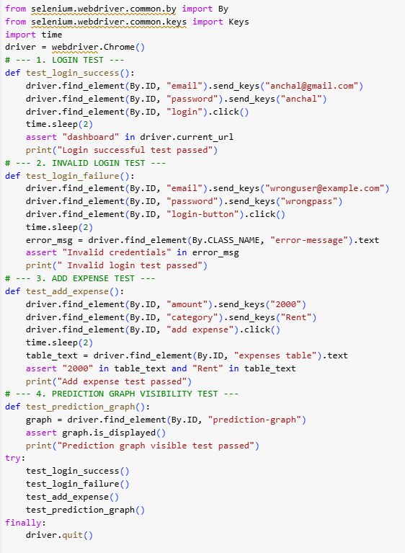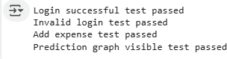As this test passed, we can conclude that the prediction feature's UI component is rendered and visible to the user.

Fig. 6 Testing

# Chapter 7: Results and Discussion

## Screenshots of User Interface (UI) for the respective module

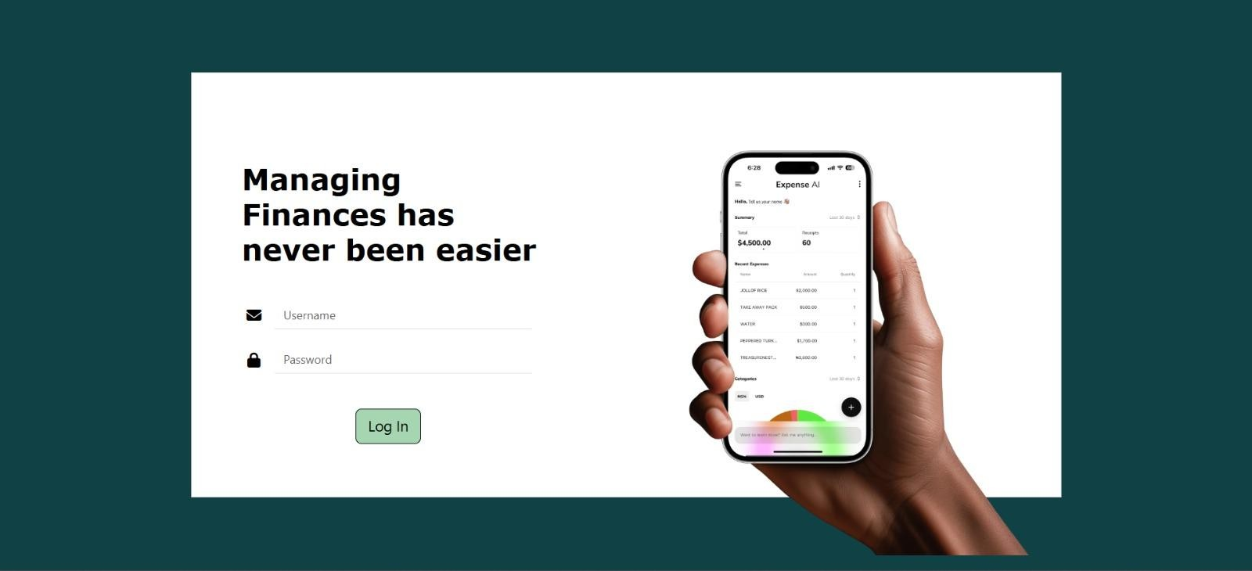

Fig.7 Login Page

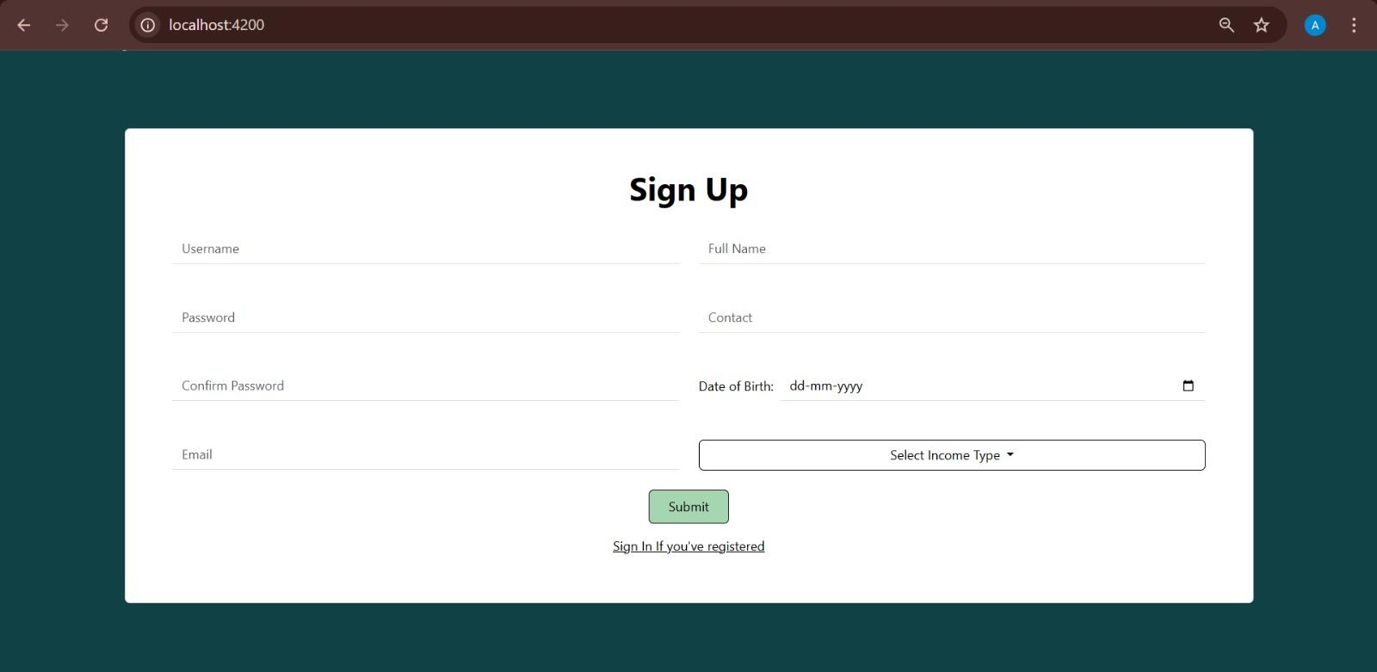

Fig.8 Sign Up Page

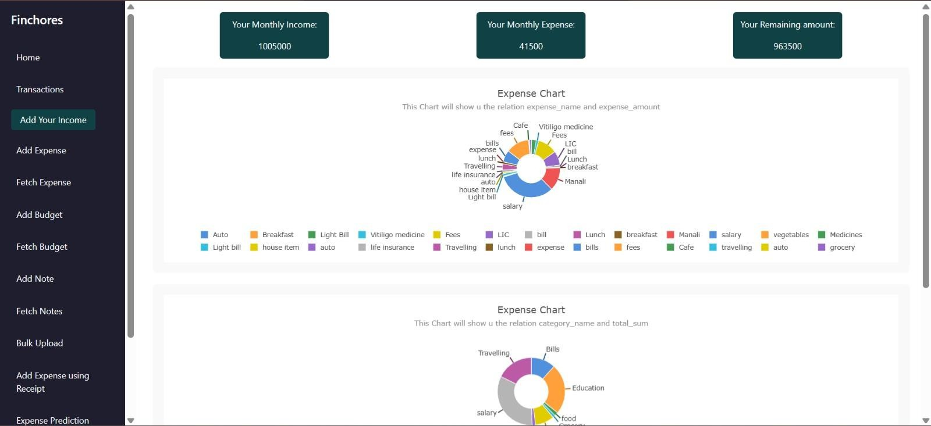

Fig.9 Home Page

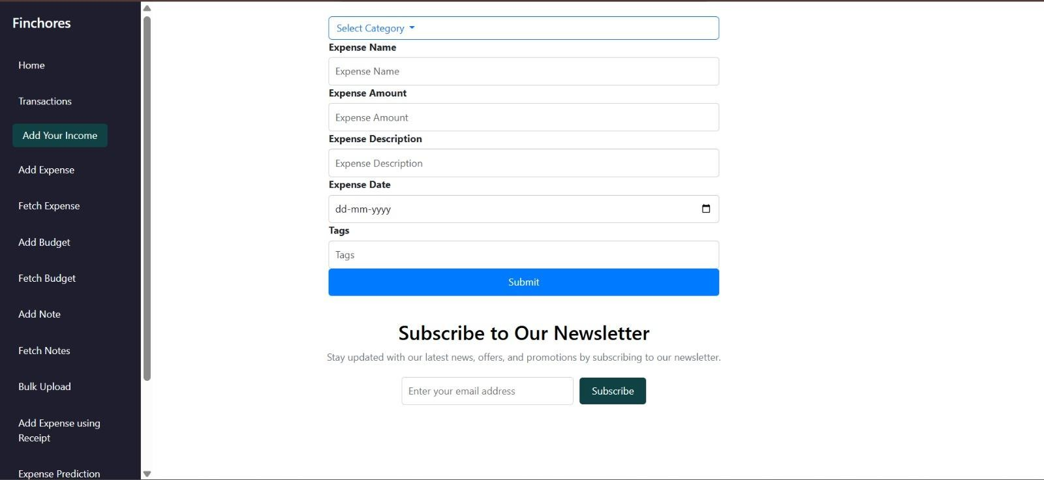

Fig.10 Add Expense Page

Fig.11 Add Budget Page

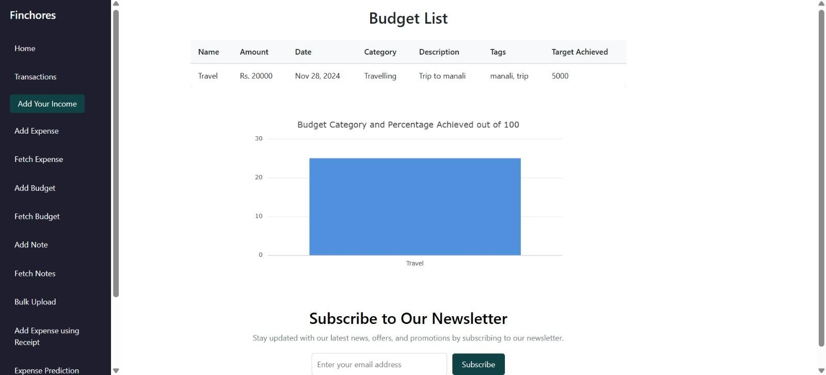

Fig.12 Fetch Budget Page

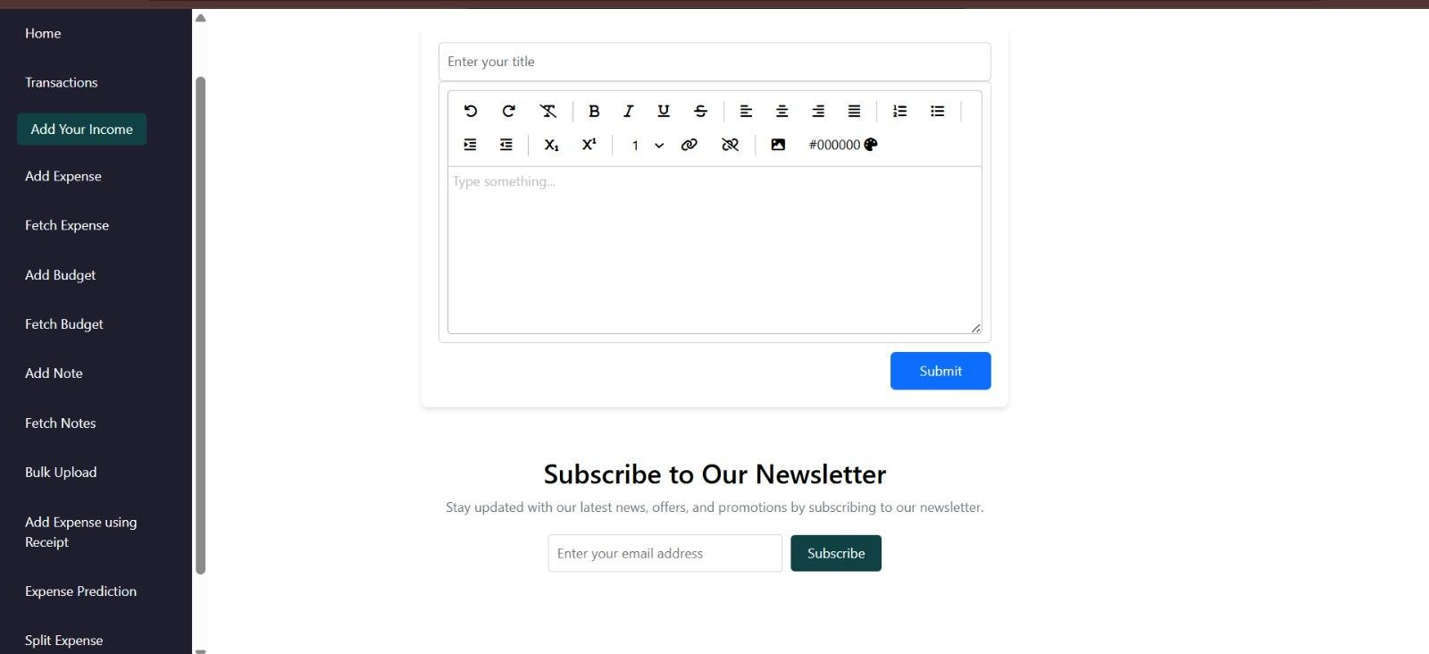

Fig.13 Add Note Page

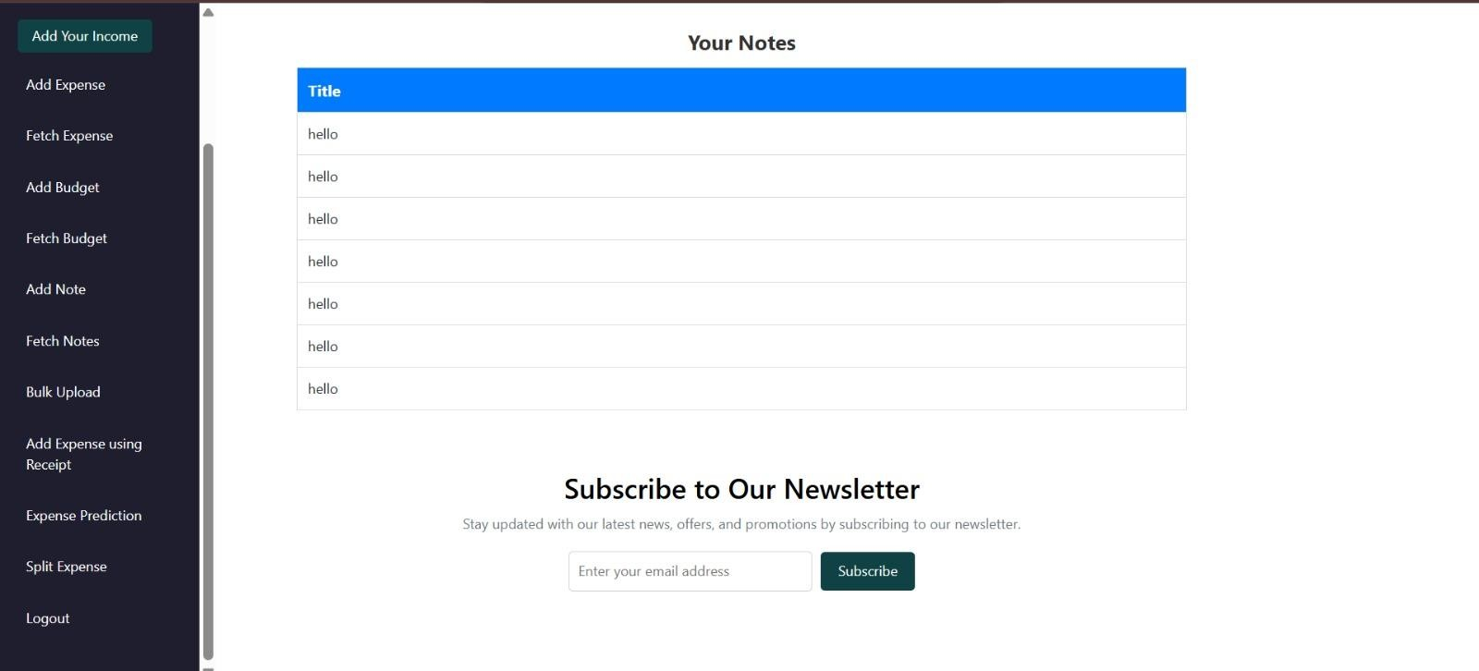

Fig.14 Fetch Notes Page

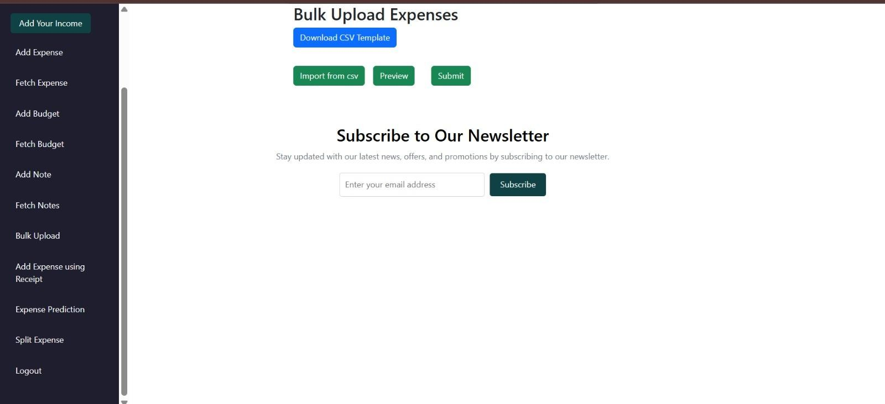 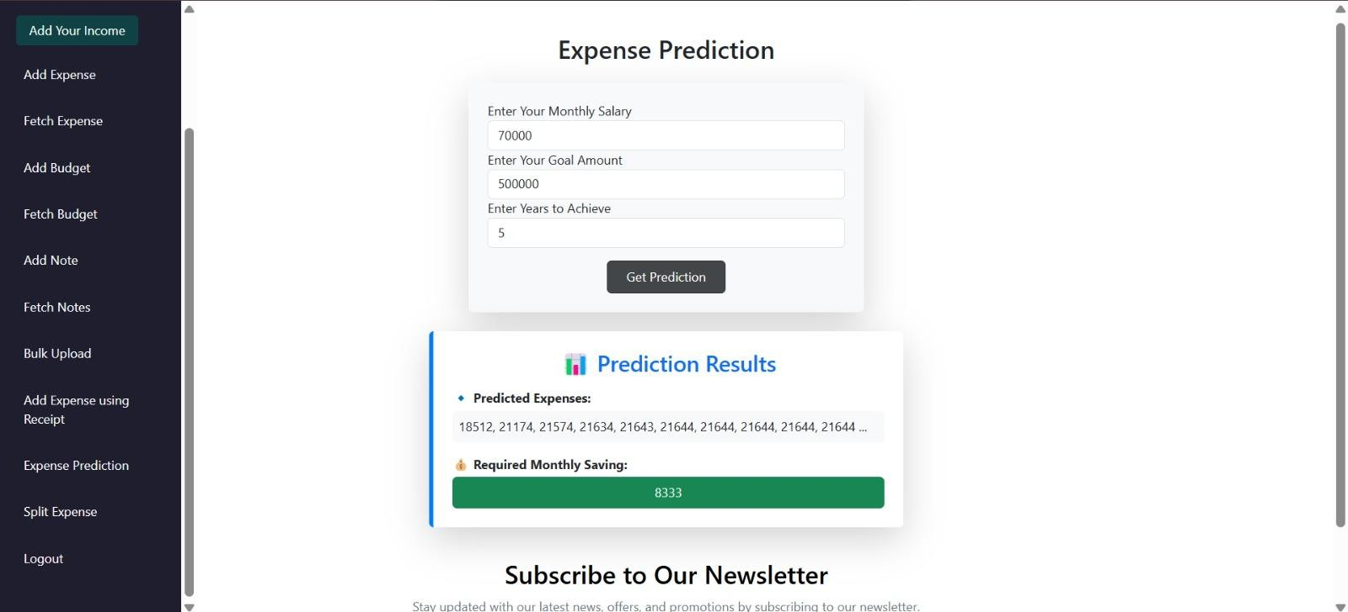

Fig.15 Bulk Upload Page

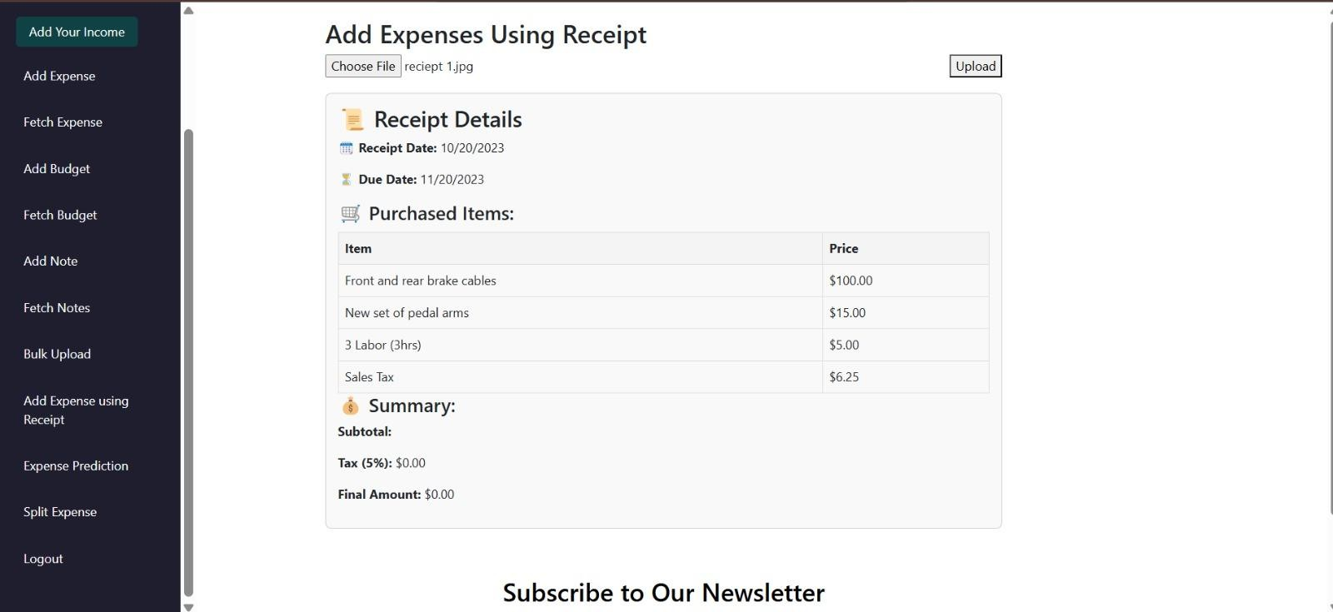

Fig.16 Add Expenses using Receipt Page

Fig.17 Expense Prediction using ARIMA Page

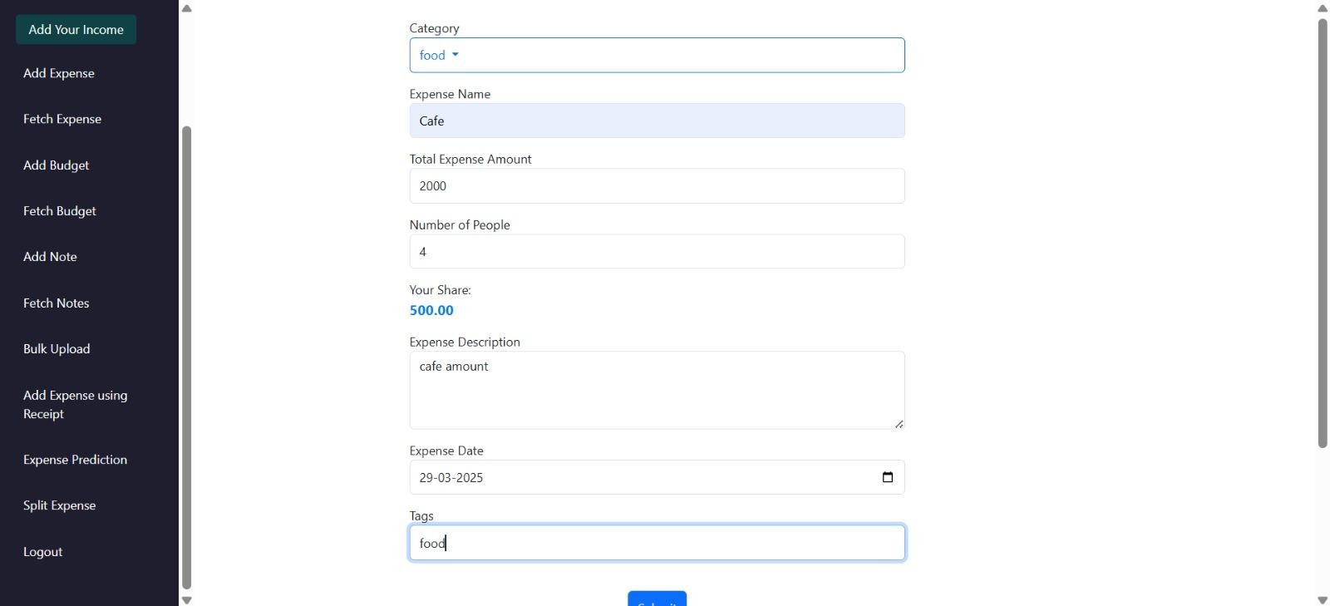

Fig.18 Splitwise Page

## Performance Evaluation measures

### Prediction Accuracy (ARIMA Model for Goal-Based Investment)

* + Accuracy – Measures how close the ARIMA model’s forecasts are to actual outcomes (typically represented as 1 - MAPE or based on a defined acceptable error margin).
  + Mean Absolute Percentage Error (MAPE) – Measures prediction accuracy as a percentage.
  + Mean Squared Error (MSE) – Evaluates how close the predicted values are to the actual values.

##### OCR Accuracy (Tesseract for Receipt Scanning)

* + Precision – Fraction of correctly identified text from the total detected text.
  + Recall – Fraction of correctly identified text out of all actual text on the receipt.
  + F1-Score – Harmonic mean of precision and recall for balanced evaluation.

### System Usability & Efficiency

* + Response Time – Time taken for the system to respond to user actions.
  + System Uptime – Percentage of time the system is operational and available.
  + Task Completion Rate – Percentage of user tasks (e.g., adding expenses, goals) completed successfully.
  + User Satisfaction Score – Feedback-based metric assessing user experience and ease of use.

##### Authentication and Security

* + Login Success Rate – Percentage of successful logins versus failed attempts.
  + Average Signup Time – Time taken by a new user to complete the registration process.

## Input Parameters / Features considered

### User Authentication

#### Login

* + - Username – Unique identifier used to log into the system.
    - Password – Secret key to securely access the user account.

#### Sign-Up

* + - Full Name – User's complete name for identification.
    - Username – Chosen unique ID for account login.
    - Password – Secure password for account protection.
    - Confirm Password – Re-entered password to verify accuracy.
    - Date of Birth (DOB) – Used for age verification and personalization.
    - Contact Number – Phone number for communication and verification.
    - Email Address – For account recovery and notifications.
    - Income Type – Specifies the nature of user's income (e.g., salaried, freelance).

#### Expense Management

* + - Category – Classifies the type of expense (e.g., groceries, rent).
    - Amount – The cost associated with the expense.
    - Name – Title or entity related to the expense (e.g., Starbucks).
    - Description – Additional details about the transaction.
    - Date – When the expense occurred.
    - Tags – Optional keywords to help in organizing expenses.

#### Notes Module

* + - Title – Short heading for the note.
    - Note Content – Detailed content or reminder the user wants to store.

#### Budget Management

* + - Category – Expense area the budget is allocated to.
    - Name – Label for the budget entry.
    - Description – Explanation or notes about the budget.
    - Amount – The total amount allocated for the budget.
    - Tags – Optional keywords for easier tracking.
    - Target Date to Achieve – Deadline to reach the budget goal.

#### Splitwise (Group Expense Sharing)

* + - Category – Type of shared expense (e.g., dinner, trip).
    - Amount – Total cost to be split among members.
    - Name – Title of the expense or event.
    - Description – Details of what the shared cost covers.
    - Date – Date of the shared transaction.
    - Tags – Optional labels for easier retrieval.
    - Number of People Involved – Total number of people splitting the cost.

#### Goal-Based Investment

* + - Monthly Salary Amount – User's income per month for planning investments.
    - Number of Years for Investment – Time horizon to achieve financial goals.

#### Receipt Scanning

* + - Receipt Photo – Image of the physical receipt to extract data using OCR.

## Graphical and statistical output



Fig. 19 Graphical Output(1)

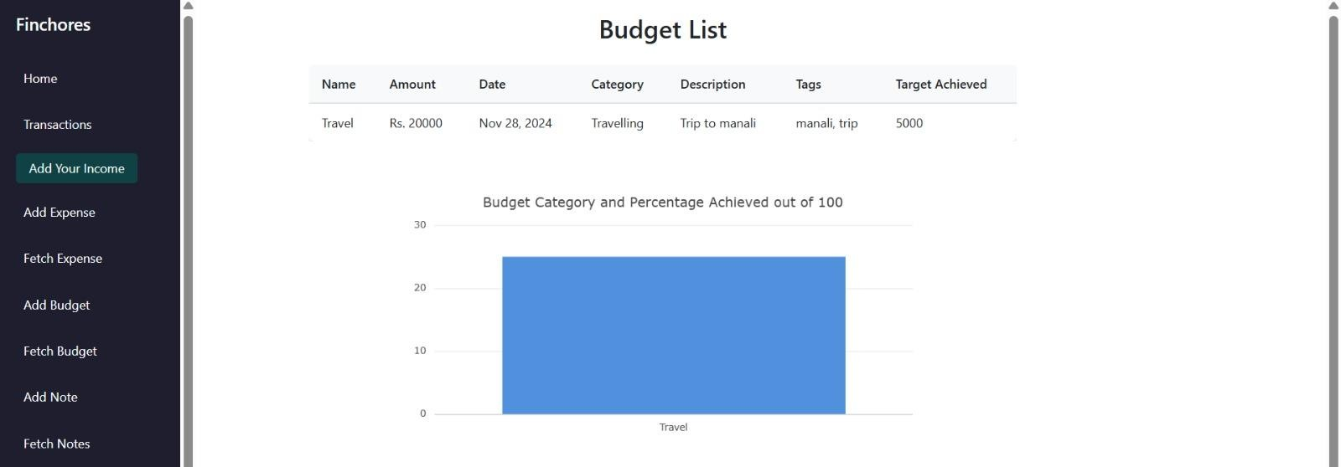

Fig. 20 Graphical Output(2)

## Comparison of Results with Existing Systems

When compared to existing personal finance management systems like **Mint**, **PocketGuard**, and

**GoodBudget**, Finchores provides a simpler, more focused experience for users looking primarily to:

### Manually Track Income and Expenses:

Unlike apps like Mint that fetch transactions automatically, Finchores requires users to input income and expenses manually or upload receipts. This offers higher customization but adds manual effort.

### Visual Financial Insights:

The generated **Expense Charts** (pie charts and bar graphs) in Finchores give a clear overview of category-wise spending and budget achievement. Although visualization tools in Finchores are basic compared to the dynamic and interactive charts in Mint or YNAB, they are intuitive and easy to interpret for first-time users.

### Budget Planning:

Finchores allows users to set budgets for specific goals (example: "Trip to Manali") and track target achievement. This is similar to GoodBudget's envelope system but currently lacks multi-envelope budgeting and progress forecasting found in more mature apps.

### Receipt-Based Expense Entry:

Finchores' feature to **add expenses using receipt scanning** sets it apart from many basic apps, but OCR accuracy still lags behind premium apps using AI-powered scanners like those in Expensify.

### Prediction Capabilities:

The use of **ARIMA** model for **expense prediction** is a unique feature, not commonly found in many free budgeting apps. However, it still requires refinement for abrupt changes and anomalies.

In summary, Finchores offers a competitive starting point with its core features but has scope for enhancements to match or exceed premium systems.

## Inference Drawn

### User-Friendly Interface:

The layout is simple and structured, offering straightforward navigation between adding income, expenses, budgets, and viewing financial summaries.

### Effective Visualization:

Pie charts and bar graphs help users quickly understand their spending patterns and budget status without needing deep financial knowledge.

##### Clear Budget Tracking:

Users can set targets for expenses and monitor how close they are to achieving these goals, promoting better financial discipline.

### Data-driven Expense Management:

With the integration of expense prediction using historical data and receipt uploads, users can get a semi-automated experience for personal finance tracking.

### Scope for Automation and Security Improvement:

Manual data entry and basic security measures are current limitations that, if addressed, can significantly enhance user experience and platform adoption.

Overall, **Finchores** successfully meets its goal of providing a lightweight, beginner-friendly platform for personal finance management while laying a strong foundation for future improvements like mobile support, AI categorization, and banking API integration.

### Comparison table for FinChores with existing systems:

|  |  |  |  |
| --- | --- | --- | --- |
| **Features** | **FinChores** | **Mint** | **GoodBudget** |
| Entry Method | Manual + Receipt OCR | Auto bank sync | Manual |
| Visualization | Basic charts | Advanced charts | Simple charts |
| Budgeting | Goal-based | Full budgeting | Envelope system |
| Prediction | Available (ARIMA) | Not available | Not available |
| Mobile App | No | Available | Available |
| Bank Integration | No | Yes | No |
| Security | Basic | Advanced (2FA) | Basic |

Table 1. Comparison with existing systems

# Chapter 8: Conclusion

## Limitations

While the Finchores website addresses many aspects of personal finance tracking, certain limitations exist that could affect the user experience and the system’s scalability:

### Data Security and Privacy Concerns:

Financial data is highly sensitive, and the current platform does not implement advanced encryption techniques like end-to-end encryption or two-factor authentication. This could pose a risk if the platform is scaled or exposed to a wider audience.

### Basic OCR Functionality:

The OCR (Optical Character Recognition) system, built using Tesseract, struggles with inconsistent receipt formats, handwritten notes, and poor-quality images. Errors in text extraction could lead to inaccurate expense tracking.

##### Limited Forecasting Accuracy:

While the ARIMA model helps with predicting monthly expenses, it assumes linearity and stationarity. It may not handle sudden lifestyle changes, financial emergencies, or one-time high expenses well, potentially leading to misleading forecasts.

### Lack of Real-time Collaboration:

Users cannot share access with family members or financial advisors in real time, which limits the application for family budgeting or joint expense planning.

### Minimal Mobile Optimization:

The current web interface is primarily designed for desktops. On mobile devices, users may experience layout issues, slower performance, or missing UI functionalities, which could affect adoption by users who prefer mobile-first access.

### No Integration with Banking APIs:

Users need to manually upload receipts or input data. Automated bank transaction fetching and categorization are not yet implemented, which adds friction to the process.

## Conclusion

Finchores is a thoughtfully designed personal finance management tool that empowers users to take control of their financial habits. Through features like expense logging, OCR-based receipt processing, and ARIMA-based monthly forecasting, the platform supports informed decision-making and planning. It stands out by combining both data extraction and predictive modeling into one seamless interface.

By providing a centralized dashboard for users to track where their money is going, Finchores encourages accountability and awareness, which are the first steps toward financial independence. The platform has laid

a strong foundation by integrating essential tools and technologies, making personal finance easier and more intuitive for users with minimal technical knowledge.

Despite a few limitations in scalability, security, and advanced analytics, Finchores has shown the potential to evolve into a comprehensive personal finance ecosystem. Its current design is suitable for individuals or small families looking for a simplified way to manage their expenses, and it demonstrates the effective use of machine learning in everyday applications.

## Future Scope

There are several exciting directions in which Finchores can evolve to better serve users and meet modern financial planning demands:

### Mobile App Development:

Launching dedicated Android and iOS applications would increase usability and accessibility. Features like push notifications for bill reminders, voice-based input for receipts, and quick entry widgets could enhance the user experience significantly.

### AI-Powered Expense Categorization:

Implementing machine learning algorithms such as Naive Bayes or BERT-based models for Natural Language Processing (NLP) could allow the system to automatically classify transactions into categories (e.g., groceries, utilities, entertainment) with high accuracy, based on context.

* + 1. **Banking Integration via APIs**:

Using secure APIs (like Plaid or Salt Edge) to fetch and analyze bank transaction data would eliminate the need for manual data entry. This would save time and increase accuracy.

### Collaborative Family Budgeting:

Enable shared accounts where multiple family members can log their expenses, contributing to a common budget. Role-based access control can allow customization of permissions.

### Security Enhancements:

With growing data and usage, implementing advanced encryption, biometric logins, and regular security audits would be essential for trust and compliance.

### Integration with Tax Calculators:

Add modules to estimate income tax based on stored expenses and receipts, which could be useful during tax filing seasons.

### Multilingual and Regional Support:

Adding support for local Indian languages and customizing financial categories as per regional practices would make the tool more inclusive and user-friendly.

**References**

1. Design and Implement of Real Time Expense Tracker Using ML

Lavesh Lingayat, Neha Yadav, Prajwal Rathod, Pranay Durutkar, Prof. Shilpa Ghode

G.H. Raisoni College of Engineering

1. eExpense: A Smart Approach to Track Everyday Expense

Shahed Anzarus Sabab; Sadman Saumik Islam; Md. Jewel Rana; Monir Hossain

1. Splitwise: Efficient Generative LLM Inference Using Phase Splitting

Pratyush Patel; Esha Choukse; Chaojie Zhang; Aashaka Shah; Íñigo Goiri; Saeed Maleki

1. Online Income and Expense Tracker S. Chandini, T. Poojitha, D. Ranjith, V.J. Mohammed Akram, M.S. Vani, V. Rajyalakshmi.
2. An innovation in paper receipts: the electronic receipt management system Katherine T. Wadsworth; Michael T. Guido; John F. Griffin; Arcan Mandil
3. Chores: enhanced run-time support for shared-memory parallel computing Derek L. Eager, John Jahorjan
4. Forecasting health expenditures in Iran using the ARIMA model (2016-2020)

Maryam Ramezanian, Ali Akbar Haghdoost, Mohammad Hossein Mehrolhassani, Masoud Abolhallaje,

Reza Dehnavieh, Behzad Najafi, Ali Akbar Fazaeli

1. EXPENSE TRACKER - Neha Jain, Devanshu Mishra, Akash Sahani, Himanshu Prajapati.
2. An Intelligent Invoice Processing System Using Tesseract OCR.

Ashlin Deepa R N; Suhas Chinta; Nikhil Kumar Ashili; B Sankara Babu; Revanth Reddy Vydugula; Raj Sripada VSL

1. ARIMA Models - Robert H. Shumway & David S. Stoffer
2. An ARIMA model for the forecasting of healthcare waste generation in the Garhwal region of Uttarakhand, India

Ankur Chauhan and Amol Singh

1. Automated invoice processing with machine learning: Benefits, risks and technical feasibility Hedberg, Niclas KTH, School of Industrial Engineering and Management (ITM). 2020 (English)
2. Unit root testing in ARMA models: A likelihood ratio approach Hernández González, Juan Ramón
3. Angular Development with TypeScript By Anton Moiseev, Yakov Fain
4. Design and Implementation of Energy Management System Based on Spring Boot Framework by Fang Zhang,Guiling Sun *,Bowen Zheng and Liang Dong.

“FinChores” - Manage Life, Master Finances

Anchal Motwani Computer Department

Vivekanand Education Society’s Institute of Technology Mumbai, India [2021.anchal.motwani@ves.ac.in](mailto:2021.anchal.motwani@ves.ac.in)

Darpan Moorpani Computer Department

Vivekanand Education Society’s Institute of Technology Mumbai, India [2021.darpan.moorpani@ves.ac.in](mailto:2021.darpan.moorpani@ves.ac.in)

Anjala Goreja Computer Department

Vivekanand Education Society’s Institute of Technology Mumbai, India [2021.anjala.goreja@ves.ac.in](mailto:2021.anjala.goreja@ves.ac.in)

Karan Kewalramani Computer Department

Vivekanand Education Society’s Institute of Technology Mumbai, India [2021.karan.kewalramani@ves.ac.in](mailto:2021.karan.kewalramani@ves.ac.in)

Mrs. Priti Joshi Assistant Professor

Department Of Computer Engineering

V.E.S. Institute of Technology, Mumbai-40074, India

[priti.joshi@ves.ac.in](mailto:priti.joshi@ves.ac.in)

In today's fast-paced world, managing personal finances has become increasingly complex, with consumers facing a wide range of goods and services. Consequently, managing expenses efficiently is more important than ever. Finchores is a dynamic and user-friendly expense tracker designed to help individuals maintain control over their finances. The platform enables users to easily log their income, track monthly expenses, and monitor remaining balances. With a built-in budgeting feature, users can set goals for savings and gain insights into their spending patterns through detailed visualizations, such as pie charts, over daily, weekly, monthly, and yearly periods. Additionally, Finchores introduces a unique bookkeeping function that helps users document incoming and outgoing payments, along with relevant details such as payees and payment purposes. Powered by ARIMA models, Finchores also offers predictive analytics to forecast future trends in income and expenses, ensuring better financial decision-making. The platform is a comprehensive tool for anyone looking to streamline their financial management and gain a clear understanding of their financial situation.

KEYWORDS - Expense tracker, Splitwise, Monthly expenses, Budgeting feature, Savings goals, Chore Management, ARIMA models, Tesseract OCR

Introduction :

In an era where financial stability plays a crucial role in ensuring a comfortable lifestyle, managing personal finances has become a critical concern. With the growing complexity of financial transactions, it is no longer enough to simply track income and expenses; individuals need smart, efficient tools to understand their financial habits and plan for the future. Finchores addresses this need by providing a comprehensive expense tracking solution that helps users manage their finances with ease.

The platform offers a range of features, allowing users to log their income, record monthly expenses, track remaining balances, and visualize their

spending habits through intuitive charts. Beyond just tracking, Finchores empowers users to set budgets, monitor savings goals, and stay on top of financial commitments. The addition of a unique bookkeeping feature allows users to keep a detailed

record of payments received and made, including the purpose and recipient, making it a complete financial management tool. Furthermore, by integrating predictive models like ARIMA, Finchores enables users to forecast future expenses and income, helping them make informed financial decisions.

One of the standout features of Finchores is the integration with WhatsApp, allowing users to directly add their expenses to the platform through WhatsApp messages. This feature streamlines the process, enabling users to effortlessly update their expenses without needing to open the website or app.

With a user-centric design, robust functionality, and seamless WhatsApp integration, Finchores is more than just an expense tracker; it is a powerful tool for achieving financial clarity and stability. Whether it's managing daily expenses, planning for long-term savings, or understanding spending trends, Finchores provides the insights and features users need to take control of their financial future.

Problem Statement :

Managing personal finances is crucial for achieving financial stability and growth, yet many individuals encounter barriers that prevent them from effectively tracking their income and expenses. Factors such as irregular income streams—common among freelancers and gig workers—can complicate financial management, leading to stress and missed investment opportunities. A significant challenge lies in the overwhelming nature of existing financial tools, which often do not consider individual user circumstances, such as income variability or personal financial goals. This oversight makes it difficult for individuals to understand their financial standing and make informed decisions. The core issue is the necessity for an accessible, accurate, and user-friendly platform that empowers users to manage their finances effectively. "FinChores" aims to bridge this gap by providing a comprehensive solution that tracks income and expenses while offering personalized financial recommendations. By leveraging data analytics, the platform encourages users to make informed decisions

about their financial health, ultimately promoting financial literacy and economic empowerment.

Literature Survey-

Title Entitled "Design and Implementation of Real-Time Expense Tracker Using Machine Learning" by Lavesh Lingayat, Neha Yadav, Prajwal Rathod, Pranay Durutkar, and Prof. Shilpa Ghode. This paper presents a system that utilizes Support Vector Machines (SVM) and Random Forest algorithms to forecast users' future expenses based on their salaries and spending patterns. By analyzing historical transaction data, the system offers personalized budget recommendations and suggests life insurance policies tailored to the user's financial profile, aiming to enhance personal financial management through predictive analytics and real-time monitoring.

Title Entitled "eExpense: A Smart Approach to Track Everyday Expenses" by Abhishek Dadhich, Siddhant Jain, Shreya Jain, and Shreya Mathur. This study introduces an Android application named eExpense, designed to automate expense tracking by scanning bills and receipts using Optical Character Recognition (OCR) technology. The app categorizes expenses based on predefined tags, monitors income through SMS notifications from bank transactions, and computes monthly and yearly financial summaries. Additional features include graphical representations of expense trends and integration with budgeting tools, aiming to reduce manual expense entry and improve accuracy in personal finance management.

Title Entitled "Splitwise: Efficient Generative LLM Inference Using Phase Splitting" by Shahul Esmail, Avani Raj, and Abhishek Chugh. This IEEE paper presents *Splitwise*, a method for optimizing generative LLM inference by dividing computation into two phases: prompt processing (compute-heavy) and token generation (memory-heavy). The approach assigns these tasks to different hardware to reduce latency and operational costs while maintaining high throughput. Experimental results show significant performance gains, making LLMs more scalable and efficient in real-time applications.

The paper, titled "Online Income and Expense Tracker", proposes a PHP-based web application to manage personal finances. It addresses limitations in existing systems like lack of reminders, manual calculations, and poor usability. Key features include user registration, daily expense tracking, graph-based analytics, and email notifications summarizing monthly expenses. Users can upload bill images, categorize payments, and manage lending/borrowing data. The system aims to automate and simplify budgeting tasks with a user-friendly interface.

Title Entitled "An Innovation in Paper Receipts: The Electronic Receipt Management System" by Gayatri Sahasrabuddhe. This paper introduces an electronic receipt management system designed to address the challenges associated with traditional paper receipts. The system proposes a centralized digital repository accessible through a web-based interface, employing an XML-based communication protocol to standardize receipt formats across merchants. This approach aims to reduce paper waste, enhance user convenience by allowing easy access to past transactions, and improve financial documentation efficiency. Additional functionalities include automatic expense logging, search and filtering options, and seamless integration with tax preparation software, making financial documentation more efficient and eco-friendly.

Title Entitled "A Survey of Financial Literacy Among University Students" by Haşmet Sarıgül. This study investigates the financial literacy levels of university students and examines the influence of demographic factors such as gender, academic discipline, and family background. Based on a survey of 1,127 students from three universities, the research assesses knowledge in areas like banking, savings, insurance, and investments. Results show significant relationships between student characteristics and financial literacy levels, emphasizing the importance of targeted educational strategies.

Title Entitled "TreadMarks: Distributed Shared Memory on Standard Workstations and Operating Systems" by Pete Keleher, Alan L. Cox, Sandhya Dwarkadas, and Willy Zwaenepoel. This paper presents TreadMarks, a software-based distributed shared memory (DSM) system that allows parallel

applications to run efficiently on networks of standard workstations. TreadMarks implements lazy release consistency and multiple-writer protocols to optimize performance. The system supports parallel computing without requiring changes to the underlying hardware or operating systems, making it accessible and cost-effective for high-performance applications.

Title Entitled "CHORES: A computerized housekeeping records system" by June A. Taylor. This paper introduces CHORES, a computerized system for managing housekeeping operations, particularly in institutional settings. The system simplifies task scheduling, tracking, and documentation by leveraging automated data handling. Originally built using Lotus software, CHORES improves operational efficiency, accuracy, and staff accountability. It demonstrates how even simple digital tools can significantly upgrade traditional manual recordkeeping systems in hospitality and healthcare sectors.

Title Entitled "Forecasting Health Expenditures in Iran Using the ARIMA Model (2016-2020)" by Maryam Ramezanian, Ali Akbar Haghdoost, Mohammad Hossein Mehrolhassani, Masoud Abolhallaje, Reza Dehnavieh, Behzad Najafi, and Ali Akbar Fazaeli. This study employs the Autoregressive Integrated Moving Average (ARIMA) model to forecast Iran's health expenditures from 2016 to 2020. Utilizing data from 1971 to 2015, the research predicts that total health expenditures will increase from approximately 1,228,338 billion IRR in 2016 to 2,698,346 billion IRR in 2020. Out-of-pocket payments are projected to constitute over 41% of total health expenditures by 2020. The findings underscore the necessity for sustained governmental support in Iran's health sector in the coming years.

Title Entitled EXPENSE TRACKER by Neha Jain, Devanshu Mishra, Akash Sahani, and Himanshu Prajapati. This paper introduces an expense tracker designed to help users manage their finances by logging, categorizing, and analyzing expenses. Built with technologies like HTML, CSS, JavaScript, and Django, it features budget setting, alerts, and visual reports. The system is user-friendly, secure, and responsive, aiming to promote better financial habits. Despite challenges in data security and

real-time visualization, it performs well and offers future scope for AI integration, bank syncing, and multi-currency support.

Proposed Work

The proposed system is a comprehensive financial management solution designed to help users track expenses, manage budgets, and receive personalized financial insights. It leverages Machine Learning (ML) models to provide savings and investment recommendations, enhancing financial literacy and promoting responsible spending habits.

Key Functionalities

1. Expense Tracking

This module allows users to log and analyze their spending habits, ensuring better financial control:

Split Expenses with Groups/Friends: Users can share and split bills with others, making expense management among groups easier.Compared to current designs, Splitwise clusters achieve up to

* 1. × higher throughput at 20% lower cost. Alternatively, they can deliver 2.35× more throughput under the same power and cost budgets[3].
     + Transfer Money: Direct peer-to-peer transactions for settling shared expenses.
* Real-Time Expense Analysis: Visualizing expenses using graphs and charts for better decision-making.
* Categorized Expense Management: Users can add, edit, and delete expenses with categories such as groceries, entertainment, bills, etc.
* Receipt Upload and Storage: Securely storing digital receipts for easy retrieval and expense validation.

1. Budget Management

Tracking regular expense is a key factor to maintain a budget[2].This module helps users plan and monitor their financial goals:

* Financial Literacy Lessons and Quizzes: Educating users on budgeting, saving,

investing, and responsible spending through interactive content.

* ML Model for Savings Recommendations: Analyzing income and spending patterns to suggest optimal savings plans tailored to individual needs.
* Progress Tracking: Monitoring how well users adhere to their budgeting goals and providing periodic insights.

1. Goal-Based Investment

* ML-Driven Investment Advice: Based on user-defined financial goals, risk appetite, and income, the system suggests suitable investment opportunities.
* Portfolio Recommendations: Helping users diversify their investments across stocks, mutual funds, fixed deposits, or real estate, ensuring long-term financial growth.

1. Personalized Financial Insights

* Automated Expense Categorization: Using AI/ML to classify transactions into relevant spending categories without manual input.
* Smart Alerts & Notifications: Users receive alerts for overspending, bill payments, and saving reminders based on their financial habits.

1. User Profile & Data Management

* Secure Financial History Storage: Users can maintain a long-term record of their financial transactions, accessible across multiple devices.
* Multi-Platform Access (Web & Mobile): The system is available 24/7 on web browsers and mobile apps, ensuring seamless financial tracking from anywhere.

1. Security & Compliance

* Data Encryption & Privacy Protection: Ensuring that all user financial data is stored securely with AES encryption.
* Regulatory Compliance: Adhering to financial regulations like GDPR and PCI DSS to protect user data and privacy.
* Two-Factor Authentication (2FA): Enhanced security for user accounts to prevent unauthorized access.

1. ARIMA and Tesseract OCR

The difficulties of predicting personal spending have begun to be studied in the field of predictive analytics. Time-series analysis and regression models are frequently used in this research [1]. The ARIMA (AutoRegressive Integrated Moving Average) model is used for time series forecasting, particularly when there is a need to predict future values based on historical data[11]. The model is beneficial in situations where data shows trends or seasonality over time, which is common for financial data like expenses or savings.

**Need for ARIMA:**

* **Trend Forecasting**: It helps in predicting future values by capturing underlying trends in the data.
* **Handling Seasonality**: ARIMA can account for seasonal variations, making it useful in cases where expenses fluctuate based on certain months or seasons.
* **Financial Planning**: For tasks like predicting future expenses (e.g., monthly expenses based on past data), ARIMA can help by providing insights that guide budgeting and saving strategies.

**ARIMA Algorithm:**

1. **AR (AutoRegressive)**: It models the relationship between an observation and a number of lagged observations (previous values).
2. **I (Integrated)**: It involves differencing the raw observations to make the time series stationary (removing trends).
3. **MA (Moving Average)**: It models the relationship between an observation and a residual error from a moving average model applied to lagged observations.

ARIMA is often represented as ARIMA(p, d, q), where:

* + **p** is the number of lag observations included in the model (AR part),
  + **d** is the number of times the raw observations are differenced (I part),
  + **q** is the size of the moving average window (MA part).

For our case, we have used ARIMA to analyze past monthly expenses (time series data) and forecast how much money needs to be saved monthly based on this historical data.

Tesseract OCR (Optical Character Recognition) is a powerful tool for extracting text from images, especially useful when dealing with scanned documents, such as receipts or invoices[12]. It converts printed or handwritten text into machine-readable format, which can then be stored or processed further.

**Need for Tesseract OCR:**

* + **Automated Data Entry**: It automates the process of extracting text from images, such as receipts, eliminating the need for manual entry.
  + **Expense Tracking**: By scanning receipts, OCR allows for easy extraction of itemized expenses, which can be categorized and stored for financial tracking or analysis.
  + **Time-Saving**: It saves time by quickly converting paper receipts into digital data that can be used for record-keeping, budgeting, and financial planning.

**Tesseract OCR Algorithm:**

1. **Preprocessing**: The image is first cleaned by removing noise, enhancing contrast, and converting it to grayscale. This step helps improve the accuracy of OCR.
2. **Text Detection**: The OCR engine processes the image to detect the layout of the text. Tesseract identifies characters, words, and lines.
3. **Character Recognition**: Each detected character is recognized and mapped to a corresponding Unicode character.
4. **Postprocessing**: The output text is corrected by checking for spelling or formatting errors and then outputted in a

readable format, such as plain text or structured data.

In our case, using Tesseract OCR to scan receipts helped us automate the expense tracking process, allowing to store, categorize, and analyze our expenses efficiently without manual data entry. After logging into the system, a user can add the bills with an option to attach the image of the bill or not[4].

Performance & Non-Functional Requirements

* + High Performance & Scalability: The system should support millions of transactions efficiently with cloud-based infrastructure.
  + Cross-Platform Compatibility: Ensuring smooth integration with banks, digital wallets, and other financial services.
  + Reliability & Uptime: Guaranteeing a 99.9% uptime for uninterrupted access to financial tools.

Block Diagram:

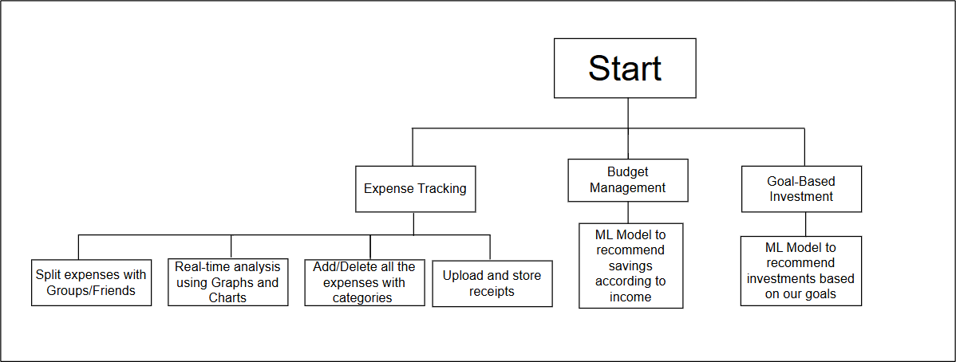

Fig. 1: Block Diagram

SnapShots:



Fig. 2: Login Page



Fig. 3: Sign Up Page



Fig. 4: Home Page



Fig. 5: Add Expense Page

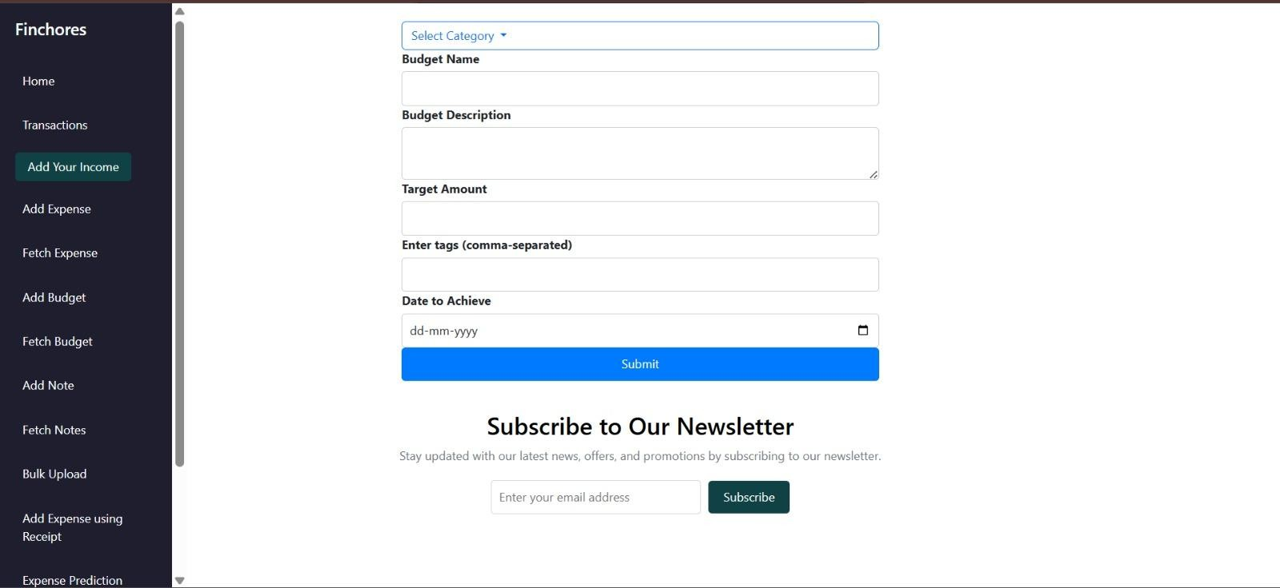 

Fig. 6: Add Budget Page



Fig. 7: Fetch Budget Page



Fig. 8: Add Note Page



Fig. 9: Fetch Notes Page

Fig. 10: Bulk Upload Page



Fig. 11: Add Expenses using Receipt Page



Fig. 12: Expense Prediction using ARIMA Page



Fig. 13: Splitwise Page

Conclusion-

FinChores - Manage Life, Master Finance effectively addresses the need for accessible and efficient financial management, particularly for individuals navigating the complexities of personal finance in today's digital economy. This innovative web-based platform offers automated income and expense tracking, empowering users to gain insights into their financial health based on reported data without the necessity of professional financial consultations. By leveraging extensive datasets and advanced data analytics, FinChores analyzes user inputs to deliver critical recommendations for budgeting, saving, and investing, helping individuals make informed decisions about their financial futures. This system enhances the efficiency and cost-effectiveness of personal finance management while empowering users to take charge of their economic well-being. This feature is particularly beneficial for those in underserved communities, where access to financial advisors or educational resources may be limited. By integrating personalized insights and a chore management system, FinChores not only simplifies financial decision-making but also promotes overall household resource management, aligning users’ financial and daily life management into a cohesive, user-friendly experience.

References-

1. Design and Implement of Real Time Expense Tracker Using ML

Lavesh Lingayat, Neha Yadav, Prajwal Rathod, Pranay Durutkar, Prof. Shilpa Ghode

G.H. Raisoni College of Engineering

1. eExpense: A Smart Approach to Track Everyday Expense

Shahed Anzarus Sabab; Sadman Saumik Islam;

Md. Jewel Rana; Monir Hossain

1. Splitwise: Efficient Generative LLM Inference Using Phase Splitting

Pratyush Patel; Esha Choukse; Chaojie Zhang;

Aashaka Shah; Íñigo Goiri; Saeed Maleki

1. Online Income and Expense Tracker S. Chandini, T. Poojitha, D. Ranjith, V.J. Mohammed Akram, M.S. Vani, V. Rajyalakshmi.
2. An innovation in paper receipts: the electronic receipt management system

Katherine T. Wadsworth; Michael T. Guido; John F.

Griffin; Arcan Mandil

1. Chores: enhanced run-time support for shared-memory parallel computing

Derek L. Eager, John Jahorjan

1. Forecasting health expenditures in Iran using the ARIMA model (2016-2020)

Maryam Ramezanian, Ali Akbar Haghdoost, Mohammad Hossein Mehrolhassani, Masoud Abolhallaje, Reza Dehnavieh, Behzad Najafi, Ali Akbar Fazaeli

1. EXPENSE TRACKER - Neha Jain, Devanshu Mishra, Akash Sahani, Himanshu Prajapati.
2. An Intelligent Invoice Processing System Using Tesseract OCR.

Ashlin Deepa R N; Suhas Chinta; Nikhil Kumar Ashili; B Sankara Babu; Revanth Reddy Vydugula;

Raj Sripada VSL

1. ARIMA Models - Robert H. Shumway & David S. Stoffer
2. An ARIMA model for the forecasting of healthcare waste generation in the Garhwal region of Uttarakhand, India

Ankur Chauhan and Amol Singh

1. Automated invoice processing with machine learning: Benefits, risks and technical feasibility

Hedberg, Niclas KTH, School of Industrial Engineering and Management (ITM). 2020 (English)

1. Unit root testing in ARMA models: A likelihood ratio approach

Hernández González, Juan Ramón

1. Angular Development with TypeScript By Anton Moiseev, Yakov Fain
2. Design and Implementation of Energy Management System Based on Spring Boot Framework by Fang Zhang,Guiling Sun *,Bowen Zheng and Liang Dong.

Plagiarism Report:

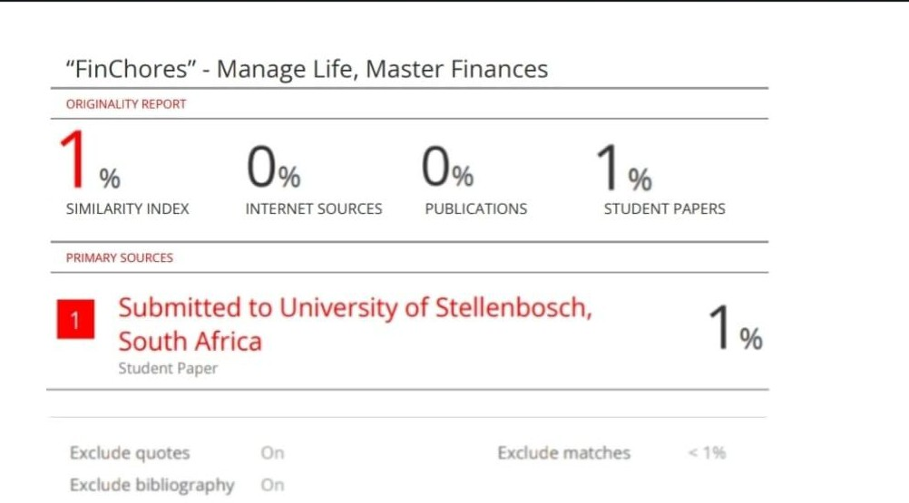

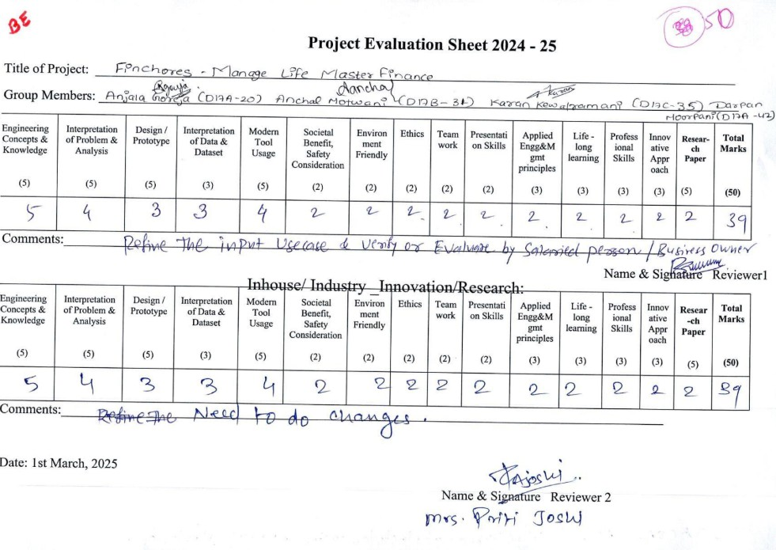Review Sheet 1:

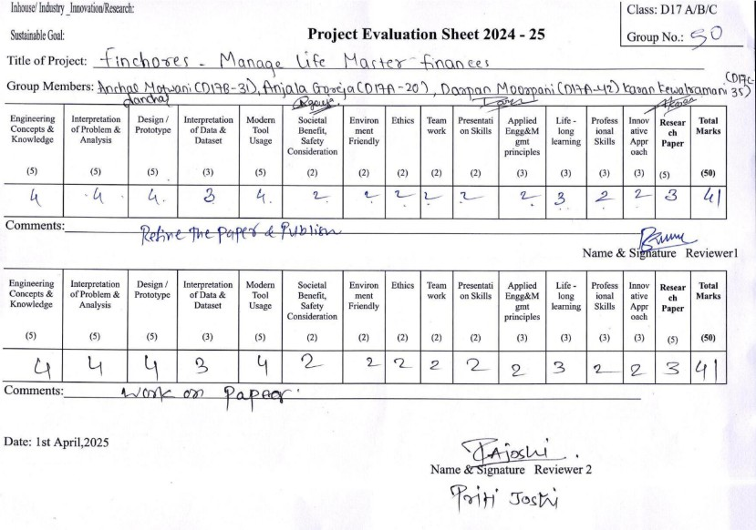Review 2: