**Vivekanand Education Society's Institute of Technology**



**Department of Computer Engineering**

**Group No.: 6**

Date : 2nd August, 2024

**Project Synopsis Template (2024-25) - Sem V**

**MapMyForest**

Dr. Mrs.Gresha Bhatia

Deputy HOD, CMPN

| Chinmay Desai | Gautam Rai | Shaanveer Singh | Atharva Deore |
| --- | --- | --- | --- |
| V.E.S.I.T | V.E.S.I.T | V.E.S.I.T | V.E.S.I.T |
| 2022.chinmay.desai@  ves.ac.in | 2022.gautam.rai@  ves.ac.in | 2022.shaanveer.singh@  ves.ac.in | 2022.atharva.deore@  ves.ac.in |

**Abstract**

The project aims to develop an image analytics solution to automate tree enumeration in forest areas designated for land diversion due to developmental projects. Traditional methods are often time-consuming and error-prone. This solution leverages satellite imagery or aerial photographs to detect, count, and categorize trees, providing accurate and timely information to support decision-making. The system will include a computer vision algorithm, validation mechanisms, and user-friendly visualizations, while adhering to ethical and environmental standards.

**Introduction**

With increasing developmental activities leading to forest land diversion, accurately assessing tree populations is crucial for environmental impact assessment and conservation efforts. Conventional tree enumeration methods, such as manual surveys, are inefficient and prone to inaccuracies. This project addresses the need for an automated, scalable, and accurate solution to streamline the process of tree enumeration using advanced image analytics techniques.

**Problem Statement**

Manual methods of tree enumeration are labor-intensive and prone to errors. There is a need for a more efficient, accurate, and automated approach to assess tree populations in forest areas being considered for diversion. The challenge is to develop an image analytics solution that can accurately detect, count, and categorize trees from satellite or aerial imagery, while ensuring high accuracy, scalability, and integration with existing forest management tools.

**Proposed Solution**

The proposed solution is a computer vision-based image analytics system that processes satellite or aerial imagery to detect and enumerate trees within specified forest areas. The system will:

* Utilize advanced algorithms to analyze images and identify trees.
* Count and categorize trees based on species and diameter.
* Validate results against ground-truth data for accuracy.
* Offer scalable and efficient processing of large datasets.
* Provide visualizations and integrate with existing forest management systems.
* Adhere to ethical and environmental guidelines.

**Methodology / Block Diagram**

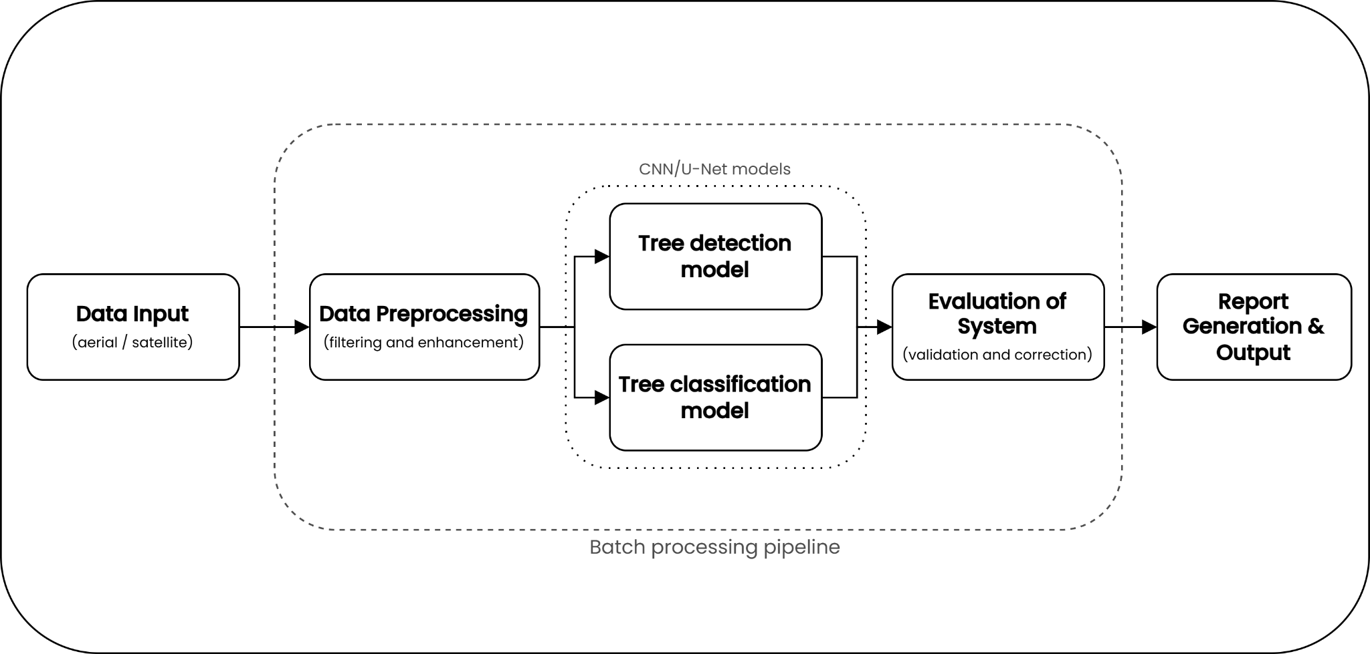

**Hardware , Software and tools Requirements**

**Hardware**: A computer with high performance gpu for training the ml model.

Recommended Specifications:

**CPU**: Intel i5 (10th gen or newer), AMD Ryzen 5

**GPU**: Nvidia RTX 30xx series

**RAM**: 32GB or more

**Storage**: 1TB SSD

**Operating system**: Windows 10 / 11

**Software**:

* **Computer vision libraries**: OpenCV (v4.8.0), TensorFlow (v2.14.0), PyTorch (v2.0.1).
* **Image processing tools**: QGIS (v3.30.3), ArcGIS (v3.1.0).
* **Data visualization tools**: Tableau (v2023.2).
* **Frontend**: React (v18.2.0), Material Ui (v5.14.8).
* **Backend**: Nodejs (v20.5.1) , Express (v4.18.2) / Flask (v2.0.1).
* **Database**: MongoDB (v6.0.4) / PostgreSQL (v15.4).

**Tools**:

* **Satellite or aerial imagery sources**: Google Earth Engine, Sentinel Hub.
* **Computer Vision Tool**: Rovren Flow.
* **Design**: Figma/Canva

**Proposed Evaluation Measures**

* **Accuracy**: Measure the precision of tree detection and counting by comparing with ground-truth data.
* **Scalability**: Assess the system’s performance with varying sizes of image data.
* **Efficiency**: Evaluate processing time and resource usage for large datasets.
* **User Feedback**: Collect feedback from users regarding the integration and visualization features.

**Conclusion:**

The image analytics solution aims to revolutionize tree enumeration by offering a scalable, accurate, and efficient approach to analyzing forest imagery. By automating the process, it will facilitate better decision-making for land diversion and conservation efforts, while integrating seamlessly with existing forest management tools and adhering to ethical and environmental standards.

**References:**

1. Martin Brandta, Rasmus Fensholta, “Deep learning enables image-based tree counting, crown segmentation, and height prediction at national scale” PNAS Nexus, 2023.
2. F.Z. Bassine, A. Errami, M. Khaldoun “Real time Algorithm for Tree Detection, Recognition and Counting in a Video Sequence”, J . Mater. Environ. Sci., Volume 11, Issue 3, Page 367-377, 2020.
3. CHIA-YEN CHIANG, CHLOE BARNES "Deep Learning-Based Automated Forest Health Diagnosis From Aerial Images" accepted July 9, 2020, date of publication July 28, 2020, date of current version August 18, 2020.
4. WASSIM BOUACHIR, NIZAR BOUGUILA "Computer Vision System for Automatic Counting of Planting Microsites Using UAV Imagery" Received May 17, 2019, accepted June 8, 2019, date of publication June 19, 2019, date of current version July 9, 2019.
5. Y. Wang and Y. Zou, ‘‘Fast visual object counting via example-based density estimation,’’ in Proc. IEEE Int. Conf. Image Process. (ICIP), pp. 3653–3657, Sep. 2016.
6. S. V. Koneru et al., "Detection and Enumeration of Trees using Cartosat2 High Resolution Satellite Imagery," IEEE International Conference on Aerospace Electronics and Remote Sensing Technology (ICARES), Bali, Indonesia, 2018, pp. 1-6, doi: 10.1109/ICARES.2018.8547072, 2018.
7. G. Grenzdörffer, ‘‘UAS-based automatic bird count of a common gull colony,’’ Int. Arch. Photogram., Remote Sens. Spatial Inf. Sci., vol. 1, p. W2, 2013.
8. V. Lempitsky and A. Zisserman, ‘‘Learning to count objects in images,’’ in Proc. Adv. Neural Inf. Process. Syst., pp. 1324–1332, 2010.
9. A. Krizhevsky, I. Sutskever, and G. E. Hinton, ‘‘ImageNet classification with deep convolutional neural networks,’’ in Proc. Adv. Neural Inf. Process. Syst., pp. 1097–1105, 2012.
10. K. Chen, C. C. Loy, S. Gong, and T. Xiang, ‘‘Feature mining for localised crowd counting,’’ in Proc. BMVC, vol. 1. no. 2, p. 3, 2012.
11. N. Ahuja and S. Todorovic, ‘‘Extracting texels in 2.1 D natural textures,’’ in Proc. IEEE 11th Int. Conf. Comput. Vis., pp. 1–8, Oct. 2007.