**MapMyForest: Automated Tree Enumeration and**

**Forest Analysis Using Aerial Imagery and Deep**

**Learning Models**

Dr. Gresha Bhatia

*Dept. Of Computer Engineering*  
*VESIT,* Mumbai, India  
gresha.bhatia@ves.ac.in

Shaanveer Singh  
*Dept. Of Computer Engineering*  
*VESIT,* Mumbai, India  
2022.shaanveer.singh@ves.ac.in

Chinmay Desai  
*Dept. Of Computer Engineering*  
 *VESIT,* Mumbai, India  
2022.chinmay.desai@ves.ac.in

Atharva Deore  
*Dept. Of Computer Engineering* *VESIT,* Mumbai, India  
2022.atharva.deore@ves.ac.in

Gautam Rai  
*Dept. Of Computer Engineering  
VESIT,* Mumbai, India  
2022.gautam.rai@ves.ac.in

***Abstract*—The project aims to develop software that utilizes image and video analytics to automate tree enumeration in forest areas, facilitating efficient monitoring and informed decision-making for developmental projects. Traditional methods, such as manual surveys, are time-consuming and prone to errors. The software will employ the YOLO object detection model, specifically trained to detect trees from aerial or satellite imagery for tree enumeration, along with database management using MongoDB. This approach enables precise monitoring, early detection of changes, cost-effective forest management, and enhanced conservation efforts.**

***Keywords—YOLO(You look Only Once), CNN (Convolutional Neural Network), tree enumeration, machine learning, Deforestation, Environmental Impact Assessment (EIA), Image Analytics, Sustainability.***

I. INTRODUCTION

Tree enumeration in India presents significant challenges, as we still rely heavily on manual methods to count the number of trees that need to be cut before developing a particular area. When the area is vast, the data collected is often inaccurate, rendering it ineffective.Moreover, these traditional methods cannot provide sufficient details regarding conservation rules and regulations that must be followed during the deforestation process.This is where the solution, MapMyForest, comes into picture. The aim of this research paper is to address the challenges of tree enumeration and analysis using aerial imagery. The paper focuses on how the imagery will be processed to gather accurate information, such as the environmental impact, regulations to be followed, and more. Our solution allows users to upload aerial images, which will be analyzed to enumerate the number of trees. The objective is further to identify endangered trees and provide specific recommendations for handling them. Additionally, the aim is to deliver a comprehensive analysis and outline the relevant laws and regulations that must be adhered to, depending on the specific domain under consideration. The paper is subdivided into a number of sections. The major objectives dealt with are mentioned in section II. Literature survey and the work done in the domain is elaborated in section III. Block diagram representation and the methodology worked upon is elaborated in section IV. Section V elaborates on the results obtained and the performance measures obtained for tree enumeration. The conclusion is further mentioned in section VI.

# II. OBJECTIVES

The major objective is to map the forest through the application of tree enumeration concepts and is detailed below .

1. **Automating Tree Enumeration:**

The aim is to develop a machine learning-based solution utilizing image analytics for automating tree enumeration in forest areas. With this objective , the focus is on enhancing accuracy and efficiency of tree enumeration as compared to traditional manual methods.

1. **Report Generation:**

Based on the data collected from aerial images and on-ground video footage, this objective aims to generate detailed reports related to tree enumeration and classification. The report will include an analysis of the environmental impact, recommended solutions for sustainable development, and a summary of laws and regulations specific to the region.

1. **Deforestation Solutions:**

This objective aims to develop a solution that would process user-submitted images and assess the impact of deforestation. The system will provide mitigation strategies and enforce legal regulations specific to deforestation issues, adhering to regional laws and policies in the respective country.

# III. LITERATURE SURVEY

The research began with determining the work done in the domain of tree enumeration.The objective of the literature review was to evaluate the stability and dependability of various tools and algorithms used in satellite image processing. It dug into comparative analyses of performance measures and studied the usefulness of machine learning and deep learning techniques in solving complicated image analysis jobs.  
In addition, it examined the integration of data from multiple sources and talked about the difficulties in achieving compatibility and data fusion. Through the consolidation of these results, the study helped establish a strong basis for next developments in satellite image analysis, emphasizing the promotion of environmental monitoring and sustainability programs.

| **Title of the paper** | **Abstract** | **Lacuna** |
| --- | --- | --- |
| Satellite Image Analytics for Tree Enumeration for Diversion of Forest Land” , ssrn-4870495  Saniya Kakade  et al., July 2024 | The project developed a system to automate tree enumeration using satellite imagery and image analytics | The major drawback of the paper is that it does not provide an analysis of the accuracy of the tree enumeration process. |
| Intelligent Forest Assessment: Advanced Tree Detection and Enumeration with AI” , ISSN 2582-7421, Ms. Shubhangi Mahule, May 2024 | This paper focussed on developing a tree detection and counting system using YOLOv8 and Roboflow annotations. It achieved high precision and recall for tree enumeration. | Limited and insufficient real-time environmental data integration as well as inadequate regional variability and customization for different mining regions. |
| Deep learning enabled image based tree counting, crown segmentation, and height prediction at national scale", Martin Brandta et al, PNAS Nexus, 2023 | The paper demonstrates a deep learning framework for tree counting, crown segmentation, and height prediction using remote sensing images, showing national-scale effectiveness. | It operated on limited image quality, and needed testing in different regions.This resulted in high computational demands. |
| Remote Sensing Application for Analysis of Forest Change Detection, Swati Mohod, et al. 2022 | The paper used remote sensing to monitor and analyze forest changes in Yavatmal, India, using NDVI to track vegetation health over time. | Limited Discussion on Methodological Challenges Spatial Scale and Heterogeneity |

IV. METHODOLOGY

The aim of MapMyForest is to provide an automated platform for landowners to assess the forest cover on their land. By uploading drone, aerial, or satellite imagery, users can enumerate trees on their land and convert that information into a comprehensive report.

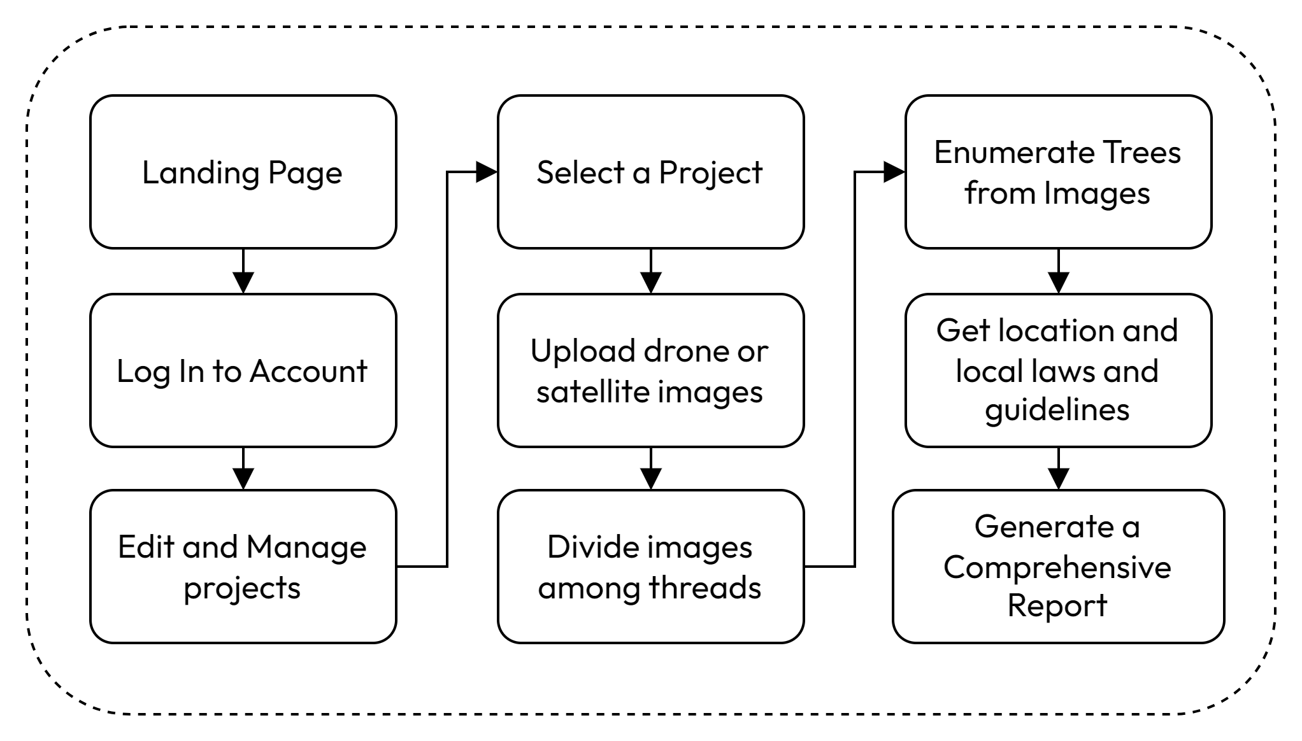

Fig 4.1: System Flow Chart

The workflow of the proposed system is depicted in Fig. 4.1. Upon accessing the front-end interface, the user is presented with the landing page. By providing valid credentials, the user gains access to the system, enabling functionalities such as the addition of new projects, as well as the modification or deletion of existing ones.

On selecting a specific project, the system displays detailed information about the project, including geospatial data visualized on a map, any previously uploaded imagery, and the current processing status of the project.

The "Upload Images" functionality, accessible via the sidebar, allows the user to upload multiple images into the system. Upon completion of the upload process, the user can initiate the image processing pipeline by clicking the Submit button. At this point, the system prompts the user to revisit the application once the processing is complete. Additionally, a notification email is dispatched to the user upon pipeline completion.

Once processing is completed, the user is provided with a comprehensive project report. This report includes metrics such as the total tree count and insights relevant to potential land development opportunities.

### Fig 4.2 : System Block Diagram

### From Fig 4.2 we can divide the system’s backend into three major steps, described as follows:

### **A. Tree Enumeration**

Tree enumeration is conducted using aerial or satellite imagery provided by the user. The images are processed using the DeepForest library’s pre-trained model fine-tuned over our custom dataset designed to identify tree crowns in high-resolution images. The steps involved are as follows:

1. Data Input: Users upload aerial or satellite imagery through the platform’s interface. These images are associated with specific user projects.
2. Parallel Processing: To enhance performance and reduce processing time, the platform uses multithreading and batch processing. This enables simultaneous inference of multiple images, distributing computational tasks evenly across multiple available threads.
3. Tree Detection: The DeepForest model is applied to the images, identifying and counting tree crowns. The output includes the total tree count and spatial distribution data. From the

This module outputs an image with annotations for all the trees detected, a dataframe with the bounding boxes of the trees, the area covered by the trees and the total count of trees in that image.

### **B. Report Generation**

A comprehensive report is generated using a Large Language Model (LLM) to provide users with actionable insights. The steps for report generation are:

1. Data Aggregation: Output from tree enumeration is combined with additional metadata, such as geographical location and local environmental regulations.
2. Content Drafting: The LLM synthesizes the data into a descriptive report. This includes:
   * An overview of the forested land’s tree count.
   * Recommendations for sustainable development, taking into consideration local laws and environmental guidelines.
   * Insights into potential ecological and economic opportunities.

By integrating these components, MapMyForest provides an end-to-end solution for forest analysis, enabling users to make informed decisions about the management and development of their land swiftly.

V.RESULTS

The results from the models used in the MapMyForest project demonstrate significant advancements in tree enumeration accuracy. This section compares the performance of our models against existing benchmarks and highlights key findings:

### **A. Tree Enumeration Results**

Using annotated aerial and satellite imagery datasets, the YOLOv11 model was evaluated for tree detection and counting accuracy. The performance metrics, including mean Average Precision (mAP), precision, and recall, are summarized in Table I. Our YOLOv11 model outperformed previous models in both precision and recall, showcasing its robustness in detecting individual trees across diverse forest environments.

#### **Table I: Performance Metrics Comparison**

| **Metric** | **YOLOv11 Model** | **DeepForest Model** |
| --- | --- | --- |
| mAP (%) | 55.2 | **73.8** |
| Precision (%) | 53.3 | **78.4** |
| Recall (%) | 54.9 | **80.2** |

The visual outputs of the DeepForest model display detected tree locations with bounding boxes overlaid on aerial images. Post-processing techniques, including non-max suppression, effectively reduced false positives, further enhancing accuracy.

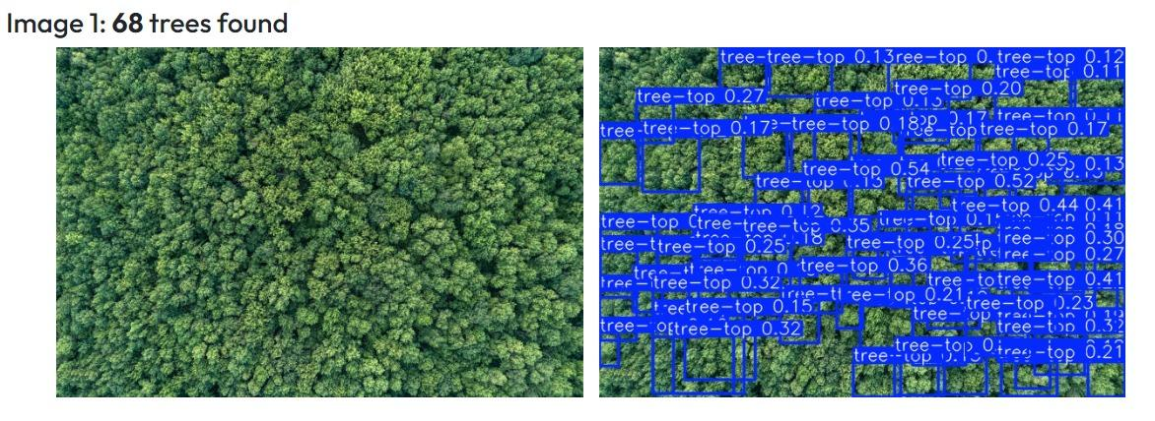

Fig 5.1.1: Tree Enumeration with Older Model

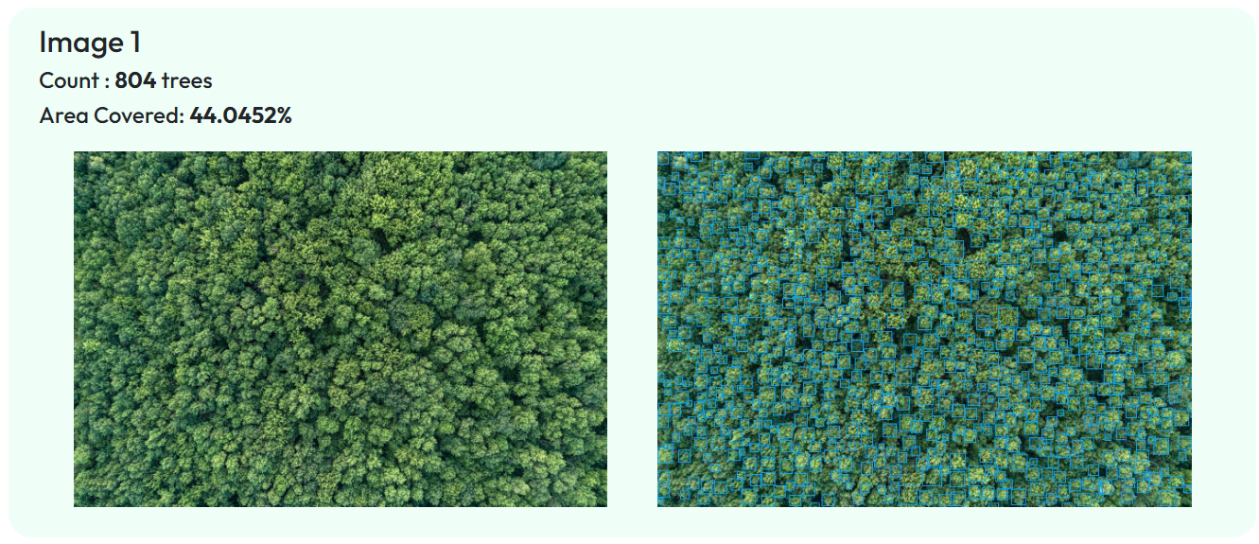

Fig 5.1.2: Tree Enumeration with DeepForest Model

From Fig 5.1.1, we can observe that the older model made very hallucinated inferences when presented with an image with a high density of trees. On the other hand, in Fig 5.1.2, we can see the newer (DeepForest Pre-built) model provides fairly accurate bounding boxes and counts for the same image.

### **C. Report Generation Results**

The reports directly fetch data from tree enumeration and tree classification results. They also add insights into their environmental impacts keeping the project's location into consideration. Additionally, the system offers guidance on legal compliance and steps to follow during the deforestation process.

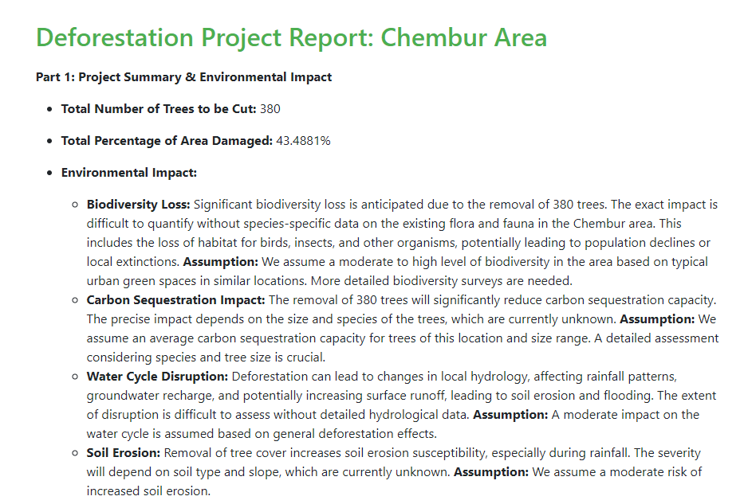

Fig 5.2.1: Generated Report

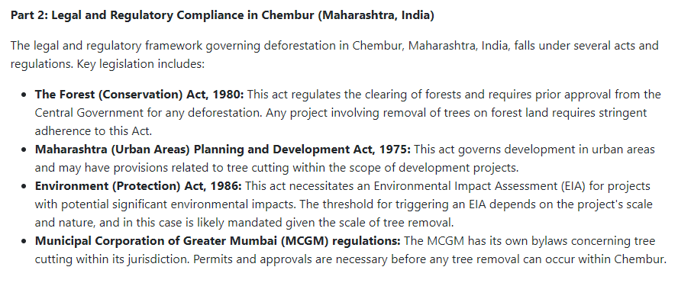

Fig 5.2.2: Dedicated analysis for project’s geo-location

Fig 5.2.1 and Fig 5.2.2 show how MapMyForest’s Report Generation generates a report considering tree count, any environmental impact after deforestation and takes into account any relevant laws and regulations for the land owner to consider.

VI. CONCLUSION

This project effectively demonstrates the feasibility of using aerial imagery and machine learning algorithms to automate tree enumeration in forest areas. By deploying the YOLO model for tree recognition, the project significantly enhances the accuracy and efficiency of forestry Environmental Impact Assessments (EIA). This novel methodology reduces reliance on traditional, labor-intensive approaches, providing a scalable and cost-effective solution for monitoring forest ecosystems.

Integrating a project management system and automated report generation offers detailed insights into the environmental impact of deforestation activities. These reports not only highlight the extent of ecological changes but also provide guidance on adhering to legal compliance throughout the deforestation process. This comprehensive approach ensures informed decision-making and promotes sustainable development practices, making it a valuable tool for environmental authorities, forestry corporations, and other stakeholders.

VI. REFERENCES

1. B. G. Weinstein, S. Marconi, M. Aubry‐Kientz, G. Vincent, H. Senyondo, and E. P. White, "DeepForest: A Python package for RGB deep learning tree crown delineation," *Methods in Ecology and Evolution*, vol. 11, no. 12, pp. 1743–1751, Dec. 2020. doi: [10.1111/2041-210X.13472](https://doi.org/10.1111/2041-210X.13472).
2. B. G. Weinstein, S. Marconi, S. Bohlman, A. Zare, and E. P. White, "Individual Tree-Crown Detection in RGB Imagery Using Semi-Supervised Deep Learning Neural Networks," *Remote Sensing*, vol. 11, no. 11, p. 1309, Jun. 2019. doi: [10.3390/rs11111309](https://doi.org/10.3390/rs11111309).
3. R. Khot, et al., “A Survey on Tree Enumeration Using Satellite Image and Optimal Path Finding,” *International Research Journal of Modernization in Engineering, Technology and Science (IRJMETS)*, Oct. 2024.
4. S. Kakade, et al., “Satellite Image Analytics for Tree Enumeration for Diversion of Forest Land,” *SSRN*, Jul. 2024.
5. S. Mahule, T. Pranathi, T. B. Ranjan, T. A. Kiran, and A. Siddhartha, “Intelligent Forest Assessment: Advanced Tree Detection and Enumeration with AI,” *International Journal of Science and Research (ISSN 2582-7421)*, May 2024.
6. D. Dukale, et al., “Application of Image Analytics for Tree Enumeration and Diversion of Forest Land,” *International Journal for Research in Applied Science and Engineering Technology (IJFMR)*, Feb. 2024.
7. M. Brandt and R. Fensholta, “Deep Learning Enables Image-Based Tree Counting, Crown Segmentation, and Height Prediction at the National Scale,” *PNAS Nexus*, 2023.
8. S. Mohod, et al., “Remote Sensing Application for Analysis of Forest Change Detection,” *2022 International Conference for Advancement in Technology (ICONAT)*, 2022.
9. F. Z. Bassine, A. Errami, and M. Khaldoun, “Real-Time Algorithm for Tree Detection, Recognition and Counting in a Video Sequence,” *Journal of Materials and Environmental Science (J. Mater. Environ. Sci.)*, vol. 11, no. 3, pp. 367–377, 2020.
10. C.-Y. Chiang and C. Barnes, “Deep Learning-Based Automated Forest Health Diagnosis From Aerial Images,” *IEEE Access*, published Jul. 28, 2020, current version Aug. 18, 2020.
11. W. Bouachir and N. Bouguila, “Computer Vision System for Automatic Counting of Planting Microsites Using UAV Imagery,” *IEEE Access*, published Jun. 19, 2019, current version Jul. 9, 2019.
12. Y. Wang and Y. Zou, “Fast Visual Object Counting via Example-Based Density Estimation,” in *Proceedings of IEEE International Conference on Image Processing (ICIP)*, pp. 3653–3657, Sep. 2016.
13. S. V. Koneru, et al., “Detection and Enumeration of Trees Using Cartosat-2 High-Resolution Satellite Imagery,” in *Proceedings of IEEE International Conference on Aerospace Electronics and Remote Sensing Technology (ICARES)*, Bali, Indonesia, pp. 1–6, 2018, doi: 10.1109/ICARES.2018.8547072.
14. G. Grenzdörffer, “UAS-Based Automatic Bird Count of a Common Gull Colony,” *International Archives of Photogrammetry, Remote Sensing and Spatial Information Sciences*, vol. 1, p. W2, 2013.