## VIVEKANAND EDUCATION SOCIETY’S INSTITUTE OF TECHNOLOGY

**(An Autonomous Institute Affiliated to University of Mumbai Department of Computer Engineering)**

### Department of Computer Engineering



##### Project Report on

**AI–based Pavement Condition Monitoring & Management System for Sustainable Urban Infrastructure**

Submitted in partial fulfillment of the requirements of Third Year (Semester–VI), Bachelor of Engineering Degree in Computer Engineering at the University of Mumbai Academic Year 2024-25

By

###### Kushl Alve D12B / 04 Neelkanth Khithani D12B / 23 Jatin Navani D12B / 34 Vedang Gambhire D12B / 16

**Project Mentor**

Dr. Sharmila Sengupta

# University of Mumbai

## (AY 2024-25)

**VIVEKANAND EDUCATION SOCIETY’S INSTITUTE OF TECHNOLOGY**

**(An Autonomous Institute Affiliated to University of Mumbai Department of Computer Engineering)**

**Department of Computer Engineering**



# CERTIFICATE

This is to certify that ***Kushl Alve, Neelkanth Khithani, Vedang Gambhire, Jatin Navani*** of Third Year Computer Engineering studying under the University of Mumbai has satisfactorily presented the project on “*AI–based Pavement Condition Monitoring & Management System for Sustainable Urban Infrastructure*” as a part of the coursework of Mini Project 2B for Semester-VI under the guidance of ***Dr. Sharmila Sengupta*** in the year 2024-25.

Date

|  |  |  |
| --- | --- | --- |
|  |  |  |
| Internal Examiner |  | External Examiner |

Project Mentor Head of the Department Principal Dr. Mrs. Nupur Giri Dr. J. M. Nair

Declaration

We declare that this written submission represents our ideas in our own words and where others' ideas or words have been included, we have adequately cited and referenced the original sources. We also declare that we have adhered to all principles of academic honesty and integrity and have not misrepresented or fabricated or falsified any idea / data / fact / source in our submission. We understand that any violation of the above will be cause for disciplinary action by the Institute and can also evoke penal action from the sources which have thus not been properly cited or from whom proper permission has not been taken when needed.

|  |  |
| --- | --- |
| Kushl Alve (04) | Neelkanth Khithani (23) |
| Vedang Gambhire (16) | Jatin Navani (34) |

Date:

## ACKNOWLEDGEMENT

We are thankful to our college Vivekanand Education Society’s Institute of Technology for considering our project and extending help at all stages needed during our work of collecting information regarding the project.

It gives us immense pleasure to express our deep and sincere gratitude to Assistant Professor **Dr. (Mrs.) Sharmila Sengupta** (Project Guide) for her kind help and valuable advice during the development of project synopsis and for her guidance and suggestions.

We are deeply indebted to the Head of the Computer Department **Dr. (Mrs.) Nupur Giri** and our Principal **Dr. (Mrs.) J. M. Nair ,** for giving us this valuable opportunity to do this project.

We express our hearty thanks to them for their assistance without which it would have been difficult in finishing this project synopsis and project review successfully.

We convey our deep sense of gratitude to all teaching and non-teaching staff for their constant encouragement, support and selfless help throughout the project work. It is a great pleasure to acknowledge the help and suggestion, which we received from the Department of Computer Engineering.

We wish to express our profound thanks to all those who helped us in gathering information about the project. Our families too have provided moral support and encouragement several times.

### Computer Engineering Department

###### COURSE OUTCOMES FOR T.E MINI PROJECT 2B

Learners will be to:-

|  |  |
| --- | --- |
| **CO No.** | **COURSE OUTCOME** |
| CO1 | Identify problems based on societal /research needs. |
| CO2 | Apply Knowledge and skill to solve societal problems in a group. |
| CO3 | Develop interpersonal skills to work as a member of a group or leader. |
| CO4 | Draw the proper inferences from available results through theoretical/  experimental/simulations. |
| CO5 | Analyze the impact of solutions in societal and environmental  context for sustainable development. |
| CO6 | Use standard norms of engineering practices |
| CO7 | Excel in written and oral communication. |
| CO8 | Demonstrate capabilities of self-learning in a group, which leads to  lifelong learning. |
| CO9 | Demonstrate project management principles during project work. |

## ABSTRACT

The project titled "AI-based Pavement Condition Monitoring and Management System for Sustainable Urban Infrastructure" aims to improve the infrastructure of Mumbai by addressing critical pavement issues using advanced artificial intelligence (AI) technology. The system integrates with existing municipal infrastructure to monitor pavement conditions in real-time, utilizing cameras mounted on authorized garbage trucks. This generates geo-tagged video data that is processed to detect anomalies like potholes, illegal parking, and other obstructions. The insights are displayed on a dashboard accessible to municipal authorities, enabling efficient decision-making for maintenance and urban planning. By automating the monitoring and maintenance of pavements, the system reduces the need for manual inspections, leading to quicker responses and more sustainable urban infrastructure management. It aligns with national initiatives like the AMRUT and Smart City Mission, aiming to enhance pedestrian safety and urban walkability, while fostering collaboration among government bodies, NGOs, and private entities. The project involves developing a prototype of an electronic control unit (ECU), data collection and anomaly detection using AI, cloud deployment for scalability, and a user-friendly dashboard for visualizing pavement conditions. The system's impact will be measured by improvements in maintenance response times, infrastructure conditions, and overall city planning

efficiency.

|  |  |  |
| --- | --- | --- |
| **INDEX** | | |
|  | **Title** | **Page No.** |
|  | **Abstract** | **5** |
|  | **Chapter 1: Introduction**   * 1. Introduction   2. Motivation   3. Problem Definition   4. Existing Systems   5. Lacuna of the existing systems   6. Relevance of the Project | **9** |
|  | **Chapter 2: Literature Survey**  A. Overview of Literature Survey   * 1. Research Papers Referred      1. Abstract of the research paper      2. Inference drawn   2. Inference drawn | **17** |
|  | **Chapter 3: Requirement Gathering for the Proposed System**   * 1. Introduction to requirement gathering   2. Functional Requirements   3. Non-Functional Requirements   3.4.Hardware, Software, Technology and tools utilized  3.5 Constraints | **20** |
|  | **Chapter 4: Proposed Design**   * 1. Block diagram of the system   2. Detailed Design   3. Project Scheduling & Tracking: Gantt Chart | **22** |
|  | **Chapter 5: Implementation of the Proposed System**  5.1. Methodology Employed  5.2 Algorithms and flowcharts  5.3 Dataset Description | **27** |

|  |  |  |
| --- | --- | --- |
|  | **Chapter 6: Data Collection**   * 1. Data Collection Details   2. Results and Observations | **31** |
|  | **Chapter 7: Results and Discussion**   * 1. Screenshots of User Interface (GUI)   2. Performance Evaluation measures   3. Results and Observations   4. Graphical and statistical output   5. Inference drawn | **34** |
|  | **Chapter 8: Conclusion**   * 1. Limitations   2. Conclusion   3. Future Scope | **37** |
|  | **References** | **39** |

# APPENDIX

1. **List of Figures**

|  |  |  |
| --- | --- | --- |
| **Fig No.** | **Heading** | **Pg. no.** |
| **1** | Proposed System in the Smart City Infrastructure | **10** |
| **2** | Block Diagram for the Proposed System for Data and Monitoring | **22** |
| **3** | Proposed Service Level Architecture Diagram | **24** |
| **4** | Gantt chart (Bar Diagram) of Time Schedule of Activities (with milestones) | **26** |
| **5** | Video Snapshot of the Data Collection Drive; Dated: 3rd December 2024 | **32** |
| **6** | Video Snapshot of the Data Collection Drive; Dated: 9th December 2024 | **32** |
| **7** | Video Snapshot of the Data Collection Drive; Dated: 12th December 2024 | **32** |
| **8** | Video Snapshot of the Data Collection Drive; Dated: 14th December 2024 | **33** |
| **9** | B.M.C. Dashboard for the Administrator to monitor their Constituency for  any issues with object and date filtering options | **34** |
| **10** | Map–based visualization of the objects on the trail of the Data (Video)  Collection Route / Location Pins | **34** |
| **11** | Frame-wise Detection Outputs Captured on January 12, 2025, with Processed  Results Securely Stored in AWS S3 Cloud Storage | **34** |
| **12** | Experimental Simulation of Road Surface Conditions Captured via Mobile Device, with Object Detection Performed Using Raspberry Pi Camera  Integrated with a YOLO Base Model to Validate ECU Functionality | **35** |
| **13** | Confusion Matrix Representing the Performance Evaluation of the Object  Detection Model | **35** |
| **14** | Precision-Recall Curve Depicting the Trade-off Between Precision and Recall  for the Object Detection Model | **36** |
| **15** | Confidence Curve Analysis Illustrating the Model’s Prediction Confidence  Across Various Detection Thresholds | **36** |

1. **List of tables**

|  |  |  |
| --- | --- | --- |
| **Table No.** | **Heading** | **Pg. no.** |
| 1 | Count of the Classes present in the Image Dataset | **30** |
| 2 | Video Data Collection Schedule | **31** |
| 3 | Video Data Collection Details | **31** |

# Chapter 1: Introduction

#### Introduction

The Atal Mission for Rejuvenation and Urban Transformation - AMRUT programme *Ministry of Housing and Urban Affairs* [1] focuses on reducing pollution by switching to public transport or constructing facilities for non-motorized transport and infrastructure creation. The Smart Cities Mission *Government of India* [2] with the objective of inclusive urban development by providing core infrastructure, and implementing 'Smart' solutions through retrofitting, redevelopment, and Greenfield development. The PUSHP Mantra highlights five key values—Progressive, Unstoppable, Spiritual, Humanity First, and Prosperous Bharat—PM Modi's vision by utilizing technology to enhance urban infrastructure. [3] City of Mumbai, a densely populated metropolitan city, faces the above urban and city planning challenges, particularly in managing, accounting and auditing effective management of its pavements / footpaths ‘Walkable cities do not happen by accident. Cities only become walkable if they are planned and designed with walkability in mind.’ [4] In the National Survey of Walkability Index [5], Mumbai scored 0.85.

Mumbai got its ‘Pedestrian First’ footpath policy in 2014 aiming– ‘reduce pedestrian conflicts with vehicular traffic to minimum’, ‘right to pedestrian’, ‘connected and continuous’, ‘footpaths to be constructed on both sides of the road of minimum width 9 meters–2023-24 policy’, but is not seen in action by Brihanmumbai Municipal Corporation (B.M.C.) directed by the Bombay High Court last February 2023 stated by the Question of Cities [6]. The Mumbai pedestrian urban infrastructure facilities reveal several challenges like–illegally parked vehicles often blocking entire pedestrian pathways, encroachments [7] by shanties, hawkers, and vendors obstructing the smooth flow of movement, seasonal problems such as falling tree branches, waste dumping, and inherent pavement issues—like broken, waterlogged, or uneven surfaces—further restrict safe pedestrian passage etc. all accounting for nearly 50% of the road fatalities. [6]

Our project which aligns with AMRUT programme, Smart City Mission and PUSHP Mantra proposes a 3–dimensional solution for the problem (1) ***Data and Monitoring:*** Effective evaluation requires accurate data and reliable monitoring systems, which our system aims to provide by camera video data acquisition across 24 administrative wards. The automated monitoring reduces the need for extensive manpower. (2) ***Urban Planning and Integration:*** System aligns and complements the pre–existing intra–governmental system and entities with a broader view of urban development and smart city development plans. (3) ***Maintenance and Sustainability:*** Our system’s ability to monitor the

deterioration of pavements over time ensures that long-term planning is supported, allowing authorities to perform preemptive repairs and prioritize maintenance based on predicted risks. Aiming to solve these critical pavement issues by using advanced AI technology coupled with the existing Mumbai city infrastructure. We are targeting smart city planning by mounting an Electronic Control Unit (ECU) on municipal corporation authorized garbage trucks for collecting geo–tagged videos of the lateral and surface views of the roads. Garbage trucks in Mumbai usually have fixed garbage collection routes [8] across all 24 administrative wards which can be effective against manual inspection of pavements and would generate periodic location–based data by the mounting of our cameras.

The significant images segregated from the video processing hardware unit would give insight regarding the condition of the pavements on that road. Now the usage of different image processing techniques will be used for extracting pool of features / defects including surface level and vertical objects with factors such as ***environmental*** (fallen trees / branches

/ uplifting of pavement due to tree roots etc.), ***maintenance defects*** (cracks or uneven surfaces / potholes / waterlogging etc.), ***encroachments*** (illegal parked vehicles / barricades

/ hoardings (boards), shanties, unauthorized hawkers / vendors), others (broken lamp post / open manholes, broken benches and railing etc.) with images of features along with their geo–tagged location.

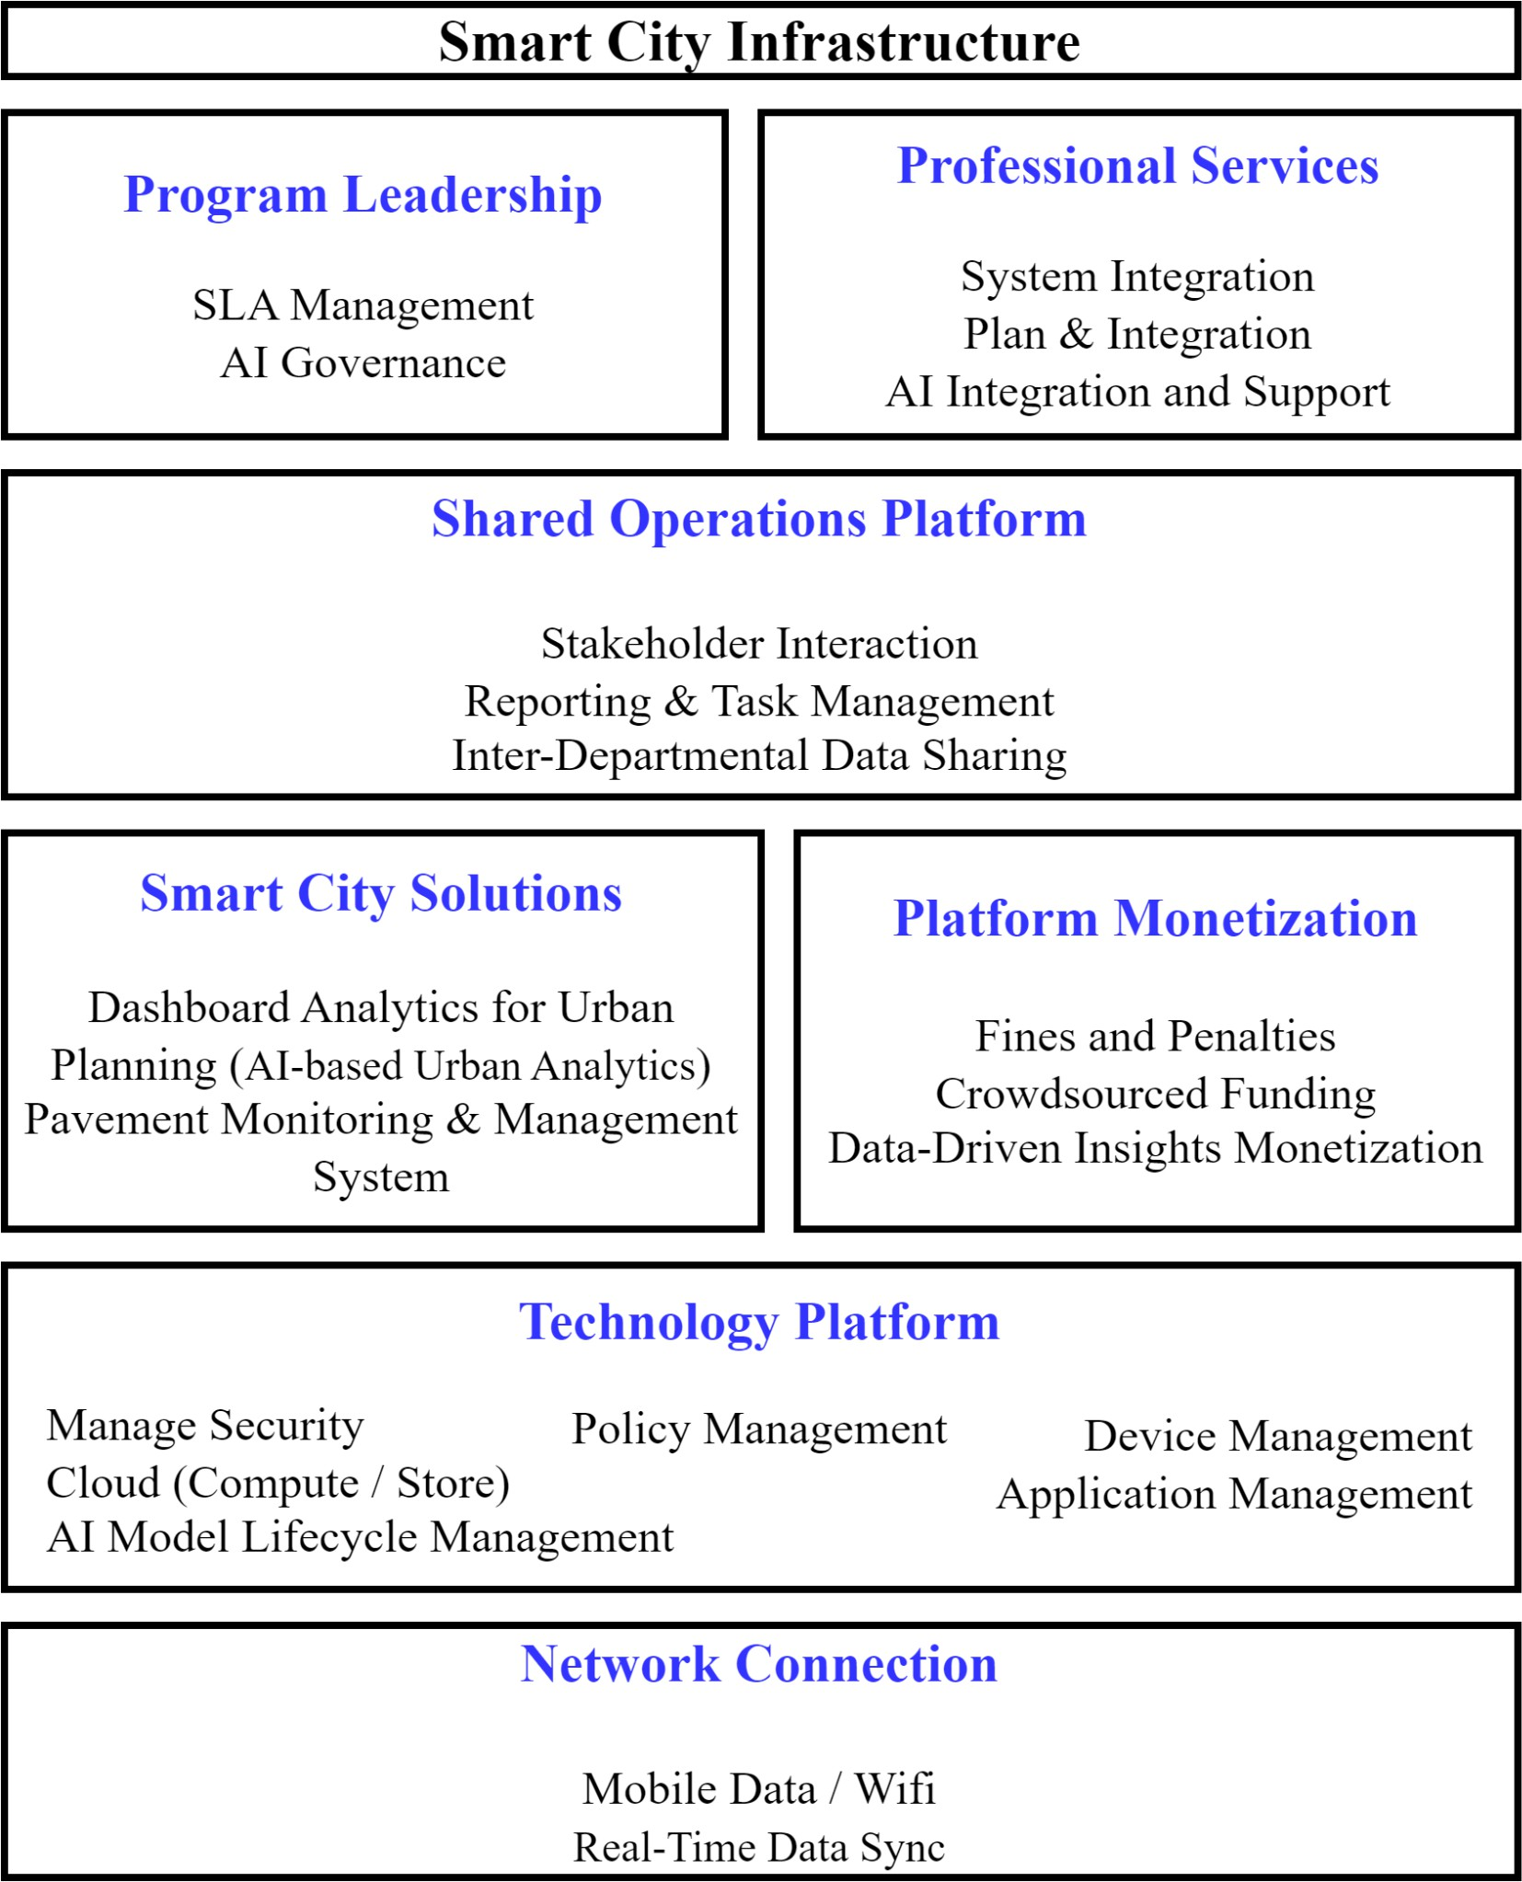

**Figure 1.** Proposed System in the Smart City Infrastructure

These extracted insights / anomalies are then used for a ready visualization displayed using a dashboard made available to the municipal corporation (typically B.M.C). administrative authorities. This would further facilitate improved decision making for city planning, synchronous crisis addressal within the departments of municipal corporations. along with periodic surveys and timely maintenance. The anomaly detection using image processing, feature extraction, object detection and AI would not only provide better actionable insights by the municipal corporation admin but also predict future pavement deterioration trends, season–wise pavement condition data thus aiding long-term urban planning and precise budget allocation for maintenance.

When our system detects any pavement issue, monitored by the local constituency Corporator [9], the dashboard will provide critical information such as an image, the severity of the issue, its type, and its geo-tagged location. This enables the Corporator to make informed decisions through the system dashboard, where they can audit the issue and generate a pavement issue complaint based on the referred details from our system. The complaint is then forwarded by the Corporator to the respective Ward Authority–Assistant Commissioner for further action, who contacts the department head to resolve the issue. We have identified three key departments within the municipal corporation / Brihanmumbai Municipal Corporation (B.M.C.) framework that align with our project scope: (1) ***Maintenance Department***, (2) ***Environment Department***, (3) ***Encroachment Department***.

[11] The HOD then assigns the task to a team of officials responsible for addressing the pavement conditions, while also preparing an expense report, which is submitted to the Additional Commissioner for approval. This ensures not only the resolution of the issue but also the accountability of the tasks completed, thereby creating a seamless loop within the Urban Planning process. This overall structure is aiming for improval of the factors in the core of Smart Urban Planning like reducing the *latency* in the pre-existing methods, improval of sustainability indexes: ***walkability index*** *(WI)*, ***traffic congestion index*** *(TCI)*, ***safety index*** *(SI)* under Mumbai, improving the ***Infrastructure Maintenance Efficiency*** *(IME)*, ***Public Transport Accessibility*** *(PTA)*. Sustainable Development Goals: No. 09 ***Innovation and Infrastructure***, No. 11 ***Sustainable Cities and Infrastructure***. Providing data for Perspective Planning and SLA (Service Level Agreement) guarantee from the Detection and Monitoring System.

#### Motivation

The rapid urbanization of cities like Mumbai has led to significant challenges in infrastructure management, particularly concerning the maintenance of pavements. Poorly maintained pavements pose serious risks to public safety, contribute to traffic disruptions, and increase repair costs for municipalities. Traditional inspection methods are often inefficient, relying on manual surveys that are time-consuming and prone to human error. Moreover, the lack of continuous monitoring limits the ability to identify and address emerging issues, leading to further deterioration of urban infrastructure. The urgent need for effective solutions to enhance pavement condition assessment and management has become increasingly critical in ensuring the safety and accessibility of urban spaces. By addressing these challenges, there is an opportunity to not only improve public safety but also to promote sustainable urban development and enhance the overall quality of life for city residents.

#### Problem Definition

* + - To automate the detection and reporting of pavement defects and encroachments using AI-powered image processing and geo-tagged video data, eliminating the reliance on manual inspections across Mumbai's administrative wards.
    - To enable real-time and continuous monitoring of pedestrian infrastructure through a scalable system mounted on municipal garbage trucks, ensuring efficient data collection without disrupting existing operations.
    - To support municipal authorities with a centralized dashboard that visualizes pavement anomalies, predicts deterioration trends, and facilitates timely complaint resolution through structured inter-departmental workflows.
    - To strengthen urban planning by integrating predictive analytics and periodic infrastructure assessments, thereby enhancing long-term maintenance planning, budget allocation, and service-level accountability.
    - To contribute to national goals under AMRUT, Smart Cities Mission, and the PUSHP mantra by improving walkability, public safety, and infrastructure efficiency in densely populated urban environments like Mumbai.

###### Objectives

* ***Hardware Electronic Control Unit* (ECU) Prototyping**
  + This unit will be mounted on either side of the authorized autonomous vehicle to capture real time video of the roadside. Significant frames extracted from the videos will be uploaded onto the cloud.
* Curation of a dataset
  + The images will further be the source for object detection and anomaly analysis and will provide significant status about the surface and lateral views of the pavement.
* Visualization of curated dataset
  + Summarizing the curated dataset along with providing critical information such as pavement conditions, obstructions and maintenance needs, including analytics to facilitate effective decision-making and operational efficiency.
* Object and anomaly detection
  + Training Machine Learning algorithm for detecting anomalies.
  + Optimization of the trained model for more accuracy.
* Scaling and deployment of detection system
  + Deployment of the system on cloud infrastructure to achieve scalability. This involves hosting both software and hardware components on the cloud to facilitate remote management, crowdsourcing and revenue generation by the civic bodies (typically B.M.C.)
  + System to handle large volumes of data and perform analysis and periodical report generation, scale seamlessly with increasing data loads, adapt to changing requirements.
* Align with the Civic Bodies/ Organization Infrastructure
  + Aligning the detection system with the civic body (typically B.M.C.) existing infrastructure to enhance coordination, improve data sharing, and streamline maintenance decision-making processes.
* Impact Measurement of the System in Urban City ( B.M.C, Mumbai)
  + Assessing the system’s effectiveness in the civic body workflow by evaluating improvements in maintenance response times, infrastructure conditions, and pedestrian safety, operational efficiency.

#### Existing System

One of the existing systems in India for road infrastructure feedback is the Meri Sadak mobile application, developed by the Ministry of Rural Development. It enables citizens to register complaints regarding the quality and condition of roads under the Pradhan Mantri Gram Sadak Yojana (PMGSY). Users can upload images and textual complaints, which are geo-tagged and forwarded to relevant authorities for resolution. While Meri Sadak promotes public participation and transparency, it largely relies on manual inputs, which limits its ability to provide large-scale, real-time, and objective assessments of pavement conditions across urban areas like Mumbai.

#### Lacuna’s in Existing System

1. Smart monitoring of road pavement deformations from UAV images by using machine learning. [12]
   * **Limitations on Ground-Level Hazards**: UAVs may miss key pedestrian hazards like obstructions, illegal parking, or street-level dangers, limiting their effectiveness for urban pedestrian safety projects.
   * **Weather and Operational Dependencies**: UAV operations are impacted by adverse weather conditions (e.g., monsoons) and require regulatory approvals, making them less reliable for continuous monitoring in congested areas.
2. Smartphone applications for pavement condition monitoring: A review.[13]
   * **Accuracy Concerns**: The accuracy of smartphone-based monitoring can vary due to factors such as driver behavior, vehicle dynamics, and the specific smartphone model, which can affect the consistency of data collection.
   * **Environmental Sensitivity**: The paper notes that environmental factors, such as weather conditions and vehicle speed, can affect the accuracy of smartphone data for PCM. These variables may lead to inconsistent detection rates.
   * **Data Variability**: The smartphone sensors collect **indirect data,** which requires significant preprocessing, including signal filtering and machine learning, to transform the raw data into actionable insights. This can increase the complexity and computational requirements.
3. Improved YOLOv5-Based Real-Time Road Pavement Damage Detection in Road Infrastructure Management. [14]
   * **Computational Complexity :** This is mainly due to the enhancements made to the YOLOv5 architecture, such as incorporating ECA-Net and Focal Loss, which potentially would **hinder the deployment** on low-power or resource-constrained devices.
   * **Overfitting, Latency, Bias :** Although label smoothing was used to prevent overfitting, the model may still struggle with **diverse environments and road conditions not reflected in the training data**. Furthermore, despite improvements in real-time processing, larger datasets or high-resolution images could **reduce detection speeds**, especially in edge devices. Lastly, the model's reliance on the RDD 2022 dataset could introduce biases if the **data does not fully represent global road damage types**, potentially skewing its performance in varied real-world scenarios.
4. Pavement Patch Detection and Measurement from Video Data Using a Parking Camera. [15]
   * **Initial Setup Costs :** Although using existing vehicle-mounted cameras is cost-effective compared to dedicated inspection vehicles, the initial setup costs for integrating these cameras into municipal vehicles and ensuring proper calibration can still be substantial.
   * **Impact of Weather Conditions :** The effectiveness of video data can be compromised by weather conditions, including rain, snow, or fog, which may obscure visibility and affect the clarity of captured images. This can lead to missed detections or false positives.
5. The State-of-the-Art Review on Applications of Intrusive Sensing, Image Processing Techniques, and Machine Learning Methods in Pavement Monitoring and Analysis. [16]
   * **Challenges with Cost and Complexity :** The installation of intrusive sensors is costly, complex, and requires skilled personnel for data interpretation. Additionally, the system generates large volumes of data, which can be difficult to process in real-time.
6. Road Pavement Monitoring Using Smartphone Sensing with a Two-Stage Machine Learning Model. [17]
   * **Training Data Requirements :** The effectiveness of machine learning models is contingent upon the availability of a large and diverse dataset for training. Collecting sufficient labeled data for various road conditions can be challenging and resource-intensive.
   * **Categorization Challenges :** The model categorizes anomalies into broad categories (normal road, large cracks, bumps, potholes). This simplification may overlook nuanced defects or variations in pavement conditions that require more detailed analysis.
7. Road Condition Monitoring Using Smart Sensing and Artificial Intelligence. [18]
   * **Challenges:** Key challenges include the need for real-time processing, data standardization, and improved characterization of pavement damage to enhance maintenance prioritization.

#### Relevance of the Project

Mumbai faces severe challenges with deteriorating pavements, obstructed pedestrian pathways, and encroachments, leading to low walkability and high pedestrian fatalities. Manual inspection methods are inefficient and delay maintenance. The project aligns with national initiatives like AMRUT, Smart Cities Mission, and PUSHP Mantra, focusing on sustainable urban development and improved pedestrian infrastructure. It proposes an AI-based system using geo-tagged video data collected from municipal garbage trucks covering all 24 administrative wards, enabling automated, real-time pavement condition monitoring. The system detects pavement defects, environmental hazards, and encroachments, providing actionable insights through a dashboard accessible to municipal authorities for better decision-making and timely maintenance. It supports long-term urban planning by predicting pavement deterioration trends and optimizing budget allocation for repairs. The project enhances accountability by integrating complaint workflows involving local corporators and ward authorities, ensuring resolution and monitoring of pavement issues. Expected outcomes include improved walkability, traffic congestion, safety indices, and infrastructure maintenance efficiency, contributing to Sustainable Development Goals 9 (Industry, Innovation, and Infrastructure) and 11 (Sustainable Cities and Communities).

# Chapter 2: Literature Survey

#### A. Overview of the Literature Survey

The literature survey explores various methods and technologies for pavement monitoring and management. It covers approaches ranging from traditional manual inspections to advanced technologies like UAVs, smartphone-based sensors, vehicle-mounted cameras, and intrusive sensing methods. Each technology has its strengths and weaknesses. Manual inspections are labor-intensive and inefficient. UAVs offer high-resolution imagery but are limited by weather and regulatory constraints. Smartphone applications are cost-effective but less accurate due to variability in sensor quality and environmental factors. Improved deep learning models like YOLOv5 enhance real-time damage detection but face challenges in generalizing to diverse road conditions and computational complexity. Vehicle-mounted camera systems provide a cost-effective data collection method but need AI for comprehensive analysis. Intrusive sensing offers real-time structural health monitoring but is costly and generates large data volumes. The literature highlights the need for an integrated, automated, and scalable approach tailored for specific urban contexts to overcome the limitations of existing systems.

#### Research Papers Referred

1. Smart monitoring of road pavement deformations from UAV images by using machine learning. [12]

* **UAV (unmanned aerial vehicles):** Smart Monitoring of road pavement deformations using high-resolution **aerial images of road surfaces** combined with machine learning techniques is used to detect surface defects, such as potholes and cracks. The paper focuses on pre-processing the data and using **decision tree classification** for effective **crack detection.**
* **High-Resolution Data and Advanced Detection**: UAVs capture multispectral images for detecting surface defects like cracks and potholes. Machine learning algorithms, including classification trees and Canny edge detection, enhance accuracy (up to 96% in some cases). UAVs offer high-resolution imagery (up to 2 cm/pixel), allowing even small cracks to be detected, contributing to the system’s high precision.

1. Smartphone applications for pavement condition monitoring: A review. [13]

* **Smartphone Sensors**: Smartphones equipped with accelerometers, gyroscopes, and GPS capture data on road conditions. Machine learning algorithms process this data to detect surface defects like **roughness, potholes, and cracks** with reasonable accuracy, sometimes achieving results comparable to more costly methods.

1. Improved YOLOv5-Based Real-Time Road Pavement Damage Detection in Road Infrastructure Management. [14]

* **Efficient Channel Attention module (ECA-Net) :** Focuses on enhancing the YOLOv5 model for more efficient and accurate real-time detection of road pavement damages, such as **vertical and horizontal cracks, alligator cracks, and potholes.** Trained on the RDD 2022 dataset, which features images from six countries, the enhanced model demonstrates improved accuracy, robustness, and speed, making it a valuable tool for real-time road infrastructure management.
* **Generalization to new or unseen damage types :** As the model is primarily trained on the RDD 2022 dataset, which might not cover all possible road conditions globally.

1. Pavement Patch Detection and Measurement from Video Data Using a Parking Camera. [15]

* **Patch Detection for Pavement Assessment :** The system automates the detection of pavement defects, particularly **road patches**, by using video data collected from **car-mounted cameras**. The method relies on **visual characteristics such as closed contours and similar textures** between the patch and the surrounding intact pavement. This data is processed through image processing algorithms to detect and track defects like patches.
* **Cost Efficiency :** By using existing vehicle-mounted cameras, the system eliminates the need for expensive, dedicated road inspection vehicles, which can cost as much as £500,000 to purchase and £20 to £40 per kilometer to operate.

1. The State-of-the-Art Review on Applications of Intrusive Sensing, Image Processing Techniques, and Machine Learning Methods in Pavement Monitoring and Analysis. [16]

* **Intrusive Sensing and Real-time Monitoring :** It can detect and predict pavement conditions, such as **cracks, potholes, and structural weaknesses**. The system uses

embedded sensors (e.g., stress-strain, fiber optic) to continuously monitor pavement conditions under traffic loads, offering real-time updates on structural health.

* **Advanced Image Processing :** Techniques such as noise reduction, edge detection, and morphological operations improve accuracy in detecting surface defects like cracks and potholes.
* **Machine Learning for Automation :** Algorithms such as SVM, ANN, and CNN automate the detection and prediction of pavement defects, providing high accuracy and reducing the need for manual inspections.

1. Road Pavement Monitoring Using Smartphone Sensing with a Two-Stage Machine Learning Model. [17]

* **Utilizes smartphone sensors** integrated into a two-stage machine learning model. **First stage:** Random Forest Classifier detects potential road anomalies. **Second stage:** Gaussian Process Classifier classifies anomalies into categories like normal road, large cracks, road bumps, and potholes.
* Transforms time-series data into **geospatial data**, making the system speed-independent and adaptable to urban settings.

1. Road Condition Monitoring Using Smart Sensing and Artificial Intelligence. [18]

* **Advanced Technologies in RCM**: Road Condition Monitoring uses smart sensors **(RGB cameras, thermal sensors, LiDAR)** and AI technologies (ML and DL models) to detect and classify pavement distresses like cracks and potholes efficiently.
* **Platforms and Approaches**: Ground vehicles, UAVs, and smartphones are key platforms for sensor deployment, each offering unique advantages. DL models, especially CNNs, are prominent for high-accuracy detection and segmentation of road issues

#### Inference Drawn

The literature survey underscores the need for automated pavement monitoring systems due to the inefficiencies of manual inspections, revealing trade-offs between accuracy, cost, and scalability among technologies like UAVs, smartphones, and intrusive sensors. An integrated approach, combining multiple technologies for comprehensive assessment, is vital, alongside real-time monitoring for timely maintenance and proactive urban planning.

# Chapter 3: Requirement Gathering for the Proposed System

#### Introduction to Requirement Gathering

Requirement gathering is a critical phase in system development that involves understanding and documenting what is necessary for a system to fulfill its purpose. For our AI-based pavement condition monitoring system, it involves identifying the needs of stakeholders, the data collection methods, and technological specifications required for successful implementation in the urban infrastructure of Mumbai.

#### Functional Requirements

* + - **Video Data Collection**: Real-time video feed collection via an Electronic Control Unit (ECU) mounted on municipal garbage trucks.
    - **Geo-tagging**: Embedding location metadata with every video frame for accurate localization of anomalies.
    - **Image Extraction**: Frame extraction from videos to isolate significant images for analysis.
    - **Anomaly Detection**: Detection of anomalies such as potholes, encroachments, illegal parking, broken infrastructure using AI-based object detection.
    - **Severity Analysis**: Classify anomalies based on severity levels (minor, moderate, critical).
    - **Dashboard Interface**: Visualization of anomalies with filters for location, type, and severity.
    - **Complaint Generation Module:** Allow corporators to raise complaints and forward them to appropriate departments.
    - **Role-based Access:** Different users (Corporators, Ward Officers, Department Heads) have role-specific access and control over the system.

#### Non-Functional Requirements

* + - **Performance**: The system should process and display detection results within a minimal response time.
    - **Scalability**: Able to handle high volumes of video data from all 24 municipal wards.
    - **Reliability**: Must ensure 99.9% uptime and reliable detection of anomalies.
    - **Security**: Secure data transmission and storage using encryption and authenticated access.
    - **Usability**: The dashboard should be intuitive, multi-lingual, and user-friendly for non-technical municipal workers.
    - **Maintainability**: Easy to update models, ECU firmware, and dashboard interfaces as technology evolves.

#### Hardware, Software, Technology and Tools Utilized

|  |  |
| --- | --- |
| **Hardware** | **Software** |
| Raspberry Pi 4 with Wi-Fi module and GPS. Pi Camera. Battery and power indicators for uninterrupted operation. | **Programming Languages**: Python, JavaScript  **Libraries**: OpenCV, YOLOv5, TensorFlow or PyTorch  **Dashboard**: ReactJS for frontend, NodeJS with ExpressJS for backend  **Database**: PostgreSQL  **Cloud Services**: AWS for cloud storage, computing, and scalability |

* 1. **Constraints**

The proposed system, while innovative, faces certain practical limitations. One of the primary constraints lies in the hardware capabilities—using resource-constrained devices like Raspberry Pi for real-time video processing and AI inference may impact the speed and accuracy of anomaly detection. Environmental factors such as poor lighting, rain, or obstruction due to traffic can affect video clarity, leading to possible false negatives or false positives in detection. Additionally, collecting consistent, high-quality data across varied terrains and city conditions remains a challenge. These conditions can impact both the performance of the AI model and the reliability of results. There's also the challenge of ensuring that the trained AI model generalizes well across different wards, considering variations in road structure, damage types, and encroachments.

# Chapter 4: Proposed Design

#### Block Diagram

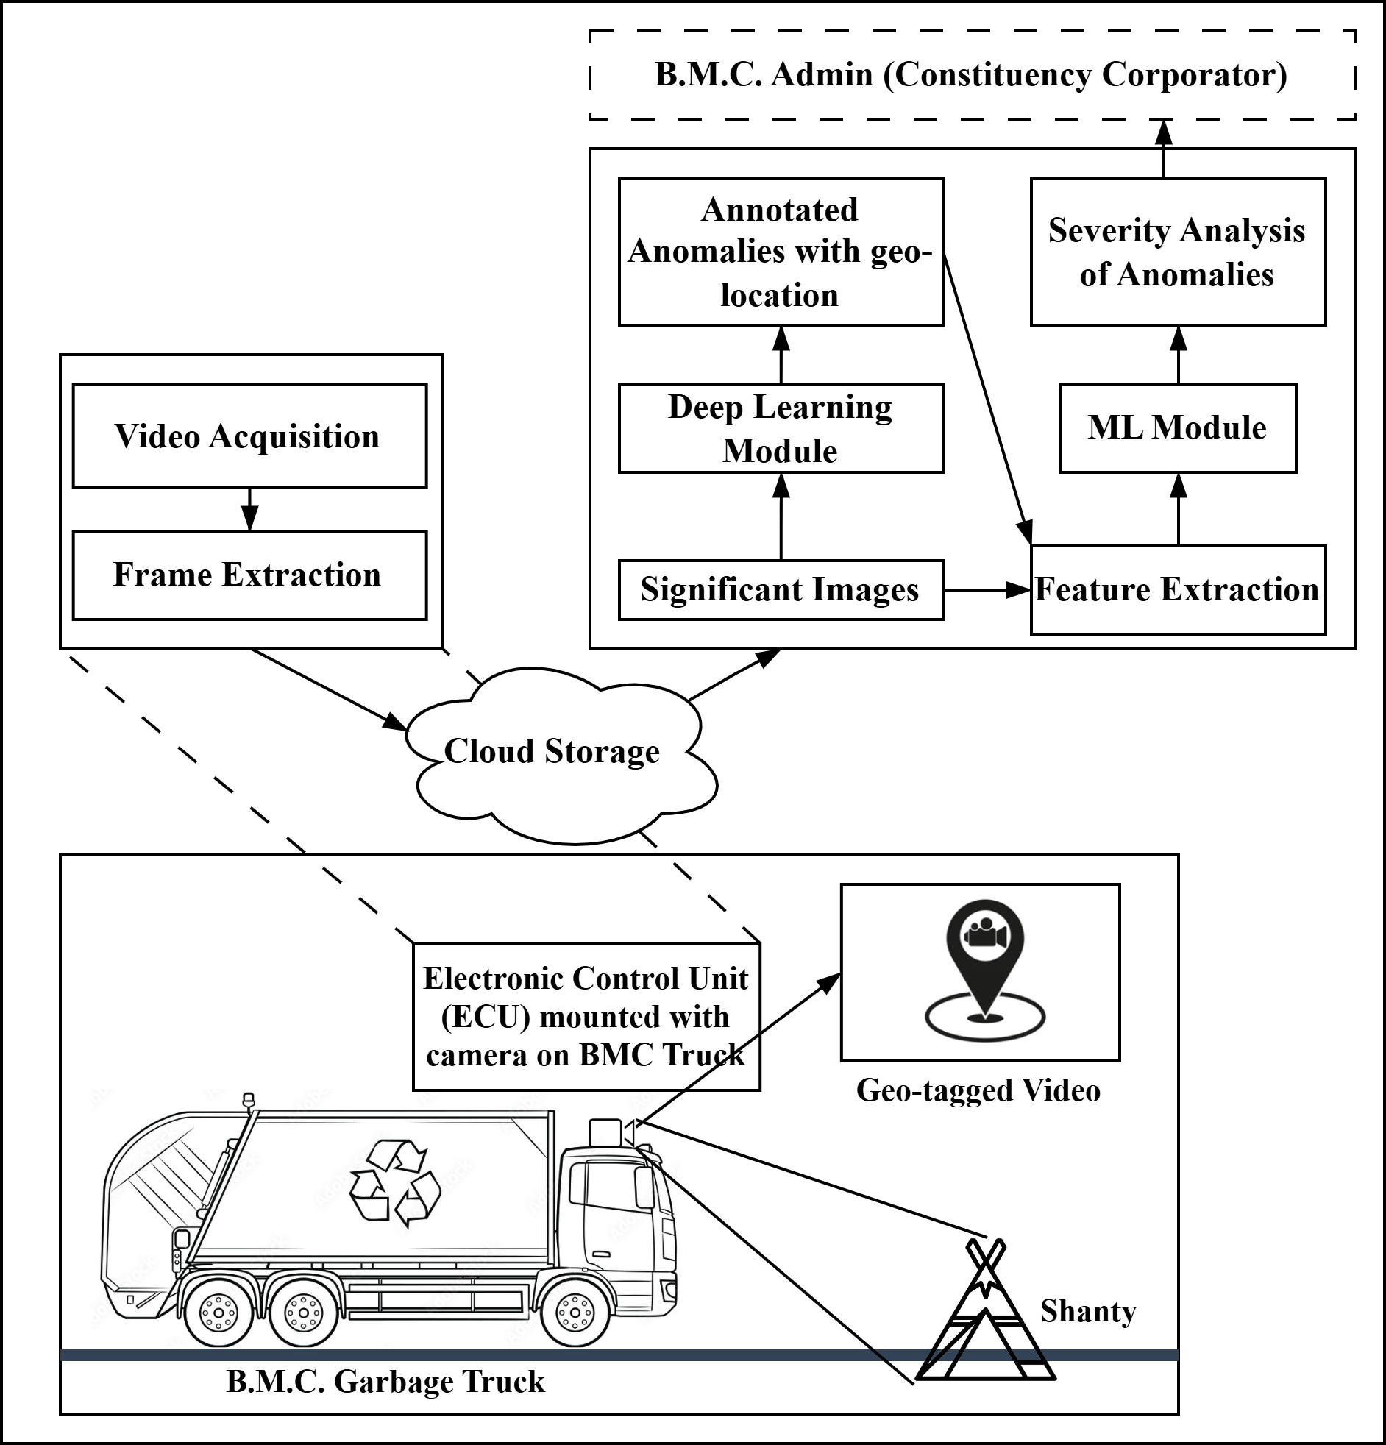

**Figure 2.** Block Diagram for the Proposed System for Data and Monitoring

Mumbai being a metropolitan city with dense urbanization has been facing pavement management issues [6] in terms of settlements around them, illegal parking, hawkers on the pavements, huge hoardings, fallen trees etc. Sometimes the surface condition of the pavements also deteriorates and potholes, open manholes, uneven roads, cracks and even waterlogging become a huge crisis for pedestrians as well as travelers.

Civic body. authorized garbage trucks usually move along these pavements [8] and can be used to gather our research related data. The idea is to mount an ***Electronic Control Unit*** on these trucks for collecting videos of the lateral and surface views of the roads. The significant images segregated after video processing would give insight regarding the condition of the pavements on that road as well as its geo-tagged location, thus providing a curated dataset for further analysis.. This would provide ***cost effectiveness*** against manual inspection of pavements and would generate ***periodic location–based data***. Further the video data generated would be substantial for ***planning and maintenance by civic/municipal divisional authorities*.** Usage of different image processing techniques and AI for extracting pool of features / defects including surface level and vertical objects with factors such as environmental (fallen trees / branches / uplifting of pavement due to tree roots etc.), defects (cracks or uneven surfaces / potholes / waterlogging etc.), human

interference (illegal parked vehicles / barricades / hoardings (boards), shanties, unauthorized hawkers / vendors), others (broken lamp post / open manholes, broken benches and railing etc.). This would provide a trained AI model for validation and testing of unseen cases.

The Municipal Authorities would highly benefit from the ***ready dashboard visualization*** provided regarding the anomalies (hoarding, potholes etc.) detected from the images along with its geo–location so as to integrate prompt action for management of pavements. Usage of ***cloud infrastructure and storage*** for raw video data would ensure a secure and reliable backup for the future. An ***user-friendly, multi–lingual, (one of a kind) web application*** for the ***municipality***. would be developed for pavement condition monitoring and management. This would further facilitate improved decision making, ***synchronous crisis addressal*** within the departments of Municipal Authorities along with ***periodic surveys and timely maintenance***. The anomaly detection using image processing, feature extraction, object detection and AI would not only provide better ***actionable insights*** by the Municipality Officials but also help in predicting ***future pavement deterioration trends****,* ***season–wise pavement condition data*** thus aiding ***long-term urban planning and precise budget allocation*** for maintenance by the Municipal authorities.

The project supports key government initiatives like the ***AMRUT*** [1]***, Smart City Mission*** [2]***, PUSHP*** [3], aligning with national goals of enhancing urban infrastructure, reducing urban congestion, and improving pedestrian safety through smarter city planning. This would create research potential to **foster collaborations** between Municipal bodies, NGOs, SMEs, private technology providers, architects and contractors contributing to ***smart city initiatives*** and possibly ***stimulating local start-ups***. This would create labor opportunities for ***daily–wage workers*** and ***business ideas*** for all other stakeholders.

##### Detailed Design

The demands of the city infrastructure of Mumbai require a multi-layered system to ensure efficient urban planning and management. BMC **lies in the Network Connection layer**, which integrates mobile data and Wi-Fi for real-time data synchronization. A **Technology Platform** is provided for managing security, policies, devices, and AI models, supporting operational efficiency and revenue generation opportunities. Our solution will also function as a **Shared Operations Platform**, enabling inter-departmental data sharing and task management, benefiting secondary stakeholders. **Smart City Solutions**, such as AI-based analytics for urban planning and pavement monitoring, will enhance decision-making. Additionally, **Platform Monetization** introduces revenue streams through fines, penalties, and data monetization.

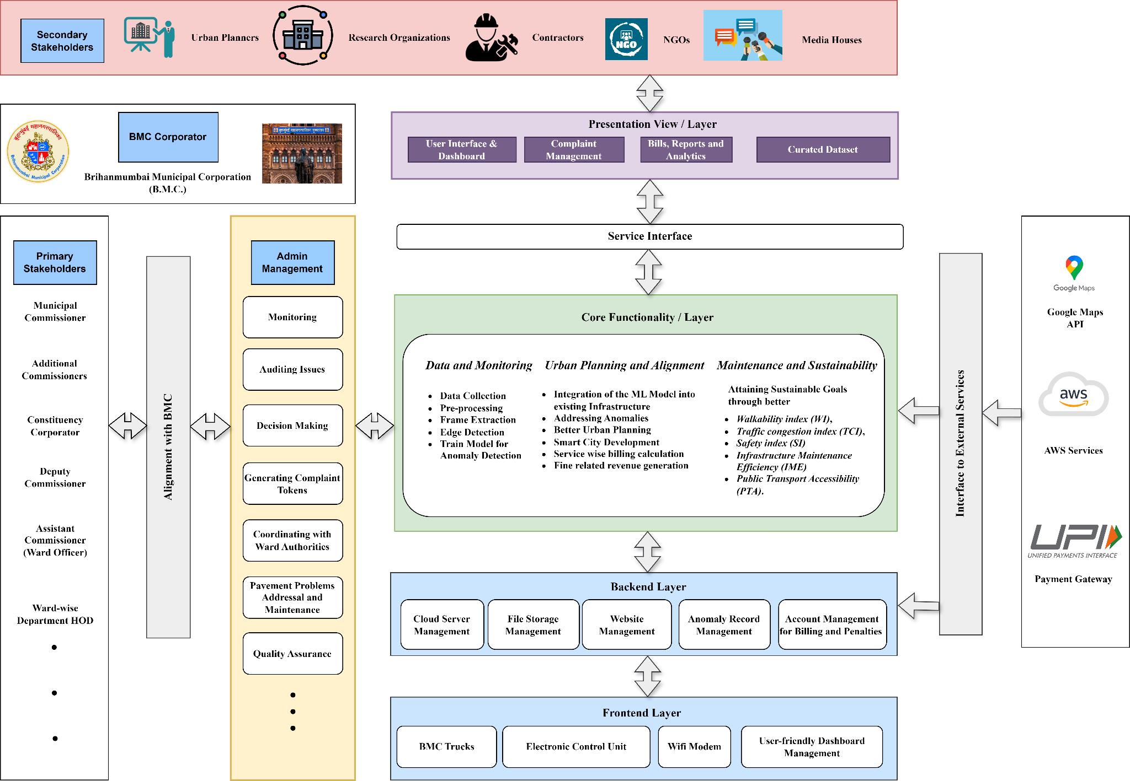

**Figure 3.** Proposed Service Level Architecture Diagram

The **Network layer consists of** both hardware and software components. The Electronic Control Unit (ECU), mounted on municipal corporation trucks, captures geo-tagged videos and generates datasets through frame extraction, which are uploaded to cloud storage. The AI module then processes this dataset using machine learning algorithms for feature extraction, anomaly detection, and severity analysis, providing actionable insights for pavement management.

The solution aligns seamlessly with the existing municipal corporation/Brihanmumbai Municipal Corporation (B.M.C.) infrastructure, requiring no overhauling of the existing framework. Complaints raised by Constituency Corporators will be processed through the established channels, where Ward Officers oversee technical aspects, and the appropriate departments—Maintenance, Environment, or Encroachment—are tasked with addressing issues. This alignment ensures that our AI-based system complements BMC's workflows, enhancing task allocation and reporting without disrupting the current processes. Upon alignment of this system with the municipal corporation infrastructure, system Dashboard can be utilized by the Ward Corporator to monitor and audit irregularities in the pavements of its constituency and to help them generate a Maintenance Complaint Report for his area to submit it to the relevant municipal corporation divisional authorities. Internal coordination within the municipal corporation / Brihanmumbai Municipal Corporation (B.M.C.) will be improved via the following factors:

* + 1. Elimination of manual time consuming and high cost pavement inspections,
    2. Enhancing quick responsive decision-making for maintenance and improvements activities,
    3. Legal eviction procedure and revenue loss due to encroachments,
    4. Administering the policy of fine/challan/penalty and thus initiate Revenue generation,
    5. Improving task prioritization and resource allocation to the Departmental workforce team,
    6. Bill generation for manpower/material usage and efficient distribution of funds for maintenance,
    7. Reduction of public complaints regarding delays in construction and extended response times for grievances,
    8. Facilitating the identification of high walkability areas, ensuring satisfaction of common man,
    9. Planning and developing sustainable cities through optimized urban infrastructure management.

The Research Outcomes of the Pavement Management System can be utilized by ***primary (within BMC) and secondary (non-BMC)*** stakeholders who can implement actionable insights and adopt technological advancements, leading to sustainable city planning and optimized urban infrastructure management. Additionally, it can contribute and align with India's National–level Programmes and Missions under Smart City and Urban Infrastructure like–AMRUT, Smart City Mission, PUSHP. It also increases the engagement of diverse stakeholders—including central and state government bodies (for e.g. MMRDA), other state urban planners, technology providers, and community members creating a robust ecosystem for implementing smart solutions. In the field of Communication / Dissemination / Advocacy, it highlights the role of media coverage, decision-making through endorsement, and even promotes the involvement of special interest groups like disaster management bodies, etc. An evidence base is established through crowdsourcing contributions and stimulating new research, ensuring a continuous feedback loop for improving sustainability measures. It emphasizes the need for policy changes and reorganization of departments and services within the municipal corporation/ Brihanmumbai Municipal Corporation (B.M.C.).

#### Project Scheduling & Tracking: Gantt Chart

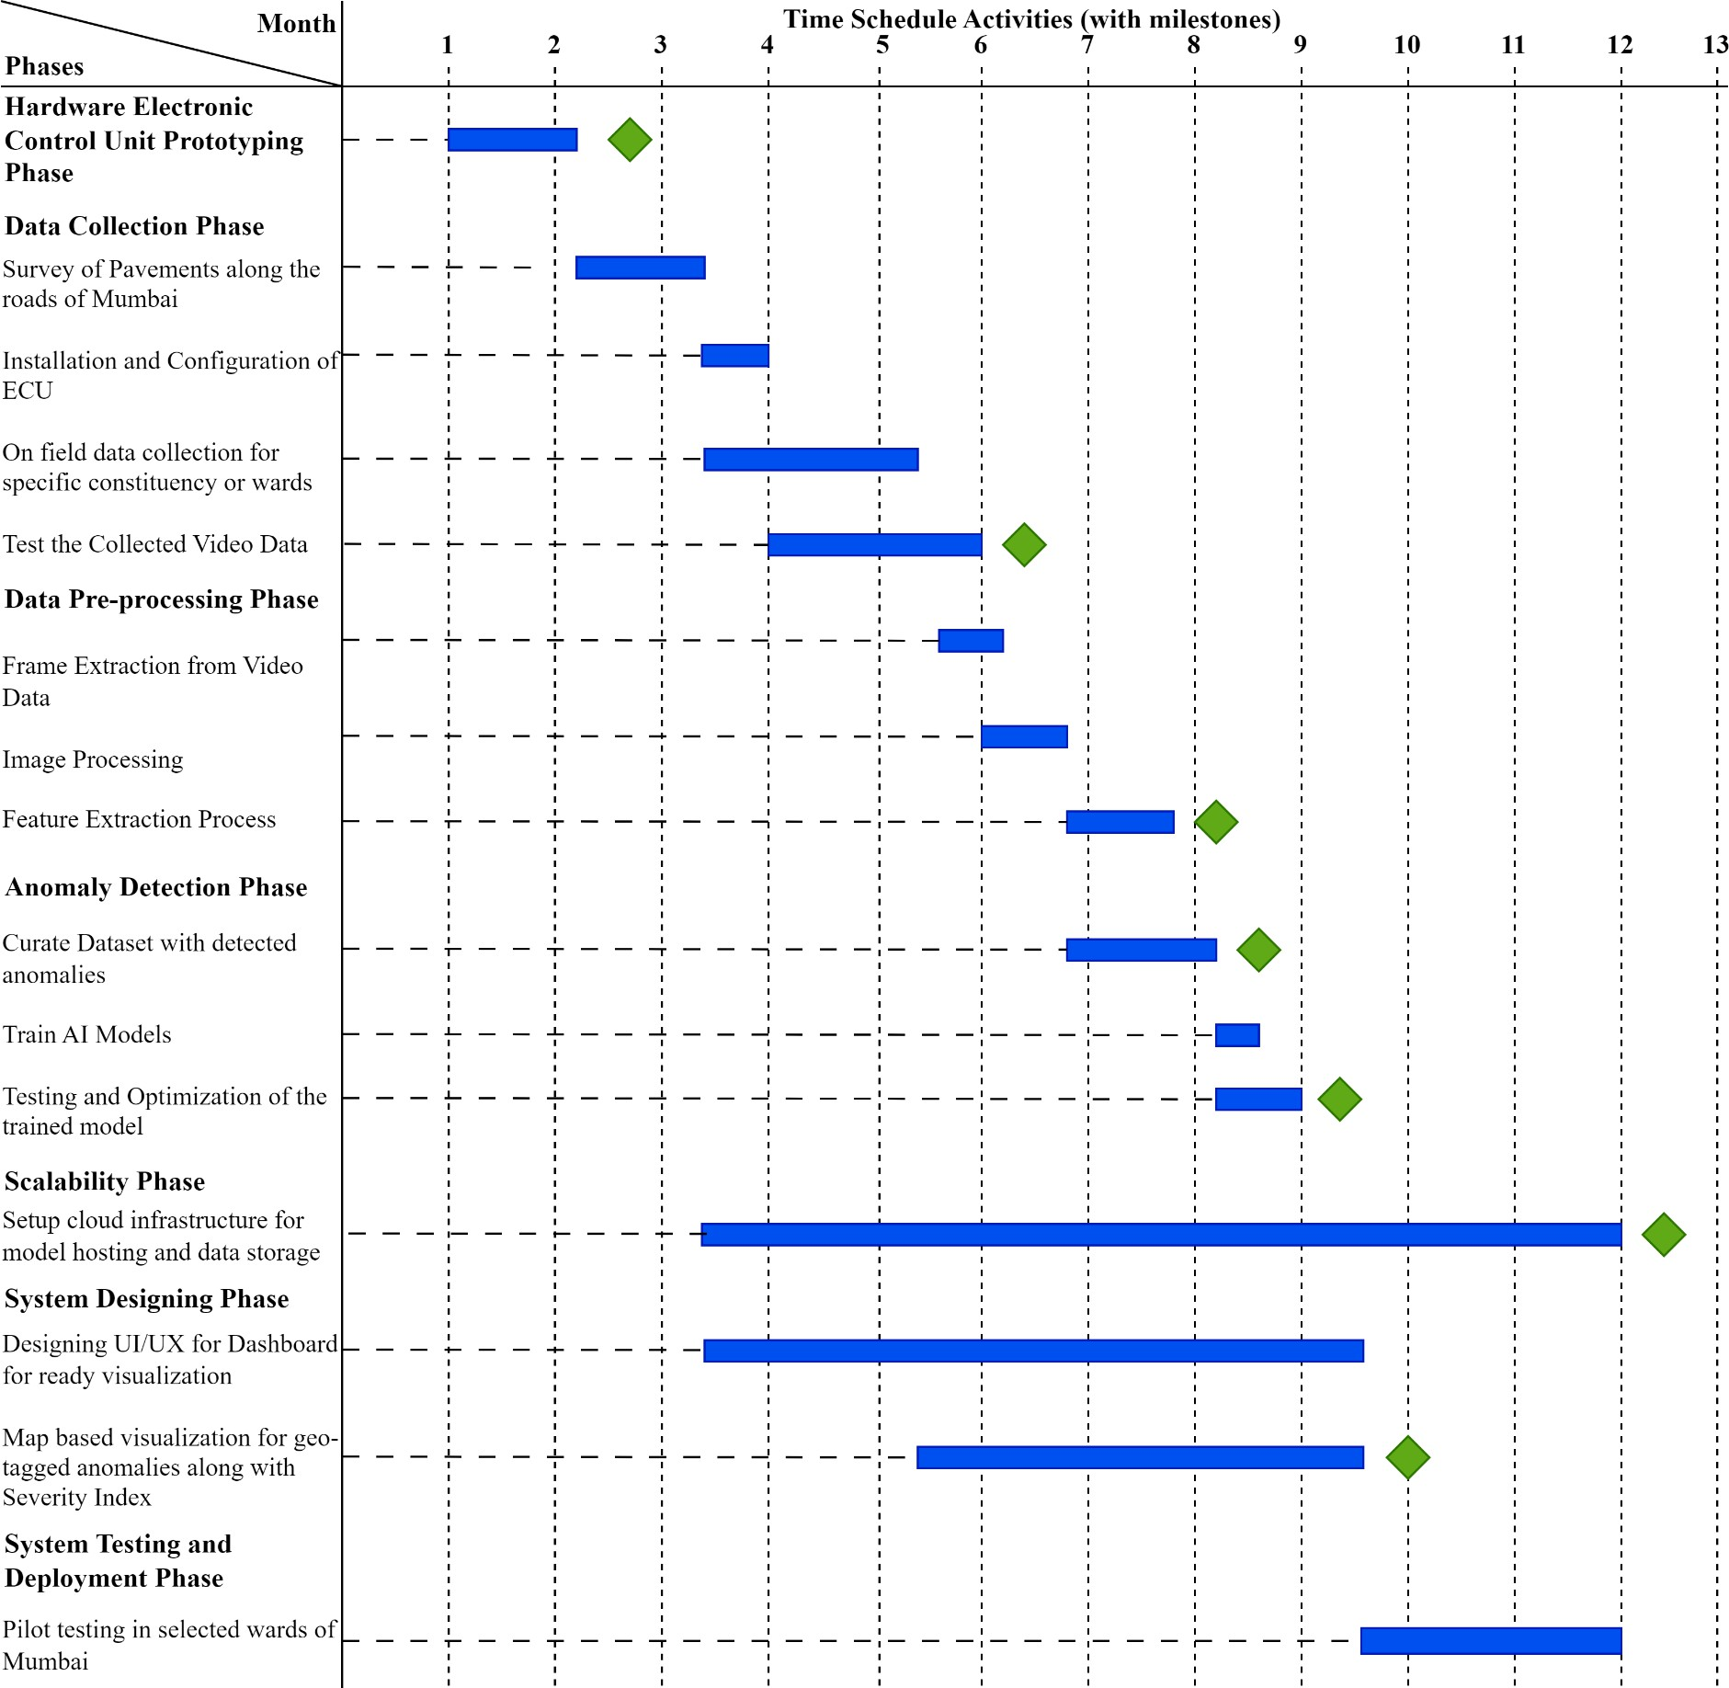

**Figure 4.** Gantt chart (Bar Diagram) of Time Schedule of Activities (with milestones)

# Chapter 5: Implementation of the Proposed System

#### Methodology Employed

1. Electronic Control Unit (ECU) for Municipal Corporations Trucks

The Electronic Control Unit (ECU) will use a Video Processing Unit (VPU) connected to the camera along with a GPS module for location data. The Raspberry Pi processes the video and generates differential images and uploads it to the cloud via a Wi-Fi Modem. The system operates with a stable power supply, monitored by a Battery Capacity Indicator to ensure continuous functionality during monitoring routes.

1. Data Collection

Equip municipal corporation. authorized garbage trucks with ECU for daily video data of pavement conditions. The captured images from the video uploaded on the cloud will facilitate anomaly detection using image processing and AI. The images will be associated with a precise location, facilitating better tracking of pavement conditions.

1. Data Pre–processing and Feature Extraction

Frame extraction to isolate relevant images of pavement and footpath surfaces. Further image processing will be performed for noise reduction, segmentation, edge detection and feature extraction for identifying environmental anomalies (fallen trees / branches / uplifting of pavement due to tree roots etc.), pavement defects (cracks or uneven surfaces / potholes / waterlogging etc.), human interference (illegal parked vehicles / barricades / hoardings (boards), shanties, unauthorized hawkers / vendors ) and others (broken lamp post / open manholes, broken benches and railings etc.).

1. Anomaly Detection

Use the extracted image features to create a curated dataset for training the AI model. The dataset will contain various classes of anomalies with labeled data for each anomaly type using deep learning algorithms. Further optimization will be included to improve accuracy and reduce latency, ensuring that the model works efficiently even in real-time and large-scale urban scenarios.

1. Scalability

Host the trained model, raw video data, and processed images on a cloud infrastructure. This will allow for scalable and remote access to the system for municipal corporation officials. Video data and extracted insights will be securely stored for future reference and analysis. The system will handle large volumes of incoming data, performing anomaly detection and generating reports on pavement conditions, complete with geo-tagged imagery.

1. Visualization

An user-friendly dashboard will be developed to provide municipal corporation administrators with updates on pavement conditions. The dashboard will feature: (1) Map-based visualization for geo-tagged anomalies. (2) Detailed information on each anomaly type with images and severity analysis. (3) Actionable insights, such as which department to contact for repair.

1. Testing and Deployment

The system will be tested through pilot deployment in selected wards of Mumbai. Validation will include accuracy assessments of anomaly detection, efficiency in data processing, and user satisfaction with the dashboard’s functionality. Mumbai–pavements performance data will be used to refine and improve the model and system components.

1. Alignment with Existing Infrastructure

The production–ready website will be delivered to the municipal corporation. Then the Corporators will be able to log in and access dashboards specific to their respective constituencies for monitoring conditions, auditing issues, and initiating complaints tokens for solving the maintenance issues. The complaints will be forwarded by them to the relevant Authorities for further Smart City Urban Planning.

1. Impact Measurement for Maintenance and Sustainability

The system’s impact in the municipal corporation workflow will be evaluated through key performance parameters such as reduced maintenance response times (latency reduction), improved pavement and infrastructure conditions, and pedestrian safety and accessibility.

#### Algorithms and Flowcharts

* + 1. System Overview:
       - The Electronic Control Unit (ECU), mounted on municipal corporation trucks, captures geo-tagged videos of pavement conditions in the city.
    2. Data Generation:
       - As the trucks drive around, they record videos that are processed to generate datasets through frame extraction. These datasets are then uploaded to cloud storage for further analysis.
    3. AI Module Processing:
       - The AI module processes these datasets using machine learning algorithms for:
         * **Feature Extraction**: Identifying specific characteristics of pavement conditions.
         * **Anomaly Detection**: Recognizing defects or unusual conditions.
         * **Severity Analysis**: Assessing the seriousness of identified issues.
    4. Image Processing Techniques:
       - Various image processing techniques are employed to extract features and defects, including:
         * **Environmental Factors**: Identifying issues such as fallen trees or branches and uplifted pavement due to tree roots.
         * **Maintenance Defects**: Spotting cracks, uneven surfaces, potholes, and areas prone to waterlogging.
         * **Encroachments**: Detecting illegal parking, barricades, hoardings, shanties, and unauthorized vendors obstructing the pathways.
         * **Other Issues**: Highlighting problems such as broken lamp posts, open manholes, and damaged benches or railings.
    5. Visualization and Decision Making:
       - The extracted insights and anomalies are visualized on a user-friendly dashboard made available to municipal corporation authorities, such as the

B.M.C. This visualization aids improved decision-making for city planning.

* + 1. Long-Term Planning and Maintenance:
       - The system facilitates periodic surveys and timely maintenance of pavements. Anomaly detection and feature extraction provide better actionable insights for municipal administration, enabling predictions of future pavement deterioration trends and seasonal pavement condition data.

#### Dataset Description

|  |  |
| --- | --- |
| **Class Names** | **Count in the Dataset** |
| *bike* | 497 |
| *hawker* | 303 |
| *scooter* | 704 |
| *street-vendor* | 454 |
| **Annotated Dataset Snapshot on Roboflow** | |
|  | |

**Table 1.** Count of the Classes present in the Image Dataset

The dataset consists of 1,958 annotated images categorized into four classes commonly found obstructing pavements in urban areas: bike (497 instances), hawker (303 instances), scooter (704 instances), and street-vendor (454 instances). Created and labeled using Roboflow, this dataset is designed to train object detection models—such as YOLOv5—to identify and classify typical obstructions on footpaths. The dataset reflects a realistic distribution of these objects, making it suitable for smart city applications like pedestrian safety monitoring.

# Chapter 6: Data Collection

#### Data Collection Details

To ensure effective implementation of the proposed pavement monitoring system, a structured and repeatable data collection process was established. This involved capturing high-resolution, geo-tagged video data across a designated urban area over a fixed timeline. The goal was to acquire visual and spatial information of road and pavement conditions under consistent environmental and traffic conditions. The data serves as the foundational input for the AI-based anomaly detection model, ensuring the model’s accuracy, reliability, and generalizability across different scenarios.

###### Video Data Collection Schedule

The data collection was conducted over a continuous period of four weeks, comprising four dedicated cycles. The process commenced on 3rd December 2024 and concluded on 15th January 2025. During this period, video drives were scheduled weekly to ensure variability in temporal factors such as lighting, weather conditions, and pedestrian activity. One comprehensive report was generated based on these iterations, summarizing the observations and technical feasibility of the data captured. The consistency in temporal sampling ensured diverse real-world representations for model training and analysis.

|  |  |  |  |  |
| --- | --- | --- | --- | --- |
| **Total Weeks** | **Iterations (Cycles)** | **Start Date** | **End Date** | **No. of Reports** |
| 04 / 28 days | 04 times Data Collection | 03-12-2024 | 15-01-2025 | 01 |

**Table 2.** Video Data Collection Schedule

###### Video Data Collection Details

|  |  |  |
| --- | --- | --- |
| **Sr. No.** | **Details** | |
| **1.** | Targeted Area | Chembur / M-Ward |
| **2.** | Kms to be covered | 12 (6 each way) |
| **3.** | Vehicle | Car (30-50 km/hr) |
| **4.** | Video Capturing Device | Phone Camera / 1920 x 1080p (preferably) / Nos. 2 |
| **5.** | Frames per second | 15-30 |
| **6.** | Average Video Duration | 10-15 minutes |
| **7.** | Geo-tagging | Location Data in the JPEG of each frame |

**Table 3.** Video Data Collection Details

#### Results and Observations

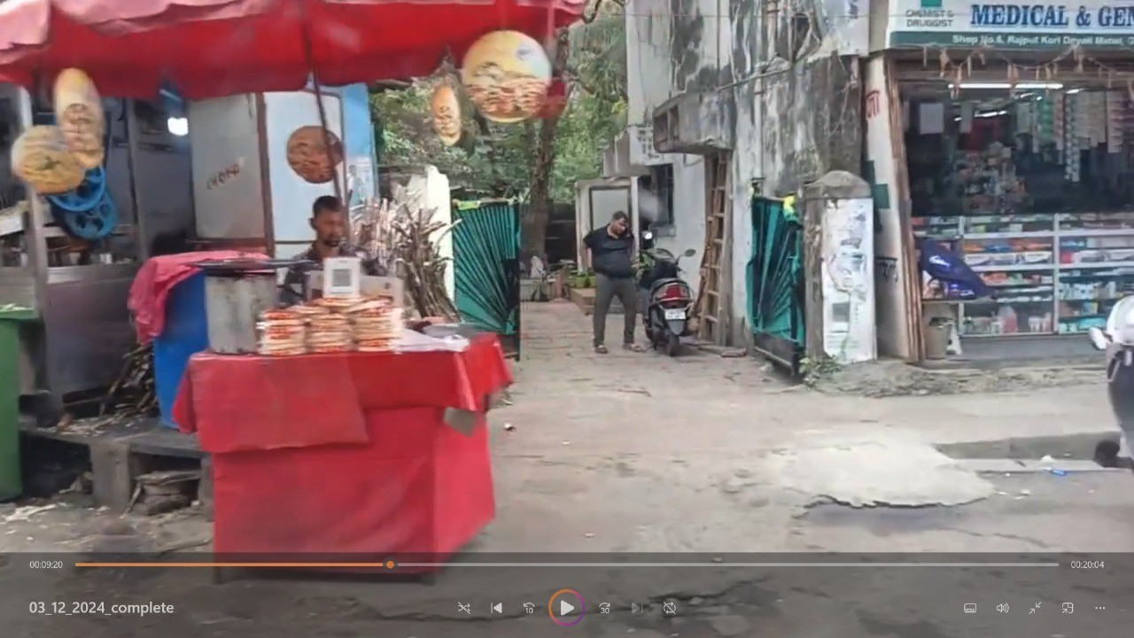Preliminary observations from the captured video snapshots revealed key insights about the pavement infrastructure in the selected region. The images clearly showcased various conditions such as surface cracks, water accumulation, and unauthorized encroachments by vendors and vehicles. Each data collection iteration highlighted evolving conditions, enabling temporal comparison and the assessment of changes over time.

**Figure 5.** Video Snapshot of the Data Collection Drive; Dated: 3rd December 2024

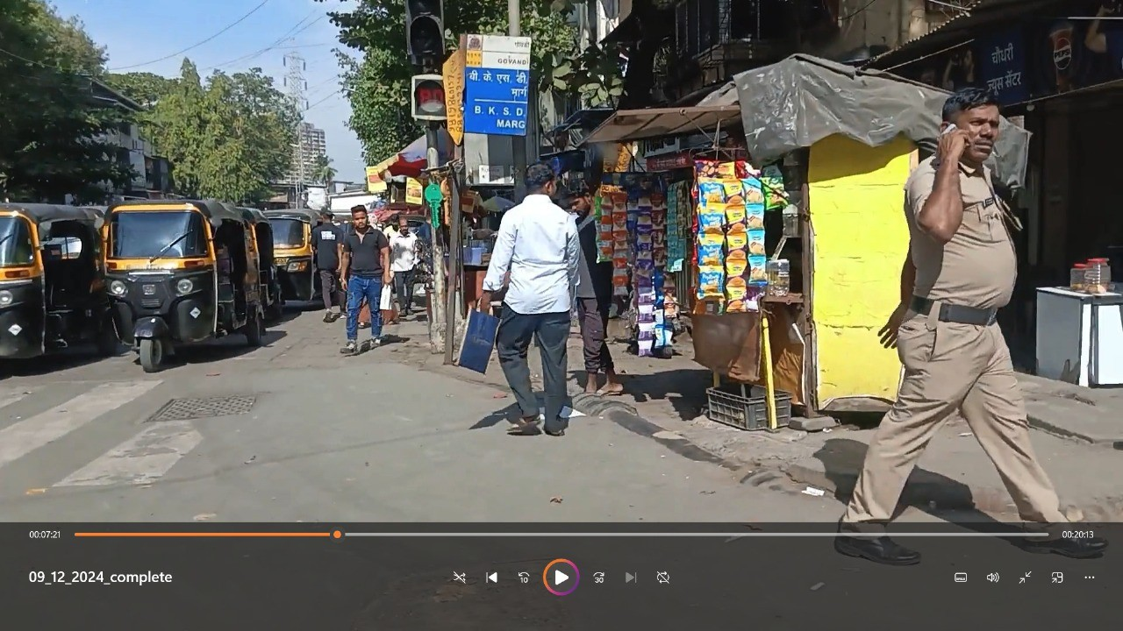

**Figure 6.** Video Snapshot of the Data Collection Drive; Dated: 9th December 2024

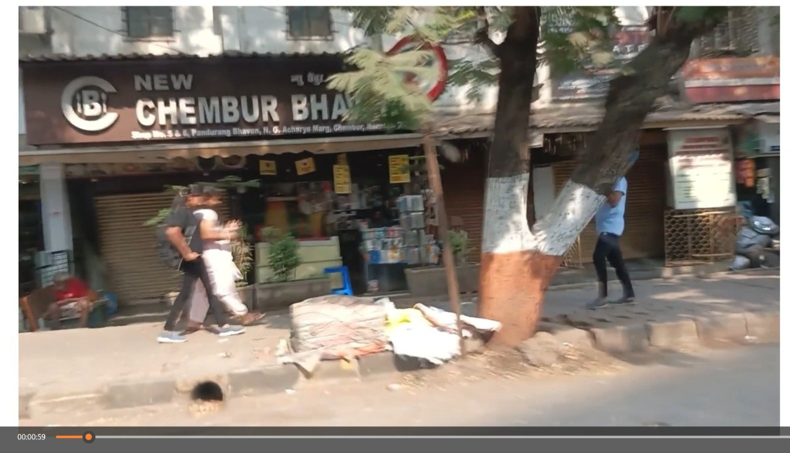

**Figure 7.** Video Snapshot of the Data Collection Drive; Dated: 12th December 2024

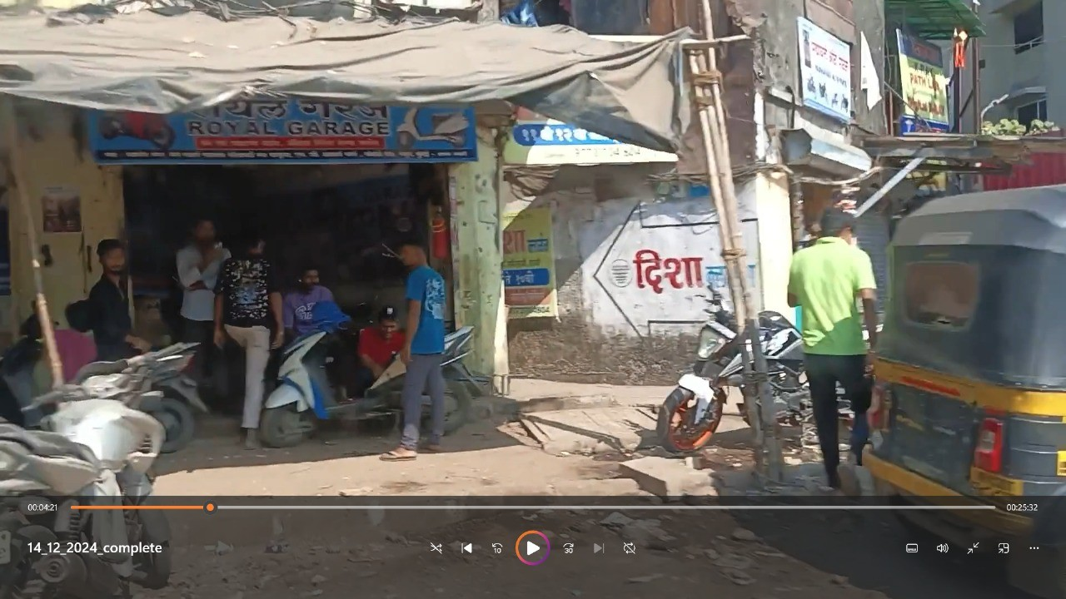

**Figure 8.** Video Snapshot of the Data Collection Drive; Dated: 14th December 2024

# Chapter 7: Results and Discussion

#### Screenshots of User Interface (GUI)

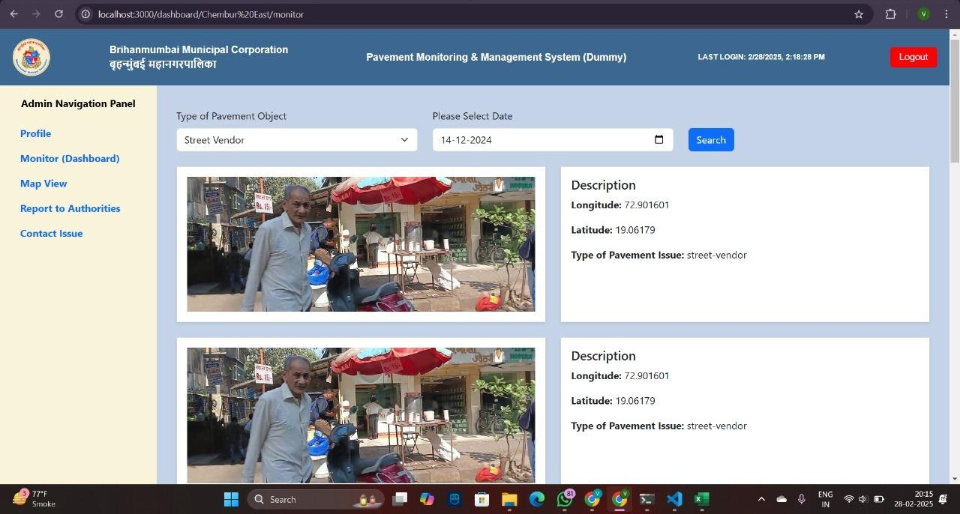

**Figure 9.** B.M.C. Dashboard for the Administrator to monitor their Constituency for any issues with object and date filtering options

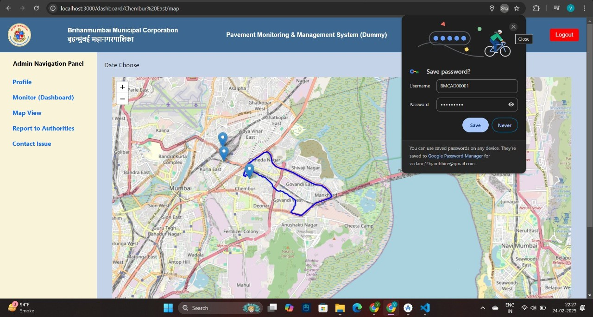

**Figure 10.** Map–based visualization of the objects on the trail of the Data (Video) Collection Route / Location Pins

#### Results and Observations

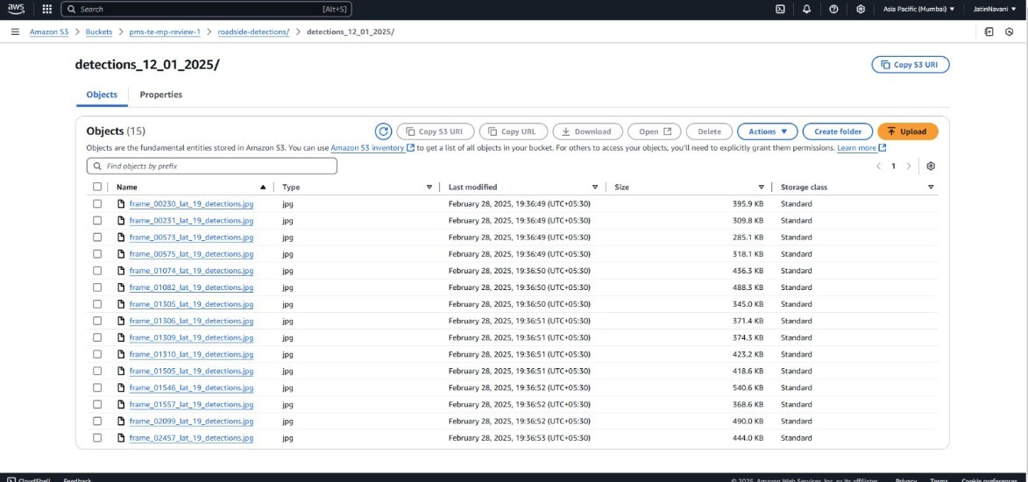

**Figure 11.** Frame-wise Detection Outputs Captured on January 12, 2025, with Processed Results Securely Stored in AWS S3 Cloud Storage

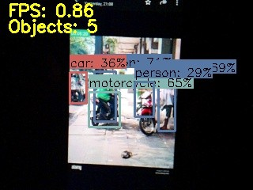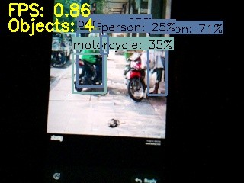

**Figure 12.** Experimental Simulation of Road Surface Conditions Captured via Mobile Device, with Object Detection Performed Using Raspberry Pi Camera Integrated with a YOLO Base Model to Validate ECU Functionality

#### Graphical and Statistical Output

The YOLOv5 model was trained over 100 epochs on the dataset consisting of 1,958 annotated images encompassing four classes: bikes, hawkers, scooters, and street vendors. Below we present the model training results presented in the given graphs to provide insights on the performance.

|  |  |
| --- | --- |
|  | **Figure 13.** Confusion Matrix Representing the Performance Evaluation of the Object Detection Model  Motorcycles show the highest detection accuracy (0.72), making them the most reliably identified obstruction type. Vendor detection accuracy (0.64) is reasonable but shows some confusion with background elements (0.35). There is some misclassification between motorcycles and background (0.34), suggesting challenges in distinguishing motorcycles against complex urban backgrounds. |

|  |  |
| --- | --- |
|  | **Figure 14.** Precision-Recall Curve Depicting the Trade-off Between Precision and Recall for the Object Detection Model  Motorcycle detection achieves strong performance with an AP of 0.760, indicating reliable detection with minimal false positives.Vendor detection shows moderate performance with an AP of 0.489, suggesting more challenges in consistently identifying vendors across diverse scenarios. The overall [mAP@0.5](mailto:mAP@0.5) of 0.625 indicates satisfactory performance across classes, though with room for improvement, particularly for vendor detection. |
|  | **Figure 15.** Confidence Curve Analysis Illustrating the Model’s Prediction Confidence Across Various Detection Thresholds  The recall-confidence curve shows rapid recall drop-off above 0.6 confidence, suggesting that using thresholds higher than this would significantly reduce detection coverage. The F1-confidence curve peaks at approximately 0.248 confidence with an F1 score of 0.67, suggesting this as an optimal threshold balancing precision and recall. |
|  |

# Chapter 8: Conclusion

#### Limitations

* + 1. **Data Quality Issues:** Variability in video quality due to environmental factors (e.g., lighting, weather) can affect analysis accuracy. To address data integrity issues, preprocessing techniques such as noise reduction and resolution standardization will be applied. Additionally, quality checks will be integrated into the data collection process.
    2. **Technological Constraints - Errors & Cloud Issues:** Limited computational resources may hinder real-time processing capabilities. This limitation will be mitigated by optimizing algorithms for efficiency, utilizing lightweight architectures, and exploring cloud-based solutions for scalability and reliability.
    3. **Potential for Missing Anomalies:** Automated monitoring systems may not detect all anomalies due to occlusions or unfavorable camera angles. To mitigate this risk, periodic manual inspections will complement automated monitoring. Multiple scanning rounds in specific areas will help uncover hidden obstructions and validate the automated system’s findings.
    4. **Deep Learning Model Limitations:** The performance of deep learning models can suffer from overfitting, especially if the training dataset lacks diversity in pavement conditions. To counter this, data augmentation techniques will be employed to artificially expand the dataset, and cross-validation will be used to enhance robustness and improve the model’s generalization capability.
    5. **Device Malfunction:** Hardware malfunctions, such as camera failures, can disrupt data collection. Regular maintenance and prompt replacement of faulty equipment will ensure system continuity.
    6. **Latency Issues:** Delays in processing and communication can impact real-time responses. By optimizing communication protocols and reducing computational overheads, latency will be minimized to maintain system efficiency.
    7. **Ethical Considerations and Privacy Concerns:** Video data from public spaces may raise ethical and legal challenges. Stringent anonymization (masking) protocols will be implemented to protect individual privacy and adhere to legal and ethical standards.
    8. **False Detections:** Automated systems may occasionally produce false detections. These will be managed by enabling manual validation by the system's administrator (e.g., BMC admin) to review flagged cases and make corrections as needed.

#### Conclusion

The proposed system aims to transform the maintenance of urban infrastructure, in Mumbai where pedestrian safety is significantly affected by deteriorating pavement conditions. Through the integration of advanced technologies such as video processing, machine learning, and cloud deployment, this system provides an automated and scalable solution to identify pavement anomalies like cracks, potholes, obstructions, and encroachments. With an ECUmounted on Municipal Corporation trucks, real-time data collection becomes seamless, while the cloud infrastructure facilitates remote monitoring and analysis. The system’s user-friendly dashboard equips authorities with critical insights for prioritizing maintenance tasks based on the severity of detected issues, thus reducing the dependency on labor-intensive manual inspections and significantly enhancing pedestrian safety. Additionally, this system contributes to the long-term goals of developing smarter cities with more walkable and safer environments.

#### Future Scope

In the future, several enhancements can further optimize and expand the system's capabilities. Continuous improvements in AI models will increase accuracy in detecting more complex anomalies. Real-time data processing can be enhanced through the use of edge computing to reduce latency. The system can be scaled for implementation in other cities, accommodating different infrastructure challenges by customizing datasets and models to suit varied geographical conditions. Collaborating with public and private stakeholders, including government agencies, civil engineers, and private companies, will help refine the system and ensure its effectiveness in guiding urban planning and policy decisions.

# References

1. "AMRUT (Atal Mission for Rejuvenation and Urban Transformation)," *Ministry of Housing and Urban Affairs*, [Online]. Available: <https://mohua.gov.in/cms/amrut.php>.
2. Ministry of Housing and Urban Affairs, Government of India**,** “Smart cities mission,” *MoHUA*, [Online]. Available: <https://mohua.gov.in/cms/smart-cities.php>.
3. Times of India, "5 petals of PUSHP will make Viksit Bharat: PM Modi tells Indian diaspora in New York," *The Times of India*, Sep. 27, 2024. [Online]. Available: [https://timesofindia.indiatimes.com/world/us/5-petals-of-pushp-will-make-viksit-bharat-pm-modi-tell](https://timesofindia.indiatimes.com/world/us/5-petals-of-pushp-will-make-viksit-bharat-pm-modi-tells-indian-diaspora-in-new-york/articleshow/113576007.cms) [s-indian-diaspora-in-new-york/articleshow/113576007.cms](https://timesofindia.indiatimes.com/world/us/5-petals-of-pushp-will-make-viksit-bharat-pm-modi-tells-indian-diaspora-in-new-york/articleshow/113576007.cms).
4. "About," *Pedestrians First*, [Online]. Available: <https://pedestriansfirst.itdp.org/about>.
5. V. Nikumbh, "Mumbai Reader No. 9," *Urban Design Research Institute*, [Online]. Available: [https://www.udri.org/wp-content/uploads/Mumbai%20Reader/MR%209/MR%209%20vineet%20Nik](https://www.udri.org/wp-content/uploads/Mumbai%20Reader/MR%209/MR%209%20vineet%20Nikumbh%20Low.pdf) [umbh%20Low.pdf](https://www.udri.org/wp-content/uploads/Mumbai%20Reader/MR%209/MR%209%20vineet%20Nikumbh%20Low.pdf).
6. "Footpaths in India: The Dangerous Gap Between Policy and Reality," *Question of Cities*, [Online]. Available:

<https://questionofcities.org/footpaths-in-india-the-dangerous-gap-between-policy-and-reality/>.

1. "Land Encroachment in Maharashtra," Law Crust, [Online]. Available: <https://lawcrust.com/land-encroachment-in-maharashtra/>.
2. "Trash collection schedule, routes on BMC's website," *Times of India*, [Online]. Available: [https://timesofindia.indiatimes.com/city/mumbai/trash-collection-schedule-routes-on-bmcs-website/ar](https://timesofindia.indiatimes.com/city/mumbai/trash-collection-schedule-routes-on-bmcs-website/articleshow/48322230.cms) [ticleshow/48322230.cms](https://timesofindia.indiatimes.com/city/mumbai/trash-collection-schedule-routes-on-bmcs-website/articleshow/48322230.cms).
3. R. Puranik, "Understanding Mumbai’s Municipal Corporation," *Citizen Matters*, Mar. 28, 2022. [Online]. Available: <https://citizenmatters.in/understanding-mumbais-municipal-corporation/>.
4. Municipal Corporation of Greater Mumbai, "Departmental Manuals," *MCGM Portal*. [Online]. Available: <https://portal.mcgm.gov.in/irj/portal/anonymous/qldeptmanuals>.
5. "Meri Sadak PMGSY," Ministry of Rural Development, Government of India. [Online]. Available: <https://rural.gov.in/en/services/meri-sadak-pmgsy>.
6. H. B. Ibrahim, M. Salah, F. Zarzoura, et al., "Smart monitoring of road pavement deformations from UAV images by using machine learning," *Innov. Infrastruct. Solut.*, vol. 9, no. 16, 2024. [Online]. Available: <https://doi.org/10.1007/s41062-023-01315-2>.
7. A. M. Al-Sabaeei, M. I. Souliman, and A. Jagadeesh, "Smartphone applications for pavement condition monitoring: A review," *Constr. Build. Mater.*, vol. 404, p. 134207, 2023. [Online]. Available: <https://doi.org/10.1016/j.conbuildmat.2023.134207>.
8. A. Sami, A. S. Saadman, K. Deb, and I. H. Sarker, "Improved YOLOv5-Based Real-Time Road Pavement Damage Detection in Road Infrastructure Management," *Algorithms*, vol. 16, no. 9, p. 452, 2023. [Online]. Available: <https://doi.org/10.3390/a16090452>.
9. S. C. Radopoulou and I. Brilakis, "Patch detection for pavement assessment," *Autom. Constr.*, vol. 53,

pp. 95-104, 2015. [Online]. Available: <https://doi.org/10.1016/j.autcon.2015.03.010>.

1. Y. Hou, Q. Li, C. Zhang, G. Lu, Z. Ye, Y. Chen, L. Wang, and D. Cao, "The State-of-the-Art Review on Applications of Intrusive Sensing, Image Processing Techniques, and Machine Learning Methods in Pavement Monitoring and Analysis," *Eng.*, vol. 7, pp. 845-856, 2021. [Online]. Available: <https://doi.org/10.1016/j.eng.2020.07.030>.
2. K. Zhao, S. Xu, J. Loney, A. Visentin, and Z. Li, "Road pavement health monitoring system using smartphone sensing with a two-stage machine learning model," *Automation in Construction*, vol. 167, 2024, Art. no. 105664. Available: <https://doi.org/10.1016/j.autcon.2024.105664>.
3. E. Ranyal, A. Sadhu, and K. Jain, "Road Condition Monitoring Using Smart Sensing and Artificial Intelligence: A Review," *Sensors*, vol. 22, no. 8, Art. no. 3044, Apr. 2022. Available: <https://doi.org/10.3390/s22083044>.
4. A. Tendolkar, "How India's richest civic body earns and spends," *NDTV Profit*, Feb. 6, 2019. [Online]. Available:

<https://www.ndtvprofit.com/business/how-indias-richest-civic-body-earns-and-spends>.

1. R. Pinto, "BMC cracks down on 20K hawkers in 2 months; residents say not enough," *Times of India*, [Online]. Available:

[http://timesofindia.indiatimes.com/articleshow/116562021.cms?utm_source=contentofinterest&utm_](http://timesofindia.indiatimes.com/articleshow/116562021.cms?utm_source=contentofinterest&utm_medium=text&utm_campaign=cppst) [medium=text&utm_campaign=cppst](http://timesofindia.indiatimes.com/articleshow/116562021.cms?utm_source=contentofinterest&utm_medium=text&utm_campaign=cppst).