# SmartCart:

# Optimised Shopping Experience

Submitted in partial fulfillment of the requirements of the degree

**BACHELOR OF ENGINEERING** IN **COMPUTER ENGINEERING**

By

**Ekta Chhabria**

**Aditya Ajith**

**Jay Dadlani**

**Om Goplani**

**Dr Prashant Kanade**



# Vivekanand Education Society’s Institute of Technology,

**An Autonomous Institute affiliated to University of Mumbai**

# HAMC, Collector’s Colony, Chembur,

**Mumbai-400074**

**University of Mumbai (AY 2024-25)**

# CERTIFICATE

This is to certify that the Mini Project entitled **“SmartCart: Optimised Shopping Experience ”** is a bonafide work of **Ekta Chhabria (12), Aditya Ajith(01), Jay Dadlani(13), Om Goplani(68)** submitted to the University of Mumbai in partial fulfillment of the requirement for the award of the degree of **“Bachelor of Engineering”** in **“Computer Engineering” .**

## Dr Prashant Kanade

Mentor

## Dr. Nupur Giri Dr (Mrs) J. M. Nair

Head of Department Principal

# Mini Project Approval

This Mini Project entitled “SmartCart: Optimised Shopping Experience**”** by **Ekta Chhabria (12), Aditya Ajith(01), Jay Dadlani(13), Om Goplani(68)** is approved for the degree of **Bachelor of Engineering** in **Computer Engineering.**

**Examiners**

**1………………………………………**

(Internal Examiner Name & Sign)

## 2…………………………………………

(External Examiner name & Sign)

Date: Place:

# Contents

## Abstract ii

## Acknowledgments iii

## List of Abbreviations iv

## List of Figures v

## List of Tables vi

## List of Symbols vii

## Introduction 1

* 1. Introduction
  2. Motivation
  3. Problem Statement & Objectives
  4. Organization of the Report

1. **Literature Survey 4**
   1. Survey of Existing System
   2. Limitation Existing system or Research gap
   3. Mini Project Contribution

## Proposed System 9

**3.1** Introduction

**3.2** Architectural Framework / Conceptual Design

**3.3** Algorithm and Process Design

**3.4** Methodology Applied

**3.5** Hardware & Software Specifications

**3.6** Experiment and Results for Validation and Verification

**3.7** Result Analysis and Discussion

**3.8** Conclusion and Future work.

## References 16

## Abstract

"SmartCart: Optimised Shopping Experience" is an innovative e-commerce platform aimed at providing a smooth and user-friendly shopping experience. The platform is being designed with essential features like a product catalog, cart management system, secure user login, and payment gateways to ensure a seamless process for both customers and businesses.

In the future, we plan to integrate Business Intelligence (BI) tools into the platform. These BI tools will allow businesses to gather valuable insights from customer data, such as their shopping habits and preferences. With this information, businesses can make better decisions about product offerings, optimize their sales strategies, and improve how they manage their inventory.

The goal of SmartCart is to enhance both customer satisfaction and business operations. For customers, this means a more personalized and efficient shopping experience, while for businesses, it means being able to make informed decisions that drive growth and increase profitability. By combining user-friendly design with powerful data-driven insights, SmartCart aims to be a modern solution for the e-commerce industry.

## ii

**Acknowledgement**

We would like to express our deepest gratitude to **Dr. Prashant Kanade**, our project mentor, for his unwavering support, insightful guidance, and valuable time throughout the duration of this project. His mentorship has been instrumental in helping us navigate the challenges of the project and ensuring that we stay on the right path.

We are equally thankful to **Dr. J. M. Nair**, Principal of Vivekanand Education Society's Institute of Technology, for her constant encouragement and motivation. Her leadership and support have provided us with a positive environment conducive to learning and growth.

We extend our heartfelt appreciation to **Dr. Nupur Giri**, Head of the Department of Computer Engineering, for her continuous backing and for fostering an academic atmosphere that encourages innovation and critical thinking. Her guidance and encouragement have been a source of inspiration for us.

Our sincere thanks also go to **Mrs. Priya R. L**, the project coordinator, for her excellent coordination, timely feedback, and motivation, which have helped us stay organized and meet our deadlines.

Additionally, we would like to thank all the faculty members of the Computer Engineering department who have provided their assistance, valuable input, and moral support, which has been crucial in the successful completion of this project.

Lastly, we are grateful to our peers and classmates, whose camaraderie and collaboration have been invaluable during this journey. This project has been a true team effort, and we are thankful to everyone who contributed to making it a success.

**iii**

**List of Abbreviations**

| Sr. No | Short Form | Abbreviated Form |
| --- | --- | --- |
| 1 | BI | Business Intelligence |
| 2 | AI | Application Programming Interface |
| 3 | UI | User Interface |
| 4 | UX | User Experience |
| 5 | ETL | Extract, Transform, Load |
| 6 | SQL | Structured Query Language |
| 7 | KPI | Key Performance Indicator |

**iv**

**List Of Figures**

| **Sr. no.** | **Figure No.** | **Name of the figure** | **Page No.** |
| --- | --- | --- | --- |
|  | 1.1 | SmartCart Ecosystem Overview | 1 |
|  | 2.1 | Limitations in the Existing System | 7 |
|  | 3.1 | Architectural Framework | 9 |
|  | 3.2 | Landing Page | 11 |
|  | 3.3 | Product Page | 12 |
|  | 3.4 | Purchase | 12 |
|  | 3.5 | User Dashboard | 13 |
|  | 3.6 | Admin Board for Analysis | 13 |
|  | 3.7 | Customer Engagement via Notification | 14 |
|  | 3.8 | Order Tracking Provision | 14 |

**Chapter I: Introduction**

**1.1 Introduction**

**"SmartCart: Optimised Shopping Experience"** is a next-generation e-commerce platform designed to revolutionize the way customers shop online and how businesses manage their operations. The primary focus of the platform is to provide a seamless and personalized shopping experience by integrating **Business Intelligence (BI)** tools. In today’s highly competitive online marketplace, businesses need more than just an attractive website; they need advanced tools that allow them to understand their customers better, track their sales patterns, and manage inventory in real time. **SmartCart** addresses these challenges by combining user-friendly design with powerful BI features that help businesses grow by making informed, data-driven decisions.

In the ever-expanding world of e-commerce, customer preferences are constantly changing, and businesses need to adapt quickly to stay ahead. **SmartCart** aims to provide businesses with the tools they need to do just that, by offering insights that help them track customer behavior, predict trends, and optimize their offerings. For users, **SmartCart** enhances their shopping journey by providing personalized recommendations, easy navigation, and secure transactions, making their experience more enjoyable and efficient.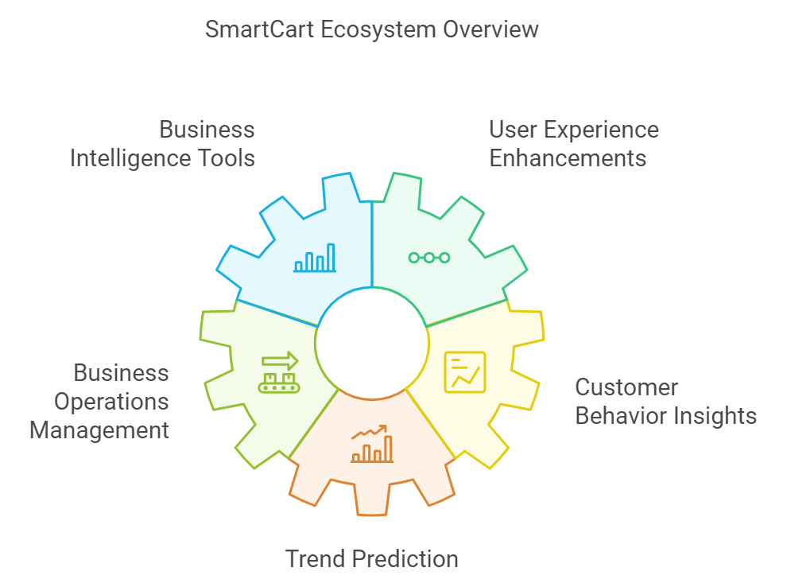

**Fig 1.1 SmartCart Ecosystem Overview**

**1.2 Motivation**

The development of **SmartCart** is driven by the increasing demand for more intelligent and personalized online shopping experiences. Consumers today expect more than just a platform to buy products—they want a customized experience that feels tailored to their specific needs. However, many existing e-commerce platforms fail to fully leverage the wealth of customer data available to them, which could be used to enhance the shopping experience and boost business performance.

At the same time, businesses are looking for ways to optimize their operations, especially in terms of inventory management and sales strategies. With the right tools, they could make better decisions about what products to stock, how to price them, and when to offer discounts, all based on real-time data and trends. **SmartCart** aims to fill this gap by integrating **Business Intelligence** to help businesses make sense of their data and use it to improve their decision-making processes.

Furthermore, the platform is motivated by the desire to bridge the gap between what users expect from an e-commerce platform and what businesses can deliver. By using BI, **SmartCart** ensures that businesses can offer a more engaging and dynamic shopping experience, ultimately leading to higher customer satisfaction and business growth.

**1.3 Problem Statement & Objectives**

### Problem Statement:

In today’s fast-paced digital world, many e-commerce platforms do not make the most of the data they collect to benefit both customers and businesses. This results in several key challenges:

* **Lack of personalized insights**: Current platforms struggle to provide tailored shopping experiences for individual customers, which leads to missed opportunities to increase sales and improve customer satisfaction.
* **Limited use of Business Intelligence**: While some platforms offer basic analytics, they often require technical expertise to interpret. This makes it difficult for businesses to make quick and informed decisions based on real-time data.

### Objectives:

The **SmartCart** project aims to tackle these challenges by achieving the following objectives:

1. **User-Friendly Platform**: Develop a responsive and easy-to-use e-commerce platform that works smoothly across different devices such as computers, tablets, and smartphones, ensuring a seamless experience for all users.
2. **Integration of BI Tools**: Incorporate powerful Business Intelligence tools that will help businesses:
   * Track customer behavior and preferences.
   * Analyze sales trends and identify top-performing products.
   * Make informed decisions about pricing, product offerings, and marketing strategies using real-time data.
3. **Personalized Customer Experience**: Use customer data to offer personalized product recommendations and shopping suggestions, improving the overall user experience. The system will continuously learn from customer behavior to refine these recommendations.
4. **Data-Driven Decision Making**: Provide businesses with clear and actionable insights through easy-to-use dashboards and automated reports, helping them make informed decisions without needing extensive technical knowledge.

**1.4 Organization of the Report**

In this report, we further discuss the following points:

* Literature survey of existing systems
* Limitations of existing systems
* Mini project contribution
* The proposed system
* Working of the project
* Details of hardware and software used
* Results
* Performance analysis
* Conclusion

**Chapter II: Literature Survey**

**2.1 Survey of Existing System**

Existing e-commerce platforms primarily focus on providing a streamlined shopping experience for users. However, these platforms often rely heavily on manual analysis by data experts to gain insights from customer data. While they have large datasets, the integration of advanced Business Intelligence tools is often limited to large-scale businesses with dedicated data science teams.

#### 2.2 Limitations of Existing Systems / Research Gap

| **Sr No** | **Name of the Author** | **Date of Publication** | **Key Takeaways** | **Limitations** |
| --- | --- | --- | --- | --- |
| 1. | Yogesh Malhotra | January 2001 | 1. **Outdated Methods:** Old knowledge management practices struggle in fast-paced environments. 2. **Need for Innovation:** New approaches are needed to create knowledge effectively. 3. **Rigidity Issues:** Rigid methods can't keep up with today's changing knowledge demands. | Current KMS often suffer from a too-rationalistic, static or decontextualized understanding of what constitutes knowledgementation. |
| 2. | Amit Ranjan, Madhvendra Misra, Jitendra Yadav | 1 June 2021 | 1. **Product Quality**: High product quality is a crucial factor that positively affects purchase intentions. 2. **Product Price**: Competitive pricing and discounts are powerful motivators for online purchases. 3. **Impact of Social Media:** The study suggests that social media plays a significant role in influencing customer purchase intentions on e-commerce platforms. | The study does delves into how different demographic factors (such as age, income, or education level) might influence the relationship between these factors and purchase intentions. |

| 3. | Cecilia Olexova | 12 May 2014 | 1. **Importance of Requirements Engineering:** Proper requirements engineering is crucial in BI adoption, as mistakes at this stage can lead to significant challenges. 2. **BI Enhances Decision-Making:** BI tools provide advanced data analysis capabilities, enabling retail managers to make more informed and timely decisions driving business success. | Many BI initiatives fail because the tools do not fully meet the needs of end users, highlighting a gap between system design and actual usage requirements. |
| --- | --- | --- | --- | --- |
| 4. | Emmanuel Eboigbe | 10 July 2023 | 1. -**Big Data’s Impact**: Modern BI must handle both structured and unstructured data effectively. 2. -**Self-Service BI Models**: AI and data analytics enable users to generate insights and make data-driven decisions without extensive technical skills. | AI-driven self-service BI models require specialized skills in data analytics to derive meaningful insights and support informed decision-making. |
| 5. | Pham Quang Huy and Vu Kien Phuc | 5 September 2023 | 1. **Impact of COVID-19 on SMEs:** The research highlights how the COVID-19 pandemic forced small and medium enterprises (SMEs), especially to adopt E-commerce (EC) 2. **Role of Big Data and Business Intelligence (BI):** The study emphasizes the importance of Business Intelligence (BI) in helping SMEs adapt to present trends. | The study centers on manufacturing SMEs in developing countries, which may not reflect other regions or industries.Traditional BI systems often overlook unstructured and external data, risking biased decisions. |
| 6. | [Tânia Ferreira](https://www.researchgate.net/profile/Tania-Ferreira-15?_tp=eyJjb250ZXh0Ijp7ImZpcnN0UGFnZSI6InB1YmxpY2F0aW9uIiwicGFnZSI6InB1YmxpY2F0aW9uIn19) | March 2017 | **BI and E-commerce Integration:** The paper  outlines a multi-level architecture for  combining BI with e-commerce, which includes data collection, processing, analysis, and reporting. This architecture transforms raw e-commerce data into actionable knowledge, supporting more informed decision-making and enhancing overall business performance. | The integration of BI and e-commerce systems can be expensive, involving significant costs for software, hardware, and skilled personnel. These costs may be prohibitive for smaller businesses. |
| 7. | Chibuike Daraojimba | 29 Nov 2023 | **-** **Big Data Adaptation:**  BI systems now manage both structured and unstructured data.  - **Advanced Data Insights:** Modern BI integrates with big data for deeper analysis. | The rise of AI-driven self-service BI models requires specialized skills in data analytics and AI. Organizations must address this by providing training and support to fill skill gaps and maximize the potential of these tools. |
| 8. | Morgan Jennings | 2000 | **1. Aesthetic experience** and Flow theory help improve user engagement and immersion.  **2. Cognitive aesthetics**, incorporating both visual beauty and deeper user interaction, can enhance eCommerce websites. | The concepts are largely theoretical and need further empirical validation.  Application of these ideas may vary significantly depending on the type of website or eCommerce business. |
| 9. | Saima Ritonummi | April 2020 | **1. User-Centered Design**: The case website's usability is strong, but UX can suffer from poor design decisions that impact user confidence.  **2. Cognitive Walkthrough:** This method identified usability problems, especially those that created uncertainty before purchase. | The study is limited to a single website, which may not generalize to other eCommerce contexts.  The cognitive walkthrough method, while useful, may not capture all dimensions of UX, particularly long-term user experiences. |
| 10. | Waud Osama Habbal | 30 December 2010 | **1. First Impressions Matter:** The UI of an eCommerce website is crucial for creating first impressions, as users do not have face-to-face interaction with companies.  2. Core UI Elements: Navigation, graphic design, and content organization are essential for ensuring user satisfaction and ease of use. | The study is largely theoretical and does not provide empirical data from specific case studies.  It lacks detailed guidelines on the practical implementation of UI design improvements. |

| 11. | Riccardo Mangiaracnia | December 2009 | The model is **phase-based**, providing insights into each step of the customer journey.  It **enables comparative analysis** of different eCommerce websites.  Focuses on **user experience** improvements that directly impact conversion rates. | Only assesses user interaction with the website, excluding post-transaction factors like delivery or customer service.  Primarily designed for comparing websites within specific market sectors. Adaptation required for different industries. |
| --- | --- | --- | --- | --- |
| 12. | Soomiya Hamid | 30 December 2012 | Most websites violate **basic usability** principles and fail to meet WCAG accessibility standards.  **Usability was rated low**, especially in error prevention, navigation, and user satisfaction.  **Accessibility issues were severe**, particularly in non-text content, page structure, and compatibility with assistive technologies. | The study is largely theoretical and does not provide empirical data from specific case studies.  It lacks detailed guidelines on the practical implementation of UI design improvements. |

**User Dependency**: Current systems often require technical experts for data analysis and decision-making, making the process slow and expensive.

**Lack of Personalization**: Many platforms do not offer personalized shopping experiences, missing out the opportunity to engage users on a more personal level.

**Absence of Automation**: There is a lack of automated tools such as chatbots or voice assistants to streamline customer interactions.

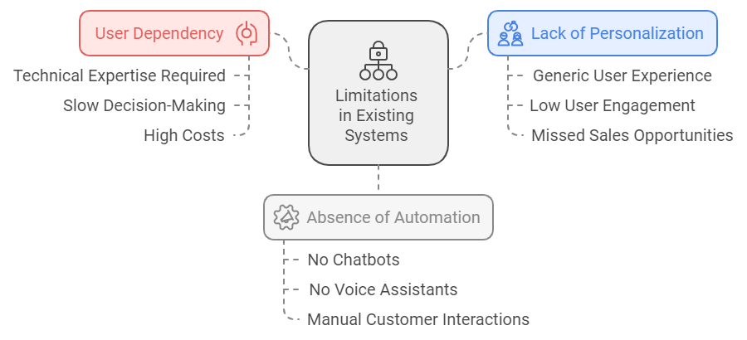

**fig 2.1 Limitations in the Existing System**

**2.3 Mini Project Contribution**

**SmartCart** addresses the gaps in current e-commerce platforms by introducing the following features:

* **Integrating BI Tools**: Enabling businesses to gain real-time insights into customer behavior and sales trends, without requiring a team of data experts. These tools will help businesses make better decisions based on data.
* **Customer Engagement Emails**: SmartCart will enhance customer interaction by sending personalized email notifications for promotions, order updates, and engagement, helping businesses maintain a strong relationship with their customers.
* **Chatbot Integration**: To improve customer interaction, SmartCart will include a chatbot feature. This chatbot will assist users with product inquiries, order tracking, and basic customer service tasks, creating a more interactive and efficient shopping experience.
* **Enhanced Customer Interaction**: The platform will provide users with a more dynamic experience through planned features like voice-assisted purchases.

**Chapter III: Proposed System**

**3.1 Introduction**

The **SmartCart** platform is a user-centric e-commerce solution designed to provide a seamless shopping experience with integrated Business Intelligence (BI) features. The platform aims to empower businesses by offering them real-time insights into customer behavior and sales trends, helping them make more informed decisions and improve their business strategies.

### 3.2 Architectural Framework / Conceptual Design

**SmartCart** is designed with a modular architecture, dividing the system into different functional blocks:

* **Frontend (User Interface)**: Developed using HTML, CSS, and JavaScript, the UI is responsive and user-friendly, ensuring a smooth shopping experience across all devices.
* **Backend (Server-Side)**: The backend, built with Django (Python), manages essential functions like user authentication, product catalogs, order processing, and payment gateways.
* **Database**: MySQL is used to securely store user information, product data, and order histories, ensuring efficient data management.
* **Business Intelligence Layer (Future Integration)**: BI tools such as Power BI or Tableau will be integrated to help businesses gain real-time insights into customer behavior and sales performance.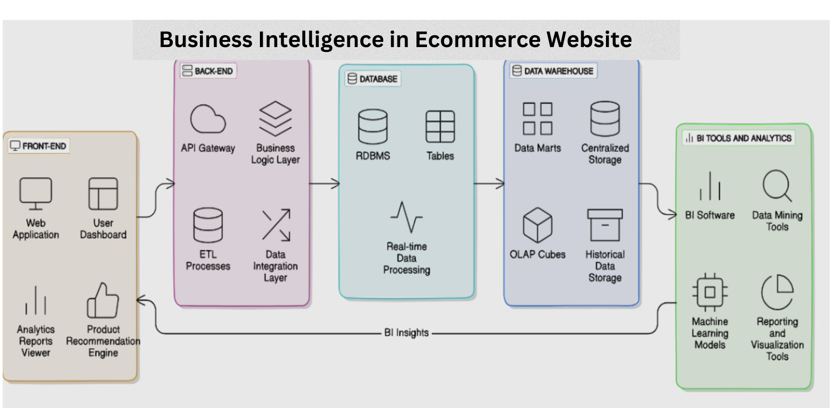

**fig 3.1 Architectural Framework**

**3.3 Algorithm and Process Design**

The platform utilizes several basic algorithms to enhance its core features:

* **Search Algorithm**: A search algorithm allows users to easily filter and sort products based on categories and price ensuring a smooth and efficient search experience.
* **Chatbot Integration**: A chatbot is integrated to assist users with common queries, order tracking, and general customer support, improving user interaction and engagement.

### 3.4 Methodology Applied

1. **Frontend Development**: Built with HTML, CSS, and JavaScript to ensure responsiveness and compatibility across various devices.
2. **Backend Development**: Django (Python) is used to handle server-side operations, including user authentication, product management, and order processing.
3. **Data Handling**: MySQL manages customer and product data securely and efficiently.
4. **BI Integration (Future Work)**: The future integration of BI tools such as Power BI or Tableau will help businesses generate real-time reports and dashboards for sales and customer behavior analytics.

### 3. 5 Hardware & Software Specifications

**Hardware**:

* **Processor**: Intel i5/Ryzen 5 or better
* **RAM**: 8 GB or higher
* **Storage**: 256 GB SSD + optional 1 TB HDD
* **Internet**: Stable connection required

**Software**:

* **Frontend**: HTML, CSS, JavaScript
* **Backend**: Laravel
* **Database**: PHPMyAdmin
* **Business Intelligence Tools**: Tableau, Power BI (Future Integration)

### 

### 3. 6 Experiment and Results for Validation and Verification

Various tests were conducted to ensure the platform's efficiency and performance:

* **Responsiveness**: The platform was thoroughly tested for smooth functionality across devices like desktops, tablets, and smartphones.
* **Search Algorithm**: The product search feature was tested to ensure accuracy and speed in handling different search queries and filters.
* **Order Tracking**: The ordered product could be easily tracked using the seamless option provision.
* **Dashboard for Admin and User:** Separate dashboards for Admin and Users was provided to track their respective activities

### 3.7 Result Analysis and Discussion

The results confirmed that **SmartCart** is a responsive and user-friendly platform. The product search feature was efficient and accurate, providing users with relevant search results quickly. The chatbot feature also successfully handled customer queries, improving user interaction and engagement. These features contribute to a smoother shopping experience and better customer satisfaction.

**fig 3.2 Landing Page**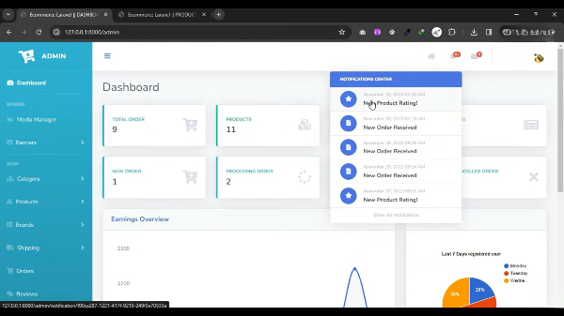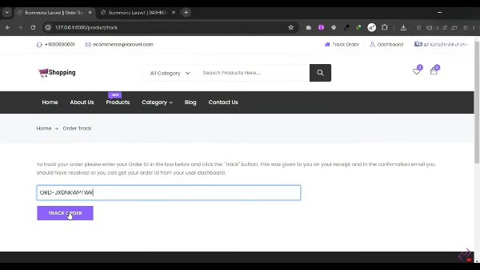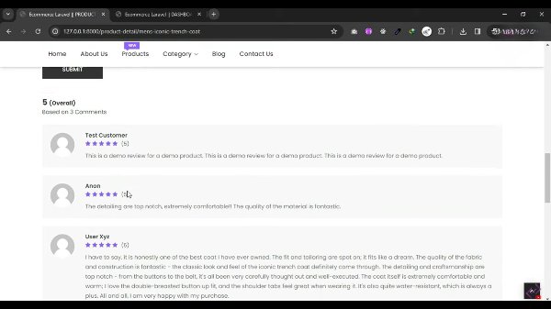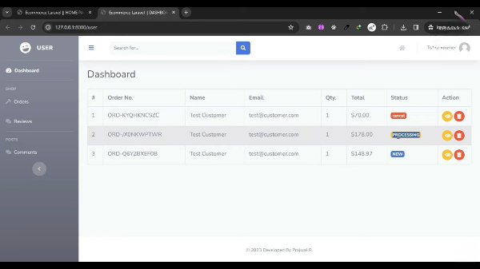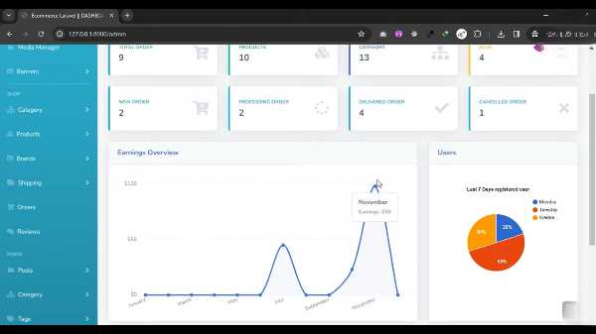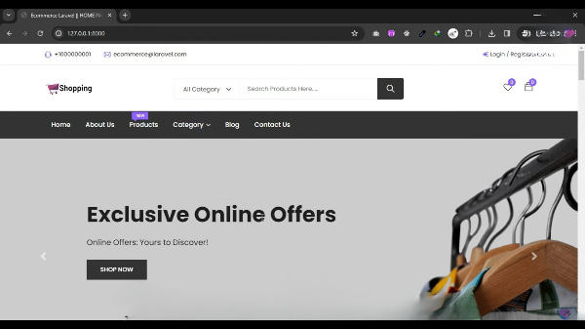

**fig 3.3 Product Page**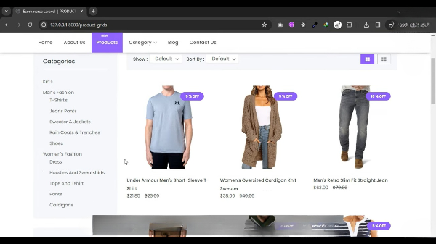

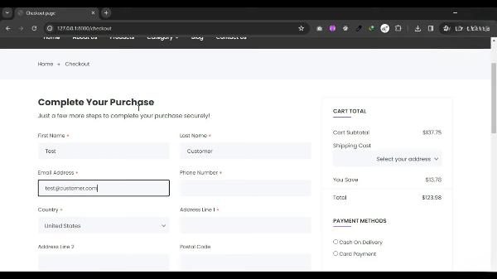

**fig 3.4 Purchase**

**fig 3.5 User Dashboard**

**fig 3.6 Admin Dashboard for Analysis**



**fig 3.7 Managing Notifications for Customer Engagement**

**fig 3.8 Order Tracking Provision**

### 3.8 Conclusion and Future Work

**SmartCart** is designed to enhance both customer experience and business decision-making. While the current version focuses on core e-commerce functionalities like product management, order processing, and customer engagement through chatbots, future updates will include powerful BI tools. These tools will allow businesses to analyze sales and customer data in real time, helping them optimize their strategies. Next steps include implementing BI dashboards, automated reporting, and voice-assisted shopping features.

**References**

**Thesis**:  
[1] C. Olexová, “Business Intelligence Adoption: A Case Study in the Retail Chain,” Ph.D. thesis, Dept. of Mgmt., Univ. of Economics Bratislava Faculty of Business Economics, Košice, 2014.  
[2] S. Ritonummi, “User Experience on an Ecommerce Website – A Case Study,” M.S. thesis, Jyväskylä Univ., School of Business and Economics, 2020.

**Journal Paper**:  
[3] T. Huy and T. Phuc, “Big Data in Relation with Business Intelligence Capabilities and E-Commerce During COVID-19 Pandemic,” *Future Bus. J.*, vol. 9, no. 5, 2023.  
[4] J. Ranjan, “Business Intelligence: Concepts, Components, Techniques and Benefits,” *Inst. Mgmt. Technol.*, 2009.  
[5] A. Bhattacharya and C. K. Reddy, “Business Intelligence in E-Commerce: A Comprehensive Review,” *J. Comput. Inf. Syst.*, 2015.  
[6] J. Lee and S. Kim, “Business Intelligence Solutions for E-Commerce: Challenges and Opportunities,” *Expert Syst. Appl.*, 2017.  
[7] A. Sharma and A. Saini, “Integrating Business Intelligence in E-Commerce Platforms: A Case Study,” *J. Bus. Anal.*, 2021.  
[8] S. Sharma and R. Yadav, “Business Intelligence for E-Commerce: Opportunities and Challenges in Indian Context,” *Int. J. Inf. Manage.*, 2017.  
[9] V. Kumar and D. Shah, “Data Analytics and Business Intelligence for E-Commerce Success,” *J. Retail. Consum. Serv.*, 2018.  
[10] T. Ferrira, “Business Intelligence for E-Commerce: Survey and Research Directions,” *Future Bus. J.*, 2017.  
[11] S. Hamid, N. Z. Bawany, and K. Zahoor, “Assessing E-Commerce Websites: Usability and Accessibility Study,” *J. Internet Bank. Commer.*, vol. 14, no. 3, 2020. [Online]. Available:<http://www.arraydev.com/commerce/jibc/>.  
[12] S. M. Ibrahimy and A. I. Ibrahimy, “The Impact of Big Data Analytics on Business Intelligence in E-Commerce: A Review,” *Future Bus. J.*, vol. 9, no. 5, 2023.  
[13] N. Kapoor and A. Agarwal, “Exploring the Role of Business Intelligence in E-Commerce,” *Int. J. Bus. Anal. Intell.*, 2014.  
[14] A. Sharma and A. Saini, “Integrating Business Intelligence in E-Commerce Platforms: A Case Study,” *J. Bus. Anal.*, 2021.  
[15] R. Mangiaracina, “The E-Commerce Customer Journey: A Model to Assess and Compare the User Experience of the E-Commerce Websites,” *Politecnico di Milano*, 2020.  
[16] W. O. Habbal and Q. Gao, “An Overview On User Interface Design Issues and Impact to E-Commerce Website Success,” Dalhousie Univ., 2020.  
[17] E. Eboige, “Business Intelligence Transformation through AI and Data Analytics,” *Future Bus. J.*, vol. 9, no. 5, 2023.

**Proceeding Paper**:  
[18] M. Jennings, “Theory and Models for Creating Engaging and Immersive E-Commerce Websites,” in *Proc. ACM SIGCPR Conf.*, 2000, pp. 77–85.  
[19] R. M. Stewart, “Some Useful Data Analysis Techniques for Gearbox Diagnostics,” in *Proc. Meeting Appl. Time Ser. Anal.*, Univ. of Southampton, 1977.