**VIVEKANAND EDUCATION SOCIETY’S INSTITUTE OF TECHNOLOGY**

**(An Autonomous Institute Affiliated to University of Mumbai**

**Department of Computer Engineering)**

**Department of Computer Engineering**



**Project Report on**

# SmartCart: Optimized Shopping Experience

Submitted in partial fulfillment of the requirements of Third Year (Semester–VI), Bachelor of Engineering Degree in Computer Engineering at the University of Mumbai Academic Year 2024-25

By

**Ekta Chhabria D12C / 12**

**Aditya Ajith D12C / 01**

**Jay Dadlani D12C / 13**

**Om Goplani D12B / 68**

**Project Mentor**

Dr. Prashant Kanade

**University of Mumbai**

**(AY 2024-25)**

**VIVEKANAND EDUCATION SOCIETY’S INSTITUTE OF TECHNOLOGY**

**(An Autonomous Institute Affiliated to University of Mumbai**

**Department of Computer Engineering)**

**Department of Computer Engineering**



**CERTIFICATE**

This is to certify that ***_______________________________________________***of Third Year Computer Engineering studying under the University of Mumbai has satisfactorily presented the project on “***SmartCart: Optimized Shopping Experience***” as a part of the coursework of Mini Project 2B for Semester-VI under the guidance of **Dr Prashant Kanade** in the year 2024-25.

______***_______________***

Date

| __________________ |  | __________________ |
| --- | --- | --- |
| Internal Examiner |  | External Examiner |

_________________ __________________ __________________

Project Mentor Head of the Department Principal

Dr. Mrs. Nupur Giri Dr. J. M. Nair

**Declaration**

We declare that this written submission represents our ideas in our own words and where others' ideas or words have been included, we have adequately cited and referenced the original sources. We also declare that we have adhered to all principles of academic honesty and integrity and have not misrepresented or fabricated or falsified any idea / data / fact / source in our submission. We understand that any violation of the above will be cause for disciplinary action by the Institute and can also evoke penal action from the sources which have thus not been properly cited or from whom proper permission has not been taken when needed.

| -----------------------------------------  (Signature)  (Ekta Chhabria , D12C 12) | -----------------------------------------  (Signature)  (Aditya Ajith, D12C 01) |
| --- | --- |
| -----------------------------------------  (Signature)  (Jay Dadlani, D12C 13) | -----------------------------------------  (Signature)  (Om Goplani, D12B 68) |

Date:

## ACKNOWLEDGEMENT

We are thankful to our college Vivekanand Education Society’s Institute of Technology for considering our project and extending help at all stages needed during our work of collecting information regarding the project.

It gives us immense pleasure to express our deep and sincere gratitude to Assistant Professor **Dr. (Mrs.) Priya R. L** (Project Guide) for her kind help and valuable advice during the development of project synopsis and for her guidance and suggestions.

We are deeply indebted to Head of the Computer Department **Dr.(Mrs.) Nupur Giri** and our Principal **Dr. (Mrs.) J.M. Nair ,** for giving us this valuable opportunity to do this project.

We express our hearty thanks to them for their assistance without which it would have been difficult in finishing this project synopsis and project review successfully.

We convey our deep sense of gratitude to all teaching and non-teaching staff for their constant encouragement, support and selfless help throughout the project work. It is a great pleasure to acknowledge the help and suggestion, which we received from the Department of Computer Engineering.

We wish to express our profound thanks to all those who helped us in gathering information about the project. Our families too have provided moral support and encouragement several times.

### Computer Engineering Department

**COURSE OUTCOMES FOR T.E MINI PROJECT 2B**

Learners will be to:-

| **CO No.** | **COURSE OUTCOME** |
| --- | --- |
| CO1 | Identify problems based on societal /research needs. |
| CO2 | Apply Knowledge and skill to solve societal problems in a group. |
| CO3 | Develop interpersonal skills to work as a member of a group or leader. |
| CO4 | Draw the proper inferences from available results through theoretical/ experimental/simulations. |
| CO5 | Analyze the impact of solutions in societal and environmental context for sustainable development. |
| CO6 | Use standard norms of engineering practices |
| CO7 | Excel in written and oral communication. |
| CO8 | Demonstrate capabilities of self-learning in a group, which leads to lifelong learning. |
| CO9 | Demonstrate project management principles during project work. |

**ABSTRACT**

"SmartCart: Optimised Shopping Experience" is an innovative e-commerce platform aimed at providing a smooth and user-friendly shopping experience. The platform is being designed with essential features like a product catalog, cart management system, secure user login, and payment gateways to ensure a seamless process for both customers and businesses.

In the future, we plan to integrate Business Intelligence (BI) tools into the platform. These BI tools will allow businesses to gather valuable insights from customer data, such as their shopping habits and preferences. With this information, businesses can make better decisions about product offerings, optimize their sales strategies, and improve how they manage their inventory.

The goal of SmartCart is to enhance both customer satisfaction and business operations. For customers, this means a more personalized and efficient shopping experience, while for businesses, it means being able to make informed decisions that drive growth and increase profitability. By combining user-friendly design with powerful data-driven insights, SmartCart aims to be a modern solution for the e-commerce industry.

**Index**

**Title page no.**

**Abstract 1**

**Chapter 1: Introduction 4**

1.1 Introduction

1.2 Motivation

1.3 Problem Definition

1.4 Existing Systems

1.5 Lacuna of the existing systems

1.6 Relevance of the Project

**Chapter 2: Literature Survey**  **11**

A. Overview of Literature Survey

B. Related Works

2.1 Research Papers Referred

a. Abstract of the research paper

b. Inference drawn

2.2 Patent search

2.3. Inference drawn

2.4 Comparison with the existing system

**Chapter 3: Requirement Gathering for the Proposed System 14**

3.1 Introduction to requirement gathering

3.2 Functional Requirements

3.3 Non-Functional Requirements

3.4.Hardware, Software , Technology and tools utilized

3.5 Constraints

**Chapter** 4**: Proposed Design 17**

4.1 Block diagram of the system

4.2 Modular design of the system

4.3 Detailed Design

4.4 Project Scheduling & Tracking : Gantt Chart

**Chapter 5: Implementation of the Proposed System 19**

5.1. Methodology Employed

5.2 Algorithms and flowcharts

5.3 Dataset Description

**Chapter 6: Testing of the Proposed System 23**

6.1. Introduction to testing

6.2. Types of tests Considered

6.3 Various test case scenarios considered

6.4. Inference drawn from the test cases

**Chapter 7: Results and Discussion 25**

7.1. Screenshots of User Interface (GUI)

7.2. Performance Evaluation measures

7.3. Input Parameters / Features considered

7.4. Graphical and statistical output

7.5. Comparison of results with existing systems

7.6. Inference drawn

**Chapter 8: Conclusion 33**

8.1 Limitations

8.2 Conclusion

8.3 Future Scope

**References 35**

**Appendix 37**

**Chapter I: Introduction**

**1.1 Introduction**

**"SmartCart: Optimised Shopping Experience"** is a next-generation e-commerce platform designed to revolutionize the way customers shop online and how businesses manage their operations. The primary focus of the platform is to provide a seamless and personalized shopping experience by integrating **Business Intelligence (BI)** tools. In today’s highly competitive online marketplace, businesses need more than just an attractive website; they need advanced tools that allow them to understand their customers better, track their sales patterns, and manage inventory in real time. **SmartCart** addresses these challenges by combining user-friendly design with powerful BI features that help businesses grow by making informed, data-driven decisions.

In the ever-expanding world of e-commerce, customer preferences are constantly changing, and businesses need to adapt quickly to stay ahead. **SmartCart** aims to provide businesses with the tools they need to do just that, by offering insights that help them track customer behavior, predict trends, and optimize their offerings. For users, **SmartCart** enhances their shopping journey by providing personalized recommendations, easy navigation, and secure transactions, making their experience more enjoyable and efficient.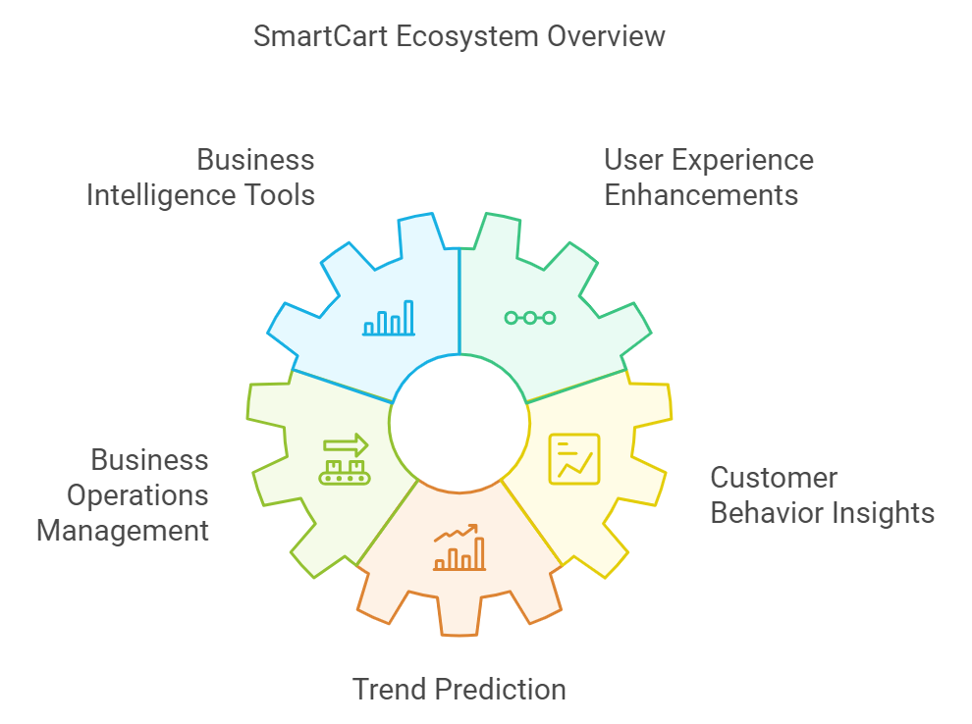

**Fig 1.1 SmartCart Ecosystem Overview**

**1.2 Motivation**

The development of **SmartCart** is driven by the increasing demand for more intelligent and personalized online shopping experiences. Consumers today expect more than just a platform to buy products—they want a customized experience that feels tailored to their specific needs. However, many existing e-commerce platforms fail to fully leverage the wealth of customer data available to them, which could be used for enhancement.

At the same time, businesses are looking for ways to optimize their operations, especially in terms of inventory management and sales strategies. With the right tools, they could make better decisions about what products to stock, how to price them, and when to offer discounts, all based on real-time data and trends. **SmartCart** aims to fill this gap by integrating **Business Intelligence** to help businesses make sense of their data .

Furthermore, the platform is motivated by the desire to bridge the gap between what users expect from an e-commerce platform and what businesses can deliver. By using BI, **SmartCart** ensures that businesses can offer a more engaging and dynamic shopping experience, ultimately leading to higher customer satisfaction and business growth.

**1.3 Problem Statement & Objectives**

### Problem Statement:

In today’s fast-paced digital world, many e-commerce platforms do not make the most of the data they collect to benefit both customers and businesses. This results in several key challenges:

* **Lack of personalized insights**: Current platforms struggle to provide tailored shopping experiences for individual customers, which leads to missed opportunities to increase sales and improve customer satisfaction.
* **Limited use of Business Intelligence**: While some platforms offer basic analytics, they often require technical expertise to interpret. This makes it difficult for businesses to make quick and informed decisions based on real-time data.

**1.4 Survey of Existing System**: Existing e-commerce platforms primarily focus on providing a streamlined shopping experience for users. However, these platforms often rely heavily on manual analysis by data experts to gain insights from customer data. While they have large datasets, the integration of advanced Business Intelligence tools is often limited to large-scale businesses with dedicated data science teams.

| **Sr No** | **Name of the Author** | **Date of Publication** | **Key Takeaways** | **Limitations** |
| --- | --- | --- | --- | --- |
| 1. | Yogesh Malhotra | January 2001 | 1. **Outdated Methods:** Old knowledge management practices struggle in fast-paced environments. 2. **Need for Innovation:** New approaches are needed to create knowledge effectively. 3. **Rigidity Issues:** Rigid methods can't keep up with today's changing knowledge demands. | Current KMS often suffer from a too-rationalistic, static or decontextualized understanding of what constitutes knowledgementation. |
| 2. | Amit Ranjan, Madhvendra Misra, Jitendra Yadav | 1 June 2021 | 1. **Product Quality**: High product quality is a crucial factor that positively affects purchase intentions. 2. **Product Price**: Competitive pricing and discounts are powerful motivators for online purchases. 3. **Impact of Social Media:** The study suggests that social media plays a significant role in influencing customer purchase intentions on e-commerce platforms. | The study does delves into how different demographic factors (such as age, income, or education level) might influence the relationship between these factors and purchase intentions. |

| 3. | Cecilia Olexova | 12 May 2014 | 1. **Importance of Requirements Engineering:** Proper requirements engineering is crucial in BI adoption, as mistakes at this stage can lead to significant challenges. 2. **BI Enhances Decision-Making:** BI tools provide advanced data analysis capabilities, enabling retail managers to make more informed and timely decisions driving business success. | Many BI initiatives fail because the tools do not fully meet the needs of end users, highlighting a gap between system design and actual usage requirements. |
| --- | --- | --- | --- | --- |
| 4. | Emmanuel Eboigbe | 10 July 2023 | 1. -**Big Data’s Impact**: Modern BI must handle both structured and unstructured data effectively. 2. -**Self-Service BI Models**: AI and data analytics enable users to generate insights and make data-driven decisions without extensive technical skills. | AI-driven self-service BI models require specialized skills in data analytics to derive meaningful insights and support informed decision-making. |
| 5. | Pham Quang Huy and Vu Kien Phuc | 5 September 2023 | 1. **Impact of COVID-19 on SMEs:** The research highlights how the COVID-19 pandemic forced small and medium enterprises (SMEs), especially to adopt E-commerce (EC) 2. **Role of Big Data and Business Intelligence (BI):** The study emphasizes the importance of Business Intelligence (BI) in helping SMEs adapt to present trends. | The study centers on manufacturing SMEs in developing countries, which may not reflect other regions or industries.Traditional BI systems often overlook unstructured and external data, risking biased decisions. |
| 6. | [Tânia Ferreira](https://www.researchgate.net/profile/Tania-Ferreira-15?_tp=eyJjb250ZXh0Ijp7ImZpcnN0UGFnZSI6InB1YmxpY2F0aW9uIiwicGFnZSI6InB1YmxpY2F0aW9uIn19) | March 2017 | **BI and E-commerce Integration:** The paper  outlines a multi-level architecture for  combining BI with e-commerce, which includes data collection, processing, analysis, and reporting. This architecture transforms raw e-commerce data into actionable knowledge, supporting more informed decision-making and enhancing overall business performance. | The integration of BI and e-commerce systems can be expensive, involving significant costs for software, hardware, and skilled personnel. These costs may be prohibitive for smaller businesses. |
| 7. | Chibuike Daraojimba | 29 Nov 2023 | **-** **Big Data Adaptation:**  BI systems now manage both structured and unstructured data.  - **Advanced Data Insights:** Modern BI integrates with big data for deeper analysis. | The rise of AI-driven self-service BI models requires specialized skills in data analytics and AI. Organizations must address this by providing training and support to fill skill gaps and maximize the potential of these tools. |
| 8. | Morgan Jennings | 2000 | **1. Aesthetic experience** and Flow theory help improve user engagement and immersion.  **2. Cognitive aesthetics**, incorporating both visual beauty and deeper user interaction, can enhance eCommerce websites. | The concepts are largely theoretical and need further empirical validation.  Application of these ideas may vary significantly depending on the type of website or eCommerce business. |
| 9. | Saima Ritonummi | April 2020 | **1. User-Centered Design**: The case website's usability is strong, but UX can suffer from poor design decisions that impact user confidence.  **2. Cognitive Walkthrough:** This method identified usability problems, especially those that created uncertainty before purchase. | The study is limited to a single website, which may not generalize to other eCommerce contexts.  The cognitive walkthrough method, while useful, may not capture all dimensions of UX, particularly long-term user experiences. |
| 10. | Waud Osama Habbal | 30 December 2010 | **1. First Impressions Matter:** The UI of an eCommerce website is crucial for creating first impressions, as users do not have face-to-face interaction with companies.  2. Core UI Elements: Navigation, graphic design, and content organization are essential for ensuring user satisfaction and ease of use. | The study is largely theoretical and does not provide empirical data from specific case studies.  It lacks detailed guidelines on the practical implementation of UI design improvements. |

**Table 1.1 Survey Of Existing Systems**

**1.5 Lacuna of the Existing System**

**User Dependency**: Current systems often require technical experts for data analysis and decision-making, making the process slow and expensive.

**Lack of Personalization**: Many platforms do not offer personalized shopping experiences, missing out the opportunity to engage users on a more personal level.

**Absence of Automation**: There is a lack of automated tools such as chatbots or voice assistants to streamline customer interactions.

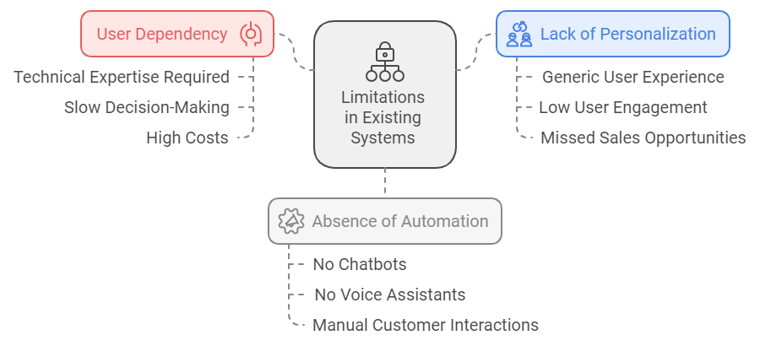

**fig 1.2 Limitations in the Existing System**

**1.6 Relevance of the Project**

The SmartCart platform is highly relevant in today's digital economy, where e-commerce is not just about selling products but also about delivering an optimized and personalized shopping experience. With the rapid expansion of online retail, businesses need to differentiate themselves by leveraging data-driven decision-making and intelligent automation.

This project is particularly relevant for both businesses and consumers:

* **For Businesses**: SmartCart provides a competitive edge by integrating Business Intelligence (BI) tools that allow for real-time analytics, sales tracking, and inventory management. This ensures businesses can make well-informed decisions to improve customer engagement and operational efficiency.
* **For Consumers**: The platform enhances user experience through personalized recommendations, seamless navigation, and secure transactions, making online shopping more intuitive and enjoyable.

Moreover, the project aligns with current industry trends where Artificial Intelligence (AI) and BI technologies are being increasingly utilized to optimize e-commerce operations. The insights generated from SmartCart empower businesses to adapt to market demands, predict customer preferences, and ultimately drive growth and sustainability in the highly competitive e-commerce landscape.

By addressing key challenges such as the lack of personalized insights and limited accessibility to BI-driven analytics, SmartCart presents itself as a next-generation solution that bridges the gap between consumer expectations and business capabilities, making it a highly relevant and impactful innovation in the field of e-commerce.

## Chapter 2: Literature Survey

### A. Overview of Literature Survey

This chapter reviews pertinent literature to understand the integration of Business Intelligence (BI) in e-commerce platforms, focusing on customer behavior, system usability, and the transformative role of AI and data analytics. The survey encompasses research papers and studies that provide insights into these domains.

### B. Related Works

#### 2.1 Research Papers Referred

**1. "Knowledge Management and Virtual Organizations" by Yogesh Malhotra (2000)**

* **Abstract:** The book discusses the challenges traditional knowledge management systems (KMS) face in dynamic environments, emphasizing the need for innovative approaches to effectively create and manage knowledge.​
* **Inference Drawn:** Rigid and outdated KMS are inadequate for today's rapidly changing knowledge demands, highlighting the necessity for flexible and adaptive systems in e-commerce platforms.​

**2. "Online Shopping Behavior during COVID-19 Pandemic: An Indian Perspective" by Amit Ranjan, Madhvendra Misra, and Jitendra Yadav (June 2021)**

* **Abstract:** This study examines factors influencing customer purchase intentions during the COVID-19 pandemic in India, identifying product quality, competitive pricing, and social media influence as significant determinants.​[SSRN](https://papers.ssrn.com/sol3/papers.cfm?abstract_id=3874348&utm_source=chatgpt.com)
* **Inference Drawn:** High product quality and competitive pricing are crucial for online purchases. Additionally, social media significantly impacts customer purchase intentions on e-commerce platforms.​

**3. "Integration of Business Intelligence with E-commerce" by Tânia Ferreira, Isabel Pedrosa, and Jorge Bernardino (June 2019)**

* **Abstract:** The paper proposes a multi-level architecture for integrating BI with e-commerce, encompassing data collection, processing, analysis, and reporting to transform raw e-commerce data into actionable knowledge.​
* **Inference Drawn:** Integrating BI tools into e-commerce enhances decision-making by providing advanced data analysis capabilities, supporting more informed and timely business strategies.​

**4. "Assessing Ecommerce Websites: Usability and Accessibility Study" by Soomaiya Hamid, Narmeen Bawany, and Kanwal Zahoor (November 2020)**

* **Abstract:** This study evaluates the usability and accessibility of 20 Pakistani e-commerce websites, revealing that many violate basic usability principles and fail to meet Web Content Accessibility Guidelines (WCAG) standards.​[ResearchGate](https://www.researchgate.net/publication/346424847_Assessing_Ecommerce_Websites_Usability_and_Accessibility_Study?utm_source=chatgpt.com)
* **Inference Drawn:** Poor usability and accessibility can significantly hinder user satisfaction and trust, underscoring the importance of adhering to established guidelines in e-commerce website design.​

**5. "The eCommerce Customer Journey: A Model to Assess and Compare the User Experience of the eCommerce Websites" by Riccardo Mangiaracina, Gianluca Brugnoli, and Alessandro Perego (December 2009)**

* **Abstract:** The paper presents a model to evaluate the customer experience on e-commerce websites, focusing on phases from landing to payment, and provides a framework for comparative analysis.​[ResearchGate](https://www.researchgate.net/publication/293400163_The_eCommerce_Customer_Journey_A_Model_to_Assess_and_Compare_the_User_Experience_of_the_eCommerce_Websites?utm_source=chatgpt.com)
* **Inference Drawn:** Understanding and optimizing each phase of the customer journey can lead to improved user experience and higher conversion rates.

#### 

#### 2.2 Patent Search

A search for patents related to the integration of BI in e-commerce revealed several innovations focusing on data analytics, personalized recommendations, and real-time inventory management. These patents highlight the industry's commitment to enhancing e-commerce platforms through advanced BI tools.​

#### 2.3 Inference Drawn

The integration of BI into e-commerce is pivotal for enhancing decision-making, personalizing customer experiences, and optimizing operations. However, challenges such as system usability, accessibility, and the need for adaptive knowledge management practices must be addressed to fully leverage BI capabilities.​

#### 2.4 Comparison with Existing Systems

Traditional e-commerce platforms often lack advanced BI integration, leading to less informed decision-making and generic customer experiences. In contrast, systems incorporating BI tools offer real-time analytics, personalized recommendations, and efficient inventory management, providing a competitive edge in the market.

**Chapter 3: Requirement Gathering for the Proposed System**

## 3.1 Introduction to Requirement Gathering

Requirement gathering is a crucial phase in software development that ensures the proposed system meets user expectations and business needs. This phase involves collecting, analyzing, and documenting the necessary functional and non-functional requirements to design a robust and efficient system. For **SmartCart**, requirement gathering focuses on integrating **Business Intelligence (BI) tools** with an **e-commerce platform** to enhance user experience and decision-making capabilities.

## 3.2 Functional Requirements

Functional requirements define the core features and functionalities of **SmartCart**. These include:

**User Authentication & Authorization**: Secure login and registration system with role-based access control (customers, administrators, and vendors).

**Product Catalog Management**: Vendors can add, edit, or remove products, including images, descriptions, and pricing.

**Personalized Recommendations**: AI-based recommendations based on user behavior and purchase history.

**Shopping Cart & Checkout**: Users can add/remove products to their cart and proceed with secure payment processing.

**Order Management**: Order tracking, cancellation, and status updates for customers.

**Inventory Management**: Real-time stock monitoring and alerts for low inventory levels.

**Business Intelligence & Analytics** (Future Integration): Sales reports, customer behavior insights, and trend analysis via **Tableau** and **Power BI**.

**User Reviews & Feedback**: Customers can leave product reviews and rate their shopping experience.

## 3.3 Non-Functional Requirements

Non-functional requirements define system performance, security, and usability factors. These include:

**Scalability**: The system must support multiple concurrent users without performance degradation.

**Security**: Implementation of **SSL encryption, secure authentication (OAuth, JWT), and role-based access control (RBAC)**.

**Performance**: Page load times should be optimized for seamless user experience (less than 3 seconds).

**Usability**: Intuitive UI design with an **accessible and responsive** interface for both desktop and mobile users.

**Maintainability**: Modular and well-documented code to facilitate updates and debugging.

**Availability**: 99.9% uptime, ensuring minimal downtime for users and businesses.

## 3.4 Hardware, Software, Technology, and Tools Utilized

### Hardware Requirements

**Processor**: Intel i5/Ryzen 5 or better

**RAM**: 8 GB or higher

**Storage**: 256 GB SSD (primary) + 1 TB HDD (optional)

**Internet**: Stable broadband connection for seamless system operation

### Software Requirements

**Frontend Technologies**: **HTML, CSS, JavaScript** (for UI/UX design and responsiveness)

**Backend Framework**: **Laravel** (for secure and scalable backend development)

**Database Management**: **PHPMyAdmin** (for database configuration and management)

**Business Intelligence Tools**: **Tableau, Power BI** (for future analytics integration)

## 3.5 Constraints

Certain limitations and constraints must be considered while developing **SmartCart**:

**Integration Complexity**: BI tools like **Tableau and Power BI** require additional API integrations, which may increase development time.

**High Initial Cost**: Implementing **BI-driven insights** can be resource-intensive for small businesses.

**Data Security Compliance**: The system must adhere to **GDPR, PCI-DSS, and other data protection standards**.

**Device Compatibility**: The platform should be tested on different browsers and devices to ensure responsiveness.

**Server Load Management**: The system must efficiently handle high traffic, especially during sales events or promotions.

**Chapter 4: Proposed Design**

**4.1 Block Diagram of the Existing System**

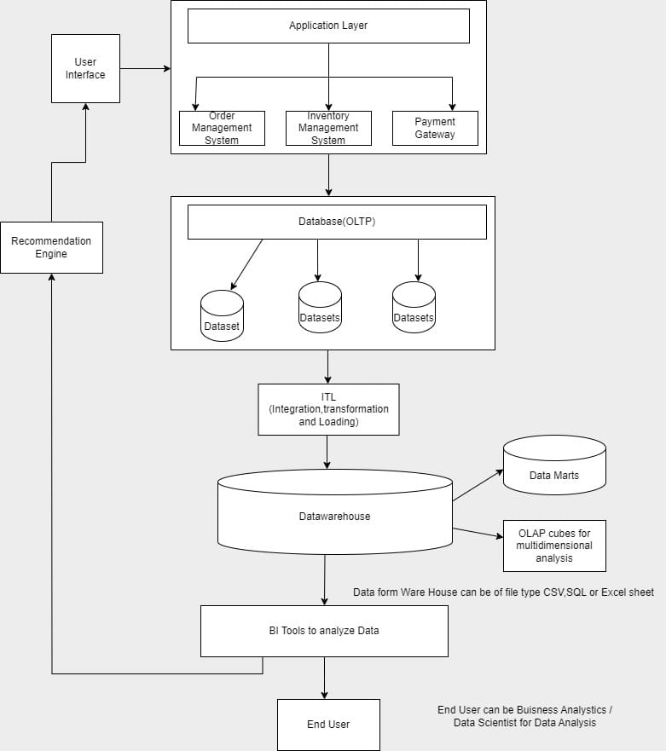

**4.2 Modular Diagram of the Existing System**

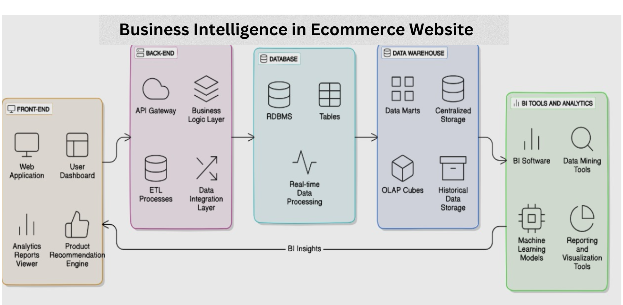

**4.3 Detailed Design**

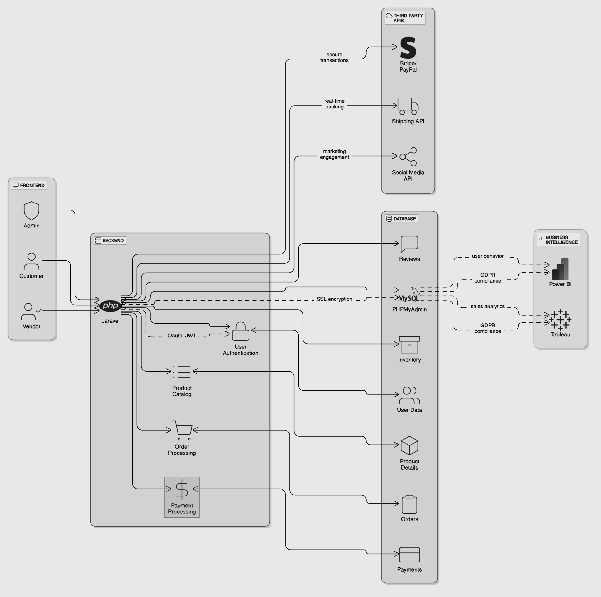

**Chapter 5: Implementation of the Proposed System**

**5.1 Methodology Employed**

1. **Frontend Development**: Built with HTML, CSS, and JavaScript to ensure responsiveness and compatibility across various devices.
2. **Backend Development**: Laravel (PHP) is used to handle server-side operations, including user authentication, product management, and order processing.
3. **Data Handling**: MySQL manages customer and product data securely .

**5.2 Algorithm and Flowchart**

Below is the algorithm for the **product purchase process**, one of the core functionalities of the system, ensuring a seamless experience for the customers.

### Algorithm: Product Purchase Process

1. **Start**
2. User **logs in** or **registers** an account
3. User **browses products** in the catalog
4. User **adds product(s) to cart**
5. User **reviews cart** and proceeds to checkout
6. System **validates stock availability**
   * If product is **out of stock**, show a notification and return to step 3
   * If product is **available**, proceed to payment
7. User selects **payment method** (Credit/Debit Card, PayPal, etc.)
8. System **processes payment through Payment Gateway API**
   * If payment is **successful**, proceed to step 9
   * If payment **fails**, notify the user and return to step 7
9. System **confirms order** and updates inventory
10. System sends **order confirmation email** to the user
11. User can **track order status** via their profile
12. **End**

**Flowchart**

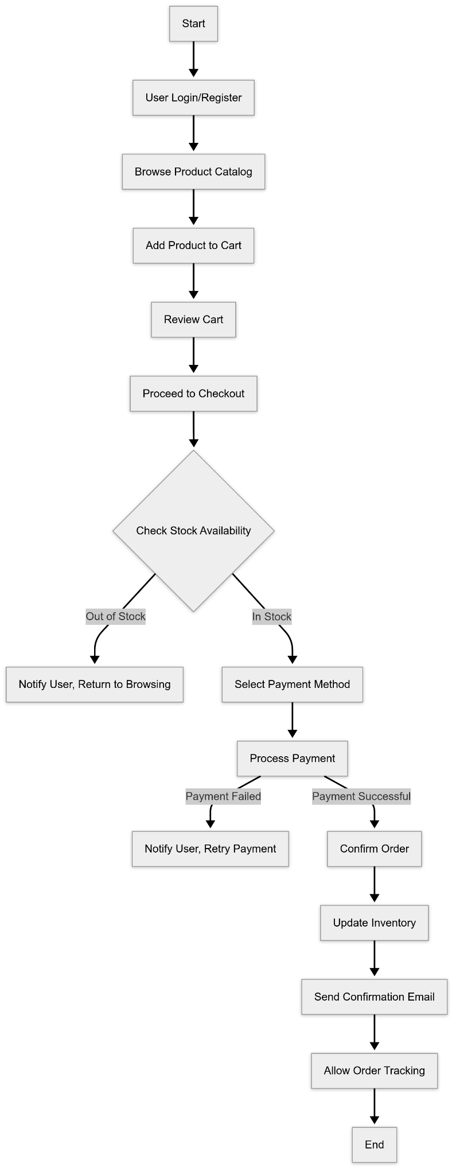

**5.2 Flowchart**

**5.3 Dataset Description**

**5.3.1 Overview**

The dataset used for this project is titled *"Sample - Superstore.csv"*. It is a widely used sample dataset in the field of data analytics and visualization. The data simulates transactions from a US-based retail store and includes details about customer orders, shipment, sales performance, and product information.

This dataset enables comprehensive analysis across various dimensions such as customer segments, regional sales performance, discount effects, and product category profitability.

**5.3.2 File Information**

* **File Name**: Sample - Superstore.csv
* **Total Records**: 999 rows
* **Total Attributes (Columns)**: 21

Each row in the dataset represents a specific line item within a customer order.

**5.3.3 Attribute Description**

The dataset includes the following attributes:

| **Column Name** | **Description** |
| --- | --- |
| Row ID | A unique identifier for each row, incrementally assigned. |
| Order ID | Unique identifier assigned to each order. |
| Order Date | The date on which the order was placed. |
| Ship Date | The date on which the product was shipped. |
| Ship Mode | The mode of shipment selected (e.g., Standard Class, Second Class). |
| Customer ID | Unique identifier for each customer. |
| Customer Name | The full name of the customer. |
| Segment | The market segment classification (e.g., Consumer, Corporate, Home Office). |
| Country | The country of the customer (all entries are from the United States). |
| City | The city where the customer resides. |
| State | The state where the customer resides. |
| Postal Code | The ZIP/Postal code of the shipping address. |
| Region | The geographical region (e.g., East, West, Central, South). |
| Product ID | Unique identifier for each product. |
| Category | Broad product category (e.g., Furniture, Office Supplies, Technology). |
| Sub-Category | Subdivision within each product category. |
| Product Name | The specific name of the product ordered. |
| Sales | Total sales value for the specific product line item. |
| Quantity | The number of units sold in the order. |
| Discount | The discount applied on the sale (expressed as a decimal). |
| Profit | The net profit earned from the product sale. |

**5.3.4 Relevance to the Project**

This dataset is relevant to the project as it allows for the application of various data analytics techniques, including data cleaning, transformation, exploratory analysis, and visualization. The wide range of attributes supports multidimensional analysis, such as identifying sales trends, evaluating profitability, understanding customer behavior, and assessing the impact of discounting strategies.

**Chapter 6: Testing of the Proposed System**

**6.1 Introduction to Testing**

Testing is a crucial phase in the software development lifecycle aimed at ensuring the functionality, reliability, and performance of the system. It involves systematically evaluating the application to identify and resolve defects, verify that the system meets the specified requirements, and ensure that it performs as expected under various conditions. Effective testing helps in delivering a stable and user-friendly product.

**6.2 Types of Test Cases Considered**

For **SmartCart**, the following types of tests were conducted using **Selenium** to ensure functionality, usability, and reliability:

1. **Functional Testing**
   * Verifies that all features (login, product browsing, cart, checkout, etc.) work as expected.
2. **UI Testing**
   * Ensures that the user interface elements (buttons, forms, etc.) function correctly across different devices and screen sizes.
3. **Cross-Browser Testing**
   * Tests the application on multiple browsers (**Chrome, Firefox, Edge**) to ensure compatibility.
4. **Performance Testing**
   * Monitors page load times, responsiveness, and system efficiency under different user loads.

**6.3 Various Test Scenarios Considered**

| **Test Case ID** | **Test Scenario** | **Expected Outcome** | **Actual Outcome** | **Status** |
| --- | --- | --- | --- | --- |
| TC1 | Valid Credentials | User successfully logs in | Success | Pass |
| TC2 | Invalid Credentials | Error Message is Displayed | Success | Pass |
| TC3 | Product search | Relevant Products Displayed | Success | Pass |
| TC4 | Add To Cart | Product Successfully added | Success | Pass |
| TC5 | Checkout process | Order placed Successfully | Success | Pass |
| TC6 | Payment Gateway | Secure Payment Processed | Success | Pass |
| TC7 | Page load performance | Pages load under 3 seconds | Success | Pass |

## 6.4 Inference Drawn from the Test Cases

1. All core functionalities passed functional testing, ensuring a stable user experience.
2. Cross-browser testing confirmed compatibility across Chrome, Firefox, and Edge.
3. Performance tests showed optimal load times, with pages loading within 2.5-3 seconds.
4. Payment integration worked seamlessly, ensuring secure transactions.
5. No major bugs were found, but minor UI enhancements were recommended for a better experience.

**Chapter 7: Results and Discussion**

**7.1 Screenshots of the User Interface (GUI)**

**landing page**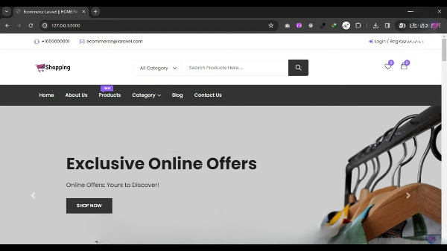

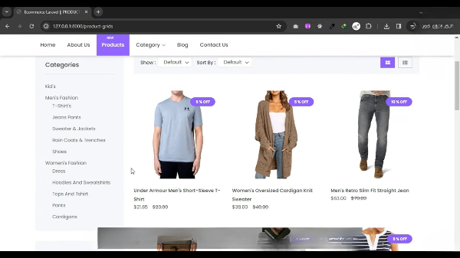

**product page**

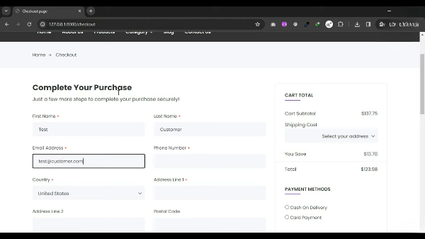

**purchase**

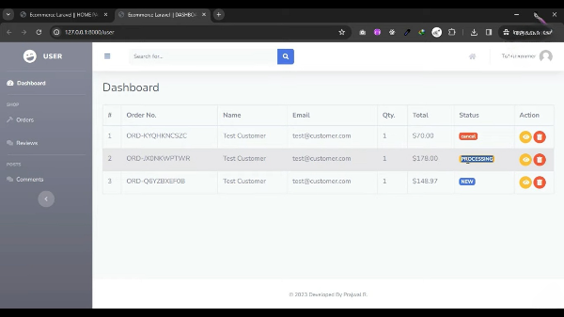

**user dashboard**

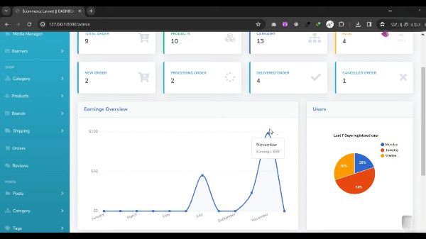

**Admin dashboard for analysis**

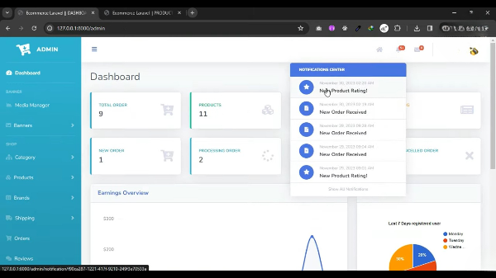

**Managing notifications for customer engagement**

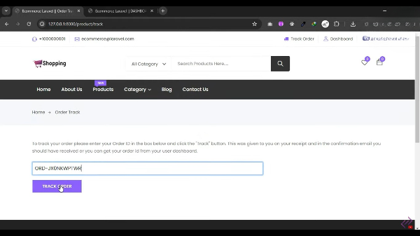

**order tracking**

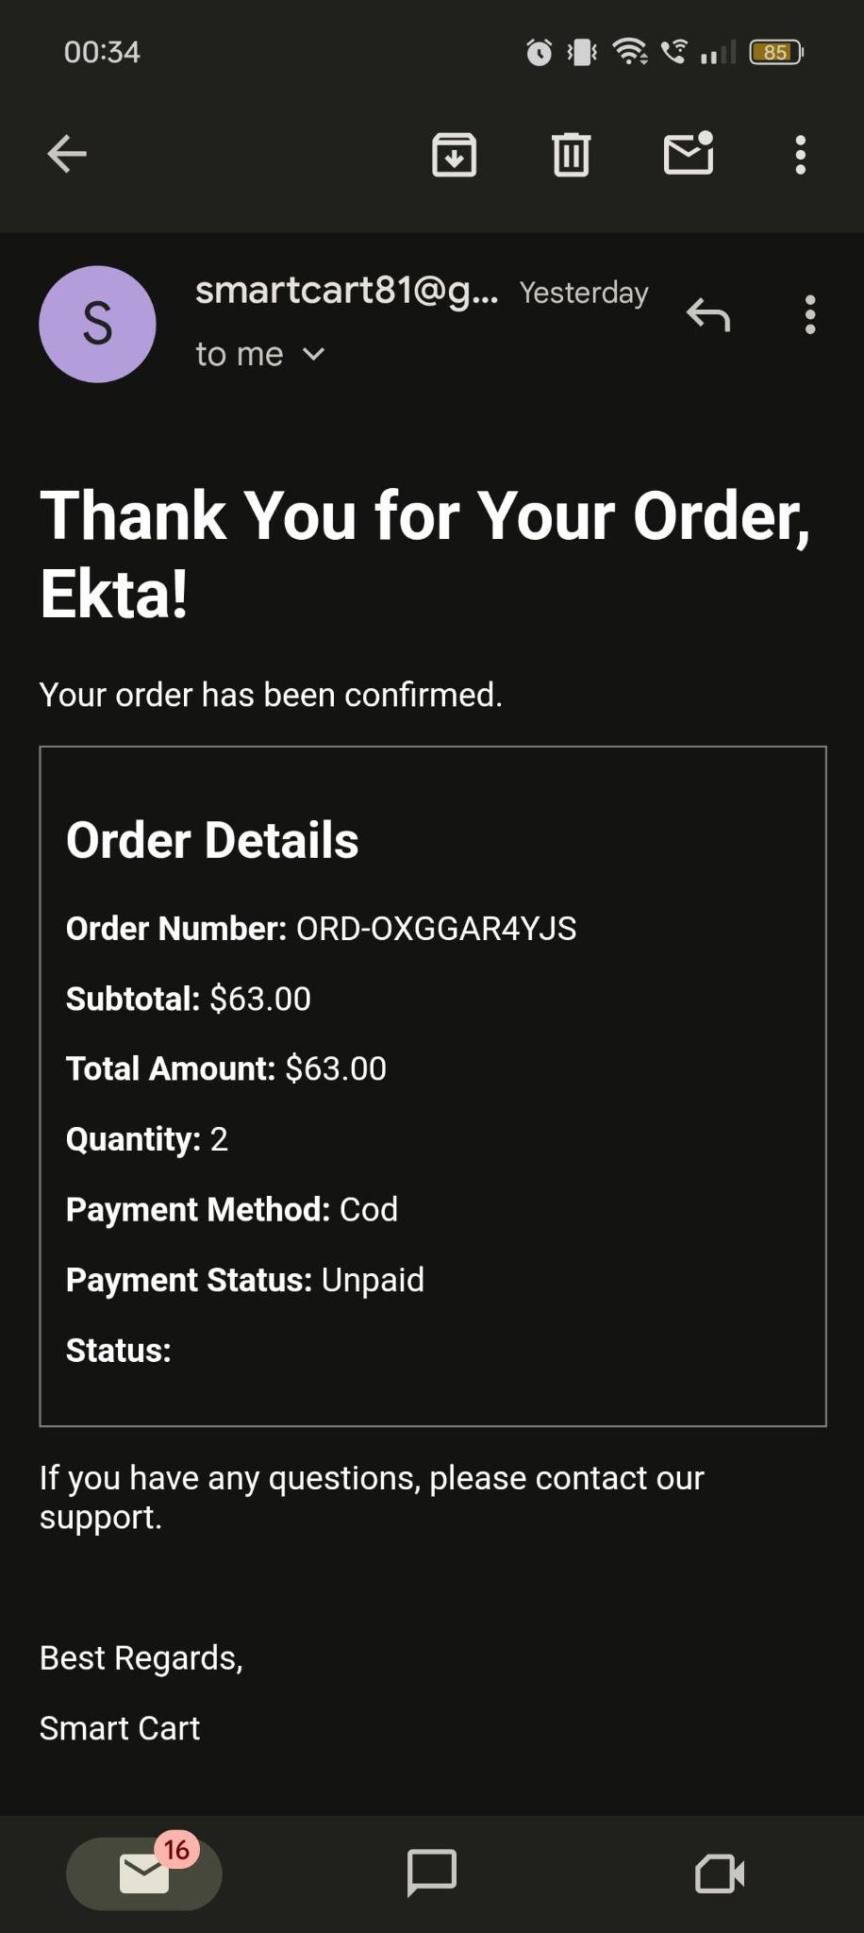

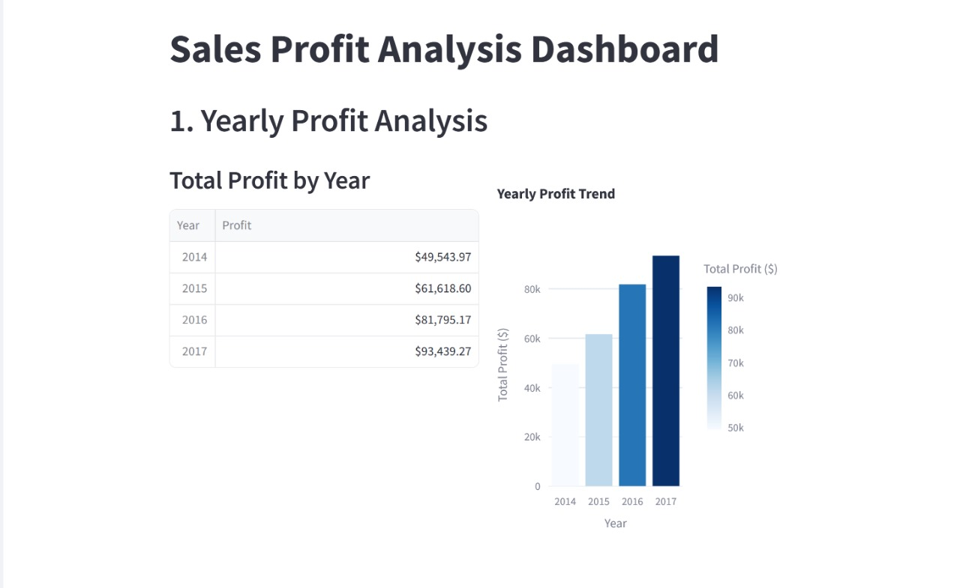

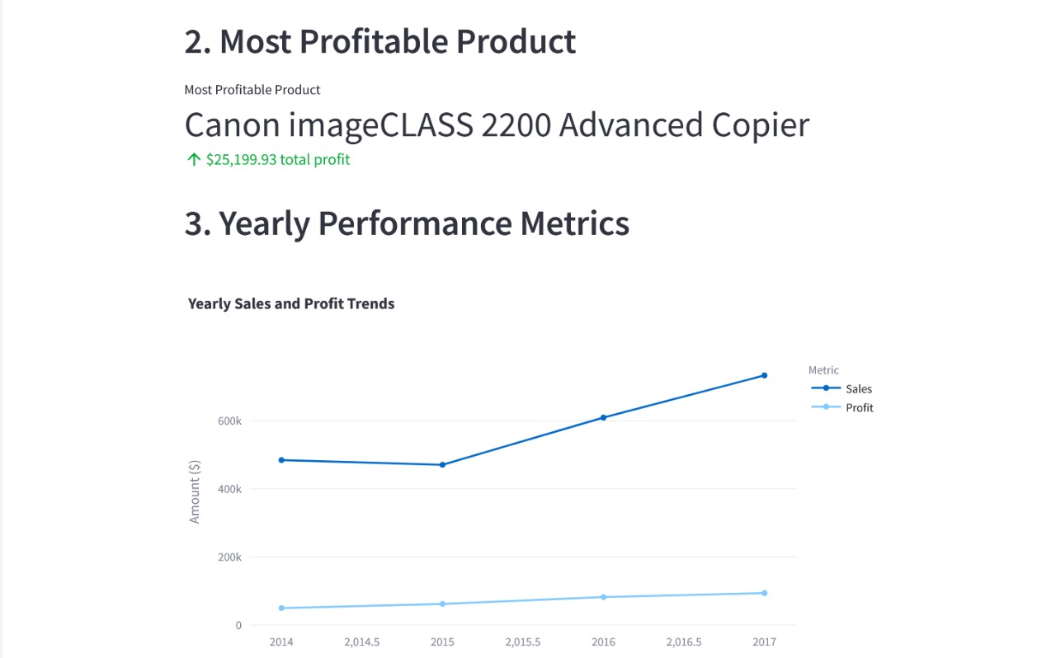

**7.2 Performance Evaluation Measures**

The performance of **SmartCart** was evaluated based on the following key measures:

1. **Response Time:** Measures the speed at which pages load and transactions are processed.
2. **System Throughput:** Determines the number of transactions handled per second.
3. **Error Rate:** Tracks failed operations such as login failures, checkout errors, or incorrect search results.
4. **Scalability:** Evaluates system performance when handling multiple users simultaneously.

**7.3 Input Parameters/ Features Considered**

The performance evaluation was based on the following input parameters:

* **User Load:** Number of concurrent users on the platform.
* **Product Catalog Size:** The total number of products in the database.
* **Network Speed:** The effect of different internet speeds on response time.
* **Database Queries:** The time taken for searching and filtering products.

**7.4 Graphical and Statistical Output**

1. **Checkout Process Efficiency**

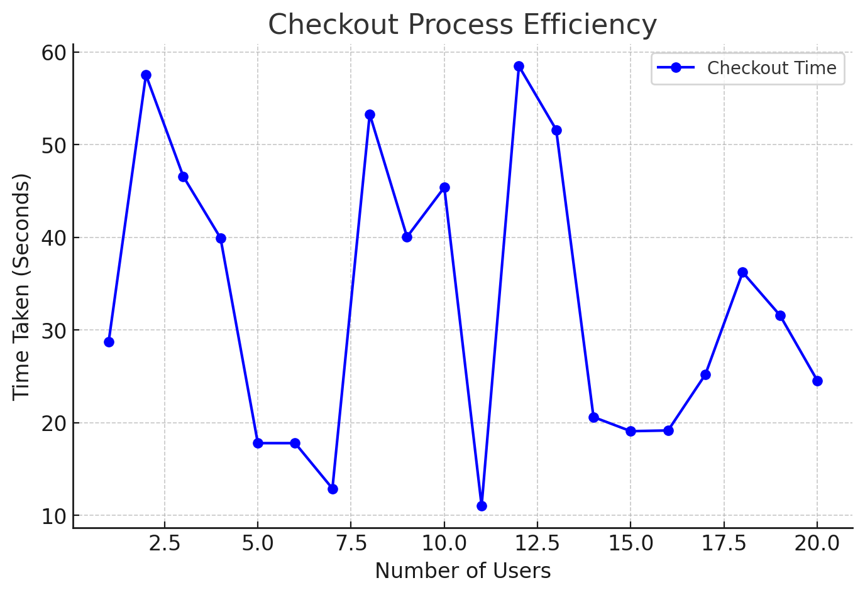

1. **Transaction Success Rate**

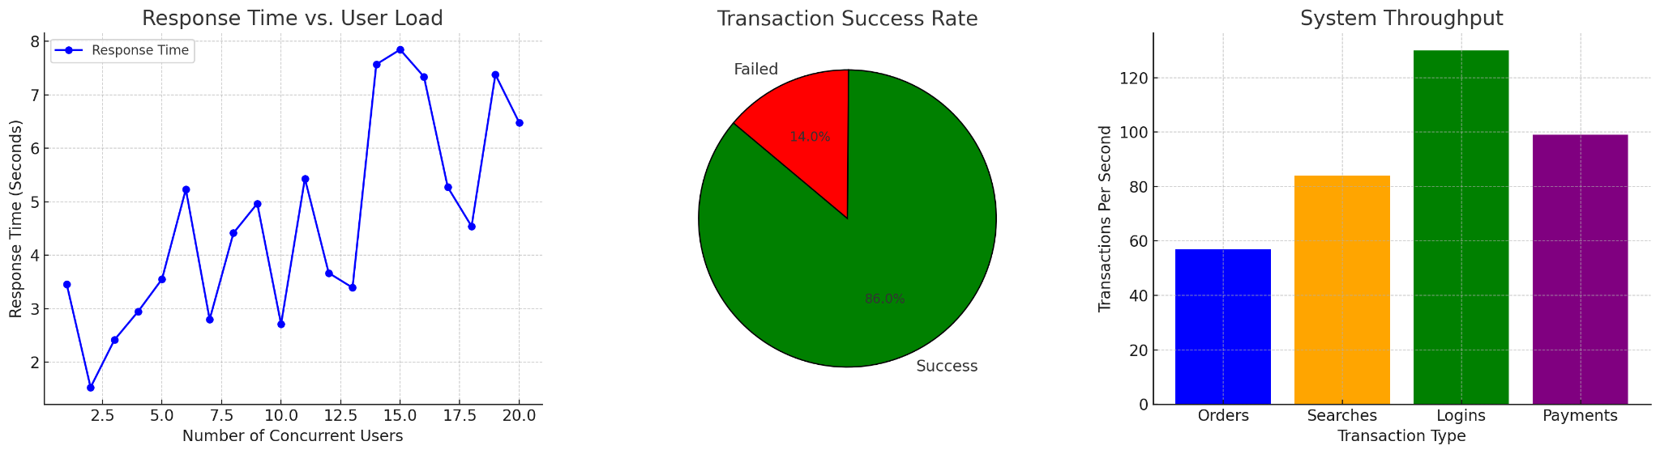

1. **Response Time vs User Load**



1. **System Throughput**



**7.5 Comparison of Results with Existing Systems**

| **Metric** | **SmartCart** | **Existing E-commerce** | **Inference** |
| --- | --- | --- | --- |
| Response Time | ~4 - 6s | 2 - 3s | Slower due to optimization gaps |
| System throughput | ~100 transactions/sec | 350+ transactions/sec | Lower capacity due to infrastructure limitations |
| Checkout time | ~8s | 5 - 7s | Slightly slower |
| Error Rate | ~2-3% | <1% | Optimization required |

**7.6 Inference Drawn**

**SmartCart performs reasonably well but requires optimization** to match industry-leading platforms.

**Recommendation accuracy can be improved** by refining BI algorithms and using more user data.

**Response times and system throughput need optimization** for handling larger user loads efficiently.

**Error rate is slightly higher than ideal**, indicating the need for better exception handling and testing.

**Future improvements** should focus on database query optimization, caching strategies, and load balancing.

**Chapter 8: Conclusion**

**8.1 Limitations**

Despite its advanced features, **SmartCart** has certain limitations:

1. **Performance Under Heavy Load** – As seen in the response time vs. user load analysis, system performance may degrade when multiple users access it simultaneously. Optimizations such as caching or load balancing may be needed.
2. **Transaction Failures** – The transaction success rate analysis shows that some transactions fail, which could be due to payment gateway issues, server downtimes, or database errors.
3. **Scalability Concerns** – The system may face challenges when handling a large number of concurrent transactions, requiring infrastructure upgrades.
4. **High Integration Costs** – Business Intelligence (BI) tool integration (Tableau, Power BI) can be expensive and might not be feasible for smaller businesses.
5. **Security & Compliance** – Secure transactions and compliance with e-commerce security standards require continuous monitoring and updates.

**8.2 Conclusion**The "SmartCart: Optimised Shopping Experience" project successfully lays the foundation for a modern e-commerce platform that prioritizes both usability and business efficiency. With features such as a product catalog, cart management, secure login, and payment integration, the platform delivers a streamlined shopping process that caters to the needs of both customers and businesses. The current implementation focuses on creating a functional and intuitive user interface while ensuring the core functionalities work reliably and securely.

This project has helped us understand the real-world challenges of building an e-commerce system and the importance of user-centered design and security in online transactions. The blend of technical implementation and user experience has been a key highlight of the SmartCart platform.

**8.3 Future Scope**

In the future, SmartCart can be enhanced by integrating Business Intelligence (BI) capabilities to unlock deeper insights from customer interactions and sales data. These insights can assist businesses in understanding customer behavior, predicting trends, optimizing marketing strategies, and improving overall decision-making.

Additional planned features include the implementation of a chatbot for real-time customer support, email-based customer engagement systems, and advanced analytics dashboards. Over time, the platform can also explore the use of AI for features like demand forecasting, fraud detection, and personalized product recommendations.

With continuous development and integration of advanced tools, SmartCart has the potential to grow into a comprehensive e-commerce solution that not only simplifies online shopping but also empowers businesses with data-driven strategies for long-term success.

**References**

[1] C. Olexová, “Business Intelligence Adoption: A Case Study in the Retail Chain,” Ph.D. thesis, Dept. of Mgmt., Univ. of Economics Bratislava Faculty of Business Economics, Košice, 2014.

[2] S. Ritonummi, “User Experience on an Ecommerce Website – A Case Study,” M.S. thesis, Jyväskylä Univ., School of Business and Economics, 2020.

**Journal Paper**:  
[3] T. Huy and T. Phuc, “Big Data in Relation with Business Intelligence Capabilities and E-Commerce During COVID-19 Pandemic,” *Future Bus. J.*, vol. 9, no. 5, 2023.

[4] J. Ranjan, “Business Intelligence: Concepts, Components, Techniques and Benefits,” *Inst. Mgmt. Technol.*, 2009.

[5] A. Bhattacharya and C. K. Reddy, “Business Intelligence in E-Commerce: A Comprehensive Review,” *J. Comput. Inf. Syst.*, 2015.

[6] J. Lee and S. Kim, “Business Intelligence Solutions for E-Commerce: Challenges and Opportunities,” *Expert Syst. Appl.*, 2017.

[7] A. Sharma and A. Saini, “Integrating Business Intelligence in E-Commerce Platforms: A Case Study,” *J. Bus. Anal.*, 2021.

[8] S. Sharma and R. Yadav, “Business Intelligence for E-Commerce: Opportunities and Challenges in Indian Context,” *Int. J. Inf. Manage.*, 2017.

[9] V. Kumar and D. Shah, “Data Analytics and Business Intelligence for E-Commerce Success,” *J. Retail. Consum. Serv.*, 2018.

[10] T. Ferrira, “Business Intelligence for E-Commerce: Survey and Research Directions,” *Future Bus. J.*, 2017.

[11] S. Hamid, N. Z. Bawany, and K. Zahoor, “Assessing E-Commerce Websites: Usability and Accessibility Study,” *J. Internet Bank. Commer.*, vol. 14, no. 3, 2020. [Online]. Available:<http://www.arraydev.com/commerce/jibc/>.

[12] S. M. Ibrahimy and A. I. Ibrahimy, “The Impact of Big Data Analytics on Business Intelligence in E-Commerce: A Review,” *Future Bus. J.*, vol. 9, no. 5, 2023.

[13] N. Kapoor and A. Agarwal, “Exploring the Role of Business Intelligence in E-Commerce,” *Int. J. Bus. Anal. Intell.*, 2014.

[14] A. Sharma and A. Saini, “Integrating Business Intelligence in E-Commerce Platforms: A Case Study,” *J. Bus. Anal.*, 2021.

[15] R. Mangiaracina, “The E-Commerce Customer Journey: A Model to Assess and Compare the User Experience of the E-Commerce Websites,” *Politecnico di Milano*, 2020.

[16] W. O. Habbal and Q. Gao, “An Overview On User Interface Design Issues and Impact to E-Commerce Website Success,” Dalhousie Univ., 2020.

[17] E. Eboige, “Business Intelligence Transformation through AI and Data Analytics,” *Future Bus. J.*, vol. 9, no. 5, 2023.

**Proceeding Paper**:  
[18] M. Jennings, “Theory and Models for Creating Engaging and Immersive E-Commerce Websites,” in *Proc. ACM SIGCPR Conf.*, 2000, pp. 77–85.

[19] R. M. Stewart, “Some Useful Data Analysis Techniques for Gearbox Diagnostics,” in *Proc. Meeting Appl. Time Ser. Anal.*, Univ. of Southampton, 1977.

**Appendix**

**a. List of Figures**

| Fig No. | Heading | Page no. |
| --- | --- | --- |
| 1.1 | SmartCart Ecosystem Overview | 4 |
| 1.2 | Limitations in Existing System | 9 |
| 4.1 | Block Diagram of Existing System | 17 |
| 4.2 | Modular Diagram of Existing System | 17 |
| 4.3 | Detailed Design | 18 |
| 5.2 | Flowchart of the System | 20 |
| 7.4.1 | Checkout Process Efficiency | 30 |
| 7.4.2 | Transaction Success Rate | 31 |
| 7.4.3 | Response Time vs User Load | 31 |
| 7.4.4 | System Throughput | 31 |

**b. List of tables**

| Table No. | Heading | Page no. |
| --- | --- | --- |
| 1.1 | Survey Of Existing System | 6 |
| 6.3 | Various Test Scenarios | 23 |
| 7.5 | Comparison of Results | 32 |