eVAULT: Enhanced Blockchain Verified Access and Unified Legal Records Technology

Submitted in partial fulfilment of the requirements of the degree
BACHELOR OF ENGINEERING IN COMPUTER ENGINEERING

By
Prashant B. Barai (D12A/09)
Sandeep Jagdale (D12A/30)
Ammar Ansari (D12A/07)
Puneet Singh Kewalramani (D12A/36)

Name of the Mentor
Prof. Dr. Priya R.L.



Vivekanand Education Society’s Institute of Technology,
An Autonomous Institute affiliated to University of Mumbai

HAMC, Collector’s Colony, Chembur,
Mumbai-400074
University of Mumbai (AY 2024-25)
VIVEKANAND EDUCATION SOCIETY’S INSTITUTE OF TECHNOLOGY
(An Autonomous Institute Affiliated to University of Mumbai
Department of Computer Engineering)

Department of Computer Engineering


CERTIFICATE

This is to certify that _______________________________________________of Third Year Computer Engineering studying under the University of Mumbai has satisfactorily presented the project on “-----------------------------------------------------------------” as a part of the coursework of Mini Project 2B for Semester-VI under the guidance of —-----------------------. in the year 2024-25.
_____________________
Date

__________________ |  | __________________
Internal Examiner |  | External Examiner

_________________ __________________ __________________
Project Mentor Head of the Department Principal
Dr. Mrs. Nupur Giri Dr. J. M. Nair

Declaration

We declare that this written submission represents our ideas in our own words and where others' ideas or words have been included, we have adequately cited and referenced the original sources. We also declare that we have adhered to all principles of academic honesty and integrity and have not misrepresented or fabricated or falsified any idea / data / fact / source in our submission. We understand that any violation of the above will be cause for disciplinary action by the Institute and can also evoke penal action from the sources which have thus not been properly cited or from whom proper permission has not been taken when needed.

-----------------------------------------  (Signature)  -----------------------------------------  (Name of student and Roll No.) | -----------------------------------------  (Signature)  -----------------------------------------  (Name of student and Roll No.)
-----------------------------------------  (Signature)  -----------------------------------------  (Name of student and Roll No.) | -----------------------------------------  (Signature)  -----------------------------------------  (Name of student and Roll No.)

Date:

ACKNOWLEDGEMENT

We are thankful to our college Vivekanand Education Society’s Institute of Technology for considering our project and extending help at all stages needed during our work of collecting information regarding the project.

It gives us immense pleasure to express our deep and sincere gratitude to Assistant Professor Dr. (Mrs.) Priya R. L (Project Guide) for her kind help and valuable advice during the development of project synopsis and for her guidance and suggestions.

We are deeply indebted to Head of the Computer Department Dr.(Mrs.) Nupur Giri and our Principal Dr. (Mrs.) J.M. Nair , for giving us this valuable opportunity to do this project.

We express our hearty thanks to them for their assistance without which it would have been difficult in finishing this project synopsis and project review successfully.

We convey our deep sense of gratitude to all teaching and non-teaching staff for their constant encouragement, support and selfless help throughout the project work. It is a great pleasure to acknowledge the help and suggestion, which we received from the Department of Computer Engineering.

We wish to express our profound thanks to all those who helped us in gathering information about the project. Our families too have provided moral support and encouragement several times.

Computer Engineering Department
COURSE OUTCOMES FOR T.E MINI PROJECT 2B
Learners will be to:-

CO No. | COURSE OUTCOME
CO1 | Identify problems based on societal /research needs.
CO2 | Apply Knowledge and skill to solve societal problems in a group.
CO3 | Develop interpersonal skills to work as a member of a group or leader.
CO4 | Draw the proper inferences from available results through theoretical/ experimental/simulations.
CO5 | Analyze the impact of solutions in societal and environmental context for sustainable development.
CO6 | Use standard norms of engineering practices
CO7 | Excel in written and oral communication.
CO8 | Demonstrate capabilities of self-learning in a group, which leads to lifelong learning.
CO9 | Demonstrate project management principles during project work.

Contents

Abstract ii

Acknowledgments iii

List of Abbreviations iv

List of Figures v

List of Symbols vi

Introduction 10
  - Introduction
  - Motivation
  - Problem Statement & Objectives
  - Organization of the Report

- Literature Survey 17

  - Survey of Existing System
  - Limitation Existing system or Research gap
  - Mini Project Contribution

Proposed System 29

  - Introduction
  - Architectural Framework / Conceptual Design
  - Algorithm and Process Design
  - Methodology Applied
  - Hardware & Software Specifications
  - Experiment and Results for Validation and Verification
  - Result Analysis and Discussion
  - Conclusion and Future work.

References 50

Abstract
In today's rapidly evolving digital landscape, many sectors are transforming, yet the Indian legal system remains entrenched in outdated, paper-based practices. This reliance leads to significant delays, human errors, and potential document tampering, undermining the efficacy, transparency, and integrity of the judicial process and eroding public trust.
eVAULT (Enhanced Blockchain Verified Access and Unified Legal Records Technology) addresses these challenges by introducing a blockchain-powered legal documentation system. It enables secure creation, submission, verification, and tracking of legal records throughout their lifecycle. By decentralizing document storage using IPFS, the system ensures records remain immutable, traceable, and protected from unauthorized changes.
Utilizing Hyperledger Fabric, a permissioned blockchain framework, eVAULT logs and audits all document transactions, while the InterPlanetary File System (IPFS) provides decentralized storage for multimedia evidence, enhancing capacity and reducing costs without compromising data integrity.
Each document receives a unique digital signature through advanced cryptographic techniques, ensuring authenticity and immutability. The system also offers real-time notifications and updates to all stakeholders, including lawyers, registrars, and judges, keeping them informed about case progress.
Real-time updates and notifications keep stakeholders—lawyers, registrars, and judges—informed of case progress. eVAULT streamlines legal workflows, enhances accountability, and fosters trust by integrating blockchain security into traditional judicial processes, making legal data secure, transparent, and accessible when needed.
Ultimately, it revolutionizes case management by integrating blockchain's security features into traditional judicial workflows, ensuring sensitive legal data is secure, transparent, and accessible when needed.

List of Abbreviations
- eVAULT: Enhanced Blockchain Verified Access and Unified Legal Records Technology
- IPFS: InterPlanetary File System
- PoW: Proof of Work
- PoS: Proof of Stake
- CID: Case ID
- JS: JavaScript
- DB: Database
- HLD: High-Level Design
- LLD: Low-Level Design
- UI: User Interface
- UX: User Experience

List of Figures
- Blockchain Architecture in eVAULT 30
- Workflow Diagram of eVAULT System 36
- Data Flow Diagram (DFD) of eVAULT System 37
- Front-end Implementation 41

List of Symbols
- H: Hash of Evidence
- S: Digital Signature
- T: Timestamp of a Transaction
- CID: Case ID
- IPFS-H: IPFS Hash

1. Introduction

1.1 Introduction
Many industries have embraced technology to improve their operations in today’s fast-paced digital landscape, yet the legal sector remains largely dependent on outdated manual record-keeping and paper-based documentation. This reliance on antiquated methods results in inefficiencies, significant delays, human errors, and an increased risk of document tampering, all of which contribute to a decline in public trust due to burdensome administrative processes and a lack of transparency.
Legal professionals manage extensive volumes of sensitive information, including court records and evidence, which are susceptible to loss, unauthorized access, and tampering. The pressing need for modernization becomes more urgent with the growing number of cases and the complexities woven into legal procedures.
The eVAULT project emerges as a transformative solution to these pressing challenges by revolutionizing the management of legal records through the power of blockchain technology. It provides a decentralized, secure, and transparent framework that effectively addresses the inefficiencies of traditional judicial systems while ensuring the integrity and immutability of legal documentation. Each transaction, from evidence submission to verification and status updates, is logged in an unalterable ledger, thereby making tampering nearly impossible and enhancing trust among all stakeholders involved.
eVAULT empowers legal professionals—such as lawyers, registrars, stamp reporters, bench clerks, and judges—by facilitating seamless communication and straightforward access to critical evidence and information. The system guarantees a fast, accurate, and tamper-proof flow of information, minimizing fraud risks and complications through its decentralized architecture, which prevents any single entity from controlling or compromising the system.
The benefits of eVAULT go beyond mere operational efficiency; secure and transparent legal documents cultivate confidence, accountability, and responsibility among all parties in the judicial process. Ultimately, this innovative solution will expedite the dispensation of justice.

1.2 Motivation
The motivation behind the eVAULT project stems from the significant challenges facing the Indian judicial system. With one of the largest populations in the world, India also has a vast number of legal cases that are often delayed due to outdated practices. Long wait times for case resolutions, complicated paper-based documentation, and a lack of transparency have resulted in one of the largest backlogs of pending cases globally.
These inefficiencies frustrate legal practitioners and erode public confidence in the system. Manual handling of documents and physical storage create risks of loss, misplacement, and manipulation of records. This environment increases the likelihood of errors or fraud, further delaying justice by keeping stakeholders uninformed about case progress.
As the population grows, the judicial system faces an increasing burden from the rising complexity and volume of legal cases. Without modernization, this burden will only escalate, hindering productivity and diminishing the quality of service provided by legal practitioners. Such inefficiencies can delay or deny justice, compromise evidence, and lead to unfair trials.
eVAULT addresses these issues through blockchain technology, which is secure, transparent, immutable, and decentralized, making it ideal for modernizing legal documentation and case management. eVAULT eliminates the inefficiencies of traditional record-keeping, prevents document tampering, and provides a streamlined, transparent platform for legal professionals and stakeholders.
By changing how legal cases are managed, eVAULT ensures the security and traceability of evidence, from document uploads to verdicts. This will enhance confidence in the judicial process, benefiting legal professionals, their clients, and the public by fostering a more transparent, accountable, and effective legal system. Ultimately, eVAULT will lead to improved legal practices in India, where digital transformation in the judiciary becomes essential for ensuring access to justice for all.

1.3 Problem Statement & Objectives

Problem Statement
The judicial system in India, much like in many other countries, faces several challenges in managing legal documents efficiently. Currently, case records and supporting evidence such as written documents, images, videos, and audios are handled manually and stored in physical formats, making the entire process cumbersome, prone to errors, and lacking transparency. Despite the increasing digitalization of other sectors, the legal field has been slow in adopting digital innovations to manage critical legal documents securely and effectively. The eVAULT system aims to address the gaps present in the current system by introducing blockchain technology into the legal document management process. Below is a detailed breakdown of the issues currently plaguing the system and the objectives of the proposed solution.

Current Challenges in Legal Document Management
- Manual Process and Paper-Based Workflow:
  - Inefficiency and Time Delays: One of the key challenges of the existing system is that case documents are handled and processed manually by various personnel, leading to significant delays. Legal professionals and court officials have to rely on physical paper documents, which are passed around for verification and processing, contributing to inefficiencies.
  - Physical Storage: Physical storage of these documents requires extensive space and resources, and retrieving files often takes substantial time, causing further delays in judicial proceedings.
  - Vulnerability to Damage or Loss: Paper documents are vulnerable to damage from environmental factors like fire, floods, and pests, as well as risks of misplacement or intentional tampering, which can compromise the integrity of the legal process.

- Lack of Transparency and Traceability:
  - Limited Access Control: The current system provides limited control over who can access the documents at different stages of verification, leading to concerns about data leaks or unauthorised access.
  - No Clear Audit Trail: In the existing system, tracking the journey of case files and understanding who has accessed or modified them is difficult. There is no reliable mechanism to trace the flow of documents across various authorities in the judicial chain.
- Inconsistent Verification Process:
  - Human-Dependent Verification: Document verification is a fully manual process handled by personnel like Desk Babu (Registrar) and Stamp Reporter. The manual nature of this task means that it is susceptible to errors, inconsistencies, and, in some cases, bias. The absence of an automated way to streamline this process adds to the inefficiency.
- Case Allocation Issues:
  - Non-Random Allocation: Currently, documents are often manually allocated to judicial personnel for verification, leading to potential biases or uneven workload distribution. The lack of a structured allocation mechanism affects the fairness and speed of the verification process.
- Lack of Real-Time Updates:
  - Delayed Communication: Lawyers and legal professionals are often left in the dark when it comes to case progress. Updates on case status, new evidence, and decisions are not communicated in real-time, leading to inefficiencies and unnecessary delays in proceedings.
  - Manual Status Updates: The manual nature of updating case statuses by Bench Clerks means that any changes to court schedules, case developments, or rescheduled dates often take time to reflect in the system, leaving parties uninformed.

Objectives
To address these challenges, the eVAULT system is designed to introduce an automated, secure, and transparent method of managing legal documents using blockchain technology. The proposed system leverages Hyperledger Fabric, IPFS (InterPlanetary File System), and smart contracts to build a decentralised and tamper-proof legal document management system, while still allowing human verification. The following objectives aim to bridge the existing gaps in the legal document management process:
- Automation of Case Allocation and File Handling:
  - Objective: To eliminate manual bias and uneven workload distribution by automating the random allocation of case files to judicial personnel, such as the Desk Babu and Stamp Reporter.
  - Sub-Objective: Develop an algorithm that automates case allocation, linking new verifications to previously verified documents through a unique Case ID, ensuring fairness and minimizing redundant checks.
- Decentralized Document Storage and Traceability:
  - Objective: To create a decentralized, immutable repository for all legal documents, ensuring secure storage, transparency, and full traceability of all access and modifications.
  - Sub-Objective: Integrate IPFS for decentralized evidence storage and use blockchain to store metadata and document hashes, creating an immutable ledger for secure tracking of all document actions.
- Secure Digital Verification and Signature Process:
  - Objective: To enhance the manual verification process digitally, reducing errors and improving traceability.
  - Sub-Objective: Implement a digital signature system where verified documents are signed by the Stamp Reporter and linked to the unique Case ID on the blockchain, ensuring tamper-proof records.

- Real-Time Case Updates and Notifications:
  - Objective: To provide real-time updates on case statuses, ensuring legal professionals have instant access to the latest information.
  - Sub-Objective: Use event-driven programming to trigger real-time notifications for case status changes, ensuring prompt updates and reducing communication delays.
- Enhanced Data Security and Privacy:
  - Objective: To protect sensitive legal documents with encryption and access control, allowing only authorized personnel to view or modify case files.
  - Sub-Objective: Apply role-based access control via Hyperledger Fabric, with cryptographic hashing and encryption to ensure data security and integrity.
- Integration of Traditional Judicial Processes with Digital Systems:
  - Objective: To integrate traditional legal processes with digital technologies for improved efficiency.
  - Sub-Objective: Design a system that supports manual verification while enhancing efficiency with digital file handling and compliance with existing legal frameworks.

1.4 Organization of the Report
This report is structured to provide a comprehensive overview of the eVAULT project:
- Chapter 1: Offers a detailed introduction to the project, including motivation, problem statements, and objectives, setting the context for the ensuing discussions.
- Chapter 2: Delivers a thorough literature survey, examining existing systems, identifying limitations, and illustrating the research gap that eVAULT addresses.
- Chapter 3: Describes the proposed system in detail, covering architectural frameworks, algorithm designs, methodologies applied, and specifications.
- Chapter 4: Discusses the implementation and testing of the eVAULT system, presenting results that validate its efficacy.
- Chapter 5: Concludes the report, summarising findings and proposing directions for future work to further enhance the system.

2. Literature Survey

2.1 Survey of Existing Systems

Year | Objective | Data Input | Methodology | Performance Metrics | Advantages | Disadvantages
2024  [1] | To develop a secure and efficient legal documentation management system using Blockchain and IPFS to ensure integrity and de-centralized storage of legal documents. | Legal documents (contracts, agreements, court filings), user access data, cryptographic hashes, and smart contracts. | -Upload documents to IPFS.  -Generate cryptographic hash.  -Store hash on Blockchain.  -Implement access control.  -Verify document integrity via Blockchain.  -Use smart contracts for legal processes. | Security, efficiency, scalability, and integrity in document access, storage, retrieval, and maintenance. | Enhanced security with Blockchain and IPFS, decentralized storage, document immutability, and automation through smart contracts. | High Cost, Complexity, Scalability Issues, Data Privacy Concerns.
2024  [2] | Design a smart contract architecture for automating insurance processes. | Policyholder information, insurance policy details, and claim information. | - Blockchain: For safe transaction recording.  - BPM: For automating workflows.  - Smart Contracts: For policy management. | Automation, Processing Time, Cost Efficiency, Fraud Prevention. | Automation, Transparency, Cost Reduction, Fraud Prevention. | Interoperability, Regulatory Compliance,  Adoption Barriers.
2024  [3] | Explore blockchain for preserving digital evidence in judicial processes. | Digital Evidence (Documents, Images, Videos, Metadata). | - Blockchain: For tamper-proof evidence storage.  - Digital Signatures: For authenticity verification.  - Cryptographic Techniques: For securing evidence | Evidence security, retrieval efficiency, and legal admissibility. | Integrity, transparency, and trustworthiness. | Cost, complexity, and scalability.

Year | Objective | Data Input | Methodology | Performance Metrics | Advantages | Disadvantages
2024  [4] | Create a blockchain-based e-vault for securely storing legal records. | Legal Records (Case Files, Contracts, Agreements). | - Blockchain: For safe storage of records.  - Smart Contracts: For document access.  - Cryptographic Hashing: For document integrity. | Security of Document Storage, Accessibility, and Retrieval Efficiency. | Security, Transparency, Efficiency, and Immutability. | Implementation Cost, Technical Complexity, and Adoption Barriers.
2024  [5] | Enhance privacy in cyber-physical systems via blockchain-assisted data sharing. | Data from Cyber-Physical Systems and Encrypted User Data. | - Blockchain: For tamper-proof evidence storage.  - Smart Contracts: To automate verification processes.  - Cryptographic Hashing: To ensure evidence integrity. | Data Privacy, System Efficiency, and Deniability. | Enhanced Privacy, Data Control, and Legal Compliance. | Implementation Complexity and Overhead in Data Management.
2024  [6] | Examine blockchain's application in preserving electronic evidence in copyright cases. | Copyright Data, Electronic Evidence, and Legal Metadata. | -Blockchain: For secure digital evidence storage.  -Digital Signatures: To verify authenticity.  - Cryptographic Hashing: To maintain evidence integrity. | Evidence Integrity, Legal Admissibility, and Efficiency. | Improved Evidence Integrity, Reduced Tampering, and Trustworthiness. | Implementation Complexity and Legal and Regulatory Challenges.
2024  [4] | Create a blockchain-based e-vault for securely storing legal records. | Legal Records (Case Files, Contracts, Agreements). | - Blockchain: For safe storage of records.  - Smart Contracts: For document access.  - Cryptographic Hashing: For document integrity. | Security of Document Storage, Accessibility, and Retrieval Efficiency. | Security, Transparency, Efficiency, and Immutability. | Implementation Cost, Technical Complexity, and Adoption Barriers.
2024  [5] | Enhance privacy in cyber-physical systems via blockchain-assisted data sharing. | Data from Cyber-Physical Systems and Encrypted User Data. | - Blockchain: For tamper-proof evidence storage.  - Smart Contracts: To automate verification processes. | Data Privacy, System Efficiency, and Deniability. | Enhanced Privacy, Data Control, and Legal Compliance. | Implementation Complexity and Overhead in Data Management.
Year | Objective | Data Input | Methodology | Performance Metrics | Advantages | Disadvantages
2024  [6] | Examine blockchain's application in preserving electronic evidence in copyright cases. | Copyright Data, Electronic Evidence, and Legal Metadata. | -Blockchain: For secure digital evidence storage.  -Digital Signatures: To verify authenticity.  - Cryptographic Hashing: To maintain evidence integrity. | Evidence Integrity, Legal Admissibility, and Efficiency. | Improved Evidence Integrity, Reduced Tampering, and Trustworthiness. | Implementation Complexity and Legal and Regulatory Challenges.
2024  [7] | Streamline the process of filing FIRs using a blockchain-based system to ensure secure, immutable, and transparent records, enhancing accountability. | FIR Details (incident descriptions, personal details) and Blockchain Records. | - Use Blockchain for recording FIRs.  - Implement smart contracts for FIR submission.  - Develop a user-friendly interface.  - Utilize cryptographic hashing for integrity verification. | Transparency (visibility of FIRs), Security (prevention of unauthorized modifications). | Improved trust and transparency, and reduced delays in FIR registration. | Resistance from traditional law enforcement and challenges in ensuring accessibility for non-technical users.
2024  [8] | Propose an IoT-driven blockchain architecture for managing the healthcare supply chain and protecting medical records, addressing challenges of fragmented healthcare systems to enhance patient safety. | Medical Records, Supply Chain Data, and IoT Sensor Data. | - Design  - Access Control  - Consensus  - Evaluation | Execution Time, Resource Consumption, and Throughput. | Enhanced Security, Improved Data Integrity, Access Control, and Traceability. | Compliance Issues, Scalability Concerns, and Integration Challenges.
Year | Objective | Data Input | Methodology | Performance Metrics | Advantages | Disadvantages
2024  [9] | The paper aims to develop a blockchain solution to reduce corruption by creating a document verification process that minimizes third-party access, ensuring document safety and integrity. | Document verification process, third-party access to sensitive information, and user authentication. | The methodology involves creating, storing, retrieving, and extracting documents using blockchain technology to eliminate third parties from the verification process, ensuring security and tamper-proof information. | The system can significantly support achieving Sustainable Development Goal 16. | The proposed solution eliminates third parties from document verification, reduces corruption, and frees up state resources. | Scalability, Adoption, and Regulatory Challenges.
2023  [10] | Develop a blockchain-based system for secure certificate verification. | Certificate Information (ID, Issuance Date, Issuing Authority). | - Blockchain: For secure, unchangeable ledger.  - Smart  Contracts: To automate issuance and verification.  - Cryptographic Hashing: For data security. | Efficiency, Verification Time, Security, and Fraud Detection. | Security, Transparency, Efficiency, and Immutability. | Scalability, Complexity, and Integration Challenges.
2023  [11] | Conduct a comprehensive review of blockchain's role in document authentication. | Document Details, Authentication Records, and User Credentials | - Blockchain: For decentralized and secure document storage.  - Encryption: For protecting document privacy.  - Decentralized Storage: To ensure accessibility and control. | Accuracy, Security, Immutability, and Transparency. | Enhanced Security, Improved Trust, and Decentralization. | Integration Challenges, High Implementation Costs, and Scalability Issues.
Year | Objective | Data Input | Methodology | Performance Metrics | Advantages | Disadvantages
2023  [12] | Present an open-source blockchain application designed to modernize and secure the management of court data. | User Registration Information, Case Details, Evidence Files, and Access Credentials. | - Secure user registration with unique IDs and private keys for judges and lawyers.  - Case files are accessed via blockchain with controlled access.  - Cryptographic alerts are triggered on unauthorized attempts.  - Sensitive information is protected, ensuring the integrity and security of court records. | The system offers secure, real-time tracking of case files using cryptographic algorithms and distributed storage, ensuring authorized access and minimizing data tampering. | Enhanced Security, Decentralization, Improved Transparency, Real-time Updates, Access Control, User-Friendly Interface, Audit Trail, and Cost Efficiency. | Resistance to Change, Legal and Regulatory Challenges, Scalability Concerns, and Privacy Issues.
2022  [13] | Survey blockchain technology architecture, consensus algorithms, smart contracts, applications, and security measures. Guide users and researchers in understanding and addressing security challenges. | Existing Literature and Case Studies. | - Review: Analyze literature on blockchain.  - Comparison: Assess consensus algorithms and security measures.  - Risk Analysis: Identify and categorize security risks. | Effectiveness of Consensus Algorithms and Security Measures. | Comprehensive Coverage, Detailed Comparisons, and Identification of Research Gaps. | Scope of Survey and Dynamic Nature of Technology.
2022  [14] | Create a decentralized personal document locker using blockchain. | User Documents, Metadata, and Access Control Information. | - Blockchain: For secure and transparent data transactions.  - Deniable Encryption: For protecting user privacy. | Security, Accessibility, Data Integrity, and Privacy. | Decentralization, Security, Privacy, and User Control. | Usability Challenges, Data Management Complexity, and Cost of Implementation.
Year | Objective | Data Input | Methodology | Performance Metrics | Advantages | Disadvantages
2022  [15] | Create a decentralized digital document management system using blockchain and P2P networks to enhance security, accessibility, and collaboration. | Documents (digital files) and Blockchain Records (document transactions and user interactions). | - Use Blockchain for immutable document ledger.  - Utilize P2P network for decentralized sharing.  - Implement smart contracts for access control.  - Apply cryptographic techniques for security. | Collaboration Efficiency (real-time sharing and editing), Security (resistance to unauthorized access and tampering), and Scalability (handling users and documents). | Enhanced security and privacy through decentralized control, and improved collaboration across stakeholders. | Challenges in integration with existing systems and performance issues in low-bandwidth environments.
2022  [16] | To survey and provide an in-depth analysis of blockchain technology, focusing on its potential applications, security features, and challenges. | Secondary data from existing literature, including research papers, articles, and case studies on blockchain technology. | Survey methodology, systematically reviewing existing literature on blockchain technology, covering consensus algorithms, cryptographic techniques, and real-world applications. | Throughput, Latency, Security Metrics. | Security, Transparency, Decentralization. | Scalability, Energy Consumption: High energy usage in PoW-based blockchains, and Regulatory Issues: Lack of regulation and standardization.
2022  [17] | The research aims to develop a blockchain-based evidence transfer model for China's judicial system, ensuring integrity, consistency, and non-repudiation of records. | Evidence transfer records and transaction proposals from authorized entities detailing evidence management. | System Design: Consortium blockchain for secure judicial transactions, Consensus Mechanism: Raft algorithm for tamper-proof records, Smart Contracts: Automates evidence management, Prototype | Throughput: Number of transactions per second, Latency: Time from initiation to confirmation, and Resource Overhead: Computational and storage resources consumed. | Tamper-Proofing, Decentralization, Enhanced Security, Efficiency. | Byzantine Vulnerability, Denial of Service Attacks, Resource Consumption.
Year | Objective | Data Input | Methodology | Performance Metrics | Advantages | Disadvantages
2021  [18] | Develop a secure digital locker system using BigchainDB and IPFS to store and manage digital documents, providing a decentralized, tamper-proof solution for data integrity, security, and easy access. | Documents (e.g., legal papers, certificates) and Metadata (cryptographic hashes stored on the blockchain). | - Use BigchainDB to store metadata.  - Store documents on IPFS.  - Generate cryptographic hash.  - Implement access control.  - Integrate BigchainDB and IPFS for decentralized storage. | Data Integrity, Storage Efficiency, Access Time. | Enhanced Security and Data Integrity, Decentralized Storage, Reduced Storage Redundancy. | Performance impacted by IPFS network latency, Complexity in implementation.

2.2 Limitations of Existing Systems or Research Gap
While many systems, aside from the efforts of companies such as Ripple and Microsoft's Study, continue pouring into the legal sector in a bid to digitise and modernise this domain, most of them remain quite limited. Those limitations result in inefficiencies and delays with associated security concerns that have a disastrous effect on the overall effectiveness of case management and document handling. Below is a detailed list of the limitations of the existing systems in the legal domain:
- No Real-Time Updates:
  - Case status, document filing, or evidence verification updates are delayed, causing inefficiency and deadlines to be missed.
  - Fixed time updates result in weeks of delay, leading to wrong judgments or workflow issues.
- Centralized Data Storage:
  - Single point of failure; security breaches, data corruption, or hardware failures can compromise the entire system.
  - Confidential legal records are at risk if there’s unauthorized access or a system crash.
- Transparency Issues:
  - Lack of transparency makes it hard to verify the authenticity of legal documents, evidence, or decisions.
  - Limited audit trails lead to distrust in the document verification process.
- Manual Verification Processes:
  - Time-consuming, prone to human error, and inefficient for handling large volumes of legal records.
  - Missed details in documents can lead to delays and compromised data safety.
- Poor Data Integrity and Security:
  - Lack of cryptography or secure mechanisms to ensure document integrity.
  - No encryption or digital verification, making documents vulnerable to unauthorized access or tampering.
- Incomplete Audit Trails:
  - Lack of complete tracking of who accessed or modified documents.
  - Without audit trails, it’s difficult to verify document authenticity during the case lifecycle.

- Scalability and Performance Issues:
  - System performance degrades as case volumes and digital evidence grow.
  - Results in system crashes, slow responses, and downtime, affecting case processing.
- Unavailability and Poor User Experience:
  - Systems are not user-friendly, requiring expert knowledge, and lack mobile accessibility.
  - Limits access to legal information, especially in remote or underserved areas.
- Poor Evidence Management:
  - Inefficient organization, storage, and retrieval of multimedia evidence like images, videos, and audio files.
  - Human intervention in evidence retrieval causes further delays.
- Difficulty in Inter-Jurisdictional Cooperation:
  - Lack of support for collaboration across jurisdictions, leading to delays and errors in case handling.
  - Different systems or protocols in different regions make coordination difficult.
- Over-Reliance on Hard Copies:
  - Continued requirement for paper files in legal procedures despite digitization efforts.
  - Physical documents are prone to being lost, misplaced, or deteriorated.
- Lack of Standardization:
  - Lack of uniformity in legal documentation and procedures across jurisdictions.
  - Different standards complicate processes, making systems incompatible and slowing case management.

2.3 Mini Project Contribution
eVAULT is designed to address significant flaws in the current practice of legal document management systems using new technologies of blockchain and decentralised storage. Contribution of this mini-project in solving above identified key issues: data integrity, security, real-time update, and process automation. Below are the principal contributions of the eVAULT project:
- Blockchain-Powered Document Management
  - Introduces a decentralized framework using Hyperledger Fabric.
  - Ensures document immutability, security, and traceability through blockchain.
  - Smart contracts automate document uploads, status updates, and tracking of verifications.
- Decentralized Storage with IPFS
  - Integrates IPFS for decentralized storage of large multimedia files (documents, images, videos).
  - Metadata and IPFS hash are stored on the blockchain to ensure immutability and reduce on-chain storage costs.
  - Improves accessibility and reliability of document storage.
- Automated Case Allocation
  - Uses a random task allocation algorithm to distribute case files fairly among judicial personnel like the Registrar (Desk Babu) and Stamp Reporter.
  - Eliminates manual bias and ensures even workload distribution.
  - Case allocation is based on case type, enhancing efficiency.
- Secure Digital Verification and Signatures
  - Digitally enhances the manual verification process, with the Stamp Reporter verifying and signing documents.
  - Digital signatures are linked to a unique Case ID, ensuring traceability and security.
  - Prevents tampering and ensures authenticity of all verified documents.
- Real-Time Case Updates and Notifications
  - Provides real-time updates on case status changes, ensuring lawyers and judicial personnel receive immediate notifications.
  - Automatically updates case status (court dates, evidence submissions) on the lawyer's dashboard.
  - Reduces delays and enhances communication among legal professionals.
- Enhanced Security and Privacy
  - Implements strict access controls and encryption to safeguard sensitive legal documents.
  - Uses Hyperledger Fabric’s permissioned blockchain to limit access based on roles (lawyers, Registrar, Stamp Reporter, Judge, Bench Clerk).
  - Cryptographic hashing ensures data remains secure and tamper-proof, even during access.
- Seamless Integration with Traditional Judicial Workflows
  - Integrates the traditional manual verification process with digital solutions.
  - Judicial officers (Registrar, Stamp Reporter) perform their roles using digital tools without disrupting existing workflows.
  - Combines traditional methods with blockchain's transparency and efficiency.
- Traceable and Tamper-Proof Case History
  - Tracks every action (upload, verification, modification) on the blockchain, ensuring a tamper-proof trail of case activities.
  - Provides full transparency and accountability by storing a comprehensive history of all actions.
  - Legal professionals can easily audit case histories when needed.
- Reduction in Paperwork and Manual Errors
  - Digitizes all case files, reducing the reliance on physical paperwork and minimizing the risk of losing important documents.
  - Automates repetitive tasks like case allocation and status tracking, reducing manual errors.
  - Improves document accessibility and retrieval, enhancing overall efficiency.
- Audit and Accountability Mechanisms
  - Provides comprehensive audit trails for all document interactions, ensuring that every modification, verification, and access is logged.
  - Allows easy identification of responsible parties in case of discrepancies or conflicts.
  - Enhances accountability for all judicial and legal professionals involved.
- User Activity Monitoring
  - Implements monitoring of user activities within the system, ensuring transparency in who accessed what and when.
  - Detects and logs unauthorized access attempts, ensuring a secure and compliant environment.
  - Can generate reports for administrative purposes and legal compliance.
- Role-Based Data Access
  - Implements strict role-based access control (RBAC), ensuring that only authorized individuals can access sensitive case files or modify information.
  - Reduces the risk of internal data leaks and ensures compliance with data privacy regulations.
  - Provides different levels of access to various stakeholders, from lawyers to court officials.

3. Proposed System

3.1 Introduction
eVAULT is a next-generation law document management platform developed to address the challenges facing India's judicial ecosystem. Automated paperwork, lengthy procedures, and a lack of transparency contribute to delays in court processes. By leveraging blockchain technology and decentralized storage solutions, eVAULT aims to streamline the legal process from initial case filing to final judgment, resulting in a smoother, more reliable, and secure system.
The legal system struggles with managing thousands of files and documents prone to change, loss, or unauthorized access. eVAULT offers a non-tamperable digital ledger where activities such as evidence uploads, document validations, and case status changes are immutably recorded on the blockchain. This traceability promotes accountability and helps curb corruption by allowing stakeholders to see how each step is executed.
In addition to robust security, eVAULT features a user-centered interface designed for lawyers, registrars, stamp reporters, court clerks, and judges. The platform automates administrative processes like evidence verification and case follow-ups, enabling lawyers to concentrate on their core tasks rather than getting bogged down by traditional paperwork and manual data handling. Real-time notifications keep all stakeholders informed about key updates, enhancing accountability and efficiency.
The eVAULT system is modular, allowing smooth interaction among different roles, with each module tailored to the responsibilities of the respective stakeholder. Event-driven programming and smart contracts ensure the integrity of tasks such as case allocation, evidence validation, and judgment recording, minimizing delays and making the entire process predictable and manageable.
eVAULT aligns with the Digital India initiative, promoting a paperless judiciary and reducing environmental impacts associated with traditional workflows. The use of the InterPlanetary File System enables efficient handling of high-volume case-related data, such as multimedia evidence, without central server dependency. eVAULT revolutionizes India's legal processes.
3.2 Architectural Framework / Conceptual Design
The eVAULT system uses a modular structure tailored to the roles of stakeholders in the judicial process. Its design enables seamless coordination among legal professionals, court administrators, and judges, while enhancing transparency and accountability. The system focuses on ease of use, real-time data updates, and data security, ensuring timely access to information and efficient case management.
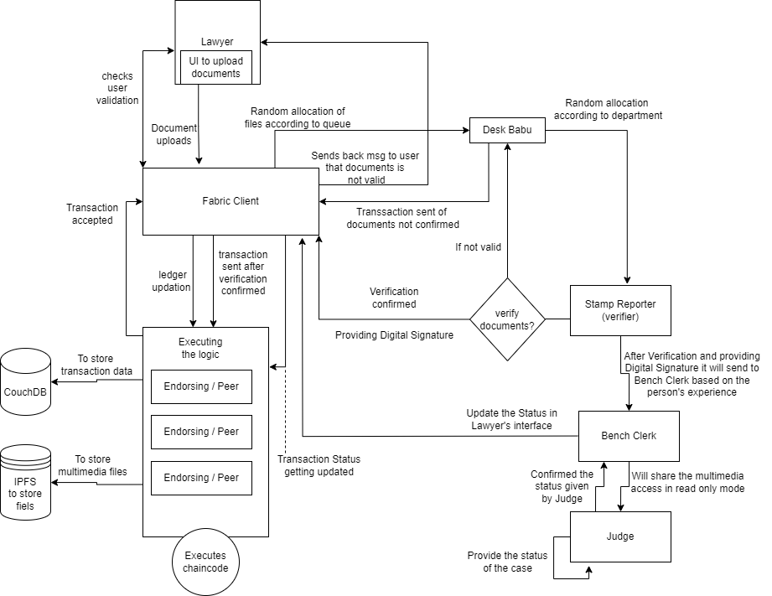
3.2 Block Diagram

Main Modules under eVAULT
- Lawyer Module
Lawyer Module is the primary entry point for the legal expert as it allows lawyers to:
- Establish new cases through registration of case details as well as uploading case material documents, such as petitions and evidence.
- Digital evidence upload and management such as PDFs, multimedia files, or scanned documents with timestamp and entry on the blockchain for authenticity and immutability.
- Real-time tracking of case progress via a dashboard displaying status updates and key milestones such as case review, hearing dates, or judgments.
- An action on the case triggers notifications like document validation, setting a hearing date, etc.
- It is designed to offer seamless user experience thereby allowing lawyers more time for the legal practice and less time in pursuit of administrative hurdles.

- Registrar (Desk Babu) Module
The Registrar Module handles the initial case allocation and basic verification of case details. This module is the first step in ensuring smooth processing and unbiased allocation, maintaining the integrity of the overall workflow from the start. Its key functions include:
- Case Assignment: The module initiates the random allocation of the case to the appropriate Stamp Reporter based on the type of case, ensuring fairness and neutrality in the assignment process to avoid any bias.
- General Case Verification: The Registrar performs a preliminary check, ensuring that the case type and required details are properly filled. However, this is not an in-depth verification, just a basic validation before moving forward.
- Submission to Stamp Reporter: After the general verification, the Registrar submits the case file to the system, which randomly assigns it to a Stamp Reporter specializing in the relevant case type for detailed verification.

- Stamp Reporter (Steno Babu) Module
The Stamp Reporter Module would massively feature during the validation process through
- Normalisation and validation of evidence to ensure stamped documents had met the standards of the law in terms of dispensation.
- Validated documents use digital signatures, which accepts its authenticity and cannot be changed. It uses blockchain-based signatures, which is against changing and leaves traces throughout the process.
- It notifies the Bench Clerk once verification has been successful and lets the next step in the workflow process continue without delay.
- All documents are validated appropriately while being marked as secure before they reach access to judges in this module.

- Bench Clerk Module
This module acts as a middleman between the stamp reporter and the judge. Key functions it performs include:
- Manages the flow of case-related information, ensuring that all confirmed evidence is correctly communicated to the judge.
- Change status of a case based on progression at the various stages. It will allow other stakeholders to keep track of the development as well (e.g., lawyers).
- Scheduling of hearings and notifying all parties of the future court events such as dates for hearing and passing judgement.
- This module will ensure that there are no bottlenecks within the judicial process with effective communication among various components of the system.

- Judge Module
The Judge Module is the heart of the system, and it gives judges permission to view certified evidence and legal documents in the most secure and user-friendly interface possible.
- All case details will be at the disposal of the judges: previous updates, validated documents, and hearing notes. Judgments and decisions are taken directly within the system so that each ruling is recorded and traceable immediately.
- Update case status that tracks progress or closure with real-time notifications to attorneys and clerks.
- Create an electronic judgement that is safely stored and can be retrieved from blockchain records with absolute assurance of authenticity and immutability
- The module will enable judges to track case reviews more efficiently without having to rely on the paper files. This, in turn, will allow the judges to make decisions more quickly and to have better case management.

3.3 Algorithm and Process Design
The eVAULT system employs sophisticated algorithms and cutting-edge programming paradigms that assist in the safe, efficient, and transparent conduct of operations within the legal workflow. Each algorithm is crafted with great care for dealing with core issues such as workload distribution, validation of documents, and real-time engagement of all stakeholders so that all kinds of automation happen as smoothly and fairly as possible.
- Random Allocation Algorithm
The Random Allocation Algorithm directs the case to be allocated reasonably among the Registrars and Stamp Reporters to avoid any form of bias or manipulation in the outcome. Aspects connecting to randomness in the case assignment in judicial settings develop fairness and accountability together with prospects that will minimise malpractice.
- Bias Minimization: Random allocation provides no scope for arbitrary decision-making or any chances of preferential assignment of cases.
- Workload Balancing: It maintains balancing workloads among different registrars or reporters by monitoring the current assignments and distributing new cases dynamically for underutilised resources.
- Fairness and Efficiency: Such a system eliminates the possibility of case cherry-picking through officials, as it incorporates a randomised process that can ensure greater transparency and integrity in operations.
- Adaptive Logic: At times, such parameters as the priority of cases, levels of workload, or staff expertise can be added to the algorithm such that significant cases are addressed without jeopardising equality.
- The algorithm ensures proper systematic flow of cases, sets up an even distribution of the workload, and at all times maintains the essence of transparency in the operations.

- Verification Algorithm
The Verification Algorithm is essential for the accuracy, continuity, and legitimacy of submitted legal evidence and documents into the system.
- Multi-Stage Validation-An instance may involve multi-step verifications for example; evidence may need to be cross-checked against earlier case records or other databases for authenticity.
- Blockchain-based verification: Once verified, the documents receive a digital signature and are recorded on the blockchain ledger, which assigns an immutable, tamper-proof record of verification for the documents verified. This is to say that the verified documents are both safe and traceable through their lifecycle.
- Error Handling If any mismatch is found during the verification process-for instance, signatures missing or wrong format-thereby the system automatically notifies the concerned party, either a lawyer or registrar, to make necessary corrections. At this point, only validated and correct documents continue their journey in the process.
By eliminating human mistakes and making the verification process easy and smooth, the algorithm increases the reliability of judicial workflows while authenticating evidence only for making decisions.

- Event-Driven Programming for Real-Time Notifications
eVAULT uses event-driven programming that will enable the in-time, interactive system that lets all stakeholders know of the status updates of the case and critical actions with no delay.
- Event Listeners and Triggers: In the system, event listeners monitor a multitude of activities such as :
- Case creation or updating the current case information.
- Evidence submission, verification, or rejection
- Adding, modify, and cancel a hearing schedule
- Judgement or orders by the judge
- Notification System: Each event is notified to the concerned users through their dashboards, emails, or mobile alerts immediately upon being identified. This means that lawyers, registrars, judges, as well as other persons, are always on their toes.
- Parallel Process Parallel processing is allowed by the event-driven system, whereby several events may be processed almost in parallel. For example, while an update of a hearing schedule is going on, another event listener may keep listening to, in parallel, a document verification alert without blocking any process.
- Increased Resiliency Real-time notifications help in avoiding delay in communication among the stakeholders thereby reducing bottlenecks of the judicial workflows thus improving engagement and collaboration.
This helps eVAULT to build an advanced legal document management system. The Random Allocation Algorithm ensures that fairness is maintained in the distribution of cases, while the Verification Algorithm ensures that the check conducted on compliance is accurate and secure; the event-driven programming model allows immediate feedback to stakeholders about any activities undertaken. It is this very combination which would form the backbone of an open, efficient, and secure judicial workflow.

- Flow Diagram
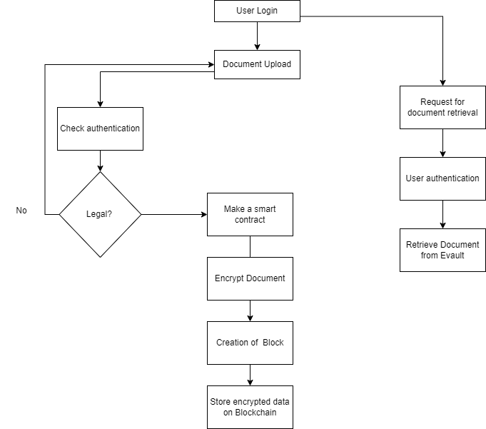

3.3 Flow Diagram

- Data Flow Diagram (DFD)
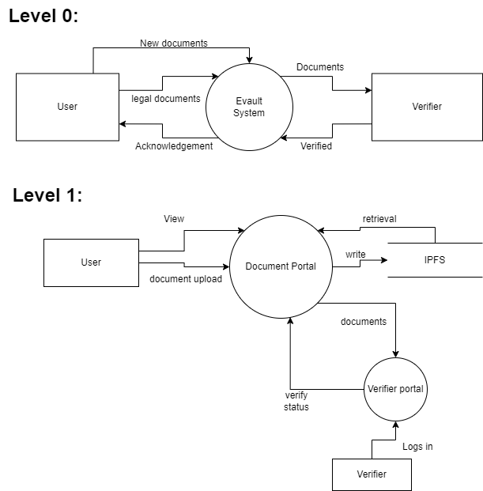
Level 2
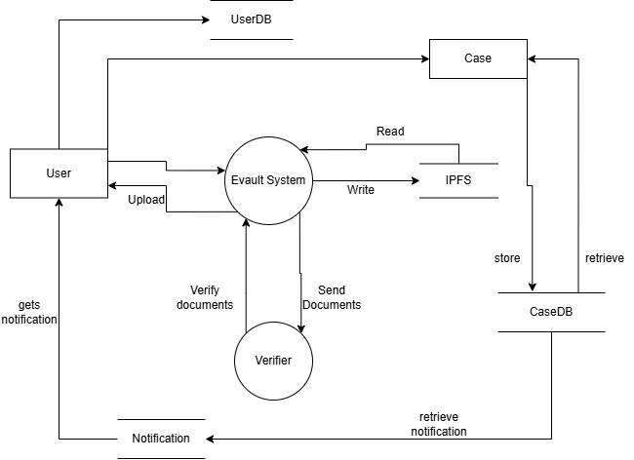

3.4 Methodology Applied
Blockchain Implementation (Hyperledger Fabric):
- Utilizes Hyperledger Fabric for secure, decentralized, and tamper-proof document management.
- Each document and transaction (e.g., file uploads, case updates) is hashed and stored immutably on the blockchain.
IPFS Integration for Document Storage:
- Documents (papers, images, videos) are stored off-chain in IPFS for decentralized storage.
- Only metadata and document hashes are stored on the blockchain, ensuring efficient handling of large files.
Smart Contracts for Workflow Automation:
- Smart contracts automate tasks like case creation, document submission, and verification.
- They manage the random allocation of cases and apply digital signatures to verified documents.
Real-time Updates with CouchDB:
- CouchDB serves as the world state database for real-time case updates.
- Status changes, like court decisions and evidence submissions, are immediately reflected on relevant user dashboards.
Random Task Allocation:
- A random allocation algorithm assigns verification tasks to registrars (Desk Babu) and stamp reporters, ensuring fairness and removing bias.
User Interface (Vite):
- Frontend developed using Vite for an efficient and user-friendly dashboard experience.
- Role-based access and real-time tracking of case status ensure secure, timely information for stakeholders.

3.5 Hardware & Software Specifications
- Hardware Requirements:
  - Server with minimum 16 GB RAM
  - Dual-core CPU or higher
  - Minimum 500 GB SSD for storage
- Software Requirements:
  - Hyperledger Fabric for blockchain implementation
  - IPFS for decentralised storage
  - CouchDB as the world state database
  - Vite for frontend development
  - Node.js for backend services

3.6 Experiment and Results for Validation and Verification
- Prototype Development:
  - The Figma design for all the organizational modules involved in the eVAULT system has been completed.
  - The actual front-end development using Vite for all the organizational modules involved in the eVAULT system has been completed.
  - These modules represent various stakeholders including lawyers, the Registrar, Stamp Reporters, Bench Clerks, and Judges.
  - IPFS for decentralized storage is implemented successfully.
- Interface Evaluation:
  - User interfaces (UI) for each module were designed with user-friendly interactions, role-based access, and task-specific functionalities.
  - The dashboard layouts were tailored to meet the workflow of each role within the system, ensuring that they align with the real-life legal processes.
- Initial Testing:
  - The design prototypes were reviewed to verify that they correctly represent the workflows outlined in the system’s architecture.
  - Navigation, document upload, and case status update flows were thoroughly tested in the front-end prototype to ensure smooth transitions and ease of use.
  - Uploading the cases to IPFS was also tested.
- Stakeholder Feedback:
  - The prototypes have been shared with the project team for initial feedback.
  - Observations related to user experience, role-based functionality, and interface clarity have been gathered for further refinements.
- Next Steps:
  - Based on the feedback, minor adjustments to UI elements will be made.
  - Following this, multi-channel smart contract will be implemented

3.7 Implementation and Testing

3.7.1 Lawyer Dashboard: Portal for lawyers to manage cases and documents.
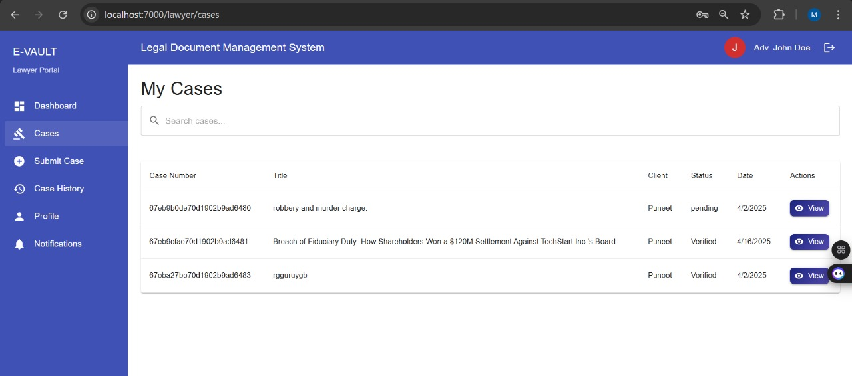
Fig 3.7.1 (a) My Cases Page for Lawyer

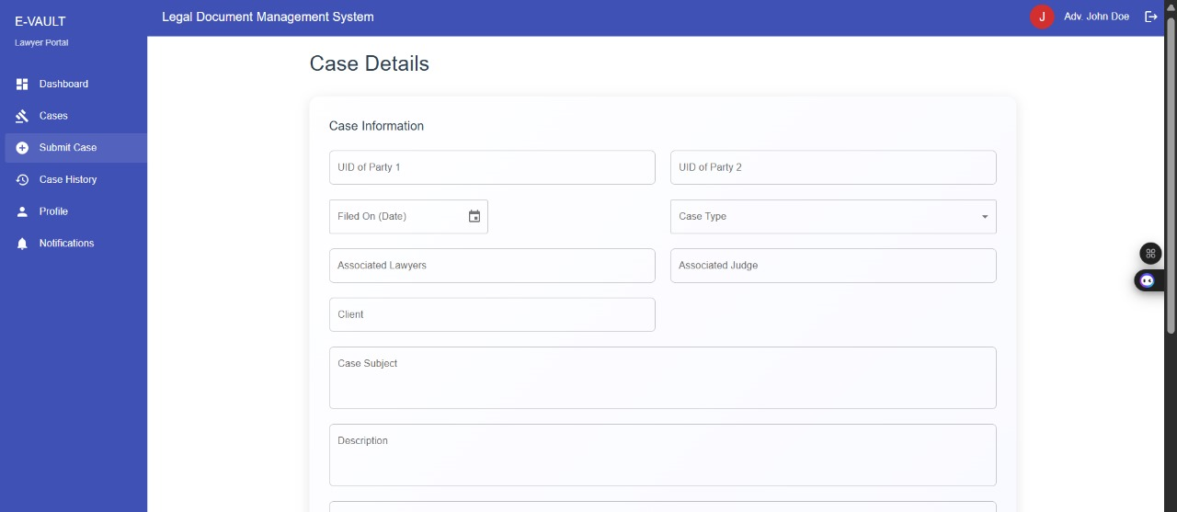
Fig 3.7.1 (b) Submit Case Page for Lawyer

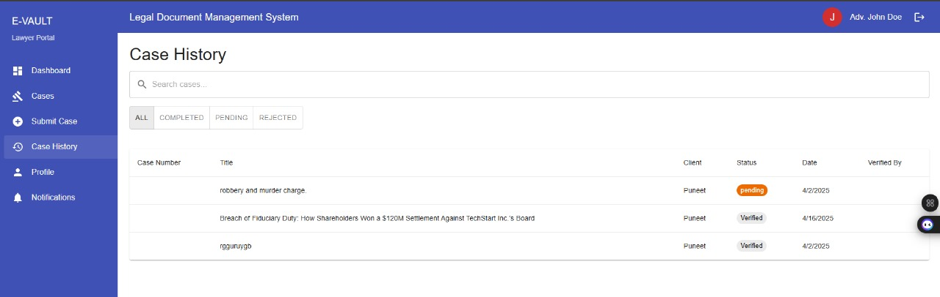
Fig 3.7.1 (c) Case History Page for Lawyer

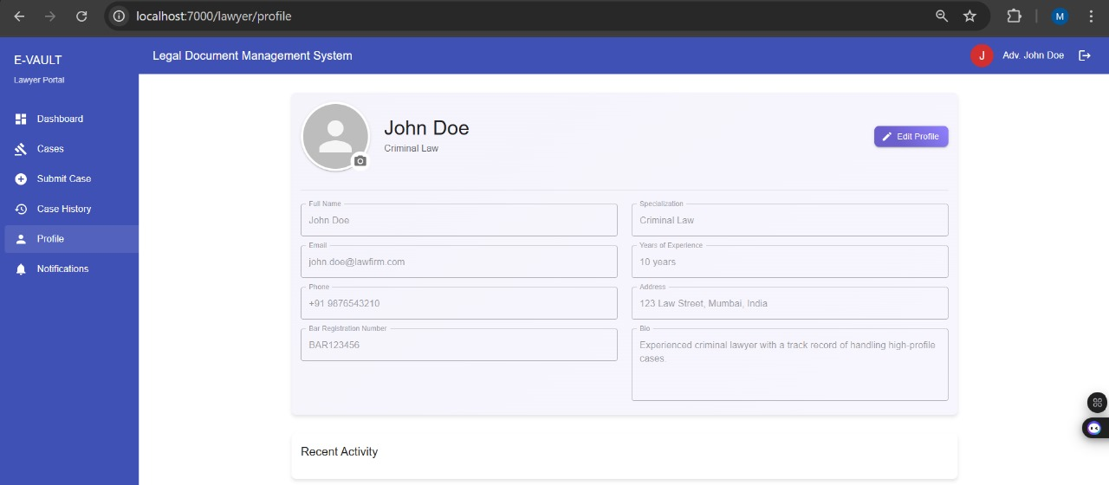
Fig 3.7.1 (d) Profile Page for Lawyer

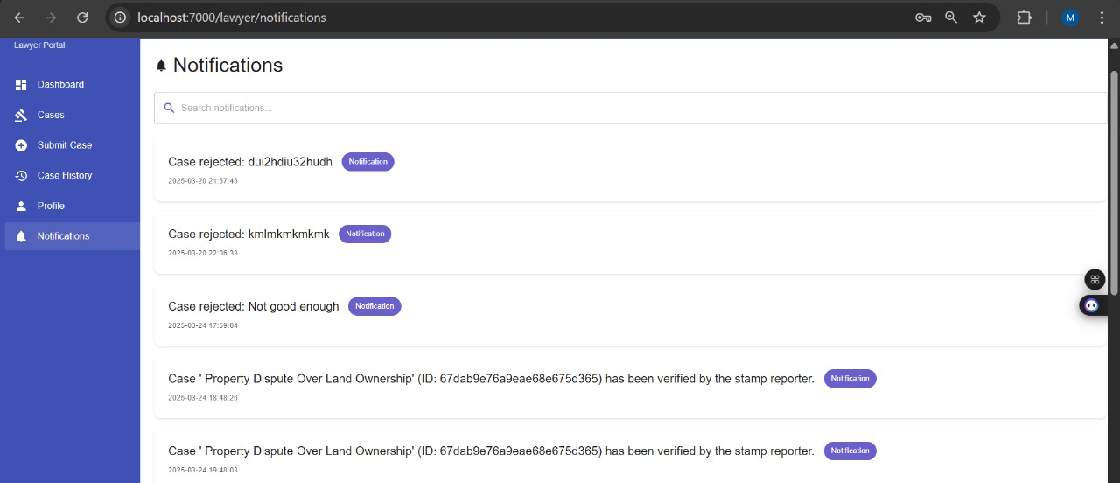
Fig 3.7.1 (e) Case Notification page for Lawyer
3.7.2 Registrar Dashboard: Overview for the registrar to monitor case statuses and actions.
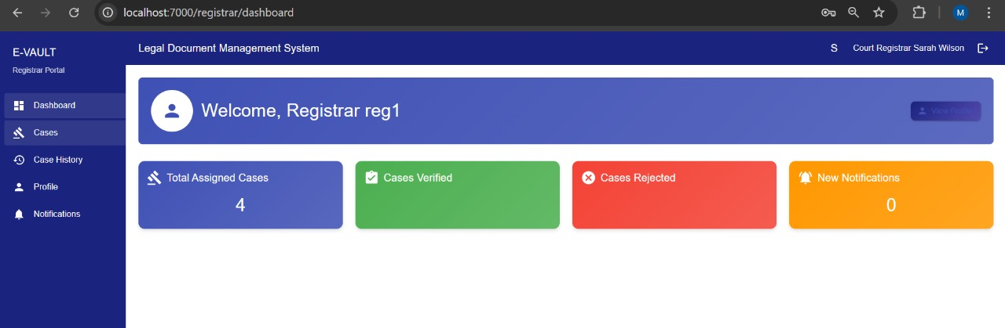
Fig 3.7.2 (a) Dashboard Page for Registrar

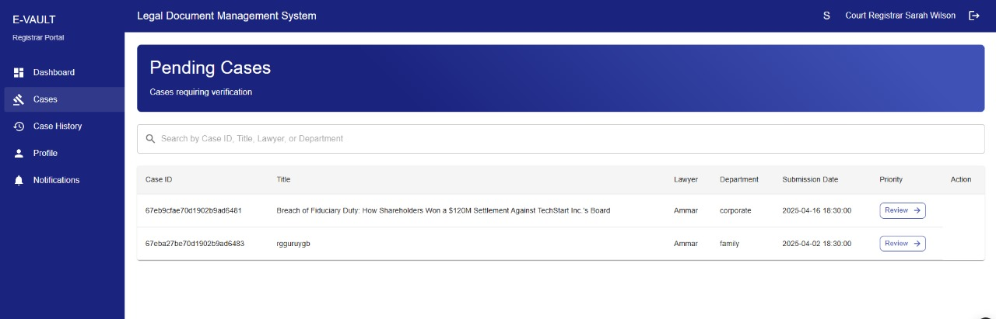
Fig 3.7.2 (b) Manage Cases Page to manage all cases

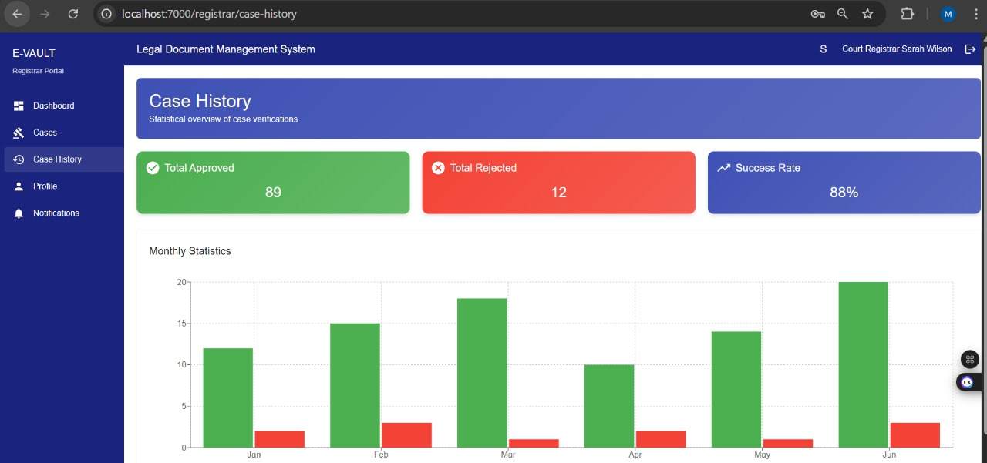
Fig 3.7.2 (c) Case History page to view past cases

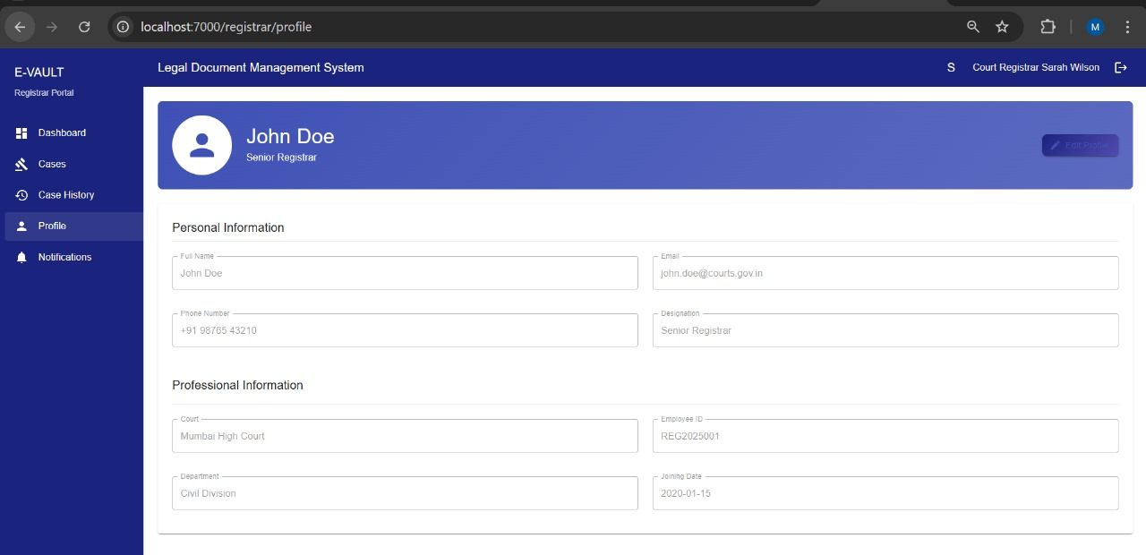
Fig 3.7.2 (d) Profile page for registrar

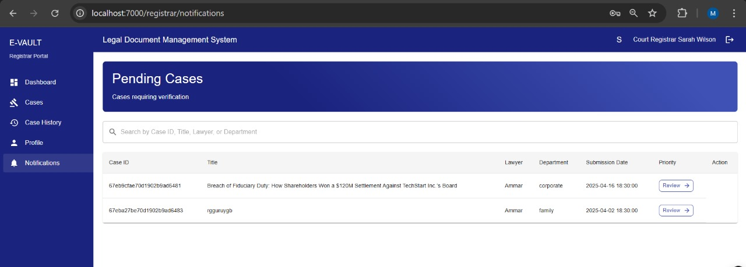
Fig 3.7.2 (e) Case notifications page to display updates for each case

3.7.3 Bench Clerk Dashboard: Workspace for bench clerks to manage court proceedings and documentation.
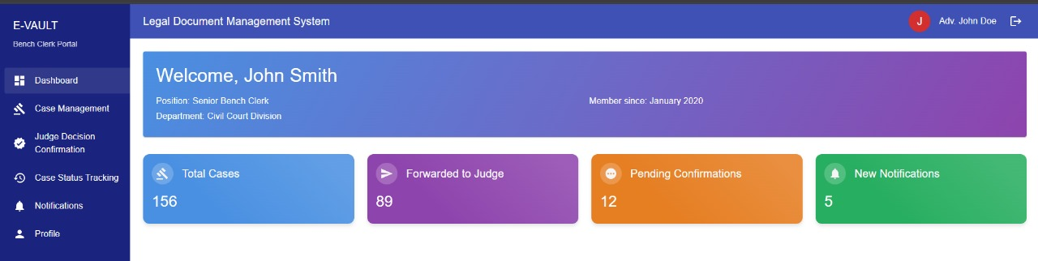
Fig 3.7.3 (a) Dashboard for Bench Clerk
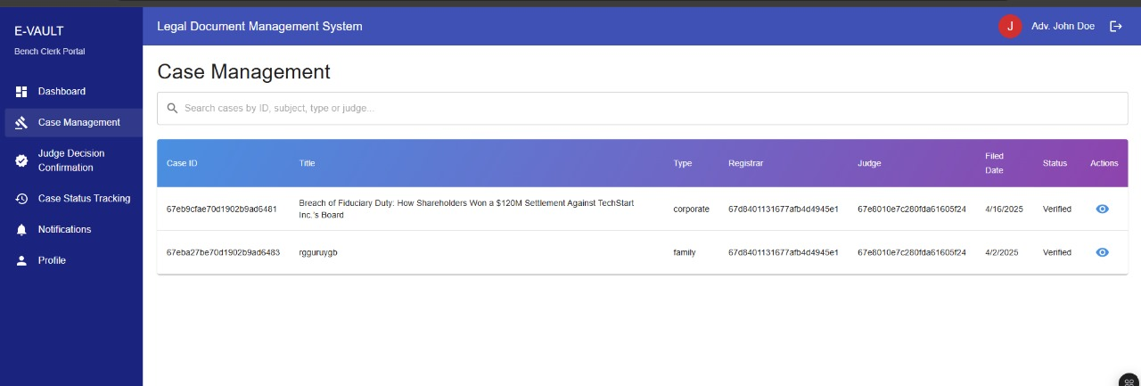
Fig 3.7.3 (b) Case Management page to manage all cases

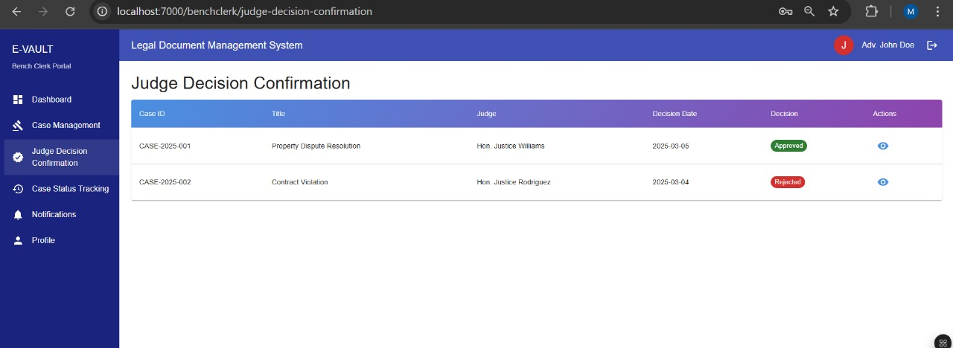
Fig 3.7.3 (c) Judge Decision Confirmation page that reflects judge’s decision for the bench clerk

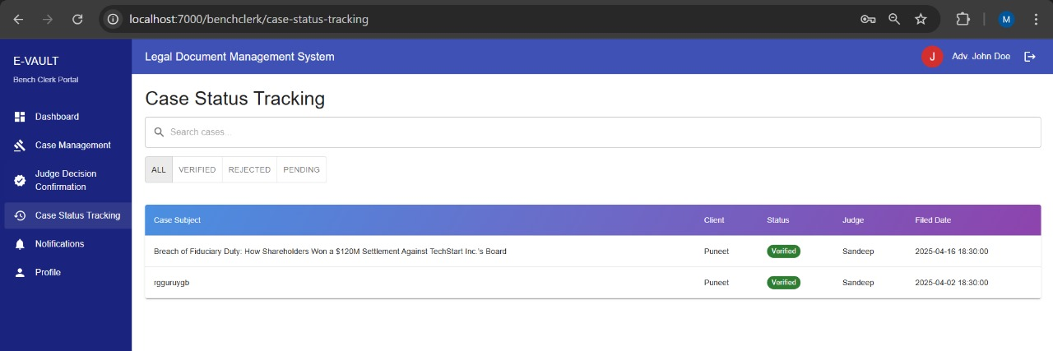
Fig 3.7.3 (d) Case Status Tracking page

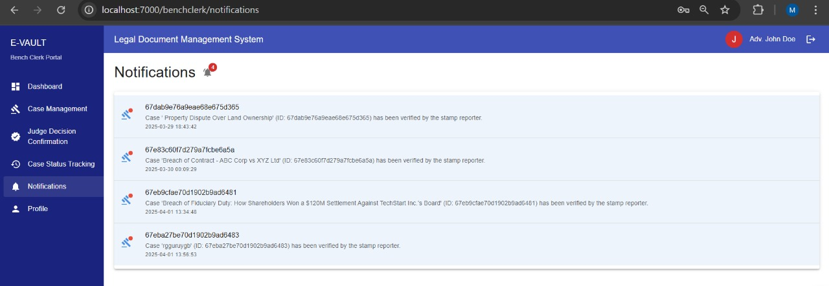
Fig 3.7.3 (e) Notifications page for all the cases

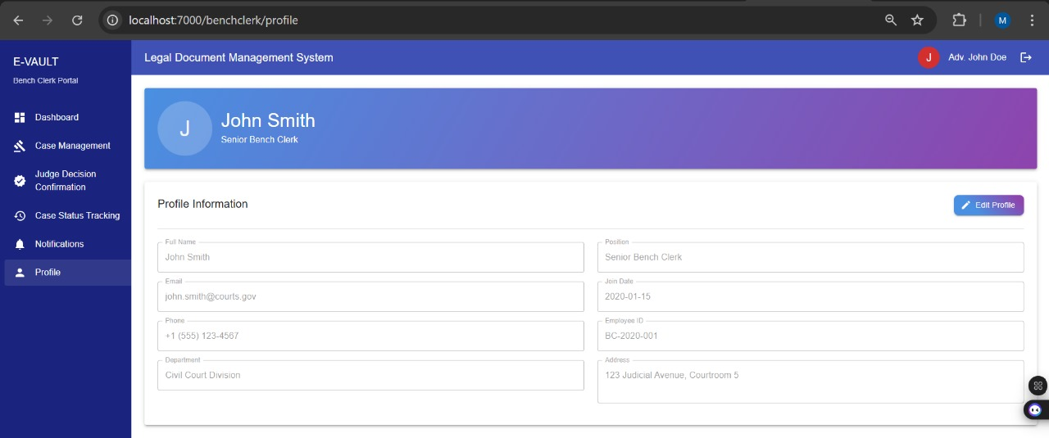
Fig 3.7.3 (f) Profile page for the bench clerk

3.7.4 Judge Dashboard: Interface for judges to review cases, evidence, and rulings.
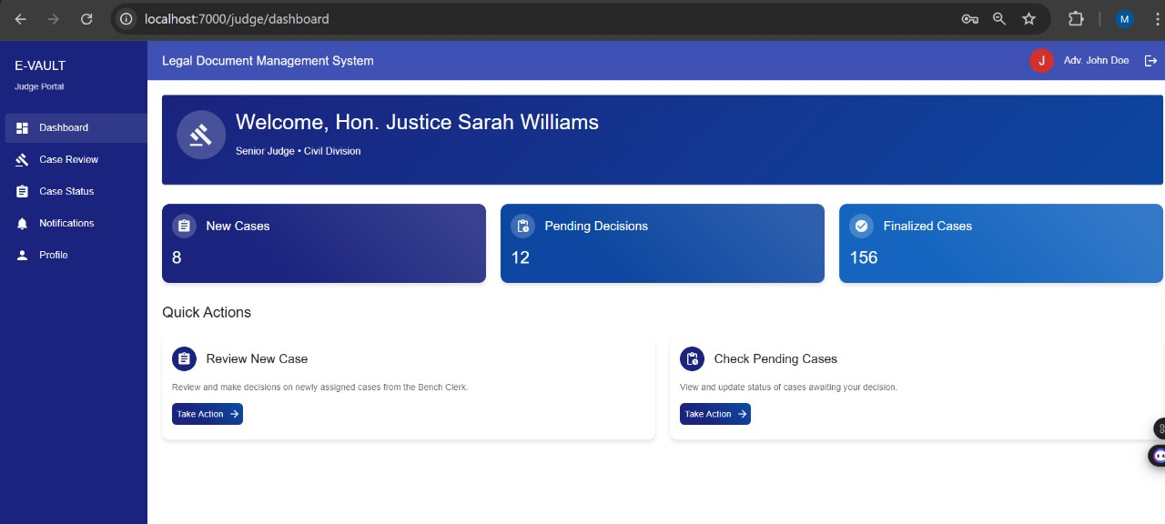
Fig 3.7.4 (a) Dashboard for the Judge

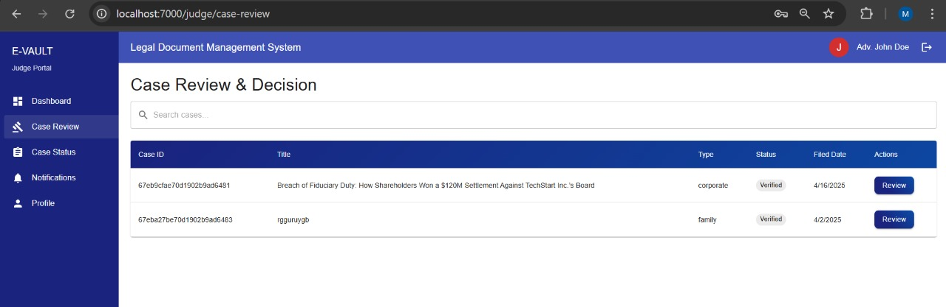
Fig 3.7.4 (b) Case Review page to review and give decisions for cases

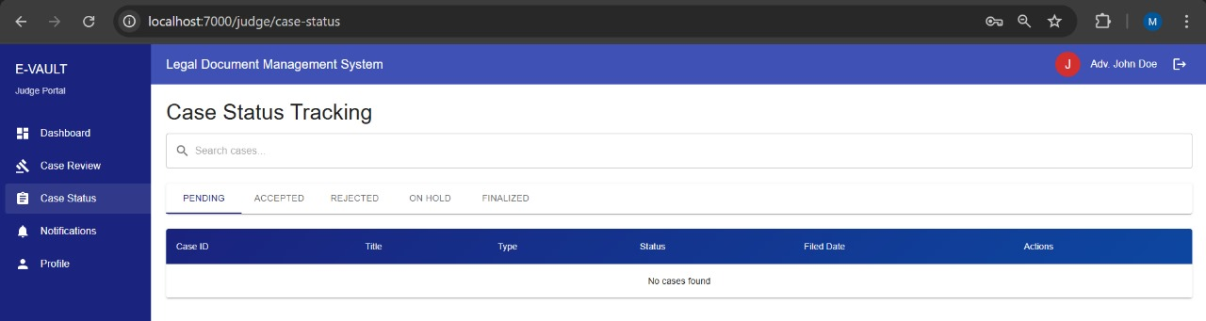
Fig 3.7.4 (c) Case Status Tracking page for the judge too track status of any case whether pending,accepted,rejected, etc

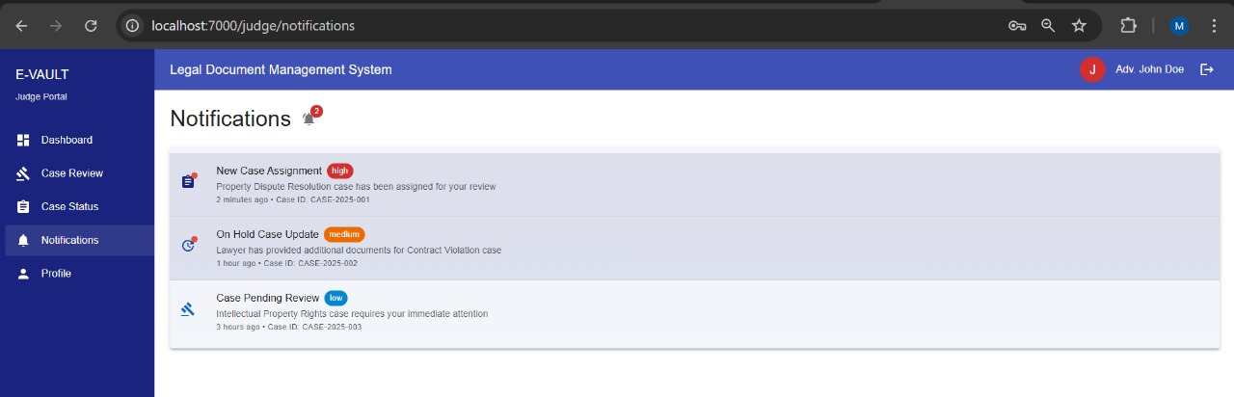
Fig 3.7.4 (d) Notifications page for case assignment, update and review

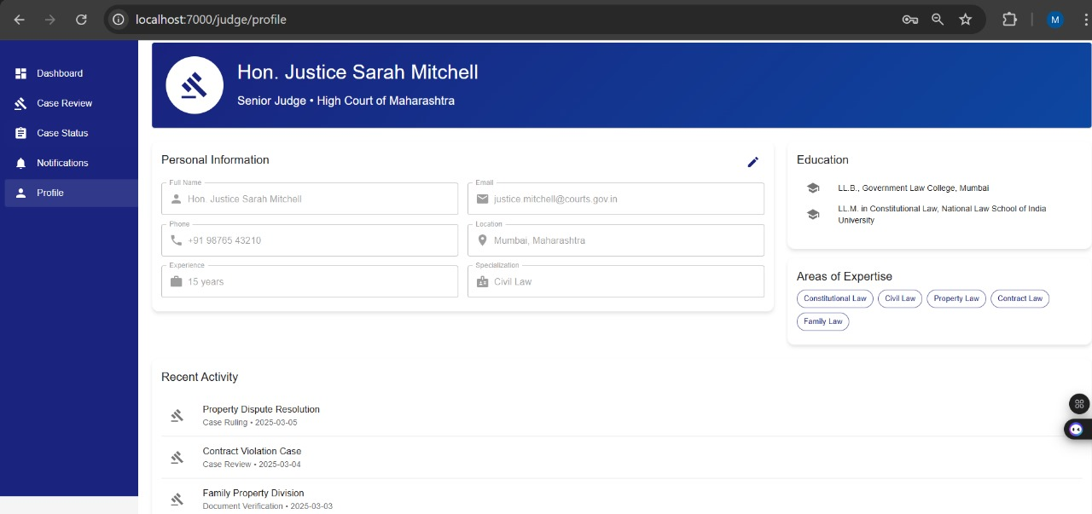
Fig 3.7.4 (e) Profile page for the judge

3.8 Conclusion and Future Work
The eVAULT system provides a comprehensive solution for digitizing and streamlining the legal document management process in the Indian judicial system. By utilizing blockchain technology with Hyperledger Fabric, along with decentralized storage through IPFS, the system ensures enhanced security, transparency, and accountability in case management. The introduction of smart contracts for access control, real-time updates, and digital signatures greatly reduces inefficiencies caused by manual processes.
The system addresses critical issues faced by existing legal platforms, such as bias in case allocation, poor data security, and manual verification processes. It enhances traceability and ensures that case files and evidence remain tamper-proof through the use of cryptographic hashes and decentralized storage mechanisms. The random allocation of tasks, real-time updates, and secure document handling transform the way legal professionals interact with case files, improving overall efficiency and reducing delays.
With the completion of the Figma prototypes for all organizational modules, the project is now well-positioned for the next stage of implementation, where these designs will be transformed into a fully functional front-end system. The integration of the backend components such as Hyperledger Fabric for blockchain functionality, IPFS for decentralized storage, and smart contracts will be essential in realizing the system’s full potential. This marks a significant step towards achieving the project's goal of creating a secure, transparent, and efficient legal document management system that integrates seamlessly with existing judicial workflows.

References
[1] A. Vijayaraj, P. Prahalathan, V. G. Reddy, D. S and A. R. D V, "Legal Documentation System Using Blockchain and Interplanetary File System," 2024 International Conference on Computing and Data Science (ICCDS), Chennai, India, 2024, pp. 1-6, doi: 10.1109/ICCDS60734.2024.10560457.
[2] A. Rachad, L. Gaiz, K. Bouragba and M. Ouzzif, "A Smart Contract Architecture Framework for Insurance Industry Using Blockchain and Business Process Management Technology," in IEEE Engineering Management Review, vol. 52, no. 2, pp. 55-68, April 2024, doi: 10.1109/EMR.2023.3348431.
[3] Shuaiqi Liu, Qingxiao Zheng, A study of a blockchain-based judicial evidence preservation scheme, Blockchain: Research and Applications, Volume 5, Issue 2, 2024, 100192, ISSN 2096-7209,
https://doi.org/10.1016/j.bcra.2024.100192. (https://www.sciencedirect.com/science/article/pii/S2096720924000058)
[4] M. V. Rajesh, V. Navya, R. Konjarla and M. Birada, "Blockchain-based E-Vault for Legal Records," 2024 3rd International Conference on Applied Artificial Intelligence and Computing (ICAAIC), Salem, India, 2024, pp. 1389-1392, doi: 10.1109/ICAAIC60222.2024.10574924.
[6] Nguyen, Minh & Loghin, Dumitrel & Dinh, Tien. (2021). Understanding the Scalability of Hyperledger Fabric.
[7] T. S. Mistry, B. B. Gor, R. K. Shukla and R. Sharma, "Easy-to-Use First Information Report (FIR) System Using Blockchain," 2024 2nd International Conference on Intelligent Data Communication Technologies and Internet of Things (IDCIoT), Bengaluru, India, 2024, pp. 1655-1660, doi: 10.1109/IDCIoT59759.2024.10467684.
[8] Alessandra Rizzardi, Sabrina Sicari, Jesus F. Cevallos M., Alberto Coen-Porisini, IoT-driven blockchain to manage the healthcare supply chain and protect medical records, Future Generation Computer Systems, Volume 161, 2024, Pages 415-431, ISSN 0167-739X, https://doi.org/10.1016/j.future.2024.07.039.
(https://www.sciencedirect.com/science/article/pii/S0167739X24003996)
[9] F. M. Enescu, C. -G. Nicolaescu, V. M. Ionescu, N. Bizon, M. C. Marica and M. -S. Răboacă, "Blockchain in Personal Document Archiving Services," 2024 16th International Conference on Electronics, Computers and Artificial Intelligence (ECAI), Iasi, Romania, 2024, pp. 1-6, doi: 10.1109/ECAI61503.2024.10607454.
[10] Thakare, Tanmay, Tanay Phatak, Gautam Wadhani, Teesha Karotra, and R. L. Priya. "Verificate–Transforming Certificate Verification Using Blockchain Technology." In Blockchain Transformations: Navigating the Decentralized Protocols Era, pp. 211-220. Cham: Springer Nature Switzerland, 2024.
[11] U. B. A, M. S, M. M. H. A. S, N. Kumar, P. Aditya and A. Manjunath, "Blockchain Technology in Document Authentication: A Comprehensive Literature Review," 2023 4th International Conference on Communication, Computing and Industry 6.0 (C216), Bangalore, India, 2023, pp. 1-5, doi: 10.1109/C2I659362.2023.10431235.
[12] B. C. J, T. K. T, Y. Y and H. V, "Court Ledger-Decentralized and Tamper-Proof Solution for Storing Evidence," 2023 International Conference on Recent Advances in Electrical, Electronics, Ubiquitous Communication, and Computational Intelligence (RAEEUCCI), Chennai, India, 2023, pp. 1-8, doi: 10.1109/RAEEUCCI57140.2023.10134019. keywords: {Productivity;Data privacy;Machine learning algorithms;Law;Manuals;Machine learning;Real-time systems;Blockchains;Safety;Reliability;Blockchain Technology;Tamper-proof Transparency}
[13]M. R. Islam and M. M. Rashid, "A Survey on Blockchain Security and Its Impact Analysis," 2023 9th International Conference on Computer and Communication Engineering (ICCCE), Kuala Lumpur, Malaysia, 2023, pp. 317-321, doi: 10.1109/ICCCE58854.2023.10246031.
[14] Singhal, Jai & Gautam, Ankit & Bhatia, Ashutosh & Agrawal, Ankit & Kaushik, Rekha. (2022). DD-Locker: Blockchain-based Decentralized Personal Document Locker. 68-73. 10.1109/ICOIN53446.2022.9687236.
[15] B. F. Islamay, Y. Purwanto and M. F. Ruriawan, "Implementation of Blockchain and Peer-to-peer Network for Digital Document Management," 2022 International Conference on Advanced Creative Networks and Intelligent Systems (ICACNIS), Bandung, Indonesia, 2022, pp. 1-6, doi: 10.1109/ICACNIS57039.2022.10055538.

