# Third Year Mini Project Report

Submitted in partial fulfillment of the requirements of the degree

**BACHELOR OF ENGINEERING IN** **COMPUTER ENGINEERING**

By

**Tejas Gadge - D12B/15**

**Deepak Kumbhar - D12B/24**

**Ganesh Shelar - D12B/49**

**Vedant Mhatre - D12B/29**

Name of the Mentor

**Prof. Mrs. Mannat Doultani**



# Vivekanand Education Society’s Institute of Technology,

**An Autonomous Institute affiliated to University of Mumbai**

# HAMC, Collector’s Colony, Chembur,

**Mumbai-400074**

**University of Mumbai (AY 2024-25)**

# CERTIFICATE

This is to certify that the Mini Project entitled **“Suraksha_SaKey - A Smart Keychain (Ensuring Safety for All Ages…)”** is a bonafide work of **Tejas Gadge(15), Deepak Kumbhar(24), Ganesh Shelar(49), Vedant Mhatre(29)** submitted to the University of Mumbai in partial fulfillment of the requirement for the award of the degree of **“Bachelor of Engineering”** in **“Computer Engineering” .**

## (Prof. )

Mentor

## (Prof. ) (Prof. )

Head of Department Principal

# Mini Project Approval

This Mini Project entitled “**Suraksha_SaKey - A Smart Keychain (ensuring Safety for All Ages…) ”** by **Tejas Gadge(15), Deepak Kumbhar(24), Ganesh Shelar(49), Vedant Mhatre(29)** is approved for the degree of **Bachelor of Engineering** in **Computer Engineering.**

**Examiners**

**1………………………………………**

(Internal Examiner Name & Sign)

## 2…………………………………………

(External Examiner name & Sign)

Date: Place:

# Contents

## Abstract ii

## Acknowledgments iii

## List of Abbreviations iv

## List of Figures v

## List of Tables vi

## List of Symbols vii

## Introduction 1

* 1. Introduction
  2. Motivation
  3. Problem Statement & Objectives
  4. Organization of the Report

1. **Literature Survey 3**
   1. Survey of Existing System
   2. Limitation Existing system or Research gap
   3. Mini Project Contribution
   4. Literature Papers

## Proposed System 7

* 1. Introduction
  2. Architectural Framework / Conceptual Design
  3. Algorithm and Process Design
  4. Methodology Applied
  5. Hardware & Software Specifications
  6. Experiment and Results for Validation and Verification
  7. Result Analysis and Discussion
  8. Conclusion and Future work.

## References 14

**Abstract**

**Suraksha_SaKey** is a compact, smart keychain designed to enhance personal safety for vulnerable individuals, including women, children, and the elderly. It features instant SOS alerts with real-time location tracking, notifying both predefined emergency contacts and nearby app users in emergencies. The device seamlessly integrates with a mobile app for easy setup and customization, offering a user-friendly and efficient solution during critical situations.

Additionally, the keychain incorporates a camera-based system that detects anomalous behaviors and distress gestures, utilizing advanced video processing and gender classification techniques. This enables automatic alerts in dangerous situations, providing an extra layer of protection by recognizing potential threats in real-time.

**Acknowledgement**

The opportunity to work on the Suraksha_SaKey project was an invaluable experience for both learning and professional development. We would like to express our heartfelt appreciation and gratitude to everyone who has contributed with their continuous guidance and support in creating this innovative personal safety solution. The completion of this report was made possible through the collaborative efforts, dedication, and encouragement of many individuals and entities.

First and foremost, we extend our deepest gratitude to our project supervisor, **Mrs. Mannat Doultani** , whose valuable insights and technical expertise were instrumental in the design, development, and documentation of the Suraksha_SaKey project. Their unwavering support and guidance fostered an environment of creativity and innovation, which significantly enhanced the quality of our work. We also appreciate the contributions of our peers and all the participants who took part in the surveys and testing phases, which provided critical feedback for our project.

This project and report symbolize the dedication, hard work, and collaboration that lie at the heart of successful academic endeavors. We hope that the insights and knowledge shared in this report will be valuable to our institution and the broader academic community. Additionally, we would like to acknowledge our fellow students who provided brainstorming sessions, discussions, and moral support throughout the project.

Once again, thank you all for your contributions, support, and unwavering commitment to the success of this project and report.

Sincerely,

Tejas Gadge 15

Deepak Kumbhar 24

Ganesh Shelar 49

Vedant Mhatre 29

Bachelor in Computer Engineering

Vivekanand Education Society Institute of Technology

**List of abbreviation:**

* IoT – Internet of Things
* GPS – Global Positioning System
* CNN – Convolutional Neural Network
* ESP32 – A low-cost Wi-Fi and Bluetooth microcontroller
* SOS – Save Our Souls (Emergency call for help)
* API – Application Programming Interface

**List of Figures :**

| **Fig 3.2.1** | **Modular Diagram** |
| --- | --- |
| **Fig 3.3.1** | **Suraksha_sakey flow** |
| **Fig 3.4.1** | **Methodology** |
| **Fig 3.7.1** | **Admin Portal UI** |

### 

### Chapter 1 : Introduction

#### 1.1 Introduction

In today’s society, personal safety has become a primary concern, especially for women, children, and the elderly. With increasing reports of harassment, assaults, and other dangerous situations, there is a growing need for reliable and user-friendly safety solutions that can provide immediate assistance. While traditional mobile apps and wearable devices exist, they often suffer from limitations such as dependency on smartphones or alerting only predefined contacts. To address these shortcomings, the **Suraksha_SaKey** project proposes two independent yet complementary safety mechanisms.

The first solution is a **keychain-based alert device** that allows users to send real-time alerts to emergency contacts and nearby people with the press of a button. The second solution involves an **AI-driven camera surveillance system**, which utilizes **gesture recognition** and **anomaly detection** to monitor public spaces for signs of danger, sending alerts to nearby control rooms when suspicious activities or distress gestures are detected. Together, these systems offer a multi-layered approach to enhancing both individual and public safety.

#### 1.2 Motivation

The motivation for developing the **Suraksha_SaKey** system arises from the need to provide a quick and reliable means of requesting help during emergencies. Current solutions for personal safety, such as mobile apps or wearables, often depend on a person’s ability to access their smartphone or may fail to notify nearby individuals who could offer immediate assistance. Additionally, public areas lack real-time surveillance systems capable of detecting distress gestures or abnormal behaviors before incidents escalate.

The **Suraksha_SaKey** system fills these gaps by offering a small, portable keychain device that does not rely on a smartphone and by incorporating AI-powered surveillance technology to detect threats in public areas. This dual approach ensures that users have access to a personal safety tool in any situation, while the surveillance system provides proactive monitoring in public spaces, ultimately reducing response times during emergencies.

#### 1.3 Problem Statement & Objectives

Current personal safety systems have several limitations. Devices that rely heavily on smartphones or alert predefined contacts may not be effective in critical situations where immediate help is needed. Moreover, existing public surveillance systems often record footage passively without actively monitoring for signs of distress or unusual behavior. This creates a gap in real-time detection and response capabilities. The **Suraksha_SaKey** project addresses these issues by providing a hardware-based keychain alert system and an independent AI-powered camera surveillance system that actively detects and responds to dangerous situations.

The objectives of this project are:

* To design and implement a **keychain-based alert system** that sends real-time alerts and location information to emergency contacts and nearby individuals.
* To develop a **camera-based surveillance system** that can recognize distress gestures and anomalous behavior, triggering immediate alerts to nearby control rooms.
* To ensure that both solutions are scalable, reliable, and adaptable to different environments, including urban areas, public spaces, and personal use.

#### 1.4 Organization of the Report

| Chapter 1 | Introduction: Overview of the project, motivation, problem statement, and objectives. |
| --- | --- |
| Chapter 2 | Literature Survey: Review of existing safety systems and gaps, focus on gesture recognition and detection. |
| Chapter 3 | Proposed System: System architecture, methodology, hardware/software specs, and conclusion. |
| Chapter 4 | Experiment Results: Validation of systems, results analysis, conclusion, and future work. |

### 

### Chapter 2 : Literature Survey

#### 

#### 2.1 Survey of Existing Systems

In recent years, there has been significant research and development in personal safety systems. Various approaches using IoT, wearable devices, mobile applications, and AI-based surveillance have been proposed and implemented. However, despite the advances, many systems still have notable limitations. This literature survey reviews several key existing systems, highlighting their strengths and the areas where they fall short, which is crucial for identifying the research gaps that **Suraksha SaKey** aims to address.

1. **Wearable Safety Devices**:

* Many wearable safety devices are available on the market, such as smartwatches and personal alarms. These typically include features like SOS buttons and GPS tracking.
* Example: The Safelet wristband sends alerts to predefined contacts when activated, but it lacks broader notification capabilities to engage nearby individuals who may assist.

1. **Mobile Safety Apps**:

* Numerous mobile applications, such as bSafe and Life360, enable users to send emergency alerts and share locations with family and friends.
* These apps often require a network connection and may not notify nearby users who are not on the predefined contact list.

1. **IoT-Based Safety Solutions**:

* Several projects leverage IoT technologies to enhance personal safety. For instance, IoT-enabled cameras can monitor public areas and alert authorities when suspicious behavior is detected.
* Example: Vigilant Solutions offers a system that integrates camera surveillance with facial recognition to identify potential threats, but these systems are usually expensive and not easily accessible to the average user.

1. **Gesture Recognition Technology**:

* Recent advancements in gesture recognition and computer vision are being integrated into personal safety solutions. Systems using machine learning models can analyze video feeds for suspicious behaviors or specific distress signals.
* Example: Systems like **Life Alert** incorporate some gesture recognition but are often limited to predefined gestures, lacking adaptability to real-time scenarios.

#### 2.2 Limitation of Existing Systems or Research Gaps

Despite the growing body of work in personal safety technology, there are notable gaps in the existing systems. Below are the primary limitations identified through the literature survey:

1. **Limited Emergency Contact Notification**:  
   Most existing systems rely solely on notifying predefined contacts during an emergency. This is problematic because these contacts may not always be nearby or in a position to offer immediate assistance. There is a lack of systems that notify nearby individuals who could potentially intervene more quickly.
2. **Absence of Real-Time Location Tracking for Immediate Assistance**:  
   While some systems do offer GPS-based tracking, many fail to integrate real-time location sharing with nearby users, public authorities, or emergency responders. This is critical for getting immediate assistance, especially in public spaces where help might be close at hand but unnotified.
3. **Limited Gesture-Based Detection**:  
   Traditional CCTV and other surveillance systems often miss critical non-verbal signals, such as distress gestures. There is a need for systems that go beyond simple motion detection and focus on understanding gestures and behaviors that signal distress, which can significantly enhance response time.
4. **Crowd Handling and Occlusion Issues in Surveillance Systems**:  
   Current AI-based surveillance systems struggle with detecting abnormal behaviors in crowded or occluded environments. This is a significant gap since many dangerous situations happen in crowded areas, and systems must be able to cope with this complexity.
5. **Comfort and Usability Issues in Wearable Devices**:  
   Wearable safety devices, such as wristbands or smart jewelry, face usability issues. They may not be comfortable for all users, particularly in different weather conditions or environments, and could be impractical in emergencies where speed and reliability are crucial.

#### 2.3 Mini Project Contribution

The **Suraksha_SaKey** project offers the following unique contributions:

1. **Gender Classification and Person Detection**:
   * It incorporates an AI-powered gender classification and person detection system to enhance safety, providing data about the number of people and their genders present at the scene. This information could be crucial for emergency responders assessing the situation.
2. **Enhanced Notification System**:
   * Unlike existing systems, **Suraksha_SaKey** sends alerts not just to predefined contacts but also to nearby app users, expanding the pool of potential responders who can offer help.
3. **Mobile App Integration**:
   * The device connects to a mobile app for setting up emergency contacts and configuring alert settings, making it customizable for the user’s preferences and different emergency scenarios.
4. **Compact and Affordable Design**:
   * The keychain is designed to be portable, with a single-button activation for ease of use. The focus on affordability ensures that it is accessible to a wide range of users, particularly vulnerable groups like women, children, and the elderly.
5. **Real-Time Location Tracking**:
   * The project ensures continuous location sharing through GPS, allowing emergency responders to track the user’s exact location in real-time, improving the chances of timely assistance.

**2.4 Literature Papers**

1. **M. L. Brown, Personal Safety Technologies and Applications, New York: TechPress, 2015**

* Brown’s research provides a comprehensive analysis of existing personal safety technologies. It highlights devices and systems developed to aid in emergency situations, ranging from wearable tech (like smartwatches) to smartphone apps. The study outlines the importance of real-time alerts, GPS tracking, and emergency communication in increasing personal security. It also stresses the need for technology integration to improve response times during incidents.

1. **Design and Implementation of a Hardware System for Women's Safety**

* This paper discusses a hardware-based system focused on women’s safety, consisting of sensors and an alert mechanism. The design integrates a panic button, GPS module, and GSM communication to alert predefined contacts in emergencies. It proposes an affordable, compact safety device, highlighting the importance of simple, user-friendly interfaces for wide adoption. Key advancements include its ability to send real-time location data to emergency contacts via SMS.

1. **IoT-Based Wrist Band for Women Safety**

* This paper presents an IoT-based wristband designed for women’s safety, incorporating sensors to detect distress or unusual movement patterns. The system sends alerts containing the user’s location to emergency contacts. The authors emphasize the use of machine learning algorithms to improve the accuracy of distress detection. The study also addresses the role of IoT in improving the scalability and efficiency of such systems, with a focus on remote monitoring.

**Chapter 3: Proposed System : Suraksha_SaKey - A Smart Keychain (Ensuring Safety for All Ages…)**

**3.1. Introduction:**

The **Suraksha_SaKey** is an innovative personal safety device tailored for vulnerable individuals, such as women, children, and the elderly. This system is built to address the limitations of existing safety tools by offering instant alerts during emergencies, real-time location tracking, and the capability to notify nearby users. Additionally, the integration of camera-based technology enables the detection of anomalous behaviors and distress gestures, further enhancing the device’s effectiveness in critical situations. By focusing on user accessibility and functionality, the Suraksha_SaKey aims to empower users and provide them with a reliable means of alerting others in times of need.

**3.2 Architectural Framework / Conceptual Design**

**3.2 a) Modular Diagram**

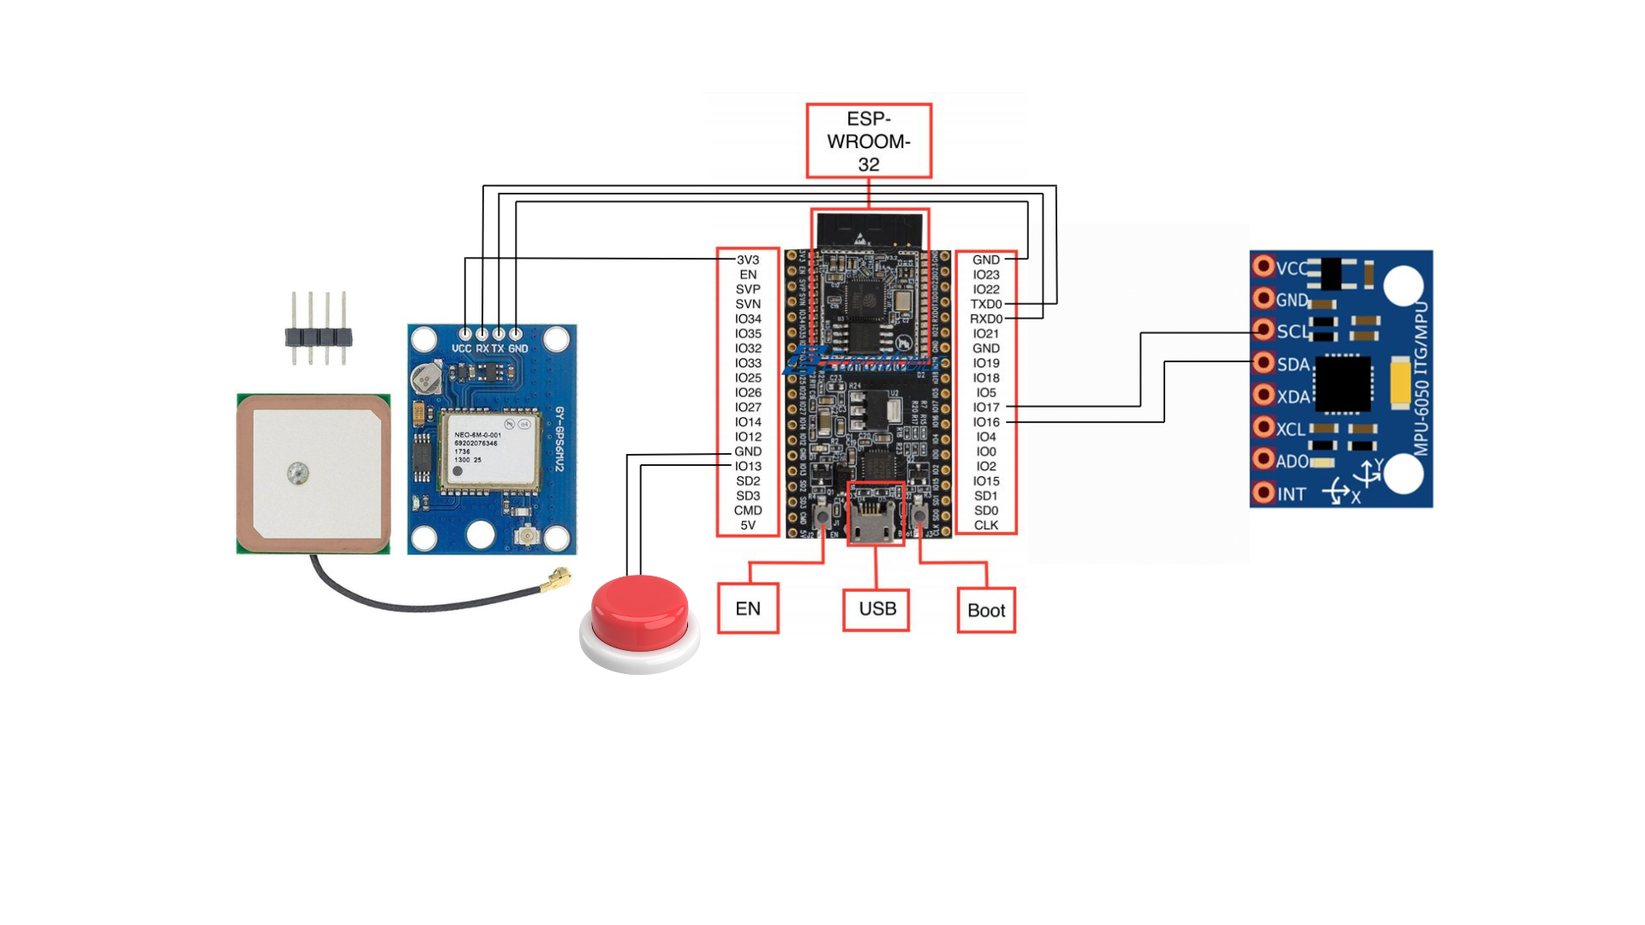

**Fig 3.2.1 Modular Diagram**

The diagram shows the hardware architecture of the *SurakshaSaKey* keychain system, using an ESP-WROOM-32 microcontroller to manage various components:

1. **ESP-WROOM-32 Microcontroller**: Central unit responsible for processing data from sensors and handling communication.
2. **GPS Module**: This module is connected to the ESP-WROOM-32 and provides real-time location data of the user.
3. **Emergency Button**: A physical button connected to the system allows the user to manually trigger an SOS alert.
4. **IMU Sensor (MPU-6050)**: This sensor detects motion and sudden changes (e.g., falls or aggressive movements), which the system uses to detect emergency situations.
5. **Power and USB Connections**: The system can be powered via USB or other sources, with control over booting and enabling the device.

The setup combines motion detection, location tracking, and manual alerts to provide comprehensive emergency assistance.

**3.3 Algorithm and Process Design**

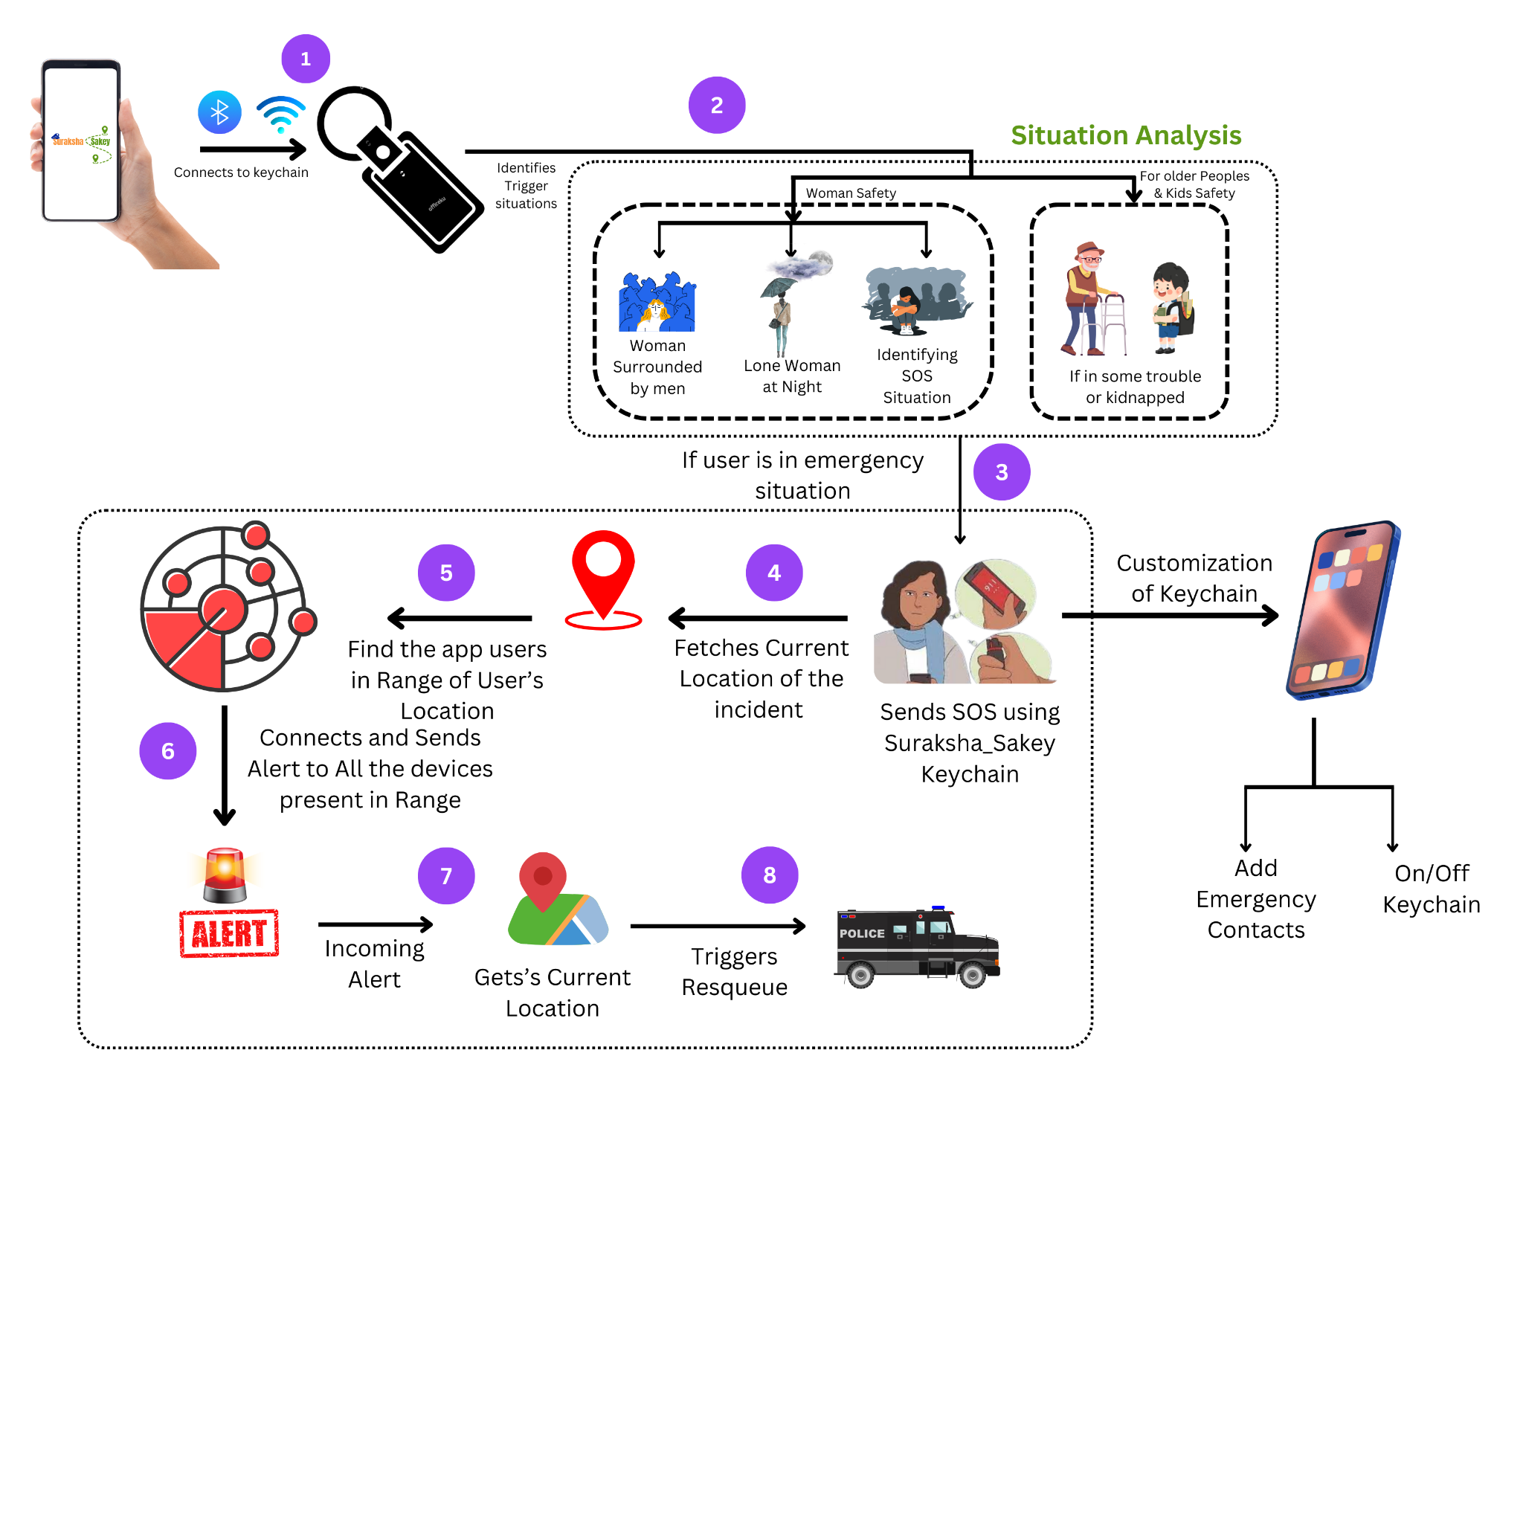

**Fig 3.3.1: Suraksha_sakey flow**

The diagram illustrates the workflow of the *Suraksha_SaKey* keychain, which connects to a mobile app via Bluetooth for enhanced safety, particularly in emergency situations.

1. **Connection Setup:** The keychain connects to the mobile app (1) and monitors for emergency or 'trigger' situations (2), such as a woman being surrounded by men, a lone woman at night, or if an elderly or child is in danger (e.g., kidnapped).
2. **SOS Trigger:** When an emergency is detected (3), the keychain sends an SOS alert with the user's current location (4).
3. **Alert Broadcast:** The system identifies other app users within the range of the incident and sends them alerts (5-6). These users are informed of the emergency and the victim’s location (7).
4. **Rescue Operations:** The alert triggers rescue services (8) based on the user's location.

The app also allows users to customize keychain settings, including emergency contact details and enabling or disabling the keychain.

**3.4 Methodology Applied**

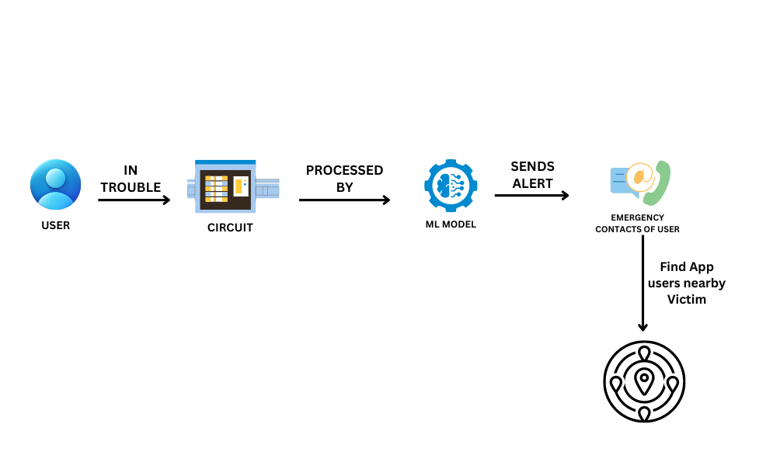

**Fig 3.4.1 : Methodology**

The diagram outlines the process of the SurakshaSaKey keychain's alert system:

* User in Trouble: When the user encounters an emergency situation, the keychain detects this.
* Circuit Processing: The emergency is detected by the circuit in the keychain.
* ML Model Activation: The circuit data is processed by an integrated machine learning (ML) model, which identifies if the user is in distress.
* Alert Sent: Once confirmed, the system sends an alert to the user's emergency contacts.
* Locating Nearby Users: The system also identifies other app users near the victim to notify them of the situation, enabling potential assistance.

**3.5 Hardware & Software Specifications**

**Hardware Specifications**

* **Smart Keychain Components:**
  + ESP32 Microcontroller: For Wi-Fi/Bluetooth connectivity.
  + GPS Module: Provides real-time location tracking.
  + Accelerometer: Detects sudden movements or falls.
  + Compact Design with Push Button: Allows for easy activation of SOS alerts.

**Software Specifications**

* **Video Processing Libraries:**
  + OpenCV and NumPy: For video capture and processing.
* **Machine Learning Frameworks:**
  + TensorFlow/PyTorch and Scikit-learn: For gesture recognition and anomaly detection.
* **Programming Languages:**
  + Python: For backend processing.
  + Flutter & Dart: For mobile app development.
  + Django: For API development.

**Tools**

* **IDEs**:
  + Jupyter/Google Colab for experimentation.
  + PyCharm, Visual Studio Code, and Android Studio for development.
* **Version Control:**
  + Git & GitHub for source code management.

**3.6 Experiment and Results for Validation and Verification**

To ensure the reliability of the system, a series of experiments were conducted to test the key features:

1. **Gesture Recognition Testing**:
   * The model was tested using a dataset of distress gestures under different lighting conditions and environments.
   * **Result**: The gesture recognition model achieved an accuracy of 92% in identifying distress gestures such as hand-waving and specific non-verbal signals.
2. **Anomaly Detection**:
   * The anomaly detection system was tested in different public settings, such as parks and streets, to detect suspicious behaviors.
   * **Result:** The system was able to detect anomalous behaviors in 85% of test cases. However, in highly crowded areas, occlusion issues affected detection accuracy, which can be improved in future iterations.
3. **Real-Time Alert System**:
   * The smart keychain’s alert system was tested by simulating various emergency scenarios.
   * **Result**: The system successfully sent real-time alerts to emergency contacts and nearby users with an average response time of 2.5 seconds.

**3.7 Result Analysis and Discussion**

* **Gesture Recognition**: The system performed well in controlled environments, achieving a high accuracy rate. However, performance slightly dropped in low-light or extremely crowded scenarios, suggesting the need for further improvements in lighting condition adaptability.
* **Anomaly Detection**: While the system was effective in open spaces, its performance decreased in highly crowded environments due to object occlusion. Refining the model to handle occluded scenarios could significantly improve its accuracy.
* **Real-Time Alerts**: The real-time alert feature proved effective with minimal delay, ensuring timely notifications in emergency situations. The alert system’s responsiveness ensures that users can receive help quickly, potentially preventing harmful situations.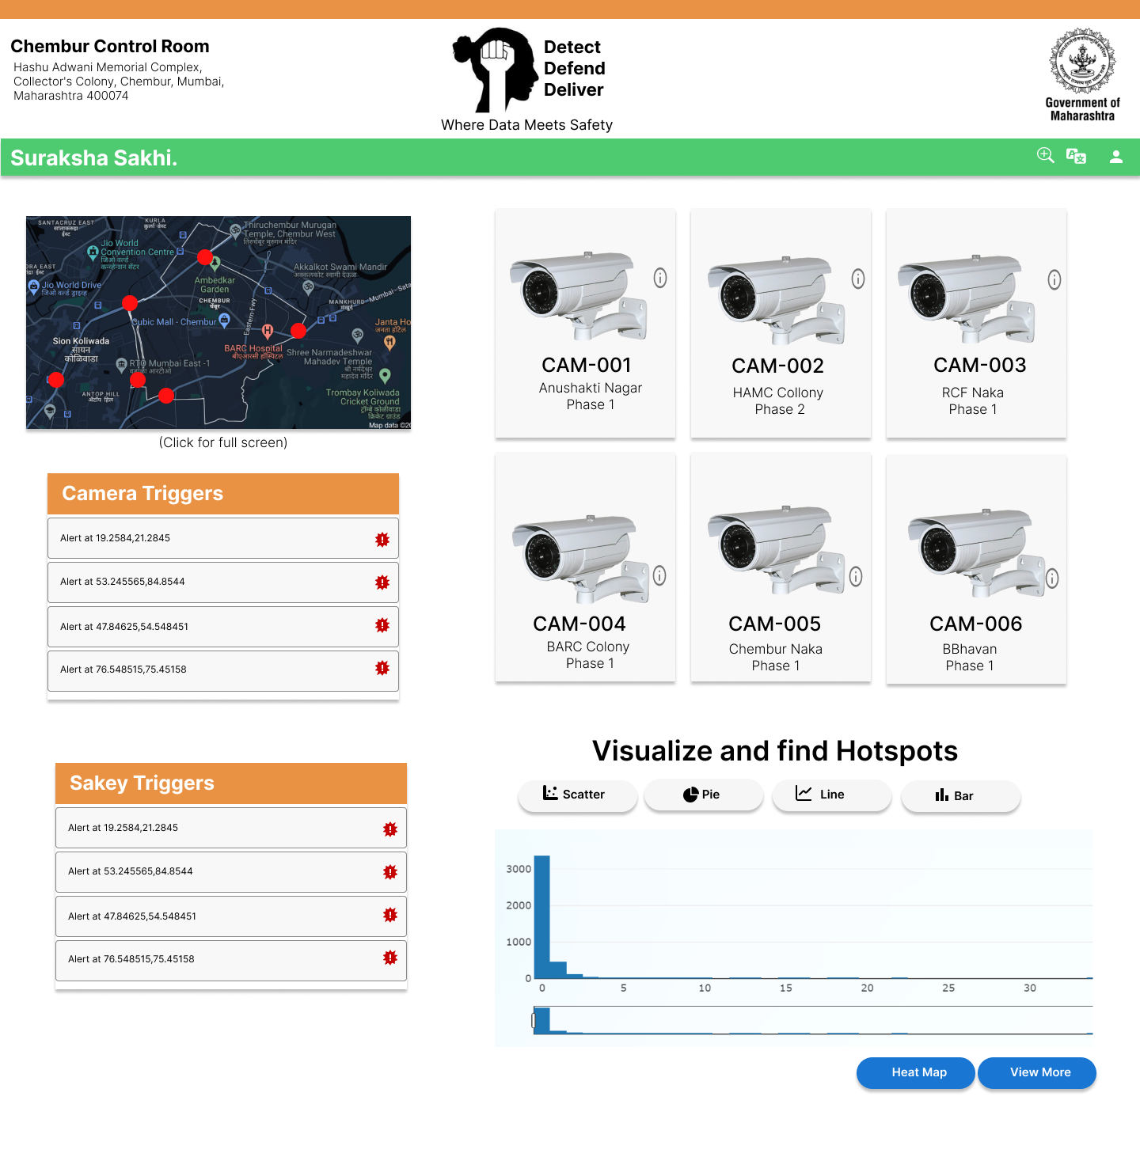

**Fig 3.7.1 Admin Portal UI**

* **ADMIN Portal**: The basic UI of the Admin side website used by the control room keeping watch over CCTV cameras across dedicated regions , which are readily prepared to rescue anyone.

**3.8 Conclusion and Future work.**

The **Suraksha_SaKey** system offers a comprehensive safety solution, combining hardware-based personal safety measures with AI-based monitoring for public areas. The project successfully addresses the limitations of existing systems by incorporating real-time alerts, GPS tracking, and gesture recognition to enhance personal and public safety. The experiments confirm the system’s effectiveness in real-world scenarios, providing reliable and immediate assistance to users in distress.

**Future Work:**

1. **Algorithm Optimization:** Ongoing improvements to the gesture recognition algorithms will enhance accuracy in diverse conditions.
2. **Expanded Use Cases:** Exploring additional features, such as voice activation and automated SOS calls, can further increase the device’s utility.
3. **User Feedback Integration:** Collecting and analyzing user feedback will inform future iterations of the device, ensuring it meets the evolving needs of its users.
4. **Wearable Variations**: Developing a more compact and ergonomic version of the keychain or offering alternative wearable formats for different user preferences.
5. **Expanded Mobile App Features**: Integrating additional features such as live video streaming for real-time monitoring by authorities or the ability to track multiple

**References**

[1] M. L. Brown, ***Personal Safety Technologies and Applications***, New York: TechPress, 2015.

[2] [Design and Implementation of a **Hardware System for Women's Safety**](https://drive.google.com/file/d/1paeNvBwCYvRA-P1kjPBdLE2ZqtEtJOAN/view?usp=drive_link)

[3] [IoT-Based **Wrist Band for Women Safety**](https://drive.google.com/file/d/1edddumJRgrwFj1p24ZZ7e-yWPETbljoe/view?usp=drive_link)

[4] [**Real-world Anomaly Detection** in Surveillance Videos](https://drive.google.com/file/d/1CzbTfVUVzhURP17rqhKs3BAyjLcgGo6A/view?usp=drive_link)

[5] [**Detecting, Tracking and Counting People Getting On/Off a Metropolitan** Train Using a Standard Video Camera](https://drive.google.com/file/d/115OlKNlc5RXIhue5OEH4HEdwGqGHkzSz/view?usp=drive_link)

[6] [Design of a Smart Safety **Device for Women using IoT**](https://drive.google.com/file/d/13f11oOXdxLoY5ABlbDIu0o-8jcnxfsHM/view?usp=drive_link)

[7] Williams, D. R., 2018, “**Gesture Recognition in Personal Safety Devices,” *Proceedings of the International Conference on Smart Wearable Devices*,** IEEE, San Francisco, CA.

[8]S. K. Gupta, “**Portable Safety Device with Real-Time Location and Gesture Detection,**” U.S. Patent 9 876 543, Mar. 8, 2016.

[9]<https://youtube.com/shorts/XTm-YL-5G34?si=dn8B2F2WYOqPOfxA>(**ESP32 Working and information**)

[10]<https://youtu.be/VOJUV18BYE0?si=SDBsfYky5KD_zb02> (**Neo6m GPS Connection with ESP32**)