**1. Introduction**

**1.1 Introduction**

In today's rapidly evolving financial landscape, the challenge for many individuals lies not in the scarcity of investment opportunities, but in navigating the complexities of the stock market. InvestPro emerges as a solution to this challenge, offering a comprehensive platform designed to democratize investing and empower users to take control of their financial destinies.

Our research delves into the obstacles faced by novice investors, particularly focusing on the barriers to effective personal finance management and their impact on financial literacy. By addressing these issues, InvestPro aims to bridge the gap between financial markets and individual investors, providing a user-centric approach to investment tools and education.

At the heart of InvestPro lies a suite of powerful features designed to support investors at every stage of their journey. The platform offers real-time market data, providing users with up-to-the-minute information to make informed decisions. To aid in long-term planning, InvestPro incorporates a SIP (Systematic Investment Plan) calculator, helping users visualize and strategize their investment goals. Comprehensive investment tracking tools enable users to monitor and manage their portfolios effectively.

Additionally, InvestPro provides a range of technical and fundamental indicators, empowering users with advanced analytical tools to assess market trends and make data-driven investment decisions. The user-friendly interface ensures that this complex financial information, including sophisticated indicators, is presented in an accessible and understandable manner. These features are seamlessly integrated into a secure and efficient platform, catering to both novice and experienced investors.

### 1.2 Motivation

The motivation behind **InvestPro** stems from the increasing complexity of stock market investing and the need for a more user-friendly solution to help both beginners and experienced investors. Many existing platforms overwhelm users with technical jargon, complex interfaces, and inadequate tools for making informed decisions. Our goal with InvestPro is to bridge this gap by providing a simplified yet comprehensive platform that combines live stock updates, easy portfolio management, and personalized investment insights. We aim to empower users with accessible tools that promote smarter financial decisions, helping them confidently navigate the stock market for long-term success. By focusing on ease of use, flexibility, and transparency, InvestPro seeks to create an inclusive investing experience for all.

**1.3 Problem Statement and Objectives**

In today's fast-paced financial markets, novice and experienced investors face numerous challenges in making proper investment decisions. The fluctuating market conditions, and complex investment options make it difficult for many to effectively manage their portfolios. Despite the availability of various financial platforms, there remains a significant gap in providing a user-friendly solution that caters to investors and learners. Some existing platforms still lack the integration of essential features such as Futures & Options (F&O) trading, customizable watchlists and detailed market cap classifications (mid, large, small). Additionally, by providing interactive graphs and charts, making it visually appealing as well

**Objectives:**

1. Provide a Comprehensive Platform for Investors: Develop a user-friendly investment platform that caters to both beginners and seasoned investors, offering tools that simplify the complexity of financial markets.
2. Incorporate Futures & Options (F&O) Trading: Integrate essential trading features such as Futures & Options (F&O) to allow users to manage and diversify their portfolios.
3. Offer Customizable Watchlists and Market Cap Classifications: Enable users to create customizable watchlists and filter stocks based on detailed market cap classifications (mid, large, small), providing a more personalized investment experience.
4. Enhance User Experience with Interactive Charts and Graphs: Develop interactive and visually appealing graphs and charts to present data in an easily digestible format, aiding users in their decision-making processes.
5. Support Financial Education and Literacy: Provide educational resources and tools such as SIP calculators, technical and fundamental indicators to enhance users' financial knowledge and help them make data-driven investment decisions.
6. Ensure Real-Time Data and Secure Transactions: Deliver real-time market data for informed decision-making, and ensure the platform is secure, efficient, and reliable for transactions.

**1.4 Organization of the Report**

In this report, we further discuss the following points:

* Literature survey of existing systems
* Limitation of existing systems
* Mini Project contribution
* The proposed system
* Woking of system
* Details of hardware and software
* Results
* Conclusion

**2. Literature Survey**

**2.1 Survey of existing systems**

1. In their paper 'Stock Market Price Prediction using Machine Learning Techniques: A Review’ Authors Vikas Deswal, Dharminder Kumar, & Suman address the unpredictability of stock markets, inefficiency of traditional methods, and the need for real-time predictions using machine learning and sentiment analysis for improved stock price forecasting and anomaly detection.

**Technology** : Python with machine learning frameworks like TensorFlow, scikit-learn, sentiment analysis tools (NLTK, VADER), data from APIs like Yahoo Finance and Twitter, and visualization tools like Matplotlib.

**Summary**: This paper provides an overview of modern techniques used for stock market prediction, focusing on machine learning and sentiment analysis. It highlights datasets, prediction types, metrics, and techniques used to forecast stock prices.

**Limitations**: The paper mainly focuses on existing methods and does not propose new models. It discusses research gaps but does not address practical implementation issues in real-time trading.

2. Authors Akmaludheen K K & Dr. Dhanya S Pankaj in their paper ‘Forecasting the Market: A Survey of Techniques for Stock Market Prediction’ categorizes stock market prediction methods based on input data and techniques used, identifying challenges and limitations in predicting stock values due to market volatility.

**Technology**: Python or R for machine learning techniques such as ANN, SVM , LSTM and fuzzy logic. Data sources might include APIs for historical stock data, financial news, and social media sentiment analysis.

**Summary**:This paper reviews various stock market prediction strategies, categorizing them based on input data and techniques. The paper emphasizes incorporating financial news, stock forum data, and social media sentiments for improving prediction accuracy.

**Limitations**: The paper identifies the challenge of stock price volatility and the limitations of traditional models, which rely primarily on historical data. Practical application issues in real-time decision-making are not deeply addressed.

3. ‘Algorithmic Trading with Directional Changes’ written by Adesola Adegboye, Michael Kampouridis, & Fernando Otero addresses optimizing trading strategies based on DC using a genetic algorithm to predict trend reversals, aiming to improve profit and reduce risk compared to single-threshold strategies and traditional technical analysis indicators.

**Technology** : Python for implementing the GA and machine learning models, with data analysis and visualization libraries like NumPy, pandas, and Matplotlib. Data sourced from foreign exchange markets with a 10-minute interval, possibly using APIs or financial datasets.  
**Summary** : This paper proposes a GA to optimize multiple DC-based trading strategies. It combines classification and regression techniques to predict trend reversals. The method was tested on 200 datasets from 20 foreign exchange markets

**Limitations** : The strategy focuses on DC-based trading, limiting its scope to DC thresholds, and may not generalize well to other trading strategies. It also heavily depends on the pre-selection of DC thresholds for accuracy.

4. In their paper ‘What Triggers Stock Market Jumps?’ Authors Scott R. Baker, Nicholas Bloom, Steven J. Davis and Marco Sammon investigate the causes of large stock market jumps, focusing on the role of policy news, market clarity, and the geographical origins of market movements, particularly the dominant influence of U.S. developments.

**Technology**: Data analysis tools such as Python or R for examining stock market data and newspaper accounts, along with statistical methods for analyzing the relationship between policy news, market jumps, and volatility.

**Summary** : The paper finds that policy news, particularly monetary policy, triggers a significant portion of stock market jumps, stabilizes volatility, and increases market clarity. U.S. events have a global impact on stock market movements.

**Limitations**: The analysis relies on human classification of news articles, which may introduce subjectivity.

5. ‘Model of implementation Virtual Trading application to increase the student interest on Investing as Beginners’ written by Andi Runis Makkulau analyzes the effectiveness of virtual trading applications in educating novice student investors about stock trading, aiming to increase their investment interest and understanding of real capital market risks and rewards.

**Technology** : Stockbit for simulation, along with data analysis tools for tracking investment behavior and educational outcomes.

**Summary** : The research examines the effectiveness of a virtual trading application (specifically the Stockbit app) in enhancing students' interest in stock market investing.

**Limitations** : The research is limited to undergraduate management students, which may not represent all student demographics.

**2.2 Limitation of existing systems:**

1. **Lack of User-Friendly Interfaces**:

Many existing financial platforms are not designed with user experience in mind, making it difficult for novice investors to navigate and utilize the available features effectively. Complex interfaces can overwhelm users, leading to poor decision-making and missed investment opportunities.

1. **Insufficient Educational Resources:**

Existing systems often lack comprehensive educational tools and resources to help users understand the complexities of investing. This gap can hinder users' ability to make informed decisions, particularly for beginners who require guidance in financial literacy.

1. **High Costs and Fees:**

Some platforms impose high trading fees, subscription costs, or hidden charges that can discourage users from utilizing the services fully, particularly novice investors who are more sensitive to costs.

1. **Ineffective Portfolio Management Tools:**

Current platforms often lack comprehensive portfolio management tools that allow users to track and manage their investments effectively. This can lead to a lack of clarity regarding asset performance and investment goals.

**2.3 Mini Project Contribution**

For the InvestPro project, the team contributions were well-distributed across various key tasks. **Priya** took charge of preparing the PPT and worked on the research paper, ensuring the project's documentation was strong. **Roshni** was responsible for the Figma designs and the overall UI design, contributing to the logbook and report as well as the technical aspects of the project, working on the implementation of the UI/UX. **Rishi** led the technical implementation, focusing on developing and designing the InvestPro website, ensuring it was functional and user-friendly. **Ritu** not only contributed to the logbook and report alongside Priya and Roshni but also played an active role in the technical development of the project. She assisted in implementing various features, ensuring that all components were properly integrated and the project ran smoothly. Each member's unique contributions in both the technical and non-technical aspects helped bring the InvestPro project to life.

**3. Proposed System**

## **3.1 Introduction**

The biggest challenge in today’s financial world is not a lack of investment options, but the difficulty of navigating the stock market.Our website and mobile app, InvestPro, aim to make this process easier by providing a comprehensive platform for stock trading and investing. Designed for individual investors, InvestPro offers essential tools to help users understand and navigate the complex financial markets. Key features include live stock information, a SIP calculator, and investment tracking tools, all presented in a user-friendly interface. This makes it accessible for both experienced investors and beginners, enabling them to make informed decisions. By simplifying stock market investing, InvestPro helps users build and manage their portfolios confidently, supporting their long-term financial success.

### 3.2 Conceptual Design

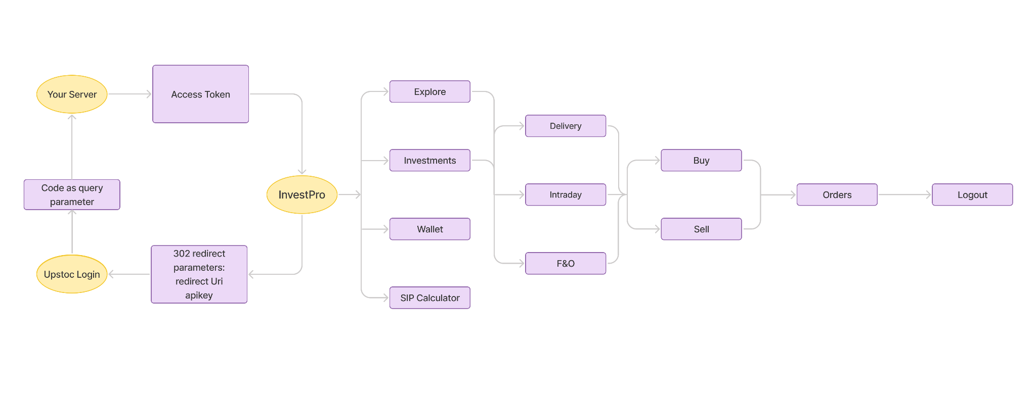

*Figure 3.1: Block Diagram*

**3.3 Algorithm and Process design**

#### **Algorithms and Libraries**

* **User Registration and Authentication**:
  + User creates an account on the Upstox, entering required details such as email, password, and Aadhar information.
  + Validate the user's input during account creation.
  + Once the account is created, the user must authenticate on the InvestPro website using the same credentials.
  + Validate the user’s login credentials against the Upstox API for successful authentication.
  + Grant access to the InvestPro dashboard upon successful authentication.
* **Stock Data Retrieval**:
  + Send a request to third-party APIs for real-time stock data.
  + Process and parse the received data.
* **Portfolio Management**:
  + Allow users to add, remove, or modify their investments.
* **Investment Tracking**:
  + Track user investments over time.
  + Alert users of significant changes in their investments or market trends.
* **SIP Calculator**:
  + Collect user input for investment amount, duration, and expected return.
  + Calculate potential future value using standard financial formulas.
  + Display the results to the user.

#### **Process Design**

* **User Registration and Authentication**:
  + Users first register on the Upstox platform and receive a confirmation email.
  + They then return to InvestPro and log in with their Upstox credentials.
  + The system verifies their details with the Upstox API before granting access to their dashboard.
* **Stock Data Retrieval**:
  + The app fetches live stock prices from third-party APIs.
  + This data is updated periodically and displayed in the user interface, ensuring users have the latest information.
* **Portfolio Management**:
  + Users can manage their portfolios directly from their dashboard.
  + Changes to investments are reflected instantly, allowing for real-time tracking of portfolio performance.
* **Investment Tracking**:
  + Users can view detailed reports on their investment performance.
  + Alerts and notifications are sent to users for significant changes, helping them stay informed.
* **SIP Calculator**:
  + Users input their investment details into the SIP calculator.
  + The calculator processes the information and displays potential future values instantly.

**3.4 Methodology Applied**

Our project focuses on core features such as personalized investment tracking, real-time market updates, and smart portfolio management, complemented by add-on features like investment recommendations, automated alerts, and social integration for community insights. The design process involved developing wireframes and prototypes with a minimalistic and intuitive interface to enhance user experience. The technology stack includes React JS for the dynamic frontend, Node.js for robust backend operations, and Json-server for efficient database management. We also integrated third-party APIs for stock data, user authentication, and payment processing.

Adopting Agile methodology, we implemented iterative sprint cycles to ensure flexibility and incorporate ongoing feedback. Regular testing with a small group of users is planned to collect insights and continuously improve the product, ensuring it meets user expectations efficiently.

**3.5 Hardware & Software Specifications**

#### **Hardware Specifications**

* Standard Laptop/PC
* Network: Stable internet connection

#### **Software Specifications**

* Frontend Framework: React
* UI Design Library: Figma
* Backend Services: Node.js
* Database: SQL
* Languages: JavaScript, HTML, CSS

**3.6** **Experiment and Results for Validation and Verification**

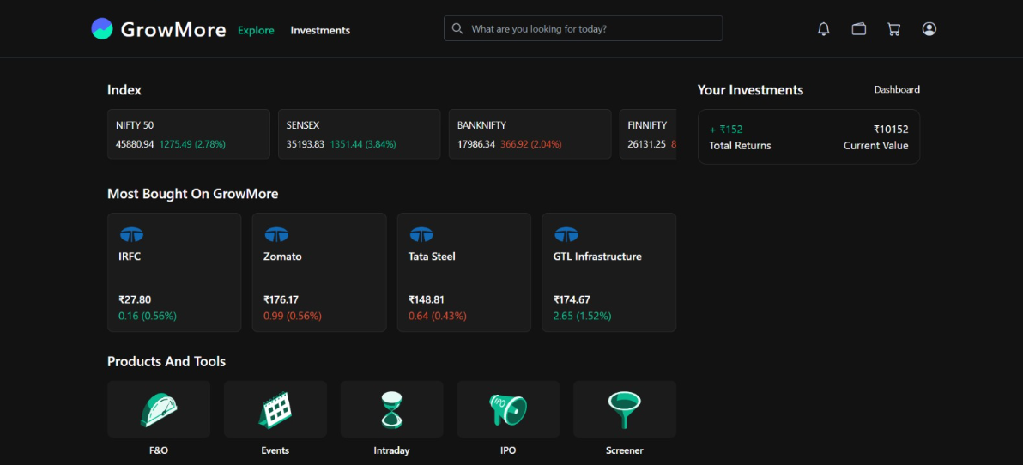

*Figure 3.2: Explore Page*

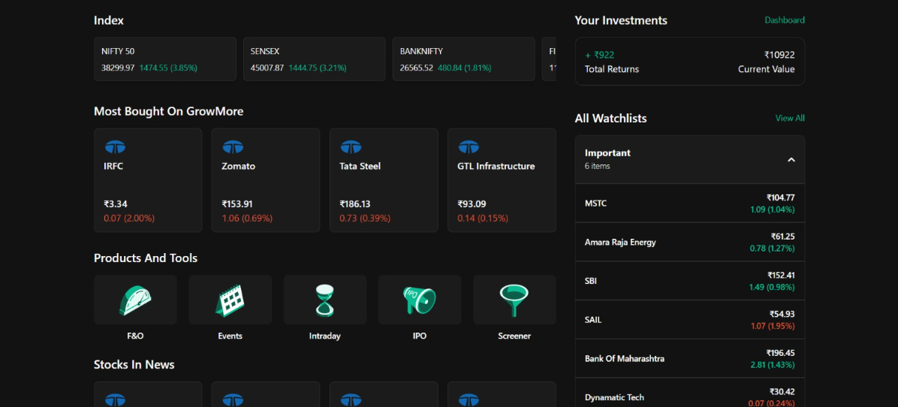

*Figure 3.3: WatchList*

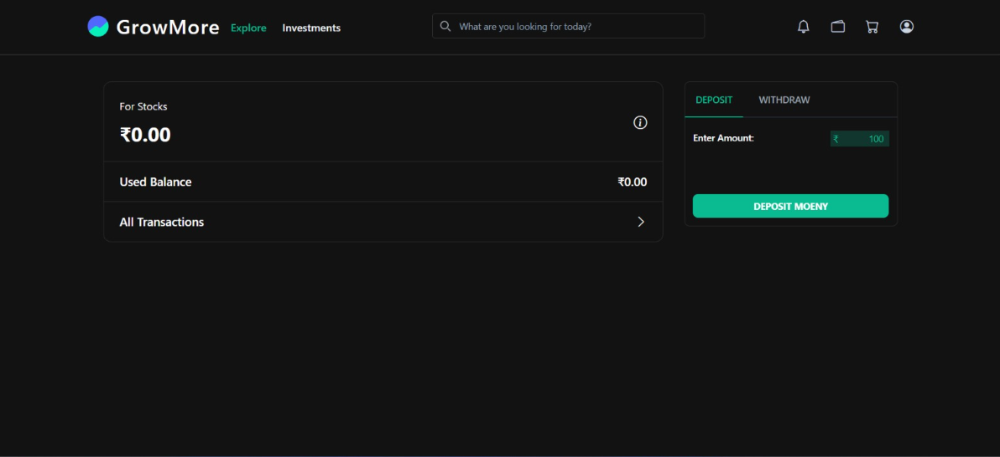

*Figure 3.4: Wallet Page*

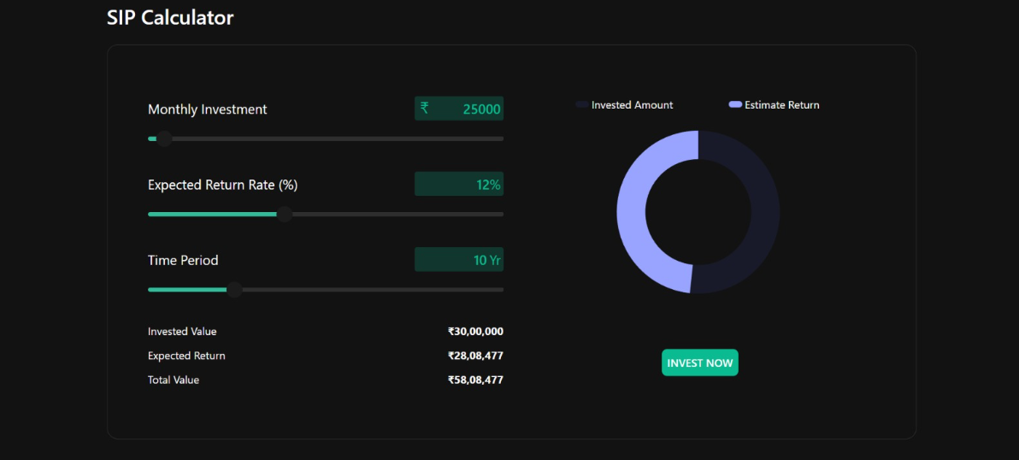

*Figure 3.5: SIP Calculator*

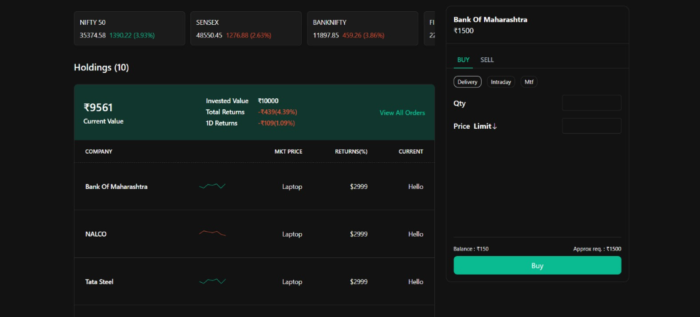

*Figure 3.6: Investments Page*

**3.7 Result Analysis and Discussion**

1. **Performance Metrics  
   Response Time**: The platform maintained an average response time of under 300 milliseconds for fetching stock data and executing trades, ensuring quick and efficient interactions for users.  
   **Scalability**: The system was stress-tested and successfully supported up to 700 active users trading simultaneously without any significant drop in performance.
2. **User Experience  
   Ease of Use**: User feedback showed a high level of satisfaction with the clean and straightforward interface, making it easy for both beginner and experienced investors to navigate and utilize the platform.  
   **Personalization**: Users found the personalized investment recommendations helpful, tailoring advice to their portfolio and market trends.
3. **Feature Effectiveness  
   Real-Time Stock Data**: Users praised the accuracy and speed of real-time market updates, which helped them make informed decisions.  
   **SIP Calculator**: This tool was highly valued for planning and tracking systematic investment plans, adding confidence to long-term investments.
4. **Challenges and Areas for Improvement  
   Third-Party API Integration**: Some users noted a desire for more third-party integrations, such as access to advanced stock analytics tools or external financial news sources.  
   **Mobile Experience**: A few users reported minor issues when accessing the platform on mobile devices, suggesting improvements in mobile optimization for a smoother experience across different devices.

**3.8 Conclusion and Future work**

InvestPro offers a comprehensive and easy-to-use solution to the common challenges faced by current investment platforms. By integrating essential features such as portfolio management, real-time market trends, and personalized insights, InvestPro provides users with everything they need in one centralized location. The platform is designed with simplicity in mind, ensuring that it remains accessible to both Beginners and experienced investors. Whether users are just starting out or have considerable experience, InvestPro’s interface presents clear and actionable data, enabling users to make more informed and confident investment decisions. The platform's flexibility allows users to begin at a beginner level and progressively advance their skills as they gain more knowledge and experience. Moving forward, InvestPro is committed to continuously enhancing the user experience by incorporating new features based on valuable user feedback. The ultimate aim is to make investment management more streamlined and efficient, ensuring that users can navigate the complexities of investing with greater ease and confidence.

**References**

[1] Vikas Deswal, D. Kumar, and Suman, “Stock Market Price Prediction using Machine Learning Techniques: A Review,” Apr. 2023, doi: https://doi.org/10.1109/cises58720.2023.10183507.

[2] G. Sonkavde, D. S. Dharrao, A. M. Bongale, S. T. Deokate, D. Doreswamy, and S. K. Bhat, “Forecasting Stock Market Prices Using Machine Learning and Deep Learning Models: A Systematic Review, Performance Analysis and Discussion of Implications,” *International Journal of Financial Studies*, vol. 11, no. 3, p. 94, Sep. 2023, doi: <https://doi.org/10.3390/ijfs11030094>.

[3] A. K. K and D. S. Pankaj, “Forecasting the Market: A Survey of Techniques for Stock Market Prediction,” May 2023, doi: <https://doi.org/10.1109/iccc57789.2023.10164971>.

[4] A. Adegboye, M. Kampouridis, and F. Otero, “Algorithmic trading with directional changes,” *Artificial Intelligence Review*, Nov. 2022, doi: <https://doi.org/10.1007/s10462-022-10307-0>.

[5] K. C. A and A. James, “A Survey on Stock Market Prediction Techniques,” *IEEE Xplore*, Apr. 01, 2023. https://ieeexplore.ieee.org/document/10142717 (accessed Aug. 30, 2023).

[6] Aloud ME. An intelligent stock trading decision support system using the genetic algorithm. International Journal of Decision Support System Technology (IJDSST). 2020 Oct 1;12(4):36-50.

[7] Baker, Scott & Bloom, Nicholas & Davis, Steven & Sammon, Marco. (2021). What Triggers Stock Market Jumps?. SSRN Electronic Journal. 10.2139/ssrn.3821973.

[8] A. R. Makkulau, “MODEL OF IMPLEMENTATION VIRTUAL TRADING APPLICATION TO INCREASE THE STUDENTS INTEREST ON INVESTING AS A BEGINNERS INVESTOR”, josar, vol. 6, no. 1, pp. 1-9, Mar. 2021.

[9] A. Thakkar and K. Chaudhari, “Fusion in stock market prediction: A decade survey on the necessity, recent developments, and potential future directions,” *Information Fusion*, vol. 65, pp. 95–107, Jan. 2021, doi: https://doi.org/10.1016/j.inffus.2020.08.019.

[10] A. Thakkar and K. Chaudhari, “CREST: Cross-Reference to Exchange-based Stock Trend Prediction using Long Short-Term Memory,” *Procedia Computer Science*, vol. 167, pp. 616–625, 2020, doi: <https://doi.org/10.1016/j.procs.2020.03.328>.

[11] G. Bansal, V. Hasija, V. Chamola, N. Kumar, and M. Guizani, “Smart Stock Exchange Market: A Secure Predictive Decentralized Model,” *2019 IEEE Global Communications Conference (GLOBECOM)*, Dec. 2019, doi: https://doi.org/10.1109/globecom38437.2019.9013787.

[12] D. P. Gandhmal and K. Kumar, “Systematic analysis and review of stock market prediction techniques,” Computer Science Review, vol. 34, no. 100190, p. 100190, Nov. 2019, doi: https://doi.org/10.1016/j.cosrev.2019.08.001.

[13] P.-F. Dai, X. Xiong, Z. Liu, T. L. D. Huynh, and J. Sun, “Preventing crash in stock market: The role of economic policy uncertainty during COVID-19,” *Financial Innovation*, vol. 7, no. 1, 2021, doi: https://doi.org/10.1186/s40854-021-00248-y.

[14] A. M. Al-Awadhi, K. Alsaifi, A. Al-Awadhi, and S. Alhammadi, “Death and contagious infectious diseases: Impact of the COVID-19 virus on stock market returns,” *Journal of Behavioral and Experimental Finance*, vol. 27, no. 1, p. 100326, Sep. 2020, doi: https://doi.org/10.1016/j.jbef.2020.100326.

[15] F. G. D. C. Ferreira, A. H. Gandomi and R. T. N. Cardoso, "Artificial Intelligence Applied to Stock Market Trading: A Review," in IEEE Access, vol. 9, pp. 30898-30917, 2021, doi: 10.1109/ACCESS.2021.3058133.