**Vivekanand Education Society's Institute of Technology**

**Department of Computer Engineering**

**Group No.: 47**

**Date :-**

**Project Synopsis (2023-24) - Sem V**

GrowMore : Your Stock Market Companion

Mrs. Rupali Hande

Assistant Professor, CMPN

Priya Anandani Rishi Daryani

V.E.S.I.T V.E.S.I.T [2022.priya.anandani@ves.ac.in](mailto:2022.priya.anandani@ves.ac.in) [2022.rishi.daryani@ves.ac.in](mailto:2022.rishi.daryani@ves.ac.in)

Roshni Gurbani Ritu Ruprela

V.E.S.I.T V.E.S.I.T [2022.roshni.gurbani@ves.ac.in](mailto:2022.roshni.gurbani@ves.ac.in) [2022.ritu.ruprela@ves.ac.in](mailto:2022.ritu.ruprela@ves.ac.in)

**Abstract**

Investing in financial markets can be challenging due to complex data, volatile market conditions, and various investment options. Despite numerous financial platforms, investors often struggle with separated features and lack of comprehensive tools. A significant challenge is the need for integrated solutions that provide essential features. Additionally, effective investment management requires user-friendly interfaces, accurate data, and timely alerts. Empowering investors with these tools can enhance their decision-making and optimize their financial strategies.

**Introduction**

The major challenge in today’s financial world is not the lack of investment opportunities but the complexity of navigating the stock market. Our website/mobile app GrowMore aims to simplify this process by providing a comprehensive platform for stock trading and investing. Our website/mobile app is designed to help individual investors understand and navigate the complex financial markets, giving them the tools they need to succeed.

The system of our website/mobile app consists of several key features that meet the needs of various users. These include live stock information, SIP calculator, and investment tracking tools, all integrated into a user-friendly interface. By offering real-time market data our platform supports both novice and experienced investors in making informed decisions.

Aligned with our goal of making investing accessible and efficient, GrowMore helps users reach their financial goals. By simplifying stock market investing, our website/mobile app helps users build and manage their portfolios with confidence, contributing to their long-term financial success. Additionally, our secure trading platform guarantees that your transactions are safe and efficient. Join the GrowMore community today and take control of your financial future with confidence and ease.

**Problem Statement**

In today's fast-paced financial markets, novice and experienced investors face numerous challenges in making proper investment decisions. The fluctuating market conditions, and complex investment options make it difficult for many to effectively manage their portfolios. Despite the availability of various financial platforms, there remains a significant gap in providing a user-friendly solution that caters to investors and learners. Some existing platforms still lack the integration of essential features such as Futures & Options (F&O) trading, customizable watchlists and detailed market cap classifications (mid, large, small). Additionally, by providing interactive graphs and charts, making it visually appealing as well.

**Proposed Solution**

* Our proposed solution is to develop a financial platform that integrates essential features for user-friendly experience.
* The platform will offer Futures & Options (F&O) trading, enabling users to trade advanced financial instruments with ease.
* Customizable watchlists will allow users to track and monitor their preferred stocks, insights into the most bought stocks will provide real-time data on popular stock purchases.
* Detailed market cap classifications for mid, large, and small-cap stocks will be available, alongside interactive charts and graphs for better analysis and decision-making. Automated buy and sell features will execute trades based on user-defined criteria, and timely alerts will notify users about stock movements and market events.
* Additionally, a separate SIP calculator will help users plan and manage systematic investment plans.
* This solution aims to empower investors with the tools and information they need to make informed decisions and optimize their investment strategies.

**Methodology / Block Diagram**

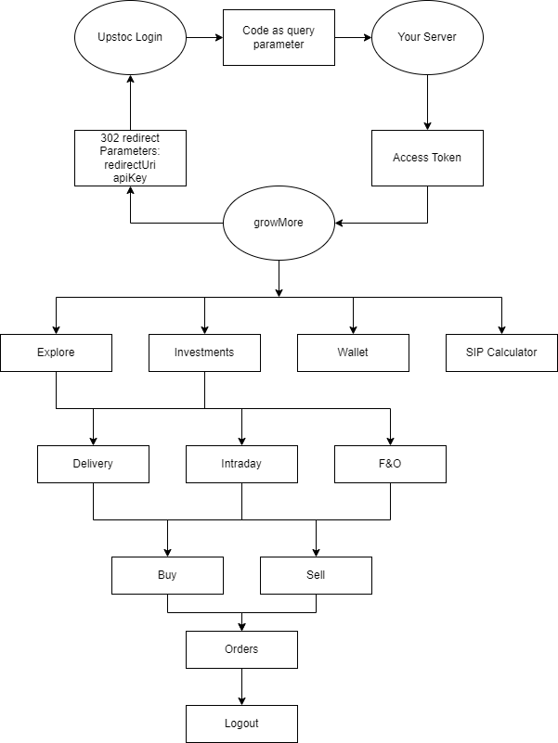

**Hardware , Software and tools Requirements**

**Hardware: -** PC:

Minimum Requirements

OS: Windows 11

Processor: Ryzen 5 or AMD equivalent

RAM: 1GB RAM

Storage: 64GB

Browser: Google Chrome, Microsoft Edge, Firefox

**Software: -** HTML5, CSS, JavaScript,React Framework, Firebase

**Proposed Evaluation Measures**

* User Friendliness: Expediency and ease of use of the UI and UX, ensuring a seamless experience for users navigating the platform.
* Data Accuracy: Precision of financial data, including stock prices, market caps, and analyst estimates, ensuring users make informed decisions.
* Functionality: Comprehensive integration of features such as F&O trading, customizable watchlists, interactive charts, automated trading, and SIP calculators.
* Performance and Reliability: Platform stability and speed, ensuring real-time data updates and execution of trades without delays.
* Security: Robust measures to protect user data and transactions, maintaining trust and compliance with financial regulations.
* Traders & Investors Engagement: Features tailored to diverse user needs, encouraging active participation and investment management.

**Conclusion**

In conclusion, GrowMore is a complete platform that makes stock market investing easier. Our website/mobile app connects individual investors with essential tools like real-time stock information, SIP calculator, and easy-to-use investment tracking features. The main goal of our website/mobile app is to make investing simple, efficient, and rewarding for everyone. By creating a comforting and supportive environment, our platform helps users confidently handle market ups and downs and reach their financial goals. More than just simplifying investments, GrowMore aims to help users take control of their financial future, building a community of informed and successful investors. This smart solution connects individual investors to the financial markets, ensuring everyone has the chance to invest wisely and grow their wealth.

**References**

Investopedia (<https://www.investopedia.com/>)

The Wall Street Journal (<https://www.wsj.com/finance/stocks?mod=nav_top_subsection>)

World Bank reports on financial markets (<https://www.worldbank.org/>)

Reports from the Securities and Exchange Board of India (SEBI) (<https://www.sebi.gov.in/>)

Barriers to Investing in The Stock Market (<https://www.masteryourcardusa.org/resource/barriers-to-investing-in-the-stock-market/> )