**Load balancing using Amazon Web Services – Auto Scaling feature**

1. **Create launch configuration**

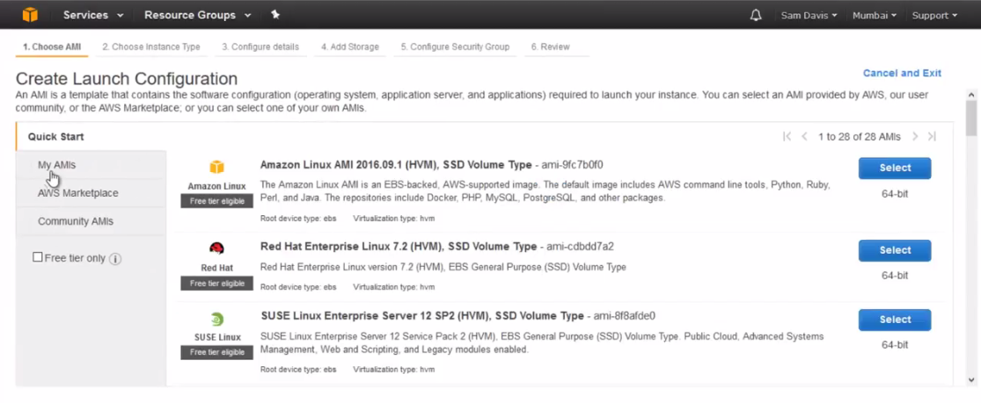

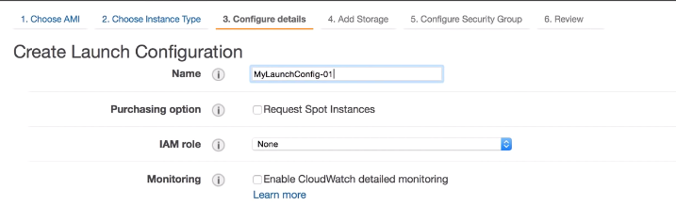

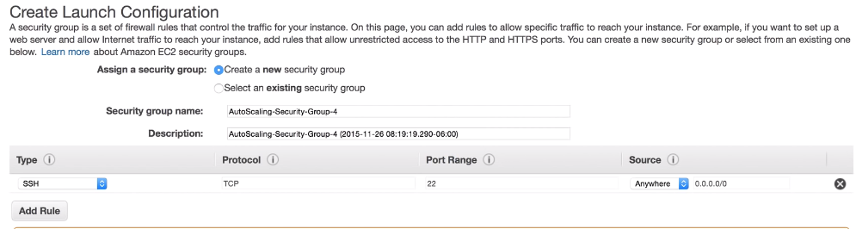

1. **Create auto scaling group**

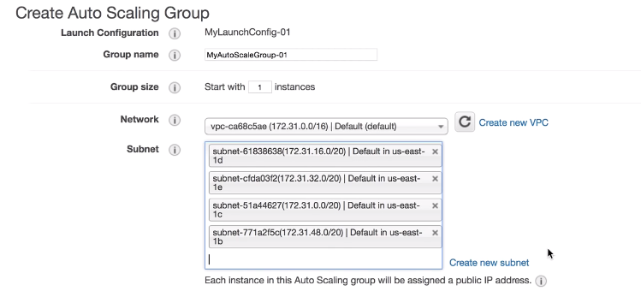

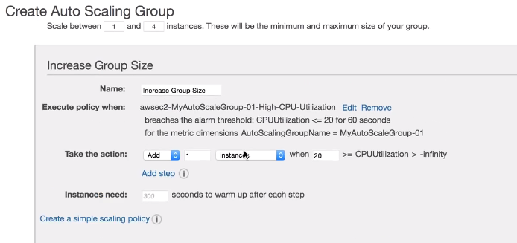

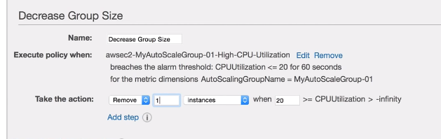

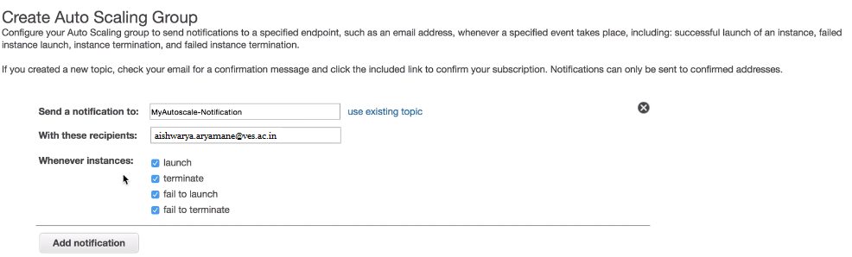

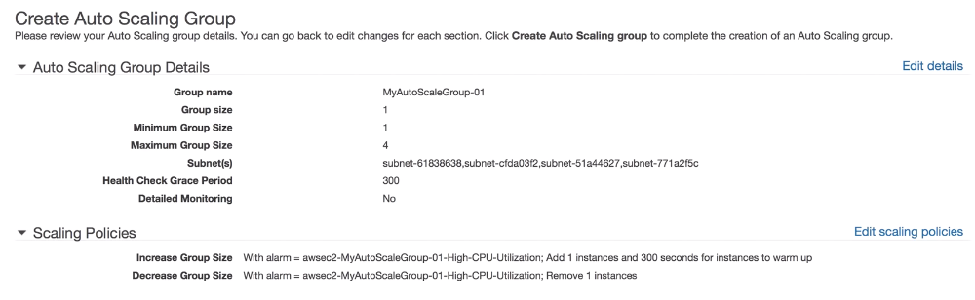

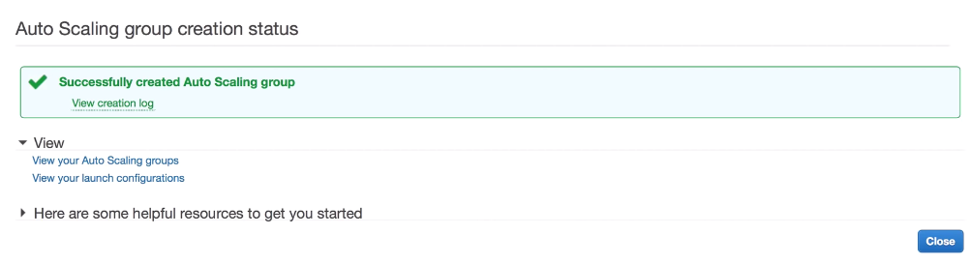

1. **Monitor the instances that are being created**

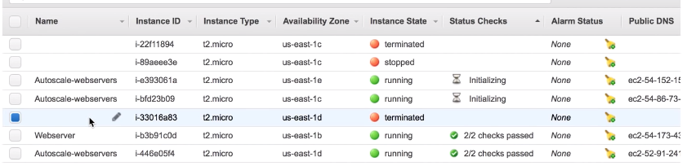

Instance i-446e05f4 is created.

1. **Increase load at the instance using a script.**

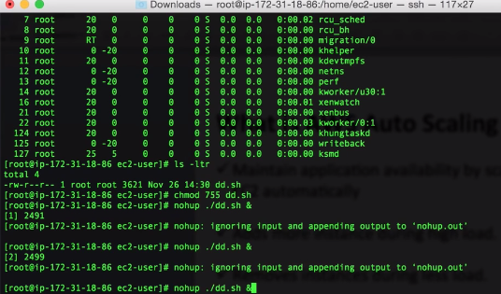

CPU usage has increased

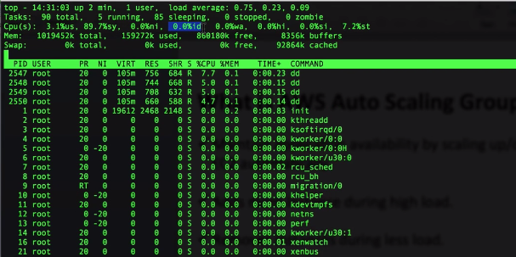

1. **New instance is created**

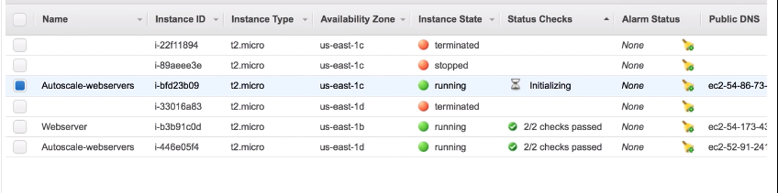

Notification is received on the email ID.

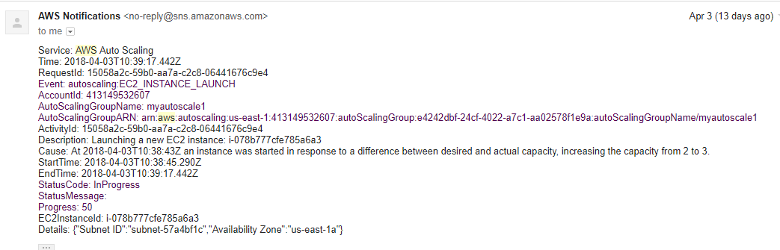

4 instances are created.

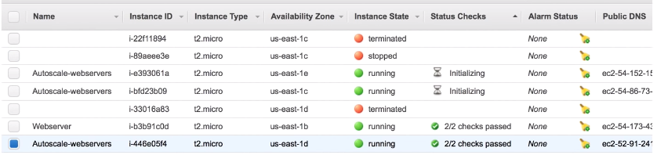

CPU usage goes low after sometime

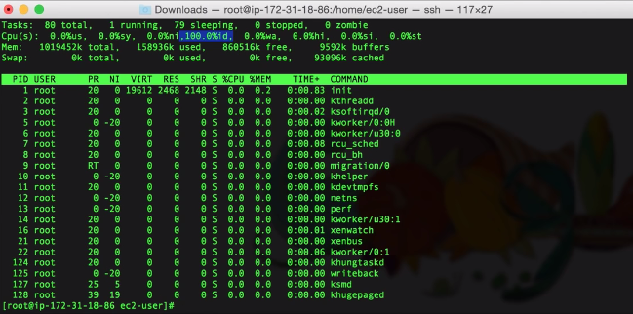

Instance starts terminating as CPU usage is low.

