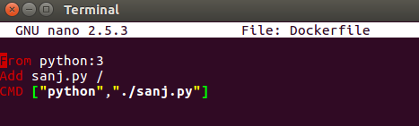

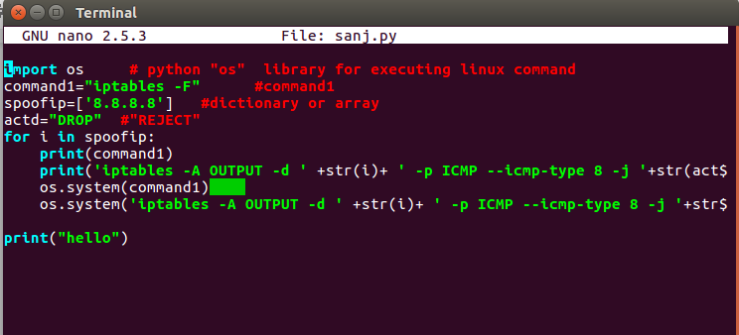

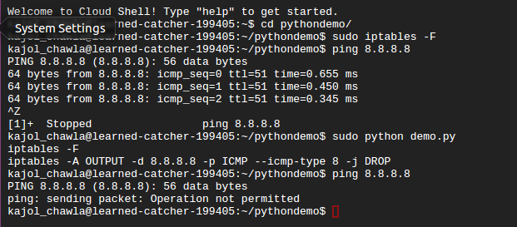

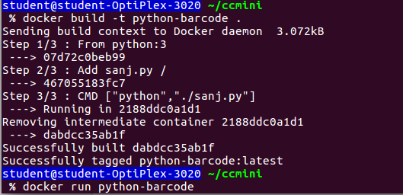

[root@27df14c224be /]# ping 8.8.8.8

PING 8.8.8.8 (8.8.8.8) 56(84) bytes of data.

64 bytes from 8.8.8.8: icmp_seq=1 ttl=59 time=12.9 ms

64 bytes from 8.8.8.8: icmp_seq=2 ttl=59 time=4.42 ms

64 bytes from 8.8.8.8: icmp_seq=3 ttl=59 time=8.54 ms

^Z

[1]+  Stopped                 ping 8.8.8.8

[root@27df14c224be /]# iptables -L

Chain INPUT (policy ACCEPT)

target     prot opt source               destination