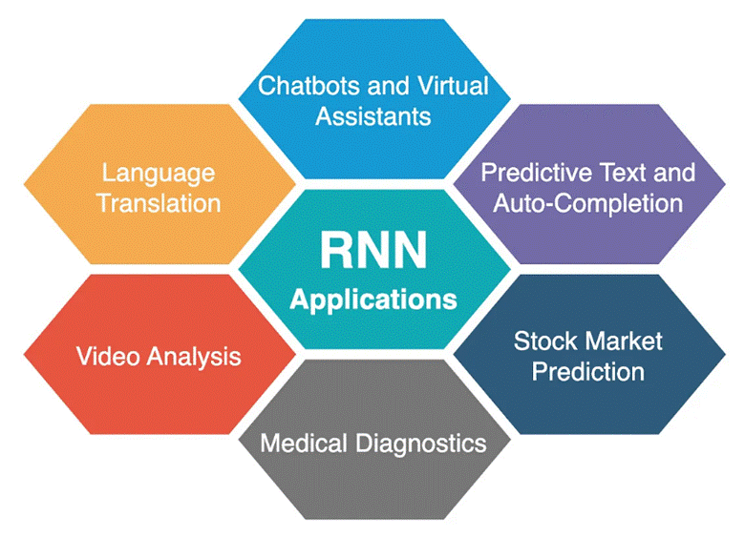What is RNN?

Recurrent Neural Network is a generalization of feed-forward neural network that has an internal memory. RNN is recurrent in nature as it performs the same function for every input of data while the output of the current input depends on the past one computation. After producing the output, it is copied and sent back into the recurrent network. For making a decision, it considers the current input and the output that it has learned from the previous input.

Unlike feed-forward neural networks, RNNs can use their internal state (memory) to process sequences of inputs. This makes them applicable to tasks such as unsegmented, connected handwriting recognition or speech recognition. In other neural networks, all the inputs are independent of each other. But in RNN, all the inputs are related to each other.

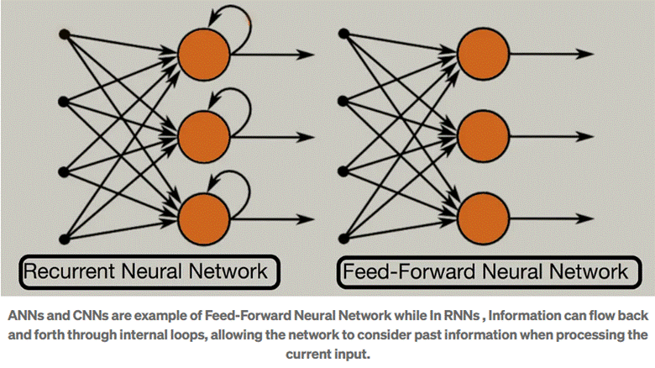

What is Sequential data?
Sequential data is information that has a specific order and where the order matters. Each piece of data in the sequence is related to the ones before and after it, and this order provides context and meaning to the data as a whole.

Here’s an example to illustrate:
Imagine a sentence like “The quick brown fox jumps over the lazy dog.” Each word in the sentence is a piece of data. The order of the words is crucial because it determines the meaning of the sentence. “Fox brown quick the jumps over lazy dog” wouldn’t make much sense, right?
Here are some other common types of sequential data:
Time series data: This refers to data points collected at regular intervals over time. Examples include stock prices, temperature readings, or website traffic. The order of the data points matters because it shows how the value changes over time.
Natural language text: All written language is sequential. The order of words in a sentence or paragraph is essential for conveying meaning and understanding the relationships between ideas.
Speech signals: Spoken language is another example of sequential data. The order of sounds like phonemes, syllables, and words is crucial for understanding the spoken message.
RNN is best suited for sequential data.
It can handle arbitrary input / output lengths. RNN uses its internal memory to process arbitrary sequences of inputs.
This makes RNNs best suited for predicting what comes next in a sequence of words. Like a human brain, particularly in conversations, more weight is given to recency of information to anticipate sentences.
RNN that is trained to translate text might learn that “dog” should be translated differently if preceded by the word “hot”.
RNN has internal memory.
RNN has memory capabilities. It memorizes previous data. While making a decision, it takes into consideration the current input and also what it has learned from the inputs it received previously. Output from the previous step is fed as input to the current step creating a feedback loop.
So, it calculates its current state using a set of current input and the previous state. In this way, the information cycles through a loop.
In a nutshell, we can say that RNN has two inputs, the present and the recent past. This is important because the sequence of data contains crucial information about what is coming next, which is why a RNN can do things other algorithms can’t.

Why use RNN?

Traditional Artificial Neural Networks (ANNs) are powerful tools, but they struggle with sequential data like text because they require fixed-size inputs. Each input in an ANN is treated independently, making them unsuitable for tasks where the order and relationships between elements are crucial.
Suppose we use the zero padding concept in which Shorter sequences are padded with zeros at the end to reach the length of the longest sequence in the batch. These zeros act as placeholders and don’t carry any meaningful information. Padding introduces irrelevant zeros that the network needs to process alongside the actual data, increasing computational burden.

And also due to no sequences in passing input in ANN, we lose the context or sequential information. Apart from this if any user gives the input length of higher size that we expect then in that scenario we can do nothing. For example, we set our input size to be 5 words but any user gives it 15 words at a time then in that case we can’t handle it with ANN.

Types of RNN
So we have established that Recurrent neural networks, also known as RNNs, are a class of neural networks that allow previous outputs to be used as inputs while having hidden states. RNN models are mostly used in the fields of natural language processing and speech recognition. Let's look at its types:

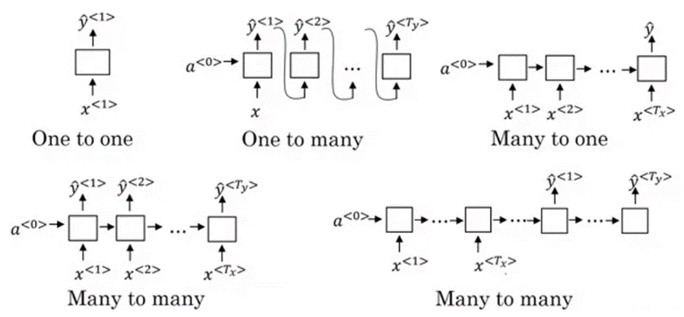

One to One RNN
One to One RNN (Tx=Ty=1) is the most basic and traditional type of Neural network giving a single output for a single input, as can be seen in the above image.It is also known as Vanilla Neural Network. It is used to solve regular machine learning problems.

One to Many
One to Many (Tx=1,Ty>1) is a kind of RNN architecture that is applied in situations that give multiple outputs for a single input. A basic example of its application would be Music generation. In Music generation models, RNN models are used to generate a music piece(multiple output) from a single musical note(single input).

Here are some common applications of one to many RNNs:
Image Captioning: Based on a single image input, the RNN generates a sentence or paragraph describing the image content (multiple outputs).
Music Generation: The RNN receives a single starting note or short melody as input and produces a sequence of musical notes forming a complete piece (multiple outputs).

Many to One
Many-to-one RNN architecture (Tx>1,Ty=1) is usually seen for sentiment analysis models as a common example. As the name suggests, this kind of model is used when multiple inputs are required to give a single output.

Take for example The Twitter sentiment analysis model. In that model, a text input (words as multiple inputs) gives its fixed sentiment (single output). Another example could be the movie ratings model that takes review texts as input to provide a rating to a movie that may range from 1 to 5.
Here are some common applications of many-to-one RNNs:
Sentiment Analysis: Given a sentence or review text (sequence of words), classify its overall sentiment (positive, negative, or neutral) as the single output.
Spam Detection: Analyze an email’s content (sequence of words) to determine if it’s spam (single output).

Many-to-Many
As is pretty evident, Many-to-Many RNN (Tx>1,Ty>1) Architecture takes multiple input and gives multiple output, but Many-to-Many models can be two kinds as represented above.
1. Tx=Ty:
This refers to the case when input and output layers have the same size. This can be also understood as every input having an output, and a common application can be found in Named entity Recognition.
2.Tx!=Ty:
Many-to-Many architecture can also be represented in models where input and output layers are of different sizes, and the most common application of this kind of RNN architecture is seen in Machine Translation. For example, “I Love you”, the 3 magical words of the English language translates to only 2 in Spanish, “te amo”. Thus, machine translation models are capable of returning words more or less than the input string because a non-equal Many-to-Many RNN architecture works in the background.
Common Applications of Many-to-Many RNNs:
Machine Translation: Translate text from one language to another (e.g., English to French).
Video Captioning: Generate captions describing the content of a video (sequence of video frames as input, sequence of words as output).
Text Summarization: Summarize a long document into a shorter version with key points (sequence of sentences as input, shorter sequence of sentences as output).

How RNNs work?
The diagram depicts a simplified sentiment analysis process using a Recurrent Neural Network (RNN). Sample text is assigned sentiment labels (0/1 for positive/negative). Unique words are converted to numbers for the RNN to understand. These numbers are fed into the RNN one by one, with each word considered a single time step in the sequence. This demonstrates how RNNs can analyze sequential data like text to predict sentiment.

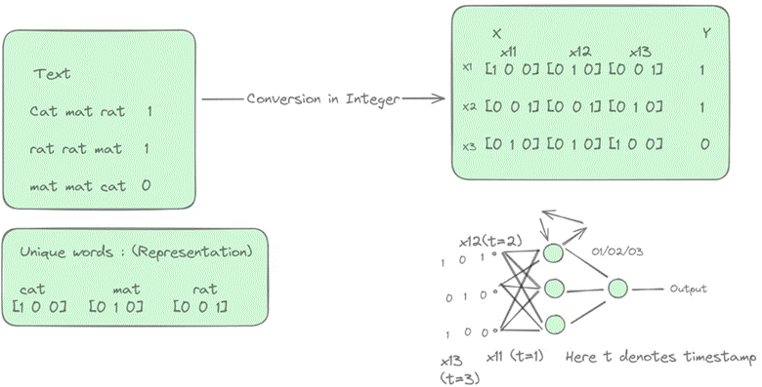

Let’s say input weights are denoted by wi, output weights with wo, feedback loop weights with wh and biases for first hidden layer is bi and bias for output layer is bo, then mathematical formulation for above is given by:

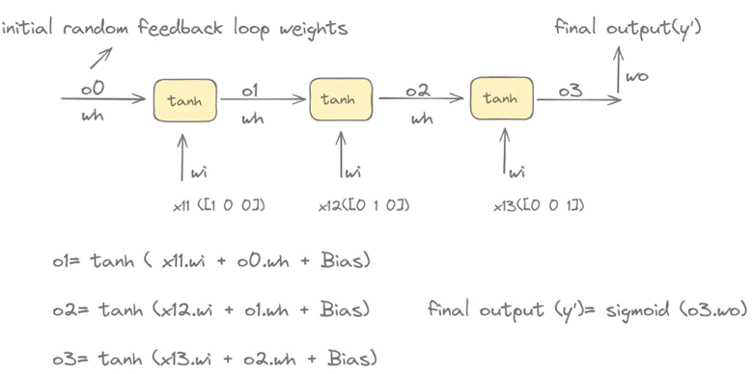

Backpropagation in RNNs
Backpropagation in RNNs, also known as Backpropagation Through Time (BPTT), is a crucial technique for training these networks. It allows them to learn and improve their performance on tasks involving sequential data.
Let’s take an example to understand the back propagation in many to one RNNs architecture :

1. Forward Pass:
The RNN processes a sequence of inputs one step at a time. At each step, the current input and the previous hidden state are fed into the network’s activation function to generate a new hidden state and an output.

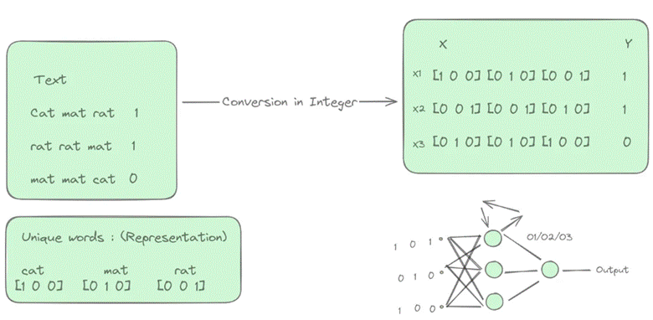
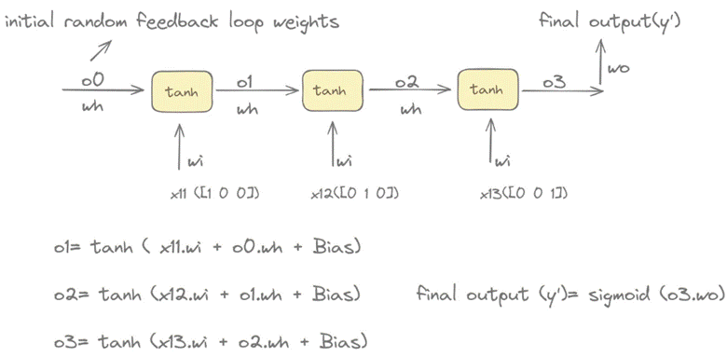

2. Error Calculation:
After processing the entire sequence, the difference (error) between the network’s final output and the desired output for the sequence is calculated.
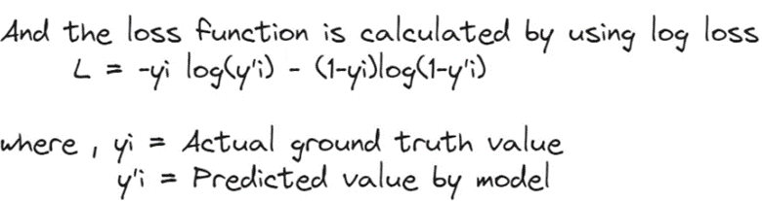

3. Weight Update:
Using the gradients, the weights in the actual RNN are adjusted in a way that will minimize the error in future predictions. Weights that significantly contributed to the error are adjusted more than those with minimal influence. Update of weights are calculated as shown in the figure:

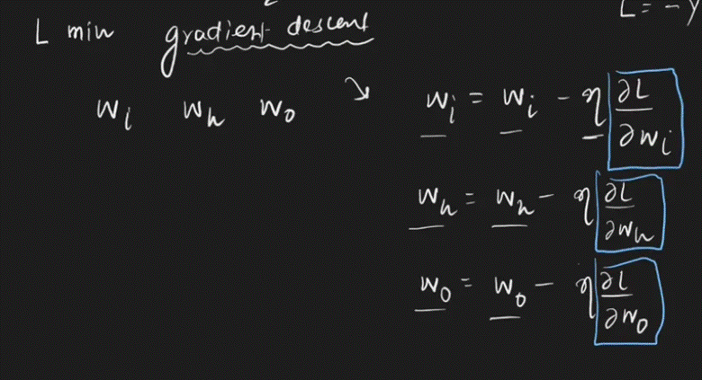

For calculating gradient, the following dependency needs to be understand :

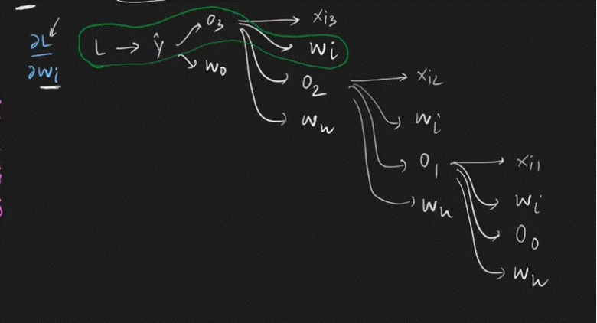
And after understanding above dependency we can write the gradient w.r.t. to wi in the following way:

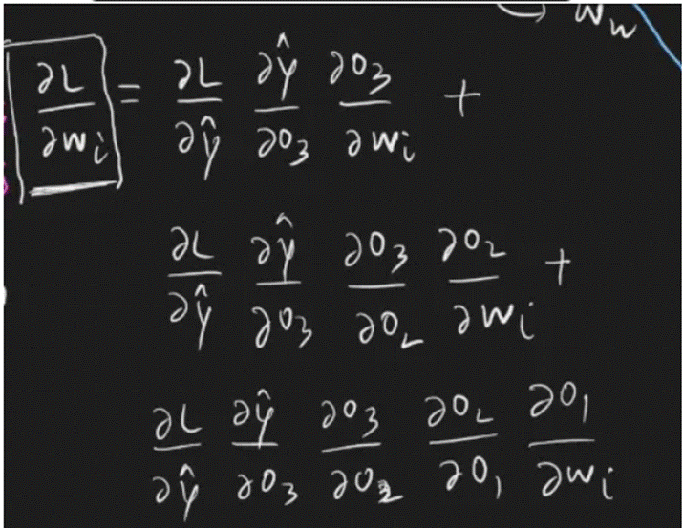

We can also write above equation in the following way also:

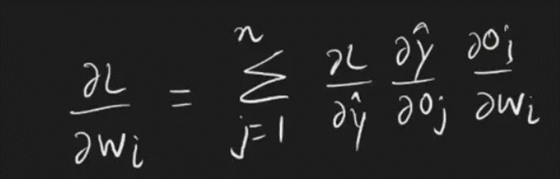

Problems with RNNs :

Vanishing Gradient Problem:
This is a major hurdle for RNNs, especially vanilla RNNs. It occurs when gradients (signals used to update weights during training) become very small or vanish as they propagate backward through the network during BPTT. This makes it difficult for the network to learn long-term dependencies in sequences, as information from earlier time steps can fade away.
In RNNs, information from previous time steps is used to influence the current output. This is achieved by feeding the output of a layer back as input to the next layer in the sequence. However, during back propagation through these layers.
Gradients are multiplied by weights at each step.
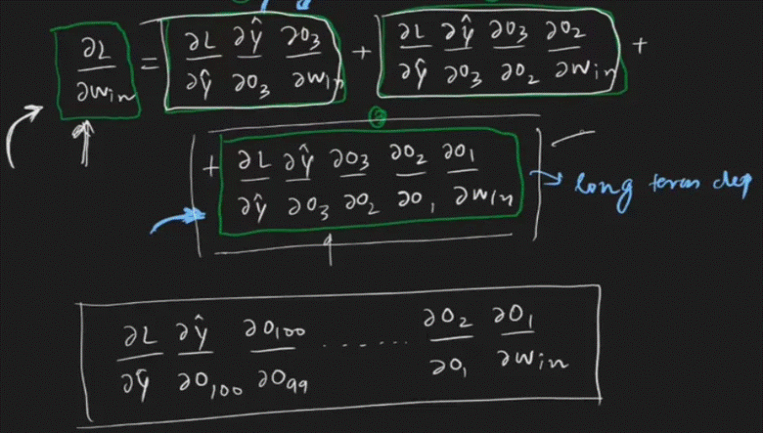

If these weights are all less than 1 in absolute value, this product becomes progressively smaller as we go back in time. This shrinks the error gradients for earlier time steps, making it difficult for the network to learn long-term dependencies present in the sequence.
RNNs struggle to learn from long sequences due to vanishing gradients. This makes them unsuitable for tasks like predicting future events based on long passages. However, RNNs excel at analyzing recent inputs, which is perfect for short-term predictions like suggesting the next word on a mobile keyboard.
This can be solved using following methods:
1. Appropriate Weight Initialization
2. Choosing the right Activation Function
3. LSTM (Long Short-Term Memory) Best way to solve the vanishing gradient issue is the use of LSTM (Long Short-Term Memory)
Exploding Gradient: When we assign high importance to the weights, exploding gradient issues occur. In this case, values of a gradient become too large and slope tends to grow exponentially. This can be solved using following methods:
1. Identity Initialization
2. Truncated Back-propagation
3. Gradient Clipping

What is LSTM (Long Short Term Memory)?
As we discussed, traditional RNNs are not able to memorize data for a long time and begin to forget its previous inputs. To overcome this problem of vanishing and exploding gradient LSTM is used. They are used as a solution for short term memory learning. Also in RNN when a new information is added RNN completely modifies the existing information. RNN is not able to distinguish between important or not so important information. Whereas in LSTM there is small modification in existing information when a new information is added because LSTM contains gates which determine the flow of information.
The gates decide which data is important and can be useful in future and which data has to be erased. The three gates are input gate, output gate and forget gate.
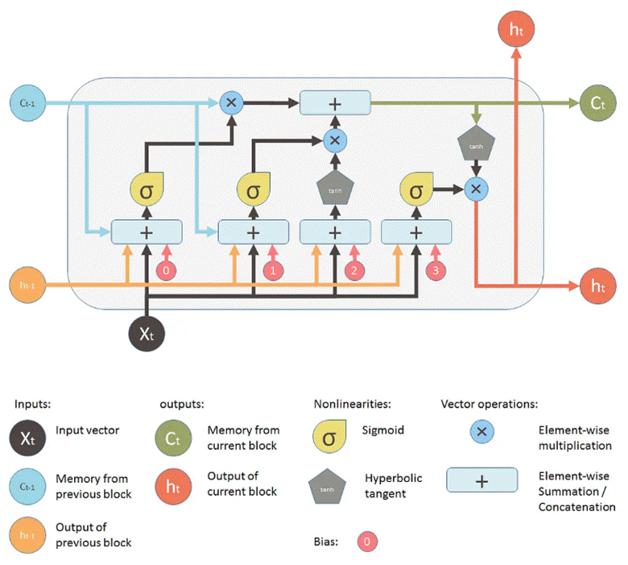

Forget Gate: This gate decides which information is important and should be stored and which information to forget. It removes the non important information from the neuron cell. This results in optimization of performance. This gate takes 2 inputs- one is the output generated by the previous cell and the other is the input of the current cell. Following required bias and weights are added and multiplied and sigmoid function is applied to the value. A value between 0 and 1 is generated and based on this we decide which information to keep. If value is close to 0 the forget gate will remove that information and if value is close to 1 then information is important and has to be remembered.

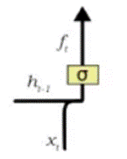

Input Gate: This gate is used to add information to neuron cells. It is responsible for what values should be added to the cell by using an activation function like sigmoid. It creates an array of information that has to be added. This is done by using another activation function called tanh. It generates values between -1 and 1. The sigmoid function acts as a filter and regulates what information has to be added in the cell.

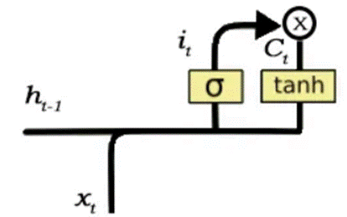

Output Gate: This gate is responsible for selecting important information from the current cell and showing it as output. It creates a vector of values using the tanh function which ranges from -1 to 1. It uses previous output and current input as a regulator which also includes sigmoid function and decides which values should be shown as output.

Squashing / Activation Functions in LSTM
1. Logistic (Sigmoid) Function : In the range of 0 to 1.
2. Hyperbolic Tangent (tanh): Outputs range from -1 to 1.

Tips for Improving Model Performance
We can improve our model performance by adding more layers. It is always preferred to have more (dense) layers than to have wide layers of less number.
But, we must take care to not overfit the data and for that we can try using various regularization methods.
Batch normalization: Batch normalization (batchnorm) is a technique to improve performance and accuracy of a neural network. Batch normalization occurs per batch. That is why it is called batch normalization. We normalize (mean = 0, standard deviation = 1) the output of a layer before applying the activation function, and then feed it into the next layer in a neural network. So, instead of just normalizing the inputs to the network, we normalize the inputs to each hidden layer within the network.
GRU

