|  |
| --- |
| Migrate Documents into Integrity with Excel |
| Type: Customization |
| <Customer Name>  <Location> |
| Volker Eckardt  veckardt@ptc.com |

Content

1 Introduction 3

1.1 Use Case 3

1.1.1 Overview 3

1.1.2 Description 3

1.1.3 Custom Validations 3

1.1.4 Examples 3

1.1.5 Additional Hints 4

1.2 User Process 4

2 Implementation Steps 6

2.1 Overview 6

2.2 Detailed Steps 7

3 Testing / Debugging 7

4 Technical Concept 8

4.1 Overview 8

4.2 Gateway Configuration 8

5 Open Issues 9

6 Appendix 10

6.1 Mapping File Example 10

# Introduction

This utility is a custom solution to load document information from Excel directly into Integrity. In this process the Gateway will be used, especially because the Gateway fully supports also an update process.

## Use Case

### Overview

Our Clients usually provide data in Word, or in Excel. To load the same into Integrity, a specific configuration is required. The solution provides high flexibility by using the Integrity Gateway standard.

### Description

In this case, a custom solution has been developed to support data load with Excel, in a pre-defined Excel template. The template has to have at least the following columns: Section, Text, Category and External ID, and also Assigned User.

### Custom Validations

When uploading the data into Integrity, the load process will validate the following data constellations, and reports them as errors in case of discrepancies:

1. The Section has to have an entry
2. The Section Level, identified by number of dot’s in the column, has to be provided and the validation will ensure that a level isn’t skipped
3. The External ID has to be provided
4. The External ID has to be unique.

### Examples

Provided Excel Data:

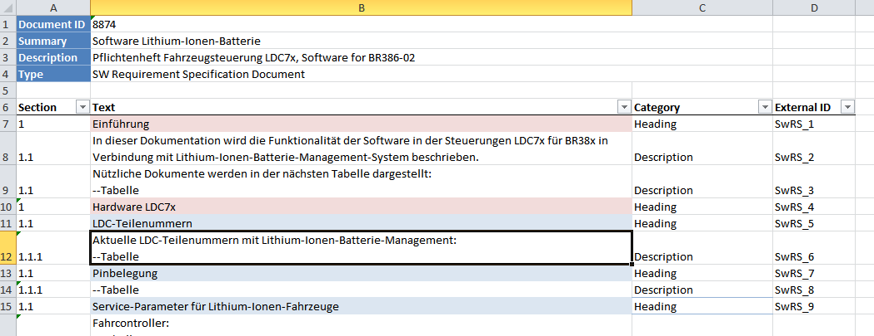

Result In Integrity:

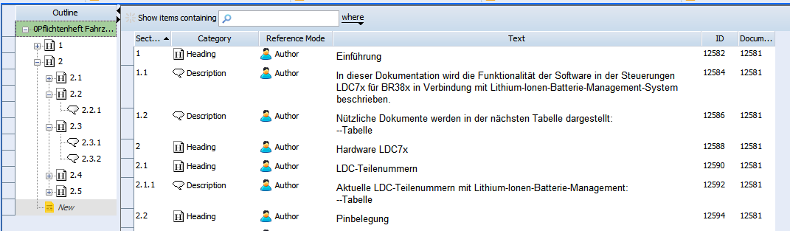

### Additional Hints

This load tool allows you also to update existing data, previously loaded.

* If you have made changes to the document in Integrity already, then those changes will get the content back from the Excel sheet.
* Hierarchical changes in Integrity will be removed
* Hierarchical changes in the Excel sheet will be synchronized with Integrity
* Additional content, entered by hand in Integrity, will be ignored (and not deleted). The reason is that the manually entered content will usually not have the External ID filled in. In case someone has entered the External ID in Integrity by hand, this external ID will be recognized by the load process and usually treated as an external item.

Important

Please be careful with updating your already loaded content. Even if the solution as such is designed to add and reorder the content nodes, check always the wizard information provided before you finally commit your changes.

## User Process

To Import data from Excel the user has to perform the following steps:

1. Fill the template with Data to be loaded
2. When importing the first time, leave the document ID empty
3. Start the Gateway  
   (M) Document > Import
4. Select the Excel document to be loaded
5. Select the appropriate import configuration  
   a) Requirement Document or  
   b) Test Specification  
     
   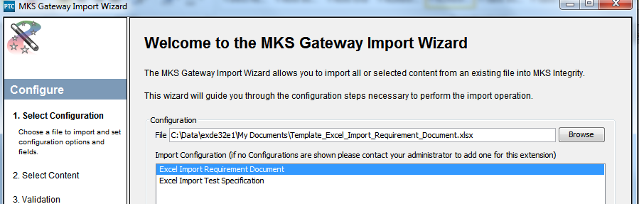
6. Follow the wizard for the validation and import  
     
   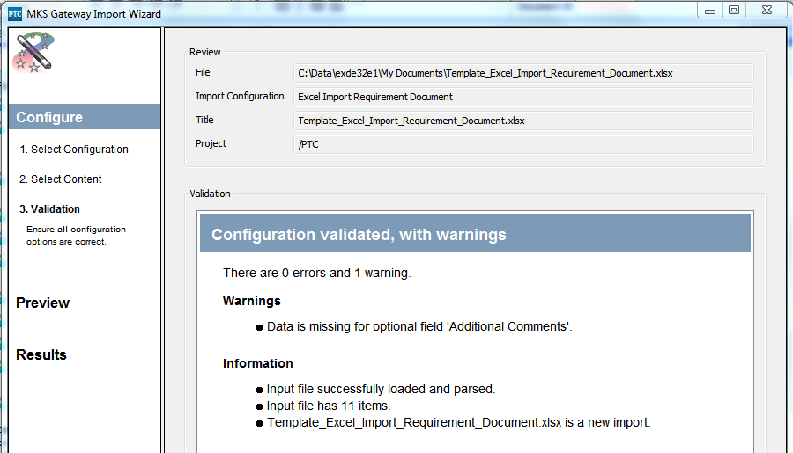
7. Review the final result  
     
   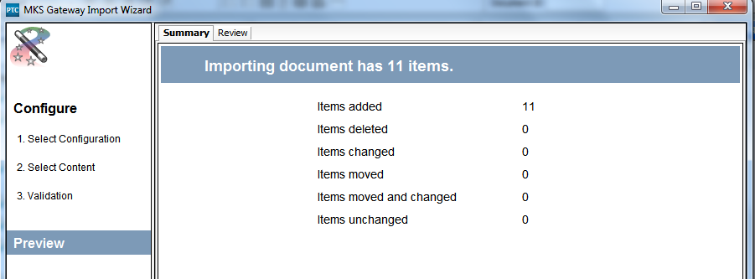
8. And also in Integrity  
     
   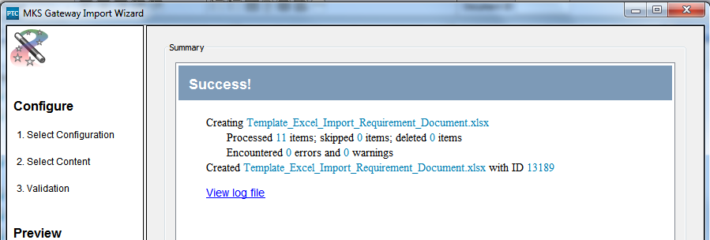

# Implementation Steps

## Overview

The implementation requires a number of files and templates, they are:

* 1. Java Classes   
     - IntegrityCustomImport.jar  
     - lib/poi-3.11-20141221.jar  
     - lib/poi-ooxml-3.11-20141221.jar  
     - lib/poi-ooxml-schemas-3.11-20141221.jar
  2. XMLFiles  
     - Mapping file: Excel_Import_Requirement_Document.xml  
     - Mapping file: Excel_Import_Test_Suite.xml
  3. 2 corresponding Entries in   
     gateway-tool-configuration.xml
  4. Import Templates

## Detailed Steps

Perform the following steps:

1. Copy the jar file to “IntegrityClient10.x”.
2. Copy the Mapping files to the servers’ gateway/mappings directory
3. Add the entries in gateway-tool-configuration.

Now, the importer is ready to use.

# Testing / Debugging

This gateway extension writes the custom output into the usual log files, Gateway.log and GatewayAppl.log. The custom section writes further details into the GatewayAppl, for example:

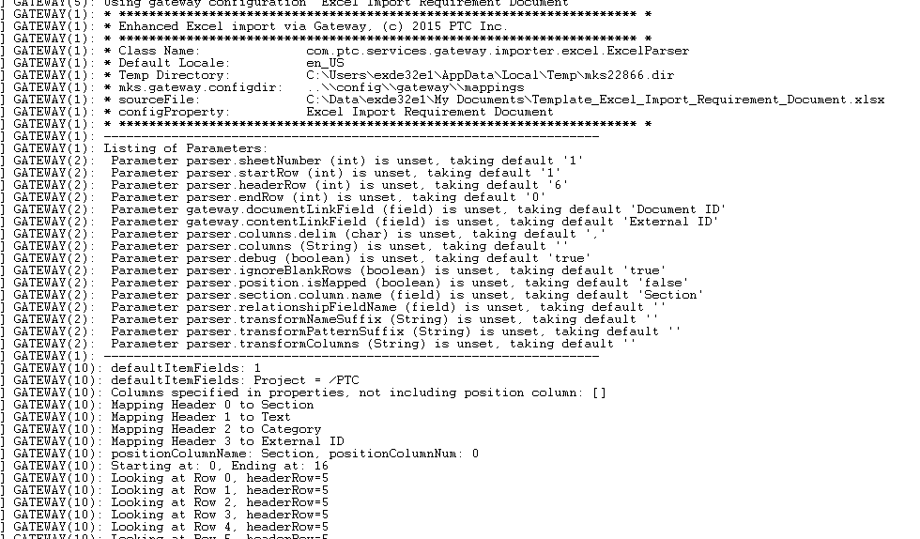

# Technical Concept

## Overview

The following techniques are used:

1. Java overload technique for the Gateway
2. Java POI Library for Excel file reading
3. Gateway standard logging
4. Configurable property file (all values are defaulted)
5. Server Excel configurations and templates

## Gateway Configuration

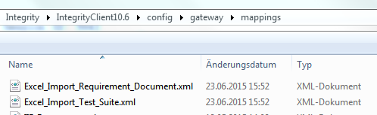

For RM Document:   
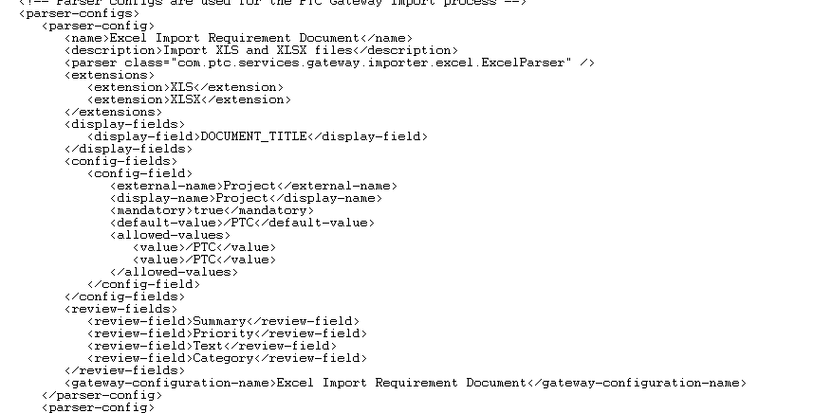

For Test Spec:  
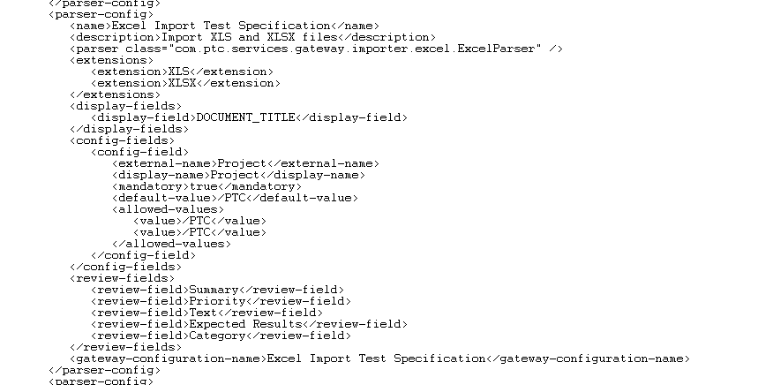

# Open Issues

The following issues are identified, and might be considered for a future release:

1. Recognizing also Fonts within Excel for importing  
   This feature is already in a beta mode.

# Appendix

## Mapping File Example

Excel_Import_Requirement_Document.xml  
