Assignment 01

Vitor Ferreira Lins

30/09/2021

1. Indtroduction

1.1. Discriptive statistics

The data reviewed in this article is taken from the Brazillian Institute of Geography and Statistics (IBGE) and contains data from the Agriculture Census of 2017, the subject chosen was the production of milk for each city in the “agreste” region of the state of Pernambuco.

The data collected contains three missing values, all of which are associated with the city of Sairé, for that reason, for every further analysis in this paper, this city will be disregarded. On the table below, are the descriptive data from the chosen dataset:

Table 1: Discriptive statistics

|  |  |  |  |  |  |
| --- | --- | --- | --- | --- | --- |
| Variables | Mean | SD | 1st Quartile | Median | 3rd Quartile |
| n_heads | 9996.29 | 7969.46 | 5190.75 | 7308.50 | 11940.00 |
| n_milk_cows | 1967.71 | 2809.14 | 386.25 | 781.50 | 2160.75 |
| l_prod_milk | 5643.84 | 9654.70 | 657.50 | 1379.00 | 4540.25 |
| n_settlements | 831.41 | 597.42 | 419.25 | 736.00 | 1040.50 |
| n_rep_heads | 3077.07 | 3307.76 | 1112.00 | 1788.50 | 3733.50 |
| a_pasture | 9306.26 | 8348.71 | 3828.13 | 7171.40 | 10452.69 |
| l_prod_milk/cow | 2098.36 | 1217.59 | 1409.13 | 1810.83 | 2667.83 |
| n_heads/a | 1.23 | 0.44 | 0.93 | 1.15 | 1.58 |

The variable “city” indexes the data for each following variable, “n_heads” tells the amount of head of cattle in the municipality, “n_milk_cows” is for the number of cows used to extract milk, “l_prod_milk” shows the production of milk in the city in liters, “n_settlements” is for the number of settlements that part or all production is destined for milk production, “n_rep_heads” shows the number of cattle destined to reproduction (2 or more years of age), “a_pasture” is for the number of the total area destined for pasture in the cities (hectare), “l_prod_milk/cow” shows the production of milk per cow (in liters), and finally, “n_heads/a” shows the number of cattle heads per area of pasture.

Figure 1: Boxplot of the data

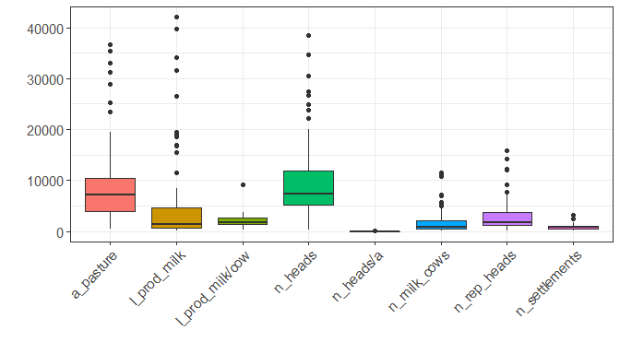

2. Literature Review

The modeling chosen relies on the input-output approach, required for the formulation of an efficiency frontier. The following papers have a series of elaborated analyses on which this article will be inspired:

Table 2: Efficiency modeling on literature

|  |  |  |  |  |
| --- | --- | --- | --- | --- |
| Authors | Year | DMUs | Inputs | Outputs |
| Yuping Bai; Xiangzheng Deng; Yue Zhang; Chao Wang; Yu Liu | 2019 | Household size; Livestock density; Frequency of extreme drought; Purchase of forage; Enclousure of livestock | Grassland area; Labor; Capital | Total meat production of pigs, cattle and sheep |
| Hinrich D. Schultea; Linda Armbrecht; Rasmus Bürgerc; Matthias Gaulyd; Oliver Musshoffa; Silke Hüttele | 2018 | Herd size; costs; Land and capital; Water quality | Grazing area; Set of cattle welfare indicators; | Milk production per cow |
| S.H. Evers; S. McParland; L. Delaby; K.M. Pierce; B. Horan | 2021 | Number of lactations; Number of cows | Profit index (EBI); Milk; Fertility; Beef; Maintenance; PTA; Milk yield; Fat yield; Protein yield | Milk solid production; Mid-lactation bodyweight |
| Hasan Yilmaz; Fekadu Gelaw; Stijn Speelman | 2020 | NA | Concentrate feed intake; Rughgage feed intake; Farmholder age, experience and education; household population; Feeding type; Barn type; Maize silage production; Ratio of dairy cows | Milk production |
| Geraldo da Silva e Souza; Eliane Gonçalves Gomes | 2020 | Agricultural credit; Proportion of technical instructed households; GINI index per city; Social, environmental and demogrphic indexes | Expenses with labor, land and technological inputs | Production gross income |
| Ruxin Zhanga; Shuhao Tana; David Hannawayb; Weizhu Daia | 2020 | Height of grass; Coverage of grass; Variety of palatable grass | Livestock; Labor; Machinery; Capital | Livestock income; Grassland condition |
| Souhil Harchaoui; Petros Chatzimpiros | 2017 | NA | Cereals; Oilcrops meal; Fodder and grasses | Meat beef, sheep and goat; Meat pork; Meat chicken; Eggs; Milk |
| Zhaomin Hu; Zhe Zhao; Yue Zhang; Haichun Jing; Shuqin Gao; Jingyun Fang | 2019 | NA | Capital; Labor; Land (grassland) | Livestock value |
| Wei Huang; Bernhard Bruemmer; Lynn Huntsinger | 2016 | NA | Grassland area; Labor; Capital; Initial yak | Yak meat; Revenue of other outputs |
| Katarina Labajova; Helena Hansson; Mette Asmild; Leif Göransson; Carl-Johan Lagerkvist; Maria Neil | 2016 | NA | Feed; Labour; Variable inputs; Fixed inputs; Land | Income from pig production; Income from production not related to pigs |

Some papers to put in evidence here are Souza e Gomes (2020), and Schultea et. al.(2018), which put in evidence interesting factors to observe while modeling for efficiency, specifically for milk production.

In summary, both papers approach the efficiency of milk production by the quality of life of the cattle, but in two different ways. The first one goes about the amount and variety of the grass and the area available for pasture, while the second paper mentioned correlates the quality of life with the time spent on pasture, and some other factors, like the quality of the water.