Measuring Efficiency on Milk Production Farms on the Cities of the Agreste Region of Pernambuco

Vitor Ferreira Lins

30/09/2021

**Abstract:** The present paper intends to conduct an efficiency analysis of cow milk production in the farms of the Agreste region of the Brazilian state of Pernambuco. The results obtained show the relationship between the size of city production and their efficiency, as well as their geographical disposal for identifying possible spillover effects on their production efficiency.

Keywords: *Efficiency Analysis; Milk Production; Spillover Effect.*

# 1. Indtroduction

## 1.1. Discriptive statistics

The data reviewed in this article is taken from the Brazillian Institute of Geography and Statistics (IBGE) and contains data from the Agriculture Census of 2017, the subject chosen was the production of milk for each city in the “agreste” region of the state of Pernambuco.

The data collected contains three missing values, all of which are associated with the city of Sairé, for that reason, this city will be disregarded from every further analysis in this paper. On the table below, are the descriptive data from the chosen dataset:

### Table 1: Discriptive statistics

|  |  |  |  |  |  |
| --- | --- | --- | --- | --- | --- |
| Variables | Mean | SD | 1st Quartile | Median | 3rd Quartile |
| n_heads | 9996.29 | 7969.46 | 5190.75 | 7308.50 | 11940.00 |
| n_milk_cows | 1967.71 | 2809.14 | 386.25 | 781.50 | 2160.75 |
| l_prod_milk | 5643.84 | 9654.70 | 657.50 | 1379.00 | 4540.25 |
| n_settlements | 831.41 | 597.42 | 419.25 | 736.00 | 1040.50 |
| n_rep_heads | 3077.07 | 3307.76 | 1112.00 | 1788.50 | 3733.50 |
| a_pasture | 9306.26 | 8348.71 | 3828.13 | 7171.40 | 10452.69 |
| l_prod_milk/cow | 2098.36 | 1217.59 | 1409.13 | 1810.83 | 2667.83 |
| n_heads/a | 1.23 | 0.44 | 0.93 | 1.15 | 1.58 |

The variable “city” indexes the data for each following variable, “n_heads” tells the amount of head of cattle in the municipality, “n_milk_cows” is for the number of cows used to extract milk, “l_prod_milk” shows the production of milk in the city in liters, “n_settlements” is for the number of settlements that part or all production is destined for milk production, “n_rep_heads” shows the number of cattle destined to reproduction (2 or more years of age), “a_pasture” is for the number of the total area destined for pasture in the cities (hectare), “l_prod_milk/cow” shows the production of milk per cow (in liters), and finally, “n_heads/a” shows the number of cattle heads per area of pasture.

One peculiarity of this data set is on the distribution of all variables being very similar, with a clustering of small values and less than 20 observations with high values, as outliers.

### Figure 1: Boxplot of the data

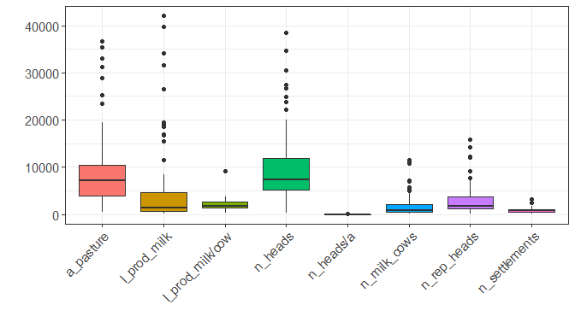

From the distribution of liters of milk produced (“l_prod_milk”), it’s possible to distinguish a few outliers, that represent the cities where most of the milk is produced for this region, these cities will be considered most important and, for this article, their efficiency benchmark will have higher importance.

### Table 3: Biggest milk producing units

|  |  |  |
| --- | --- | --- |
| City | Milk Produced (liters) | Total milk production |
| Itaíba | 42042 | 10.64% |
| Pedra | 39711 | 10.05% |
| São Bento do Una | 34195 | 8.66% |
| Buíque | 31689 | 8.02% |
| Venturosa | 26598 | 6.73% |
| Tupanatinga | 19520 | 4.94% |
| Bom Conselho | 19013 | 4.81% |
| Águas Belas | 18514 | 4.69% |
| Capoeiras | 16902 | 4.28% |
| Pesqueira | 16702 | 4.23% |
| Iati | 15478 | 3.92% |
| Sanharó | 11433 | 2.89% |

# 2. Literature Review

The modeling chosen relies on the input-output approach, required for the formulation of an efficiency frontier. The following papers have a series of elaborated analyses on which this article will be inspired:

### Table 3: Efficiency modeling on literature

|  |  |  |  |
| --- | --- | --- | --- |
| Authors | Year | DMUs | Outputs |
| Yuping Bai et. Al | 2019 | Meat Production Households | Total meat production of pigs, cattle and sheep |
| Hinrich D. Schultea et. Al | 2018 | Milk Production Households | Milk production per cow |
| S.H. Evers et. Al | 2021 | Milk Cow’s Milk Production | Milk solid production; Mid-lactation bodyweight |
| Hasan Yilmaz; Fekadu Gelaw; Stijn Speelman | 2020 | Milk Production Households | Milk production |
| Geraldo da Silva e Souza; Eliane Gonçalves Gomes | 2020 | Brazillian Cities | Production gross income |
| Ruxin Zhanga et. Al | 2020 | Multi-Household Livestock Farms | Livestock income; Grassland condition |
| Souhil Harchaoui; Petros Chatzimpiros | 2017 | Livestock Production Farms | Meat beef, sheep and goat; Meat pork; Meat chicken; Eggs; Milk |
| Zhaomin Hu et. Al | 2019 | Cattle Raising Farms | Livestock value |
| Wei Huang; Bernhard Bruemmer; Lynn Huntsinger | 2016 | Yak Production Farms | Yak meat; Revenue of other outputs |
| Katarina Labajova et. Al | 2016 | Pig Production Farms | Income from pig production; Income from production not related to pigs |

Some papers to put in evidence here are Souza e Gomes (2020) and Schultea et. al.(2018), which put some intriguing factors in evidence to observe while modeling for efficiency, specifically for milk production.

In summary, both papers approach the efficiency of milk production by the quality of life of the cattle, but in two different ways. The first one goes about the amount and variety of the grass and the area available for pasture, while the second paper mentioned correlates the quality of life with the time spent on grazing, and some other factors, like the quality of the water.

# 3. Data

## 3.1. Choosing the Efficiency Model

Before choosing a model, it was necessary to evaluate the assumptions with R’s FEAR package by Wilson, Paul W. (2008). The two tests, developed by Kneip et al. (2016) and Simar and Wilson (2020), approach the hypothesis of constant return to scale and convexity of the production, respectively, in which both were rejected.

Based on the given results, the first model selected was Free Disposability Hull (FDH), which, according to Lawrence et. al. (2017), is more robust to less substitutable inputs and creates a frontier based only on actual observations, instead of weighted averages.

Given the decreasing return to scale convexity,

## 3.2. Directional Model Hypothesis

Yet according with Lawrence et. al. (2017), the directional parameters are usually defined by specialists, because they may be able to tell which values should be assigned, given the disposal of inputs and outputs, and their theoretical relationship.

However, it is possible to a non specialist on the field to assign non discretionary variables to the model, in order for the efficiency scores to be compatible with the most basic allocation assumption, to define weather the input can be reallocated to increase efficiency or not.

For this study, it will be taken in consideration the impossibility of reallocating the number of settlements, which means that the city governments cannot increase or decrease the number o milk farms in their territory to increase efficiency, but the other variables, which are controlled by the farmers, can all be reallocated, including the area available for grazing.