Setting up Your Data

The data which appears in a chart comes from the fields in a cursor (or table, or equivalent). The alias of the cursor is stored in the required property SourceAlias:
.SourceAlias = ‘History’
The data in this cursor is not accessed directly; instead, a new cursor is created using an SQL Select statement. This means any ordering or filtering on the original cursor is ignored.
Each data series in the chart is contained in a single field. The order of the fields is not relevant, only their names. They may appear in any order, and there can be any number of additional (not-referenced) fields.
In the example cursor below, only the columns YR2005 … YR2009 contain data that will be charted; if drawn in a line chart, you would see five lines. Note that there are null values in these fields as well; these will not appear in the chart.
Depending on what type of chart is being drawn, additional (optional) columns may also be included in the cursor.
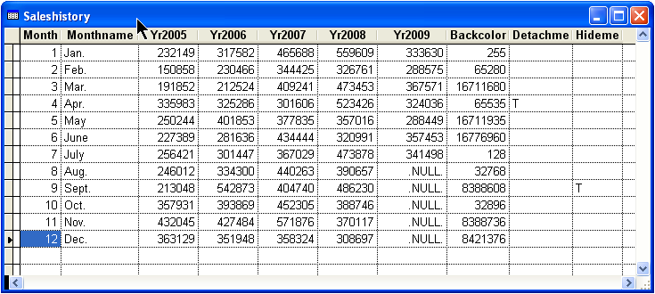
Sample cursor – each data series in a separate field
Your source data may not always be so cooperative as to be oriented so that each data series is in a field; you may have data where each data series is actually a row in a cursor (such as might be displayed in a grid).
The cursor below (SalesHistory2) contains the same data as the cursor on the previous page (SalesHistory), but with each data series in a separate row. (In fact, the cursor below is the original source for the cursor on the previous page; the cursor on the previous page was derived from it using GetChartDataFromRows.PRG.)
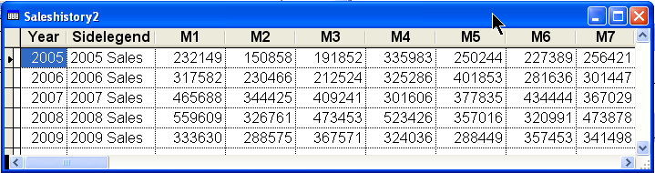
Sample cursor – each data series in a separate row
GetChartDataFromRows.PRG transforms a cursor that has its data series in separate rows into a cursor FoxCharts can use. (See the comments therein for a complete description of the parameters list).
GetChartDataFromRows.PRG requires a secondary cursor as well to describe which fields in the source cursor contain data (or other relevant information). It is fully commented.
The following converts the cursor above (SalesHistory2) using the cursor below (FieldInfo) as the secondary cursor, so that it can be used to create a chart.
GetChartDataFromRows (Thisform.FoxCharts1, “SalesHistory2”, “SideLegend”, “FieldInfo”, “SrcFldName”, “Legend”)
