The process of creating a great-looking, modern chart is an iterative process. There are a seemingly infinite number of combinations of chart types, colors and color palettes, transparencies, gradients and brush types, scaling and other properties to be considered. There are approximately one hundred different properties that can be set. Some properties work only in combination. Others apply only under certain circumstances. Achieving an attractive final result may take dozens (hundreds?) of iterations.
Beyond this, there are matters of personal taste. In particular, choices of desirable colors can vary widely from individual to individual.
Thus, it is extremely ironic that to produce a chart, the most visual of results, all the available tools have been completely non-visual – whether setting properties in code or by using PEM Editor or its outdated predecessor, the Property Window.
The Visual Chart Designer (hereinafter referred to as VCD) was born to fill this vacuum. It is designed to:
- run when a chart has already been drawn and is visible on the screen
- allow you to change the properties of the chart and see the effect of the change immediately. Almost all properties can be changed (and a list is provided of those which cannot be changed by VCD)
- view a list of all properties (and their values), or all properties that are non-default, or all properties that have changed since a given cut-off point
- copy the list of properties to the clipboard (optionally with their descriptions) in a format that allows them to be pasted directly into the method that creates the chart.
The effects of this are two-fold:
- The developer can concentrate his/her time on creating the data and making a reasonable start on the remainder of the properties. Then, he can run the chart, use VCD to modify the settings as needed, export the list of changed properties to the clipboard, and paste them back into the form to re-create the chart exactly as desired.
- This can also be provided for capable end users. This capability allows them to fine-tune reports to their own needs and tastes. In a sufficiently robust system, one could save these settings for easy retrieval, by user.
The example below shows VCD in action. The example is the VisualChartDesigner_Sample form in the Samples folder. The Visual Chart Designer form itself (on the bottom) is opened by clicking on the ‘Chart Options’ button.

Changing any of the properties in VCD, on any of the nine tabs in the pageframe, causes the chart to be re-drawn immediately. In addition, there are tooltips on each object which list the name of the property that is controlled, its value, and its description (as you would see in PEM Editor or the Property Window)
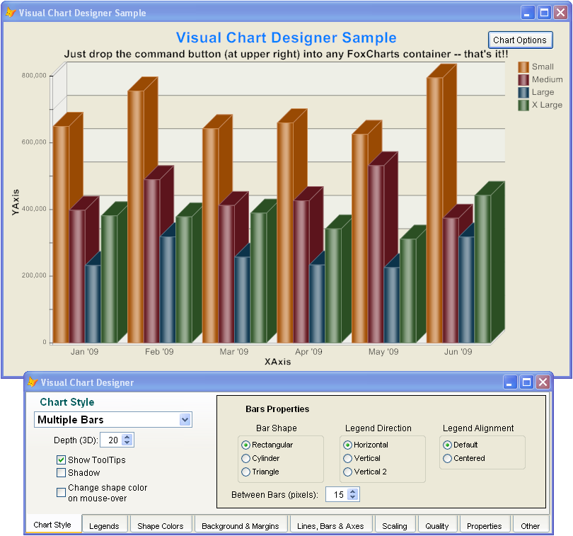

The ‘Properties’ tab can be visited at any time to see a list of the FoxCharts properties. The list can optionally include the description for each property and/or the appropriate With / EndWith structure. The list can then be saved to the clipboard for later pasting.
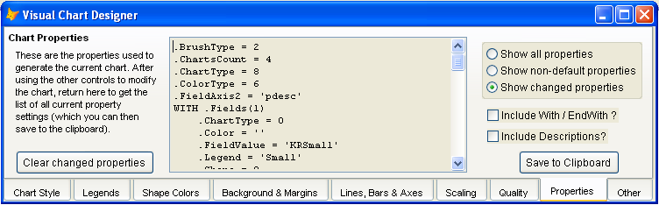

The distinction between ‘non-default properties’ and ‘changed properties’ may not be immediately clear, but is quite important.
‘Non-Default Properties’ is the standard definition of all properties that have been changed, ever.
‘Changed Properties’ means all properties that have been changed since the last time a cut-off was set. Cut-offs are set by using the method SaveChartProperties(). They are also set by using the ‘Clear Changed Properties’ button above.
A typical use of ‘Changed Properties’ is to include it immediately after the call to DrawChart() in the form creating the chart. Thus, only the properties changed thereafter in VCD would appear in the list of ‘Changed Properties’.

Installation

VCD can be added to any existing chart by adding a single control to the FoxCharts container: cmdChartOptions of VISUALCHARTDESIGNER.VCX
This control also has a property, lDevelopmentOnly, which will make it invisible and disabled when not in development mode.

