Assignment Part-II

Question 1
What is the optimal value of alpha for ridge and lasso regression? What will be the changes in the model if you choose double the value of alpha for both ridge and lasso? What will be the most important predictor variables after the change is implemented?
Answer 1
The optimal values of alpha obtained are following
- Ridge: 2.1
- Lasso: 0.00075
Impact of Doubling the hyperparameters was minimal. Since the values obtained above are optimal
In Lasso regression several more (7) predictors were made insignificant on doubling the alpha
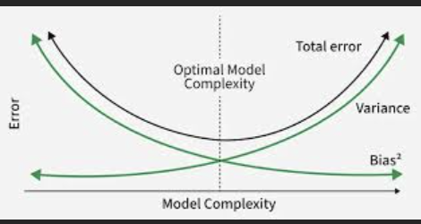
As it can be seen from the graph there is a plateau near the optimal bias and variance intersection hence on doubling a bit of R2 dropped by about 0.5-1% and RMSE increased a little.
On increasing the hyperparameter further like multiplying it with 10 noticeable changes in R2 score was observed were the drop was about 5-10 percent.

Question 2
You have determined the optimal value of lambda for ridge and lasso regression during the assignment. Now, which one will you choose to apply and why?
Answer 2
I would choose to apply lasso regression in this particular scenario.
Lasso regression was able to generate similar performance as Ridge regression but with lesser number of predictor variables (ridge – 60, lasso - 29)
Since lasso makes model more interpretable by reducing the complexity by making some predictors insignificant at the same time it also does not compromise in performance I would opt for Lasso in this case.

Question 3
After building the model, you realised that the five most important predictor variables in the lasso model are not available in the incoming data. You will now have to create another model excluding the five most important predictor variables. Which are the five most important predictor variables now?
Answer 3
On recreating the Lasso model by excluding top 5 important features ['GrLivArea', 'OverallQual', 'LotArea', 'Condition2_PosN', 'YearBuilt']
The R2 score was severely impacted and a drop of 14-15% was observed.
The 5 most important predictor variable now are [‘TotalBsmtSF’, ‘GarageCars’, ‘BsmtQual_Fa’, ‘Fireplaces’, ‘BsmtQual_TA’]

Question 4
How can you make sure that a model is robust and generalisable? What are the implications of the same for the accuracy of the model and why?

Answer 4
For the model to be more robust and generalizable it should have low bias and low variance.
For achieving low bias and low variance regularization techniques should be used like Ridge regression and lasso regression.
Ridge and lasso helps in reducing the complexity of the model and hence a good step towards generalizability.

Apart from regularization it is also very important to stop the model from overfitting or memorizing the patterns in the training data and not performing well in unseen (test data), to achieve this cross validation techniques are helpful.

The implication to achieve generalizability and robustness is that we would have to compromise a bit on accuracy by allowing some bias and reduce the variance. Since bias-variance has a relationship which requires trade off, and exactly this is what regularization allows us to do by penalizing the models to reduce complexity by reducing predictor variables coefficients and hence introducing a bit of bias to reach the sweet spot where both bias and variance are low

