GENERAL CONFEDERATION OF LABOR OF VIETNAM

**TON DUC THANG UNIVERSITY**

**FACULTY OF INFORMATION TECHNOLOGY**



SOFTWARE ENGINEERING

**Computer Store Management System**

*Instructing Lecturer*: Mr. DANG MINH THANG

*Student’s name*: **VƯƠNG GIA HÀO – 518H0009**

**CÙ ĐÌNH THI – 518H0276**

Class **: 18H50201**

Course  **: 22**

**THANH PHO HO CHI MINH, YEAR 2020**

GENERAL CONFEDERATION OF LABOR OF VIETNAM

**TON DUC THANG UNIVERSITY**

**FACULTY OF INFORMATION TECHNOLOGY**



SOFTWARE ENGINEERING

**Computer Store Management System**

*Instructing Lecturer*: Mr. DANG MINH THANG

*Student’s name*: **VƯƠNG GIA HÀO – 518H0009**

**CÙ ĐÌNH THI – 518H0276**

Class **: 18H50201**

Course  **: 22**

**THANH PHO HO CHI MINH, YEAR 2020**

ACKNOWLEDGEMENT

During the research process for the major assignment, we have received enthusiastic suggestions and help from teachers.

Firstly, we would like to express my sincere gratitude to our supervisor teacher – Mr. Dang Minh Thang, who taught and conveyed experiences to us directly during our studying and conducting this research process.

Besides, we are thoroughly grateful to all teachers of the Faculty of Information Technology in TDT University for giving us a chance to study and contact with our major.

**THE PROJECT WAS COMPLETED AT TON DUC THANG**

**UNIVERSITY**

We pledge that this is a product of our own project and is under the guidance of Mr. Dang Minh Thang. The content of research, results in this subject is honest and not published in any form before. The data in the tables used for the analysis, comment, and evaluation were collected by the authors themselves from various sources indicated in the reference section. In addition, many comments and assessments as well as data from other authors and organizations have been used in the project, with references and annotations.

**If any fraud is found, we are fully responsible for the content of our project.** Ton Duc Thang University is not involved in any copyright infringement or copyright infringement in the course of implementation (if any).

*TP. Ho Chi Minh, day 13 month 12 year 2020*

*Authors*

*(sign and write your full name)*

*Vuong Gia Hao*

*Cu Dinh Thi*

EVALUATION OF INSTRUCTING LECTURER

**Comfirmation of the instructor**

_______________________________________________________________________________________________________________________________________________________________________________________________________________________________________________________________________________________________________________________________________________________________________________________________________________

Tp. Ho Chi Minh, day month year

(sign and write your full name)

**The assessment of the teacher marked**

_______________________________________________________________________________________________________________________________________________________________________________________________________________________________________________________________________________________________________________________________________________________________________________________________________________

Tp. Ho Chi Minh, day month year

(sign and write your full name)

INTELLECTUAL PROPERTYCopyright 2020 Vuong Gia Hao and Cu Dinh Thi.

The following documentation, the content therein and/or the presentation of its information is proprietary to and embodies the confidential processes, designs, technologies and otherwise of team. All copyright, trademarks, trade names, patents, industrial designs, and other intellectual property rights contained herein are, unless  
otherwise specified, the exclusive property of team.

The ideas, concepts and/or their application, embodied within this documentation remain and constitute items of intellectual property which nevertheless belong to team.

The information (including, but by no means limited to, data, drawings,  
specification, documentation, software listings, source and/or object code) shall not be  
disclosed, manipulated, disseminated or otherwise in any manner inconsistent with the  
nature and/or conditions under which this documentation has been issued.

The information contained herein is believed to be accurate and reliable. Team  
accepts no responsibility for its use in any way whatsoever. Team Five shall not be liable for any expenses, damages and/or related costs which may result from the use of the information contained herein.

TABLE OF CONTENTS

ACKNOWLEDGEMENT i

EVALUATION OF INSTRUCTING LECTURER iii

TABLE OF CONTENTS 1

CHAPTER 1 – SURVEY – EXECUTIVE SUMMARY – INTRODUCTION SOFTWARE 3

1.1. Introduce Store 3

1.2. Organizational chart – Computer Store 3

1.3. The Scope of the System 3

1.4. Problem of Store 3

1.5. Introduction Computer Store Management System 3

CHAPTER 2 – SRS DOCUMENT 4

2.1. Actor 4

2.2. Flowchart 4

2.3. Question of Author and Customer Answer 4

2.4. Functional Requirement 4

2.5. Non-Fucntional Requirement 4

2.6. List of Use Cases 4

2.7. Use Case Diagram And Specification 4

CHAPTER 3 – DESIGN DOCUMENT 5

3.1. Class Diagram 5

3.2. Activity And Sequence Diagrams 5

3.3. Entity Relationship Diagram 5

CHAPTER 4 – REALIZE SOFTWARE 6

4.1. Database 6

4.2. Interface design and manipulation 6

CHAPTER 5 – TEST CASE – UNIT TEST – SVN/ GIT 7

5.1. Test case 7

5.2. Unit test 7

5.3. SVN/ GIT 7

5.4. Hardware and software requirements 7

REFERENCES 8

CHAPTER 1 – SURVEY – EXECUTIVE SUMMARY – INTRODUCTION SOFTWARE

* 1. Introduce Store

1.2. Organizational chart – Computer Store

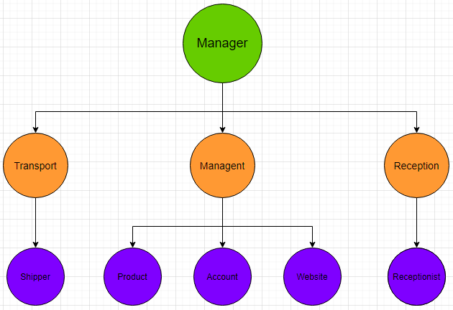

1.3. The Scope of the System

Provide software with the following requirements:

- Customer information management.

- Support customer ordering products online.

- Support manager or admin managing products.

- Support manager or admin managing orders.

- Support shipper managing order delivery.

- Full reporting system detailing customer’s invoices.

1.4. Problem of Store

- Difficult to manage customer information.

- Difficult to manage all the products.

- Difficult to manage orders.

- Customer information security is low.

- Few ways to communicate with customers.

1.5. Introduction Computer Store Management System

- This software system created to help manager manage the product, customer information easier.

- Product storage system. Product details: ID, Name, Price.

- Customer information storage system. Customer details: ID, Name, Phone, Email, Password, Birth, Address.

- Order information storage system. Order details: ID, Name.

CHAPTER 2 – SRS DOCUMENT

2.1. Actor

**Customer**: is who want to buy product from the shop.

**Manager**: is who create, update product for the shop and get the order report from the customer.

**Shipper**: get order and back order from the customer and the manager to deliver to the customer.

2.2. Flowchart

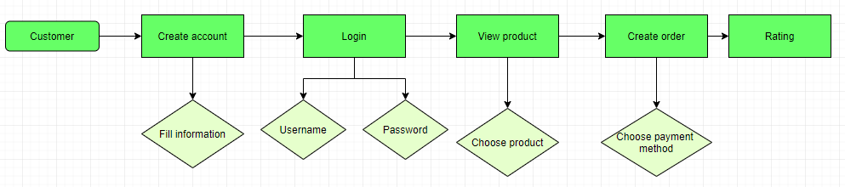**-With Customer:**

**- With Manager:**

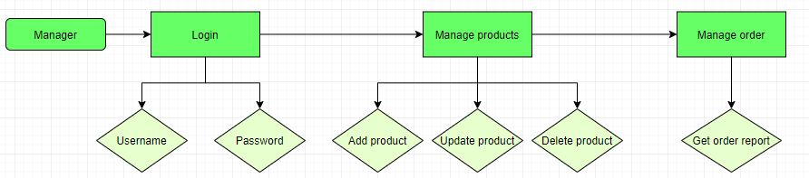

**- With Shipper:**

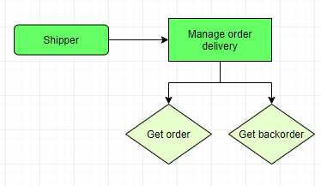

**-**

2.3. Question of Author and Customer Answer

|  |  |  |
| --- | --- | --- |
| **Section/ Screen** | **Comment/ Question** | **Answer** |
| Helps | When the manager have any problem can contact with the author a link. | We totally agree. |
| Communication | When the customers have some problem with product information they can’t communicate with shop  Offer: Create a place that help customer to communicate with customer like messaging place, or phone number. | We totally agree. |

2.4. Functional Requirement

- The system shall record customer’s information.

- The system shall record customer’s order.

- The system allow user create account.

- All information of user be secured.

- The system allow manager to add, delete, update product.

- The system shall display all products on the shop.

- The system support manager to get all the order.

- The system shall record customer’s invoices.

2.5. Non-Functional Requirement

- The login system shows all customer’s information for manager.

- The login page must have more color.

- Queries shall return within five seconds.

- Login place must on the left of the page.

2.6. List of Use Cases

**- Create account:** Customer create account

**- Manage account:** Customer change account information

**- View product:** Customer view products

**- Make order:** Customer add products in cart

**- Update order:** Customer change products in cart

**- Payment:** Customer choose payment method

**- Login:** Manager login manger account

**- Logout:** Manager logout manager account

**- Get order report**: Manager get order report from customer

**- Get order, get back order:** Shipper get order and back order from customer

2.7. Use Case Diagram And Specification

- Business Process:

*Picture 2.7.1: 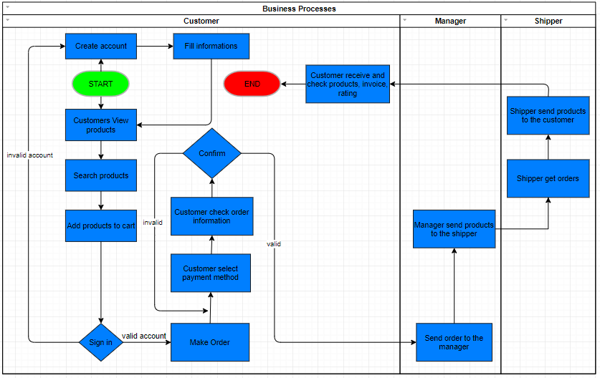Business Process*

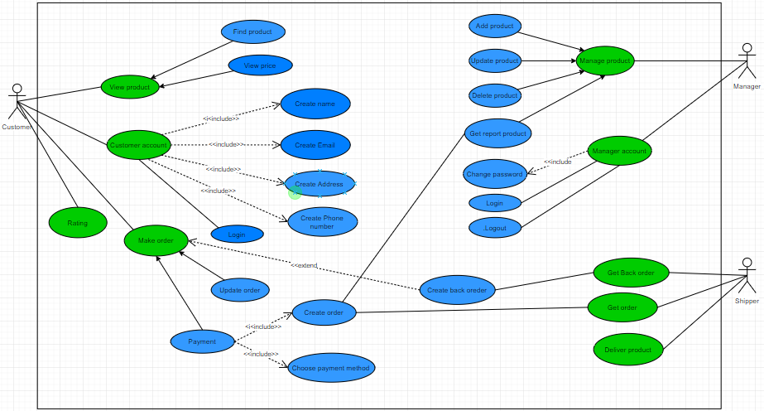-Use case diagram:

*Picture 2.7.2: Schema use case diagram about system*

-Use case specification:

CHAPTER 3 – DESIGN DOCUMENT

3.1. Class Diagram

3.2. Activity And Sequence Diagrams

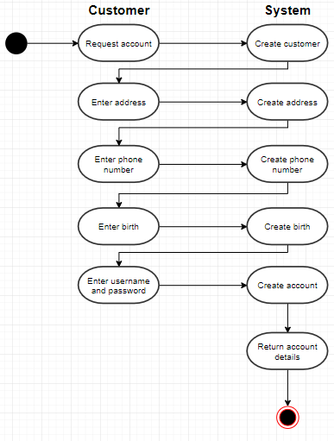

*Picture 3.2.1: Activity diagram about create customer account system.*

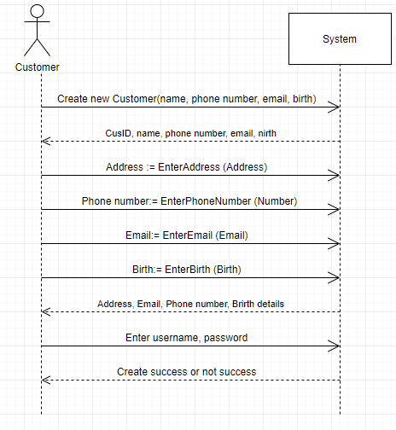

*Picture 3.2.4: Sequence diagram about Customer with System.*

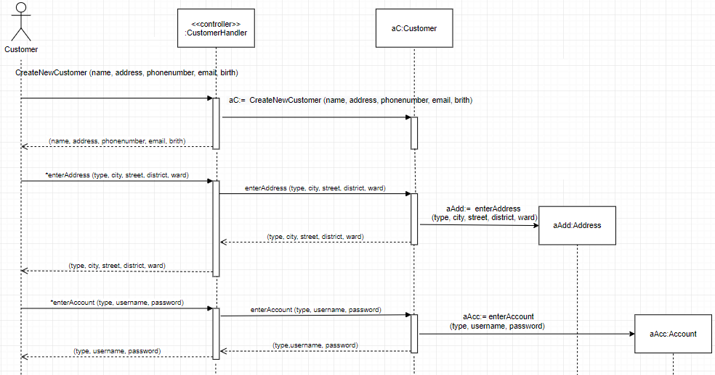

*Picture 3.2.3: Sequence diagram about create customer account system*

3.3. Entity Relationship Diagram

CHAPTER 4 – REALIZE SOFTWARE

4.1. Database

4.2. Interface design and manipulation

CHAPTER 5 – TEST CASE – UNIT TEST – SVN/ GIT

5.1. Test case

5.2. Unit test

5.3. SVN/ GIT

5.4. Hardware and software requirements

REFERENCES

1. Ton Duc Thang University’s Software Engineering Slides.

2. [W3Schools Online Web Tutorials](https://www.w3schools.com/) (w3schools.com)

3. StackOverFlow (stackoverflow.com)

4. Bootstrap Docs (getbootstrap.com/docs/5.0/getting-started/introduction)