
UNCLASSIFIED

XR-7 Advanced Signal Processing Module
EMC Compliance Test Report
Document Number RPT-XR7-2026-001
Revision 3.0
Issue Date 2026-06-18
Client Vertex Aerospace Systems Ltd
Test Laboratory Element Warwick — EMC & Wireless Laboratory
Accreditation UKAS 17025 · Lab No. 0123

Standards applied:
• EN 55032:2015 (CISPR 32) Class B
• EN 55035:2017
• IEC 61000-4-2
• IEC 61000-4-3

Revision History
Rev | Date | Author | Description
1.0 | 2026-04-02 | T. Okafor | Initial issue
2.0 | 2026-05-14 | T. Okafor | Added conducted-immunity results
3.0 | 2026-06-18 | H. Nguyen | Full re-test after firmware v2.3; all sections re-issued

Contents
• 1 Executive Summary
• 2 Equipment Under Test
• 3 Summary of Results
• 4 Radiated Emissions
• 5 Conducted Emissions
• 6 Radiated Immunity
• 7 Electrostatic Discharge Immunity
• 8 Appendix — Raw Data
• 9 Declaration of Conformity

1 Executive Summary
This report presents the electromagnetic compatibility (EMC) qualification results for the XR-7 Advanced Signal Processing Module (XR-7 Rev C, S/N SN-XR7-00417), tested at Element Warwick — EMC & Wireless Laboratory on behalf of Vertex Aerospace Systems Ltd.
Overall result: PASS — full compliance.
Testing was performed against the standards listed on the cover page. The sections that follow detail each discipline, the applicable limits, the measured results and the compliance margin. Full measurement extracts are provided in the appendix.
2 Equipment Under Test
The XR-7 is a rack-mounted advanced signal-processing module operating across 100 MHz to 6 GHz. It comprises a triple-channel RF front end, an FPGA processing core and a switched-mode DC supply.
Attribute | Value
Model | XR-7 Rev C
Serial Number | SN-XR7-00417
Power Supply | 48 V DC, 2.4 A max
Dimensions | 482 x 88 x 350 mm (19" 2U)
Operating Modes | Idle, Half-load, Full-load, Peak-burst
Cables / Ports | Shielded RF (SMA), CAT6A data, DC power harness

3 Summary of Results
Table 3-1. Summary of EMC test results.
Discipline | Standard / Limit | Key Result | Status
Radiated Emissions | EN 55032 Class B | Peak margin -6.2 dB @ 232 MHz | PASS
Conducted Emissions | EN 55032 Class B | Peak margin -4.8 dB @ 0.53 MHz | PASS
Radiated Immunity | IEC 61000-4-3, 10 V/m | Criterion A, all bands | PASS
ESD Immunity | IEC 61000-4-2, +/-8 kV | Criterion A, contact & air | PASS
Electrical Fast Transient | IEC 61000-4-4, +/-2 kV | Criterion A | PASS

4 Radiated Emissions
Standard: EN 55032:2015 Class B Site: 3 m Semi-Anechoic Chamber (SAC-2) Detector: Quasi-peak / Average, CISPR 16-1-1 receiver
Radiated emissions were measured from 30 MHz to 6 GHz with the EUT in Full-load mode, the worst-case configuration identified during pre-scan. The chamber turntable was rotated 0-360 deg and the antenna height scanned 1-4 m at each azimuth to capture maximum emissions. The highest emission occurred at 232 MHz, 6.2 dB below the Class B limit.
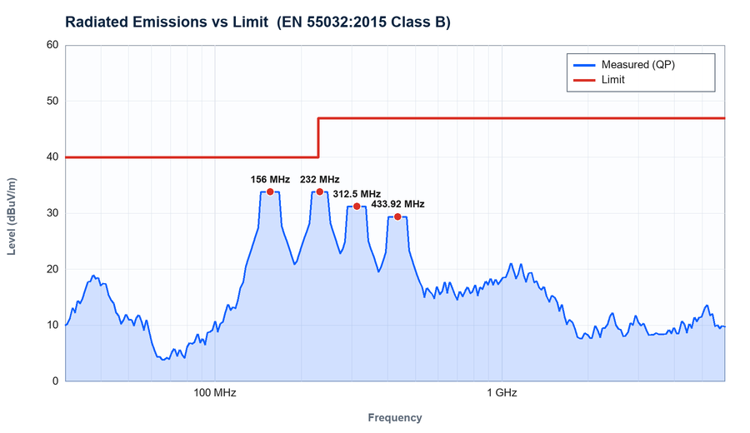
Figure RE-1. Radiated emissions, horizontal polarisation, 30 MHz - 1 GHz vs EN 55032 Class B QP limit.
Table RE-1. Highest radiated emissions (worst-case azimuth/height).
Freq (MHz) | Reading (dBuV/m) | Limit (dBuV/m) | Margin (dB) | Detector | Pol. | Status
156.00 | 33.8 | 40.0 | -6.2 | QP | H | PASS
232.00 | 33.8 | 40.0 | -6.2 | QP | H | PASS
2400.0 | 40.2 | 47.0 | -6.8 | AV | V | PASS
1200.0 | 38.7 | 47.0 | -8.3 | AV | H | PASS
312.50 | 31.2 | 40.0 | -8.8 | QP | V | PASS
433.92 | 29.4 | 40.0 | -10.6 | QP | H | PASS

5 Conducted Emissions
Standard: EN 55032:2015 Class B Site: Shielded Room 1, 50 uH/50 Ohm LISN Detector: Quasi-peak / Average, 150 kHz - 30 MHz
Conducted emissions on the AC mains port were measured across 150 kHz to 30 MHz using a two-line LISN. Both live and neutral conductors were scanned; the table lists the higher of the two. The worst-case margin was -4.8 dB at 530 kHz on the live conductor.
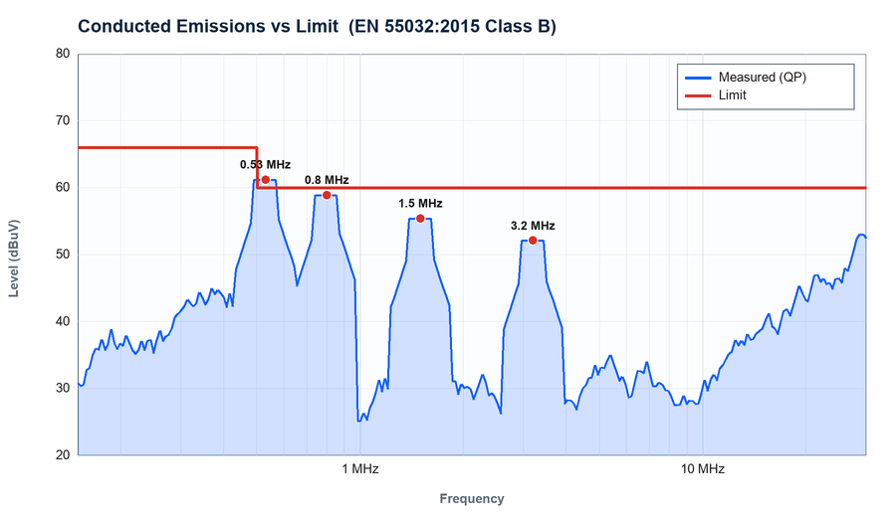
Figure CE-1. Conducted emissions on mains port (Live) vs EN 55032 Class B QP/AV limits.
Table CE-1. Highest conducted emissions.
Freq (MHz) | QP (dBuV) | QP Limit | AV (dBuV) | AV Limit | Cond. | Status
0.53 | 61.2 | 66.0 | 48.3 | 56.0 | L | PASS
0.80 | 58.9 | 63.5 | 45.1 | 53.5 | L | PASS
1.50 | 55.4 | 60.0 | 42.7 | 50.0 | N | PASS
3.20 | 52.1 | 56.0 | 39.8 | 46.0 | L | PASS
6.40 | 49.7 | 56.0 | 37.2 | 46.0 | N | PASS
12.8 | 47.3 | 60.0 | 35.6 | 50.0 | L | PASS
24.0 | 44.8 | 60.0 | 33.1 | 50.0 | N | PASS

6 Radiated Immunity
Standard: IEC 61000-4-3 Field: 10 V/m, 80% AM 1 kHz, 80 MHz - 6 GHz
The EUT was exposed to a 10 V/m field, 80% amplitude-modulated, across 80 MHz to 6 GHz on four faces in both polarisations. Signal integrity of all three RF channels was monitored continuously. No degradation beyond permitted limits was observed; performance criterion A was met throughout.
Table RS-1. Radiated immunity results by band and face.
Band (MHz) | Field (V/m) | Pol. | Face | Observation | Criterion
80 - 1000 | 10 | H | Front | No degradation | A
80 - 1000 | 10 | V | Front | No degradation | A
1000 - 2700 | 10 | H | Rear | No degradation | A
2700 - 6000 | 10 | V | Side | No degradation | A

7 Electrostatic Discharge Immunity
Standard: IEC 61000-4-2 Levels: Contact +/-4 kV, +/-8 kV; Air +/-8 kV, +/-15 kV
Electrostatic discharge was applied to all user-accessible points and to horizontal/vertical coupling planes. Ten discharges of each polarity were applied per point. The EUT continued to operate normally with no loss of function or data corruption; criterion A was achieved.
Table ESD-1. ESD immunity results.
Discharge Point | Type | Level (kV) | Discharges | Observation | Criterion
Front panel / buttons | Contact | +/-4, +/-8 | 10 each | No effect | A
Chassis seams | Contact | +/-8 | 10 each | No effect | A
Ventilation grille | Air | +/-8, +/-15 | 10 each | No effect | A
HCP / VCP | Contact | +/-8 | 10 each | No effect | A

8 Appendix — Raw Data
Table A-1. Full radiated-emissions sweep extract (worst azimuth).
Test ID | Freq (MHz) | Reading | Limit | Margin | Detector | Status
RE-1001 | 48.00 | 22.1 | 40.0 | -17.9 | QP | PASS
RE-1002 | 96.00 | 28.4 | 40.0 | -11.6 | QP | PASS
RE-1003 | 156.0 | 31.7 | 40.0 | -8.3 | QP | PASS
RE-1004 | 232.0 | 33.8 | 40.0 | -6.2 | QP | PASS
RE-1005 | 312.5 | 31.2 | 40.0 | -8.8 | QP | PASS
RE-1006 | 433.9 | 29.4 | 40.0 | -10.6 | QP | PASS
RE-1007 | 617.0 | 27.9 | 40.0 | -12.1 | QP | PASS
RE-1008 | 868.0 | 36.1 | 47.0 | -10.9 | QP | PASS
RE-1009 | 1200. | 38.7 | 47.0 | -8.3 | AV | PASS
RE-1010 | 1800. | 37.4 | 47.0 | -9.6 | AV | PASS
RE-1011 | 2400. | 40.2 | 47.0 | -6.8 | AV | PASS
RE-1012 | 3600. | 35.5 | 47.0 | -11.5 | AV | PASS
RE-1013 | 4800. | 33.9 | 47.0 | -13.1 | AV | PASS
RE-1014 | 6000. | 31.2 | 47.0 | -15.8 | AV | PASS

9 Declaration of Conformity
On the basis of the tests described in this report, the XR-7 Advanced Signal Processing Module (XR-7 Rev C) is assessed as compliant with the requirements of the standards listed, for the configuration and operating modes tested.

Table 9-1. Approvals.
Role | Name | Title | Date
Prepared by | H. Nguyen | EMC Test Engineer | 2026-06-18
Reviewed by | T. Okafor | Senior EMC Engineer | 2026-06-18
Approved by | D. Whitmore | Laboratory Manager | 2026-06-18

