AGING:

The process of monitoring a device's behavior over time to assess its performance, stability, and any potential issues that may arise as the device ages or accumulates usage. This can include tracking factors like battery degradation, app performance, and system responsiveness over extended periods.

That’s why we use to collect dump state

Steps to proceed:

1. ->Flash the device with Aging build.

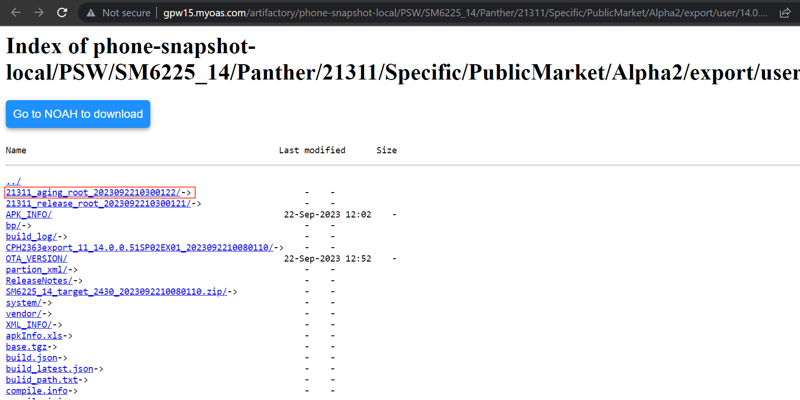

There are two ways to collect dumpstate in Android based on their processor..

1. Mediatek(MTK)
2. After flash need to give this command:

adb shell

echo c > /proc/sysrq-trigger

echo c > /proc/sysrq-trigger: This command sends a specific character (c) to the /proc/sysrq-trigger file in the Linux kernel's /proc filesystem.

In Linux, the /proc/sysrq-trigger file is used to trigger various system-level operations for debugging and emergency situations. These operations are often referred to as "Magic SysRq" commands.

The c character is used to request that the kernel perform a controlled system reboot. It's essentially a safer way to trigger a reboot compared to an abrupt shutdown.

1. after giving this command ,the device goes to orange state.(ie. Dumpstate is collecting in background)
2. And then it reboots after dump is collected.
3. To check the dump ,we need to give the following commands.

adb shell

cd data/vendor/aee_exp/db.fatal.00.KE

ls -l

adb shell: This command opens a shell session on an Android device from a connected computer using ADB. It allows you to execute commands directly on the Android device's command line.

cd data/vendor/aee_exp/db.fatal.00.KE: This command changes the current working directory on the Android device to data/vendor/aee_exp/db.fatal.00.KE. You will navigate to this directory to list its contents.

ls -l: After changing the directory, this command is used to list the contents of the current directory (db.fatal.00.KE). The -l flag is used to display the contents in a long format, which provides detailed information about each file or directory, including permissions, owner, group, file size, modification time, and file/directory name.

U will get some info regarding dump.

1. Qualcomm:
2. After flash we need to give the command.

adb shell

echo c > /proc/sysrq-trigger

1. GO to device manger--->ports--->900E
2. Goto QPST -->ports-->(some data will be loading)
3. To check the dumpstate data, Goto File manager--> sahara--> device port-->check the file size

Ex: if device is 12Gb then the data will be divided into 6…with2 gbsomething.

If proper dump is collected then …it is pass

Aging apps--->need to be cross check by simply open a particular options…

Any preconditions?

No preconditions.