Victor Gregory  
CSD310-J308  
Professor Sampson

5.2 Assignment

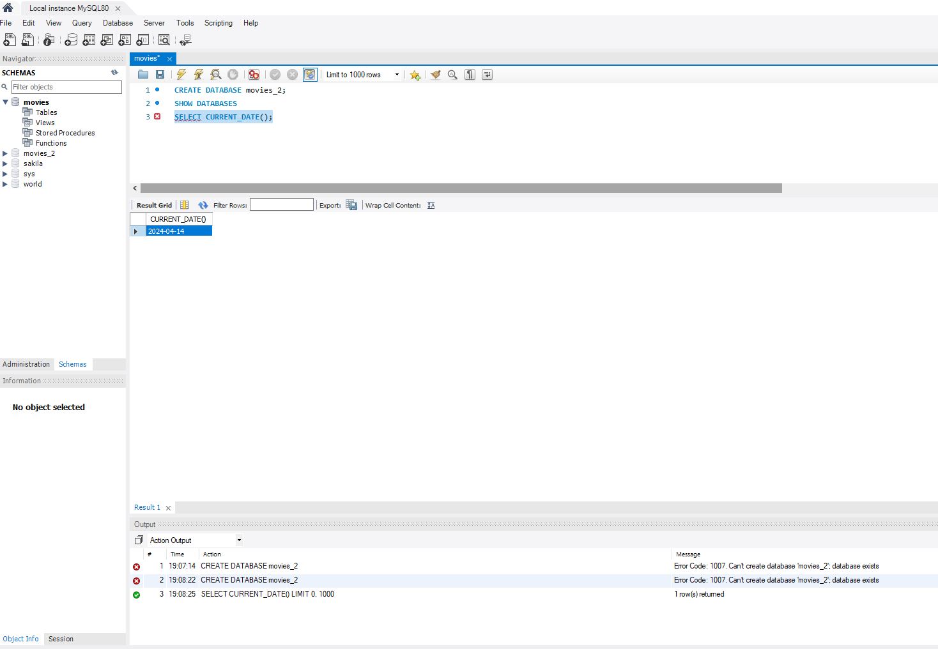

I tried the CURRENT_DATE, CREATE DATABASE, SELECT syntaxes as a way to practice.The first command has MySQL display the current date. Also, the CREATE <Action> it should be able to create tables and databases this should be able to have the user organize their data with this command.

CREATE TABLE Persons (  
 PersonID int,   
 LastName varchar (255)  
 FirstName varchar (255)  
 Address varchar (255)  
 City varchar (255)

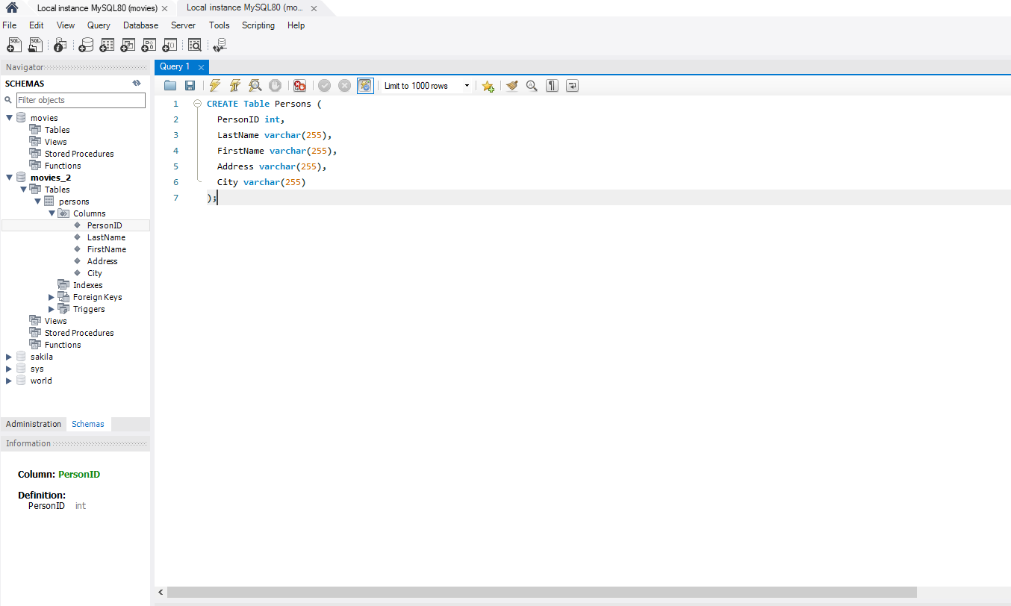

SELECT * FROM Customers

WHERE Country='Mexico';

